Supplementary file

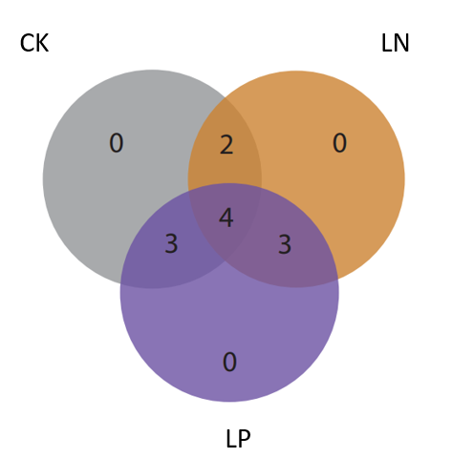
Fig. S1: Heterosis in primary root length under different soil conditions. CK: Control soil, LN: Low nitrogen soil, LP: Low phosphorus soil. The numbers indicate the extent of primary root heterosis observed in the crossed hybrids.

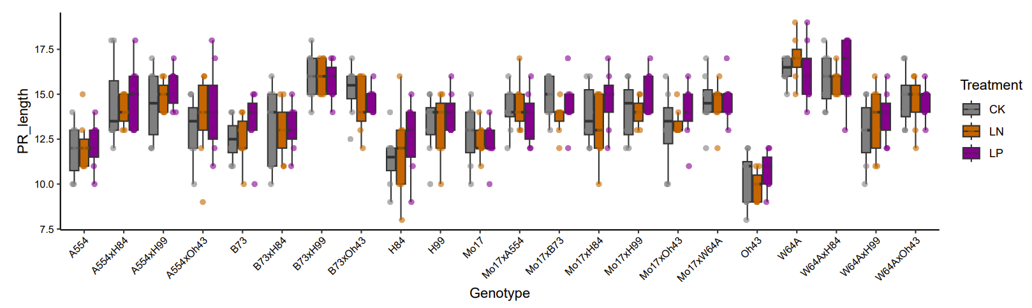
Fig. S2: Boxplot of primary root (PR) length for each genotype under different soil conditions. CK: Control soil; LN: Low nitrogen soil; LP: Low phosphorus soil.

a b
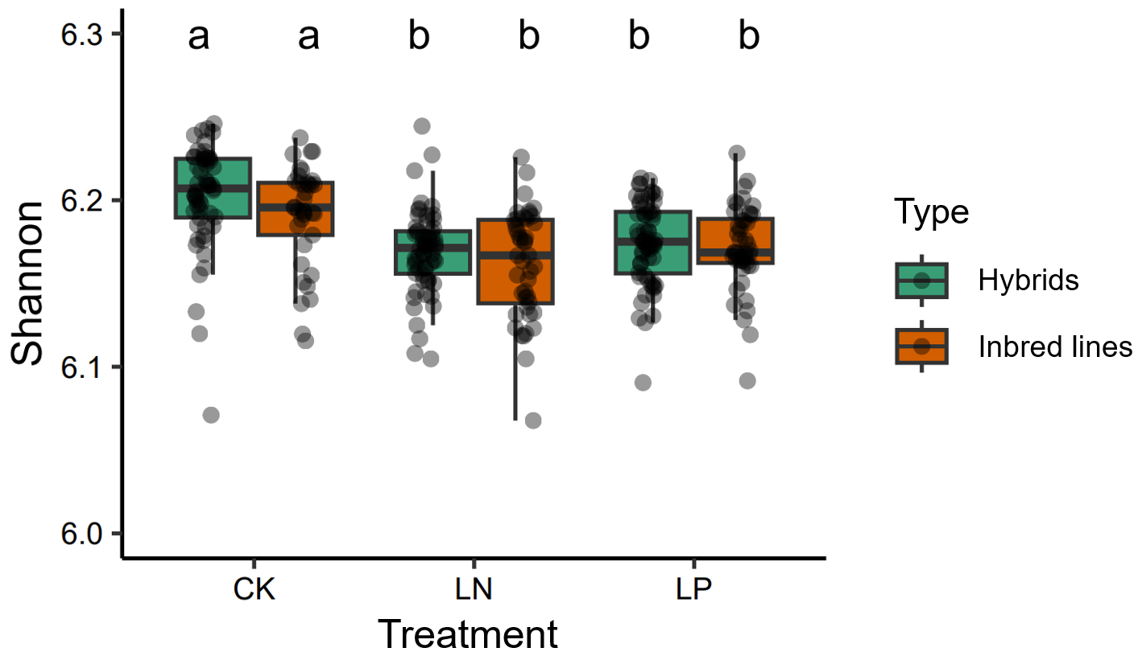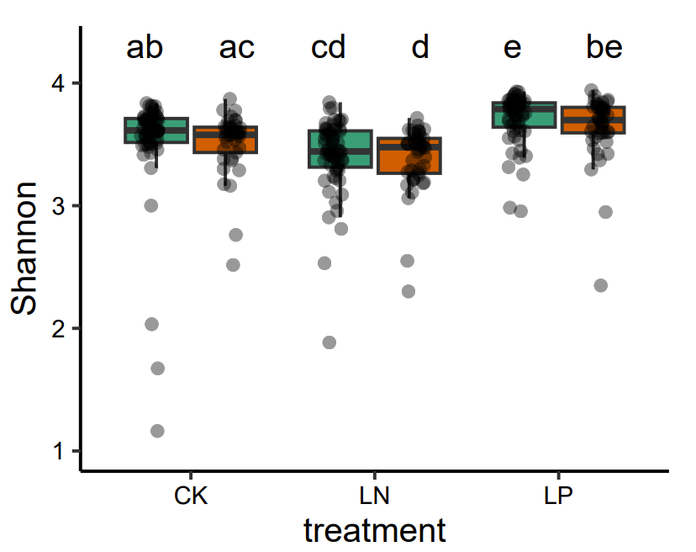
Fig. S3: Comparison of Shannon alpha diversity for bacteria (a) and fungi (b) between hybrids and inbred lines under different soil conditions. CK: Control soil; LN: Low nitrogen soil; LP: Low phosphorus soil. Colors distinguish hybrids from inbred lines. Significance levels are indicated by different letters (P <0.05).

a b
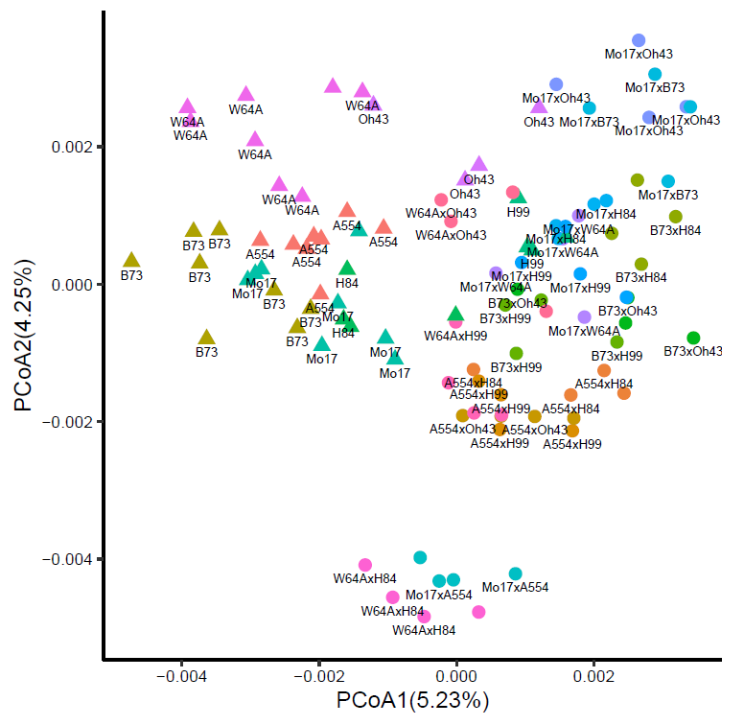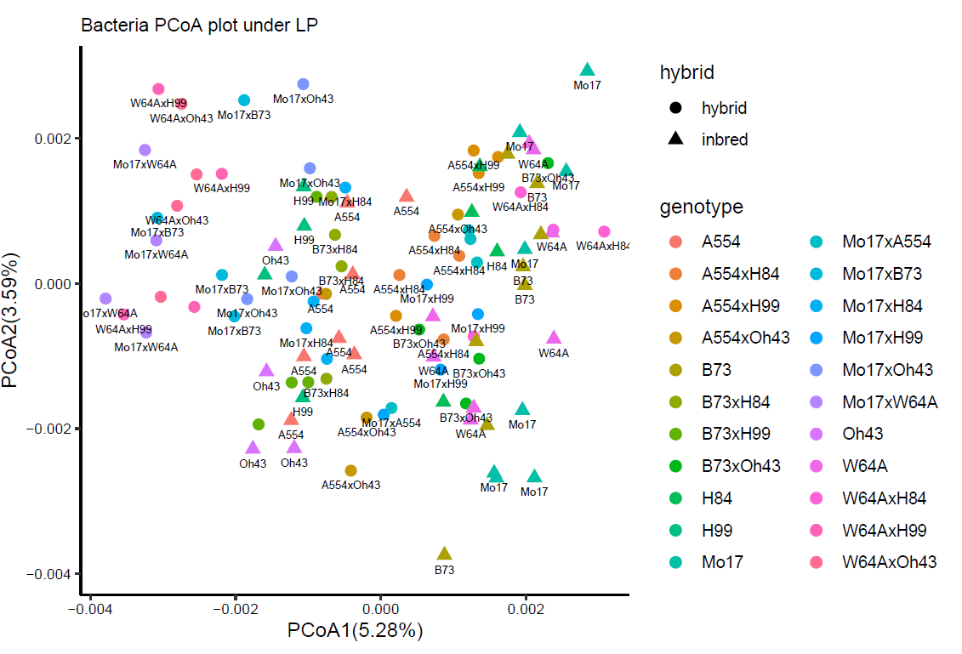
Fig. S4: PCoA plot of bacterial community composition under low nitrogen (a) and low phosphorus (b) conditions. Different colors represent different genotypes, with circles indicating hybrids and triangles representing inbred lines.

a b
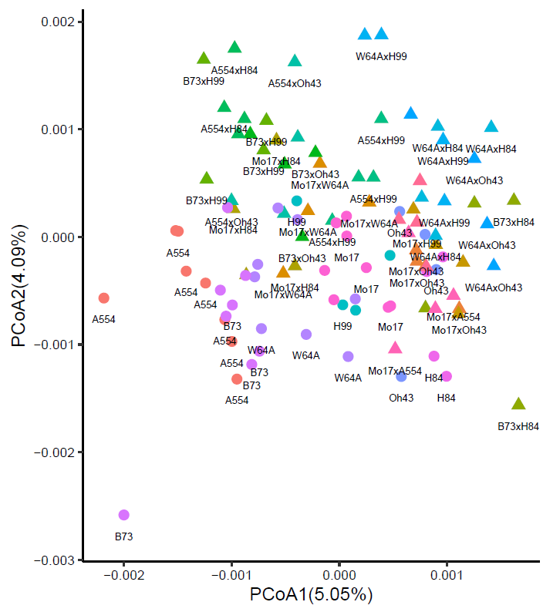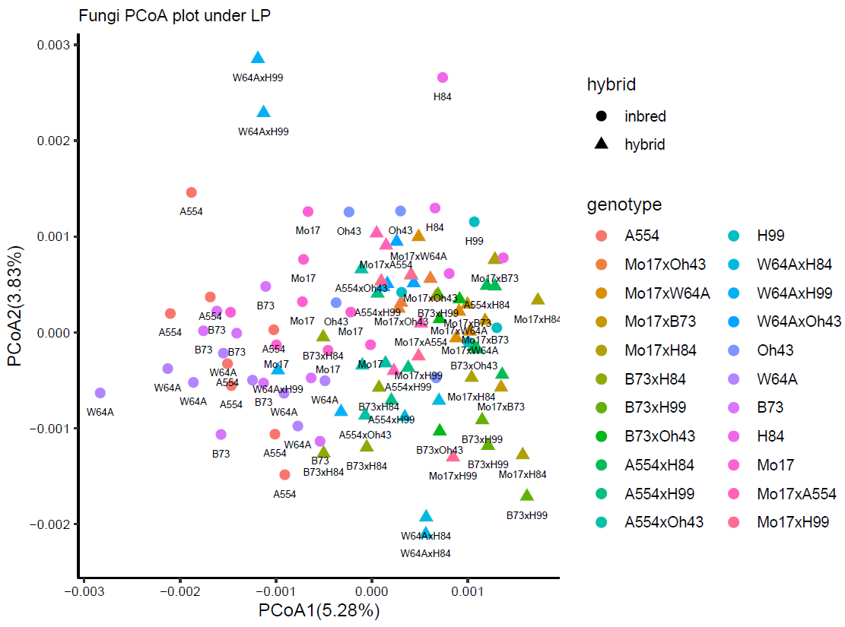
Fig. S5: PCoA plot of fungal community composition under low nitrogen (a) and low phosphorus (b) conditions. Different colors represent genotypes, with circles indicating inbred lines and triangles representing hybrids.

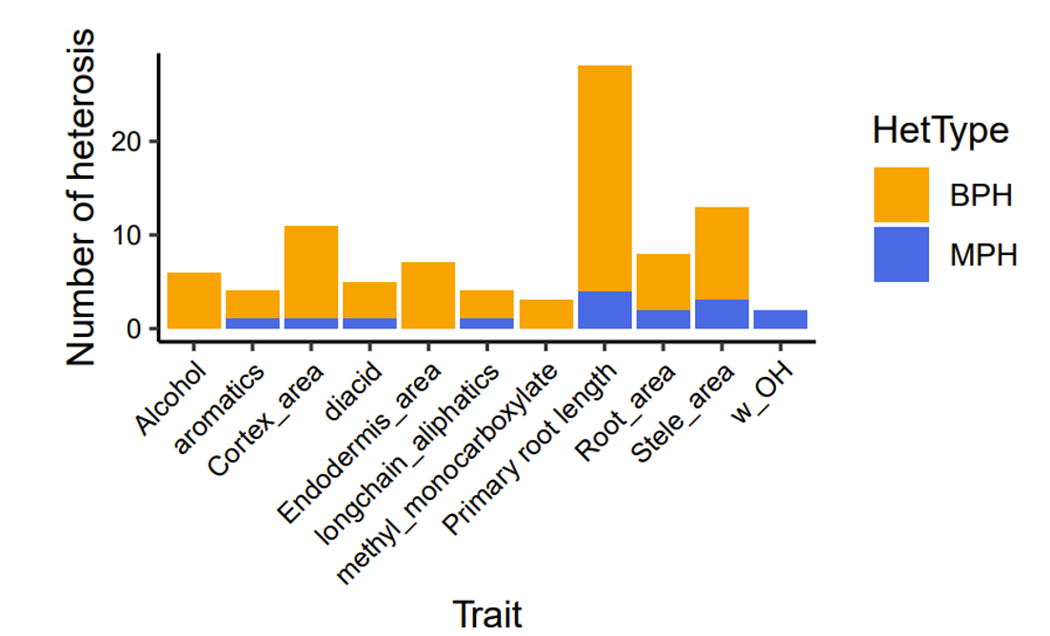
Fig. S6: Comparison of better-parent heterosis (BPH) and mid-parent heterosis (MPH) for each trait. BPH: better-parent heterosis; MPH: mid-parent heterosis.

a b
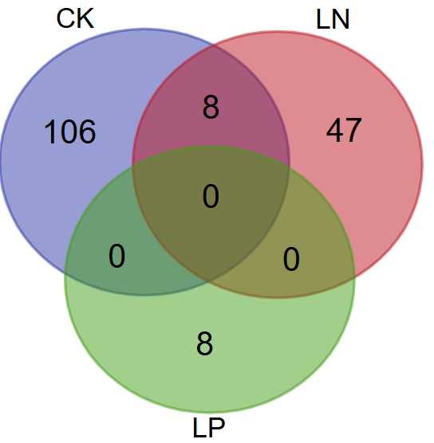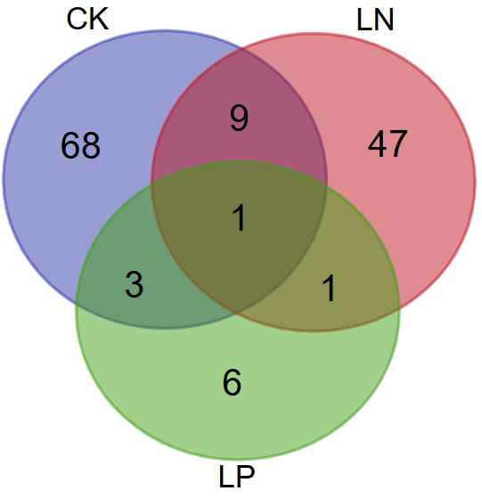
Fig. S7: Overlap of bacterial ASVs enriched in hybrids (a) and inbred lines (b) across three soil conditions. CK: control soil; LN: low nitrogen soil; LP: low phosphorus soil.

a b
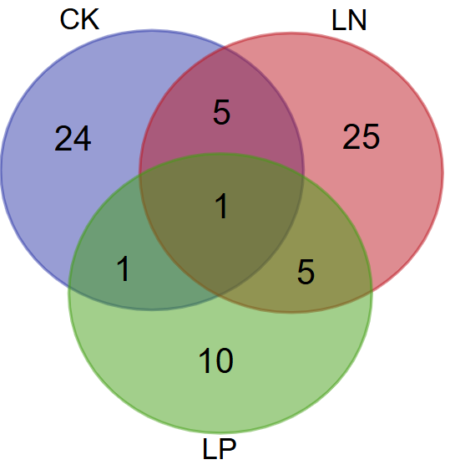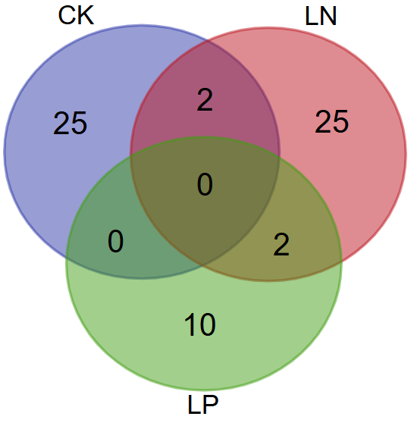
Fig. S8: Overlap of fungal ASVs enriched in hybrids (a) and inbred lines (b) across three soil conditions. CK: control soil; LN: low nitrogen soil; LP: low phosphorus soil.

a b c
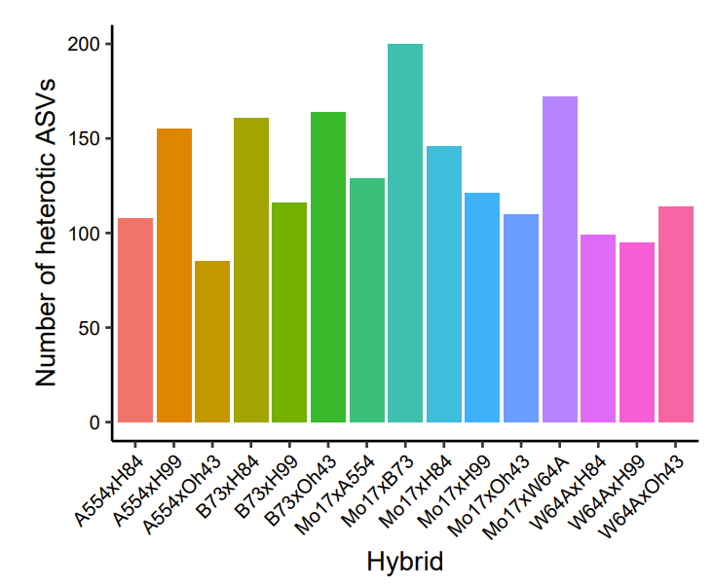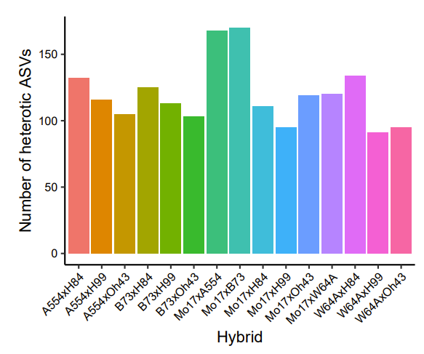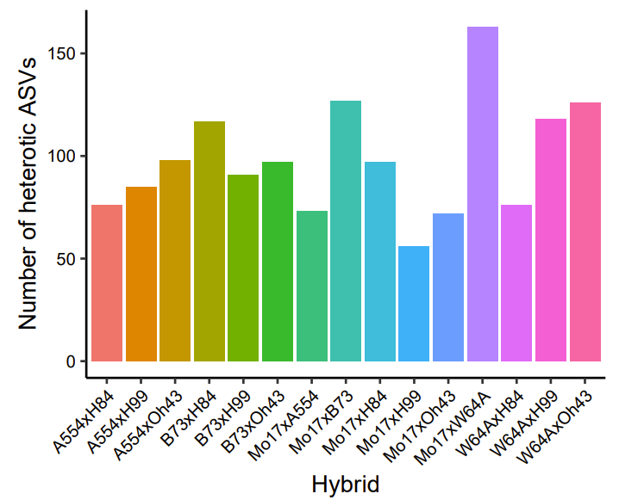
Fig. S9: Number of heterotic bacterial ASVs in each hybrid-parent triplet under control soil (a), low nitrogen soil (b), and low phosphorus soil (c). Each bar represents the number of heterotic ASVs in different hybrids relative to their parental lines.

a b c
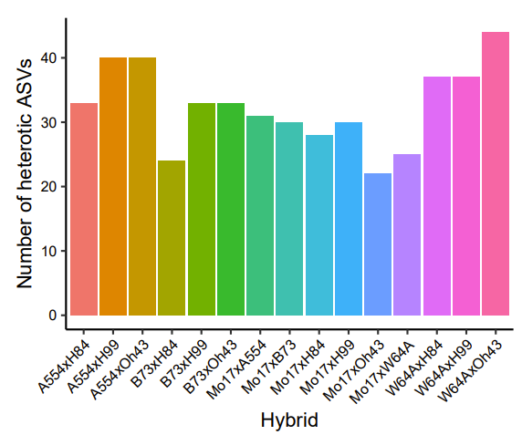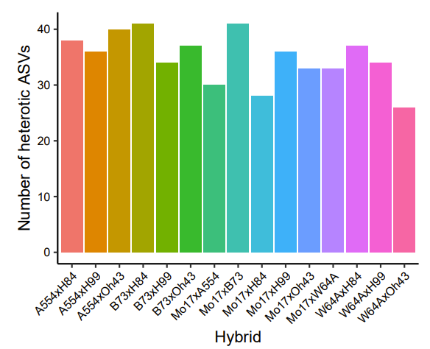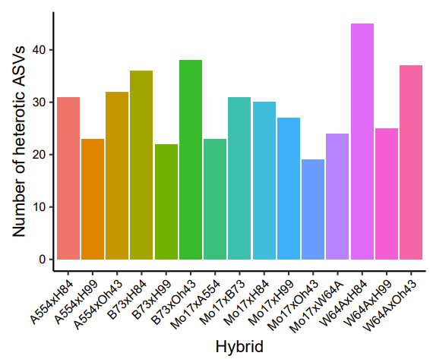
Fig. S10: Number of heterotic fungal ASVs in each hybrid-parent triplet under control soil (a), low nitrogen soil (b), and low phosphorus soil (c). Each bar represents the number of heterotic ASVs in different hybrids relative to their parental lines.

a b
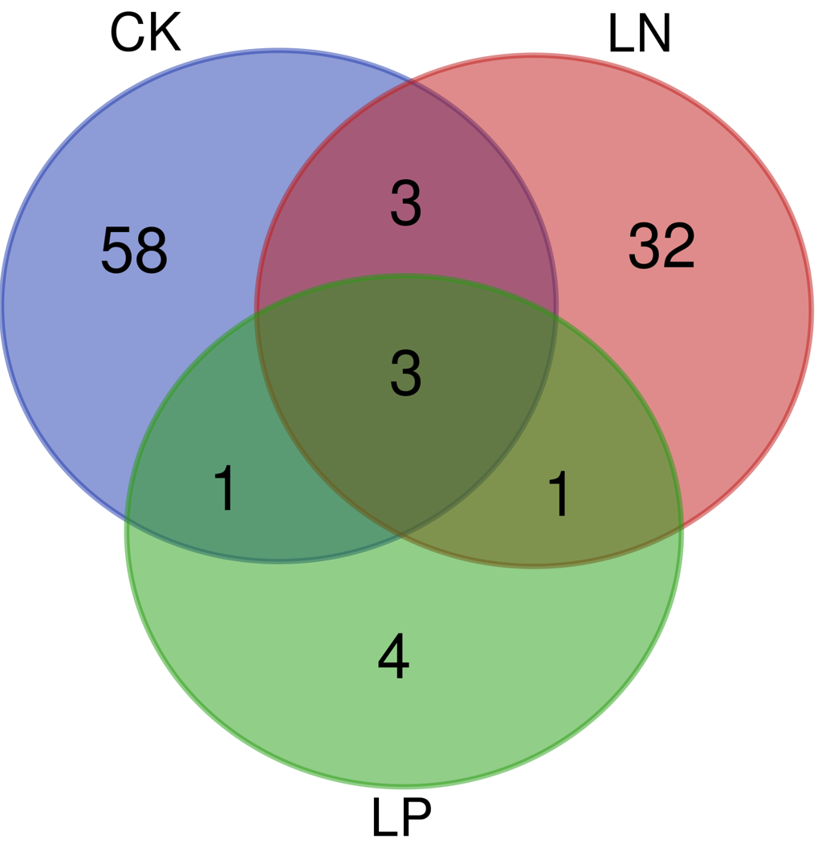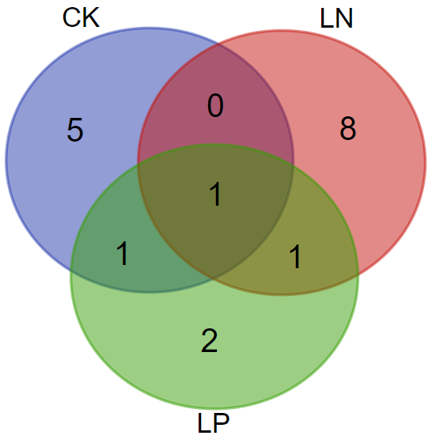
Fig. S11: Number of ASVs exhibiting heterosis in more than five hybrids for bacteria (a) and fungi (b) under each soil condition. CK: control soil; LN: low nitrogen soil; LP: low phosphorus soil.

a b c
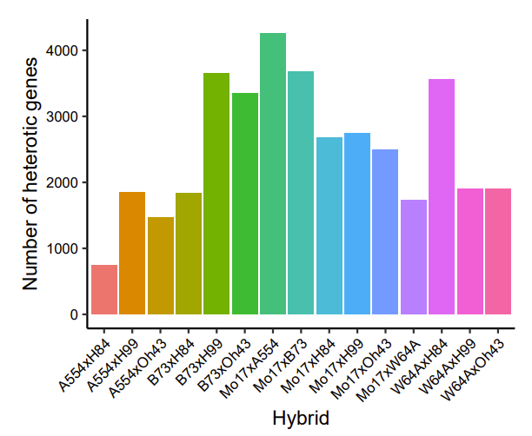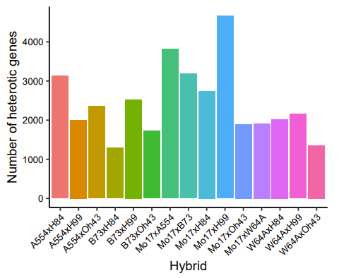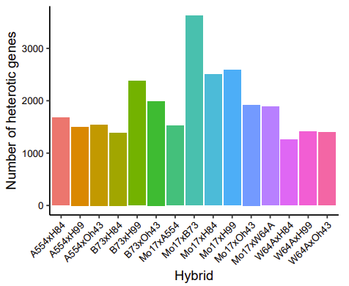
Fig. S12: Number of heterotic genes in each hybrid-parent triplet under control soil (a), low nitrogen soil (b), and low phosphorus soil (c). Bars represent the number of heterotic genes in different hybrids compared to their respective parents.

