Supplementary Figure 1: The phylogenetic tree. (A) Cladogram demonstrates the evolutionary relationship between the amino acid sequences of glycoprotein S of SARS-CoV-2 from China, Iran, and Tunisia.
The branch lengths are irrelevant and do not represent time or relative amount of character change, and its internal nodes do not represent ancestors. (B) Phylogram branching represents the true amount and duration of evolutionary changes.

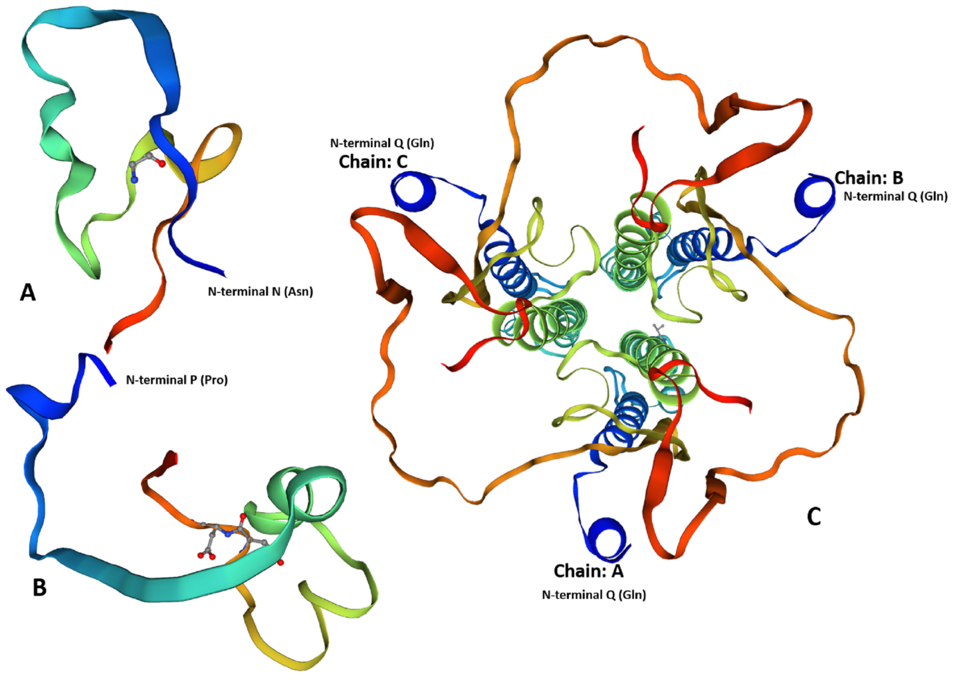
Supplementary Figure 2: SARS-CoV-2 S glycoprotein 3D models using Protein Structure Prediction (PSIPRED) in SWISS-MODEL.
The size ratios of the S glycoprotein models are preserved. The Chinese (A) and Iranian (B) models have one chain (monomer), while the Tunisian model (C) has three chains (chain A, B, and C) (homo-trimer). The color codes from the SWISS-MODEL is (Rainbow). The Global Model Quality Estimation (GMQE) score were (0.99, 0.99, and 0.97), while the global quality estimates of amino acid sequences (QMEAN) scores were (-1.48, -0.88, and -4.27) for the (Chinese, Iranian, and Tunisian models), respectively.

