APPENDIX A

Identified facilitators across Choosing Wisely priorities and sites

Table 1: Identified sustainability facilitators of PPI de-prescribing (6 FHTs)
Success Factor (Teams) | Theme | Reason(s) for success
CW represents evidence-based practice (Teams 4, 10) | The initiative is evidence-based | - As a FHT, being evidence based is part of their strategic goals (Team 4)  - The CW PPI initiative is based on credible evidence (Team 4)  - It is viewed that the evidence base is clear and credible. (Team 10)  - The evidence base for their initiative has already been developed by others. (Team 10)
Leadership support (Teams 6, 7, 10) | Clinical and senior leaders are supportive | - PPI de-prescribing initiative has been prioritized by clinical leadership as a patient safety issue, which is a top concern for the FHT (Team 6)  - The lead physician has acted as an ambassador for the PPI initiative; otherwise, the initiative wouldn’t have been as prominent and might have been lost amongst other initiatives (Team 6)  - The pharmacist is the primary staff involved in the process. The team finds success in keeping the physicians’ involvement to a minimum. However, having a clinical champion is also important to the success of the initiative. (Team 7)  - The initiative was introduced in a "top down approach"–i.e., it came from the board and was introduced to different Family Health Organizations and physicians. (Team 10)
Staff involvement, engagement, and empowerment (Teams 2, 4, 7) | Buy-in exists | - The staff have buy-in (Team 4)  - The physicians are on board with the initiative; there is staff buy-in (Team 2)
 | Simplicity facilitates buy-in | - The team credits the simplicity of the Intervention to its successful staff buy-in (Team 7)
 | Staff involvement | - Through discussions with staff, the seed for a PPI de-prescribing initiative was planted in the years previously. These discussions were held during meetings like the physicians’ quarterly meeting (Team 7)
Optimized team communication and collaboration  (Team 7) | Opportunities to present on the initiative | - The team has taken opportunities to present about this initiative and de-prescribing in general. This supported an environment which encouraged staff involvement. (Team 7)
Monitoring of progress supports the initiative (Teams 4, 6, 7, 10) | Monitoring supports the initiative | - The team meets monthly to monitor progress (Team 4)  - There are systems in place to monitor the progress of the initiative (Team 6)  - Codes in the FHT’s EMR system were created to help monitor the progress of the PPI de-prescribing activities/initiative (Team 7)  - Once a week, the program administrator pulls data on which patients are eligible for PPI reduction and informs the pharmacist; the pharmacist then sends a message to physicians ahead of patient visits to suggest they consider PPI reduction with those patients (Team 6)  - Their program administrator has created a lot of forms and put in a lot of work to help monitor their progress (Team 10)
 | Communication of monitoring supports the initiative | - Having an indicator for PPI de-prescribing on the Quality Improvement Plan (QIP) is helpful because it encourages physicians to be engaged and to see the value of the initiative, since they have to report on this once a year and be publicly accountable (Team 6)  - Data on the PPI initiative is shared with the FHT Quality Improvement Committee (Team 6)  - Monthly data is collected and data is shared quarterly with the CW committee (Team 6)
Fit with existing processes and workflows (Teams 2, 4, 7, 12) | Standardized and available CW tools and processes | - The initiative is built into the system, so even if teams change, the project can continue (Team 2)  - Staff are very aware of the initiative and the PPI custom form (Team 2)  - The physicians all have access to the Choosing Wisely PPI de-prescribing framework (Team 2)  - All staff (including new staff) have access to the same Choosing Wisely PPI resources (Team 2)
 | Use of IT tools | - Codes in the FHT’s EMR system were created to help monitor the progress of the PPI de-prescribing activities/initiative (Team 7)  - If a change to the EMR is needed to be made, the program manager will easily make the change (Team 7)  - The team has a lot of high level experience using EMRs. (Team 7)  - There are electronic tools in place to flag patients that should be reviewed for the initiative (Team 2)
 | Making the initiative easy to use for staff | - The purpose of the PPI initiative is to make their lives easier (Team 4)  - Tools are in place to help staff and physicians, such as custom forms and templates in the EMR, and tick boxes and lists rather than free form text (Team 4)  - Reminders and stamps are in place for the physicians in the EMR (Team 4)
 | Modifying the initiative to make It easier to use | - Process initially relied on cold calls to contact patients to discuss PPI de-prescribing. Patients were not responsive to this, so an encounter system (supported by electronic reminders) was developed to be used by pharmacists and physicians. (Team 1)
Fit with existing culture (Teams 2, 4, 6, 7, 12) | Culture is that you do QI | - There is a culture of working on QI, and the PPI initiative fits into this (Team 2)  - The organization wants to improve processes and patient safety, which also fits the aims of the PPI initiative (Team 2)  - The work which goes into the other FHT projects on de-prescribing naturally supports the goals of this PPI de-prescribing initiative, and vice versa. (Team 12)  - The different FHTs see the initiative as sort of a competition/challenge, which motivates them to work on it (Team 4)
Fit with existing culture (Teams 2, 4, 6, 7, 12) | Awareness | - Coinciding with the PPI initiative, there has been a lot of attention paid to the risks of PPIs in the broader medical community and in journals and medical news feeds. There has been new evidence on how significant the risks are. (Team 6)  - There is growing awareness in the media of the potential problems associated with over-prescribing and PPI use, and some patients have initiated conversations about PPI use with the pharmacist; this timing has overlapped with the PPI de-prescribing initiative and has helped with its success. (Team 6)  - The PPI initiative is also part of the Canadian CW campaign, which is considered a credible source that has received a lot of attention in the medical community, including presentations at conferences and workshops (Team 6)  - Because this is a topic that people are talking a lot about, there is a greater awareness, which results in people de-prescribing more. This supports an organization-wide culture change. (Team 7)

Table 2: Identified sustainability facilitators of PPI de-prescribing (3 hospitals)
Success Factor | Theme | Reason(s) for success
CW represents evidence-based practice (Teams 5, 9, 11) | Evidence-based practice is valued | - Clinicians (pharmacists and physicians are well aware of and practice evidence- based medicine (Team 5)  - In order to grow awareness of the initiative, the team leaned on the available evidence. In the Pre-Printed Orders (PPO), the evidence is highlighted, as well as in any communications with staff and physicians. (Team 9)  - The Team’s initiative is set up as a research study, which will contribute to the available evidence on PPI de-prescription. (Team 11)
CW represents evidence-based practice (Teams 5, 9, 11) | Initiative Is evidence based | - The PPI de-prescribing recommendation is well grounded in the evidence base (Team 9)  - Some evidence about the risks of PPIs have been substantiated by the evidence, and some have not. However, the evidence is robust enough to convince patients and physicians of the benefits of PPI de-prescription. (Team 11)  - The evidence is clear and it is an easy way to encourage buy-in among staff. (Team 9)
Optimized team communication and collaboration (Team 5) | Enhanced team collaboration ensures success | - Pharmacists work closely with the physicians and the patients (Team 5)  - Decisions made as a group (i.e., pharmacists, physicians, patients) (Team 5)  - Pharmacists can ask the physicians to de-prescribe i.e., pharmacists are more cognizant of the orders of these meds and can ask the physicians to consider de-prescribing) (Team 5)
Optimized team communication and collaboration (Team 5) | Enhanced team communication ensures success | - Pharmacists and physicians communicate regularly to discuss PPI de-prescribing and re-assessment of therapy. During the discharge planning stage, the Team is confident that if a patient is discharged while still on a PPI, that the PPI is required for that particular patient and where possible, the duration of PPI therapy is outlined if it is for a short-term use indication. (Team 5)  - Pharmacists follow up with physicians to recommend/suggest a patient be de-prescribed the PPI and if not available, they will leave electronic messages for the physicians in the EPR. These suggestions have been well-received by physicians, as pharmacists see the orders discontinued based on their suggestions. (Team 5)
Optimized team communication and collaboration (Team 5) | CW publications help support changes | - CW publications inform staff education and help to support changes in the process (i.e., de-prescribing algorithm); publications also include pamphlets for patients that pharmacists use as a decision-making and education tool for patients (Team 5)
Adequate staffing resources (Teams 5, 11) | Additional Pharmacy Resources | - As part of the hospital's new Reactivation Care Centre (RCC) program, the Pharmacy Department was given additional resources to support the hiring of a new pharmacist. This new role helps support the current/ongoing medication reviews, which include the PPI de-prescribing initiative for this patient population (Team 5)
Adequate staffing resources (Teams 5, 11) | Benefits of doing the initiative as part of a study | - If any of the Team members left, it would have a big impact. When a pharmacy student isn’t around, enrolment of patients closes down (Team 11)  - However, because there is a protocol in place (that describes the PPI de-prescribing process), someone else interested could take over from the lead Pharmacist (Team 11)
Fit with existing processes and workflows (Teams 5, 9, 11) | Standardized and available CW tools and processes | - The PPI de-prescribing initiative is well supported through the CW campaign (e.g., algorithm, tapering schedule) (Team 9)  - An algorithm is in place that outlines the process and includes steps for the PPI de-prescribing to support the process/doctor/pharmacist; i.e., the algorithm includes assessment of eligibility of a patient to be de-prescribed a PPI, the process for tapering off the PPI, tips/actions for managing any symptoms that may arise during the tapering off, etc. (Team 11)
Fit with existing processes and workflows (Teams 5, 9, 11) | Use of IT tools | - For patients who are deemed an alternative level of care (ALC) status, there is an electronic order set that was developed which includes a default order for a pharmacist's consult for a full medication review. As part of this medication review, PPIs, as well as other medications, are assessed for appropriateness for de-prescribing (Team 5)  - Created "flags" for ALC patients (Team 5)
Leadership support (Teams 5 and 9) | Senior leadership support | - Support from organization is present (Team 9)  - The CW initiative is well recognized across the hospital as being supported at the overall hospital (organization-wide) level (Team 9)
Fit with existing culture (Team 5) | Initiative is in line with strategic aims and culture | - Other CW initiatives have been implemented elsewhere in the Hospital and staff recognize the hospital as a CW leader (Team 5)

Table 3: Identified sustainability facilitators of reducing Pre-Op testing (2 hospitals)
Success Factor | Theme | Reason(s) for success
Leadership support (Teams 1 and 13) | Clinical Leadership | - The change could not have been possible without the clinical lead champions (Team 1)  - There had been an interest in developing an initiative on this topic for a long time, but they were only able to work on this once they had clinical leadership that was supportive. (Team 1)  - The initiative currently has clinical leadership support in the trial at 4 offices. It will be helpful to see if this support continues as the initiative is rolled out to the rest of the hospital. (Team 13)
Leadership support (Teams 1 and 13) | Senior Leadership support | - The initiative, which preceded CW, has been supported by the joint centers, and hospital leadership (Team 1)  - The initiative fits with the wider CW Campaign (Team 1)  - This initiative fits the strategic aims of the hospital to improve patient care and efficiency. (Team 1)
Staff involvement, engagement, and empowerment (Team 1) | Staff involvement In designing the implementation | - The staff have been very involved and came up with the tools and solutions (Team 1)  - The original working group included everyone: pharmacists, nurses, secretaries, family doctors, anesthetists, general internal medicine, surgeons and the chiefs (Team 1)
Staff involvement, engagement, and empowerment (Team 1) | Staff empowerment during the roll out of the implementation | - Frontline leadership was empowered to take on the initiative, and asked how it could be improved (Team 1) Frontline staff were empowered to make decisions (Team 1)  - The staff had the tools (the testing grid, consents, etc.) they needed in place to carry out the initiative (Team 1)
Optimized team communication and collaboration (Team 1) | There is awareness about the CW approach | - Everyone (staff) affected is aware of the approach. (Team 1)
Cost effective | There is potential for cost savings | - There are cost savings due to less testing. (Team 1)
Fit with existing processes and workflows (Teams 1 and 13) | Standardized processes help | - It is a straightforward, standardized approach. (Team 1)  - The team has trialed the pre-op optimization grid since March 2017 with 4 offices at the hospital. They received staff feedback and have revised the grid. It is currently going through an approval process. The plan is to roll out the initiative with the grid to the rest of the hospital’s 55 offices (Team 13)
Fit with existing processes and workflows (Teams 1 and 13) | CW increases efficiency in clinical workflows | - There is less paperwork for administrative staff. (Team 1)  - The initiative allowed flexibility in nurse scheduling to see urgent cases/patients (Team 1)  - From a clerical perspective, there is now less paperwork due to fewer patients requiring pre-op testing and the flow of paperwork has been streamlined. (Team 13)  - The nursing workload is lightened because there are fewer patients going through the Pre-op Clinic. (Team 1)  - The nursing workload is also lightened in Day Surgery. (Team 1)  - The initiative is easier and simpler for surgeons; processes are streamlined. (Team 1)  - Patients spend less time in pre-admission for tests they don't need. (Team 1)
Fit with existing processes and workflows (Teams 1 and 13) | Use of electronic tools | - Another EMR initiative has allowed increased access to blood work, and this has had a positive impact on the PPI initiative. (Team 1)  - The team internally tracks pre-op testing (e.g., blood work, chest x-rays, ECGs, etc). (Team 13)

Table 4: Identified sustainability facilitators of reducing BUN/Urea testing (3 hospitals)
Success Factor | Theme | Reason(s) for success
Leadership support (Team 3) | Senior Leadership | - Strong leadership from the department chiefs and corporate level in supporting the initiative. (Team 3)  - Corporate level leadership engagement in the CW campaign and committee. (Team 3)
Staff involvement, engagement, and empowerment (Teams 3, 14) | Staff engagement and involvement in the process | - They had a high level of staff engagement. (Team 3)  - During the planning stages, many discussions and consultations took place with affected stakeholders across the hospital (i.e., leaders, medical leaders, physicians, etc.). (Team 14)
Staff involvement, engagement, and empowerment (Teams 3, 14) | Clinician buy-in | - Went to clinicians first and asked them to contribute ideas on lab testing that could be decreased based on lack of benefit to patients. This encouraged buy in from clinicians at an early stage, which worked better than telling them to reduce testing as a lab cost reduction method (more authentic). (Team 3)  - Asking for clinician input and identifying clinician champions helps reach goals and get results. (Team 3)
Fit with existing processes and workflows (Team 8, 14) | Ease of implementation | - The ease of applying the CW BUN/Urea project is due to its ability to be implemented almost anywhere. (Team 8)  - The initiative is a relatively straightforward process (i.e., the "de-defaulting" of the lab test on the order sets which have been pre-determined, through review and discussions, as eligible). (Team 14)
Fit with existing processes and workflows (Team 8, 14) | Use of IT tools | - Tracking information related to this initiative is possible, and electronic systems are in place (Team 14). The BUN/urea test has now been removed from the post-surgery order set, so they no longer have the "automatic"[or 'default'] ordering of the BUN tests after surgeries. (Team 8)
Optimized team communication and collaboration (Team 8, 14) | Awareness campaign increases involvement | - The use of posters (i.e., the image of a burger bun with a red line across it) has been effective in creating/raising awareness of the Choosing Wisely BUN/urea message among (ICU) staff. As a result, the ordering of these tests has really dropped. (Team 8)
Optimized team communication and collaboration (Team 8, 14) | Communication channels | - Communication channels exist for any feedback to be shared regarding the initiative. (Team 14)
Fit with existing culture (Team 3, 8, 14) | Culture of collaboration | - The organization has a culture of collaboration across departments (i.e., between the lab and the departments of medicine, emergency department, etc.) (Team 3)  - The organization has a culture of receptiveness to change and to listen. Rapid sharing of ideas and feedback on where to remove and keep the BUN tests in the order sets and medical directives. (Team 3)
Fit with existing culture (Team 3, 8, 14) | Initiative is in line with strategic aims and culture | - The initiative is in line with the organization's strategic aims and culture. (Team 14)  - The team expects more feedback on the process and its fit with strategic aims and culture once the initiative is implemented. (Team 14)  - This initiative falls under the overall CCW initiative, which is supported by the hospital and, as such, is a good fit. (Team 8)  - The BUN/Urea project aligns with other initiatives within the hospital, which helped support this project. (Team 8)

Appendix B

Identified challenges (and actions) across CW priorities and sites

Table 1: Identified sustainability challenges of PPI de-prescribing (6 FHTs)
Challenge | Theme | Actions taken or considered to address challenge
Lack of awareness and buy-in  (Teams 2, 4, 6, 7 10, 12) | The CW initiative, its progress, results and successes are not shared among FHT staff (Team 6) | - Senior leadership at the FHT are now sharing information via their newsletters and at their meetings, including information about successes  - The lead physicians and pharmacist created a simple one-page infographic of their clinic’s PPI results  - As part of next steps, the Team will post the PPI results infographic on a bulletin board to share with the FHT  - The Team will also consider incorporating PPI de-prescribing as part of resident training  - The Team presented their PPI results at a QIC meeting and at the Family Medicine Forum  - QI Team members prepared and are disseminating weekly memos for all staff to read (e.g., to showcase PPI prescribing statistics). These statistics are updated every three months.
Lack of awareness and buy-in  (Teams 2, 4, 6, 7 10, 12) | Leadership not disseminating enough information to staff regarding the PPI de-prescribing initiative and related activities (Team 12) | - Team developed a QI initiative of the day tag that appears on staff computers  - Currently in the process of putting up posters in bathrooms, and posting/distributing patient information materials
Lack of awareness and buy-in  (Teams 2, 4, 6, 7 10, 12) | Lack of awareness of existing ‘tools’ that could facilitate the implementation of CW initiative (Team 10) | - The Clinic/Team lead emailed physicians reminding them to use the Encounter tool if discussing PPIs with patients, including the description of the its process and highlighting its features
Lack of awareness and buy-in  (Teams 2, 4, 6, 7 10, 12) | Senior leaders at the FHT are not acknowledged for playing a major role in the CW initiative (Team 2) | - Did not address
Lack of awareness and buy-in  (Teams 2, 4, 6, 7 10, 12) | Generally, there is low uptake by physicians, it’s not clear why more physicians aren’t engaging in CW (Team 4) | - The Team sent out a mass email about PPIs that led to several patients to come to the FHT to inquire about de-prescribing, so the Team will repeat this  - To increase communication and buy-in from staff, it was suggested that having staff who regularly track and de-prescribe meet with those who do not to create a positive experience around de-prescribing
Lack of awareness and buy-in  (Teams 2, 4, 6, 7 10, 12) | Lack of evidence for de-prescribing PPIs (Team 7) | - Did not address
Implementation is time consuming and resource intensive  (Teams 2, 4, 6) | Adds to the existing workload for staff, nurses, physicians (Team 10) | - Team considered sending out strategic reminders, communications around the use of an existing tool (Encounter) to help with implementation  - The Clinic/Team lead emailed physicians reminding them to use the Encounter tool if discussing PPIs with patients, including the description of the its process and highlighting its features
 | Clinicians don’t have enough time to consult with patients one-on-one regarding the benefits of stopping PPIs (Team 2) | - The Team will wait to see what happens in the long-term (i.e., any potential benefits or other outcomes of de-prescribing) before they can make any further decisions moving forward  - A recent study with residents has shown that letters sent to patients are just as effective as face-to-face interactions
 | Coordination across multiple sites is challenging (what works well in one office may not work well in another; teams are working in silos) (Team 2) | - The Team will determine whether they’ll implement physician champions at each office to improve coordination across sites  - Senior leadership is providing more clear Information to facilitate co-ordination
 | If there is only one data manager, she has to work with many different EMRs of different teams to run searches and forms (Team 2) | - Did not address
 | The current physician champion may not be able to sustain this role in the long term (Team 4) | - Did not address
 | Physicians have limited time or no time to participate (Team 4) | - Did not address
 | Physicians are too busy to attend CW meetings such as “lunch and learns”  (Team 4) | - Did not address
 | When patients go back on PPIs, it’s difficult for staff to start over with the CW process (Team 2) | - Did not address
 | Challenging to bring all physicians together at the same time to discuss the initiative (Team 4) | - Did not address
Implementation is dependent on key team members (Teams 2, 6) | It would be difficult if the data manager leaves because she knows how to run the searches and forms: “everything would fall apart if she wasn’t there” (Team 2) | - Did not address
Implementation is dependent on key team members (Teams 2, 6) | The PPI de-prescribing initiative processes may not continue without certain key team members helping with reminders and encouraging participation (Team 6) | - Did not address
Lack of clarity on roles and processes  (Team 10) | Lack of clarity on who will take over the pharmacist’s role in the CW process | - They implemented the email communication strategy to ensure that site members are aware of any staff changes and new roles
Lack of clarity on roles and processes  (Team 10) | Physicians don’t always remember to discuss PPI reduction with their patients | - The clinic lead emailed the FHT physicians to suggest a PPI prescription strategy involving giving limited PPI prescriptions (i.e., 12 weeks) with no refills and no faxed renewals. This way, if patients want to continue PPIs, they have to come back in for an appointment, and to discuss it with their physician
Lack of clarity on roles and processes  (Team 10) | There needs to be more communication about the availability of the site pharmacist to work on the initiative | - An email was sent out by the site pharmacist to team members regarding the pharmacist’s role and availability
Frequent staff turnover  (Teams 4, 6, 12) | The changing involvement of rotating residents (Teams 6, 12) | - The Team is considering incorporating PPI de-prescribing into resident training (Team 6)  - The residents are discussing PPI de-prescription in their journal club (Team 6)  - The residents continue to be involved (i.e., they attend monthly physician meetings and present updates on the initiatives); the Team will continue to discuss this (Team 12)
Frequent staff turnover  (Teams 4, 6, 12) | It’s difficult for the team to adjust to frequent staff changes (Team 4) | - Did not address
Lack of leadership engagement or a champion  (Teams 2, 4, 12) | There is no Chief to enforce the initiative, and therefore no consequences or levers when physicians don’t participate (Team 4) | - The Team suggested trying to rotate clinical leadership; however, Team members have found that it can take time for new leaders to get up to speed and they may not have the same passion or investment
 | Offices that don’t have a physician champion may have more difficulty carrying out the CW initiative (Team 2) | - Did not address
 | There needs to be someone (clinical leadership) to motivate other physicians (Team 12) | - Did not address
Lack of fit with existing workflows and culture  (Team 6) | The PPI de-prescribing initiative is not yet part of the organizational work culture | - The Team wants the PPI initiative to become a habit and part of their work culture the way other processes have become (e.g., checking blood pressure)  - They will continue to carry out a number of interventions, including education, communication, monitoring with audits and feedback, etc., until it becomes common practice and reminders are no longer needed  - The Team continues to consider supporting a research project that looks at aggregate data on PPIs at different sites to provide more evidence for physicians on the benefits of a PPI de-prescribing initiative. If they can show that it leads to less work later on, is a good return on investment, and is cost-effective, it could help the initiative become part of their work culture (This could be a research project for residents).
Lack of fit with existing workflows and culture  (Team 6) | Non-academic primary care practices will struggle to incorporate CW into their work culture | - Did not address but Team commented that most FHTs already have an academic work culture which means they pay attention to patient safety, they have a pharmacist and data manager, and they are interested in staff training and improving processes. These aspects make the FHT amenable to initiatives like Choosing Wisely. Non-academic clinics may struggle more with this.
Volume of QI initiatives  (Teams 2, 4, 6) | Reminder fatigue given the high number of QI initiatives pursued by the FHT (Team 6) | - To address reminder fatigue, the EMR group at the clinic is discussing which reminders to keep in the EMR, including PPI reminders  - When the focused effort on PPI reduction ends, the Team may meet with clinic staff and physicians to discuss how they want to continue in terms of what type of reminders they want to continue with, and what type of monitoring and tracking, etc.  - The Team will consider automating a pop-up box that appears in the chart of a patient that will identify the patient is eligible for PPI reduction – this will eventually replace the need for pharmacists to send messages reminding physicians about eligible patients in advance – this might become a resident project but they’re worried about reminder fatigue
Volume of QI initiatives  (Teams 2, 4, 6) | Staff and physicians have difficulty remembering all the QI initiatives and their EMR stamps and forms (Team 4) | - Did not address
Volume of QI initiatives  (Teams 2, 4, 6) | There are many different QI initiatives, and staff find it challenging to participate in all of them (Team 2) | - Did not address
Volume of QI initiatives  (Teams 2, 4, 6) | There are new QI plans every year that sometimes do not follow from previous QI plans (Team 2) | - Did not address
Training challenges  (Teams 4, 12) | Physicians are not showing up to training (Team 4) | - Did not address
Training challenges  (Teams 4, 12) | There needs to be training and updates and for someone to motivate other physicians (Team 12) | - Did not address

Table 2: Identified sustainability challenges of PPI de-prescribing (3 hospitals)

Challenge | Theme | Actions taken or considered to address challenge
Implementation is time consuming and resource-intensive  (Teams 5, 9, 11) | Pharmacists need time to perform medication review (Team 5) | - Created a flag in the EMR system to alert physicians when a patient becomes ALC so that the physician can order a full medication review  - The Team is Considering how a member of the Pharmacy Technician Staff can assist in the de-prescribing process activities for ALC patients
 | Initial set-up process takes time (Team 5) | - Did not address
 | CW adds to existing workload for pharmacists (Team 9) | - Updated the existing “Pre-Printed Orders (PPO) for PPI Deprescribing” form to include a communication section for physicians to indicate their decision/response to the pharmacist’s suggestion regarding de-prescribing the PPI  - Converted the existing PPO form from paper-based to an electronic version.  - The Team continues to engage pharmacy students in the initiative given the pharmacists’ time constraints. Pharmacists have been training their pharmacy students on the initiative. The students identify patients on PPIs, consult with them, and fill out the PPO form for doctors to review. They also track patients using the excel spreadsheet.  - The Team is still using the Excel spreadsheet to track patients (as it is currently their best option), however, the Team is considering different ways to monitor and track progress, such as running searches to look for PPOs scanned into the chart.  - The Team is considering ways to streamline the current process, including:  - involve other members of the care unit team (e.g., ward clerk, unit secretary)  - minimize impact on existing work flows of various care unit team members  - streamline the CW tracking (Excel file) process  - consider how the absence of pharmacy students to undertake tracking activities might impact on the CW initiative long-term  - The Team will involve all stakeholders who are/may be affected by the initiative and will discuss streamlining opportunities at existing meetings, huddles, rounds
 | Time needed for nurses to follow-up on reminders and reinforcements  (Team 9) | - Did not address
 | Need to overcome potential resource barriers if the initiative is rolled out hospital-wide (Team 11) | - The Team is completing their initiative’s current pilot testing phase (implementation pilot study) and then decisions will be made thereafter, informed by the study’s results:  - Team will plan for and advocate for investment in infrastructure to support proposed hospital-wide roll-out of the initiative  - Team will consider automating the identification of potential patients for de-prescription by setting up a flagging system in the EMR. They will connect with the IT department at the appropriate time to make this happen.  - In anticipation of the proposed future hospital-wide roll out of the initiative, the Team may consider modifying existing Medical Directives so that pharmacists can start de-prescribing patients to facilitate the process
Lack of awareness and buy-in  (Team 9, 11) | Lack of awareness of the CW initiative (Team 11) | - The Team will keep nursing staff informed of the activities, will ask the nursing staff for their input and feedback, and will involve them in the initiative based on their ongoing discussions  - The Team will present their final pilot study results (when complete) to the pharmacy team  - The Team plans to present their pilot study results (when complete) via publications, presentations, and posters.
Lack of awareness and buy-in  (Team 9, 11) | Lack of awareness (Team 9) | - Created continued, ongoing awareness of the PPI de-prescribing initiative to facilitate buy-in among physicians, nursing staff (e.g., team shared information on the PPI initiative in their newsletter including evidence about of the benefits of de-prescribing PPIs; prepared and shared with physicians and nurses a handout on PPI de-prescription; discussed the initiative at rounds and at in-person meetings with physicians)
Lack of awareness and buy-in  (Team 9, 11) | Clinical staff and leaders are hesitant to engage in the initiative (Team 11) | - Various presentations made by the Team’s senior leadership representative to clinical leadership to encourage buy-in (e.g., Operations Committee (comprised of hospital’s physician leaders and administrative leaders); Grand Rounds)
Lack of awareness and buy-in  (Team 9, 11) | Physicians feel that the hospital may not be the right arena for CW  (Team 9) | - Did not address
Lack of clarity on roles and processes  (Team 9) | Lack of awareness of how to implement new process | - Did not address
Lack of communication (Team 5) | Lack of communication by senior leadership about CW to staff | - Did not address
Lack of communication (Team 5) | Lack of communication mechanism regarding CW processes (between pharmacists and physicians) | - The Team noted that stakeholder (e.g., physician) input is required to identify what works best, for example, in terms of new processes. To seek input, and to formally communicate with them, the pharmacists and pharmacy practice leads held face to face meetings with the physicians  • The various ideas and strategies concerning the initiative will continually be discussed at the 2x/weekly educational/clinical sharing meetings
Training challenges  (Teams 5, 11) | New staff need to be trained  (Team 5) | - Added new information & materials about the PPI initiative in the Pharmacy Department’s Training and Orientation Binder
Training challenges  (Teams 5, 11) | Current staff need to be re-trained (Team 5) | - Incorporated PPI initiative information in current staff training/re-training activities
Training challenges  (Teams 5, 11) | Lack of appropriate training for staff  (Team 11) | - The Team discusses the initiative at some of the staff huddles that already take place (2 x/week) with the nursing staff on ALC floor  - Staff training for all impacted staff will take place after the initiative’s current pilot testing phase is complete
Lack of leadership engagement  (Team 9) | There is a need for more accountability in senior leadership on the “front lines” to push the initiative | - Did not address
Need for IT support  (Team 5) | There is a need for IT support to make the changes necessary to deliver CW | - Created a flag in the EMR system to alert physicians when a patient becomes ALC, so that the physician can then order a full medication review, which the pharmacist will conduct  - Although the Team planned to create a "required field" in the EMR system (i.e., so when a PPI was ordered, the physician would need to indicate reason for prescription and when it should be stopped), the Team ultimately felt this was not necessary and that their revised processes to support the initiative were sufficient and working well
Need for IT support  (Team 5) | It's challenging for IT to implement CW | - Not addressed
Lack of fit with existing workflows  (Team 9) | CW spreadsheet used by pharmacists does not fit with existing hospital EMR | - The Team is still using the Excel spreadsheet (which is outside their EMR system) to track patients, as it is currently their best option; however, the Team is considering different ways to monitor and track progress, such as running searches to look for PPOs scanned into the chart.
Implementation is dependent on key team members  (Team 5) | Dependence on key team members for CW to function | - Did not address

Table 3: Identified sustainability challenges of reducing Pre-Op testing (2 hospitals)
Challenge | Theme | Actions taken or considered to address challenge
Lack of awareness and buy-in  (Teams 1, 13) | Some patient information may not make it into the chart and it may not be evident to other staff why the patient is getting certain testing (Team 1) | - Did not address
Lack of awareness and buy-in  (Teams 1, 13) | Lack of awareness of the benefits of the CW initiative (Team 13) | - The Team held various educational events and meetings with staff (e.g., secretaries, admit clerks, nurses, etc.) and surgeons prior to the hospital-wide roll-out to familiarize them with the initiative and the pre-op optimization grid.  - The Team made available posters and handouts regarding the initiative for patients.  - The Team considered results and acquired data from other similar organizations that implemented the CW Pre-op initiative to learn about their results and which approaches worked well. The Team then shared this information with relevant stakeholders at their hospital to create awareness around the benefits of in the initiative and to make the case for engaging in the CW Pre-op initiative
Lack of awareness and buy-in  (Teams 1, 13) | Some people are still receiving pre-op testing that should not be (according to the CW initiative) | - Did not address
Lack of awareness and buy-in  (Teams 1, 13) | Behaviour change takes time: Staff who have been in place longer may be inadvertently more resistant to implementing the change (i.e., it is ‘automatic’) | - Did not address
Implementation is time consuming and resource-intensive  (Team 13) | Need to ensure sufficient resources are in place pre-hospital wide roll-out of CW initiative | - The Team increased their clerical and nursing supports for the initiative (equivalent of adding 1.0 FTE).  - The Team digitized the pre-op paperwork package, however, their long-term goal is to fully digitize the package and process, so that everything is done electronically.  - The Team continues to be mindful and alert of any possible efficiencies that could be introduced to the processes associated with the new initiative.
Lack of leadership engagement or a champion  (Team 13) | There is a need to engage senior leaders in the initiative | - To increase greater senior leadership engagement [and buy-in] as the team geared up for the hospital-wide roll out of the initiative, the Team contacted a hospital, which had experience and success with the initiative’s implementation, to request information regarding their experiences, results, and financial benefits.  - The Team shared these results, along with regular updates, with senior leaders.
Lack of fit with existing workflows  (Team 1) | Lacking a more formal process for monitoring the initiative; monitoring and reporting is currently through word of mouth and through an informal follow-up system. | - The Team conducted a quick pilot review where they asked nursing staff to identify any patients they thought may be receiving testing that perhaps should not be [based on the pre-op grid] over a 1-month period. Over the 1-month period, no such cases were found. This supports that that their new process is working well, and that staff feel comfortable consulting with surgeons if any concerns arise before any potentially inappropriate testing takes place.

Table 4: Identified sustainability challenges of reducing BUN/Urea testing (3 hospitals)
Challenge | Theme | Actions taken or considered to address challenge
Lack of awareness and buy-in  (Team 3, 8, 14) | Communications about the CW initiative may not have reached all affected stakeholders | - Information and consultation on the impending change (i.e., removal of BUN test from order sets) was shared with all site stakeholders  - A final email from the administrative director was sent out to all stakeholders once the changes were made, and a memo was added to the Lab intranet page
Lack of awareness and buy-in  (Team 3, 8, 14) | Nurses may not be engaged in the initiative and therefore may not understand why BUN testing has been reduced (Team 3) | - Engaging in conversation with staff about the initiative was important; lots of education and presentations to different groups helped to gain support and consensus for the initiative.  - Listening to frontline staff and adding the BUN test back into "Malaise" order set was good approach; the staff felt heard and this helped with greater staff buy-in.  - The Team noted that removing BUN was fairly simple and involved less effort to convince staff to change their behaviour (e.g., as compared to the PPI de-prescribing initiative).  - Physician support and engagement with this initiative has been very important.
Lack of awareness and buy-in  (Team 3, 8, 14) | There is a lack of clear evidence underpinning patient-level benefits for removing the BUN/Urea lab test, which makes it more difficult to "sell" the initiative (Team 14) | - The team did not specifically address, but considering to undertake an interrupted time series analysis to evaluate the impact of their implementation
Lack of awareness and buy-in  (Team 3, 8, 14) | It is difficult to change engrained behaviour patterns and habits of staff, who may just automatically select blood work [BUN/Urea] on the standard order sets (i.e., this is what they have always done for years vs. having to consider whether or not it is actually needed for a particular patient) | - The Team conducted an “audit and feedback” exercise in which they reviewed blood work volumes of various clinics and departments across the hospital sites. They then shared the results with the clinics, departments, and physicians themselves. Further, the Team’s clinical lead is reaching out to certain physicians to engage in a conversation about the appropriateness of their BUN ordering.  - The Team’s lab manager member also reached out to various clinic teams across the hospital sites to support behaviour change efforts through engagement, awareness, etc. of the initiative.  - The Team’s lab manager also engaged with a group of newly hired staff at one of the hospital’s sites to introduce and train them on the BUN initiative from the outset  - The Team felt the key to supporting behaviour change is to be creative and strategic about spreading the word about CW, and to continually create awareness about CW and the BUN initiative; specifically, the Team did so during various staff meetings, targeted communications, posting specific signs and reminders, sent CW resources to “Quality Boards” throughout the hospital, etc. It is expected that these activities would increase communications and awareness of CW and the BUN initiative among hospital staff and on an ongoing basis.
Lack of leadership engagement or a champion  (Teams 8, 14) | It is difficult to get clinical leaders from OB, surgery, medicine, and intensivists engaged  (Team 8) | - The Team’s clinical lead reached out to - and continues his efforts to engage with – the department clinical leaders across the hospital sites through both email correspondence and conversations  - The Team’s quality improvement member gathered statistics to help support the Team’s clinical lead’s engagement efforts
Lack of leadership engagement or a champion  (Teams 8, 14) | Despite efforts by the team to intentionally involve and engage clinical leadership, there is not a lot of feedback from the clinical leaders because a clinical leader champion is lacking for this initiative (Team 14) | - Ongoing dialogue occurred to engage site leadership prior to final changes in the order sets occurred. Concerns, reservations, and order set exclusions were considered.  - Communication at the MAC (Medical Advisory Council) took place prior to and during the order set changes.  - Once final changes were complete, the administrative director sent communications to all medical directors, directors, managers, and clinical resource leaders.
Lack of fit with existing workflows and culture  (Team 8) | BUN/Urea is challenging to implement in the Emergency Department setting. It should be considered separately, as they are unique in certain aspects (i.e., physicians who work in there; nature of work that takes place in an ER). | - Did not address
Training  (Team 3) | Concerns about the ongoing education required for staff to engage in the CW initiative | - Did not address

APPENDIX C
Evaluation survey scores and accompanying graphs

- Participants’ perceptions of the sustainability study overall
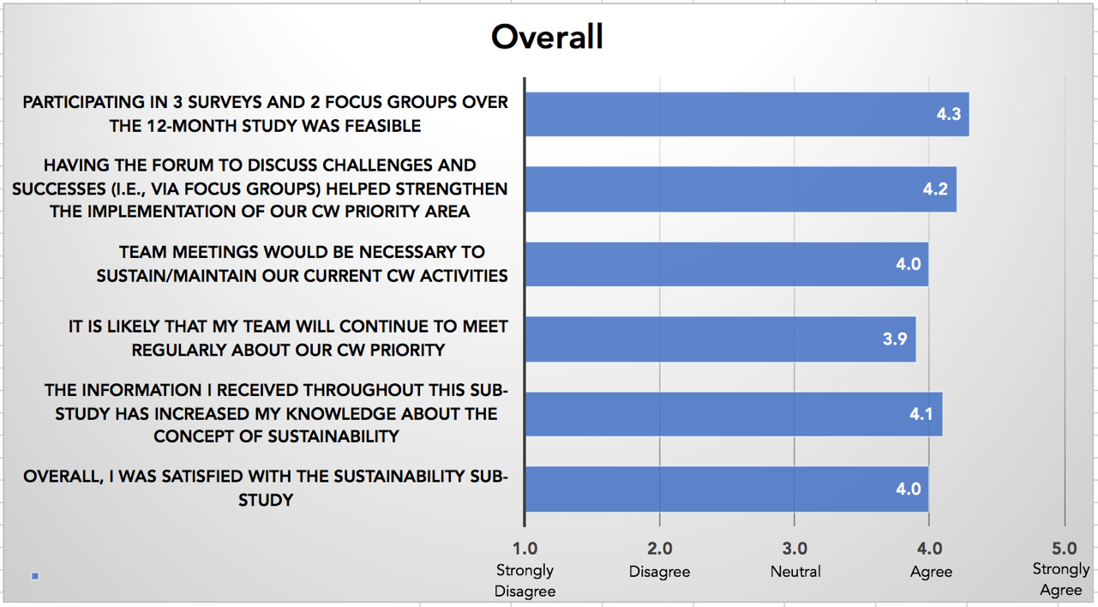

- Participants’ perception of the sustainability study information sessions

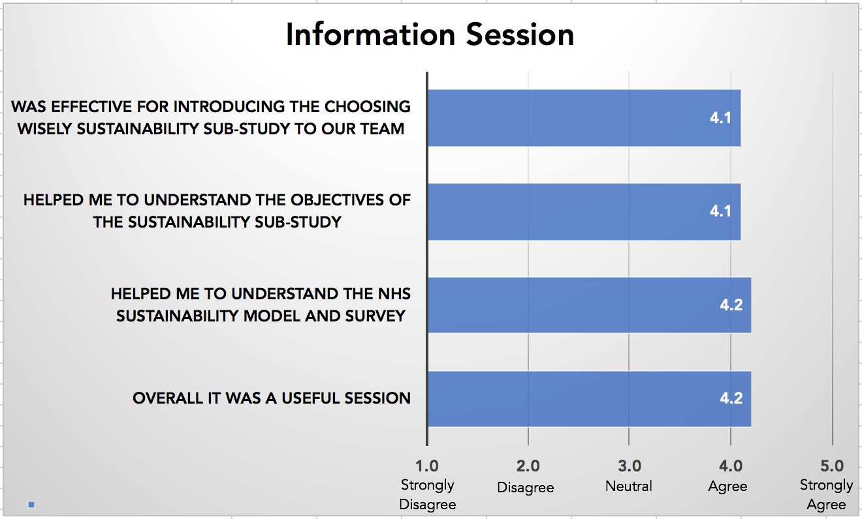

- Participants’ perception of the NHS Sustainability Survey

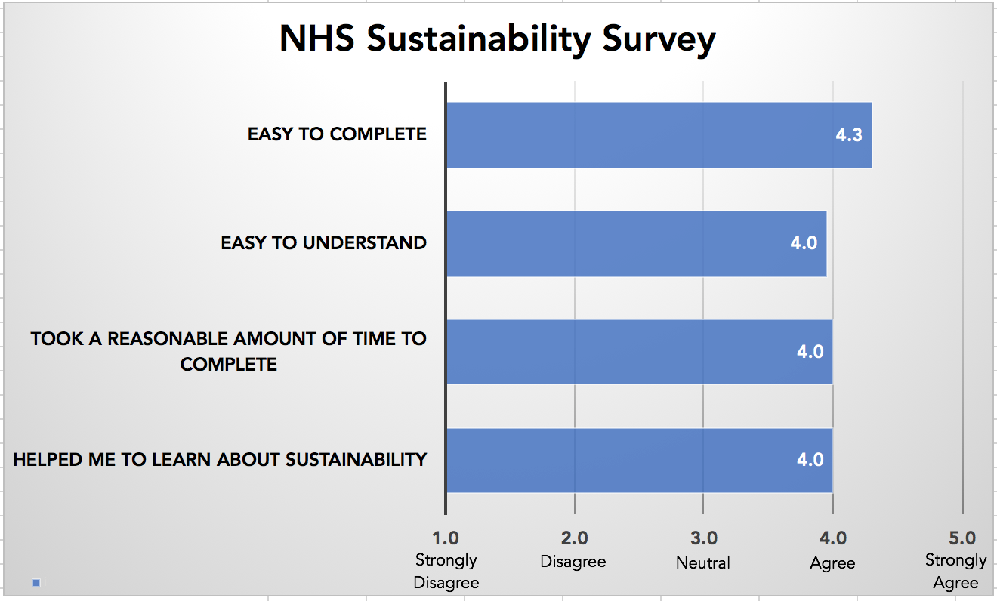

- Participants’ perception of the action planning Focus groups

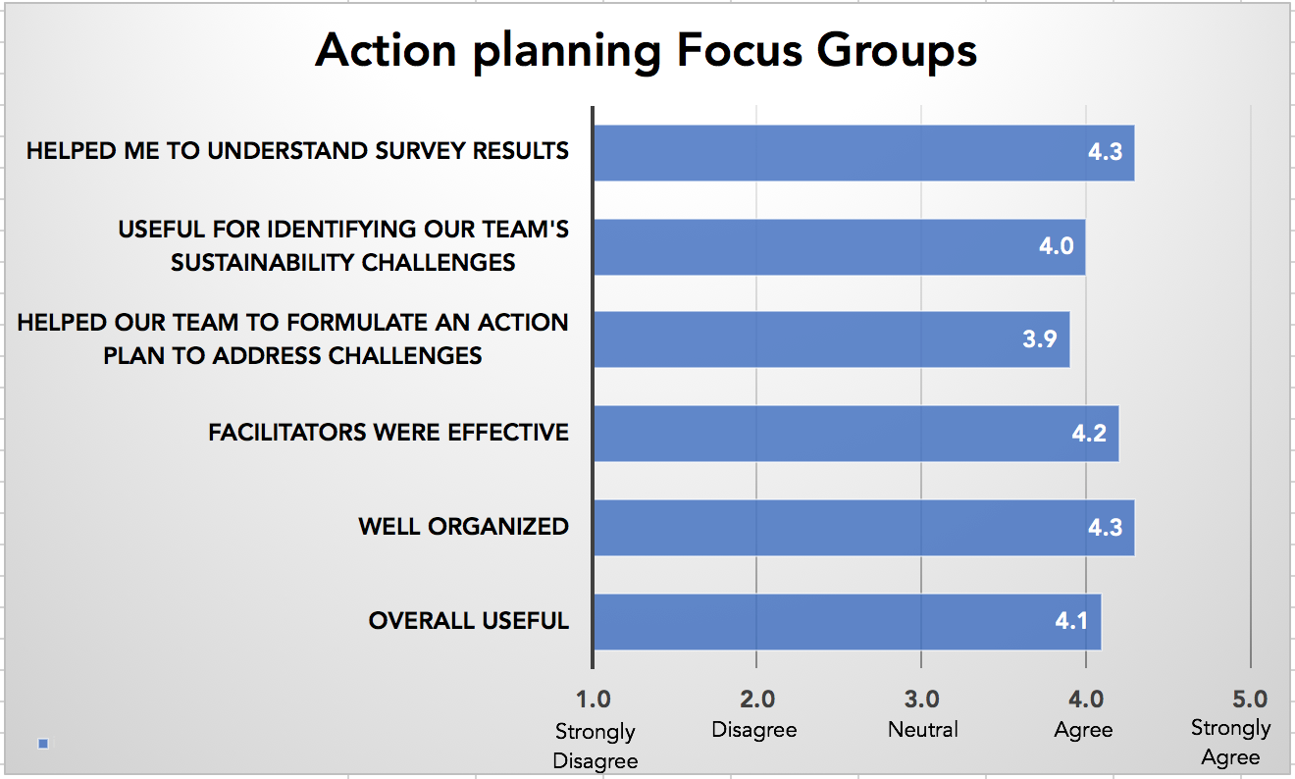

- Participants’ perception of the action plan Reports

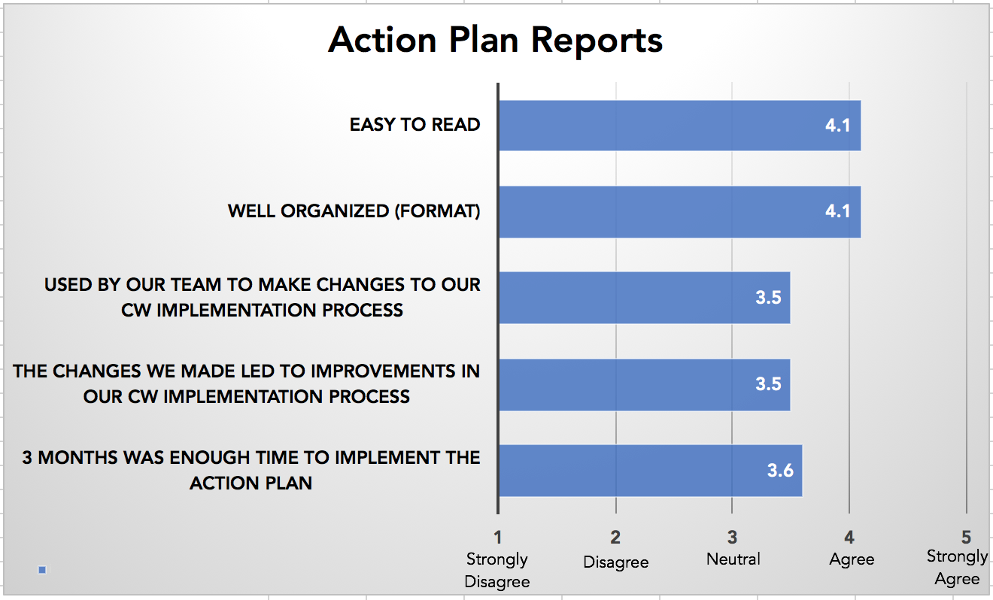

APPENDIX D

Conceptual Implementation and Sustainability Guide

The following Implementation and Sustainability Guide represents evidence-based steps that can be considered by implementation teams to adopt and sustain innovations such as the Choosing Wisely campaign. We suggest that potential adopter teams use this guide as starting point to plan for implementation and sustainability, and to customize this plan according to their identified implementation needs, contextual factors, scope of implementation, and available resources. Implementation is defined as “the initial process of embedding interventions or tools in a setting”. Sustainability is defined as: “The degree to which an innovation continues to be used after initial efforts to secure adoption is completed”. The assessment of an intervention’s sustainability potential should be considered early and assessed alongside implementation efforts and activities. Sustainability has a close relationship with and is an important implementation outcome.

Steps to Optimized Implementation and Sustainability of Innovations
Sub-domain |  |  | Purpose/Description
- Engage relevant stakeholders and establish partnerships to: |  |  | Identify and convene relevant stakeholders (e.g., clinical champions, quality improvement specialist staff), partners (e.g., senior leadership) and knowledge users (e.g., impacted staff, patients) to plan the implementation, monitoring, and evaluation of the intervention/innovation. Engaging with relevant stakeholders will also facilitate the assessment and optimization of the intervention’s/innovation’s sustainability potential. Create your intervention’s/innovation’s “Implementation/Sustainability Team”.
 | - Determine optimized communication mechanism among team |  | Define strategies that will be used to establish optimized communication amongst the team, and to enable efficient modes of communication and exchange of information (e.g., in-person, email, tele-/web-conference, newsletter)
 | - Identify and clarify roles |  | Identify and clarify roles among team members
 | - Identify any anticipated challenges and mitigating strategies to implementation |  | Identify any anticipated challenges and mitigating strategies to implementation
- Identify the implementability and sustainability of the innovation |  |  | Identify the implementability and sustainability of the intervention/innovation: determinants of implementation and sustainability from the perspective of relevant knowledge users including their readiness to change
 | - Identify the purpose of the implementation and sustainability |  | Identify the purpose of implementation and sustainability, which may involve the adoption of an innovation/intervention as originally designed or the need to adapt it in other contexts which may be very different from the one in which it was originally developed or tested. Determine when sustainability will be assessed. The sustainability potential of the intervention/innovation should be assessed early during the implementation process (i.e., during implementation planning) and at the time of implementation to identify any anticipated challenges and mitigating strategies to sustainability
 | - Assess the determinants of implementation and sustainability (barriers and facilitators to change) |  | Identify the barriers and facilitators to change and the perceived relevance, acceptability and feasibility of the implementation of an intervention/innovation. Identify the determinants of sustainability and understand if the factors influencing sustainability differ from those that influence implementation. These can be assessed using interviews, surveys and focus groups with each type of knowledge user.
 | - Assess Readiness to Change |  | Organizational readiness for change is defined as “the extent to which organizational members are both psychologically and behaviorally prepared to implement change”. Assessment of readiness provides an opportunity to identify potential challenges and can lead to better implementation outcomes. An organization is more likely to accept the change if they are ready. However, organizations, systems and people may not be ready to implement interventions/innovations even if these are effective and implementation is feasible. The following are commonly used readiness assessment tools:  - Organizational readiness: ORCA (Organizational Readiness for Implementing Change Measures); ORIC (Organizational Readiness for Implementing Change); OCRS (Organization culture and readiness survey)  - Technology readiness to change strategies: OITIRIS (Information technology innovation readiness); CPOE readiness  - I-RREACH (To guide implementation in low-resource settings  - MORE scale (Measureing Organisational Readiness for Patient Engagement)  - Ready, Set, Change (a decision-support tool that guides implementers in selecting a valid and reliable readiness assessment measure that is appropriate for their setting.
- Develop an implementation and sustainability plan |  |  | Create a plan for 1) implementation according to identified implementation objectives and readiness and 2) sustainability assessment
 | - Identify stakeholders who should be involved in the implementation |  | Identify stakeholders who should be involved in the implementation
 | - Assess the context and characteristics of the adopter environment |  | Assess both the outer (policies, legislation) and inner (organizational characteristics (e.g., structure, climate, culture, resources). This also includes understanding the learning and problem-solving skills needed by key individuals and organizations to respond to challenges related to changing environments. Use the experience and knowledge of the context that was learned during the implementation phase.
 | - Assess the fit and effectiveness of the intervention/innovation |  | Ensure that the intervention/innovation has proven effectiveness. Assess the fit of the intervention or innovation with the adopter setting (scope, resources, feasibility)
 | - Assess fidelity and adaptation of the intervention/innovation |  | Assess adaptation (whether the intervention is adapted or changes over time) and fidelity (is it doing what it’s supposed to? This could be a combination of adherence to a prescribed set of practices at the right dose or intensity, competence in delivery, and differentiation from other interventions); and efforts to align the intervention and the setting. It is important to understand when and what components of the intervention fidelity is necessary
 | - Assess the capacity to sustain the intervention/innovation |  | Funding, resources, workforce characteristics and stability, interpersonal processes. These include funding sources for conducting the sustainability assessment
 | - Adapt learnings from implementation |  | Use the experience and knowledge of the context that was learned during the implementation phase
 | - Consider the use of an implementation framework |  | Consider the use of an implementation framework to guide the implementation process and to achieve enhanced understanding and explanation of certain aspects of implementation. Implementation strategies should address barriers and readiness to change and match objectives and scope:  - CFIR framework (Consolidated Framework for Implementation Research)  - KTA framework (Knowledge to Action)  - Normalization Process Theory  - PARiHS framework (Promoting Action on Research in Health Sciences)  - PRISM model (Practial, Robust, Implementation and Sustainability)  - RAPID model (Research and Policy Development)  - RD & U framework (Research Dissemination and Utilization)  - TAM (Technology Acceptance Model)  - TDF (Theoretical Domains Framework)
 | - Consider the use of a sustainability framework |  | Consider using a sustainability framework to evaluate and assess sustainability potential of intervention:  - DSF (Dynamic Sustainability Framework)  - Framework of public health program capacity for sustainability  - NHS Sustainability Model (National Health Services)  - PRISM (Practical, Robust Implementation and Sustainability Model)
- Monitor and evaluate the implementation and sustainability of the intervention/innovation |  |  | There is a need to assess how well the implementation of the intervention/innovation is going and to make corrections if/as needed. In these stages, there are many evaluation questions that could be asked, all having to do with monitoring and evaluation activities. Depending on the purpose of the evaluation and implementation and sustainability objectives, create an evaluation plan
 | - Engage stakeholders and knowledge users |  | Engage stakeholders and knowledge users to identify the objectives and purpose of the evaluation, to select the appropriate study designs, to select outcomes, and the best approaches to evaluation. Engage experts according to identified objectives and purpose such as in the relevant content area, biostatistics, health economic analysis, behavior theory, KT, etc.
 | - Define the scope of implementation and sustainability |  | Consider factors in choosing a definition to guide research on the sustainment of the tool including clear specification of research questions regarding each factor. These factors are:  - whether, and to what extent, the core elements (the elements most closely associated with desired health benefits) are maintained;  - the extent to which desired health benefits are maintained or improved upon over time after initial funding or supports have been withdrawn;  - the extent, nature, and impact of modifications to the core and adaptable/peripheral elements of the intervention or innovation; and  - continued capacity to function at the required level to maintain the desired benefits. An intervention’s or innovation’s impact may be considered sustained if desired health benefits remain at or above the level achieved during implementation and this increase can be attributed to continuation of the program/intervention/innovation.  A program/intervention/innovation may be considered as sustained at a given point in time if, after initial implementation support has been withdrawn, core elements are maintained (e.g., remain recognizable or delivered at a sufficient level of fidelity or intensity to yield desired health outcomes) and adequate capacity for continuation of these elements is maintained
 | - Identify objectives and purpose of the evaluation |  | Identify the objectives and purpose of the evaluation. Setting the objectives for the evaluation will help to focus it and keep the process from becoming too complex and all-inclusive.
 | - Determine the focus of the implementation and sustainability evaluation |  | Determine the focus of the implementation and sustainability assessment, which could be on the intervention/innovation rather than on the system in which it is introduced. This perspective puts an emphasis on the determinants (barriers/facilitators) of the preservation, fidelity to, or discontinuation of a program. It is important that implementatbility and sustainability are examined from an ecological (how the intervention and the local context mutually adapt and evolve and how this process impacts sustainability) or complex-systems perspective, to understand the interconnection between broader environmental forces, contextual influences, and the intervention/innovation.
 | - Select the type of evaluation |  | It is important to select the most appropriate evaluation method to match your scope (e.g., local vs. multi-site implementation), and purpose/objectives and feasibility or available resources
 |  | Formative evaluation | Evaluate the feasibility, appropriateness, and acceptability of the intervention/innovation before it is fully implemented. This is usually conducted when it’s being developed or when an existing intervention is being adapted or modified
 |  | Implementation or process evaluation | Determine whether the intervention/innovation has been implemented as intended. Process evaluation includes the identification of the target population, a description of the services delivered, the use of resources, and the qualifications and experiences of the personnel participating in them. It involves determining what services were actually delivered, to whom, and with what level of resources.
 |  | Outcome evaluation | Objective-based evaluation after the intervention has made contact with at least one person or group in the target population (i.e., the degree to which it’s having an effect on the target population’s behaviours); it informs whether the intervention is effective in meeting its objectives
 |  | Economic evaluation | Cost analysis, cost-effectiveness evaluation, cost-benefit analysis, cost-utility analysis at the beginning or during the conduct of evaluation; it will show what resources are being used and their costs (direct and indirect) compared to outcomes; it provides a way to assess cost relative to effects
 |  | Impact evaluation | Assesses the effectiveness in achieving outcomes at the end of the study; provides evidence for use in practice or policy and funding decisions
 |  | Summative evaluation | Generates data about how well the intervention delivered benefits to the target population. It is conducted after the intervention’s completion or at the end of its cycle
 |  | Hybrid model | A new approach to evaluation whereby multiple evaluation objectives and outcomes can be measured alongside the inquiry. For example, a process evaluation alongside an outcome evaluation
 | - Select the appropriate study design(s) for the type of evaluation |  | Select the most appropriate study design or method to address research question(s) and purpose of evaluation. Consider whether the evaluation is for local or generalizable knowledge. For example:  - Experimental studies (e.g., RCT; pre/post design) to understand the “what”  - Qualitative (focus groups, interviews, observation) to understand the “why”
 | - Select outcomes and establish indicators |  | Implementation: Consider a wide range of outcomes (and indicators) to ensure that there is a distinction between assessing implementation effectiveness vs. treatment effectiveness. Consider intermediate outcomes such as patient self-efficacy and health behaviours that link to longer term outcomes; Consider measures that capture treatment burden, avoidance of unnecessary tests, and minimizing medication side-effects; Consider cost-effectiveness and health-related quality-of-life measures to inform economic analyses  Sustainability: The desired impact and benefits of the intervention/innovation should be identified. Stakeholder goals for sustainability should also be considered in the interpretation of findings (e.g., Must the intervention/innovation be sustained at the same level, or improved upon? To what extent is a lower level of implementation fidelity or a partially sustained program consistent with stakeholders’ goals for the project? At what point, and under what circumstances, is discontinuation, modification, or implementation of a more effective, efficient, or better-fitting intervention/innovation advisable?)
 |  | Clinical | Disease symptoms, mental state, effects of a disease or condition on patient functioning
 |  | Patient | Change in health status (mortality, quality of life); satisfaction, function, symptoms; well-being, safety
 |  | Provider | Provider satisfaction, acceptance
 |  | Process or implementation | Acceptability; adoption, appropriateness, costs, feasibility, fidelity, penetration, sustainability
 |  | Service | Efficiency, safety, effectiveness, equity, patient-centeredness, timeliness
 |  | Organizational and health care system | Attitudes, knowledge and competencies; organizational culture and climate; policies and procedures; practices and services; use of data and technology; stakeholder awareness and engagement; relationships
 |  | Economic | Cost-effectiveness; health-related quality-of-life
 | - Consider using implementation evaluation frameworks to drive the evaluation |  | - COM-B (Capacity, Opportunity, Motivation) or TDF (Theoretical Domains Framework) are behaviour change models  - Framework of implementation outcomes (used to evaluate implementation initiatives)  - Normalization Process Theory (can be used as an evaluation framework)  - PRECEED-PROCEED model (specifies implementation aspects that should be evaluated)  - RE-AIM framework (overall goal is to encourage knowledge end users to pay more attention to essential intervention elements that can improve sustainable adoption and implementation)

