Supplementary Material

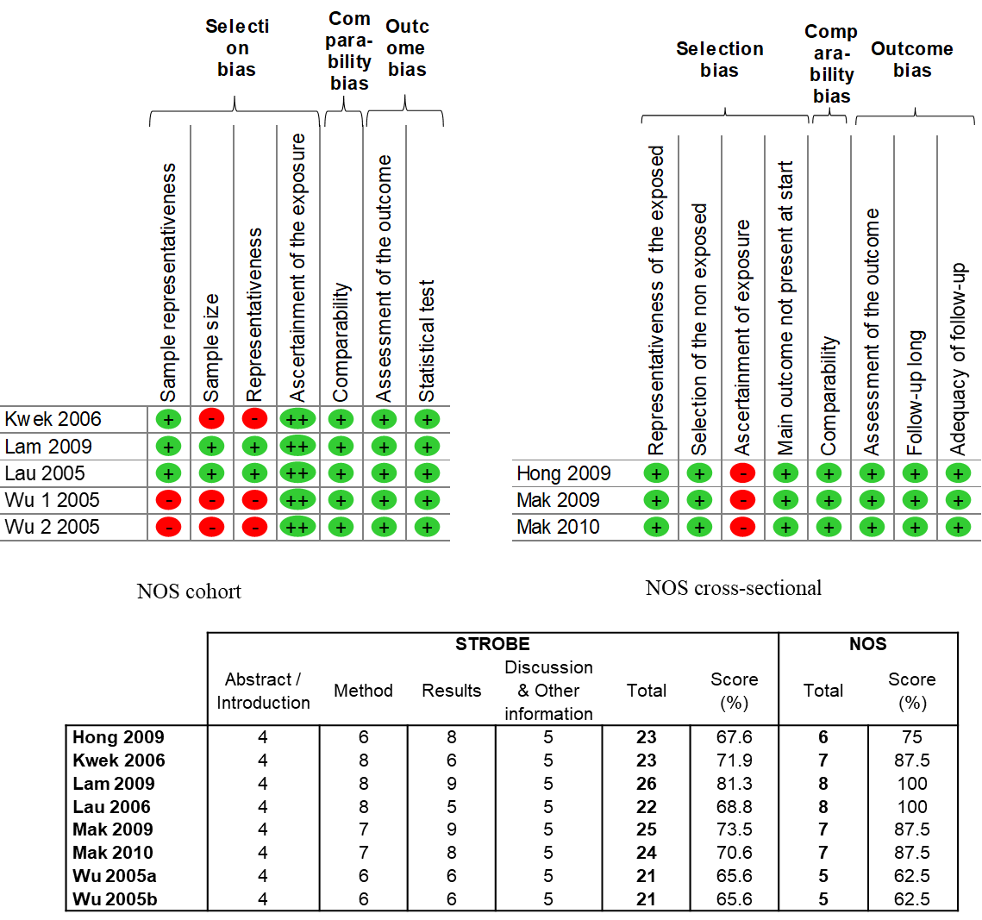

Figure S1. Quality of articles using the Newcastle-Ottawa scale (NOS) and the “STrengthening the Reporting of OBservational studies in Epidemiology” (STROBE checklist).

Figure S2. Summary of meta-analyses on IES score (total, avoidance, intrusive and hyperarousal) following the SARS-CoV-1 epidemic of 2003.

Each summary of meta-analysis is represented in the forest-plot by a white circle (dot) on a horizontal line. The dots represent the pooled-effect estimate (i.e. scores in this case), and the length of each line around the dots represent their 95% confidence interval (95CI). An overall summary of the results of meta-analyses is represented by a blue lozenge below.

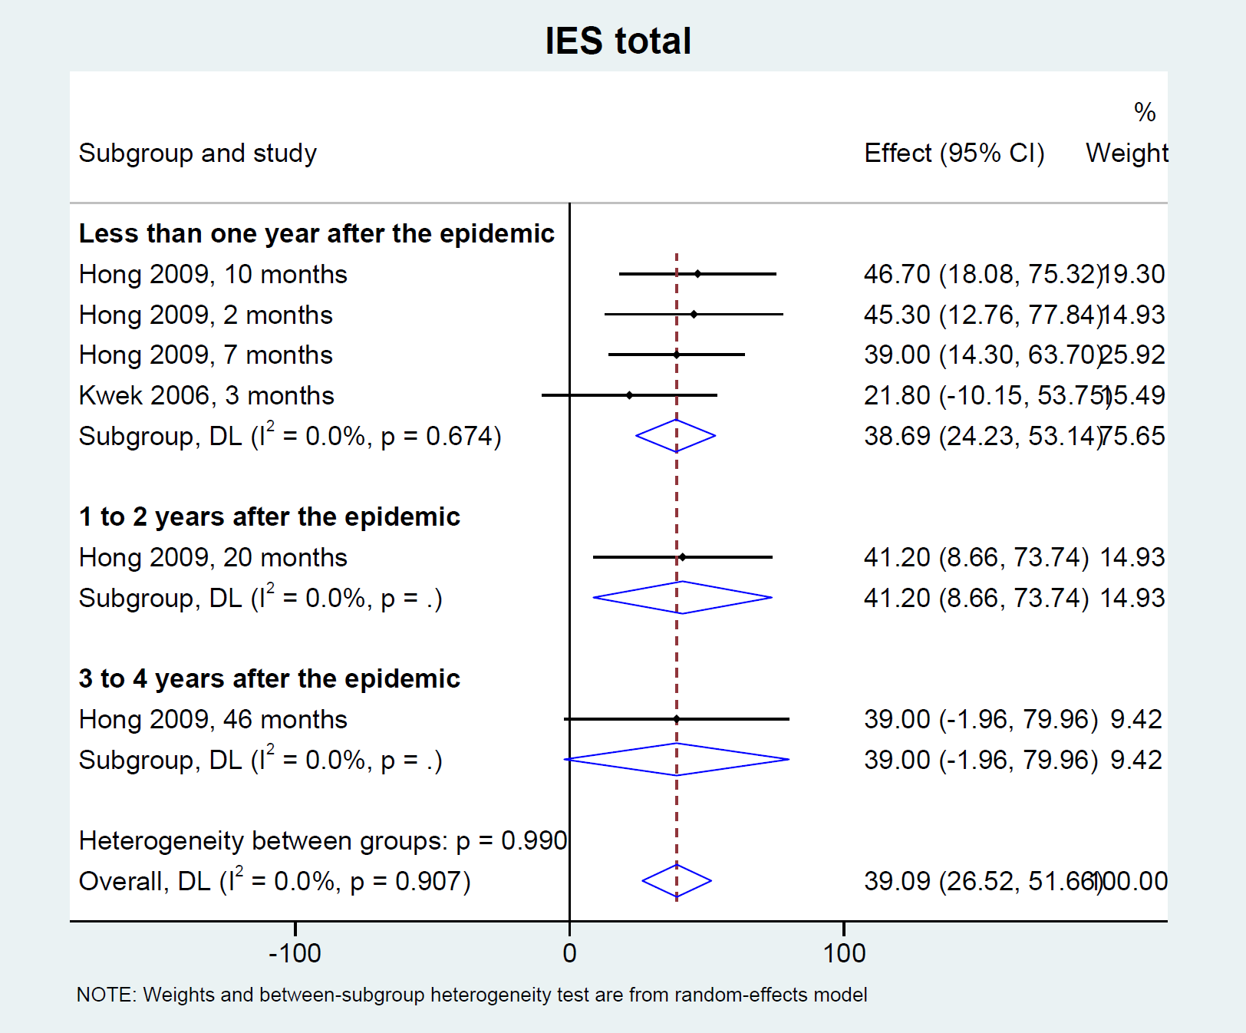

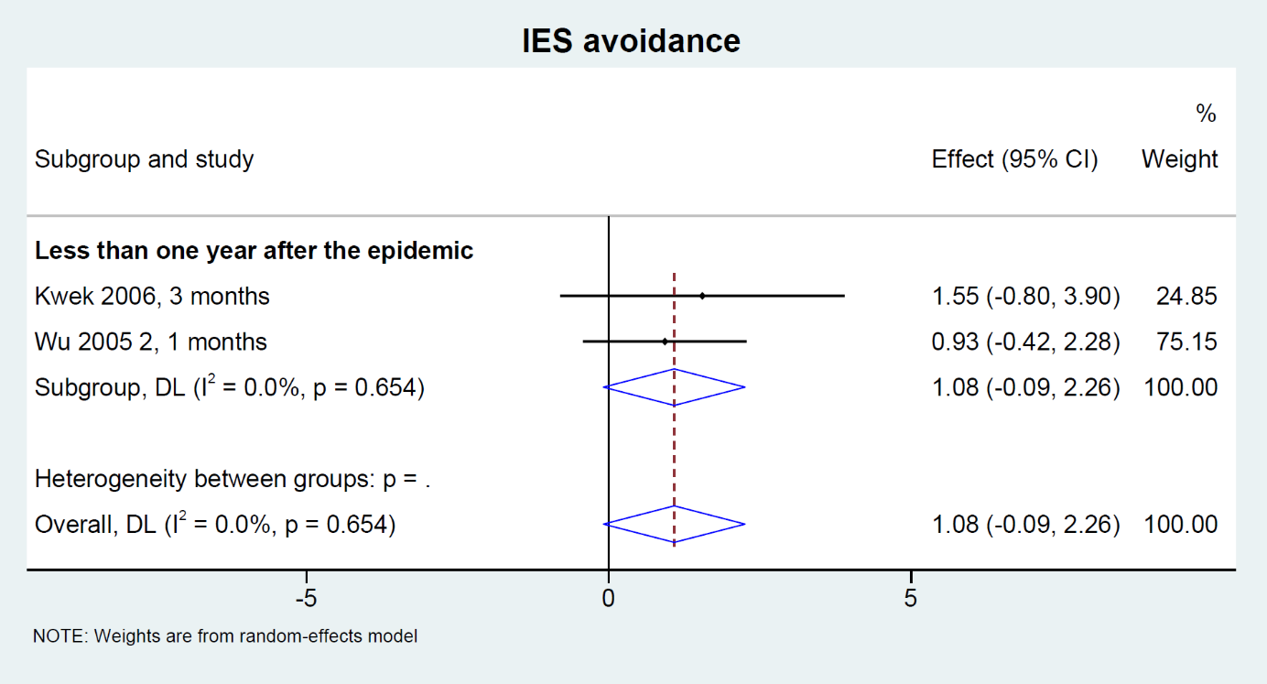
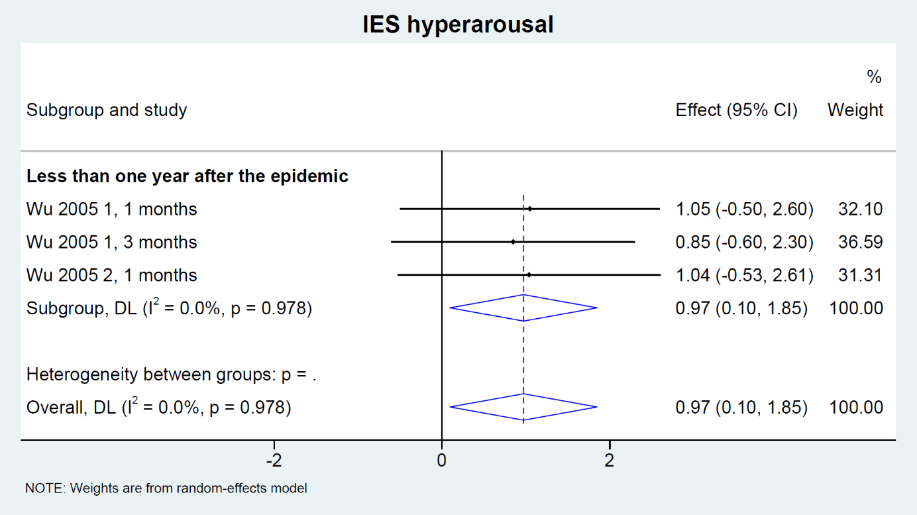
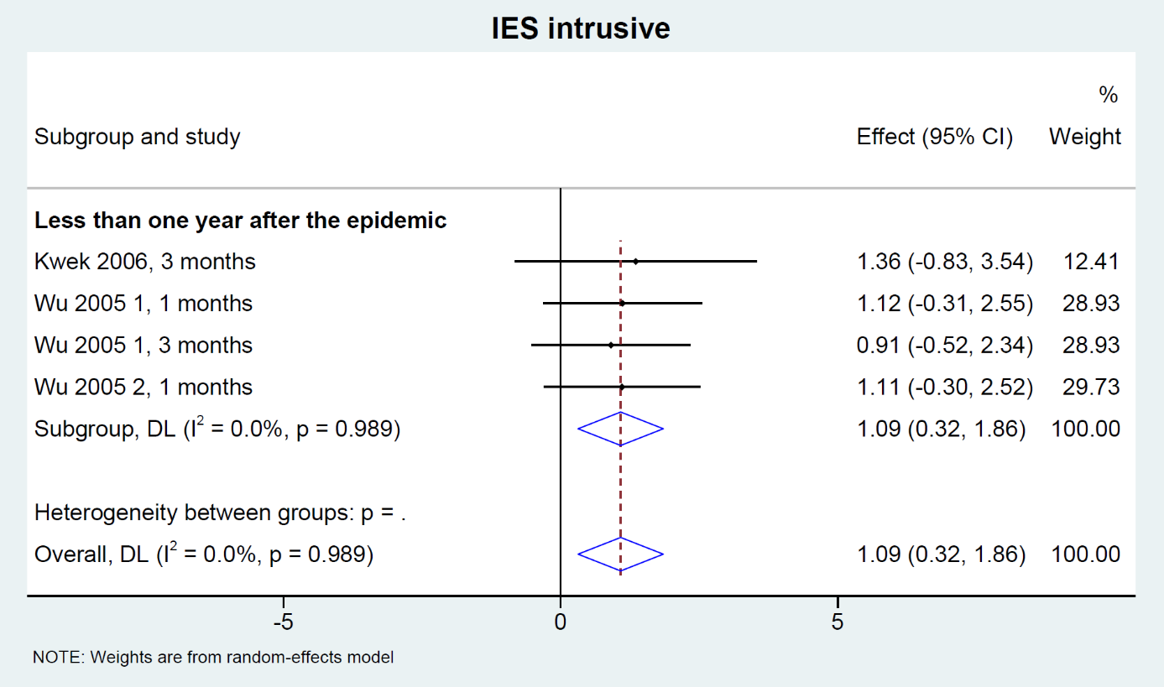

Figure S3. Detailed meta-analyses for each IES score (total, avoidance, intrusive, and hyperarousal) following the SARS-CoV-1 epidemic of 2003.

Figure S4. Factors influencing (meta-regressions) IES score (total, intrusive and hyperarousal) following the SARS-CoV-1 epidemic of 2003.

The influence of each variable on the IES scores is represented in the forest-plot by a white circle (dot) on a horizontal line. The dots represent the coefficient (i.e. the magnitude of the influence of the variable), and the length of each line around the dots represent their 95% confidence interval (95CI). When 95CI does not cross the vertical line (null effect), result is significant i.e. the variable has a significant influence on the IES scores.

Supplementary Figure 1. Quality of articles using the Newcastle-Ottawa scale (NOS) and the “STrengthening the Reporting of OBservational studies in Epidemiology” (STROBE checklist).

Figure S5. Funnel plots with pseudo 95% confidence limits on IES scores (total, avoidance, intrusive, hyperarousal).

Each dot represents a single study, with its corresponding effect size (x axis) and its associated standard error of the effect estimate (y-axis). Large high-powered studies are placed towards the top, and smaller low-powered studies towards the bottom. The plot should ideally resemble a pyramid or inverted funnel, with scatter due to sampling variation. Studies outside funnel plot are likely to present bias (Sterne JA, Sutton AJ, Ioannidis JP, Terrin N, Jones DR, Lau J, Carpenter J, Rücker G, Harbord RM, Schmid CH, Tetzlaff J, Deeks JJ, Peters J, Macaskill P, Schwarzer G, Duval S, Altman DG, Moher D, Higgins JP. Recommendations for examining and interpreting funnel plot asymmetry in meta-analyses of randomised controlled trials. BMJ. 2011 Jul 22;343:d4002. doi: 10.1136/bmj.d4002).

