Supplementary data

Table S1. Characteristics of the studies included in the meta-analysis (n=18)
Fig. S1. Funnel plot for the odds ratio of the Shannon diversity index. Exposure to biodiversity, assessed as Shannon diversity index based on dust sampling techniques (for outer layer biodiversity).
Fig. S2. Funnel plot for the odds ratio of the bacterial richness. Exposure to biodiversity, assessed as bacterial richness (for outer layer biodiversity).
Fig. S3. Funnel plot for the standardized mean difference of the Shannon diversity index (for inner layer biodiversity).
Fig. S4. Funnel plot for the standardized mean difference of the bacterial richness (for inner layer biodiversity).
Fig. S5. Funnel plot for the odds ratio of the bacterial richness (for inner layer biodiversity).

Table S1. Characteristics of the studies included in the meta-analysis (n=18)
Reference, study year (country) | Study population | Study design | Study size | Follow-up period | Definition of health outcome | Method of data collection for exposure assessment | Total score on the NOS (AHRQ)*
Outer layer biodiversity
Birzele et al. ¹, 2017 (Austria) | Children (6-12 years) | Cross-sectional | 86 | -- | Questionnaire (asthma) | Mattress dust and nasal samples. V3-V5 regions of 16S rRNA gene were sequenced | 9 (good)
Dannemiller et al. ², 2016 (USA) | Children (5-10 years) | Cross-sectional | 196 | -- | Questionnaires (active asthma, severe asthma); atopic sensitization was evaluated by specific IgE | Dust samples; V4 regions of 16S rRNA gene were sequenced | 8 (good)
Karvonen³, 2019 (Finland) | Children (10.5 years) | Cohort | 373 | 10.5 years | Parent-reported questionnaires (ever and current asthma) at 10.5-year follow-up | Dust samples (living rooms) at two months of age. V4 regions of 16S rRNA gene were sequenced | 7 (poor)
Kirjavainen et al. ⁴, 2019 (Finland) | Children (6 years) | Cohort | 431 | 6 years | Parent-reported questionnaires (ever and current asthma) at 6 years of age; atopic sensitization was evaluated by specific IgE | Dust samples (living room floor from farm and non-farm homes) at two months of age. V4 regions of 16S rRNA gene were sequenced | 7 (poor)
Fu et al. ⁵, 2020 (Malaysia) | Children (14-16 years) | Cross-sectional | 309 | -- | Questionnaires (asthma symptoms) and validated asthma score to define asthma severity | Floor dust from classrooms; 16S rRNA gene were sequenced | 8 (good)
Donovan et al. ⁶, 2021 (USA) | Adults | Cross-sectional | 26 367 census tracts | -- | Census (asthma) | Plant diversity based on data from the Global Biodiversity Information Facility (GBIF) | 9 (good)
Lai et al. ⁷, 2018 (USA) | Children (average 8.1 years old) | Randomized controlled trial | 25 | -- | Telephone survey of the child’s parent or caretaker (asthma) | Dust samples from classrooms and homes; shotgun metagenomics sequencing | 8 (good)
Fu et al. ⁸, 2021 (China) | Young adults (IQR 20–23 years) | Cross-sectional | 357 | -- | Questionnaires (asthma symptoms) and score of asthma symptoms | Settled air dust and floor dust samples from dormitory rooms; 16S rRNA gene were sequenced | 8 (good)
Fu et al. ⁹, 2021 (China) | Children (15-18 years) | Cross-sectional | 1332 | -- | Questionnaires (asthma and rhinitis symptoms) | Floor dust from classrooms (4 from rural areas and 5 from urban areas); 16S rRNA gene were sequenced | 8 (good)
Inner layer biodiversity
Bisgaard et al. ¹⁰, 2011 (Denmark) | Children (6 years) | Cohort | 411 | 6 years | Clinical diagnosis (asthma); atopic sensitization was evaluated by skin prick testing and by specific IgE | Stool samples collected at 1 and 12 months of age; 16S rRNA gene were sequenced combined with denaturing gradient gel electrophoresis and conventional culturing | 7 (poor)
Abrahamsson et al. ¹¹, 2014 (Sweden) | Children (7 years) | Cohort | 47 | 7 years | Questionnaire (asthma) and exhaled nitric oxide | Stool samples collected during the first year of life (1 week, 1 month, 1 year); 16S rRNA gene were sequenced | 7 (poor)
Park et al. ¹², 2014 (Korea) | Adults (53.4±17.1 to 68.9±7.2 years) | Cross-sectional | 47 (cases: 18 with asthma, 17 with COPD; controls; 12 | -- | NA | Oropharynx samples; V1-V3 region of 16S rRNA gene were sequenced | 3 (poor)  (excluded due to the total score on the NOS)┴
Depner et al. ¹³, 2017 (Germany, Austria and Switzerland) | Children (12 years) | Cross-sectional | 333 | -- | Questionnaires (asthma) | Throat (327) and nasal (68) samples; | 7 (good)
Li et al. ¹⁴, 2017 (China) | Adults (39.6±8.6 to 52.0±9.3 years) | Case-control | 113 (cases: 49 non-smoking asthma patients, 25 with severe asthma, 24 with non-severe asthma; controls: 15) | -- | Severe asthma was defined according to the ERS/ATS guidelines on severe asthma, while asthma severity was based on the GINA criteria; atopic sensitization was evaluated by skin prick testing | Induced sputum samples; V3-V5 region of 16S rRNA gene were sequenced | 2 (poor)  (excluded due to the total score on the NOS) ┴
Espuela-Ortiz et al. ¹⁵, 2019 (USA) | Children and young adults (6-21 years) | Case-control | 114 (cases: 57; controls: 57) | -- | Clinical diagnosis (asthma) | Saliva samples; V4 region of 16S rRNA gene were sequenced | 8 (good)
Lee et al. ¹⁶, 2019 (South Korea) | Adults (18-45 and ≥ 65 years) | Cross-sectional | 80 | -- | Clinical diagnosis (airway obstruction reversibility, methacholine challenge test, symptoms, treatment) | Upper airway nasopharyngeal samples; 16S rRNA gene were sequenced | 7 (poor)
Thorsen et al. ¹⁷, 2019 (Denmark) | Children (6 years) | Cohort | 700 | 6 years | Daily diary (asthma); atopic sensitization was evaluated by skin prick testing and by specific IgE | Airways samples collected at age 1 month; 16S rRNA gene were sequenced | 9 (good)
Toivonen et al. ¹⁸, 2020 (Finland) | Children (7 years) | Cohort | 923 | 7 years | Medical records (asthma) | Nasal samples collected at ages 2, 13, and 24 months; V4 region of 16S rRNA gene were sequenced | 8 (good)
Niemeier-Walsh et al. ¹⁹, 2021 (USA) | Children (12 years) | Cohort | 40 | 12 years | Questionnaire (asthma); atopic sensitization was evaluated by skin prick testing | Saliva and induced sputum samples collected at age 14 years; 16S rRNA gene were sequenced | 7 (poor)
Schei et al. ²⁰, 2021 (Norway) | Children (6 years) | Cohort | 278 | 6 years | Questionnaires (asthma) | Stool samples collected at 4 timepoints between 0 and 2 years | 5 (poor)
NOS: Newcastle-Ottawa quality assessment scale; NA: information not available
*Thresholds for converting the Newcastle-Ottawa scales to the Agency for Health Research and Quality (AHRQ) standards (good, fair, and poor): Good quality: 3 or 4 stars in selection domain AND 1 or 2 stars in comparability domain AND 2 or 3 stars in outcome domain; Fair quality: 2 stars in selection domain AND 1 or 2 stars in comparability domain AND 2 or 3 stars in outcome domain; Poor quality: 0 or 1 star in selection domain OR 0 stars in comparability domain OR 0 or 1 stars in outcome domain
**results reported as median (minimum-maximum)
***results reported as mean (standard deviation)
┴Total score on the NOS ≤ 3: “High risk of bias”²¹

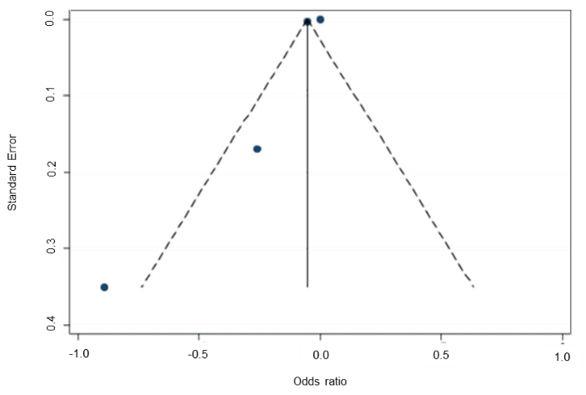
Fig. S1. Funnel plot for the odds ratio of the Shannon diversity index. Exposure to biodiversity, assessed as Shannon diversity index based on dust sampling techniques (for outer layer biodiversity).

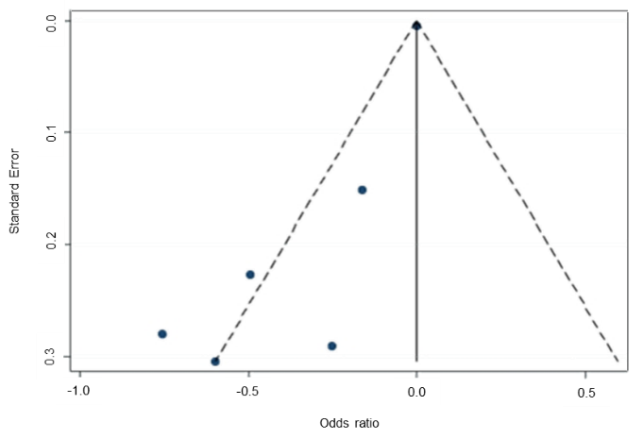
Fig. S2. Funnel plot for the odds ratio of the bacterial richness. Exposure to biodiversity, assessed as bacterial richness (for outer layer biodiversity).

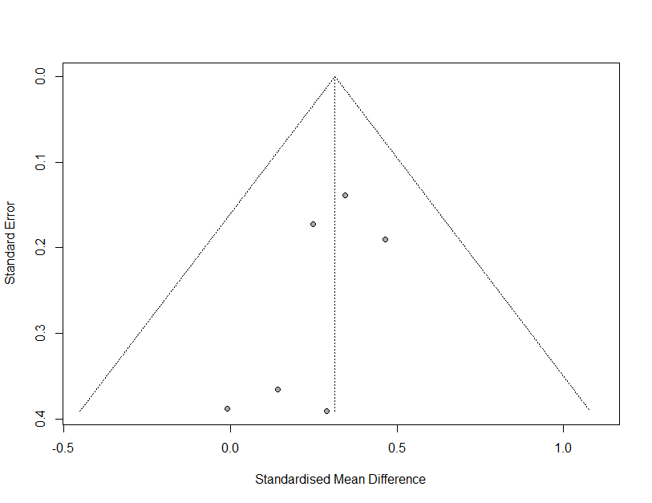
Fig. S3. Funnel plot for the standardized mean difference of the Shannon diversity index (for inner layer biodiversity).

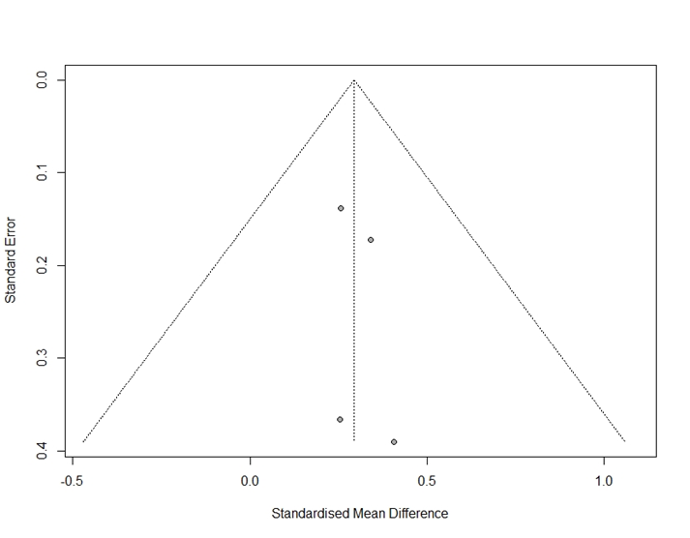
Fig. S4. Funnel plot for the standardized mean difference of the bacterial richness (for inner layer biodiversity).

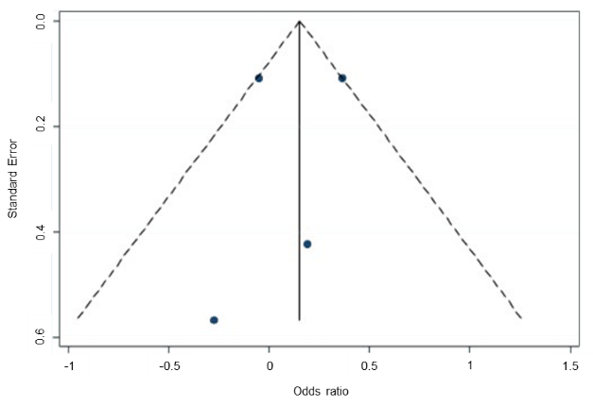
Fig. S5. Funnel plot for the odds ratio of the bacterial richness (for inner layer biodiversity).

References
1. Birzele LT, Depner M, Ege MJ, et al. Environmental and mucosal microbiota and their role in childhood asthma. Allergy 2017;72(1):109-19.
2. Dannemiller KC, Gent JF, Leaderer BP, Peccia J. Indoor microbial communities: Influence on asthma severity in atopic and nonatopic children. The Journal of allergy and clinical immunology 2016;138(1):76-83.e1.
3. Karvonen AM, Kirjavainen PV, Täubel M, et al. Indoor bacterial microbiota and development of asthma by 10.5 years of age. The Journal of allergy and clinical immunology 2019;144(5):1402-10.
4. Kirjavainen PV, Karvonen AM, Adams RI, et al. Farm-like indoor microbiota in non-farm homes protects children from asthma development. Nature Medicine 2019;25(7):1089-95.
5. Fu X, Norbäck D, Yuan Q, et al. Indoor microbiome, environmental characteristics and asthma among junior high school students in Johor Bahru, Malaysia. Environment international 2020;138:105664.
6. Donovan GH, Landry SM, Gatziolis D. The natural environment, plant diversity, and adult asthma: A retrospective observational study using the CDC's 500 Cities Project Data. Health & place 2021;67:102494.
7. Lai PS, Kolde R, Franzosa EA, et al. The classroom microbiome and asthma morbidity in children attending 3 inner-city schools. The Journal of allergy and clinical immunology 2018;141(6):2311-3.
8. Fu X, Li Y, Meng Y, et al. Derived habitats of indoor microbes are associated with asthma symptoms in Chinese university dormitories. Environmental research 2021;194:110501.
9. Fu X, Ou Z, Zhang M, et al. Indoor bacterial, fungal and viral species and functional genes in urban and rural schools in Shanxi Province, China-association with asthma, rhinitis and rhinoconjunctivitis in high school students. Microbiome 2021;9(1):138.
10. Bisgaard H, Li N, Bonnelykke K, et al. Reduced diversity of the intestinal microbiota during infancy is associated with increased risk of allergic disease at school age. The Journal of allergy and clinical immunology 2011;128(3):646-52.e1-5.
11. Abrahamsson TR, Jakobsson HE, Andersson AF, Björkstén B, Engstrand L, Jenmalm MC. Low gut microbiota diversity in early infancy precedes asthma at school age. Clinical and experimental allergy : journal of the British Society for Allergy and Clinical Immunology 2014;44(6):842-50.
12. Park H, Shin JW, Park SG, Kim W. Microbial communities in the upper respiratory tract of patients with asthma and chronic obstructive pulmonary disease. PloS one 2014;9(10):e109710.
13. Depner M, Ege MJ, Cox MJ, et al. Bacterial microbiota of the upper respiratory tract and childhood asthma. The Journal of allergy and clinical immunology 2017;139(3):826-34.e13.
14. Li N, Qiu R, Yang Z, et al. Sputum microbiota in severe asthma patients: Relationship to eosinophilic inflammation. Respir Med 2017;131:192-8.
15. Espuela-Ortiz A, Lorenzo-Diaz F, Baez-Ortega A, et al. Bacterial salivary microbiome associates with asthma among african american children and young adults. Pediatric pulmonology 2019;54(12):1948-56.
16. Lee JJ, Kim SH, Lee MJ, et al. Different upper airway microbiome and their functional genes associated with asthma in young adults and elderly individuals. Allergy 2019;74(4):709-19.
17. Thorsen J, Rasmussen MA, Waage J, et al. Infant airway microbiota and topical immune perturbations in the origins of childhood asthma. Nature Communications 2019;10(1):5001.
18. Toivonen L, Karppinen S, Schuez-Havupalo L, et al. Longitudinal Changes in Early Nasal Microbiota and the Risk of Childhood Asthma. Pediatrics 2020;146(4).
19. Niemeier-Walsh C, Ryan PH, Meller J, Ollberding NJ, Adhikari A, Reponen T. Exposure to traffic-related air pollution and bacterial diversity in the lower respiratory tract of children. PloS one 2021;16(6):e0244341.
20. Schei K, Simpson MR, Øien T, Salamati S, Rudi K, Ødegård RA. Allergy-related diseases and early gut fungal and bacterial microbiota abundances in children. Clinical and translational allergy 2021;11(5):e12041.
21. Gates M, Wingert A, Featherstone R, Samuels C, Simon C, Dyson MP. Impact of fatigue and insufficient sleep on physician and patient outcomes: a systematic review. BMJ Open 2018;8(9):e021967.

