Supporting Information for

Global health burden from acute exposure to fine particles emitted by fires

Sourangsu Chowdhury, Risto Hänninen, Mikhail Sofiev, Kristin Aunan

SI Text1: Comparison and Validation of SILAM simulations

We used the freely available SILAM chemistry transport model (https://silam.fmi.fi/) to simulate the chemistry in the atmosphere. As one of the top models in CAMS air quality forcasting ensemble, the model is frequently evaluated. In this work we used CBM05 (1) chemistry to model the tropospheric gases, together with stratospheric chemistry, including heterogeneous reactions in polar stratospheric clouds (2). The secondary aerosol formation is based on the volatily bin approach. SILAM model also includes dynamic modules for emissions of mineral-dust and sea-salt aerosol particles. As an illustration of global performance, figure ST1 shows the bias and correlation of aerosol optical depth for 2017. The model is rather unbiased with decent correlation with respect to AERONET (https://aeronet.gsfc.nasa.gov/) observation stations, confirming the model performance on aerosol particles, including PM2.5.

In figure ST2, the SILAM model results are verified against the CAMS year 2017 measurement stations in European region for PM2.5 and ozone. PM2.5 is slightly underestimated (bias: -1.8ug/m3, mean value: 11.2 ug/m3, RMSE: 12.3 ug/m3) while the model slightly overestimates the ozone (bias: 13.2 ug/m3, mean value 66.6 ug/m3, RMSE: 29.0 ug/m3). For ozone the overestimation partly originates from the moderate resolution used, which is visible at coastal stations. Total correlation of the model is 0.56 for PM2.5 and 0.68 for ozone.

We compare SILAM simulated all-source PM_{2.5} with a well established geographically weighted regression model (GWR PM_{2.5})(3, 4) , that takes into account in-situ measurements, satellite retrieved aerosol depth and chemical transport models. The comparison of population weighted exposure by country has R>0.8 for all the years from 1998-2018 (Figure ST3).

SI Text2: Uncertainties and Limitations
In this study, the 95% confidence intervals (CIs) are derived by combining the uncertainties in baseline mortality rates from the GBD data with those related to relative risk (RR) as described in a previous study. Although these confidence intervals do not account for additional uncertainties related to PM2.5 modeling and model inputs (e.g., anthropogenic emission inventories and model schemes), our comparison with measurements generally produces robust results.(SI Text1). We perform model simulations at ∼2x2 degree spatial resolution, which is insufficient to capture the urban-rural gradient in PM_{2.5}, and may average out urban and curb-side increments PM2.5 at most measurement sites. Nonetheless, a prior study found that the resolution of PM2.5 calculations, ranging from 10 km to 100 km, has minimal impact on the PM2.5 exposure estimations (5). Instead, the uncertainties in excess mortality estimates are primarily influenced by the parameters of the exposure response functions.
We also recognize that while applying the RR estimates from Chen and colleagues (6) that use mortality data from MCC studies, our results are biased by selection and participation of cities in the MCC studies. We also note that when estimating excess deaths, it is crucial to consider fluctuations in baseline disease rates, which, despite decreasing in most countries, are prone to statistical and methodological uncertainties stemming from variations in health registry data and documentation (7). In the present study, we addressed the mortality impacts of acute exposure to fire PM_{2.5}, such acute exposure scenarios have the potential to induce a rapid onset of respiratory diseases, exacerbate pre-existing respiratory and cardiovascular conditions, prompt emergency room visits, and contribute to elevated cardiovascular and respiratory morbidity, which we did not consider in the present study.
While it should be noted that various emission inventories in general have similarly large uncertainties for organic aerosols, we acknowledge that the use of different emission inventories for anthropogenic activities will influence somewhat the calculated PM2.5 exposures. However, arguably the primary uncertainty in the emission data originates from fire emission modelling. Due to the sporadic character of fires, nearly the only comprehensive way to monitor them is to use satellites, either recording the burnt area scars, or evaluating the power of active fires. Both have strong and weak points, but both share the ultimate dependency on the existence and capabilities of satellites. Any change of the satellite fleet can lead to a factor of times jumps in the fire inventory and, consequently, emission (e.g., adding the second MODIS instrument in 2002 tripled the registered fire radiative power – see http://is4fires.fmi.fi). It's important to mention that while we incorporate fires stemming from various land-use-related fuels such as grass, agricultural waste, tropical forest, temperate forest, boreal forest, shrub, and tundra, we do not distinguish emissions from distinct fire types in this study.

Minimizing the uncertainty related to changes in the fire observations throughout the considered period, we used the machine-learning Fire Forecasting Model, which was trained and tested over the best-available homogeneous time series of fires provided by two MODIS instruments onboard Aqua and Terra satellites. They provided 20 years of well-calibrated time series, 2003–2022. This period was sufficient to establish the correlations between the weather conditions, fire danger indices, and the registered fires. However, the nature of the time-agnostic algorithm does not include sociology-driven trends: the same weather situation (including history of the season) would lead to the same prediction of fires and fire emission regardless of the specific year. The model therefore showed a slight upward trend in fire intensity following the growing weather-driven fire danger. However, as IS4FIRES data show, forest management and fire prevention measures in many European regions resulted in the actual trend to be closer to neutral or, sometimes, even declining. This does not change the conclusions of the current study (the difference in predicted and observed fire intensity trends is quite small) but the absolute trend of the fire contribution suggested above should be considered rather as an upper-level estimate.

SI References
1. Yarwood 2005. Available at: https://www.regulations.gov/document/EPA-HQ-OAR-2009-0472-0111 [Accessed 11 February 2025].
2. J. Damski, L. Thölix, L. Backman, P. Taalas, M. Kulmala, FinROSE: middle atmospheric chemistry transport model. Boreal Environ. Res. 12, 535–550 (2007).
3. A. Van Donkelaar, et al., Global Estimates of Fine Particulate Matter using a Combined Geophysical-Statistical Method with Information from Satellites, Models, and Monitors. Environ. Sci. Technol. 50, 3762–3772 (2016).
4. M. S. Hammer, et al., Global Estimates and Long-Term Trends of Fine Particulate Matter Concentrations (1998–2018). Env. Sci Technol 54, 7879–7890 (2020).
5. J. Kushta, A. Pozzer, J. Lelieveld, Uncertainties in estimates of mortality attributable to ambient PM 2.5 in Europe. Environ. Res. Lett. 13, 064029 (2018).
6. G. Chen, et al., Mortality risk attributable to wildfire-related PM2·5 pollution: a global time series study in 749 locations. Lancet Planet. Health 5, e579–e587 (2021).
7. A. Pozzer, et al., Mortality Attributable to Ambient Air Pollution: A Review of Global Estimates. GeoHealth 7, e2022GH000711 (2023).

SI Text Figures
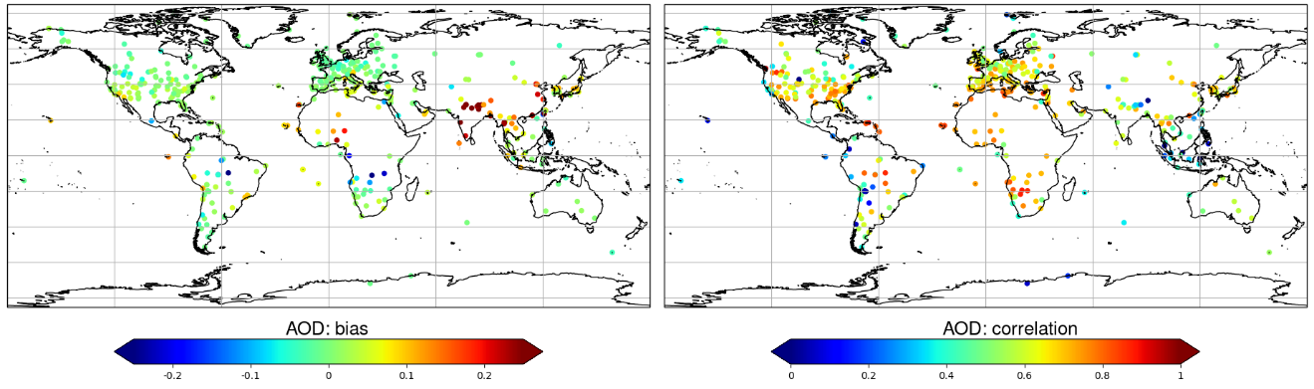
Figure ST1. Comparison of the AOD from the SILAM model with the AERONET observations stations in 2017.

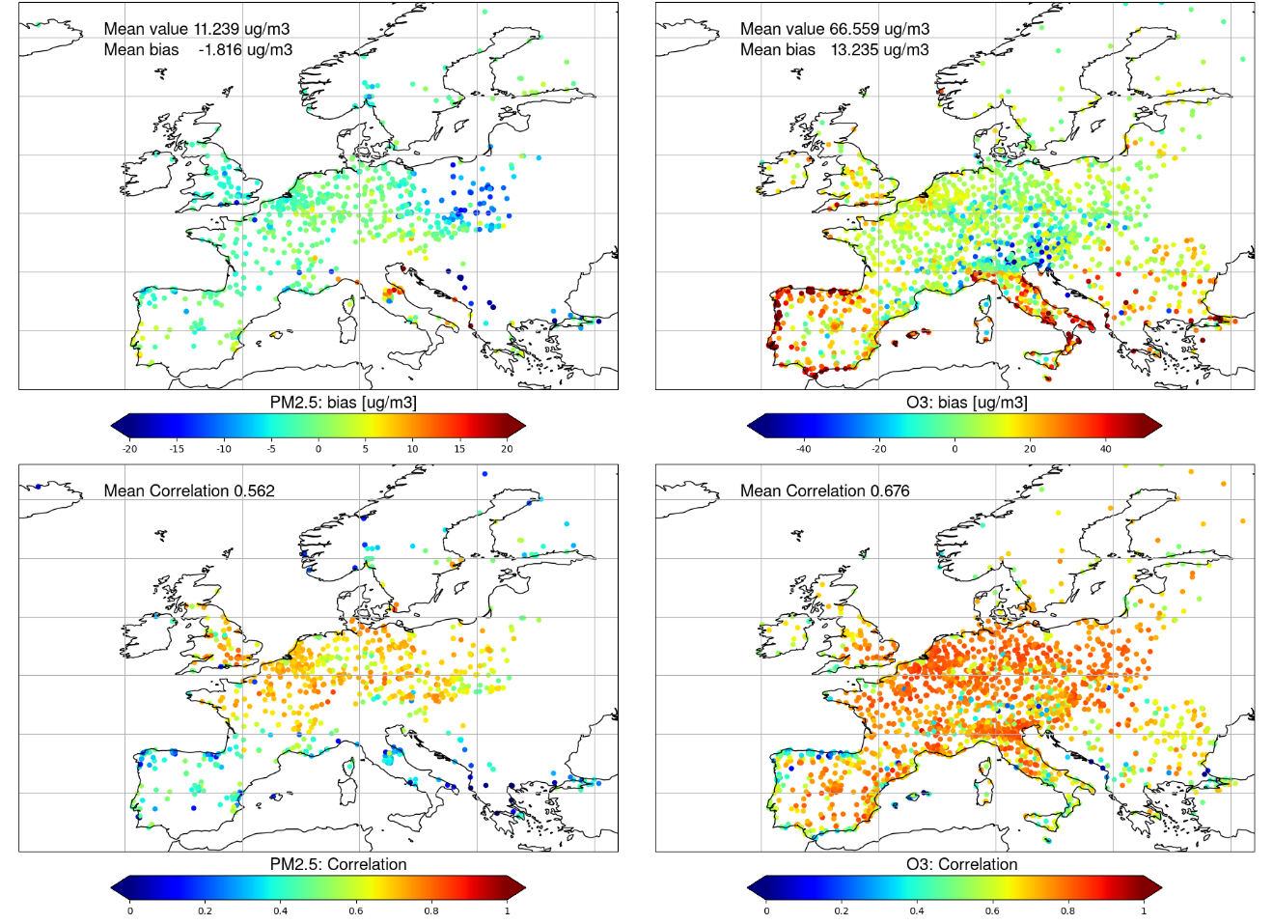Figure ST2. Model bias (top panels) and correlation (bottom panels) for PM2.5 and ozone, against the CAMS observation stations in 2017.

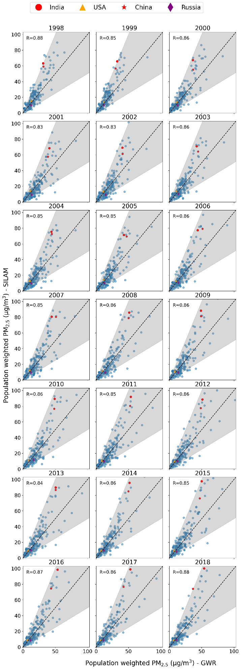
Figure ST3. Comparison of population weighted GWR PM_{2.5} and SILAM PM_{2.5} by country (each point represents population weighted PM_{2.5} for a country).

SI Tables

Table S1. Rate of change of population weighted PM_{2.5} extremes in µg/m³/yr (95 percentile, 99th percentile and the median). * indicates that the values are significant at p=0.05, and ** indicates that the values are significant at p=0.01.
regions | rate_of_change_pm25_95p | rate_of_change_pm25_99p | rate_of_change_pm25_50p
Central Asia | 0.153 | 0.136 | 0.064
Central Europe | -0.72** | -1.129** | -0.342**
Eastern Europe | -0.308** | -0.483** | -0.163**
Australasia | -0.001 | 0.0 | 0.001
High-income Asia Pacific | 0.151 | 0.405 | -0.037*
High-income North America | -0.563** | -0.664** | -0.257**
Southern Latin America | 0.069* | 0.087** | 0.081*
Western Europe | -0.804** | -1.033** | -0.358**
Andean Latin America | 0.044* | 0.06* | 0.023
Caribbean | 0.311** | 0.369** | 0.097**
Central Latin America | 0.128** | 0.127** | 0.1**
Tropical Latin America | 0.295** | 0.369** | 0.124**
North Africa and Middle East | 0.228** | 0.295** | 0.191**
South Asia | 3.256** | 3.554** | 1.712**
East Asia | 0.438 | 0.255* | 1.316
Oceania | 0.564** | 0.711** | 0.305**
Southeast Asia | 0.692** | 0.852** | 0.359**
Central Sub-Saharan Africa | 0.345** | 0.342** | 0.154**
Eastern Sub-Saharan Africa | 0.463** | 0.551** | 0.261**
Southern Sub-Saharan Africa | 0.3** | 0.306** | 0.123**
Western Sub-Saharan Africa | 0.879* | 0.942** | 0.456

Table S2. Rate of change of population weighted fire PM_{2.5} extremes in µg/m³/yr (95 percentile, 99th percentile and the median). * indicates that the values are significant at p=0.05, and ** indicates that the values are significant at p=0.01.
regions | rate_of_change_fires_95p | rate_of_change_fires_99p | rate_of_change_fires_50p
Central Asia | 0.037* | 0.039 | 0.001*
Central Europe | 0.013* | 0.034* | 0.001
Eastern Europe | 0.061* | 0.126** | 0.003**
Australasia | 0.011* | 0.019* | 0.001
High-income Asia Pacific | 0.018** | 0.038** | 0.001*
High-income North America | 0.015* | 0.017** | 0.006
Southern Latin America | 0.029** | 0.091** | 0.006*
Western Europe | 0.006 | 0.008* | 0.001
Andean Latin America | 0.06** | 0.11** | 0.004**
Caribbean | 0.014** | 0.025** | 0.003**
Central Latin America | 0.011* | 0.003** | 0.006
Tropical Latin America | 0.075** | 0.139** | 0.004**
North Africa and Middle East | 0.023** | 0.029** | 0.001*
South Asia | 0.017 | 0.119 | 0.001
East Asia | 0.022** | 0.043** | 0.003**
Oceania | -0.002 | -0.017 | 0.0
Southeast Asia | 0.0 | -0.003 | 0.0
Central Sub-Saharan Africa | 0.146* | 0.161** | 0.033**
Eastern Sub-Saharan Africa | 0.05** | 0.1** | 0.01**
Southern Sub-Saharan Africa | 0.04** | 0.12** | 0.006**
Western Sub-Saharan Africa | 0.054** | 0.152** | 0.009**

Table S3. Percentage share by region of the global population exposed to 30p50I
Region | 1990-1999 | 2000-2008 | 2010-2018
Central Sub-Saharan Africa | 36.5 | 38.2 | 38.3
Eastern Sub-Saharan Africa | 31.3 | 28.7 | 27.3
Tropical Latin America | 6.9 | 9.3 | 9.3
Western Sub-Saharan Africa | 7 | 6.7 | 8.4
Southern Sub-Saharan Africa | 8 | 6.3 | 5.5
Andean Latin America | 2 | 3 | 2.8
High-income North America | 0.2 | 0.3 | 1.4
Southern Latin America | 1.1 | 2.7 | 1.4
Eastern Europe | 0.7 | 0.4 | 1.1
Central Asia | 0.2 | 0.1 | 0.2
Central Latin America | 0.1 | 0.1 | 0.1
Southeast Asia | 2.1 | 0.4 | 0.1
Australasia | 0.1 | 0.1 | 0.1
Western Europe | 0 | 0.1 | 0
Central Europe | 0 | 0 | 0
Oceania | 0.1 | 0 | 0
Caribbean | 0 | 0 | 0
East Asia | 0 | 0 | 0
High-income Asia Pacific | 0 | 0 | 0
North Africa and Middle East | 0 | 0 | 0
South Asia | 0 | 0 | 0

SI Figures

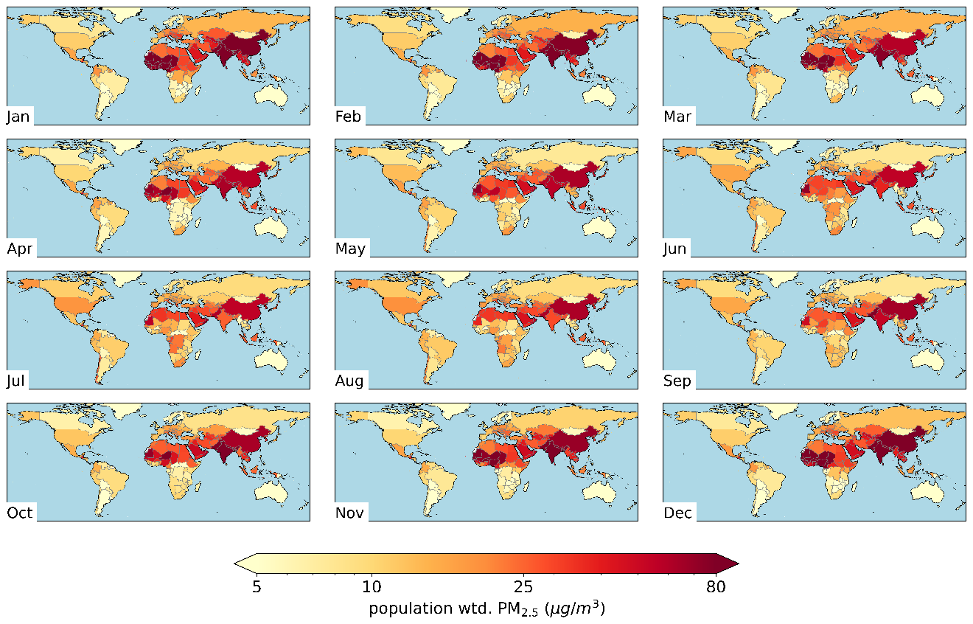
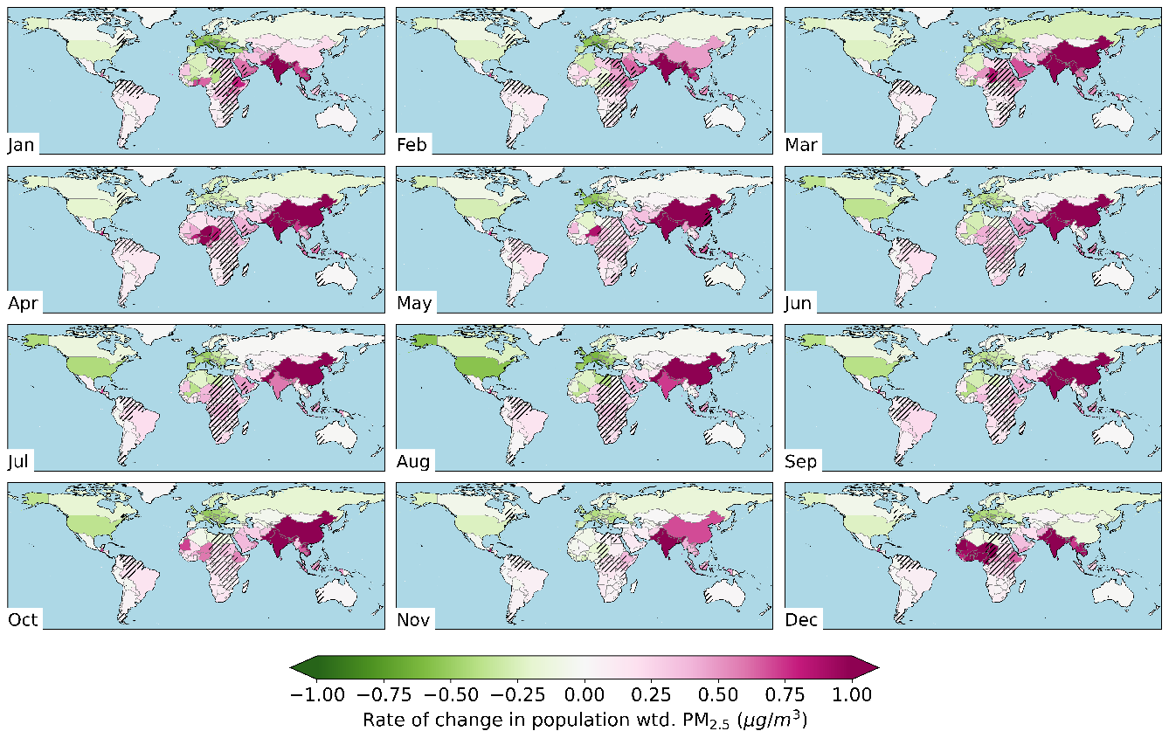

Figure S1. (a) Population weighted PM_{2.5} in µg/m³ (b) Rate of change of population weighted PM_{2.5}, in µg/m³/yr. The hatches indicate that the rate of change is not significant at p=0.05.

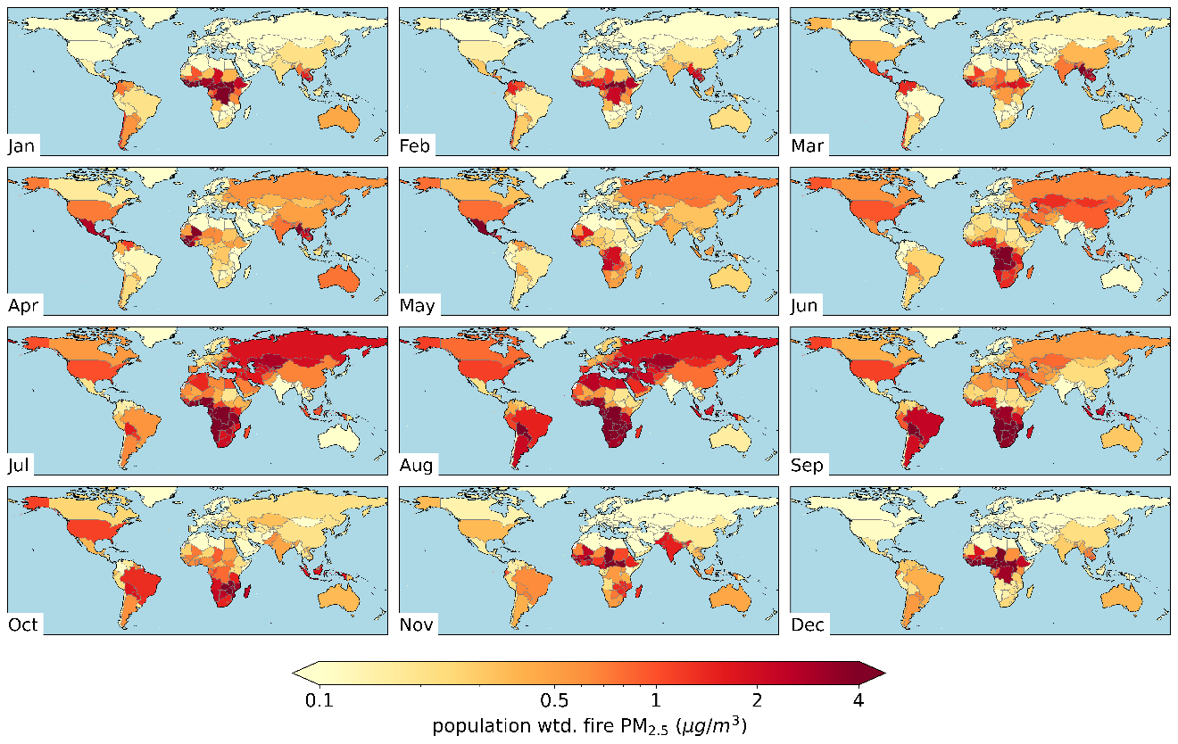
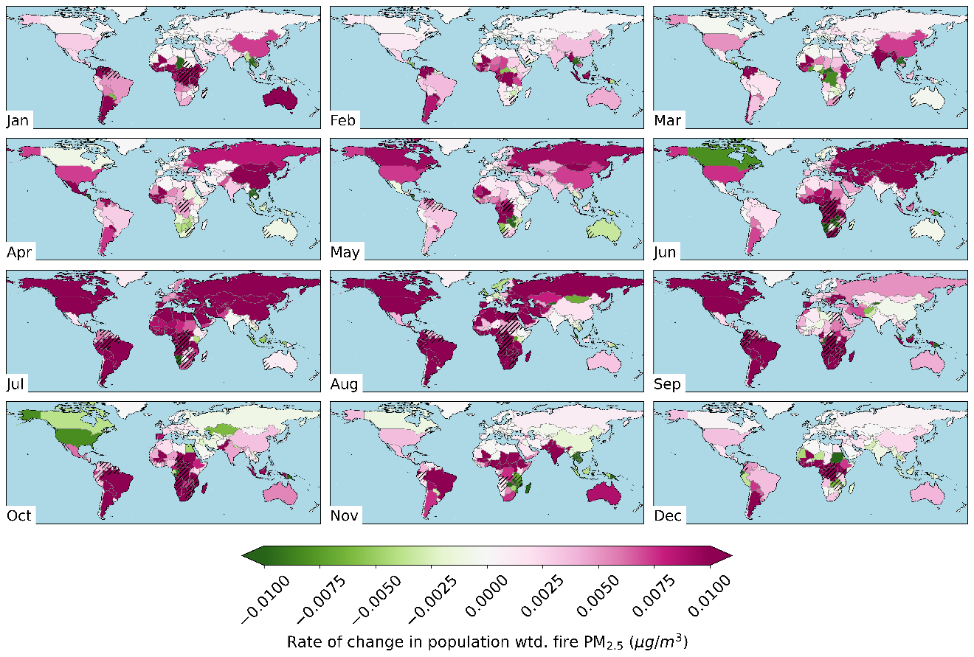
Figure S2. (a) Population weighted fire PM_{2.5} in µg/m³ (b) Rate of change of population weighted PM_{2.5}, in µg/m³/yr. The hatches indicate that the rate of change is not significant at p=0.05.

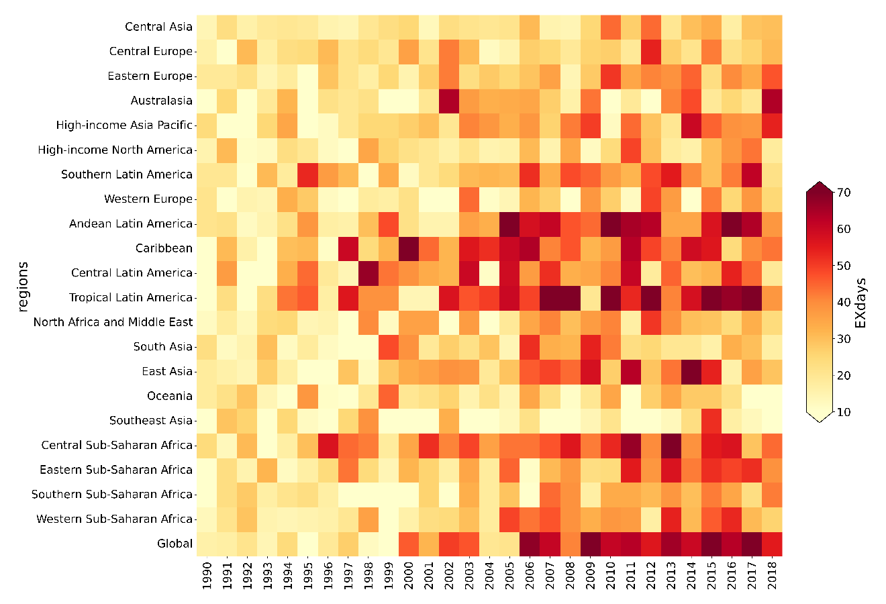
Figure S3. Heatmap of the total number of days with population-weighted fire PM_{2.5} exposure above the 'extreme' levels for 1990-94 (EXdays) by region.

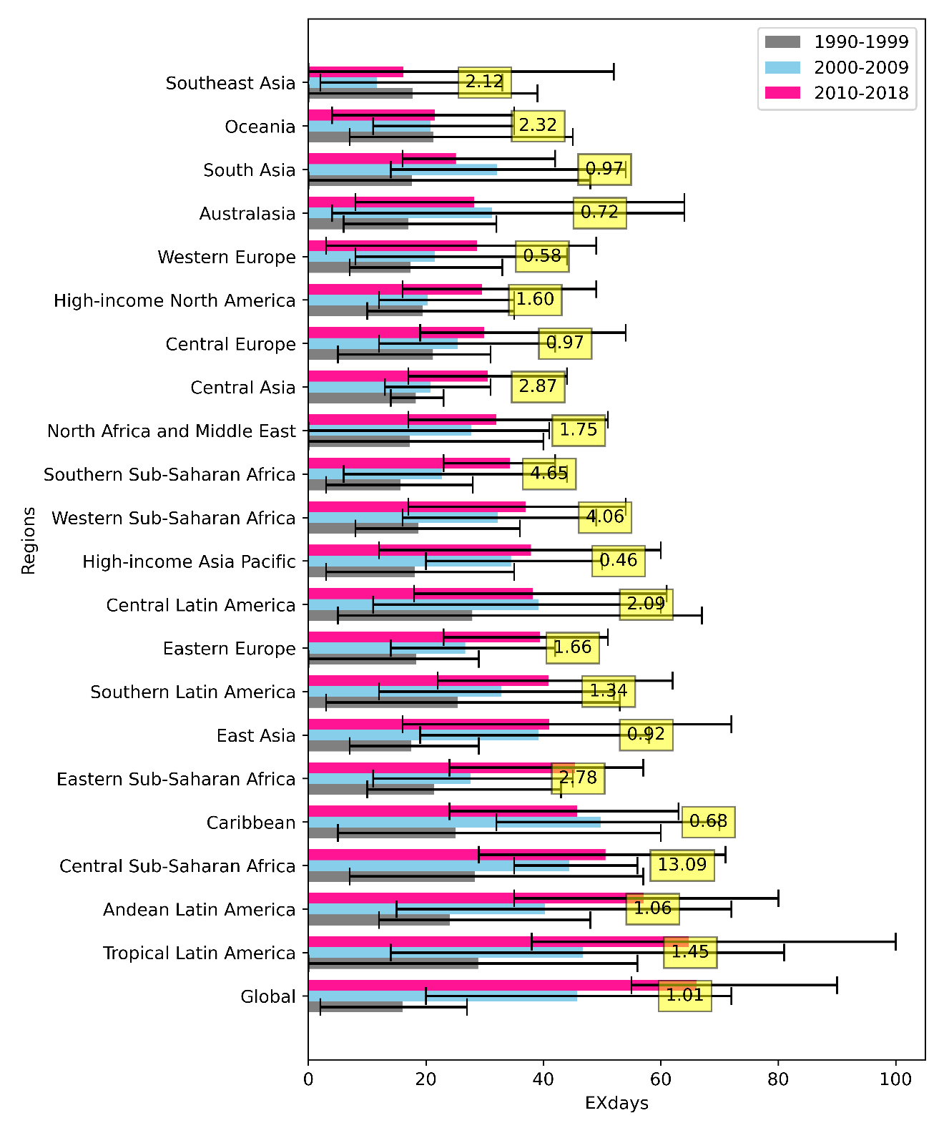
Figure S4. Average number of days with population-weighted fire PM_{2.5} exposure above the 'extreme' levels for 1990-94 (EXdays) by region in the period 1990-1999, 2000-2009 and 2010-2018. The numbers in yellow boxes indicate the 95th percentile value for fire PM2.5 (mg/m³) for the period 1990-94.

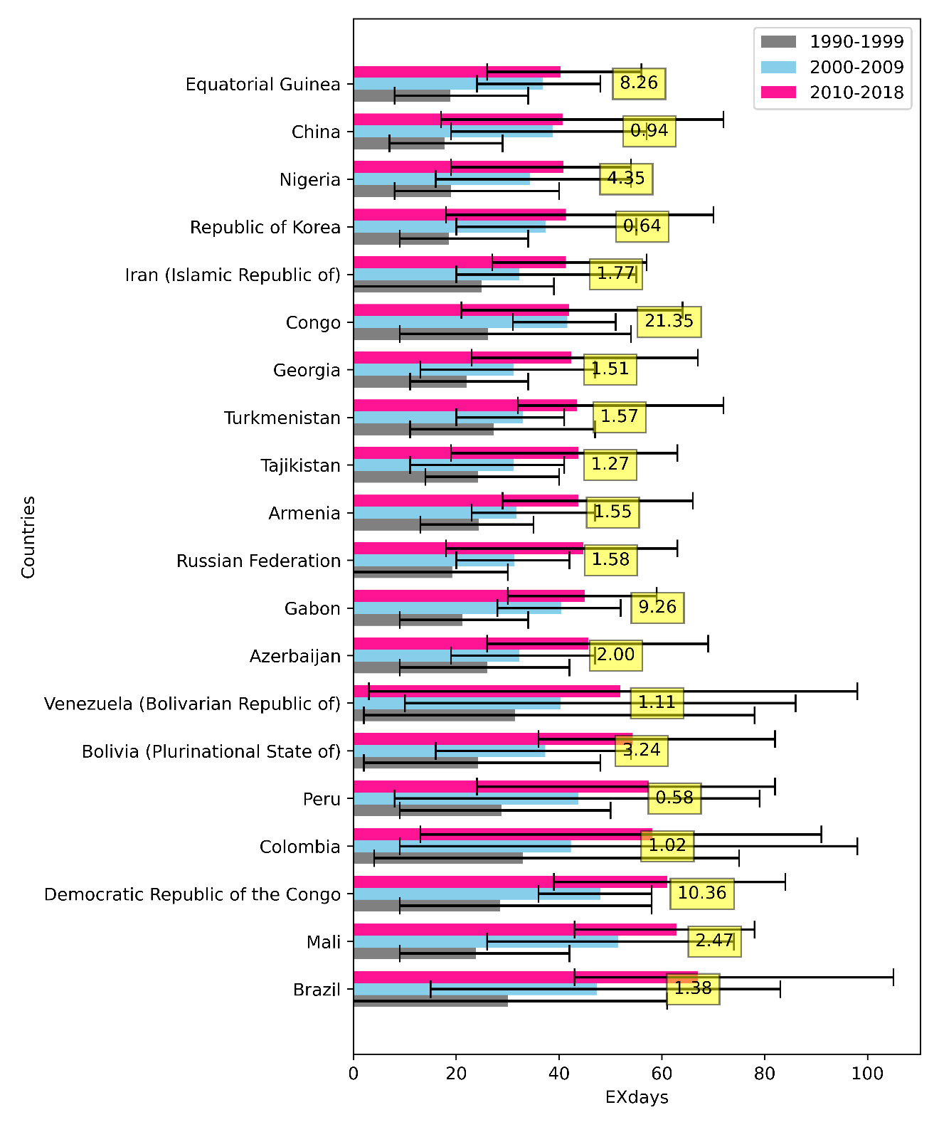Figure S5. Average number of days with population-weighted fire PM_{2.5} exposure above the 'extreme' levels for 1990-94 (EXdays) in the period 1990-1999, 2000-2009 and 2010-2018. For the top 20 countries ranked by the number of EXdays in 2010-2018. The numbers in yellow boxes indicate the 95th percentile value for fire PM2.5 for the period 1990-94.

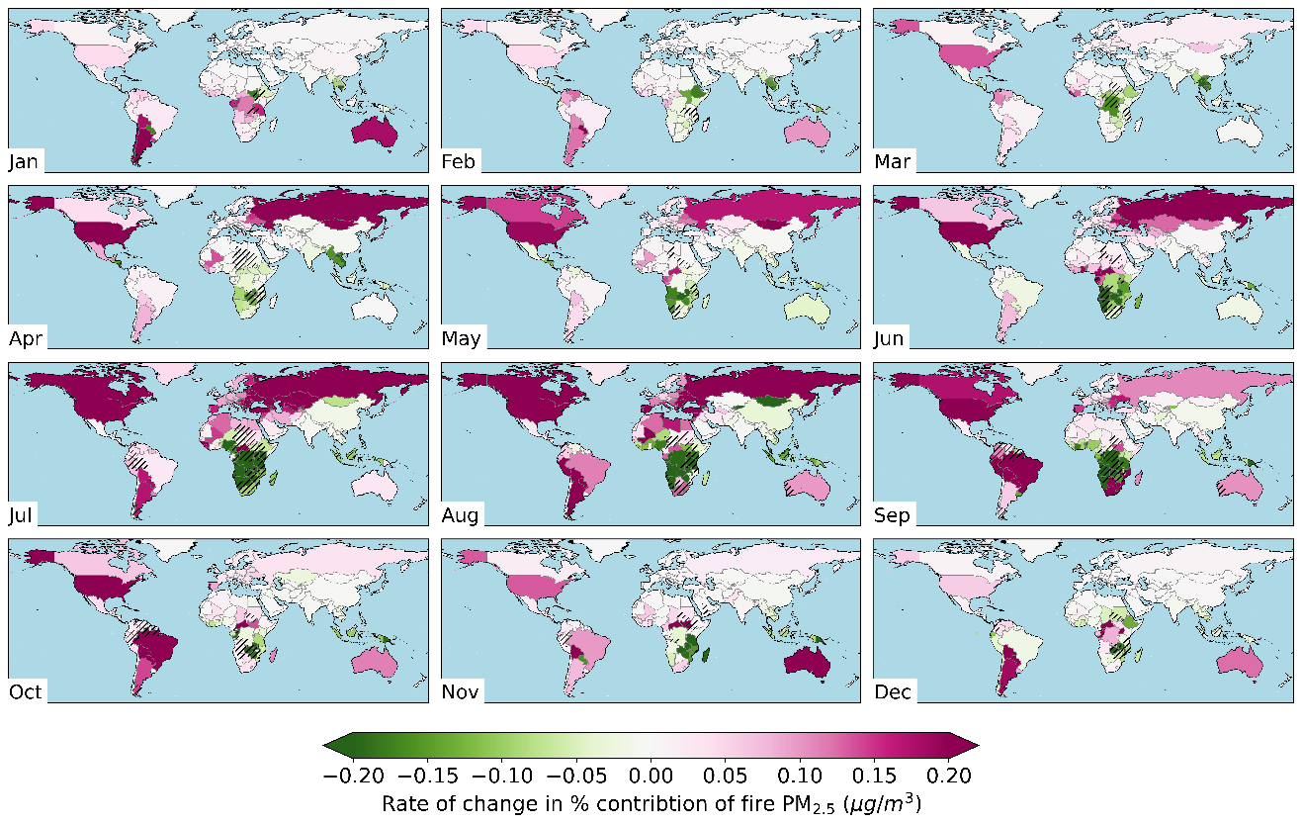

Figure S6. Rate of change in % contribution of fires to ambient PM_{2.5}.

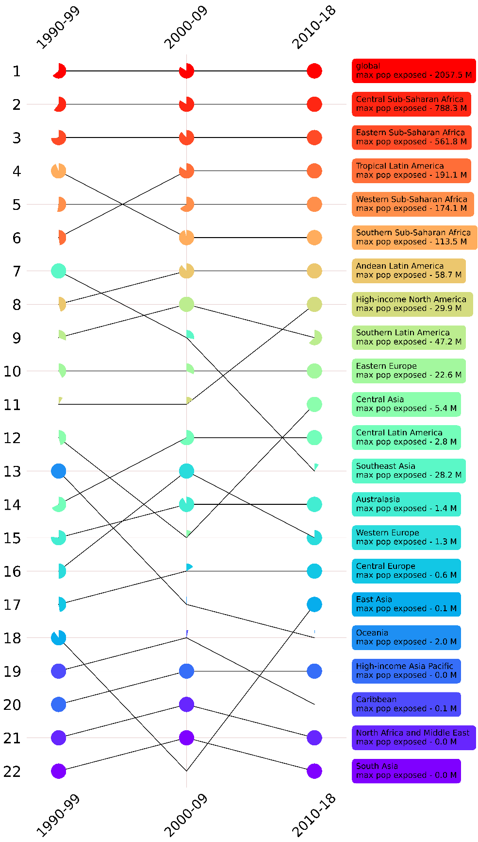
Figure S7. Rank of the regions by population exposed to 50 instances of 30% fire PM_{2.5} in total PM_{2.5} (30p50I). The complete pies for each region and globe (top=most in dark red) indicate the largest population exposed, the other pies for the respective region/globe indicate the percentage of the maximum population exposed in that period. The regions are ordered by their ranks in 2010-18.

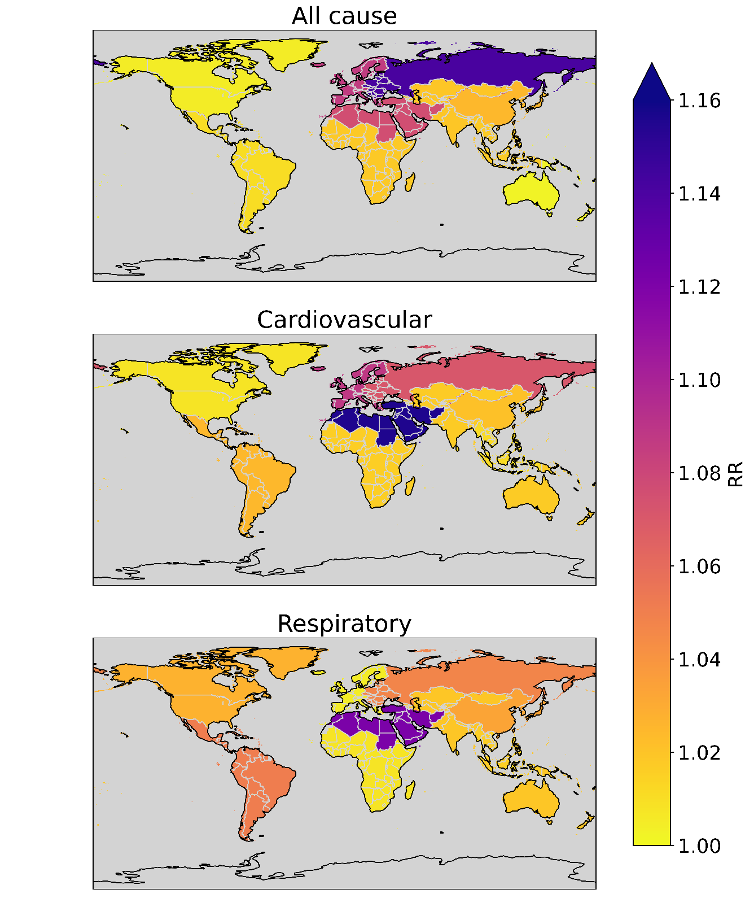

Figure S8. Relative risk for all-cause, cardiovascular and respiratory diseases.
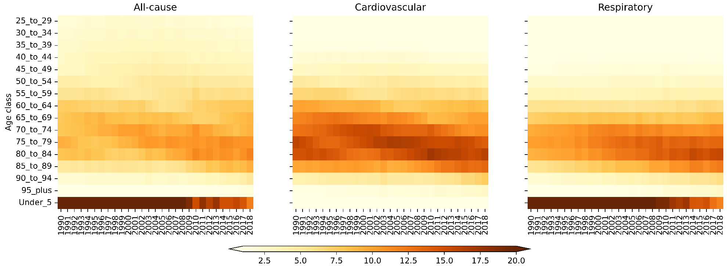
Figure S9. Percentage deaths by age-group in a year from all-cause, cardiovascular and respiratory diseases from 1990-2018.

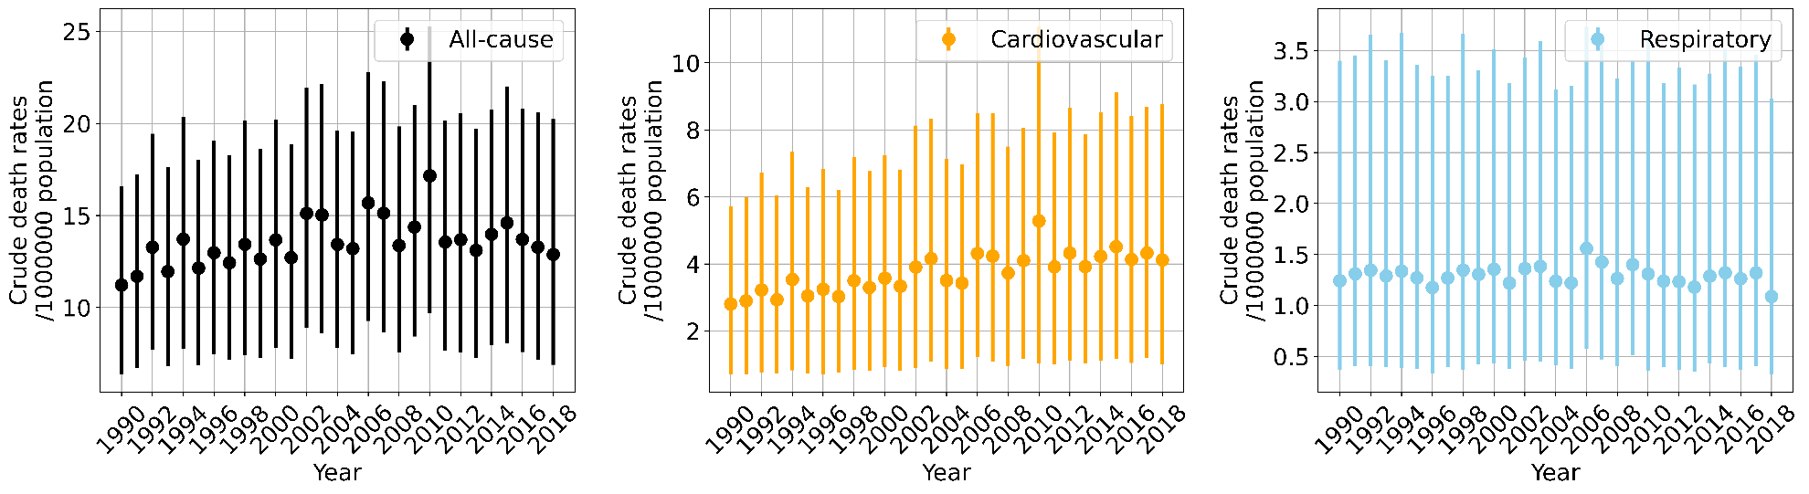

Figure S10. Global timeline of crude death rates from acute exposure to fire PM_{2.5}, categorized by all-cause (black), cardiovascular (orange), and respiratory (sky blue) diseases.

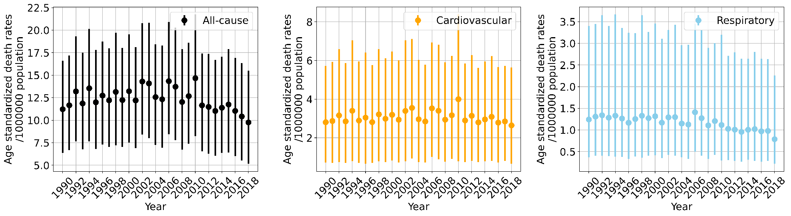
Figure S11. Global timeline of age-standardized death rates from acute exposure to fire PM_{2.5}, categorized by all-cause (black), cardiovascular (orange), and respiratory (sky blue) diseases.

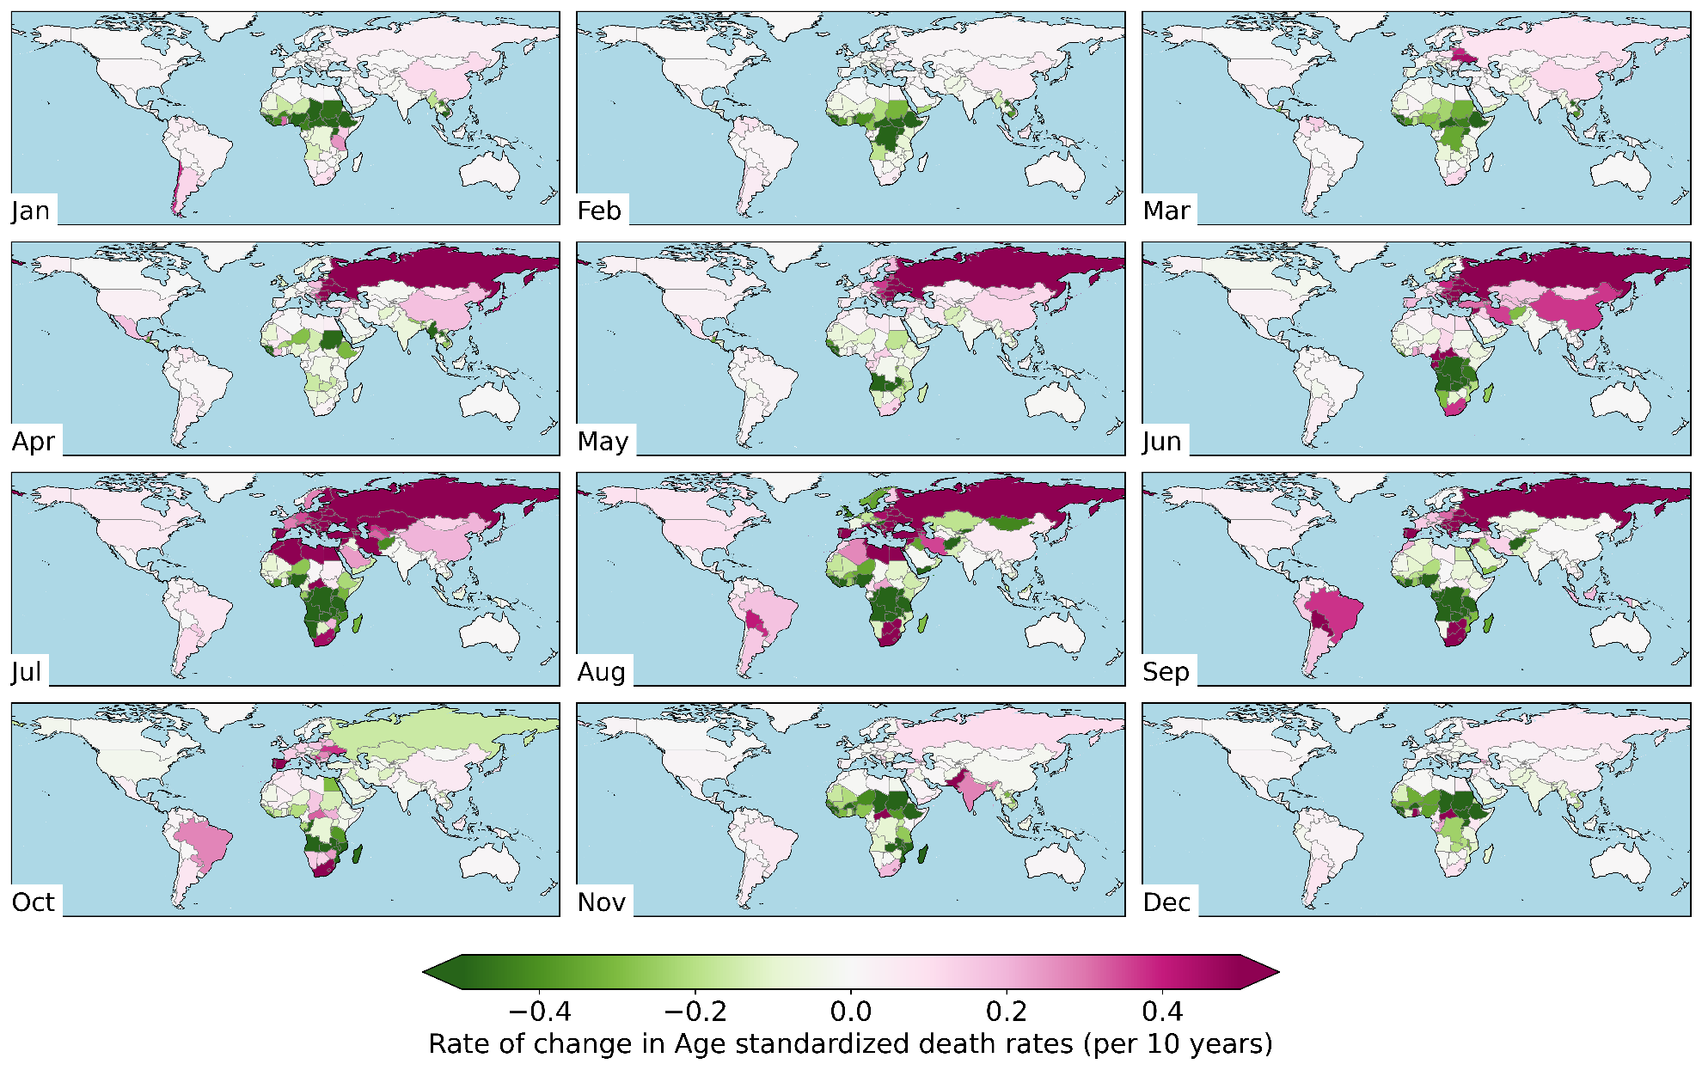
Figure S12. Rate of change in crude death rates (CDR), per 10years, for all-cause acute fire PM2.5 deaths by month (1990-2018).
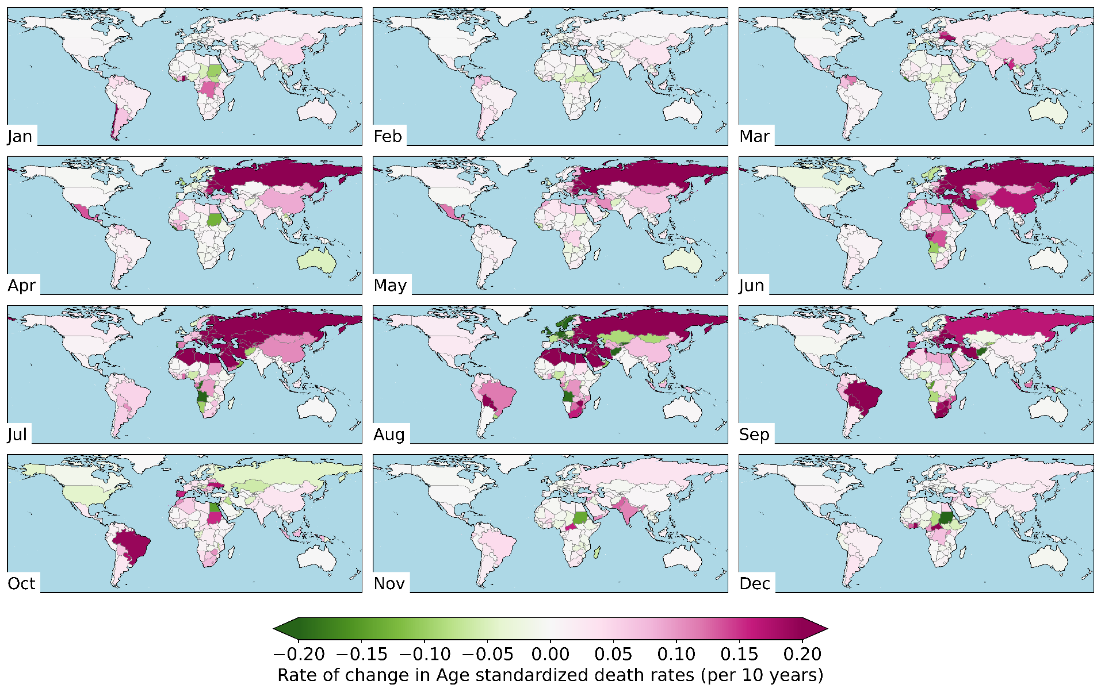
Figure S13. Rate of change in crude death rates (CDR), per 10years, for cardiovascular acute fire PM2.5 deaths by month (1990-2018).
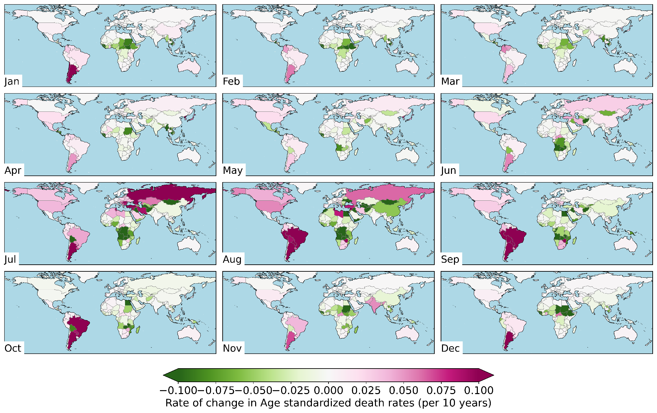
Figure S14. Rate of change in crude death rates (CDR), per 10years, for respiratory acute fire PM2.5 deaths by month (1990-2018).

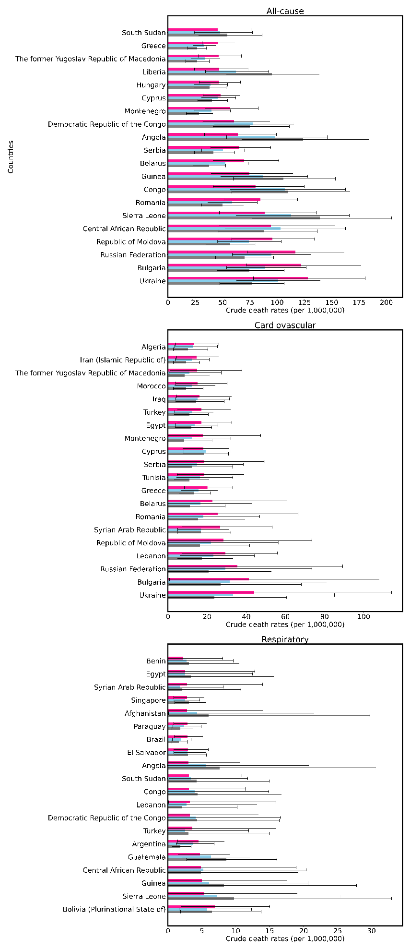
Figure S15. Crude fire PM2.5 death rates (CDR) for all-cause (top panel), cardiovascular (middle panel) and respiratory (bottom panel) diseases for the top 20 countries ranked by ADR in 2010-18.

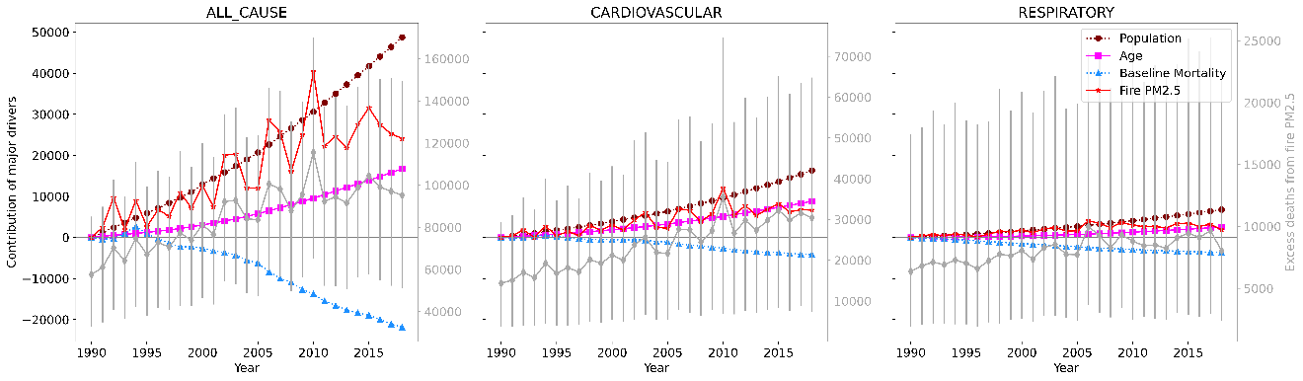

Figure S16. Impact of major factors in driving all-cause, cardiovascular and respiratory deaths associated with exposure to fire PM_{2.5} globally. Excess death estimates are in gray lines, and should be associated with the right y-axis.

