Supplementary material
Part of methodology
2.3.1 Soil EC and pH
Fifteen g of sieved soil was added to 30 mL distilled water (soil: water = 1:2, w/v), mixed, and shaken for 30 minutes. Soil EC and pH of the filtrate were determined with a digital EC meter (EC/TDS/Salinity Meter with ATC - HI2300, Hanna Instruments, Woonsocket, RI, USA) and pH meter (Lab pH meter 7110, WTW, Werkstätten, Germany) respectively (Dane and Topp 2020).
2.3.2 Soil moisture content
Ten g of wet soil sample was oven-dried in a crucible at 105˚C for 24 h. The samples were cooled in a desiccator and weighed. Soil moisture was determined as (Dane and Topp 2020):
Soil Moisture (%) = [(Wet Soil Weight – Dry Soil Weight)/Wet Soil Weight] × 100.
2.3.3 Soil bulk density
Soil bulk density (BD) is the ratio of soil mass (oven-dry weight) to bulk volume expressed in grams per cubic cm (g/cm³). In the field, soil samples for bulk density were collected in 100 cm³ volume metal rings and placed in polyethylene bags to avoid moisture loss. The oven-dry weight of the soil at 105˚C after 24 hours was used to calculate bulk density as (Jones Jr 2021):
BD (g/cm³) =W/V
where W = dry weight of soil in the metal ring; V = volume of the metal ring.
2.3.4 Soil texture
Soil texture was determined by the hydrometer method in which a dispersing solution was prepared by dissolving 40 g sodium hexametaphosphate [(NaPO3)₁₃] and 10 g sodium carbonate (Na₂CO₃) in distilled water to 1 L. A 40 g sieved and dried soil sample was added to 60 ml of dispersing solution, covered, and left overnight (Hasan and Abuel-Naga 2024). The next day, the content in the beaker was transferred to a soil stirring cup filled with three-quarters water and stirred for five minutes. The suspension was transferred to a 1 L calibrated cylinder, bringing the volume to 1 L with deionized water, stirred for five minutes, and a hydrometer reading (HR₁) was taken (Hasan and Abuel-Naga 2024). The solution was left for four hours, and a second hydrometer reading (HR₂) was taken. Soil clay, silt, and sand were calculated as (Hasan and Abuel-Naga 2024):
Clay + Silt (%) = (HR₁ - (T₁C)/wt. of soil) × 100
Clay (%) = (HR₂ - (T₂C)/wt. of soil) × 100
Sand (%) =100 – (clay + silt)
Silt (%) = (clay + silt %) - clay
2.3.5 Soil organic carbon
A 0.5 g air-dried, sieved soil sample was placed in a 500 mL titration flask, and 10 mL 1 N potassium dichromate and 20 mL concentrated sulphuric acid were added, mixed, and left for 30 minutes. About 200 mL distilled water, 10 mL orthophosphoric acid (H₃PO₄) and ten drops of diphenylamine indicator were added and mixed. The solution was titrated against 0.5 M ferrous ammonium sulfate solution until the color changed from violet-blue to green. Soil organic matter and soil organic carbon were determined using the equations (Gerenfes et al. 2022):
Organic matter (%) = (V_{blank} - V_{sample}) × 0.5 × 0.69/wt. of sample
Organic carbon (%) = OM/1.724
V_{blank} = volume of (NH4) 2SO4.FeSO4.6H2O solution required to titrate the blank (mL)
V_{sample} = volume of (NH4) 2SO4.FeSO4.6H2O solution required to titrate the sample (mL)
Wt = Weight of air-dry soil (g)
2.3.6 Soil total phosphorus, potassium, and micronutrients estimation
A 0.5 g air-dried, sieved soil sample was placed in a 250 mL conical flask and a nitric acid: hydrochloric acid mixture (2:1 v/v) was added for digestion and placed on a hot plate at 250 ˚C until white fumes appeared. Twenty mL distilled water was added to the cooled digested sample, filtered into a storage bottle, and distilled water was added to 50 mL (Sørensen et al. 2024). The extract was then prepared according to the elements to be measured. Total potassium, total phosphorus and micronutrients (Fe, Cu, Mn, Zn) were measured using a flame photometer (Pg Instrument, Leicestershire, UK), spectrophotometer (L6/L6S Split Beam UV-VIS Spectrophotometer, Guangzhou, China) and atomic absorption spectrometer (SpectrAA 220FS, Palo Alto, CA, USA), respectively (Sørensen et al. 2024).
2.3.7 Soil total nitrogen
A 1 g air-dried, sieved soil sample was digested by sulphuric acid and N content was determined by an automatic Kjeldahl nitrogen analyzer (KJEL-AUTO, MRK, VELP Scientifica, Usmate, Italy) (Aguirre 2023).
2.3.8 Soil available phosphorus and potassium
The ammonium bicarbonate diethylene triamine pentaacetic acid (ABDTPA) method was used for soil extraction. Extraction solution was prepared by adding 1.97 g diethylene triamine pentaacetic acid (DTPA) to 800 mL distilled water. Then 2 mL ammonium hydroxide (NH₄OH): deionized water (1:1) was added to facilitate dissolution and to prevent effervescence when bicarbonate was added. The solution prepared contained 0.005 M DTPA. When most of the DTPA was dissolved, 79.06 g ammonium bicarbonate (NH₄HCO₃) was added, stirred gently, the pH was adjusted to 7.6 with NH₄OH and brought to a volume of 1 L with distilled water. Thirty mL extraction solution was added to 15 g dried, sieved soil, shaken for 30 min, and the suspension was filtered using Whatman No. 42 filter paper. The extract was then prepared for phosphorus and potassium determination and was measured using a spectrophotometer (L6/L6S Split Beam UV-VIS Spectrophotometer, Guangzhou, China) and flame photometer (Pg Instrument, Leicestershire, UK), respectively (Syed 2022).
Soil nutrient stock(Mg/ha) was also calculated by using formula (Eggleston et al. 2006)
Nutrient stock(Mg/ha)= nutrient concentration(g/kg)×Bulk density(g/cm3) ×soil depth(cm)/10
2.3.9 Cation exchange capacity
Four g of air-dried, sieved soil was placed in a 40 mL centrifuge tube, and 33 mL of 1 N sodium acetate trihydrate solution was added. The cap was tightened on the tube and was shaken for five minutes. The caps were removed, the tubes were centrifuged at 1006 g for five minutes and the clear supernatant was decanted and washed with sodium acetate three times, and then washed with 33 mL 95% ethanol, shaken, centrifuged and the clear supernatant was decanted. The adsorbed sodium was replaced with 1 N ammonium acetate solution, washed three times with 1 N ammonium acetate solution, shaken for five minutes, centrifuged, and the clear supernatant was stored in a 100 mL volumetric flask. After three washes, 1 N ammonium acetate solution was added to a volume of 100 mL. The samples were read by a flame photometer against sodium standards, and values were calculated by the equation:
CEC (meq/100g) = meq/Na*V/Wt.*100/1000
V = total volume of the soil extract (mL)
Wt. = weight of air-dry soil (g)
2.3.10 Microbial biomass carbon
MBC was measured by the fumigation-extraction and titration method. A beaker with 10 g of soil was placed in a desiccator, with 30 mL of chloroform, that had been purified with 5% H₂SO₄ and distilled water, in the center to fumigate the samples. The desiccator was closed tightly, a vacuum was created, and samples were fumigated. Another soil sample was also placed in a desiccator, but without chloroform, and these samples were non-fumigated. Both desiccators were stored in the dark for 24 hours (Mori et al. 2021). The samples were removed from the desiccators, transferred to 250 mL conical flasks, and 50 mL K₂SO₄ were added, shaken for one hour, and filtered with Whatman no. 42 filter papers. Then 4 mL of extract was placed in a 250 mL conical flask, 1 mL of 0.667M K₂Cr₂O₇ and 5 mL of conc.H₂SO₄ were added, and then 2 to 3 drops of phenanthroline amine indicator were added and titrated against 0.033 M ferrous sulphate solution till the color changed from green to red. MBC was calculated by the equation (Mori et al. 2021):
MBC (%) = (blank-sample) × N of FeSO₄ × 0.003/wt. of sample × 1250

Supplementary figures and tables
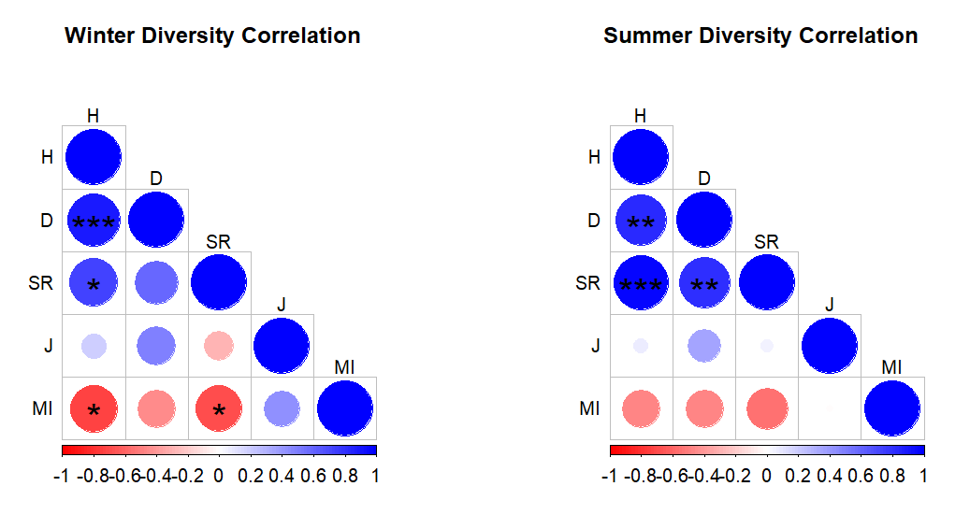
Figure S1. Spearman's rank correlation analysis for two seasons, Shannon diversity index (H), Simpson diversity index (D), Species richness (SR), Species evenness (J), Maturity index (MI). Statistical significance is presented as *p < 0.05, **p < 0.01, ***p < 0.001.
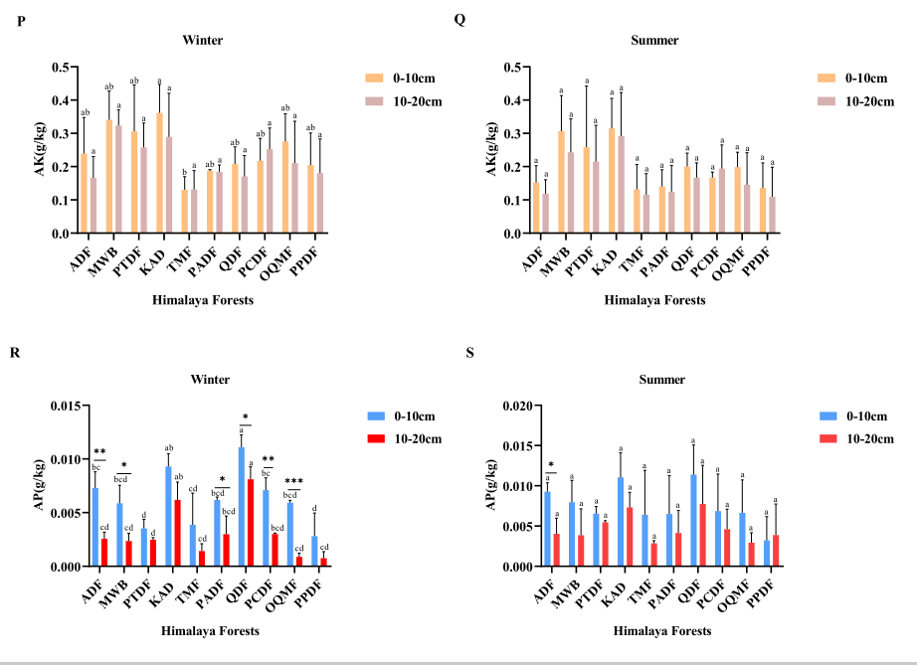
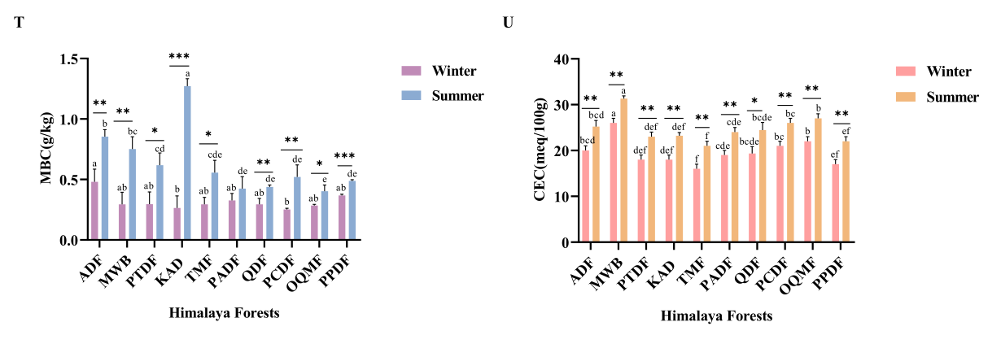
Figure S2. P, Q, R, S, T, U presenting means ±SD of available potassium (AK, g/kg), available phosphorus (AP, g/kg), microbial biomass carbon (MBC, g/kg) and cation exchange capacity (CEC, meq/100g) 0-10 cm and 10-20 cm in winter and summer. Within the forest types, means with different superscripts differ from each other (p < 0.05). Asterisks on shoulder lines indicate statistically significant differences between 0-10 cm and 10-20 cm of the same forest type: *p < 0.05, **p < 0.01, ***p < 0.001.
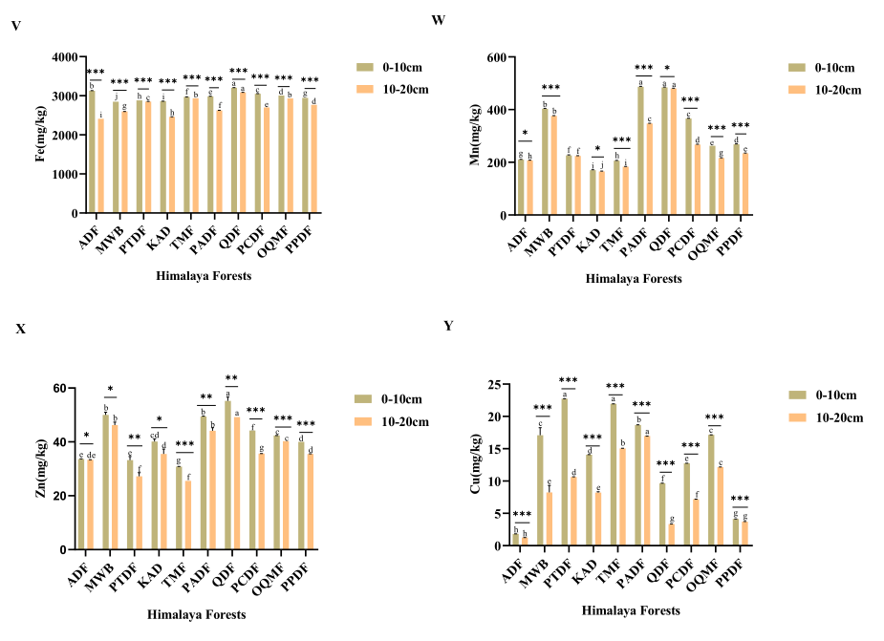
Fig.S3. V, W, X, Y presenting means ±SD iron (Fe, mg/kg), manganese (Mn, mg/kg), zinc(Zn, mg/kg) and copper(Cu, mg/kg) at 0-10 cm and 10-20 cm. Within the forest types, means with different superscripts differ from each other (p< 0.05). Asterisks on shoulder lines indicate statistically significant differences between 0-10 cm and 10-20 cmof the same forest type: *p < 0.05, **p < 0.01, ***p < 0.001.

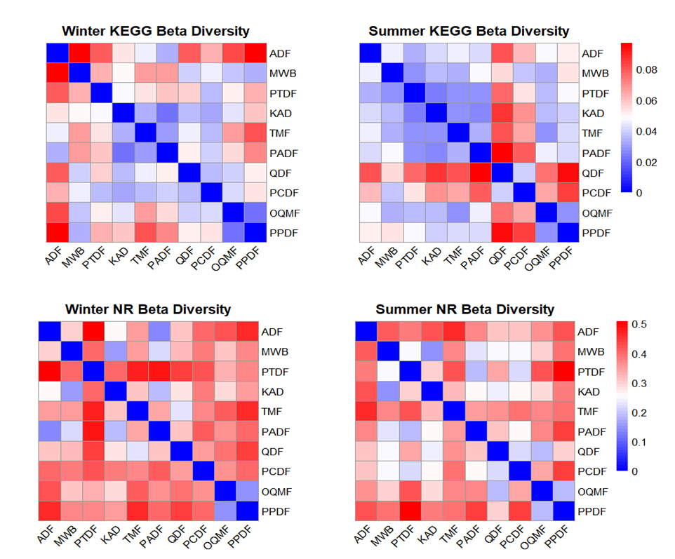
Figure S4. Kyoto Encyclopedia of Genes and Genomes (KEGG) and Non-redundant (NR) beta diversities in winter and summer in 10 forest types.
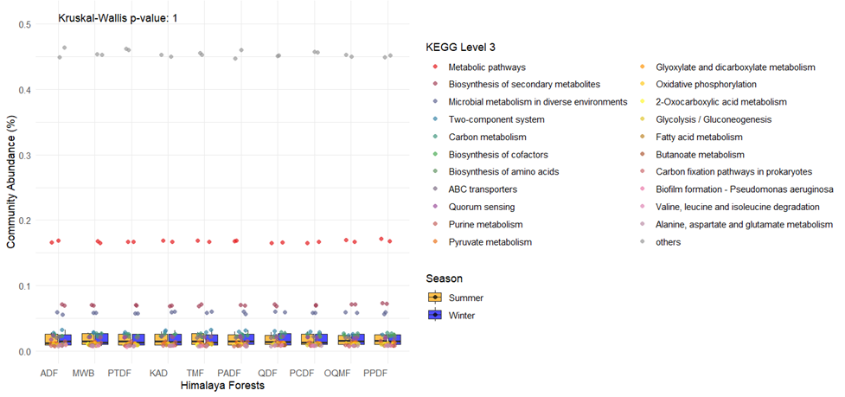
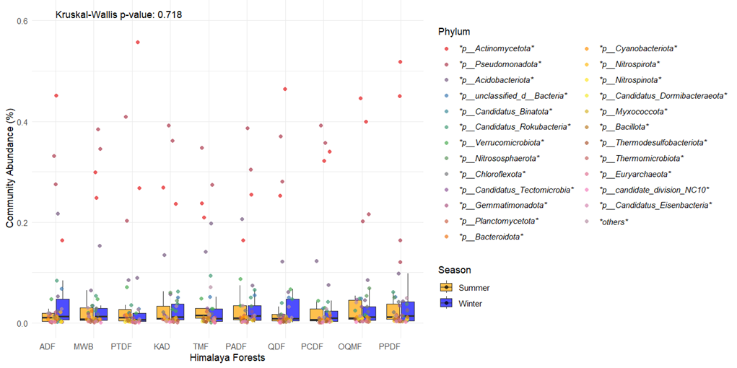
B
A
Figure S5. A. Kyoto Encyclopedia of Genes and Genomes (KEGG) level 3 and B. Non-redundant (NR) community abundance among forest types and between seasons.

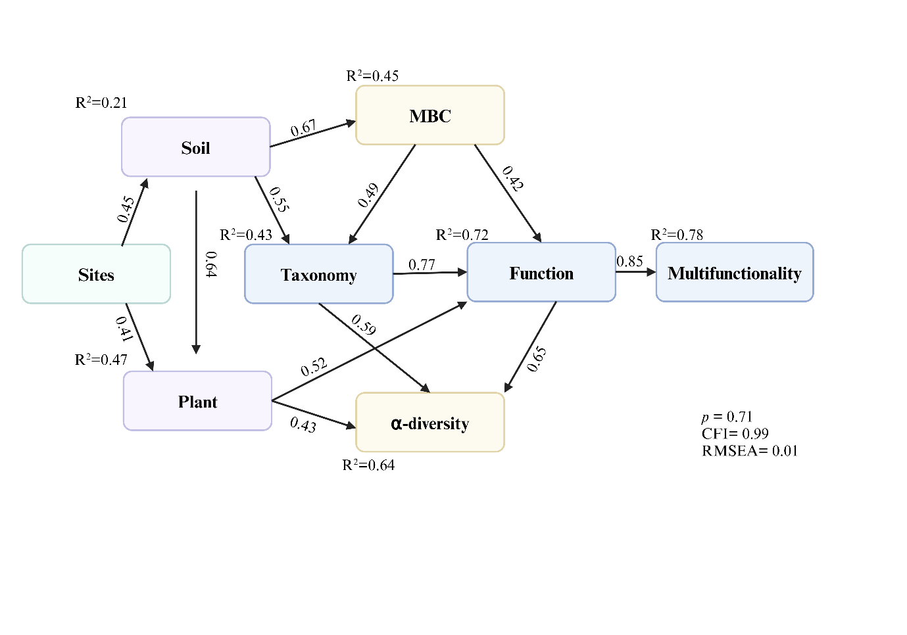
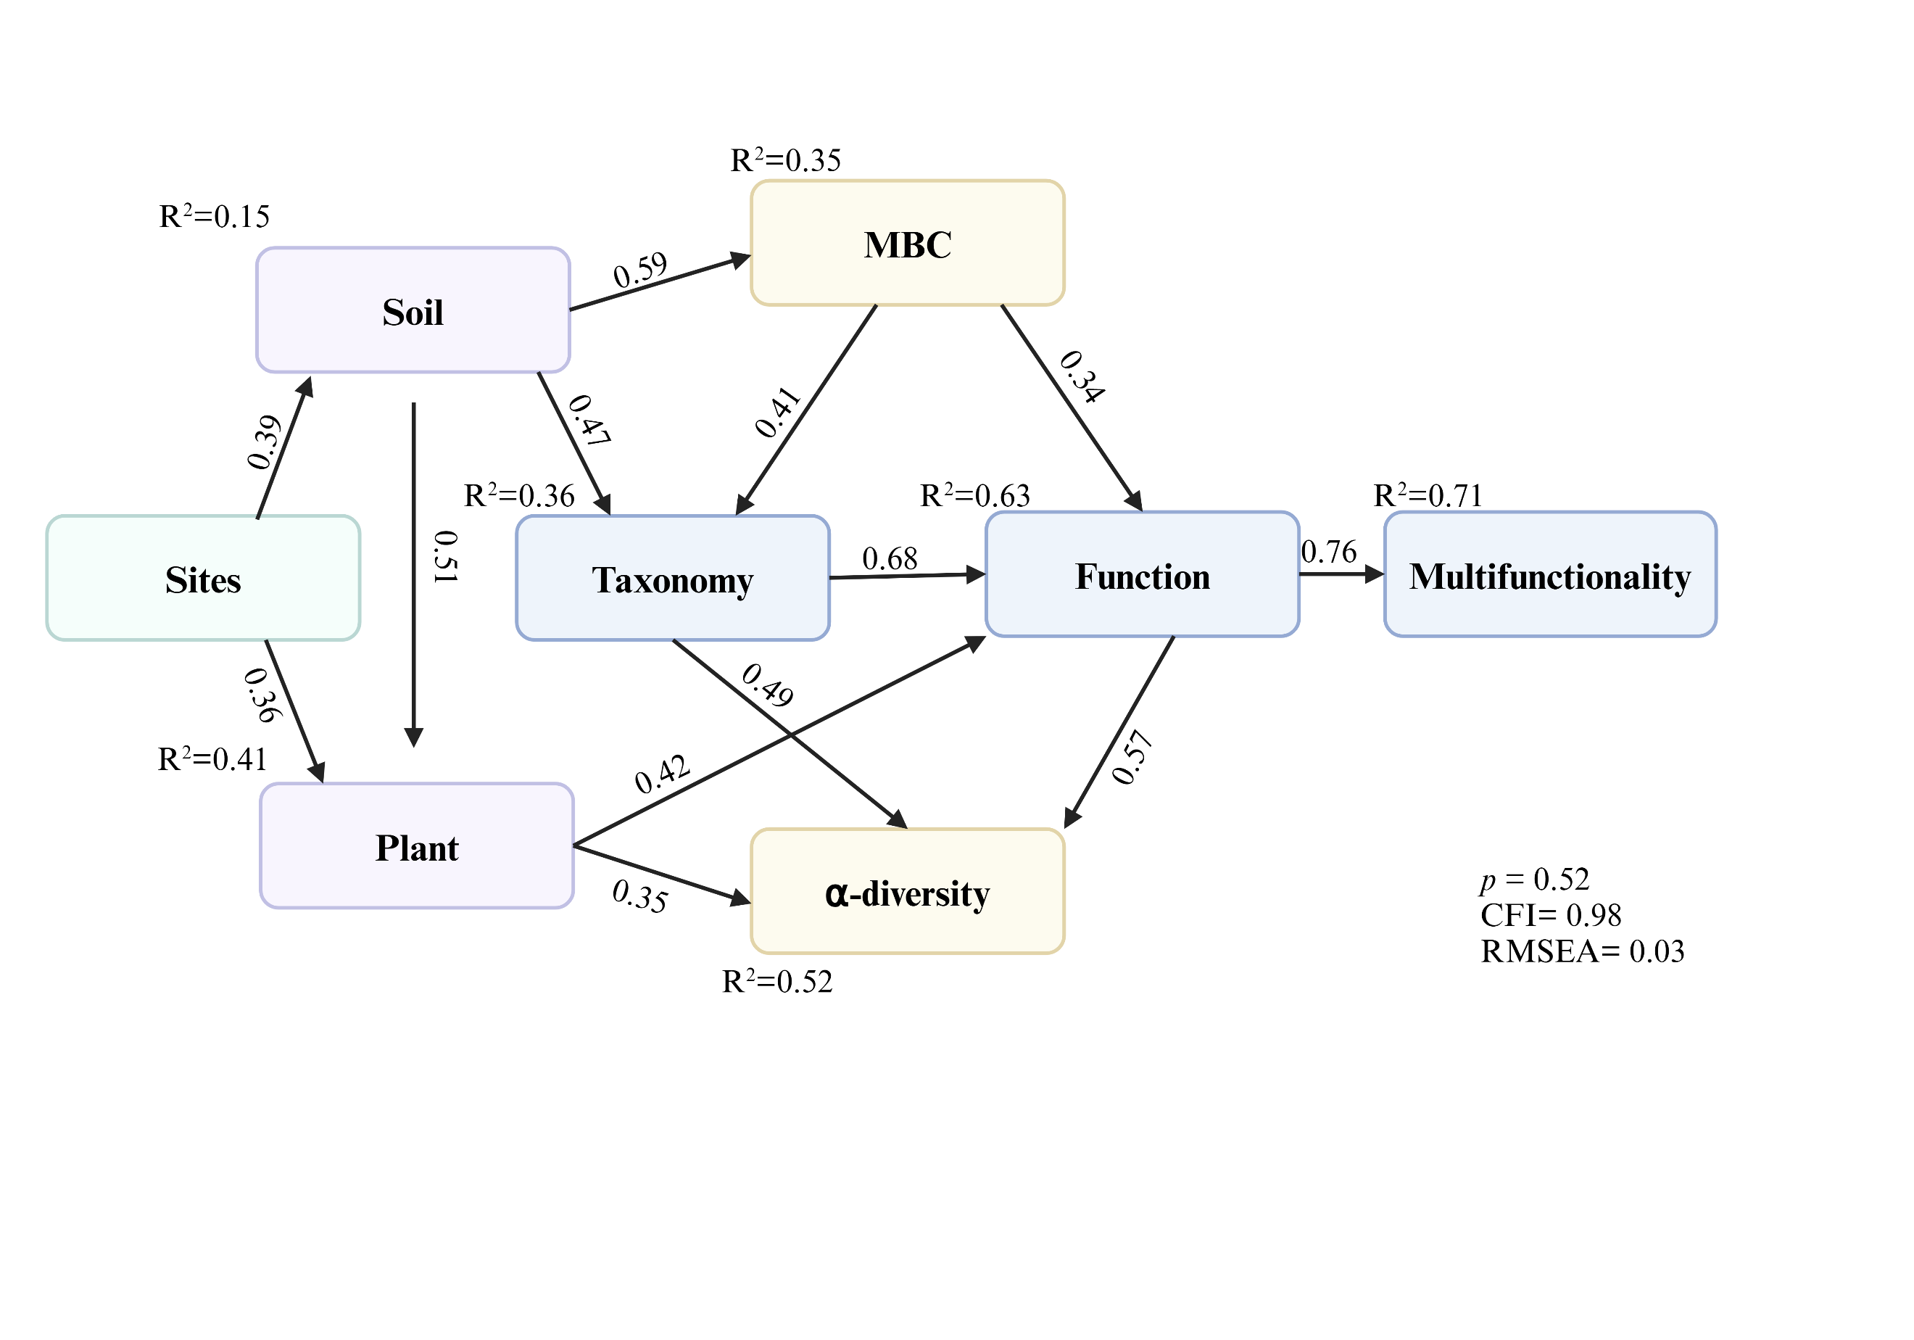
B
A

Figure S6. The structural equation model (SEM) (A.Winter, B.Summer) elucidates relationships between soil properties (Soil, MBC), microbial α-diversity, and ecosystem multifunctionality. Summer demonstrates stronger explanatory power (R² = 0.21–0.78) compared to winter (R² = 0.15–0.71), with microbial diversity showing the highest predictive capacity for multifunctionality (summer: R² = 0.78; winter: R² = 0.71).The values on the arrows are the path coefficient and (R²) the proportion of variance explained for the dependent variable. Goodness of fit statistics for each model are given.
Table S1. Diversity indices, i.e., Shannon diversity index (H), Simpson diversity index (D), species richness (SR), species evenness (J), maturity index (MI), and winter vegetation in 10 types of forests.
Forests | Locality | Altitude(m.a.s.l.) | Latitude | Longitude | H | D | SR | J | MI | Winter vegetation
ADF | Phulawai,AJK | 2816 | 34.821 | 74.605 | 2.13 | 0.86 | 0.69 | 0.89 | 63.64 | Viburnum-Abies-Phytolacca
MWB | Surgan,AJK | 2769 | 34.934 | 74.224 | 2.54 | 0.87 | 1.54 | 0.81 | 40.87 | Fragaria-Abies-Viburnum
PTDF | Brathwaar Gali AJK | 2672 | 34.261 | 73.857 | 2.13 | 0.81 | 1.24 | 0.74 | 47.78 | Fragaria-Dryopteris -Viburnum
KAD | Khapi,AJK | 2377 | 34.306 | 73.729 | 2.53 | 0.90 | 1.12 | 0.91 | 51.25 | Aesculus-Viburnum-Fragaria
TMF | Salmia Chikar,AJK | 2246 | 34.088 | 73.737 | 3.01 | 0.93 | 1.62 | 0.85 | 38.24 | Pinus-Fragaria-Apluda
PADF | Sinjli ,AJK | 2145 | 34.806 | 74.269 | 2.55 | 0.89 | 1.15 | 0.87 | 46.32 | Dryopteris-Viburnum-Heteropogon
QDF | Upper Neelum,AJK | 1756 | 34.761 | 74.234 | 2.30 | 0.87 | 0.86 | 0.85 | 53.33 | Apluda-Indigofera-Fragaria
PCDF | Lubgran ,AJK | 1599 | 34.346 | 73.809 | 2.39 | 0.87 | 1.29 | 0.81 | 49.47 | Fragaria-Cedrus-Viburnum
OQMF | Baandi ,AJK | 1072 | 34.385 | 73.719 | 2.81 | 0.93 | 1.72 | 0.83 | 34.67 | Quercus-Apluda-Oxalis
PPDF | Dewliyan,AJK | 1021 | 34.438 | 73.636 | 2.36 | 0.86 | 0.85 | 0.79 | 39.00 | Pinus-Apluda-Oxalis

Table S2. Diversity indices i.e. Shenon diversity index (H), Simpson diversity index (D), species richness (SR), species evenness (J), maturity index (MI) and summer vegetation in 10 type of forests.
Forests | Locality | Altitude(m.a.s.l.) | Latitude | Longitude | H | D | SR | J | MI | Summer vegetation
ADF | Phulawai,AJK | 2816 | 34.821 | 74.605 | 3.22 | 0.93 | 2.45 | 0.84 | 32.45 | Salix-Fragaria-Abies
MWB | Surgan,AJK | 2769 | 34.934 | 74.224 | 3.06 | 0.92 | 2.24 | 0.83 | 35.5 | Viburnum-Fragaria-Pteridium
PTDF | Brathwaar Gali AJK | 2672 | 34.261 | 73.857 | 3.63 | 0.96 | 2.78 | 0.89 | 35.17 | Viburnum-Abies-Rubus
KAD | Khapi,AJK | 2377 | 34.306 | 73.729 | 3.20 | 0.94 | 2.27 | 0.87 | 32.30 | Viburnum-Aesculus-Geranium
TMF | Salmia Chikar,AJK | 2246 | 34.088 | 73.737 | 3.57 | 0.95 | 2.88 | 0.86 | 32.78 | Viburnum-Penicum-Pinus
PADF | Sinjli ,AJK | 2145 | 34.806 | 74.269 | 3.37 | 0.94 | 2.61 | 0.86 | 28.97 | Viburnum-Fragaria-Pinus
QDF | Upper Neelum, AJK | 1756 | 34.761 | 74.234 | 3.11 | 0.93 | 2.04 | 0.84 | 35 | Isodon-Duchesnea-Indigofera
PCDF | Lubgran ,AJK | 1599 | 34.346 | 73.809 | 3.40 | 0.93 | 2.56 | 0.83 | 38.27 | Indigofera-Sorbaria-Viburnum
OQMF | Baandi ,AJK | 1072 | 34.385 | 73.719 | 3.04 | 0.93 | 1.64 | 0.85 | 45.14 | Berberis-Indigofera-Apluda
PPDF | Dewliyan,AJK | 1021 | 34.438 | 73.636 | 2.77 | 0.92 | 1.08 | 0.91 | 55.23 | Pinus-Cannabis-Heteropogon

Table S3. Winter-season soil nutrient stocks (Mg/ha, mean ± SE) at 0-10 cm and 10-20 cm depths across forest sites.
Winter season | Soil depth(cm) | ADF | MWB | PTDF | KAD | TMF | PADF | QDF | PCDF | OQMF | PPDF
SOC(Mg/ha) | 0-10 | 32.09±1.4 | 71.97±14.9 | 49.73±12.3 | 55.08±7.8 | 27.93±0.8 | 52.28±7.3 | 54.96±1.6 | 27.42±1.6 | 64.35±0.8 | 41.65±5.1
 | 10-20 | 28.73±7.5 | 58.08±12.9 | 39.15±1.6 | 54.54±13.5 | 23.60±1.7 | 50.92±5.2 | 45.38±1.6 | 24.87±0.8 | 56.74±0.8 | 35.65±5.5
TN(Mg/ha) | 0-10 | 3.59±0.3 | 5.86±0.8 | 2.78±0.7 | 5.95±1.6 | 1.83±0.7 | 4.32±0.4 | 3.99±1.2 | 1.80±0.8 | 4.07±0.5 | 2.60±0.1
 | 10-20 | 2.81±0.8 | 6.1±0.8 | 2.15±0.8 | 6.44±1.5 | 1.59±0.4 | 3.88±0.4 | 2.78±0.8 | 1.47±0.4 | 2.58±0.2 | 1.86±0.0
TK(Mg/ha) | 0-10 | 0.83±0.04 | 1.75±0.1 | 0.72±0.3 | 1.11±0.1 | 0.37±0.06 | 1.65±0.1 | 1.48±0.2 | 0.53±0.1 | 0.69±0.2 | 0.97±0.5
 | 10-20 | 0.84±0.02 | 2.0±0.1 | 0.91±0.2 | 1.19±0.09 | 0.50±0.02 | 1.40±0.1 | 1.53±0.3 | 0.69±0.04 | 0.72±0.3 | 1.02±0.5
TP(Mg/ha) | 0-10 | 0.35±0.00 | 0.58±0.00 | 0.27±0.02 | 0.41±0.05 | 0.16±0.04 | 0.41±0.01 | 0.37±0.06 | 0.17±0.01 | 0.37±0.01 | 0.29±0.01
 | 10-20 | 0.29±0.01 | 0.54±0.04 | 0.30±0.03 | 0.40±0.01 | 0.17±0.05 | 0.43±0.04 | 0.34±0.06 | 0.19±0.00 | 0.35±0.01 | 0.26±0.06
AK(Mg/ha) | 0-10 | 0.15±0.08 | 0.21±0.07 | 0.18±0.1 | 0.24±0.06 | 0.05±0.03 | 0.16±0.00 | 0.17±0.04 | 0.09±0.05 | 0.18±0.06 | 0.15±0.07
 | 10-20 | 0.12±0.05 | 0.24±0.03 | 0.20±0.06 | 0.23±0.10 | 0.08±0.04 | 0.21±0.01 | 0.15±0.05 | 0.15±0.05 | 0.15±0.1 | 0.15±0.08
AP(Mg/ha) | 0-10 | 0.0048±0.00 | 0.0037±0.00 | 0.0021±0.00 | 0.0063±0.00 | 0.0017±0.00 | 0.0056±0.00 | 0.0094±0.00 | 0.0031±0.00 | 0.0038±0.00 | 0.0021±0.00
 | 10-20 | 0.0019±0.00 | 0.0017±0.00 | 0.0019±0.00 | 0.0050±0.00 | 0.0009±0.00 | 0.0034±0.00 | 0.0074±0.00 | 0.0018±0.00 | 0.0006±0.00 | 0.0006±0.00

Table S4. . Summer-season soil nutrient stocks (Mg/ha, mean ± SE) at 0-10 cm and 10-20 cm depths across forest sites.
Summer season | Soil depth(cm) | ADF | MWB | PTDF | KAD | TMF | PADF | QDF | PCDF | OQMF | PPDF
SOC(Mg/ha) | 0-10 | 29.13±1.9 | 59.34±1.4 | 39.8±1.1 | 49.1±7.8 | 23.4±4.5 | 30.6±1.2 | 37.4±0.8 | 24.3±1.2 | 43.9±0.8 | 27.3±1.2
 | 10-20 | 20.8±0.7 | 35.5±2.6 | 27.01±0.4 | 40.18±2.1 | 19.3±0.4 | 23.2±1.2 | 31.2±1.6 | 21.4±2.3 | 36.2±0.4 | 23.6±0.8
TN(Mg/ha) | 0-10 | 3.5±0.3 | 5.8±0.8 | 2.7±0.7 | 5.8±1.6 | 1.7±0.7 | 4.2±0.4 | 3.6±1.0 | 1.7±0.8 | 4±0.5 | 2.5±0.1
 | 10-20 | 2.7±0.8 | 6.03±0.8 | 2.07±0.8 | 6.3±1.5 | 1.5±0.4 | 3.7±0.4 | 2.6±0.8 | 1.4±0.4 | 2.5±0.2 | 1.7±0.07
TK(Mg/ha) | 0-10 | 0.72±0.03 | 1.62±0.1 | 0.59±0.3 | 0.98±0.19 | 0.29±0.06 | 1.46±0.10 | 1.31±0.2 | 0.45±0.1 | 0.56±0.2 | 0.67±0.4
 | 10-20 | 0.69±0.02 | 1.85±0.1 | 0.75±0.2 | 1.03±0.09 | 0.37±0.02 | 1.06±0.23 | 1.35±0.30 | 0.57±0.04 | 0.57±0.30 | 0.84±0.53
TP(Mg/ha) | 0-10 | 0.35±0.00 | 0.58±0.00 | 0.27±0.02 | 0.41±0.05 | 0.16±0.04 | 0.41±0.01 | 0.37±0.06 | 0.17±0.01 | 0.37±0.01 | 0.29±0.01
 | 10-20 | 0.29±0.01 | 0.54±0.04 | 0.30±0.03 | 0.40±0.01 | 0.17±0.05 | 0.43±0.04 | 0.34±0.06 | 0.19±0.00 | 0.35±0.01 | 0.26±0.06
AK(Mg/ha) | 0-10 | 0.10±0.04 | 0.19±0.08 | 0.15±0.15 | 0.21±0.07 | 0.05±0.06 | 0.12±0.04 | 0.17±0.03 | 0.07±0.01 | 0.13±0.03 | 0.10±0.06
 | 10-20 | 0.09±0.03 | 0.18±0.08 | 0.17±0.08 | 0.23±0.1 | 0.07±0.05 | 0.14±0.06 | 0.15±0.03 | 0.11±0.05 | 0.10±0.07 | 0.09±0.07
AP(Mg/ha) | 0-10 | 0.006±0.00 | 0.005±0.00 | 0.004±0.00 | 0.007±0.00 | 0.002±0.00 | 0.005±0.00 | 0.009±0.00 | 0.003±0.00 | 0.004±0.00 | 0.002±0.00
 | 10-20 | 0.003±0.00 | 0.002±0.00 | 0.004±0.00 | 0.005±0.00 | 0.001±0.00 | 0.004±0.00 | 0.007±0.00 | 0.002±0.00 | 0.002±0.00 | 0.003±0.00

References
Aguirre J (2023) The Kjeldahl Method. The Kjeldahl Method: 140 Years. Springer.
Dane JH, Topp CG (2020) Methods of soil analysis, Part 4: Physical methods. John Wiley & Sons.
Eggleston H, Buendia L, Miwa K, Ngara T, Tanabe K (2006) 2006 IPCC guidelines for national greenhouse gas inventories.
Gerenfes D, Giorgis A, Negasa GJIJHFS (2022) Comparison of organic matter determination methods in soil by loss on ignition and potassium dichromate method. Int J Hortic Food Sci 4: 49-53.
Hasan MF, Abuel-Naga HJM (2024) An Alternative Method of Obtaining the Particle Size Distribution of Soils by Electrical Conductivity. 14: 804.
Jones Jr JB (2021) Soil and Plant Analysis: Laboratory Registry for the United States and Canada. CRC Press.
Mori T, Wang S, Wang C, Mo J, Zhang WJi-B, Forestry (2021) Is microbial biomass measurement by the chloroform fumigation extraction method biased by experimental addition of N and P? iForest-Biogeosciences and Forestry 14: 408.
Sørensen MK, Lemming C, Jensen ON, Nielsen NCJAC (2024) Soil Analysis by Mobile Multinuclear NMR: Quantification of Phosphorus, Aluminum, and Sodium. Analytical Chemistry 96: 17086-17091.
Syed AJ (2022) Evaluation of Different Extractants forEstimation of P, K, Ca, Mg & Micro-nutrient Cations in Soils ofKashmirValley. SKUAST Kashmir.

