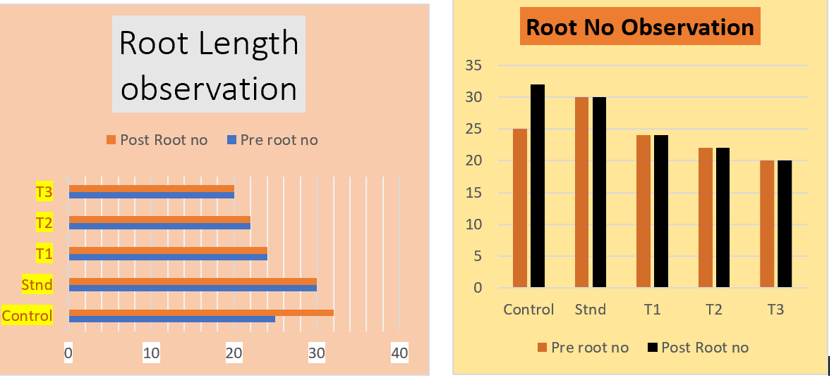
Graph 1: A- Root no observation of AC, B- Root Length observation of AC

Graph 2: Mitotic Index of different groups
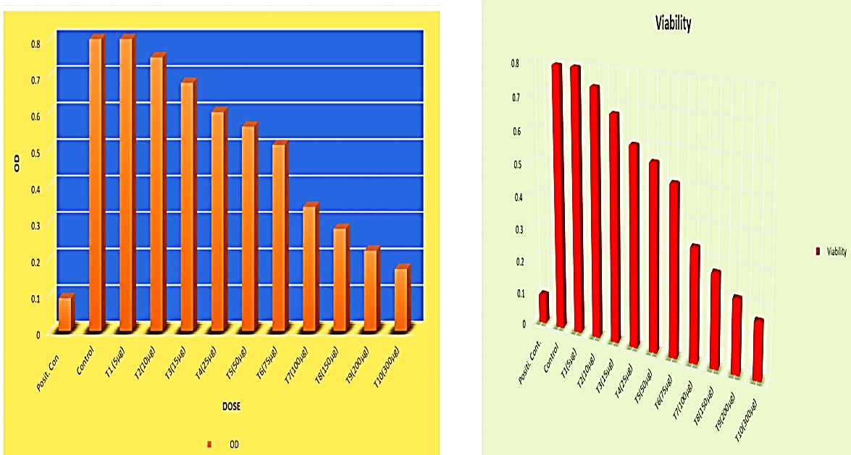
Graph 3: A- OD Graph ,B- Cell viability Graph, of different groups in MTT Assay

