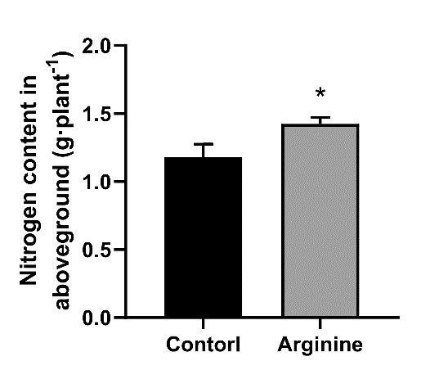
Figure S1

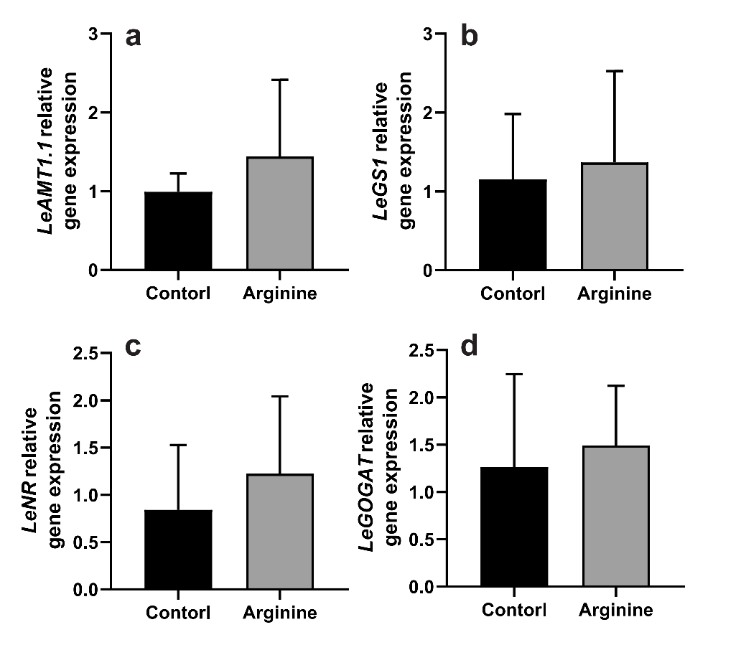
Figure S2

Table S1
Gene | Genbank accession  number | Forward  (5’-3’) | Reverse  (3’-5’)
NRT1.1 | X92853 | TACTATTCAAGCTATGGGTGTTACG | ATTTGTCCTCTTTCTTTTTTGTCCG
AMT1.1 | X92854.1 | GACGAAATGGCGGTATGGATCTGACC | GGTCAGATCCATACCGCCATTTCGTC
NR | X14060.1 | TGGTTTCAATTGGGGTGCTG | ACTTTGAACCACCACCTCCA
GS1 | AF200360.1 | ATTGGCGGTTTTCCTGGCCC | ACTGTCCCGGCATGACTTCACC
GOGAT | XM_004234782.3 | ACAGAGGTCAAAAGGCGAGT | CTTCCCTTGTGCTGCCATAC
Actin | FJ532351.1 | AGAACTATGAATTGCCTGATGGAC | TGAGCACAATGTTACCGTAGAGG

Table legend
Table S1. Primer sequences used for quantitative real time PCR

