Multi-Targeted Anti-Cancer Mechanisms of Li-Ginseng Powder in Colitis-Associated Colorectal Cancer: Integrating Inflammation, Apoptosis and Immunity
Supplementary Figure
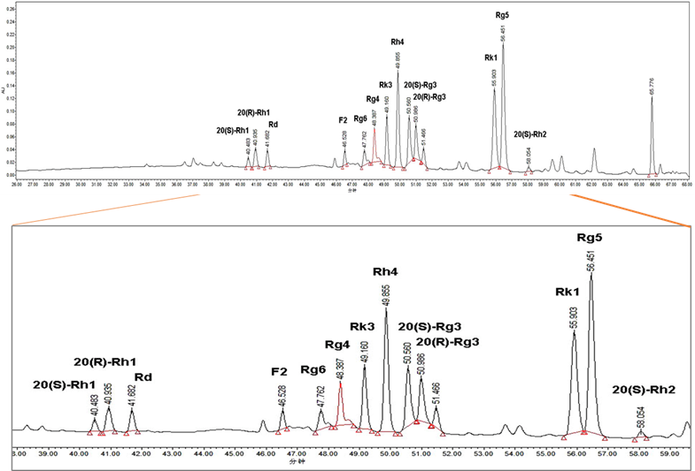
Supplementary Fig. S1 High performance liquid chromatography (HPLC) of the ginsenoside content in LGP.
Supplementary Fig. S2 Molecules structure of the main ginsenosides contained in LGP.
Supplementary Fig. S3 DAI score.
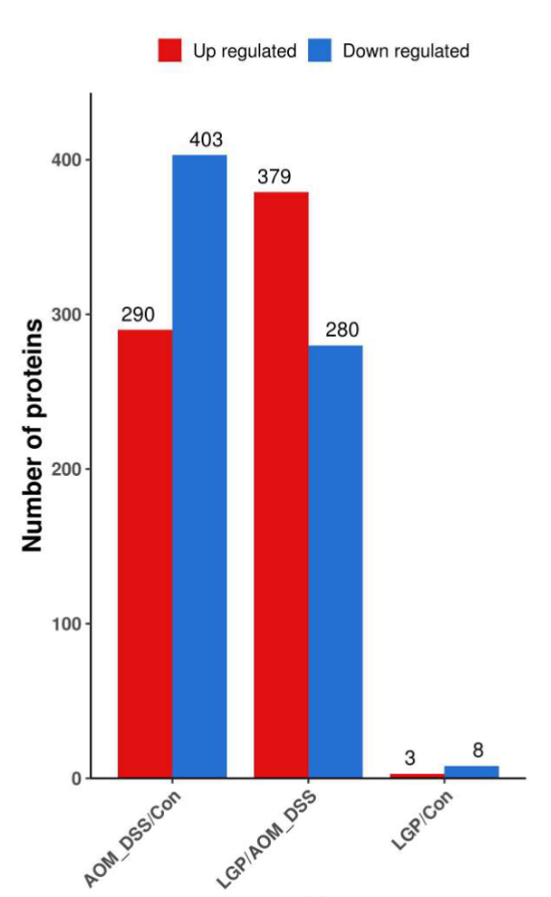
Supplementary Fig. S4 The number of differentially expressed proteins.

.
Supplementary Fig. S5 Changes of microbial community structure after LGP administration in CAC mice. The community bar chart at the phylum level.
Supplementary Fig. S6 Changes of microbial community structure and metabolism after LGP administration in CAC mice. (A) Hierarchical clustering tree in OUT level. (B) PCA, PCoA of 16S rRNA gene sequences. (C) NPLS-DA and OPLS-DA score plots based on the metabolite proﬁling in the negative (right) and positive (left) ion modes of the AOM/DSS and LGP groups.(D)Heat map and metabolic pathway network diagram for visualizing changes in the relative abundance of potential biomarkers (AOM/DSS-Low). (E) Correlation analysis of gut microbiota and metabolites
Supplementary Fig. S7 Specific immune-related pathways were regulated by LGP.
Supplementary Fig. S8 Enrichment and polarization of tumor-associated macrophages (TAMs) in colon tissues of CAC mice after LGP treatment

Supplementary Fig. S9 Changes in the epithelial-mesenchymal transition (EMT) from Proteomics analysis.
Supplementary Table
Supplementary Table S1.DAI Scoring Rules
Score | Percentage weight loss | Stool viscosity | Fecal occult blood
0 | 0 | normal | Bloodless
1 | 1-5% | Soft stools | With crimson blood clots
2 | 5-10% | Mucous stools | With bright red blood clots
3 | 10-20% | Loose liquid stools | Pull blood directly
4 | ≥20%

Supplementary Table S2. Primer sequences used for RT-PCR
Target gene | Primer Sequences
TNF-α | Forward 5’-GGTGCCTATGTCTCAGCCTCTT-3’  Reverse 5’-GCCATAGAACTGATGAGAGGGAG-3’
IL-6 | Forward 5’-TTCTGCCAGTGCCTCTTTGCTG-3’  Reverse 5’-TACCACTTCACAAGTCGGAGGC-3’
IL-1β | Forward 5’-TGGACCTTCCAGGATGAGGACA-3’  Reverse 5’-GTTCATCTCGGAGCCTGTAGTG-3’
GAPDH | Forward 5’-ACTCACGGCAAATTCAACGGCA-3’  Reverse 5’-GACTCCACGACATACTCAGCAC-3’

Supplementary Table S3. The 49 potential targets of LGP for the treatment of CAC
Uniprot ID | Full Name | Symbol
P01375 | Tumor necrosis factor | TNF
P05231 | Interleukin-6 | IL6
P40763 | Signal transducer and activator of transcription 3 | STAT3
P42574 | Caspase-3 | CASP3
P15692 | Vascular endothelial growth factor A | VEGFA
P00533 | Epidermal growth factor receptor | EGFR
P05627 | Transcription factor Jun | JUN
P24385 | G1/S-specific cyclin-D1 | CCND1
P01584 | Interleukin-1 beta | IL1B
P37231 | Peroxisome proliferator-activated receptor gamma | PPARG
P35354 | Prostaglandin G/H synthase 2 | PTGS2
P14780 | Matrix metalloproteinase-9 | MMP9
P42345 | Serine/threonine-protein kinase mTOR | MTOR
Q07817 | Bcl-2-like protein 1 | BCL2L1
P60568 | Interleukin-2 | IL2
O60674 | Janus Kinase 2 | JAK2
P09038 | Fibroblast growth factor 2 | FGF2
P19838 | Nuclear factor NF-kappa-B p105 subunit | NFKB1
P08253 | Matrix Metalloproteinase-2 | MMP2
P11802 | Cyclin Dependent Kinase 4 | CDK4
Q13547 | Histone Deacetylase 1 | HDAC1
P29466 | Caspase-1 | CASP1
P35968 | Kinase Insert Domain Receptor | KDR
P45983 | Mitogen-Activated Protein Kinase 8 | MAPK8
P24941 | Cyclin-dependent kinase 2 | CDK2
Q9NZQ7 | Programmed Cell Death 1 Ligand 1 | CD274
P17931 | Galectin 3 | LGALS3
P35228 | Nitric oxide synthase, inducible | NOS2
Q00653 | Nuclear factor NF-kappa-B p100 subunit | NFKB2
P30530 | AXL Receptor Tyrosine Kinase | AXL
Q9NR96 | Toll Like Receptor 9 | TLR9
Q92769 | Histone Deacetylase 2 | HDAC2
P45452 | Matrix Metallopeptidase 13 | MMP13
P07858 | Cathepsin B | CTSB
P11473 | Vitamin D3 receptor | VDR
P11387 | DNA Topoisomerase I | TOP1
P16455 | O-6-Methylguanine-DNA Methyltransferase | MGMT
O15379 | Histone Deacetylase 3 | HDAC3
P35408 | Prostaglandin E Receptor 4 | PTGER4
P53350 | Polo Like Kinase 1 | PLK1
P30291 | WEE1 G2 Checkpoint Kinase | WEE1
P17706 | Protein Tyrosine Phosphatase Non-Receptor Type 2 | PTPN2
Q96RI1 | Nuclear Receptor Subfamily 1 Group H Member 4 | NR1H4
P19784 | Casein Kinase 2 Alpha 2 | CSNK2A2
P16050 | Arachidonate 15-Lipoxygenase | ALOX15
Q16875 | 6-Phosphofructo-2-Kinase/Fructose-2,6-Biphosphatase 3 | PFKFB3
P09382 | Galectin 1 | LGALS1
P05023 | ATPase Na+/K+ Transporting Subunit Alpha 1 | ATP1A1
Q9HBH9 | MAPK Interacting Serine/Threonine Kinase 2 | MKNK2

Supplementary methods
Experimental reagents
Antibodies that recognized the
P50(proteintech,14220-1-AP), P-P50(santa,sc-271908),
IκBα(proteintech,10268-1-AP),P-IκBα(proteintech,82349-1-RR), STAT3(proteintech,10253-2-AP),P-STAT3(santa,sc-8059),
β-actin(proteintech,20536-1-AP), iNOS(proteintech,18985-1-AP),
COX-2(proteintech,27308-1-AP),PARP(proteintech,13371-1-AP),
cleaved Caspase 3(proteintech,82707-13-RR),Bcl-2(CST,2970S),
Bcl-XL(proteintech,10783-1-AP),Bax(proteintech,50599-2-Ig), GZMB(proteintech, 83763-5-RR),Ki-67(proteintech, 27309-1-AP),
Caspase9(proteintech, 10380-1-AP),XIAP(proteintech,10037-1-Ig),
cIAP-2(proteintech,24304-1-AP),cIAP-1(proteintech,10022-1-AP )
FITC-CD3(Biolegend,Cat#100204),PE/Cy7-CD4(Biolegend,Cat#116016),
PE-CD69(Biolegend,Cat#104508),APC-CD8(Biolegend,Cat#140410),
PE/Cy7-CD45(Biolegend,Cat#103114),APC-CD49b(Biolegend,Cat#103516),
PE-CD45(Biolegend,Cat#157604),FITC-F4/80(Biolegend,Cat#123108),
APC-CD206(Biolegend,Cat#141708),PE/Cy7-CD86(Biolegend,Cat#105014)

Screening of potential therapeutic targets of LGP against colitis-associated cancer
The PubChem database (https://pubchem.ncbi.nlm.nih.gov/) was searched to obtain the two-dimensional structure diagram in SDF format and canonical smiles of the main ginsenosides contained in LGP (Supplementary Fig. S2). The main potential targets of ginsenosides were identified by the TargetNet ("http://targetnet.scbdd.com/"), the Swiss Target Prediction ("http://swisstargetprediction.ch/"), the Similarity Ensemble Approach(SEA) ("https://sea.bkslab.org/") and the ("http://www.tcmip.cn/ETCM/index.php/Home/Index/index.html" )
(ETCM) ("http://www.tcmip.cn/ETCM/index.php/Home/Index/") database.
The genes related to colitis-associated cancer were selected from the GeneCards ("https://www.genecards.org/"), the Therapeutic Target Database (TTD, "http://db.idrblab.net/ttd/), DisGeNET (https://www.disgenet.org/search), the Comparative Toxicogenomics Database (CTD, "http://ctdbase.org/search/"), and the Online Mendelian Inheritance in Man (OMIM, https://omim.org/), where the database was searched using “colitis-associated cancer”, “colitis-associated colorectal cancer” as the keywords. The target genes of main ginsenosides contained in LGP and the target information of disease were uploaded to Venny 2.1 ("https://bioinfogp.cnb.csic.es/tools/venny/index.html") to obtain the target information of LGP intersecting with colitis-associated cancer.
Sample collection
Mice were euthanized, and the colon, heart, liver, kidney and spleen were removed intact and observed and weighed separately. The tissues were quickly divided into two parts by handling on ice, one part was stored at -80 °C for immunoblotting assay, and the other part was immersed in pre-cooled 4% paraformaldehyde solution over 10 times the volume of the tissues for HE staining and immunohistochemical assay.
Quantitative Real-Time Polymerase Chain Reaction (qRT-PCR)
The frozen and preserved colon tissue samples were weighed at about 30 mg, l mL of TRIzol was added and the samples were homogenized by grinding using a handheld grinder (10 s, repeated 3 times). The homogenized liquid was centrifuged at 12,000 rpm for 20 min at 4 °C, the supernatant was collected. Chloroform (1/5 volume of TRIzol) is added to the homogenate lysate and mixed until the solution is emulsified and milky white. After centrifugation (12,000 rpm, 4 °C, 15 min) the homogenate was divided into three layers, the colorless supernatant contains the RNA. The colorless supernatant was aspirated and 0.5-1 times the volume of isopropanol was added, and the centrifuge tube was inverted up and down to mix thoroughly and then left to stand for 10 min at room temperature. The supernatant was discarded after centrifugation (12,000 rpm, 4 °C, 10 min), equal amount of RNAisoPlus 75% ethanol was added. The wall of the centrifuge tube was gently washed upside down, and centrifuged (7,500 rpm, 4 °C, 5 min). RNA precipitation was dried for 10-20 min, RNase-free water was added to dissolve the precipitate and the purity and concentration of RNA were determined.
5 µg total RNA has proceeded for cDNA synthesis with High-Capacity cDNA Reverse Transcription Kit. Quantitative real-time experiments were conducted according to the instructions of the 7500 Real-time PCR system to determine the mRNA expression. The primer sequences are shown in Supplementary Table S1.
Nitrite assay
The colon tissue samples were homogenized with pre-prepared IP lysate (the use of RIPA lysate may produce precipitation in the subsequent reactions and affect the test). The homogenized liquid was centrifuged at 12,000 rpm, 4 °C for 20 min and the supernatant was collected. Nitrite levels in the supernatants were measured using the Griess assay. Subsequently, 50 μL of the supernatants were mixed with 50 μL reagents of Griess A and Griess B, followed by incubation for 10 min at room temperature (light protected). A wavelength of 540 nm was selected to detect the absorbance values using a microplate reader, and nitrite levels were measured by a standard curve prepared from sodium nitrite.
Immunohistochemistry
Colon tissue sections were deparaffinized in xylene for 15 min each, then immersed in gradient ethanol (100, 95, 90, 80, 70% ethanol) and distilled water for 5 min each. The antigen repair solution citrate buffer was added, heated in the microwave oven for 20 min, then cooled naturally to room temperature, and the sections were removed, rinsed with distilled water, and then rinsed twice with PBS (0.01M, pH 7.4). An appropriate amount of Solution A (white solution) was added dropwise to block endogenous peroxidase, was incubated at room temperature for 10 min, and then washed with PBS; the Solution B was incubated at room temperature for 10 min, and then dried. An appropriate amount of primary antibody working solution (1:100) was added and incubated at 4°C overnight, then washed with PBS. An appropriate amount of Solution C (biotin-labeled sheep anti-rabbit secondary antibody solution) was incubated at room temperature for 10 min and washed with PBS. HRP-labeled streptavidin (Solution D) was added dropwise and incubated at room temperature for 10 min and washed with PBS. According to the required amount, DAB-A and DAB-B were mixed at a volume ratio of 1:19 and added dropwise onto the tissue sections to be developed, and the color development time was generally 1-5 min, which was controlled by observation under the microscope. After the best color development effect was achieved, the sections were rinsed with tap water to terminate the color development. The sections were re-stained, dehydrated and transparent, sealed with neutral resin, photographed and observed.
Metabolomic analysis
The serum samples stored at -80 °C were thawed at -20 °C for 20 min and then frozen and thawed at 4 °C. To ensure the stability and reproducibility of the assay instrument, 40 μL of each serum sample was first mixed as a quality control (QC) sample. Each serum sample (including QC) was aspirated 40 μL, shaken with 120 μL methanol for 1 min, placed at -20 ℃ for 30 min, and centrifuged at 4000 g×4 ℃ for 20 min. 20 μL of the sample was then diluted with 180 μL of 50 % methanol to produce the assay sample.
Liquid chromatography and Mass spectrum: The LC analysis was performed on a Vanquish UHPLC System (Thermo Fisher Scientific, USA). Chromatography was carried out with an ACQUITY UPLC ® HSS T3 (150×2.1 mm, 1.8 µm) (Waters, Milford, MA, USA). Mass spectrometric detection of metabolites was performed on Orbitrap Exploris 120 (Thermo Fisher Scientific, USA) with ESI ion source. Simultaneous MS1 and MS/MS (Full MS-ddMS2 mode, data-dependent MS/MS) acquisition was used.
Data processing and multi-variate analysis: The raw data were first converted to mzXML format by MSConvert in ProteoWizard software package (v3.0.8789) Metabolite profiling in biomarker discovery, enzyme substrate assignment, drug activity/specificity determination, and basic metabolic research requires new data preprocessing approaches to correlate specific metabolites to their biological origin. Here we introduce an LC/MS-based data analysis approach, XCMS, which incorporates novel nonlinear retention time alignment, matched filtration, peak detection, and peak matching. Without using internal standards, the method dynamically identifies hundreds of endogenous metabolites for use as standards, calculating a nonlinear retention time correction profile for each sample. Following retention time correction, the relative metabolite ion intensities are directly compared to identify changes in specific endogenous metabolites, such as potential biomarkers. The software is demonstrated using data sets from a previously reported enzyme knockout study and a large-scale study of plasma samples. XCMS is freely available under an open-source license at http://metlin.scripps.edu/download/." processing mass spectrometry data for metabolite profiling using nonlinear peak alignment, matching, and identification" and processed using XCMS. "The comprehensive analysis of untargeted metabolomics data acquired using LC-MS is still a major challenge. Different data analysis tools have been developed in recent years such as XCMS (various forms (X) of chromatography mass spectrometry) and multivariate curve resolution alternating least squares (MCR-ALS)-based strategies. In this work, metabolites extracted from rice tissues cultivated in an environmental test chamber were subjected to untargeted full-scan LC-MS analysis, and the obtained data sets were analyzed using XCMS and MCR-ALS. These approaches were compared in the investigation of the effects of copper and cadmium exposure on rice tissue (roots and aerial parts) samples. Both methods give, as a result of their application, the whole set of resolved elution and spectra profiles of the extracted metabolites in control and metal-treated samples, as well as the values of their corresponding chromatographic peak areas. The effects caused by the two considered metals on rice samples were assessed by further chemometric analysis and statistical evaluation of these peak area values. Results showed that there was a statistically significant interaction between the considered factors (type of metal of treatment and tissue). Also, the discrimination of the samples according to both factors was possible. A tentative identification of the most discriminant metabolites (biomarkers) was assessed. It is finally concluded that both XCMS- and MCR-ALS-based strategies provided similar results in all the considered cases despite the completely different approaches used by these two methods in the chromatographic peak resolution and detection strategies. for feature detection, retention time correction and alignment. The metabolites were identified by accuracy mass (< 30 ppm) and MS/MS data which were matched with HMDB, massbank, LipidMaps, mzclound and KEGG.
Statistical analysis
The experimental data were obtained from independent triple-replicated experiments and were expressed as mean ± standard deviation (mean ± SD). GraphPad Prism 8 software was used for statistical analyses, and comparisons between groups were made using Student's t-test statistical analysis method, with P<0.5 indicating statistically significant differences between groups.

