SUPPLEMENTARY DATA
Comparative Transcriptomic Analysis of Oral Squamous Cell Carcinoma in Patients from Gujarat and Telangana States, India
Niyati Bisht¹, Srinivas Bandaru³, Anuraj Nayarisseri^{1,2*}
1. In silico Research Laboratory, Eminent Biosciences,91-A, Sector-A, Mahalakshmi Nagar, Indore-452010, Madhya Pradesh, India
2. Bioinformatics Research Laboratory, LeGene Biosciences Pvt Ltd, 91-A, Sector-A, Mahalakshmi Nagar, Indore-452010, Madhya Pradesh, India
3 Department of Biotechnology, Koneru Lakshmiah Educational Foundation (KLEF), 11 Green Fields, Vaddeswaram, Andhra Pradesh 522302.
*Author for communication email: anuraj@eminentbio.com

- Details of SEQUENCE ARCHIVE RUN (Project ID: PRJNA853478, by Gujarat Biotechnology Research Centre, Gujrat, India)

Table S1. Details about Sequence Archive Run (SRR) according to the accession numbers with sequencing data.
Run | Age | Average  spot length | Bases-giga  basepairs | Isolate | Tissue | Date  Published | Access  type | Population Phenotype
SRR19894447 | 45 | 269 | 1.55Gbp | ZTX45_2020 | Normal | 2022-06-29 | Public | Normal
SRR19894448 | 45 | 281 | 1.19Gbp | ZNT45_2020 | Normal | 2022-06-29 | Public | Normal
SRR19894449 | 39 | 280 | 1.77Gbp | ZTX43_2020 | Tumor | 2022-06-29 | Public | Tumor
SRR19894450 | 39 | 284 | 1.45Gbp | ZNT43_2020 | Normal | 2022-06-29 | Public | Normal
SRR19894451 | 48 | 283 | 1.25Gbp | ZTX58_2021 | Tumor | 2022-06-29 | Public | Tumor
SRR19894452 | 48 | 279 | 1.72Gbp | ZNT58_2021 | Normal | 2022-06-29 | Public | Normal
SRR19894453 | 37 | 285 | 1.73Gbp | ZTX40_2020 | Tumor | 2022-06-29 | Public | Tumor
SRR19894454 | 37 | 280 | 1.93Gbp | ZNT40_2020 | Normal | 2022-06-29 | Public | Normal

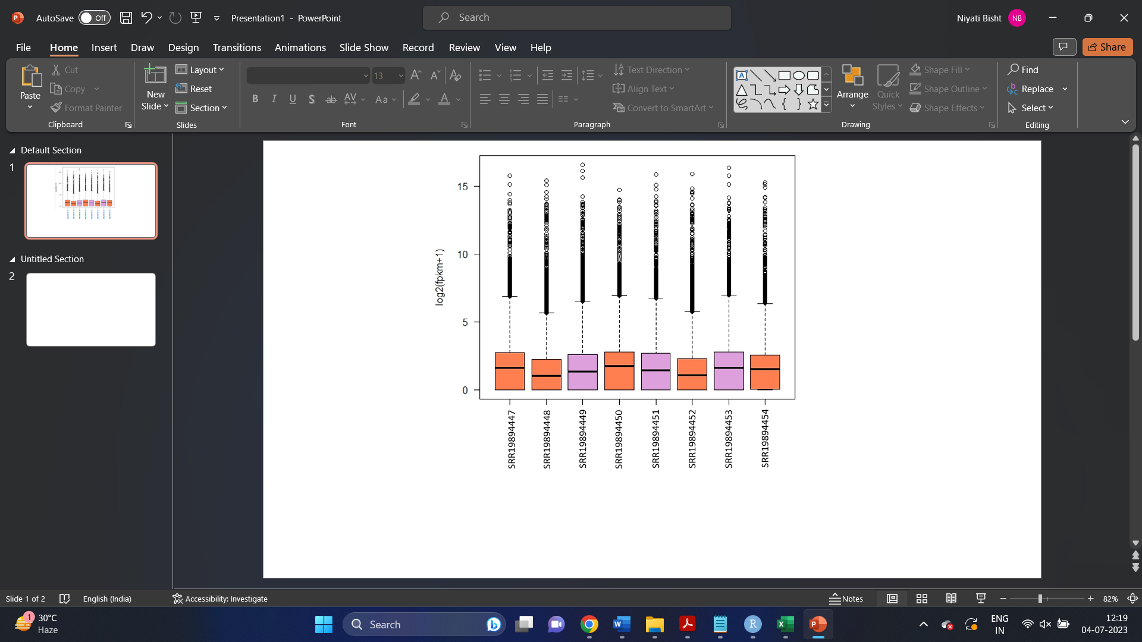
Figure S1. Total reads represented as a function of FPKM values across all the samples. The black line in each box represents the median value for FPKM values in each sample.
- Quality control of the FastQ files

For quality check, the FastQC format provided a rapid assessment of the read quality, encompassing various features such as sequence quality, N content, GC content, adapter contamination, duplication levels, and statistical information. An overview of the FastQC results is shown in Table S2 and figure S2.
Table S2. Overview of the FastQC results. The table summarizes the total sequences, per base sequence quality, sequence GC content, and per base N-content (The highlighted ones are the tumour samples)

Run | Basic statistics  (Total sequence) | Per-base-sequence quality | Sequence-GC content (%) | Per-base-N content
SRR19894447 | 5743048 | 28-40 | 55 | Nil
SRR19894448 | 4213119 | 28-40 | 54 | Nil
SRR19894449 | 6318879 | 30-40 | 54 | Nil
SRR19894450 | 511476 5 | 30-40 | 52 | Nil
SRR19894451 | 4389821 | 32-40 | 53-54 | Nil
SRR19894452 | 6161269 | 32-40 | 54 | Nil
SRR19894453 | 6064421 | 32-40 | 54-55 | Nil
SRR19894454 | 6876009 | 32-40 | 53-54 | Nil

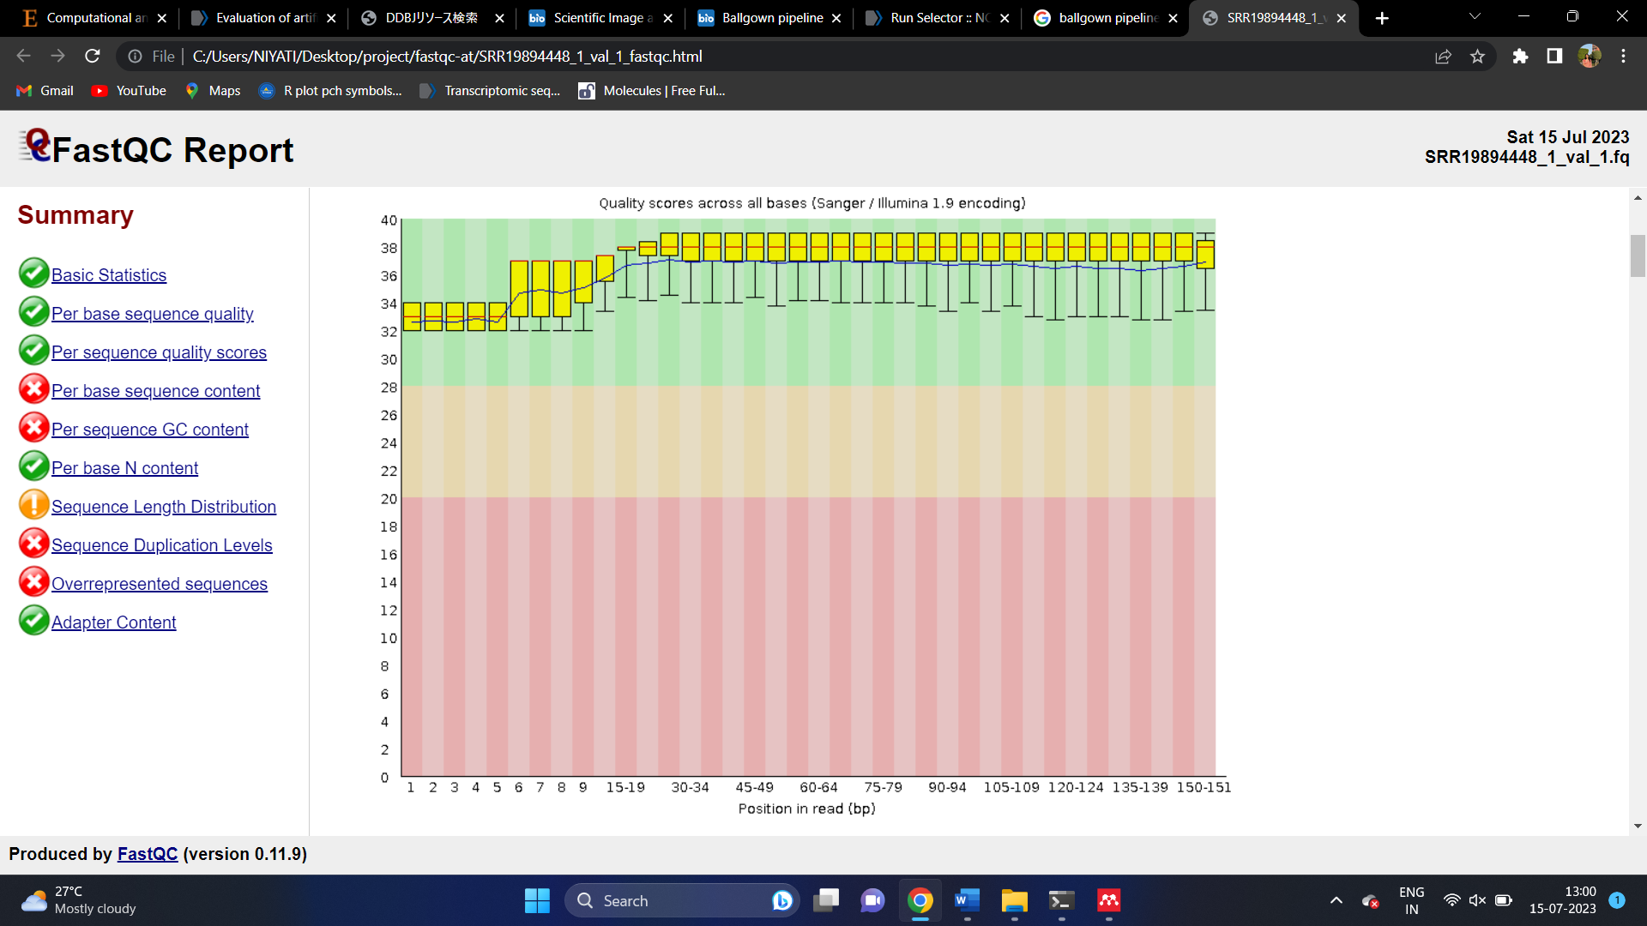
Figure S2. Post-trimming FastQC report. The trimming of the read was performed by TrimGalore wrappers and the quality check can be done post-trimming. All the reads have a quality score of more than 30 and the reads less than 30 were trimmed.

