Theoretical and Applied Climatology

Potential Biophysical Processes Associated with Increasing Lightning Strikes in the Arctic Region

Minjoo Kim^{1,2} and Eungul Lee^{1,2}
¹Department of Geography, Kyung Hee University, Seoul, Republic of Korea
²Department of Climate-Social Science Convergence, Kyung Hee University, Seoul, Republic of Korea

Corresponding author: Eungul Lee (eungul.lee@khu.ac.kr)

■ Contents of this file
- Figures S1 to S5

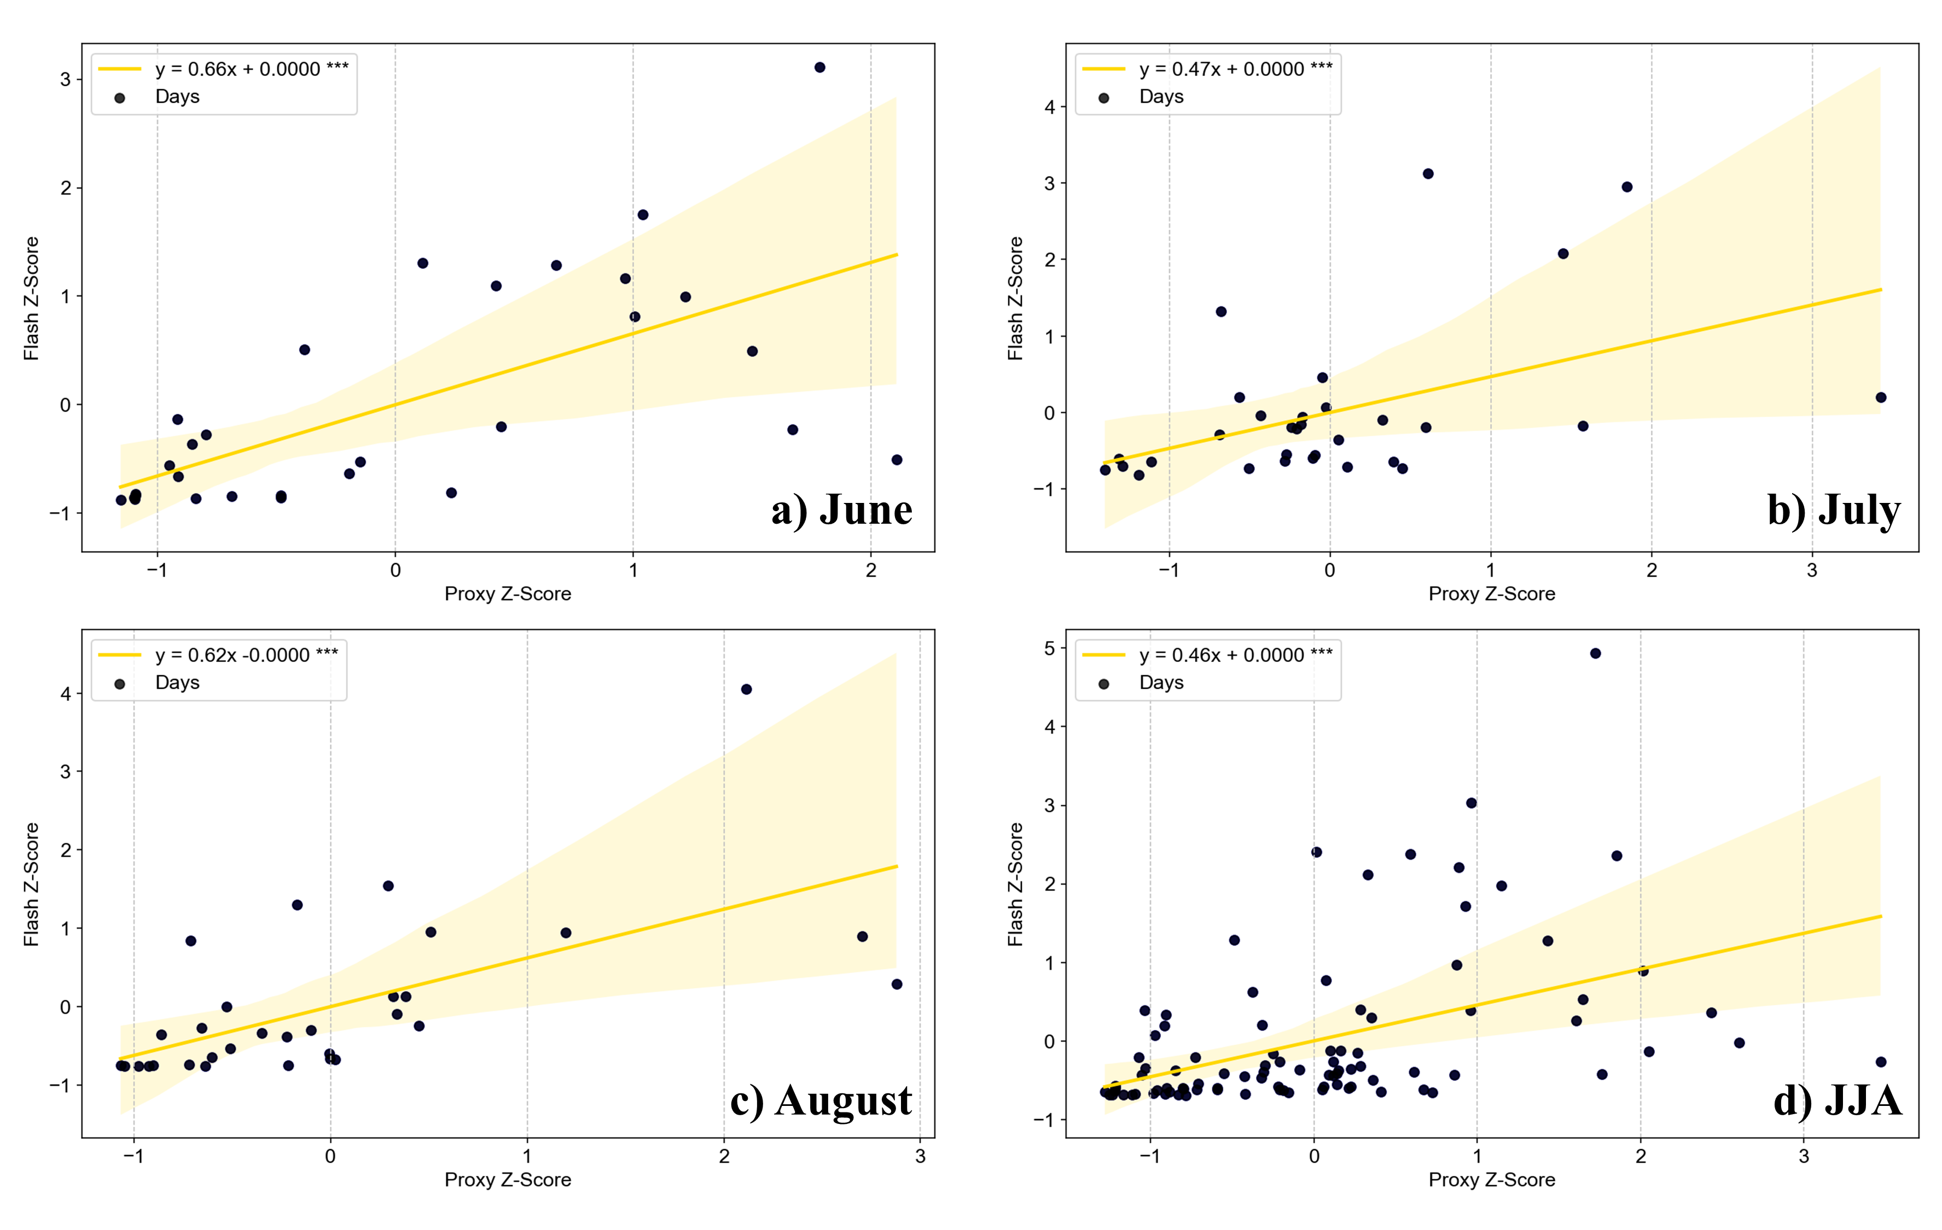
Fig. S1 Scatter plot of lightning proxy and flash count data using Z-scores for (a) June, (b) July, (c) August, and (d) JJA with regression line (yellow line) and 95% confidence interval (yellow shaded area). *** indicates significant coefficients at the 1% level

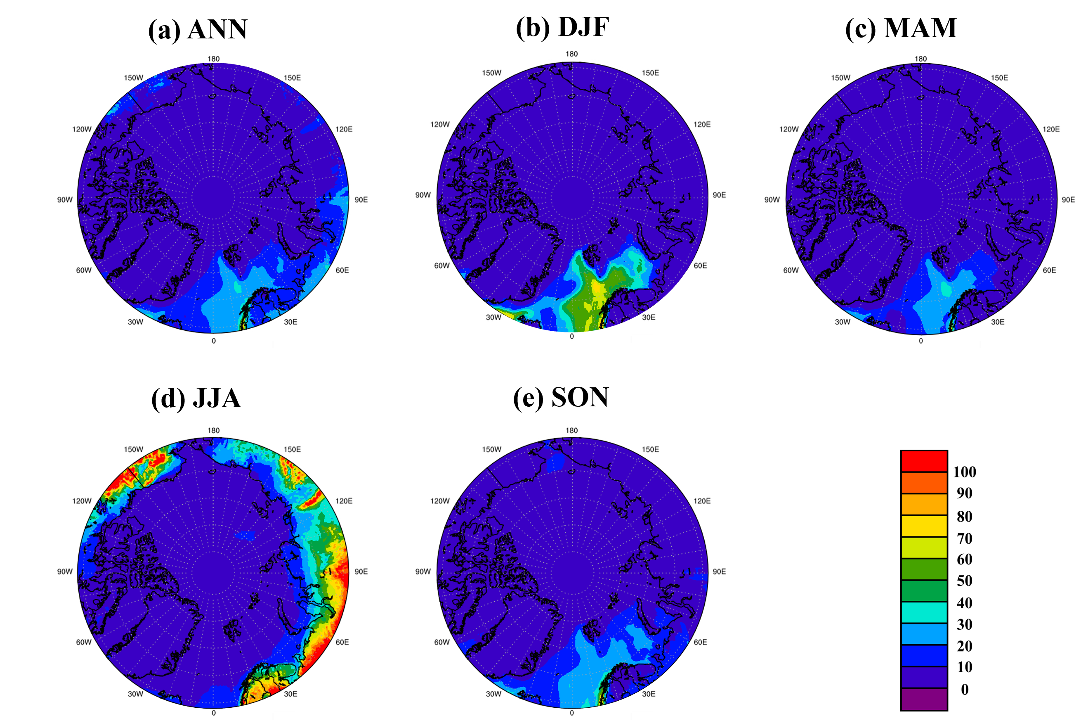
Fig. S2 Mean lightning proxy (W/m²) of (a) annual, (b) DJF, (c) MAM, (d) JJA, and (e) SON from 1982 to 2022

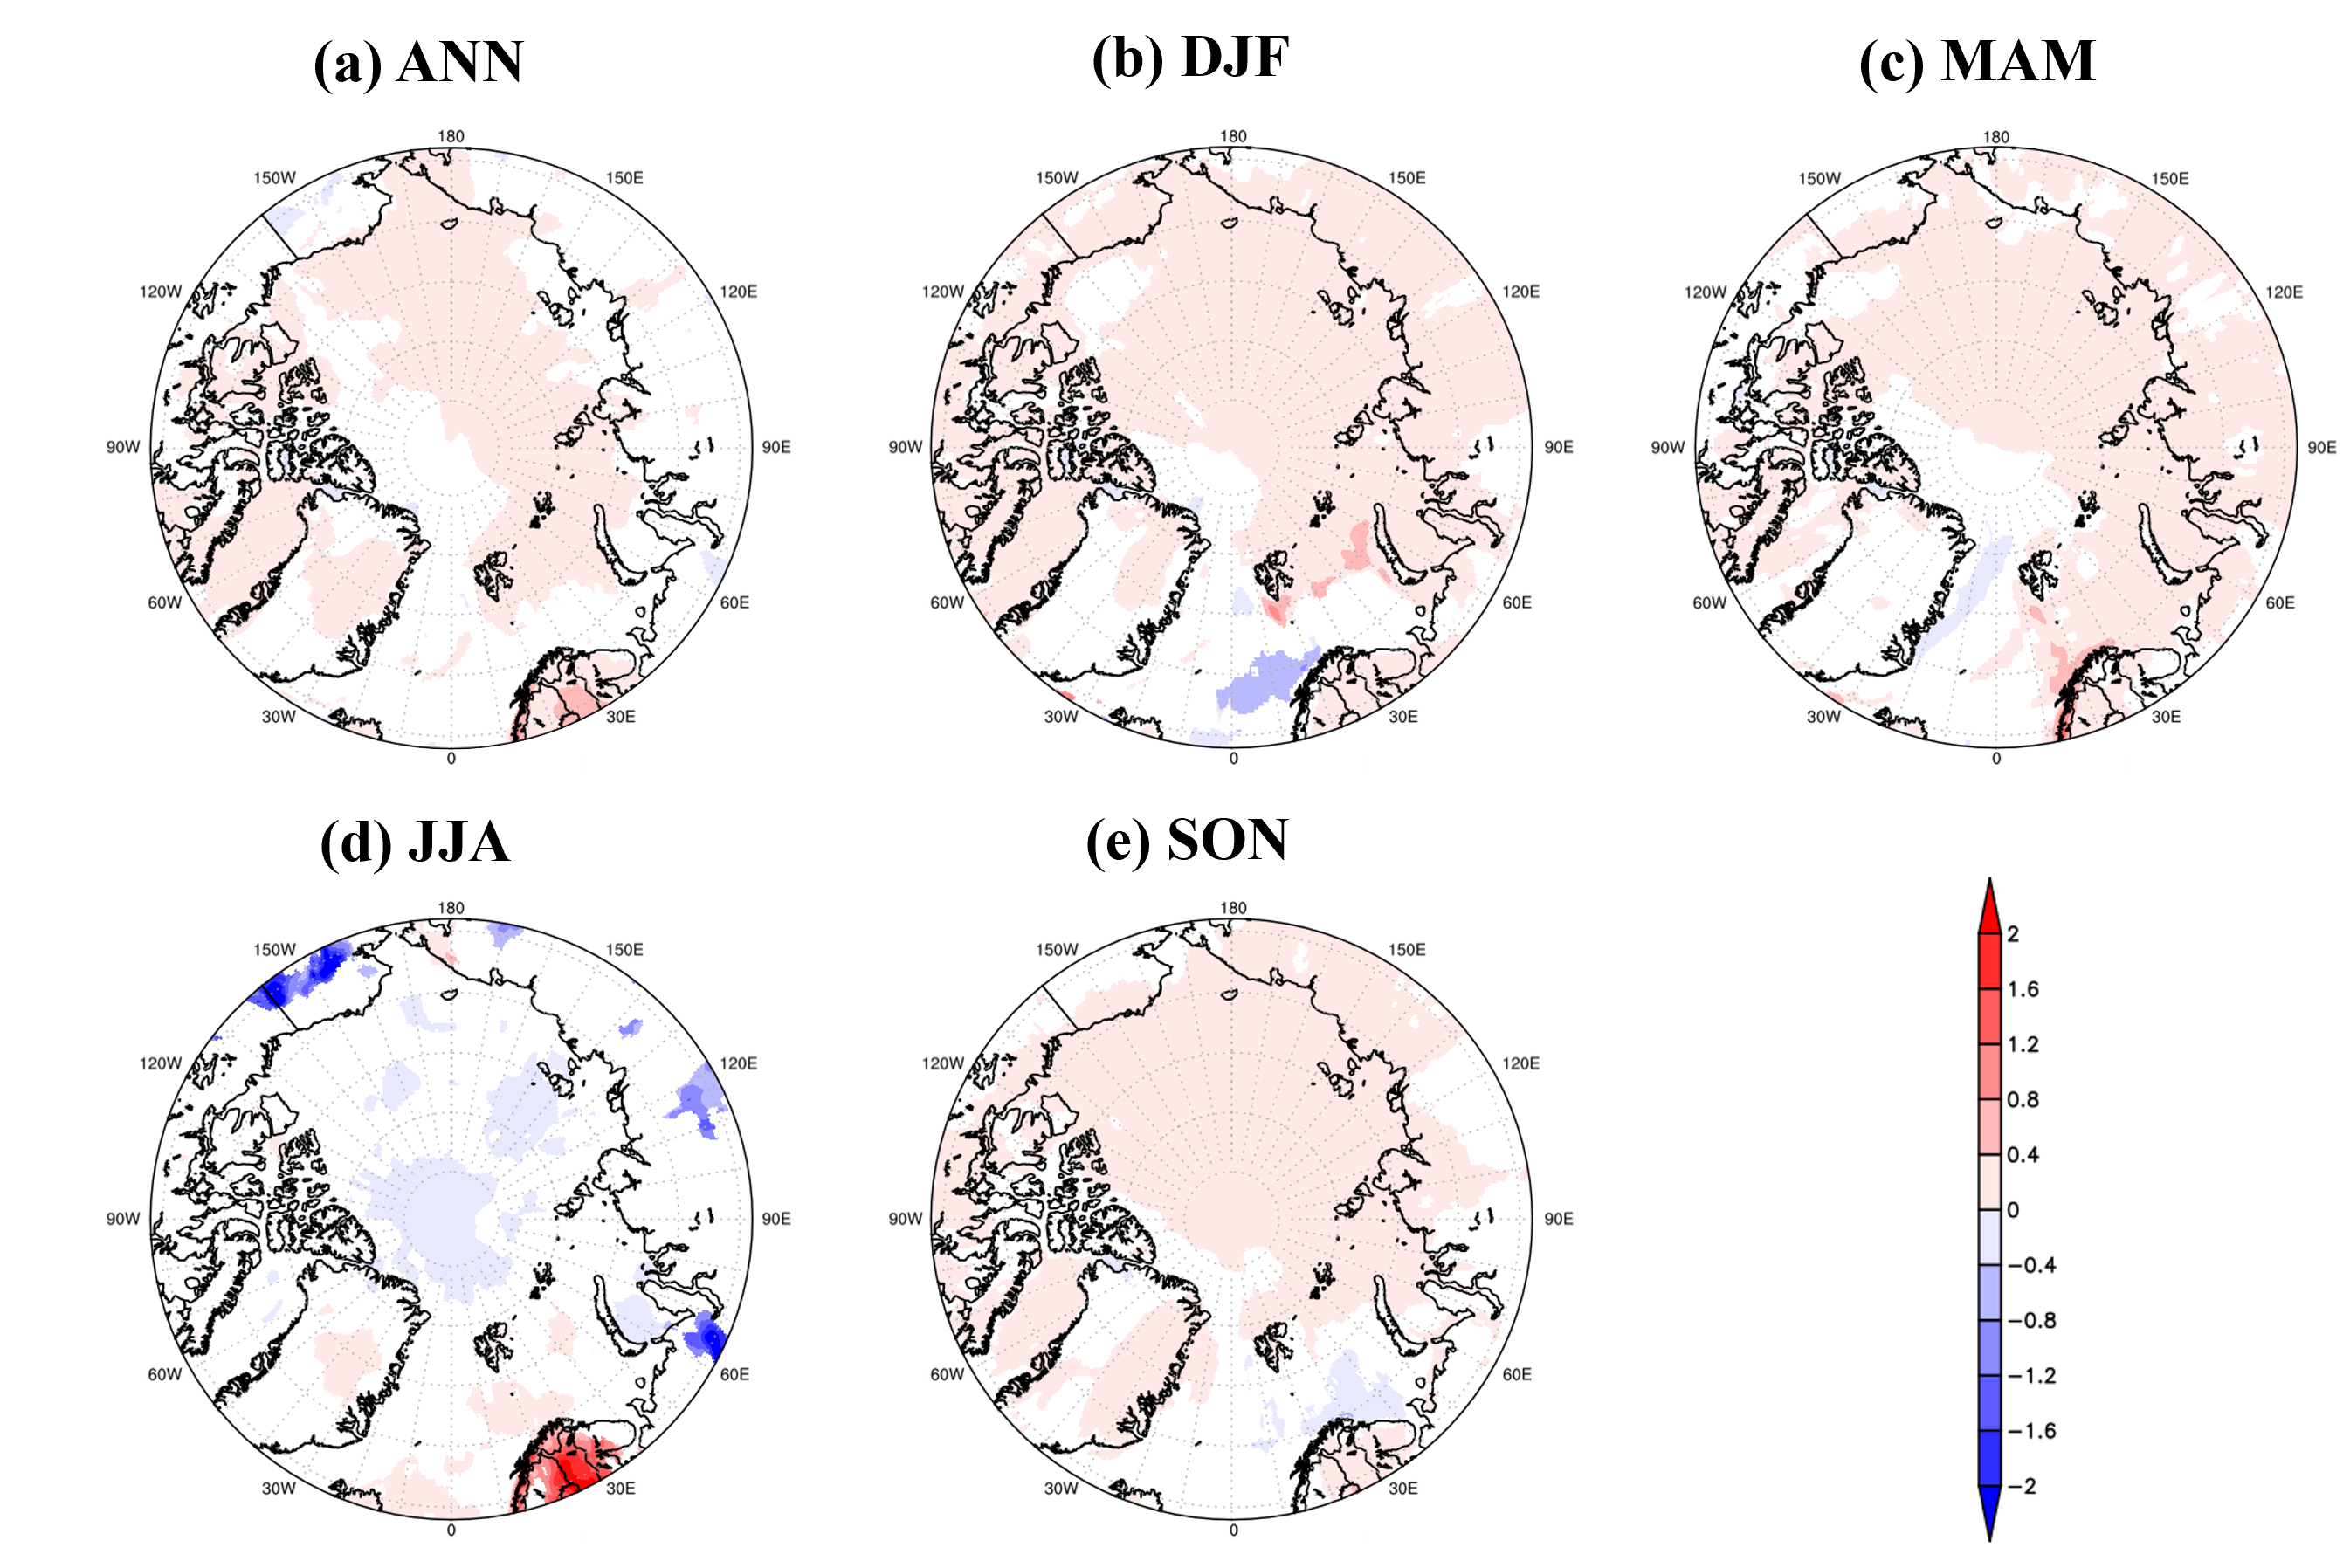
Fig. S3 Linear regression trend (per year) of lightning proxy (W/m²) in (a) annual, (b) DJF, (c) MAM, (d) JJA, and (e) SON from 1982 to 2022. Statistically significant areas are shaded at the 10% level

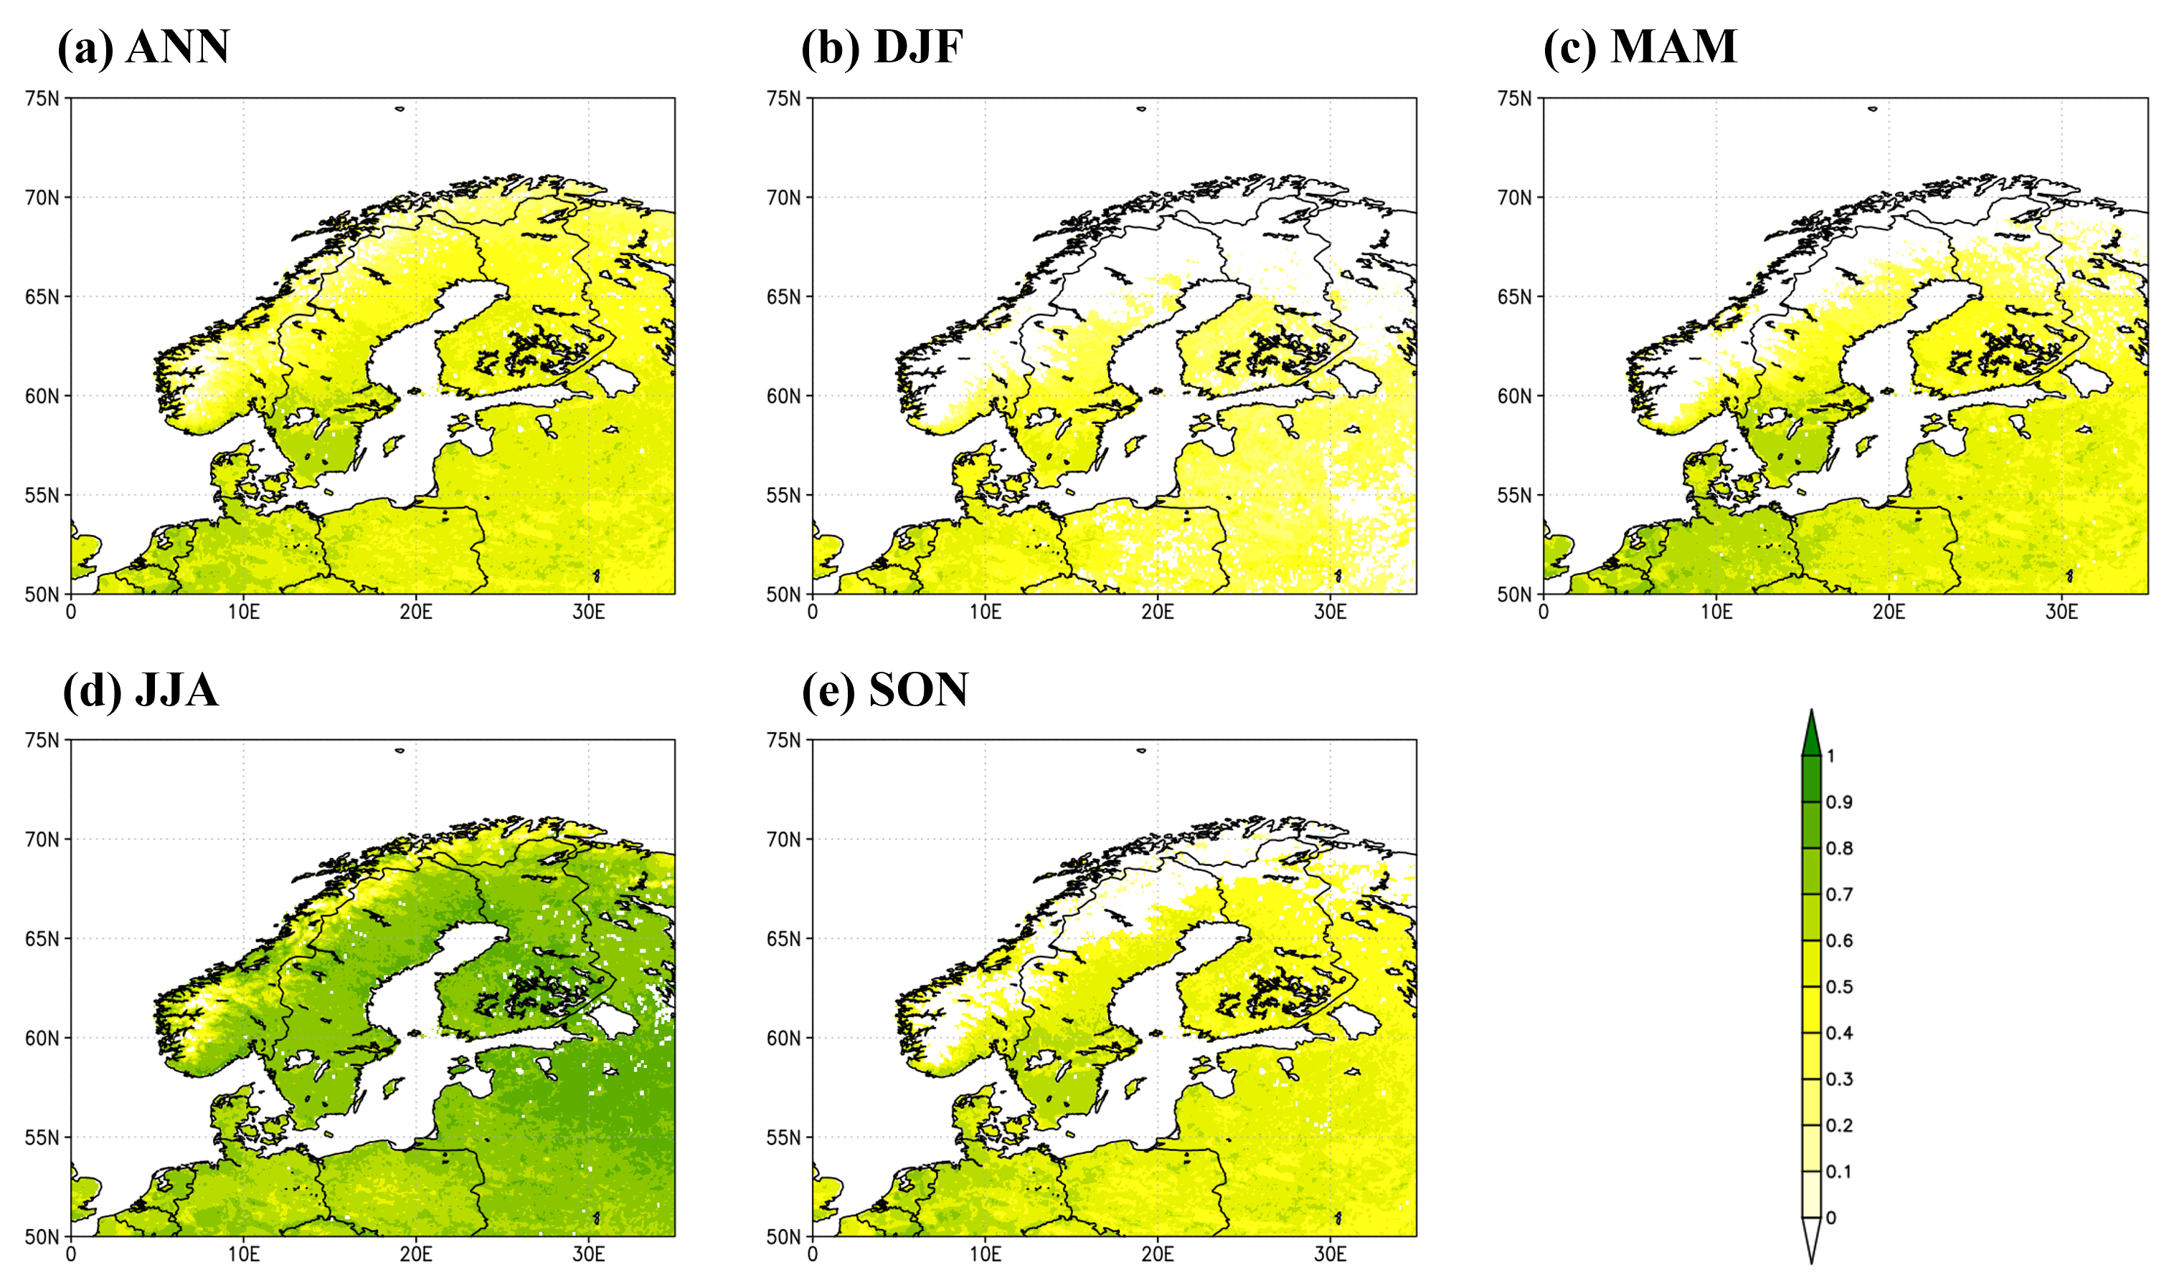
Fig. S4 Mean NDVI of (a) annual, (b) DJF, (c) MAM, (d) JJA, and (e) SON from 1982 to 2022

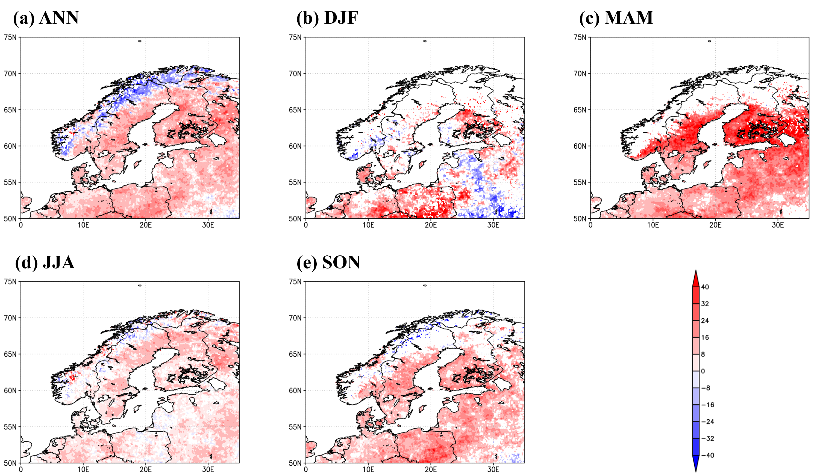
Fig. S5 Percent of NDVI change to the mean NDVI for (a) annual, (b) DJF, (c) MAM, (d) JJA, and (e) SON during 1982-2022. Statistically significant areas are shaded at the 10% level

