SUPPLEMENTARY FIGURE LEGENDS
Supplementary Figure S1. IHC analysis of ENDOU expression in different oral epithelial tissues with non-squamous differentiation
A) Normal salivary gland. B) Normal parotid gland. C) Normal submaxillary gland. D) Adamantinoma with prominent keratinized squamous patches showing moderately positive ENDOU staining. E) Adamantinoma with prominent fibrous stroma. F) Basal cell carcinoma. G) Adenoid cystic carcinoma. H) Mucoepidermoid carcinoma. I) Lymph node metastasis with a squamous cell patch showing weak positive ENDOU staining. Red arrows point to the tumor areas demonstrating positive biomarker expression.
Supplementary Figure S2. IHC analysis of ENDOU expression in precancerous oral lesions
A-C) Chronic inflammatory lesions. D-G) Squamous cell hyperplasia. H-I) Squamous cell hyperplasia with cellular atypia.
Supplementary Figure S3. Diagnostic ROC curves for ENDPU and PDPN staining

Supplementary Figure S4. PDPN is overexpressed in OSCC
A) Normal mucosa. B) OSCC showing patchy PDPN expression pattern. C) OSCC showing peripheral PDPN expression pattern. D) OSCC showing mixed (peripheral and diffused) PDPN expression pattern. E) OSCC showing diffused PDPN expression pattern. F) IHC scores for PDPN protein expression in different T stages of OSCC.

Figure S1
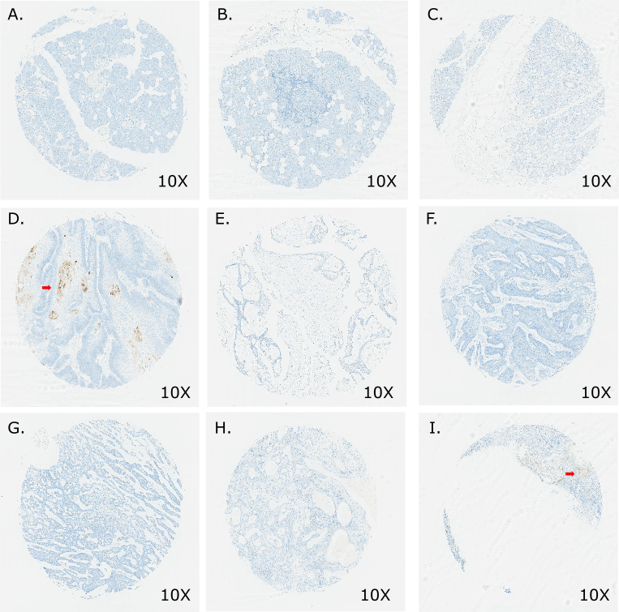

Figure S2.

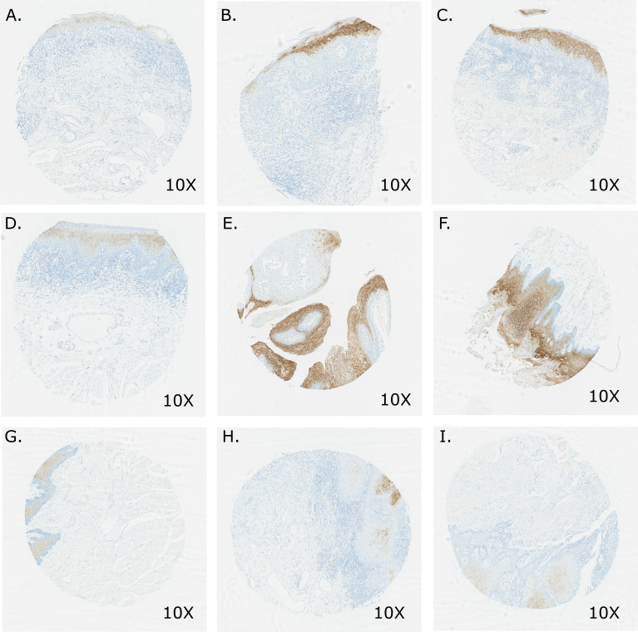

Figure S3.
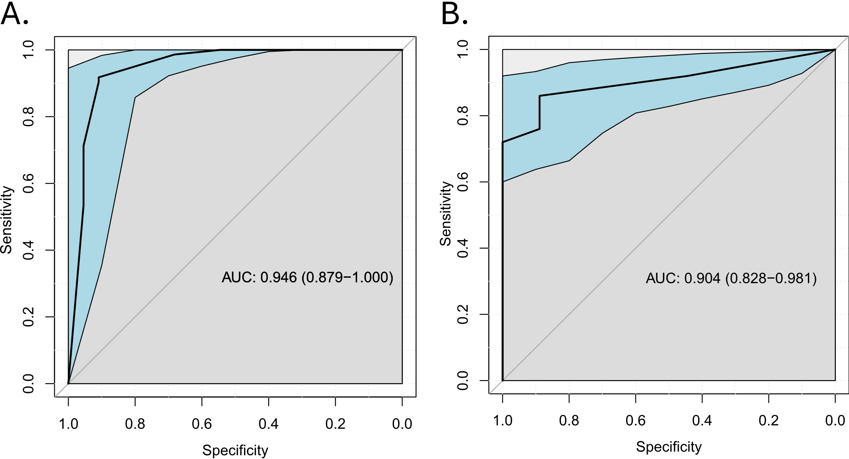

Figure S4.
