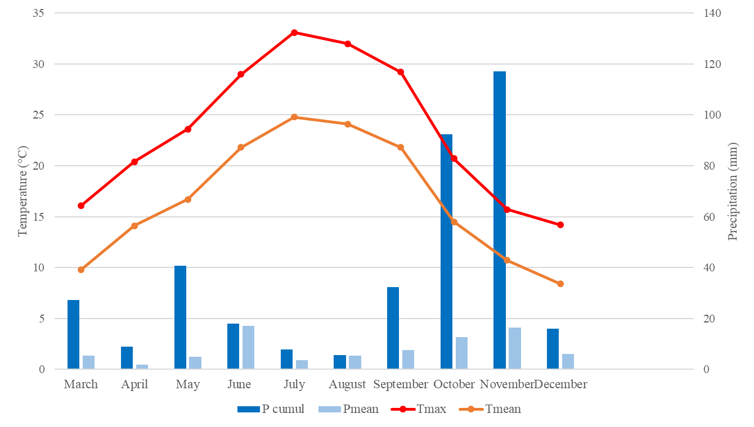
Supplementary Material 3 Weather conditions at the time of the sampling (Pcumul: cumulative precipitation; P mean: mean precipitation; Tmax: maximum temperature; mean: mean temperature)

