Brain-cognition relationships in treatment-resistant late-life depression
Peter Zhukovsky, PhD, Meryl A. Butters, PhD, Helen Lavretsky, MD, Patrick Brown, PhD, Joshua S. Shimony, MD, PhD, Eric J Lenze, MD, Daniel M Blumberger, MD, Alastair J Flint, MD, Jordan Karp, MD, Steven Roose, MD, Erin W Dickie, PhD, Daniel Felsky, PhD, Ginger E Nichol, MD, Yar Al-Dabagh, Nicole Schoer, Feyifolu Obiri, Ashlyn Runk, Kayla Conaty, Benoit H Mulsant, MD, Aristotle N Voineskos#, MD, PhD
#Please address correspondence to Dr Aristotle N Voineskos, Center for Addiction and Mental Health, 250 College Street, Toronto, ON, Canada

Supplementary Information
Overview
- MRI data acquisition
- Participant inclusion flow
- Timing of the neuropsychological and clinical assessments relative to the OPTIMUM clinical trial
- Seed-based FC analysis probing precuneus connectivity
- Sensitivity PLS regression analyses of FC-cognition associations
- Sensitivity analyses of hold-out data by scanner
- Markers predicting treatment outcomes

- MRI data acquisition
MRI data were acquired using harmonized acquisitions for 3T Siemens Prisma (Pitt, UCLA, Wash U.) and 3T GE MR750 (CAMH/Toronto, Columbia) scanners. The acquisition parameters have been optimized for high quality T1-weighted, diffusion MRI (dMRI) and rs-fMRI data aiming to ensure that key parameters including voxel size, number of diffusion-weighted directions, and flip angle are consistent across sites. We also include multi-band acquisitions for echo planar imaging (BOLD and dMRI). These parameters have previously undergone reliability testing and rigorous quality assessments (QA) through the ABCD study. We implemented standard QA protocols at each site. In addition to sequences listed in the Supplementary Table 1, two-minute field maps with reverse phase encoding directions were collected for dMRI and fMRI scans to correct for anatomic distortions.
Supplementary Table 1. Overview of the acquisition parameters.
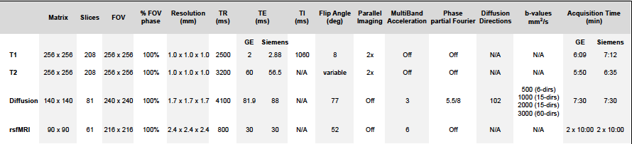

- Participant inclusion flow
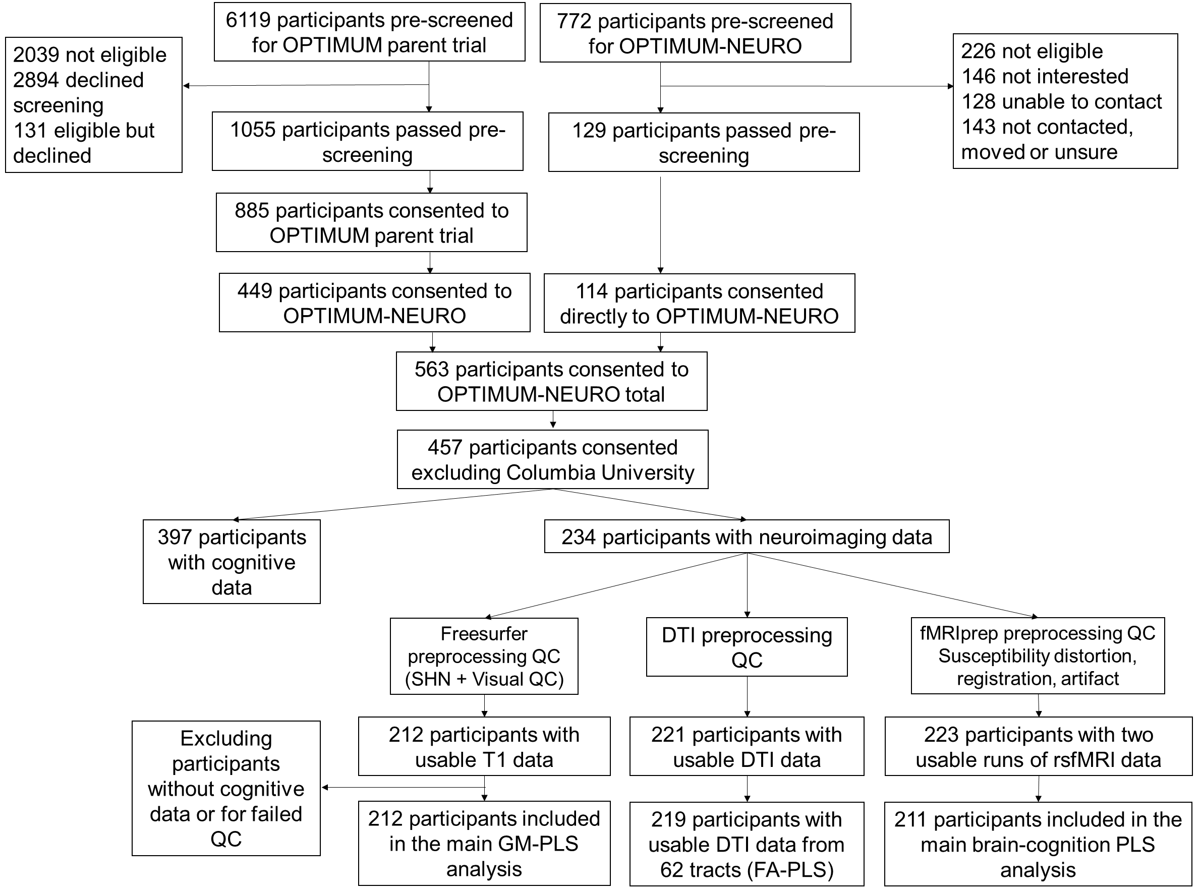
Supplementary Figure 1. Overview of the quality control (QC) and exclusion process for the structural, diffusion, and rs-fMRI analyses. Surface hole number was taken from the aseg file generated by the FreeSurfer pipeline. Visual quality checks were conducted on images with higher numbers of surface holes (>220) across the two hemispheres and images were included or excluded or included based whenever FreeSurfer reconstruction either missed a larger cortical region or if systematic misalignment was found between the observed and the reconstructed gray and white matter boundary.

- Timing of the neuropsychological and clinical assessments relative to the OPTIMUM clinical trial
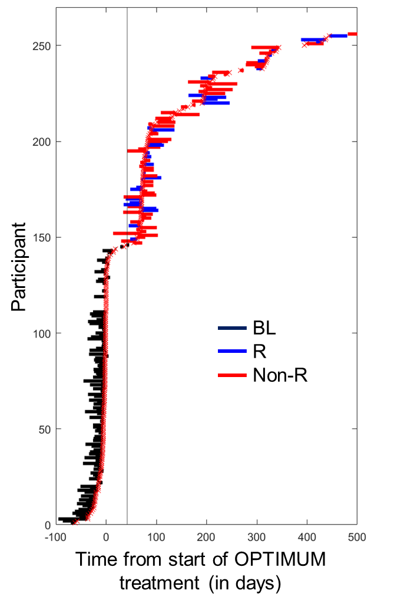
Supplementary Figure 2. Timing of the neuropsychology (NP) assessment relative to the start of treatment and the corresponding MADRS assessment. For each participant, each row shows the timing of the MADRS score (indicated by a red cross) that occurred closest to the ‘baseline’ NP assessment and the corresponding NP assessment itself, connected by a line. Non-remitted participants (non-R) who were part of the OPTIMUM trial for over 6 weeks are shown in red; remitted participants (R) who were part of the OPTIMUM trial for over 6 weeks are shown in blue, while the participants scanned at the start of the OPTUMUM trial (BL) are shown in black. Participant data was sorted according to the delay between the time of the MADRS assessment relative to the start of treatment.

- Seed-based FC analysis probing precuneus connectivity
For seed-based analyses, we correlated the average timeseries of the bilateral precuneus region (consisting the of the following ROIs from the HCP parcellation: L_7m_ROI, L_v23ab_ROI, L_d23ab_ROI, L_31pv_ROI, L_31pd_ROI, R_7m_ROI, R_v23ab_ROI, R_d23ab_ROI, R_31pv_ROI, R_31pd_ROI) with 360 ROIs in the HCP parcellation. To reduce the number of predictor variables, we collapsed across hemispheres, resulting in 180 bilateral connectivity values from the precuneus seed. A 215x180 predictor matrix was entered into a PLS regression, alongside the 215x12 outcome matrix with cognitive data. As in the main analyses, rs-fMRI timeseries were concatenated across two runs and participants with mean FD>0.7 were excluded. The PLS regression with two components explained 6.5% of variance in the cognitive data, significantly more than expected by chance (p=0.046). Bootstrapping identified several regions whose connectivity with the precuneus predicted better cognitive performance, primarily involving memory, verbal fluency and processing speed tests (Figure S3).
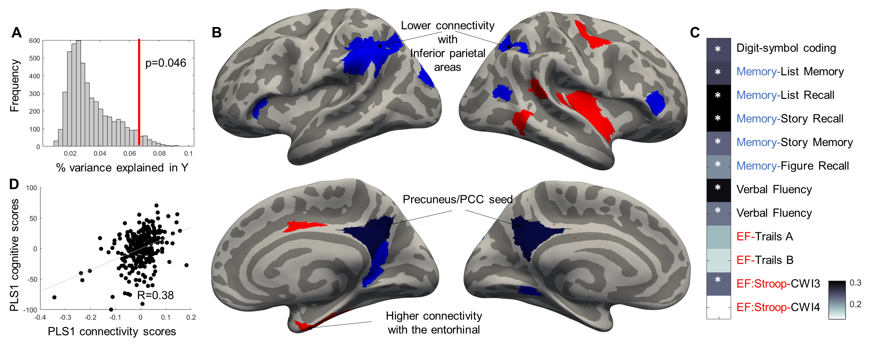
Supplementary Figure 3. Seed-based connectivity of the posterior medial DMN (pmDMN including precuneus and PCC) showed lower connectivity of the pmDMN with the inferior parietal cortex and some inferior frontal areas (part of FPN) and visual areas was associated with better cognition across the board. Higher connectivity of the pmDMN with the entorhinal was also associated with better cognition, especially in the memory domain. PLS weights Z>3 are shown in red and Z<-3 are shown in blue.

- Sensitivity PLS regression analyses of FC-cognition associations
We conducted three sensitivity analyses. Given that two distinct runs of resting-state fMRI data were collected at the start and at the end of the scanning protocol, we repeated the FC-cognition PLS in each run separately. The overall PLS model focusing on run 1 explained significantly more variance in cognitive function than expected by chance (p=0.004), and included many of the connectivities captured by the main model (|Z|>3, Figure S4B). While the overall PLS model focusing on run 2 did not explain more variance than expected by chance (p=0.244), bootstrapping revealed that many of the connectivities captured by the main model were also captured in this PLS model (|Z|>3, Figure S4C).
Further, we conducted another PLS analysis excluding participants with mean FD>0.5. This PLS model did not explain more variance than expected by chance (p=0.06), bootstrapping revealed that many of the connectivities captured by the main model were also captured in this PLS model (|Z|>3, Figure S4D).
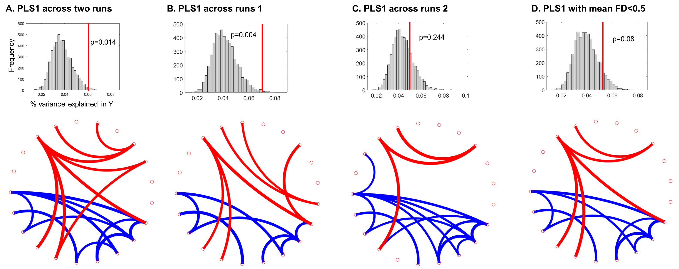
Supplementary Figure 4. Sensitivity analyses showing FC-cognition associations for each of the two runs of rs-fMRI data (B,C) acquired and with a stricter FD threshold of 0.5 (D) alongside the main analysis (A).
- Sensitivity analyses of hold-out data by scanner
In order to test whether differences in scanner types used affect prediction accuracy of the brain-cognition PLS models, we have split our sample according to the scanner type used (GE vs Siemens Prisma) and trained a PLS model on data from one scanner and tested it on data from the other scanner. The resulting prediction performance was notably worse than prediction performance in the held-out data by site, especially for gray and white matter analyses. Correcting for batch effects resulting from the scanner rather than site slightly improved prediction accuracy in held out scanner data for the DTI PLS only.
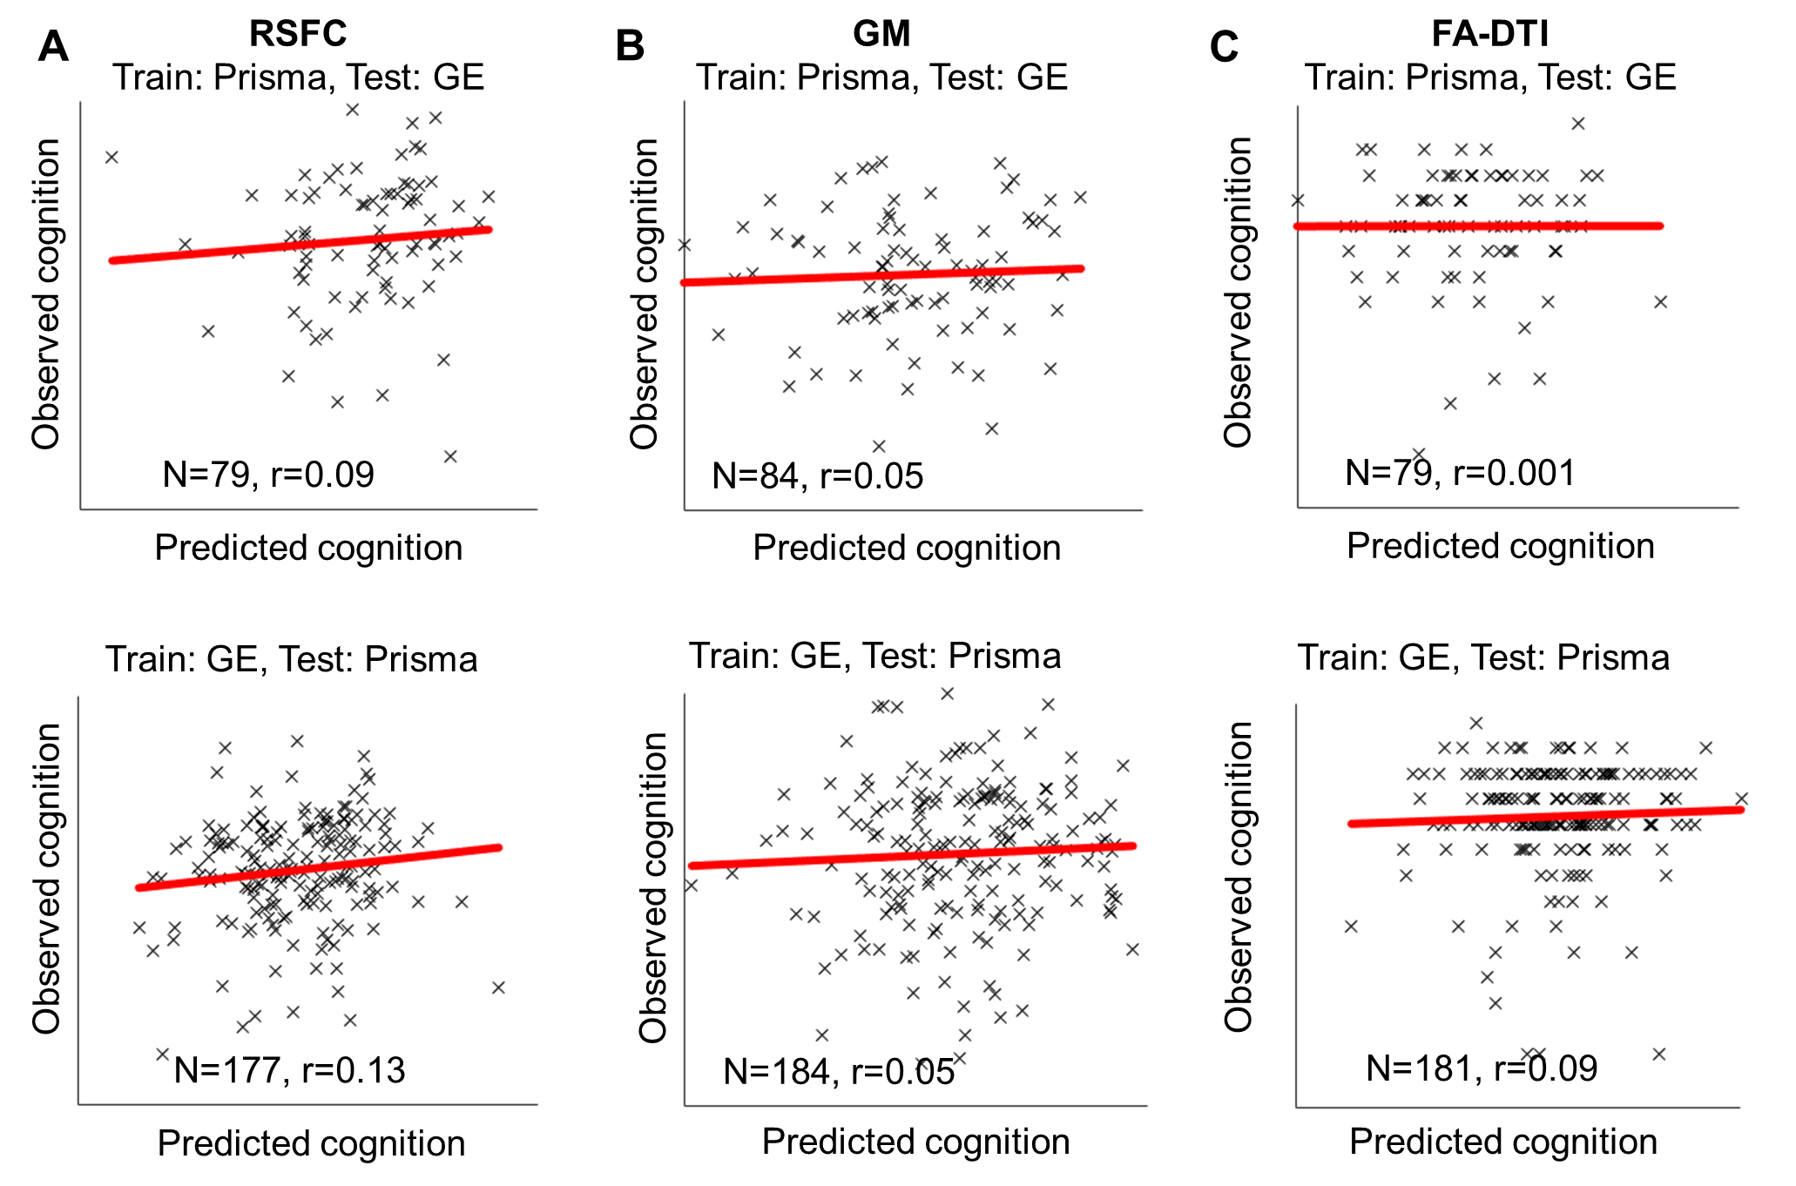
Supplementary Figure 5. Hold-out results by scanner. Training the PLS model on data from one scanner type and testing its performance on data form the other scanner type (i.e. Siemens Prisma 3T and General Electric 3T scanners) has resulted in worse performance compared with testing the held-out data by each of the five sites (Figure 2, 3, 4). GM: gray matter; RSFC: resting-state functional connectivity; FA-DTI: fractional anisotropy – diffusion tensor imaging.
- Markers predicting treatment outcomes
We created several sets of elastic net regression models aiming to predict treatment outcomes using demographic (age, sex), clinical (baseline MADRS), and neuroimaging data. The first set of models was ran in the subset of participants with gray matter data, i.e. including FreeSurfer derived cortical thickness variables in the 68 regions from the Desikan-Killiany parcellation¹ and lateralized volumes of the hippocampus, amygdala and striatum (accumbens, caudate and putamen) from the aseg parcellation, normalized for total intracranial volume. The second set of models was ran in participants with resting state functional connectivity data, while the third set was ran in participants with fractional anisotropy data. We predicted response to step 1 and step 2 separately given the different classes of drugs used in each step. In order to assess prediction performance, we ran 100 elastic models for each model set. On each of these 100 iterations, we split the sample into training and testing subsets, randomly selecting 20 participants in the testing subset for step 1 and 20 participants in the testing subset in step 2, while using the rest of the sample for training the model. Elastic net regressions represent a compromise between lasso and ridge regressions. Lasso regressions take a conservative regularization approach that sets the regression coefficient for any predictors that don’t contribute enough to the model to zero. Ridge regression takes a more liberal approach to regularization and shrinks the regression coefficient to very small values. A balance between lasso and ridge regularization was achieved by setting the alpha parameter to 0.1 (i.e. biased towards ridge regularization) in the lassoglm (MATLAB R2022) logistic regression model. On each of the 100 iterations, the regression model used 10-fold cross-validation to optimize the regression weights, setting a number of those predictors to zero. For each of the 100 models in step 1, we obtained an AUC value, visualizing the mean AUC (±95%CI) in Figure 5C. Similarly, for each of the 100 models in step 2, we obtained an AUC value, visualizing the mean AUC (±95%CI) in Figure 5G. We repeated this process while first, excluding the MRI data for each set of models, and second, excluding both the MRI data and the cognitive data, and used the resulting AUCs to assess the contributions from MRI, cognitive, and clinical/demographic data. Finally, we selected the most parsimonious model by only including predictors that survived regularization (i.e. those with non-zero values) in ≥95 of the 100 models. We assess and present the performance of this most parsimonious model in an 8-fold split of the step 1 data and a 5-fold split of the step 2 data. For each of the folds, we set the regularization parameter alpha to 0.001 aiming to include all variables and only tune their relative importance to the model. We then assess the AUCs and present a confusion matrix for the step 1 and step 2 data in Figure 5D and 5H, respectively.
Excluding participants with their neuropsychological testing completed over six weeks after start of treatment did not substantially affect the prediction performance of the elastic net models.
In addition, we operationalize treatment outcomes as change in MADRS scores throughout the OPTIMUM trial (regardless of step) and conduct a PLS regression to predict the change in MADRS scores using demographic, clinical, and gray matter data. The results of the PLS model also implicate better cognitive function (including Trails B) and higher cortical thickness of the precentral and rostral ACC as predictors of improvement in MADRS scores due to treatment. We show the associations between change in MADRS scores and these baseline variables in Supplementary Figure 6.
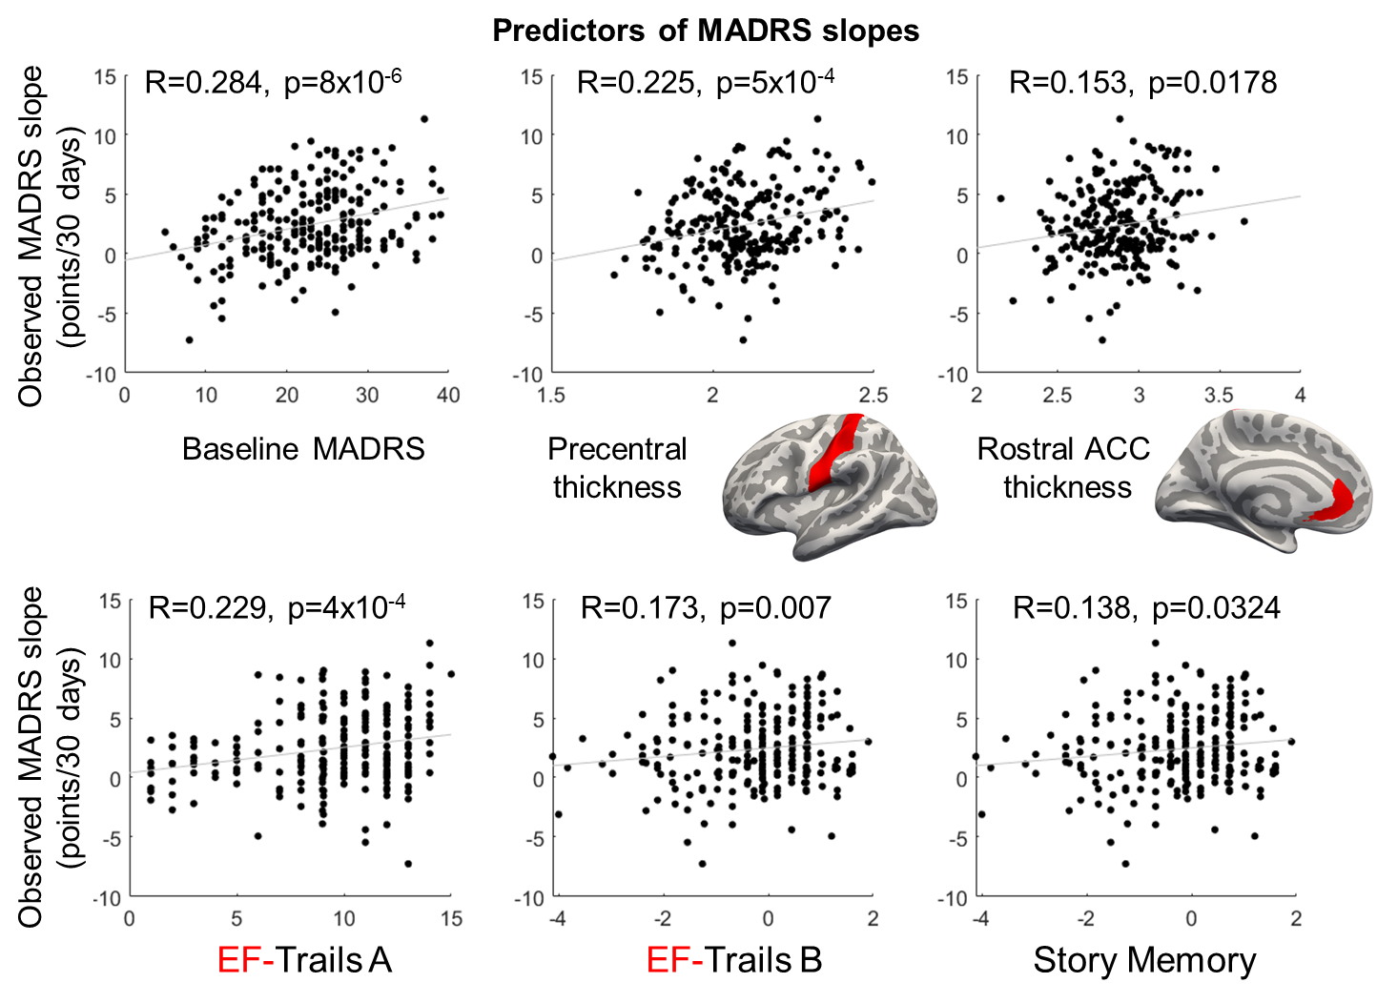
Supplementary Figure 6. Scatterplots showing the association between baseline MADRS, cognitive function, and cortical thickness and change in MADRS slopes. We show select variables that were significant in the PLS regression linking these data types with change in MADRS scores.

References
1. Desikan RS, Ségonne F, Fischl B, et al. An automated labeling system for subdividing the human cerebral cortex on MRI scans into gyral based regions of interest. Neuroimage. 2006;31(3):968-980. doi:10.1016/j.neuroimage.2006.01.021

