TableS1 Animals grouping and treatment methods
Groups | 1st step | 2nd step
Control group (n=15) | Corn oil (10 ml/kg) | 0.9% NaCl (10 ml/kg)
BPA group  (n=15) | Bisphenol A (50 mg/kg )  Corn oil(10 ml/kg) | 0.9% NaCl (10 ml/kg)
BPA+SPN group (n=30) | Bisphenol A(50 mg/kg )  Corn oil(10 ml/kg) | Specnuezhenide (30 mg/kg)  0.9%NaCl(10 ml/kg)

TableS2 Primary antibodies and HRP-labelled secondary antibodies for Immunofluorescence analysis
Name | Manufacturer | Number | Dilution ratio (IF)
nNOS | Proteintech | 29231-1-AP | 1:200
iNOS | Proteintech | 18985-1-AP | 1:200
CAT | Proteintech | 21260-1-AP | 1:500
SOD1 | Proteintech | 10269-1-AP | 1:500
SOD2 | Proteintech | 24127-1-AP | 1:100
SLC7A11 | Proteintech | 26864-1-AP | 1:500
ACSL4 | Proteintech | 22401-1-AP | 1:500
GPX4 | Proteintech | 14432-1-AP | 1:500
BAX | Proteintech | 50599-2-Ig | 1:500
BCL-2 | Proteintech | 26593-1-AP | 1:500

TableS3 Primary antibodies and HRP-labelled secondary antibodies for western blotting
 | Name | Manufacturer | Number | Molecular weight  （KDa） | Dilution ratio (WB)
NRF2 |  | Proteintech | 16396-1-AP | 110 | 1: 1000
 | HO-1 | Proteintech | 10701-1-AP | 28-33 | 1: 2000
 | NQO1 | Proteintech | 11451-1-AP | 30 | 1:2000
 | TFR1 | CST | 46222 | 90 | 1: 2000
 | ZIP8 | Proteintech | 20459-1-AP | 42-46 | 1: 1000
 | ZIP14 | Absin | abs102706 | 54 | 1: 1000
 | FPN1 | Proteintech | 26601-1-AP | 55 | 1: 1000
 | FTH | BIOSS | bs-5907R | 20 | 1: 2000
 | FTL | BIOSS | bs-6403P | 19-21 | 1: 2000
 | DMT1 | Proteintech | 20507-1-AP | 60-70 | 1: 1000
 | STEAP3 | Absin | abs135642 | 55 | 1: 1000
 | NCOA4 | Absin | abs134557 | 70 | 1: 1000
 | GPX4 | Proteintech | 14432-1-AP | 20 | 1: 2000
 | SLC7A11 | Proteintech | 26864-1-AP | 55 | 1: 2000
 | ACSL4 | Proteintech | 22401-1-AP | 79 | 1: 2000
 | BAX | Proteintech | 50599-2-Ig | 21 | 1: 2000
 | BCL-2 | Proteintech | 26593-1-AP | 26 | 1: 2000
 | β-actin | Servicebio | GB12001 | 42 | 1: 2000
 | HRP- goat anti-mouse | Servicebio | GB23301 |  | 1: 5000
 | HRP- goat anti-rabbit | Servicebio | GB23303 |  | 1: 5000

TableS4 Primer sequences
Gene name | Primer sequence (5'→3')
IL-6 | Forward | TGCAAGAGACTTCCATCCAG
 | Reverse | TCCACGATTTCCCAGAGAAC
IL-1β | Forward | AGAAGCTGTGGCAGCT
 | Reverse | TGAGGTGCTGATGTACCA
TNF-α | Forward | GAACTGGCAGAAGAGGCACT
 | Reverse | GGTCTGGGCCATAGAACTGA
IL-4 | Forward | TCAACCCCCAGCTAGTTGTC
 | Reverse | CTTGGAAGCCCTACAGACGA
IL-10 | Forward | GTAGAAGTGATGCCCCAGGC
 | Reverse | GAGAAATCGATGACAGCGCC
Tfr1 | Forward | AAACTGGCTGAAACGGAGGAGACA
 | Reverse | GCTGCTTGATGGTGTCAGCAAACT
Zip8 | Forward | CTAACGGACACATCCACTTCGA
 | Reverse | CCCTTCAGACAGGTACATGAGCTT
Zip14 | Forward | TCACGAGCTGGGAGACTTCGTT
 | Reverse | AGAAGTGACTGCCAGCCAGGA
Fpn1 | Forward | TCTCTGTGATTGTGACCGTG
 | Reverse | AATTTCCTTGCCCGTAGAGTC
Fth | Forward | GCTGAATGCAATGGAGTGTGCA
 | Reverse | GGCACCCATCTTGCGTAAGTTG
Ftl | Forward | CTTGCCCGGGACTTAGAGCA
 | Reverse | ATGGCTGATCCGGAGTAGGA
Dmt1 | Forward | CAATGTCTTTGTCGTGTCCGT
 | Reverse | GCGACCATTTTAGGTTCAGGAAT
Steap3 | Forward | GCTGGCCTTGAACTCAAAAG
 | Reverse | CGTGGTGACACACATCTTCC
Ncoa4 | Forward | AACACTGCCGACTGGGTTTT
 | Reverse | AGCTGCATACAGGCAAAGAGA
SLC7A11 | Forward | TCTGGTCTGCCTGTGGAGTA
 | Reverse | CAAAGGACCAAAGACCTCCA
Acsl4 | Forward | TGCTGCCTGTCCACTTGTTA
 | Reverse | AGTATCTGCTCCAGGGATGTCT
Gpx4 | Forward | AAGTACAGGGGTTTCGTGTG
 | Reverse | CGGCTGCAAACTCCTTGATT
Bax | Forward | TTTCATCCAGGATCGAGCAG
 | Reverse | AATCATCCTCTGCAGCTCCA
Bcl2 | Forward | GACTTTGCAGAGATGTCCAG
 | Reverse | TCAGGTACTCAGTCATCCAC
Caspase3 | Forward | AGT CAG TGG ACT CTG GGA TC
 | Reverse | GTA CAG TTC TTT CGT GAG CA
Caspase9 | Forward | TGC ACT TCC TCT CAA GGA AGG ACC
 | Reverse | TCC AAG GTC TCC ATG TAC CAG GAG C
GAPDH | Forward | GGTCCCAGCTTAGGTTCATCA
 | Reverse | CCGTTCACACCGACCTTCA

TableS5 Comparisons of weight between control and BPA groups (g)
Groups | Initial weight (1day) | Pre-modeling weight (28day)
Control | 18.02±1.01 | 34.46±1.12**
BPA | 17.89±0.87 | 32.20±0.94##
**P<0.01, compared to the initial group; ##P<0.01, compared to the control group.

TableS6 Comparisons of weight among the groups (g)
Goups | SPN treatment Days
Goups | 0 | 7 | 14 | 21 | 28 | 35
Control | 34.46±1.12 | 36.28±1.49  ª | 39.26±1.39  ^{aabb} | 40.22±1.58  ^{aabb} | 42.48±1.37  ^{aabbccdd} | 44.66±1.06  ^{aabbccddee}
BPA | 32.00±0.83## | 34.22±1.05  ^{##aa} | 35.28±1.04  ^{##aa} | 36.92±0.99  ^{##aabbd} | 38.20±0.73  ^{##aabbdd} | 40.44±1.60  ^{##aabbddee}
BPA+SPN (21) | 32.42±1.40  ## | 34.84±1.01  ^{aa} | 36.56±1.16  ^{##aab} | 38.60±1.24  ^{aabbcc} | 41.22±0.66  ^{&&aabbccdd} | 42.94±1.14  ^{#&&aabbccdde}
BPA+SPN (28) | 32.32±0.59  ## | 34.06±0.80  ^{##a} | 35.98±1.10  ^{##aab} | 38.54±1.54  ^{aabbcc} | 41.52±1.83  ^{&&aabbccdd} | 43.46±1.14  ^{&&aabbccdde}
BPA+SPN (35) | 32.06±1.02  ## | 33.64±1.00  ## | 36.46±1.28  ^{##aabb} | 38.90±1.42  ^{&aabbcc} | 42.04±1.68  ^{&&aabbccdd} | 44.36±1.02  ^{&&aabbccddee}
ªP<0.05, ^{aa}P<0.01, compared to the 0 days; ^{b}P<0.05, ^{bb}P<0.01, compared to the 7 days; ^{c}P<0.05, ^{cc}P<0.01, compared to the 14 days; ^{d}P<0.05, ^{dd}P<0.01, compared to the 21 days; ^{e}P<0.05, ^{ee}P<0.01, compared to the 28 days; #P<0.01, compared to the control group; &P<0.05, &&P<0.01, compared to the BPA group.

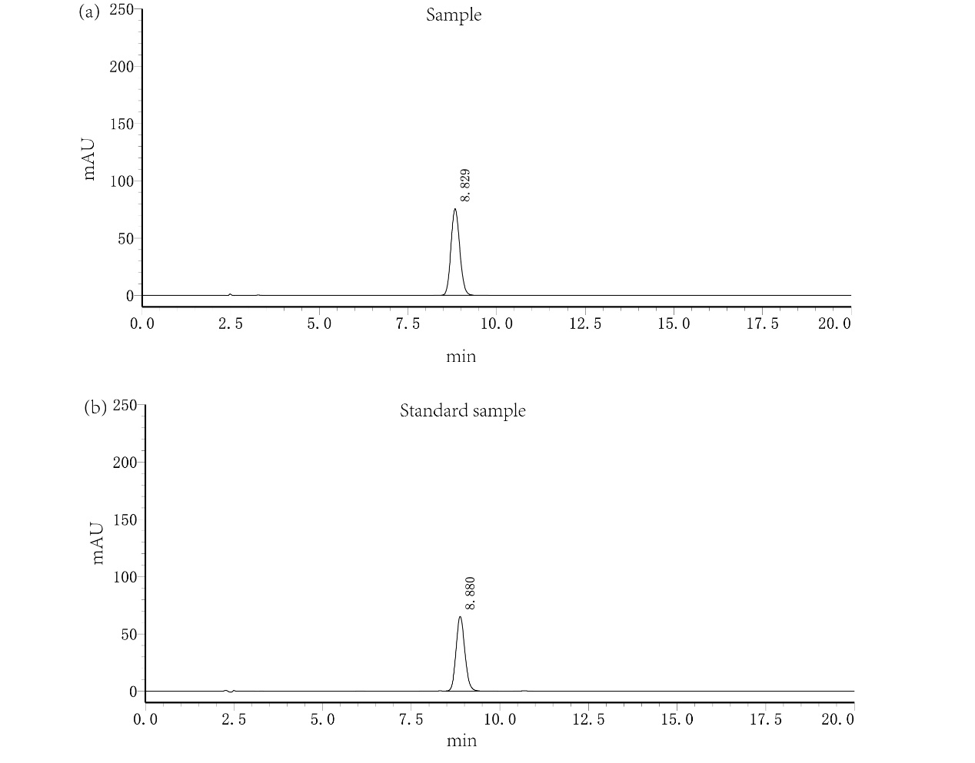
Fig.S1 The HPLC spectra of purchased product (a) and SPN standard sample (b).

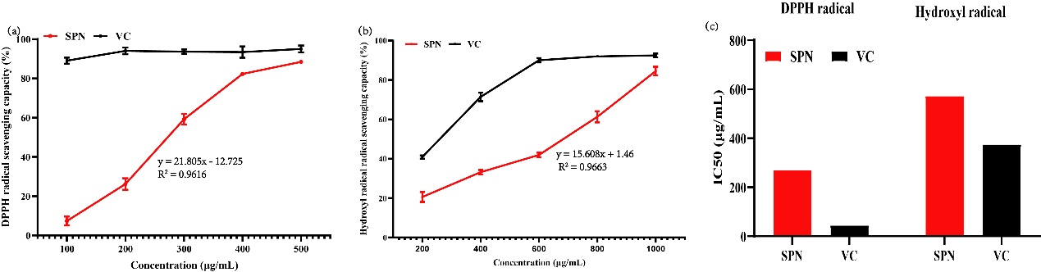
Fig.S2 Antioxidant power curves for SPN and VC determined by the DPPH (a) and hydroxyl radical (b) methods, with calculated IC-50 values (c). Data displayed the mean of five experiments, with error bars indicating SEM. VC served as the positive control.

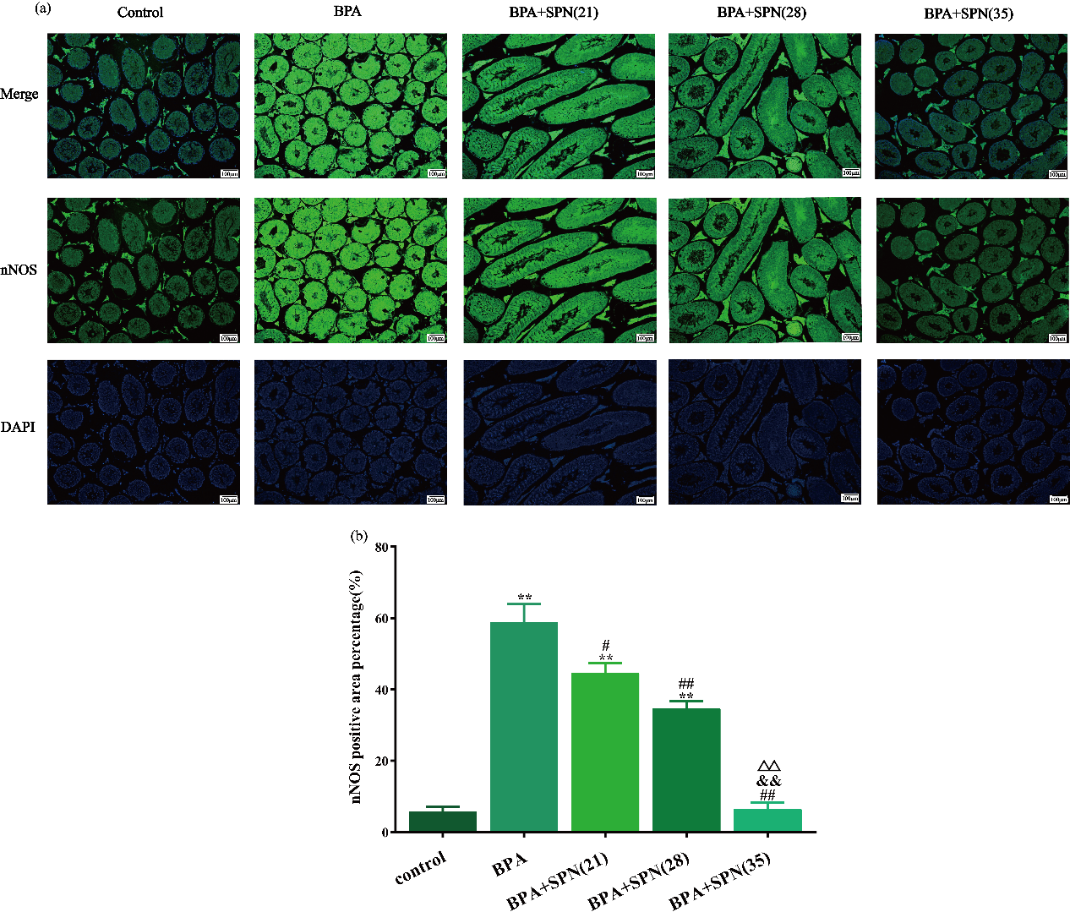
Fig.S3 Immunofluorescence staining was used to detect nNOS immunoreactivity (a), scale bar is 100 µm. The data were calculated by Image J 1.53e software and shown as means ± SEM(b).
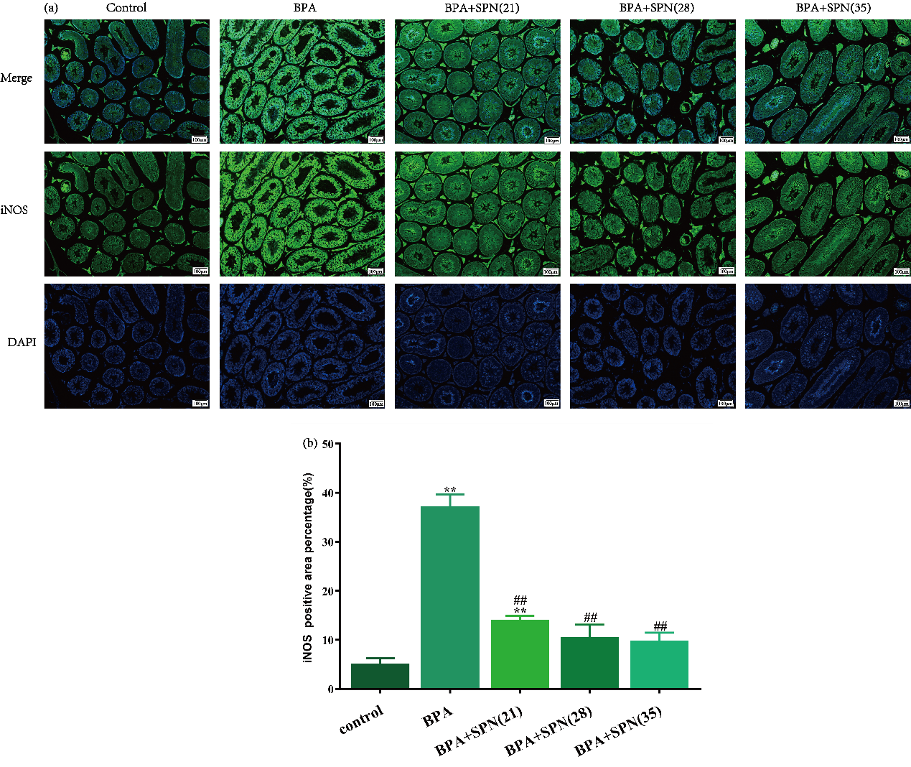
Fig.S4 Immunofluorescence staining was used to detect iNOS immunoreactivity (a), scale bar is 100 µm. The data were calculated by Image J 1.53e software and shown as means ± SEM(b).
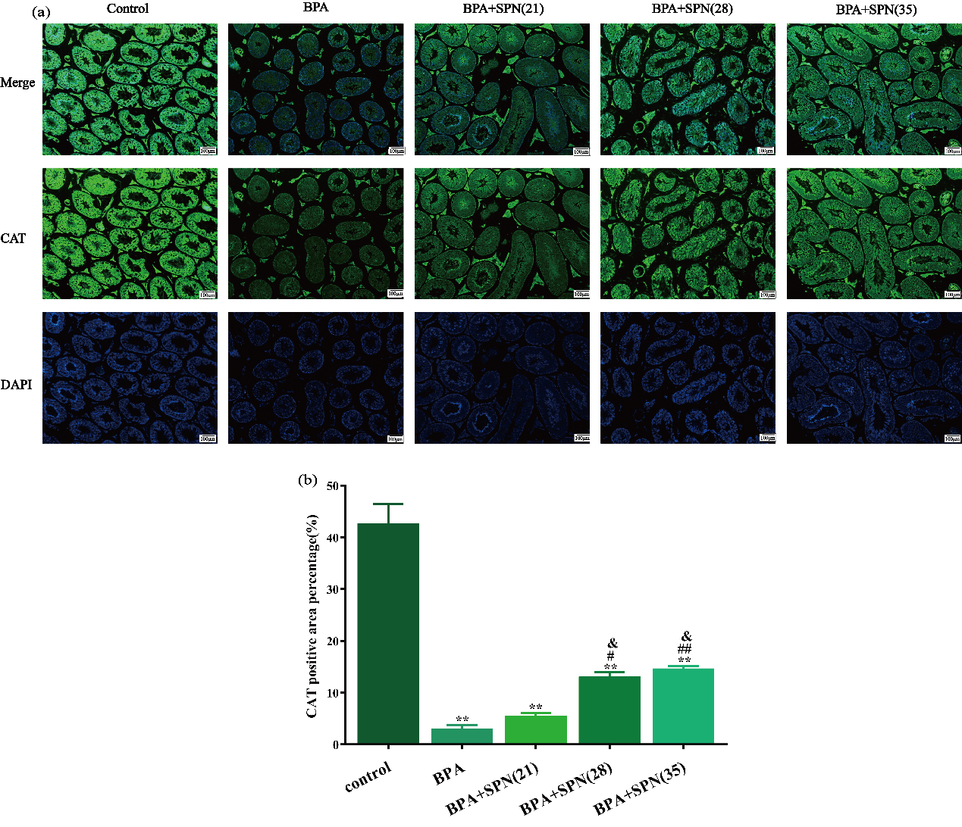
Fig. S5 Immunofluorescence staining was used to detect CAT immunoreactivity (a), scale bar is 100 µm. The data are displayed as means ± SEM (b).
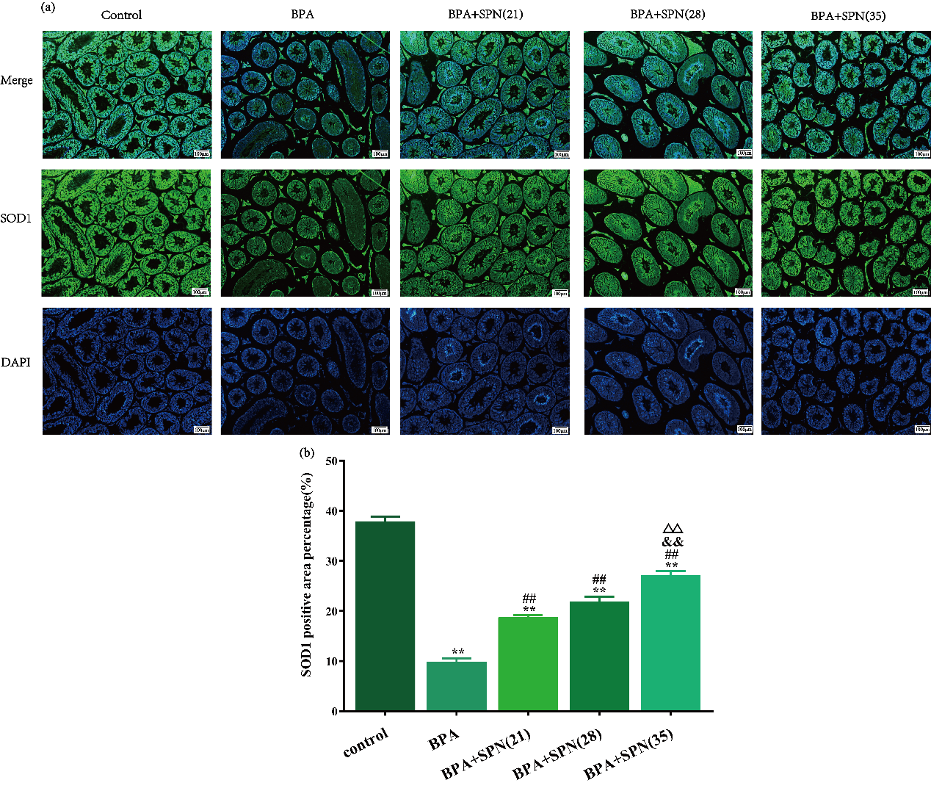
Fig.S6 Immunofluorescence staining was used to detect SOD1 immunoreactivity(a), scale bar is 100 µm. The data were calculated by Image J and shown as means ± SEM(b).
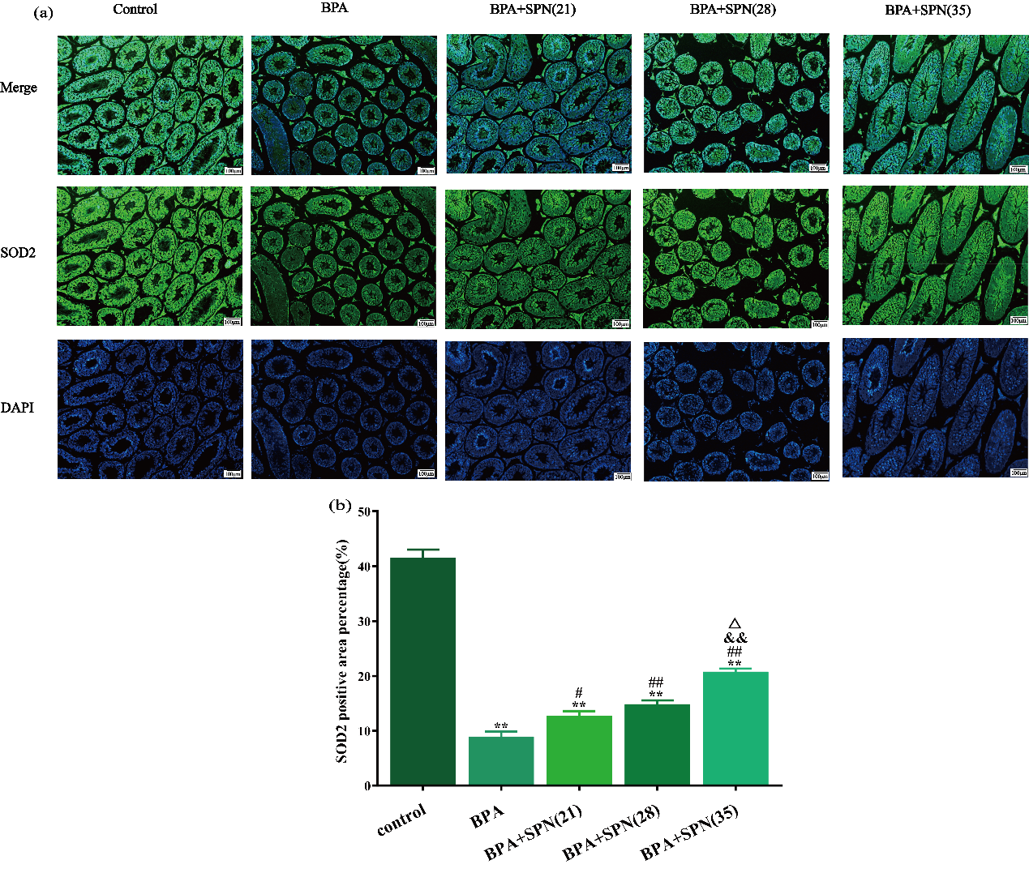
Fig.S7 Immunofluorescence staining was used to detect SOD2 immunoreactivity(a), scale bar is 100 µm. The data were calculated by Image J and shown as means ± SEM(b).

Fig.S8 Results in reducing power curve (a) and EC-50 (b) of SPN and VC. Data represent the mean of five experiments, with error bars indicating SEM. VC served as the positive control.

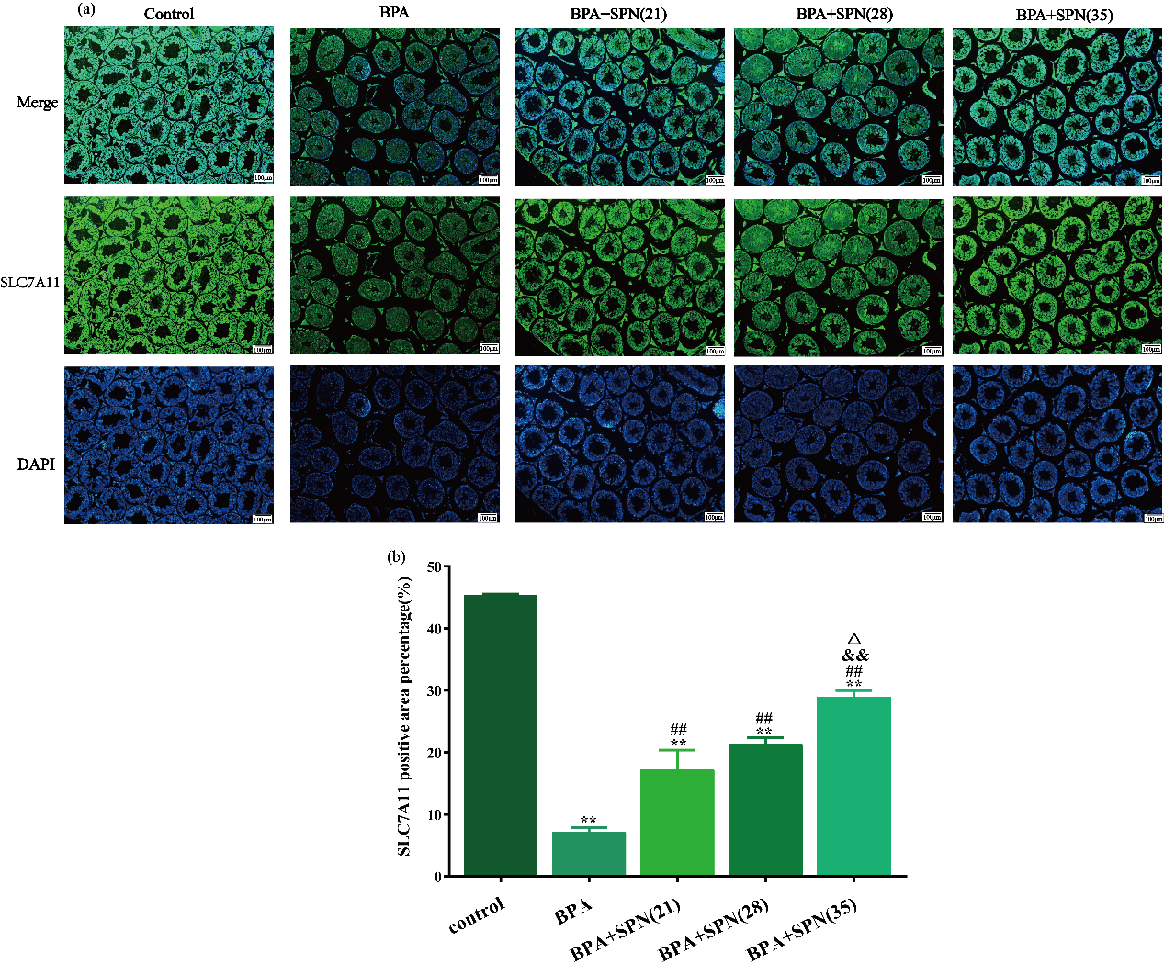
Fig.S9 Immunofluorescence staining was used to detect SLC7A11 immunoreactivity(a), scale bar is 100 µm. The data were shown as means ± SEM(b).
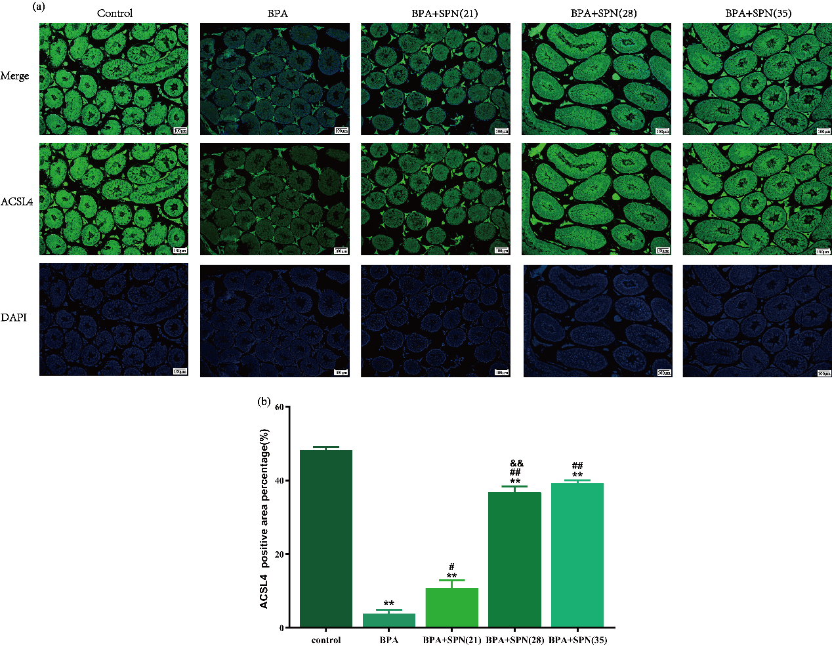
Fig.S10 Immunofluorescence staining was used to detect ACSL4 immunoreactivity(a), scale bar is 100 µm. The data were shown as means ± SEM(b).
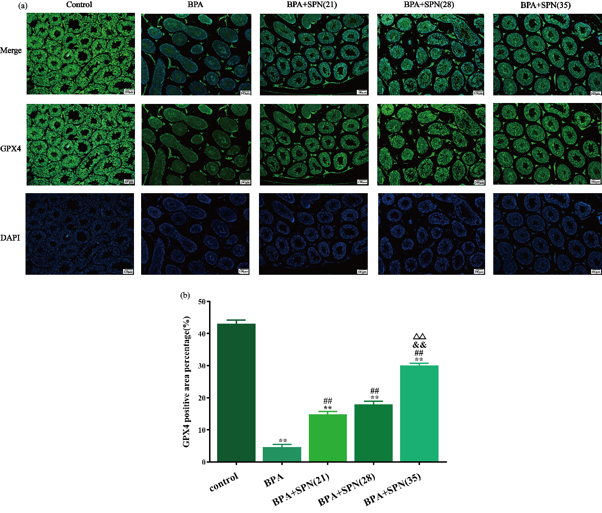
Fig.S11 Immunofluorescence staining was used to detect GPX4 immunoreactivity(a), scale bar is 100 µm. The data were shown as means ± SEM(b).

Fig.S12 The gene expression of Gpx4 and Acsl4 relative to that of GAPDH in testes. All the data are means ± SEM. ** p <0.01, in comparison with the control group; ##p <0.01, in comparison with the BPA group; &&p<0.01, in comparison with the BPA+SPN (21) group, ^{Δ}p<0.05, ^{ΔΔ}p<0.01, in comparison with the BPA+SPN (28) group.

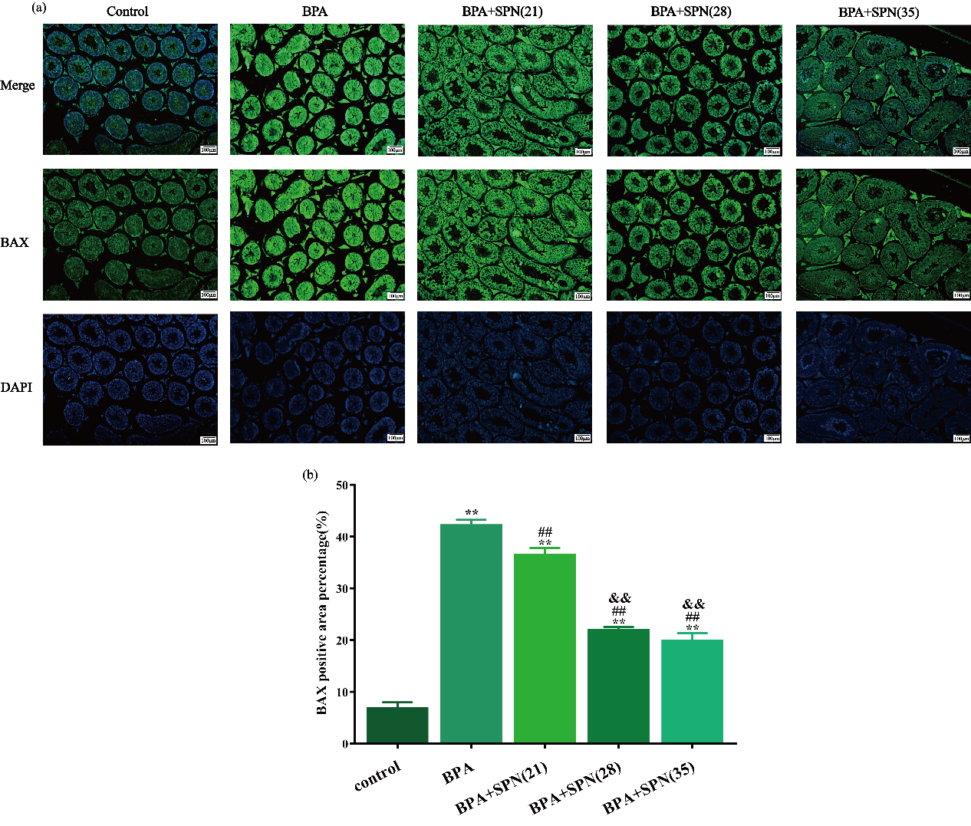
Fig.S13 Immunofluorescence staining was used to detect BAX immunoreactivity(a), scale bar is 100 µm. The data were shown as means ± SEM(b).
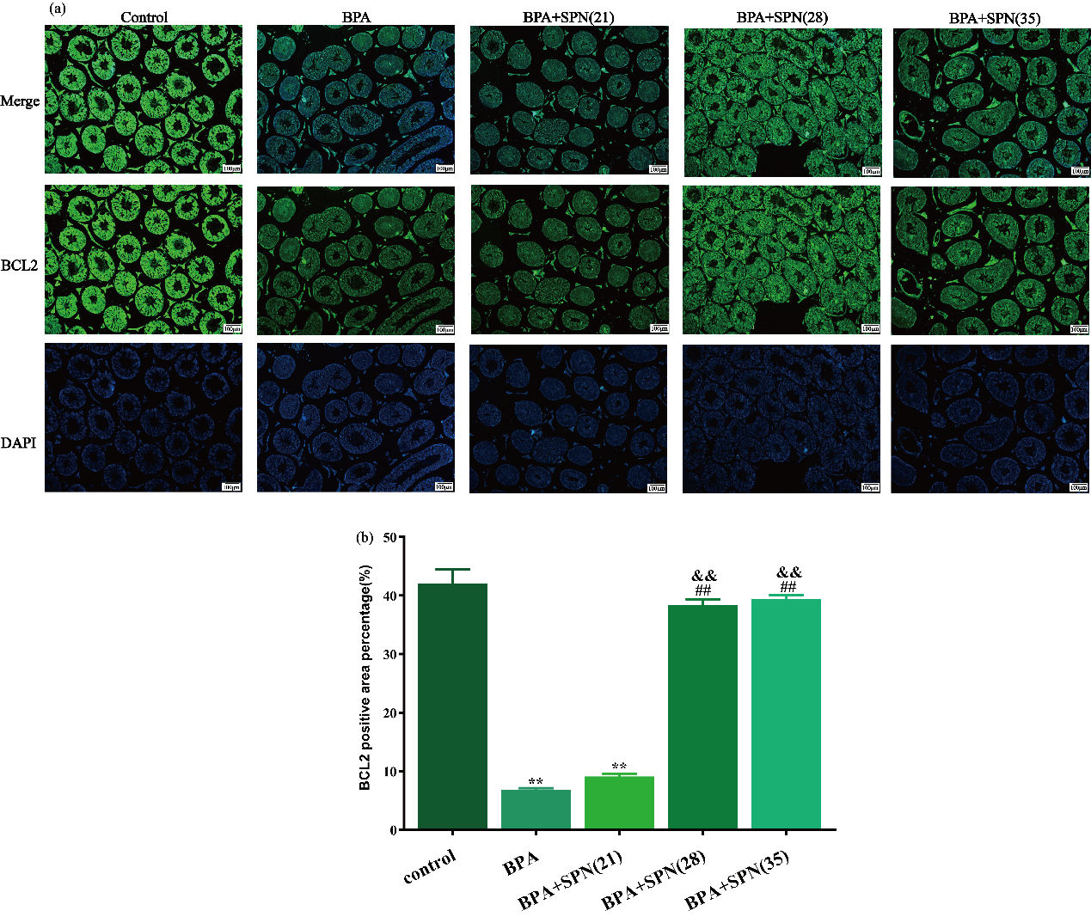
Fig.S14 Immunofluorescence staining was used to detect BCL-2 immunoreactivity(a), scale bar is 100 µm. The data were shown as means ± SEM(b).
References

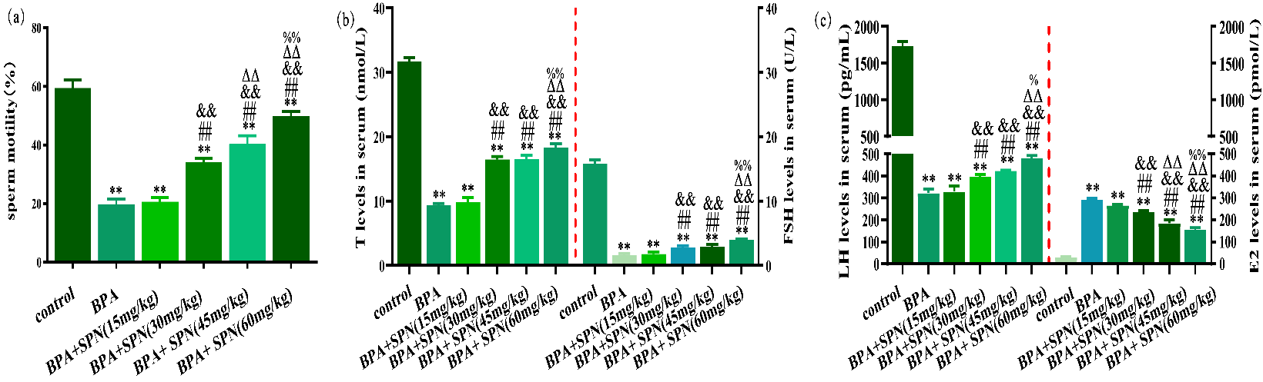
Fig.S15 Effects of SPN on sperm motility and hormonal levels in testes. (a) Sperm motility among the groups. (b) T and FSH levels of serum among the groups. (c) LH and E2 levels of serum among the groups. Data are shown as means ± SEM. *p <0.05, **p <0.01, in comparison with the control group; #p <0.05, ##p <0.01, in comparison with the BPA group; &p <0.05, &&p <0.01, in comparison with the BPA+SPN (15mg/kg) group. ^{Δ}p<0.05, ^{ΔΔ}p<0.01, in comparison with the BPA+SPN (30mg/kg) group. %p <0.05, %%p <0.01, in comparison with the BPA+SPN (45mg/kg) group.

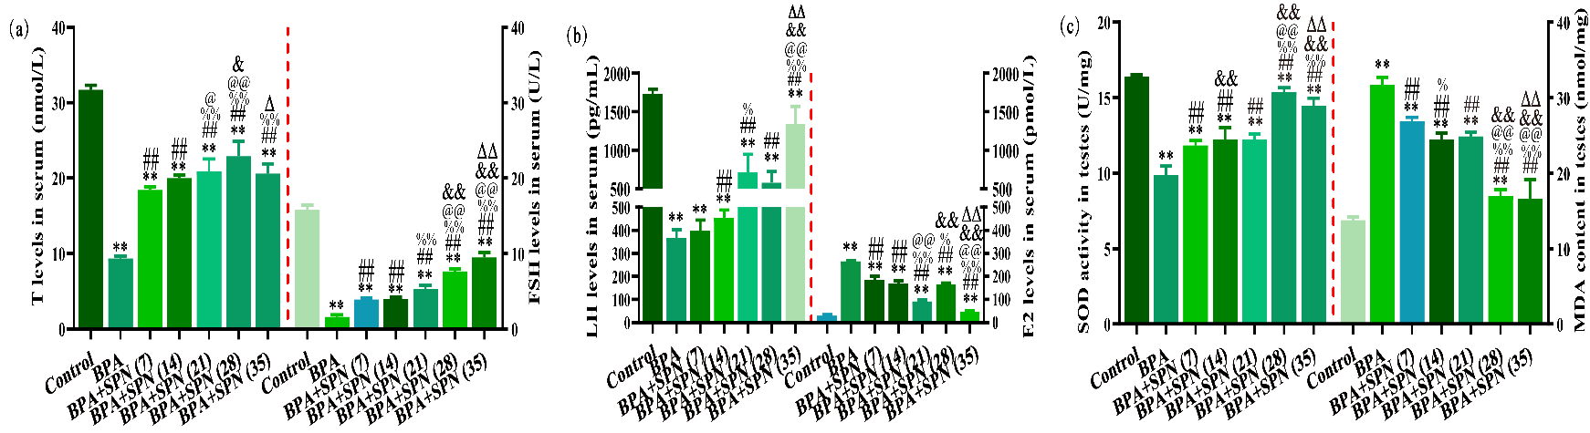
Fig.S16 Effects of SPN on BPA-induced hormonal disorder, SOD and MDA levels. (a) T and FSH levels of serum among the groups. (b) LH and E2 levels of serum among the groups. (c) SOD and MDA levels of testes among the groups. Data are shown as means ± SEM. * p <0.05, ** p <0.01, in comparison with the control group; # p <0.05, ## p <0.01, in comparison with the BPA group; % p <0.05, %% p <0.01, in comparison with the BPA+SPN (7) group. @p <0.05, @@p <0.01, in comparison with the BPA+SPN (14) group. &&p<0.01, in comparison with the BPA+SPN (21) group, ^{Δ}p<0.05, ^{ΔΔ}p<0.01, in comparison with the BPA+SPN (28) group.

