Supplementary Material
Ashton NJ et al. Diagnostic value of plasma neurofilament light: A multicentre validation study

Supplementary Table 1. Diagnostic and plasma EDTA sampling criteria for the KCL & Lund cohorts
Supplementary Table 2. Spearman Rank Correlations between age and plasma NfL separated by diagnostic groups
Supplementary Table 3. The association of plasma NfL with sex depending on diagnostic category
Supplementary Table 4. Accuracy (AUC) 95% confidence interval (CI) of plasma NfL to differentiate healthy controls, neurodegenerative and neurological disorders in the KCL (A) and Lund (B) cohorts
Supplementary Table 5. Concentration cut-offs for plasma neurofilament light calculate in the KCL cohort
Supplementary Results 1. Demographics of the KCL and Lund cohorts
Supplementary Results 2. Correlations of plasma and cerebrospinal fluid (CSF) NfL
Supplementary Figure 1. Comparison of quality control (QC) samples between KCL and Lund cohorts.
Supplementary Figure 2. The correlations of plasma NfL and age in the KCL (A) and Lund (B) cohorts.
Supplementary Figure 3. Correlations of plasma NfL and CSF NfL in the Lund cohort unadjusted for age.
Supplementary Figure 4. The sensitivity and specificities of plasma NfL to differentiate healthy controls, neurodegenerative and neurological disorders in the KCL (A) and Lund (B) cohorts
Supplementary Figure 5. The performance of plasma neurofilament light (NfL) concentration cut-offs to identify neurodegenerative disorders in ADNI.
Supplementary References

Supplementary Table 1. Diagnostic and plasma EDTA sampling criteria of the KCL & Lund cohorts

Study Cohort | Centre | Diagnostic groups | Clinical Criteria | Aβ status | EDTA plasma procedure
King’s College London (KCL) Cohort | Baltimore Longitudinal Study of ageing (BLSA)¹ | Cognitively unimpaired (Aβ-/Aβ+) | N/A | [¹¹C]PiB PET | Fasting, <4-hours, +4˚C, -80°C storage
King’s College London (KCL) Cohort | Brescia DMA Study Biobanking² | Cognitively unimpaired (Aβ-/Aβ+); Parkinson’s disease; Parkinson disease dementia; Dementia with Lewy bodies | Postuma RB³  Emre M⁴  McKeith IG⁵ | CSF  Aβ42 <550 pg/mL | Fasting, <2-hours, 3000 g, 20 min +4˚C, -80°C storage
King’s College London (KCL) Cohort | NEURODEM study, Chieti | Parkinson’s disease; Parkinson disease dementia; Dementia with Lewy bodies | Hughes AJ⁶  McKeith IG⁵ | N/A | Fasting, <2-hours, 2000 g, 10 min +4˚C, -80°C storage
King’s College London (KCL) Cohort | Dementia Case Register (DCR)⁷ | Alzheimer’s disease | McKhann G⁸ | N/A | Fasting, <2-hours, 3000 g, 8 min +4˚C, -80°C storage
King’s College London (KCL) Cohort | Biodonostia Health Research Institute biobank⁹ | Amyotrophic lateral sclerosis | El Escorial criteria¹⁰ | N/A | Fasting, <2-hours, 1500g, 15 min +4˚C, -80°C storage
King’s College London (KCL) Cohort | European Medical Information Framework (EMIF) 500 study¹¹ (Barcelona St Pau¹², Milan¹³, Perguia¹⁴) | Alzheimer’s disease; Cognitively unimpaired (Aβ-/Aβ+); Early onset Alzheimer’s disease; Mild cognitive impairment (Aβ-/Aβ+) | McKhann G⁸  Petersen RC¹⁵ | Barcelona, CSF Aβ42 <550 pg/mL; Perguia, CSF Aβ42 <800 pg/mL; CSF Milan, Aβ42 <600 pg/mL | Fasting, <2-hours, 3000 rpm, 8 min +4˚C, -80°C storage
King’s College London (KCL) Cohort | Young Onset Dementia Assessment Service (YODAS), Leicestershire Partnership National Health Service (NHS) Trust^{16,17} | Early onset Alzheimer’s disease | McKhann G⁸ | N/A | Fasting, <2-hours, 3000 g, 8 min +4˚C, -80°C storage
King’s College London (KCL) Cohort | Karolinska/Stockholm¹⁸ | Parkinson’s disease | Gelb DJ¹⁹ | N/A | Fasting, <30-minutes, 800 g, 20 min +4˚C, -80°C storage
King’s College London (KCL) Cohort | LonDownS²⁰ | Down syndrome; Down syndrome with Alzheimer’s disease | Sheehan R²¹ | N/A | Non-fasting, <3-hours, 2200 g, 10 min +4˚C, -80°C storage
King’s College London (KCL) Cohort | Translational Biomarkers in Aging and Dementia (TRIAD)²² | Cognitively unimpaired (Aβ-/Aβ+); Early onset Alzheimer’s disease; Frontotemporal dementia | Snowden JS²³  McKhann G²⁴  Neary D²⁵ | [¹⁸F]AZD4694  (visual rating) | Fasting, <2-hours, 2200 g, 10 min RT, -80°C storage
King’s College London (KCL) Cohort | Sahlgrenska University Hospital and Sahlgrenska Academy²⁶ | Multiple Sclerosis | McDonald criteria^{27,28} | N/A | Non-fasting, <30 minutes, 3000 g, 20 min +4˚C, -80°C storage
King’s College London (KCL) Cohort | Kings College London, BIODEP (BIOmarkers in DEPression) study²⁹ | Depression | DSM-5 | N/A | Fasting, <2-hours, 1600 g, 15 min RT, -80°C storage
King’s College London (KCL) Cohort | University in San Francisco (UCSF)³⁰ | Alzheimer’s disease; Cortical basal syndrome; Progressive supranuclear palsy; Cognitively unimpaired (Aβ-/Aβ+); Early onset Alzheimer’s disease; Frontotemporal dementia | McKhann G²⁴  Neary D²⁵  Petersen¹⁵ | [¹¹C]PiB PET | Fasting, <2-hours, 2000 g, 10 min +4˚C, -80°C storage
Lund Cohort | Swedish BioFINDER³¹ | Alzheimer’s disease; Cortical basal syndrome; Progressive supranuclear palsy; Cognitively unimpaired (Aβ-/Aβ+); Early onset Alzheimer’s disease; Mild cognitive impairment (Aβ-/Aβ+); Multiple system atrophy; Parkinson’s disease; Parkinson disease dementia; Dementia with Lewy bodies; Subjective cognitive decline (Aβ-/ Aβ+) | McKhann G²⁴  Rascovsky K³²  Gelb DJ¹⁹  Gilman S ³³  Litvan I ³⁴  Litvan I ³⁵ | CSF  Aβ42/Aβ40 <0.091 | Fasting, <1-hour, 2000 g, 10 min +4˚C, -80°C storage
Lund Cohort | Lund Prospective Frontotemporal Dementia Study (LUPROFS)³⁶ | Frontotemporal dementia | Rascovsky K³² | N/A | Fasting, <1-hour, 2000 g, 10 min +4˚C, -80°C storage
Lund Cohort | Erasmus Medical Centre, Rotterdam³⁷ | Alzheimer’s disease; Early onset Alzheimer’s disease; Frontotemporal dementia | McKhann G²⁴  Neary D²⁵ | N/A | Fasting, <1-hour, 2000 g, 10 min +4˚C, -80°C storage

Diagnostic group | Lund Cohort |  | KCL Cohort
Diagnostic group | r | P value | r | P value
All participants | 0.411 | <0.0001 | 0.393 | <0.0001
>60 years |  |  | 0.191 | <0.0001
<60 years |  |  | 0.354 | <0.0001
CU Aβ- | 0.491 | <0.0001 | 0.450 | <0.0001
CU Aβ+ | 0.479 | <0.0001 | 0.540 | <0.0001
SCD Aβ- | 0.587 | <0.0001 | NA | NA
SCD Aβ+ | 0.327 | <0.0001 | NA | NA
MCI Aβ- | 0.356 | <0.0001 | 0.339 | 0.010
MCI Aβ+ | 0.217 | 0.005 | 0.072 | ns
EOAD | 0.694 | ns | 0.166 | ns
AD dementia | 0.392 | <0.0001 | 0.356 | <0.0001
FTD | 0.247 | 0.005 | 0.175 | 0.025
PD | 0.591 | <0.0001 | 0.574 | <0.0001
PDD/DLB | 0.480 | <0.0001 | 0.356 | 0.001
CBS/PSP | 0.343 | ns | 0.120 | ns
MSA | 0.535 | 0.010 | NA | NA
VaD | -0.113 | ns | NA | NA
DS (all) | NA | NA | 0.658 | <0.0001
ALS | NA | NA | 0.058 | ns
MS | NA | NA | 0.062 | ns
Depression | NA | NA | 0.331 | 0.018
Supplementary Table 2. Spearman Rank Correlations between age and plasma NfL separated by diagnostic groups.
Supplementary Table 3. The association of plasma NfL with sex depending on diagnostic category
Diagnostic group | Lund Cohort |  |  |  | KCL Cohort
Diagnostic group | F, mean (SD) | M, mean (SD) | t | P value | F, mean (SD) | M, mean (SD) | t | P value
All participants | 33.8 (28.7) | 31.0 (30.8) | 1.6 | ns | 31.8 (34.3) | 37.0 (42.7) | -2.0 | 0.05
CUAβ- | 22.5 (13.0) | 21.2 (10.3) | 0.9 | ns | 17.4 (8.5) | 16.2 (8.0) | 0.8 | ns
CUAβ+ | 35.4 (89.3) | 24.0 (11.5) | 0.8 | ns | 29.0 (27.1) | 31.1 (19.6) | -0.3 | ns
SCD Aβ- | 18.2 (10.0) | 19.9 (10.7) | -0.9 | ns | NA
SCD Aβ+ | 23.0 (13.2) | 25.1 (10.8) | -0.7 | ns | NA
MCI Aβ- | 27.9 (14.9) | 28.1 (31.9) | -0.0 | ns | 25.1 (13.0) | 31.4 (19.7) | -1.4 | ns
MCI Aβ+ | 28.8 (19.0) | 30.2 (16.0 | -0.5 | ns | 24.6 (7.1) | 44.8 (45.5) | -1.8 | ns
EOAD | 25.5 (9.7) | 22.0 (8.6) | 0.87 | ns | 23.2 (16.0) | 25.0 (18.2) | -0.4 | ns
AD dementia | 47.0 (31.7) | 42.1 (23.3) | 1.0 | ns | 40.9 (5.9) | 37.0 (8.8) | 0.6 | ns
FTD | 71.1 (49.0) | 62.2 (63.4) | 1.0 | ns | 61.4 (28.2) | 59.0 (49.0 | 0.2 | ns
PD | 23.8 (21.2) | 18.6 (13.4) | 1.8 | ns | 20.6 (10.8) | 20.4 (10.9) | 0.2 | ns
PDD/DLB | 42.0 (33.7) | 42.1 (46.1) | -0.0 | ns | 45.2 (24.2) | 36.2 (15.4) | 1.6 | ns
CBS/PSP | 45.8 (12.5) | 53.7 (27.0) | -1.0 | ns | 59.6 (27.5) | 48.6 (30.7) | 0.8 | ns
MSA | 43.1 (26.7) | 47.6 (28.8) | -0.4 | ns | NA
VaD | 52.8 (21.2) | 49.6 (23.7) | 0.8 | ns | NA
DS | NA |  |  |  | 29.2 (18.1) | 30.9 (20.9) | -0.2 | ns
DS AD | NA |  |  |  | 66.8 (12.8) | 67.9 (8.7) | -0.1 | ns
ALS | NA |  |  |  | 102 (117) | 113 (88.6) | -0.4 | ns
MS | NA |  |  |  | 31.3 (36.5) | 23.6 (22.8) | 0.8 | ns
Depression | NA |  |  |  | 8.7 (4.6) | 7.7 (3.8) | 0.8 | ns

Supplementary Table 4. Accuracy (AUC) 95% confidence interval (CI) of plasma NfL to differentiate healthy controls, neurodegenerative and neurological disorders in the KCL (A) and Lund (B) cohorts
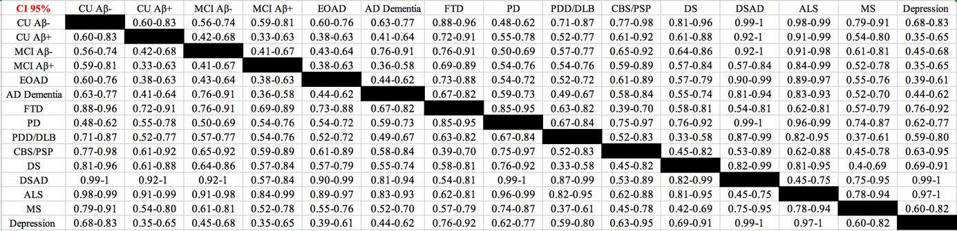
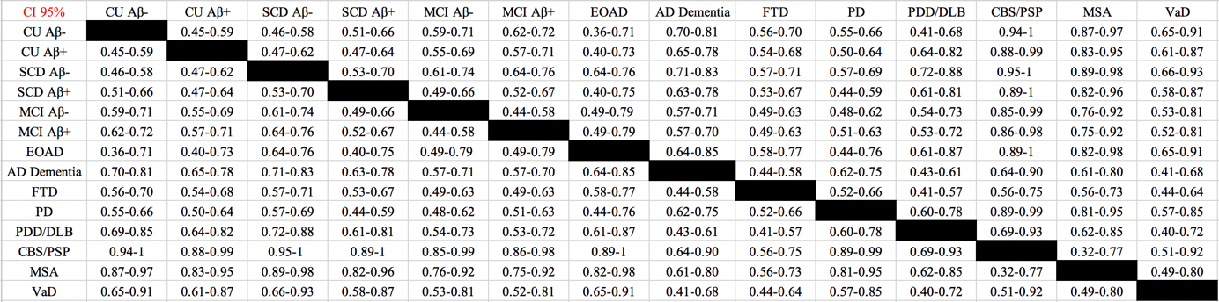

Supplementary Table 5. Concentration cut-offs for plasma neurofilament light calculated in the KCL cohort
 | Concentration cut-off method
 | 90% CI | 95% CI | 99% CI | +2SD | GMM
All ages (pg/mL) | 35.02 | 38.04 | 50.00 | 32.00 | 73.04
>60 (pg/mL) | 37.02 | 46.00 | 79.20 | 35.14 | 39.29
<60 (pg/mL) | 19.37 | 21.50 | 30.01 | 30.57 | 86.83

Supplementary Results 1. Demographics of the KCL and Lund cohorts
The demographic and clinical data for both KCL and Lund cohorts is displayed in Table 1 and Table 2. The KCL cohort was younger than the Lund cohort (KCL, M=63.6, SD=14.6; Lund, M=70, SD=6.3; P<0.05) due to the inclusion of larger groups of younger controls and certain patient groups (e.g. EOAD, Down syndrome and depression). Both cohorts were equally matched for sex and APOE ε4 carriers. In the KCL cohort, plasma NfL significantly correlated with age in the full cohort (supplementary figure 2A). However, a stronger association was observed in individuals <60 years (r=0.354, P<0.0001) compared to those >60 years (r=0.191, P<0.0001). Plasma NfL and age associations also differed by diagnostic group (supplementary table 2). In most of the groups, a significant correlation of plasma NfL existed with age although weak for FTD (r=0.175, P=0.025); non-significant findings (MCI Aβ+, EOAD, MS, ALS and CBS/PSP) were also observed. Plasma NfL was significantly increased in males (M=37.0, SD=42.7) as compared to females (M=31.8, SD=34.3; P = 0.05); this was not a consistent finding within individual diagnostic groups, however (supplementary table 3). In the Lund cohort, similar observations were found. Plasma NfL correlated with age in the whole cohort (r=0.313, P<0.0001, supplementary figure 1B) and in the majority of diagnostic groups (supplementary table 2). Like the KCL cohort, weaker correlations were observed for MCI Aβ+ (ρ=0.217, P=0.005) and FTD (r=0.247, P=0.005) with non-significant correlations for EOAD, CBS/PSP and VaD. In contrast to the KCL cohort, a non-significant increase in NfL concentration in females (M=33.8pg/mL, SD=28.7) compared to males (M=31.0 pg/mL, SD=30.8) was observed in the whole population. Once more, this was not a consistent observation across diagnostic groups (supplementary table 3). There was no influence of APOE ε4 status on the plasma NfL levels in either cohort (Table 1 and Table 2).
Supplementary Results 2. Correlations of plasma and cerebrospinal fluid (CSF) NfL
CSF NfL data was available only for the Lund cohort. In the whole cohort, plasma NfL correlated highly with CSF NfL (r=0.640, P<0.0001), which remained significant after accounting for the effect of age (r=0.492, P<0.0001). The strongest association was observed for the parkinsonian group (r=0.700, P<0.0001, supplementary figure 3) with significant associations also observed for the cognitive impairment (r=0.559, P<0.0001, supplementary figure 3) and CU groups (r=0.507, P<0.0001, supplementary figure 3). These associations remained significant after accounting for age (parkinsonian, r=0.680, P<0.0001; cognitive impairment, r=0.560, P<0.0001; CU, r=0.250, P<0.0001). Within diagnostic groups, the strongest associations were observed in PDD/DLB (r=0.819, P<0.0001) and PD (r=0.602, P<0.0001) groups, whereas the MCI (r=0.561, P<0.0001), MSA (r=0.497, P< 0.01) and AD (r=0.421, P<0.0001) groups exhibited moderate correlations. In the unimpaired groups, a moderate correlation existed between plasma and CSF NfL (CU, r=0.497, P<0.0001; SCD, r=0.527, P<0.0001).

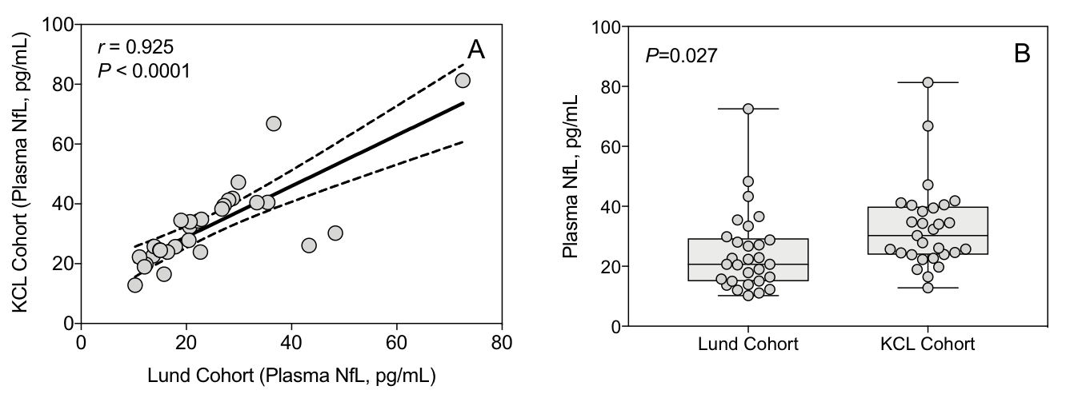
Supplementary Figure 1. Comparison of quality control (QC) samples between KCL and Lund cohorts.

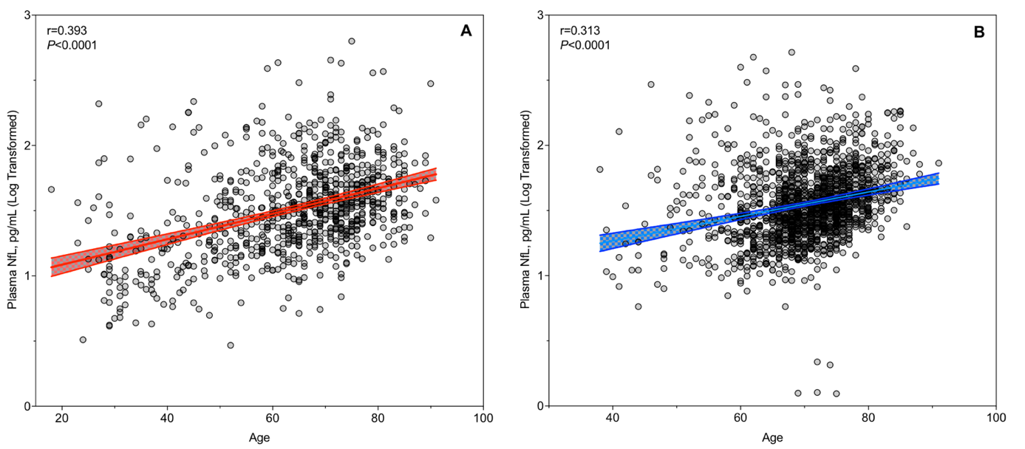
Supplementary Figure 2. The correlations of plasma NfL and age in the KCL (A) and Lund (B) cohorts.

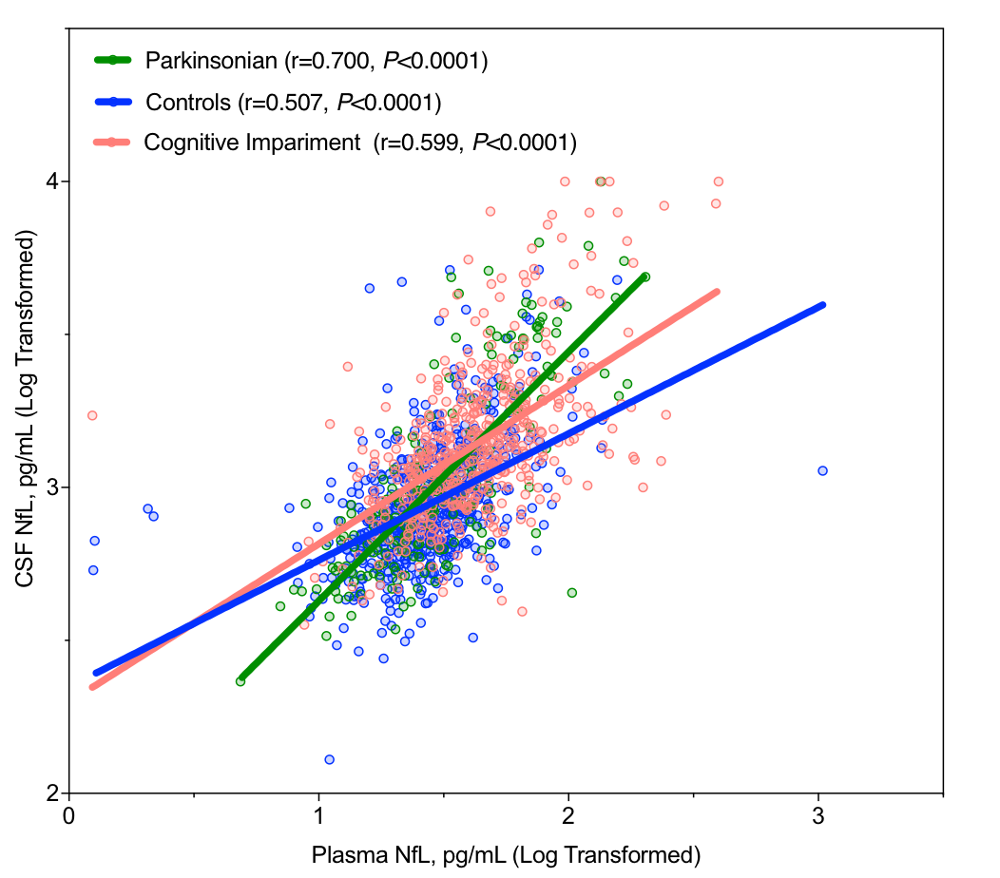
Supplementary Figure 3. Correlations of plasma NfL and CSF NfL in the Lund cohort unadjusted for age. These associations remained significant after accounting for effect of age (parkinsonian, ρ=0.680, P<0.0001; cognitive impairment, ρ=0.560, P<0.0001; CU, ρ=0.250, P<0.0001).

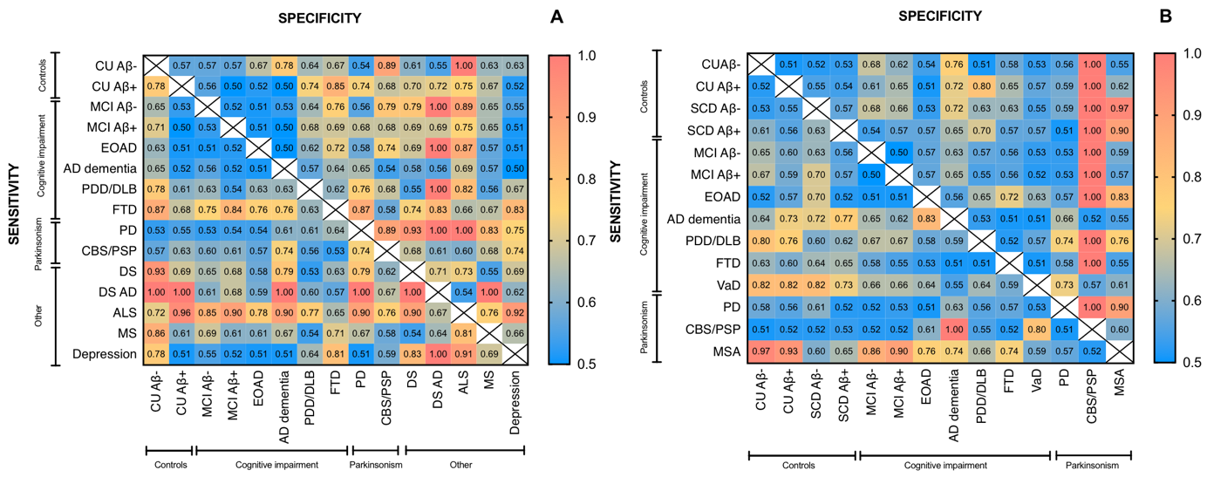
Supplementary Figure 4. The sensitivity and specificities of plasma NfL to differentiate healthy controls, neurodegenerative and neurological disorders in the KCL (A) and Lund (B) cohorts

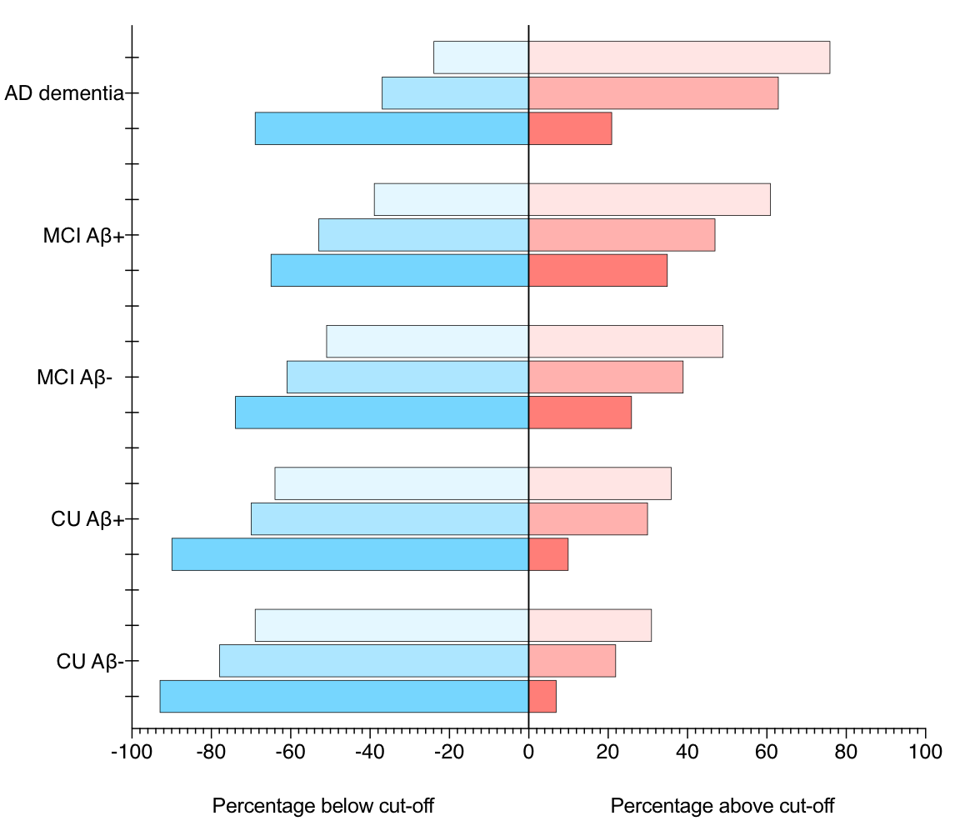

Supplementary Figure 5. The performance of plasma neurofilament light (NfL) concentration cut-offs to identify neurodegenerative disorders in ADNI.

Supplementary References
1 Ferrucci, L. The Baltimore Longitudinal Study of Aging (BLSA): a 50-year-long journey and plans for the future. J Gerontol A Biol Sci Med Sci 63, 1416-1419, doi:10.1093/gerona/63.12.1416 (2008).
2 Pilotto, A. et al. Extrastriatal dopaminergic and serotonergic pathways in Parkinson's disease and in dementia with Lewy bodies: a (123)I-FP-CIT SPECT study. Eur J Nucl Med Mol Imaging 46, 1642-1651, doi:10.1007/s00259-019-04324-5 (2019).
3 Postuma, R. B. et al. MDS clinical diagnostic criteria for Parkinson's disease. Mov Disord 30, 1591-1601, doi:10.1002/mds.26424 (2015).
4 Emre, M. et al. Clinical diagnostic criteria for dementia associated with Parkinson's disease. Mov Disord 22, 1689-1707; quiz 1837, doi:10.1002/mds.21507 (2007).
5 McKeith, I. G. et al. Diagnosis and management of dementia with Lewy bodies: third report of the DLB Consortium. Neurology 65, 1863-1872, doi:10.1212/01.wnl.0000187889.17253.b1 (2005).
6 Hughes, A. J., Daniel, S. E., Kilford, L. & Lees, A. J. Accuracy of clinical diagnosis of idiopathic Parkinson's disease: a clinico-pathological study of 100 cases. J Neurol Neurosurg Psychiatry 55, 181-184, doi:10.1136/jnnp.55.3.181 (1992).
7 Lovestone, S. et al. AddNeuroMed--the European collaboration for the discovery of novel biomarkers for Alzheimer's disease. Ann N Y Acad Sci 1180, 36-46, doi:10.1111/j.1749-6632.2009.05064.x (2009).
8 McKhann, G. et al. Clinical diagnosis of Alzheimer's disease: report of the NINCDS-ADRDA Work Group under the auspices of Department of Health and Human Services Task Force on Alzheimer's Disease. Neurology 34, 939-944, doi:10.1212/wnl.34.7.939 (1984).
9 FernAndez-Eulate, G. et al. A comprehensive serum lipidome profiling of amyotrophic lateral sclerosis. Amyotroph Lateral Scler Frontotemporal Degener 21, 252-262, doi:10.1080/21678421.2020.1730904 (2020).
10 Ludolph, A. et al. A revision of the El Escorial criteria - 2015. Amyotroph Lateral Scler Frontotemporal Degener 16, 291-292, doi:10.3109/21678421.2015.1049183 (2015).
11 Westwood, S. et al. Plasma Protein Biomarkers for the Prediction of CSF Amyloid and Tau and [(18)F]-Flutemetamol PET Scan Result. Front Aging Neurosci 10, 409, doi:10.3389/fnagi.2018.00409 (2018).
12 Alcolea, D. et al. Relationship between beta-Secretase, inflammation and core cerebrospinal fluid biomarkers for Alzheimer's disease. J Alzheimers Dis 42, 157-167, doi:10.3233/JAD-140240 (2014).
13 Galimberti, D. et al. Circulating miRNAs as potential biomarkers in Alzheimer's disease. J Alzheimers Dis 42, 1261-1267, doi:10.3233/JAD-140756 (2014).
14 Majbour, N. K. et al. Increased levels of CSF total but not oligomeric or phosphorylated forms of alpha-synuclein in patients diagnosed with probable Alzheimer's disease. Sci Rep 7, 40263, doi:10.1038/srep40263 (2017).
15 Petersen, R. C. Mild cognitive impairment as a diagnostic entity. J Intern Med 256, 183-194, doi:10.1111/j.1365-2796.2004.01388.x (2004).
16 Baillon, S. et al. Prevalence and Severity of Neuropsychiatric Symptoms in Early- Versus Late-Onset Alzheimer's Disease. Am J Alzheimers Dis Other Demen 34, 433-438, doi:10.1177/1533317519841191 (2019).
17 Velayudhan, L. et al. Smell identification function in early-onset Alzheimer's disease and mild cognitive impairment. Int Psychogeriatr, 1-6, doi:10.1017/S1041610218001503 (2018).
18 Baek, J. H. et al. GRP78 Level Is Altered in the Brain, but Not in Plasma or Cerebrospinal Fluid in Parkinson's Disease Patients. Front Neurosci 13, 697, doi:10.3389/fnins.2019.00697 (2019).
19 Gelb, D. J., Oliver, E. & Gilman, S. Diagnostic criteria for Parkinson disease. Arch Neurol 56, 33-39, doi:10.1001/archneur.56.1.33 (1999).
20 Startin, C. M. et al. The LonDownS adult cognitive assessment to study cognitive abilities and decline in Down syndrome. Wellcome Open Res 1, 11, doi:10.12688/wellcomeopenres.9961.1 (2016).
21 Sheehan, R. et al. Dementia diagnostic criteria in Down syndrome. Int J Geriatr Psychiatry 30, 857-863, doi:10.1002/gps.4228 (2015).
22 Therriault, J. et al. Association of Apolipoprotein E epsilon4 With Medial Temporal Tau Independent of Amyloid-beta. JAMA Neurol 77, 470-479, doi:10.1001/jamaneurol.2019.4421 (2020).
23 Snowden, J. S. et al. The clinical diagnosis of early-onset dementias: diagnostic accuracy and clinicopathological relationships. Brain 134, 2478-2492, doi:10.1093/brain/awr189 (2011).
24 McKhann, G. M. et al. The diagnosis of dementia due to Alzheimer's disease: recommendations from the National Institute on Aging-Alzheimer's Association workgroups on diagnostic guidelines for Alzheimer's disease. Alzheimers Dement 7, 263-269, doi:10.1016/j.jalz.2011.03.005 (2011).
25 Neary, D., Snowden, J. & Mann, D. Frontotemporal dementia. Lancet Neurol 4, 771-780, doi:10.1016/S1474-4422(05)70223-4 (2005).
26 Novakova, L. et al. Monitoring disease activity in multiple sclerosis using serum neurofilament light protein. Neurology 89, 2230-2237, doi:10.1212/WNL.0000000000004683 (2017).
27 Polman, C. H. et al. Diagnostic criteria for multiple sclerosis: 2010 revisions to the McDonald criteria. Ann Neurol 69, 292-302, doi:10.1002/ana.22366 (2011).
28 Thompson, A. J. et al. Diagnosis of multiple sclerosis: 2017 revisions of the McDonald criteria. Lancet Neurol 17, 162-173, doi:10.1016/S1474-4422(17)30470-2 (2018).
29 Nikkheslat, N. et al. Childhood trauma, HPA axis activity and antidepressant response in patients with depression. Brain Behav Immun 87, 229-237, doi:10.1016/j.bbi.2019.11.024 (2020).
30 Rabinovici, G. D. et al. Amyloid vs FDG-PET in the differential diagnosis of AD and FTLD. Neurology 77, 2034-2042, doi:10.1212/WNL.0b013e31823b9c5e (2011).
31 Palmqvist, S. et al. Performance of Fully Automated Plasma Assays as Screening Tests for Alzheimer Disease-Related beta-Amyloid Status. JAMA Neurol, doi:10.1001/jamaneurol.2019.1632 (2019).
32 Rascovsky, K. et al. Sensitivity of revised diagnostic criteria for the behavioural variant of frontotemporal dementia. Brain 134, 2456-2477, doi:10.1093/brain/awr179 (2011).
33 Gilman, S. et al. Consensus statement on the diagnosis of multiple system atrophy. J Neurol Sci 163, 94-98, doi:10.1016/s0022-510x(98)00304-9 (1999).
34 Litvan, I. et al. Clinical research criteria for the diagnosis of progressive supranuclear palsy (Steele-Richardson-Olszewski syndrome): report of the NINDS-SPSP international workshop. Neurology 47, 1-9, doi:10.1212/wnl.47.1.1 (1996).
35 Litvan, I. et al. Validity and reliability of the preliminary NINDS neuropathologic criteria for progressive supranuclear palsy and related disorders. J Neuropathol Exp Neurol 55, 97-105, doi:10.1097/00005072-199601000-00010 (1996).
36 Santillo, A. F. et al. Diffusion tensor tractography versus volumetric imaging in the diagnosis of behavioral variant frontotemporal dementia. PLoS One 8, e66932, doi:10.1371/journal.pone.0066932 (2013).
37 Meeter, L. H. H. et al. Clinical value of neurofilament and phospho-tau/tau ratio in the frontotemporal dementia spectrum. Neurology 90, e1231-e1239, doi:10.1212/WNL.0000000000005261 (2018).

