Supplementary Materials and Methods
The definition criterion of event related to study.
Preoperative
- Frailty status was assessed using FRAIL Scores, where a score of 0 indicated non-frailty, 1-2 indicated prefrailty, and >2 suggested frailty[1].
- Cognitive function was evaluated with the Mini-Cog assessment, where a score below 2 indicated mild cognitive impairment (MCI)[2].
- Perioperative pain intensity was measured using the 0-10 Visual Analog Scale (VAS), with 0 indicating no pain and 10 indicating unbearable pain.
- Symptoms of depression and anxiety were assessed using the Patient Health Questionnaire-9 (PHQ-9) and Generalized Anxiety Disorder-7 (GAD-7), respectively. A PHQ-9 or GAD-7 score greater than 5 was considered indicative of Anxiety/Depression (A/D)[3, 4].
- Metabolic syndrome (Mets) was defined as meeting three or more of the following criteria[5]: (1) obesity, (2) elevated fasting triglycerides (TG), (3) reduced high-density lipoprotein cholesterol (HDL-C), (4) elevated blood pressure, and (5) elevated glucose (Glu). High levels of lipoprotein(a) (Lp(a)) were defined as Lp(a) greater than 30 mg/dl.
Postoperative
- Postoperative delirium was assessed using the confusion assessment method (CAM) from postoperative days 1 to 7, with evaluations conducted twice daily for three consecutive days and once on day 7 from 8:00 AM to 10:00 AM and 6:00 PM to 8:00 PM. Delirium was defined as any positive result on CAM assessments during this period [6].
- Sleep quality was assessed using the Richards–Campbell Sleep Questionnaire (RCSQ) [7-9],and sleep numeric rating scale (Sleep-NRS) [10]. The Sleep-NRS, ranging from 0 to 10, gauged sleep quality, with 0 indicating excellent or good sleep and 10 indicating an inability to fall asleep throughout the night. The RCSQ assessed perception of nighttime sleep in five domains using a 100-mm visual analog scale (VAS), where higher scores indicated better sleep quality. Preoperative sleep disturbance (SD) was defined as a Sleep-NRS score >6 or RCSQ score <50 [8, 10]. For the assessment of postoperative sleep disturbances (PSD), a decrease of 1 standard deviation in RCSQ scores from baseline was considered indicative, as validated in previous studies [11].
- Cognitive function was evaluated using the Telephone Interview for Cognitive Status-modified (TICS-m), a 12-item questionnaire assessing global cognitive function via telephone, with scores ranging from 0 to 50 (higher scores indicating better function).
- Postoperative recovery quality was assessed using the Qor-15, and postoperative satisfaction was evaluated using 0~10 NRS scale, with higher scores indicating greater satisfaction.

Supplementary Table 1 Prespecified Secondary Outcomes on daytime variation (afternoon vs. morning)
Various | Unadjusted |  |  |  | Adjusted
Various | Mean Difference  (95% CI) |  |  | P | LS Mean Difference  (95% CI) |  |  | P
Secondary outcomes (7-days)
CRP ª |  | -16.09 (-22.31, -9.87) | ＜0.001 |  |  | -14.27 (-20.77, -7.78) | ＜0.001
Hb ª |  | 7.06 (-3.17, 17.292) | 0.177 |  |  | 4.11 (-6.64, 14.86) | 0.454
Hct ª |  | 0.01 (0.00, 0.02) | 0.205 |  |  | -0.00 (-0.01, 0.01) | 0.950
NLR ª |  | 4.75 (3.46, 6.04) | ＜0.001 |  |  | 5.33 (3.99, 6.66) | ＜0.001
PLR ª |  | 103.26 (76.85, 129.68) | ＜0.001 |  |  | 112.7 (85.29, 140.12) | ＜0.001
SII ª |  | 1206.39 (844.81, 1567.98) | ＜0.001 |  |  | 1335.67 (959.63, 1711.72) | ＜0.001
Day-1 VAS ª
rest |  | -0.11 (-0.29, 0.07) | 0.239 |  |  | -0.15 (-0.33, 0.04) | 0.129
movement |  | -0.08 (-0.32, 0.16) | 0.499 |  |  | -0.14 (-0.39, 0.11) | 0.264
Day-2 VAS ª
rest |  | -0.14 (-0.27, 0.00) | 0.051 |  |  | -0.13 (-0.27, 0.01) | 0.080
movement |  | -0.16 (-0.33,0.01) | 0.063 |  |  | -0.15 (-0.33, 0.03) | 0.099
Day-3 VAS ª
rest |  | -0.13 (-0.27, 0.01) | 0.064 |  |  | -0.12 (-0.26, 0.03) | 0.118
movement |  | -0.23 (-0.39, -0.07) | 0.006 |  |  | -0.23 (-0.40, -0.05) | 0.010
Day-7 VAS ª
rest |  | -0.08 (-0.18, 0.03) | 0.165 |  |  | -0.09 (-0.20, 0.03) | 0.136
movement |  | -0.17 (-0.34, 0.00) | 0.058 |  |  | -0.14 (-0.32, 0.04) | 0.137
Note: ª Number (%), ^{b} Mean (Standard Deviation), Analysis were adjusted for age, ASA, Osteoarthritis, Surgery site, Hypertension, Intraoperative hypotension.
Abbreviations: GAD-7, Generalized Anxiety Disorder-7; LOS, length of hospital stay; PAD, postoperative anxiety and depression; PHQ-9, Patient Health Questionnaire-9; POD, postoperative delirium; PONV, postoperative nausea and vomiting; PSD, postoperative sleep disturbances; RCSQ, Richards–Campbell Sleep Questionnaire; TICS-m, Telephone Interview for Cognitive Status-modified; VAS, Visual Analog Scale.

Supplementary Table 2 Outcomes between patients receiving surgery at morning and afternoon
Characteristic | M/A |  | P-value
Characteristic | Morning, N = 177¹ | Afternoon, N = 185¹ | P-value
Outcomes for 7-days after surgery
Hb, g/L | 110 (100, 117) | 113 (99, 125) | 0.110³
HCT, % | 0.33 ± 0.04 | 0.34 ± 0.05 | 0.203⁴
CRP, mg/L | 36 (22, 57) | 16 (8, 31) | <0.001³
NLR | 8.3 (6.2, 10.7) | 12.2 (9.3, 17.5) | <0.001³
PLR | 192 (144, 239) | 274 (210, 381) | <0.001³
SII | 1,809 (1,273, 2,457) | 2,904 (2,030, 4,061) | <0.001³
Activity time, day | 2.00 (2.00, 3.00) | 2.00 (1.00, 3.00) | 0.021³
LOS, day | 5.0 (4.0, 6.0) | 5.0 (4.0, 6.0) | 0.198³
Cost, yuan | 30,950 (26,446, 34,614) | 30,008 (26,333, 34,019) | 0.554³
QoR-15 | 114.0 (110.0, 117.0) | 115.0 (111.0, 118.0) | 0.241³
Day-1 VAS
rest | 3.00 (2.00, 4.00) | 3.00 (2.00, 4.00) | 0.286³
movement | 5.00 (4.00, 6.00) | 5.00 (4.00, 6.00) | 0.485³
Day-2 VAS
rest | 3.00 (3.00, 4.00) | 3.00 (3.00, 3.00) | 0.045³
movement | 5.00 (4.00, 5.00) | 5.00 (4.00, 5.00) | 0.057³
Day-3 VAS
rest | 3.00 (2.00, 3.00) | 3.00 (2.00, 3.00) | 0.158³
movement | 4.00 (4.00, 5.00) | 4.00 (4.00, 4.00) | 0.008³
Day-7 VAS
rest | 2.00 (2.00, 3.00) | 2.00 (2.00, 3.00) | 0.235³
movement | 4.00 (3.00, 4.00) | 3.00 (3.00, 4.00) | 0.060³
POD |  |  | 0.001²
no | 128 (72.3%) | 159 (85.9%)
yes | 49 (27.7%) | 26 (14.1%)
PAD |  |  | 0.125²
no | 94 (53.1%) | 113 (61.1%)
yes | 83 (46.9%) | 72 (38.9%)
Dizzy |  |  | 0.571²
no | 101 (57.1%) | 111 (60.0%)
yes | 76 (42.9%) | 74 (40.0%)
PONV |  |  | 0.191²
no | 102 (57.6%) | 119 (64.3%)
yes | 75 (42.4%) | 66 (35.7%)
PSD |  |  | <0.001²
no | 71 (40.1%) | 107 (57.8%)
yes | 106 (59.9%) | 78 (42.2%)
Outcomes for 30-days after surgery
Day-30 VAS
rest | 2.00 (1.00, 2.00) | 2.00 (1.00, 2.00) | 0.584²
movement | 3.00 (2.00, 4.00) | 3.00 (2.00, 3.00) | 0.141²
TICS-m | 33.00 (31.00, 34.84) | 33.00 (31.00, 35.00) | 0.150²
GAD-7 | 3.08 (3.00, 4.00) | 3.00 (3.00, 4.00) | 0.102²
PHQ-9 | 3.00 (2.00, 3.44) | 3.00 (2.00, 3.00) | 0.216²
Satisfaction | 7.00 (7.00, 8.00) | 7.23 (7.00, 8.00) | 0.063²
RCSQ | 6.80 (6.40, 7.20) | 7.00 (6.60, 7.20) | 0.164²
Functional recovery* |  |  | <0.001³
no | 80 (45.2%) | 52 (28.1%)
yes | 97 (54.8%) | 133 (71.9%)
Note: ¹ Median (IQR); n (%), ² Wilcoxon rank sum test, ³ Pearson's Chi-squared test, * Functional recovery defined as ability to walk without human assistance at 30 days.
Abbreviations: CRP, C-reactive protein; GAD-7, Generalized Anxiety Disorder-7; HCT, hematocrit; LOS, length of hospital stay; NLR, Neutrophil-to-Lymphocyte Ratio; PAD, postoperative anxiety and depression; PHQ-9, Patient Health Questionnaire-9; POD, postoperative delirium; PONV, postoperative nausea and vomiting; PLR, Platelet-to-Lymphocyte Ratio; PSD, postoperative sleep disturbances; RCSQ, Richards–Campbell Sleep Questionnaire; SII, Systemic-immune-inflammation index; TICS-m, Telephone Interview for Cognitive Status-modified; VAS, Visual Analog Scale.

Supplementary Table 3 Univariable and multivariable logistic regression to examine the factors correlated with functional recovery
Characteristic | Univariable |  |  | Multivariable
Characteristic | OR¹ | 95% CI¹ | p-value | OR¹ | 95% CI¹ | p-value
Gender
female | — | —
male | 0.88 | 0.56, 1.37 | 0.562
Age | 0.94 | 0.90, 0.98 | 0.002
BMI | 1.01 | 0.96, 1.07 | 0.713
ASA
Ⅲ | — | — |  | — | —
Ⅱ | 3.35 | 2.14, 5.26 | <0.001 | 2.61 | 1.53, 4.45 | <0.001
Osteoarthritis
no | — | —
yes | 3.17 | 1.99, 5.06 | <0.001
Education level
≤6 | — | —
6～12 | 0.91 | 0.58, 1.42 | 0.664
＞12 | 1.10 | 0.46, 2.61 | 0.829
Living condition
With family | — | —
Alone | 0.68 | 0.20, 2.27 | 0.532
Hypertension
no | — | —
yes | 0.77 | 0.50, 1.18 | 0.225
Diabetes
no | — | —
yes | 1.02 | 0.55, 1.91 | 0.941
CHD
no | — | —
yes | 0.50 | 0.23, 1.11 | 0.089
CVD
no | — | —
yes | 0.36 | 0.17, 0.75 | 0.006
Mets
no | — | —
yes | 0.70 | 0.45, 1.09 | 0.113
Smoking
no | — | —
yes | 0.53 | 0.28, 1.03 | 0.062
Drinking
no | — | —
yes | 0.76 | 0.40, 1.43 | 0.392
Frailty
Non-frail | — | —
Prefrail | 0.91 | 0.51, 1.62 | 0.741
Frailty | 0.68 | 0.36, 1.29 | 0.238
MIC
no | — | —
yes | 0.35 | 0.21, 0.58 | <0.001
pre-SD
no | — | —
yes | 0.87 | 0.55, 1.37 | 0.545
pre-Anxiety/Depression
no | — | —
yes | 0.70 | 0.39, 1.25 | 0.232
pre-VAS | 0.85 | 0.63, 1.16 | 0.311
pre-Hb | 1.02 | 1.01, 1.03 | 0.007
pre-HCT | 189.12 | 1.79, 20,004.07 | 0.028
Na⁺ | 1.06 | 0.98, 1.14 | 0.133
K⁺ | 1.01 | 0.95, 1.08 | 0.719
Ca2⁺ | 1.41 | 0.23, 8.58 | 0.711
Glu | 0.98 | 0.94, 1.02 | 0.350
ALB | 1.08 | 1.01, 1.15 | 0.021
pre-CRP | 0.99 | 0.98, 1.00 | 0.072
High Lpa
no | — | —
yes | 0.78 | 0.49, 1.26 | 0.310
TG | 1.04 | 0.91, 1.18 | 0.566
HDL-C | 1.21 | 0.70, 2.07 | 0.495
pre-NLR | 0.85 | 0.75, 0.96 | 0.009
pre-PLR | 1.00 | 1.00, 1.00 | 0.658
pre-SII | 1.00 | 1.00, 1.00 | 0.059
Propofol
no | — | —
yes | 0.97 | 0.62, 1.53 | 0.911
Ciprofol
no | — | —
yes | 1.03 | 0.65, 1.61 | 0.911
Remifentanil consumption | 1.05 | 0.88, 1.26 | 0.602
Remazolam
no | — | —
yes | 1.30 | 0.82, 2.05 | 0.264
Dexmetomidine
no | — | —
yes | 0.82 | 0.54, 1.26 | 0.371
Analgesic consumption | 0.75 | 0.03, 18.52 | 0.862
Intraoperative Hypotension
no | — | —
yes | 0.55 | 0.30, 1.02 | 0.058
Infusion volume | 1.00 | 1.00, 1.00 | 0.019
Estimate bleed | 1.00 | 1.00, 1.00 | <0.001
Blood transfusion
no | — | —
yes | 1.10 | 0.71, 1.72 | 0.674
Surgery site
THA | — | — |  | — | —
TKA | 4.42 | 2.79, 7.01 | <0.001 | 3.62 | 1.99, 6.58 | <0.001
PNB
no | — | —
yes | 1.28 | 0.71, 2.33 | 0.410
M/A
Morning | — | — |  | — | —
Afternoon | 2.45 | 1.58, 3.81 | <0.001 | 1.75 | 1.03, 2.97 | 0.039
Duration of Anesthesia | 1.00 | 0.99, 1.00 | 0.051
Duration of surgery | 1.00 | 0.99, 1.00 | 0.214
PCA
no | — | —
yes | 0.68 | 0.42, 1.13 | 0.139
POD
no | — | —
yes | 0.58 | 0.35, 0.98 | 0.040
PAD
no | — | —
yes | 0.55 | 0.35, 0.84 | 0.006
LOS | 0.90 | 0.84, 0.95 | <0.001 | 0.94 | 0.89, 1.01 | 0.076
post-CRP | 0.99 | 0.99, 1.00 | 0.038
post-Hb | 1.03 | 1.01, 1.04 | <0.001
post-HCT | 9,726.76 | 66.76, 1.42 ×10^06 | <0.001
Cost | 1.00 | 1.00, 1.00 | 0.003
post-NLR | 0.99 | 0.96, 1.02 | 0.540
post-PLR | 1.00 | 1.00, 1.00 | 0.771
post-SII | 1.00 | 1.00, 1.00 | 0.823
Dizzy
no | — | —
yes | 0.85 | 0.55, 1.31 | 0.464
PONV
no | — | —
yes | 0.51 | 0.33, 0.79 | 0.002
Active time | 0.39 | 0.29, 0.51 | <0.001 | 0.68 | 0.49, 0.95 | 0.025
QoR-15 | 1.10 | 1.06, 1.15 | <0.001 | 1.03 | 0.98, 1.08 | 0.272
Day-1 VAS
rest | 0.81 | 0.63, 1.03 | 0.088
movement | 0.85 | 0.71, 1.03 | 0.090
Day-2 VAS
rest | 0.63 | 0.45, 0.88 | 0.006
movement | 0.80 | 0.62, 1.05 | 0.105
Day-3 VAS
rest | 0.64 | 0.47, 0.89 | 0.007
movement | 0.65 | 0.49, 0.86 | 0.002
Day-7 VAS
rest | 0.81 | 0.53, 1.22 | 0.303
movement | 0.65 | 0.50, 0.84 | 0.001
PSD
yes | — | — |  | — | —
no | 3.45 | 2.19, 5.44 | <0.001 | 3.35 | 1.91, 5.89 | <0.001
Note: ¹OR = Odds Ratio, CI = Confidence Interval
Null deviance = 475; Null df = 361; Log-likelihood = -175; AIC = 367; BIC = 398; Deviance = 351; Residual df = 354; No. Obs. = 362.
Abbreviations: ASA, American Society of Anesthesiology; BMI, Body Mass Index; CHD, Coronary Heart Disease; CRP, C-reactive protein; CVD, Cerebrovascular Disease; GAD-7, Generalized Anxiety Disorder-7; Glu, Blood glucose; Hb, hemoglobin; HCT, hematocrit; LOS, length of hospital stay; Lpa, lipoprotein(a); Mets, Metabolic syndrome; MIC, Mild Cognitive Impairment; NLR, Neutrophil-to-Lymphocyte Ratio; PAD, postoperative anxiety and depression; PCA, Patient Controlled Analgesia; PHQ-9, Patient Health Questionnaire-9; POD, postoperative delirium; PONV, postoperative nausea and vomiting; pre-SD, preoperative Sleep Disturbance; PLR, Platelet-to-Lymphocyte Ratio; PNB, Peripheral Nerve Block; PSD, postoperative sleep disturbances; RCSQ, Richards–Campbell Sleep Questionnaire; SII, Systemic-immune-inflammation index; TG, Triglyceride; THA, total hip arthroplasty; TKA, total knee arthroplasty; TICS-m, Telephone Interview for Cognitive Status-modified; VAS, Visual Analog Scale.


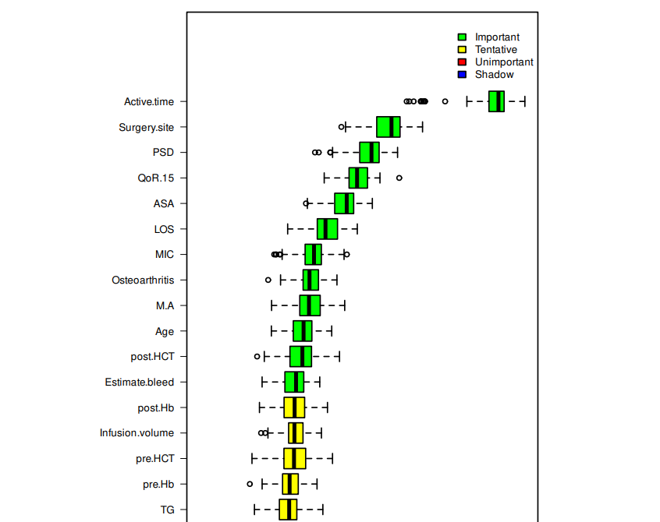
Supplementary Figure 1 Variable selection for the multiple logistic regression based on Boruta.
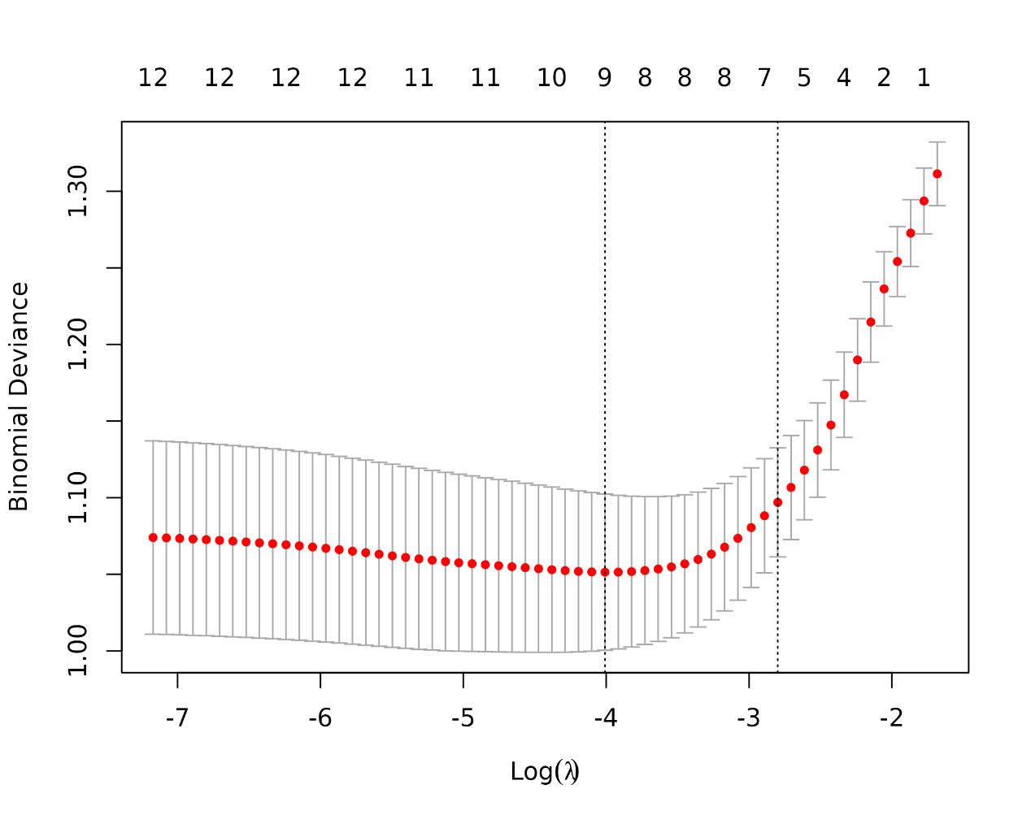
Supplementary Figure 2 The variation characteristics of the coefficient of variables.

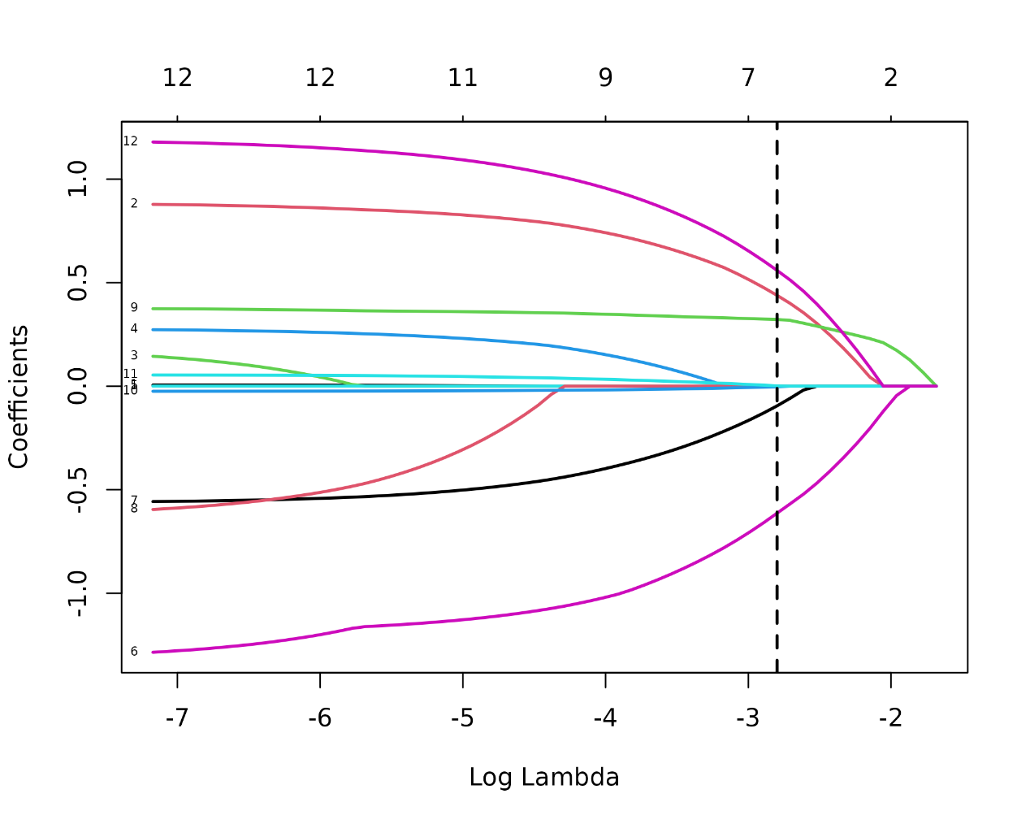
Supplementary Figure 3 The selection process of the optimum value of the parameter λ in the Lasso regression model by cross-validation method.

Reference
[1] Abellan van Kan G, Rolland Y, Bergman H, Morley JE, Kritchevsky SB, Vellas B. The I.A.N.A Task Force on frailty assessment of older people in clinical practice. The journal of nutrition, health & aging. 2008;12:29-37.
[2] Borson S, Scanlan JM, Chen P, Ganguli M. The Mini-Cog as a screen for dementia: validation in a population-based sample. Journal of the American Geriatrics Society. 2003;51:1451-4.
[3] Spitzer RL, Kroenke K, Williams JB, Löwe B. A brief measure for assessing generalized anxiety disorder: the GAD-7. Archives of internal medicine. 2006;166:1092-7.
[4] Kroenke K, Spitzer RL, Williams JB. The PHQ-9: validity of a brief depression severity measure. Journal of general internal medicine. 2001;16:606-13.
[5] Feinkohl I, Janke J, Hadzidiakos D, Slooter A, Winterer G, Spies C, et al. Associations of the metabolic syndrome and its components with cognitive impairment in older adults. BMC geriatrics. 2019;19:77.
[6] Marcantonio ER, Ngo LH, O'Connor M, Jones RN, Crane PK, Metzger ED, et al. 3D-CAM: derivation and validation of a 3-minute diagnostic interview for CAM-defined delirium: a cross-sectional diagnostic test study. Annals of internal medicine. 2014;161:554-61.
[7] Gandolfi JV, Di Bernardo APA, Chanes DAV, Martin DF, Joles VB, Amendola CP, et al. The Effects of Melatonin Supplementation on Sleep Quality and Assessment of the Serum Melatonin in ICU Patients: A Randomized Controlled Trial. Critical care medicine. 2020;48:e1286-e93.
[8] Caruana N, McKinley S, Elliott R, Gholizadeh L. Sleep Quality During and After Cardiothoracic Intensive Care and Psychological Health During Recovery. Journal of Cardiovascular Nursing. 2018;33:E40-E9.
[9] Liu. DD, Li. XP, Nie. XH, Hu. QF, Wang. JD, Hai. LZ, et al. Artificial intelligent patient-controlled intravenous analgesia improves the outcomes of older patients with laparoscopic radical resection for colorectal cancer. European geriatric medicine. 2023;14:1403-10.
[10] Qiu D, Wang XM, Yang JJ, Chen S, Yue CB, Hashimoto K, et al. Effect of Intraoperative Esketamine Infusion on Postoperative Sleep Disturbance After Gynecological Laparoscopy: A Randomized Clinical Trial. JAMA Netw Open. 2022;5:e2244514.
[11] Jiang Y, Xie Y, Fang P, Shang Z, Chen L, Zhou J, et al. Cognitive Training for Reduction of Delirium in Patients Undergoing Cardiac Surgery: A Randomized Clinical Trial. JAMA Netw Open. 2024;7:e247361.

