Isoptericola rhizosphaerae sp. nov. and Isoptericola aurantiacus sp. nov. two novel bacteria isolated from rhizosphere soil
Haifei Liu¹, Quan Yang¹, Jiawei Li¹, Fei Yang¹, Caifei Li¹, Ding Li¹, Ying Sun¹, Lifang Yang², Mingguo Jiang^{1, *}
¹School of Marine Science and Biotechnology, Guangxi Key Laboratory for Polysaccharide Materials and Modifications, Guangxi Minzu University, Nanning 530008, PR China;
² School of Chemistry and Chemical Engineering, Guangxi Key Laboratory of Chemistry and Engineering of Forest Products, Guangxi Minzu University, Nanning 530008, PR China;
*Authors for correspondence
Mingguo Jiang
Tel & Fax: +86-771-3267023
Email: mzxyjiang@163.com ORCID:0000-0003-2279-5740

Fig. S1 Phylogenetic tree based on the Neighbor-Joining tree using 16S rRNA gene sequences. The tree illustrates that the two novel species (indicated in red type) cluster with a clade of related species of Isoptericola.

Fig. S2 Phylogenetic tree based on publically available whole-genome sequence. Tree was constructed using UBCG. Rarobacter faecitabidus DSM 4813^{T}(GCF_004135385) was used as an outlier.

Fig. S3 Venn diagram of the comparative ortholog analysis of four related genomes. Venn diagram was constructed using OrthoVenn3. Strain 1, GXG3202^{T}; Strain 2, GXG9306^{T}; Strain 3, I. chiayiensis 06182M-1^{T}; Strain 4, I. halotolerans YIM 70177^{T}.

Fig. S4 Counts of metabolic related genes annoted in GXG3202^{T}, GXG9306^{T} and closely related species of Isoptericola
A:Nitrogen Metabolism; B:Photosynthesis; C:Carbohydrates; D:DNA Metabolism; E:Nucleosides and Nucleotides; F:Phages, Prophages, Transposable elements, Plasmids; G:Iron acquisition and metabolism; H:Membrane Transport; I:RNA Metabolism; G:Secondary Metabolism;K:Cofactors, Vitamins, Prosthetic Groups, Pigments; L:Stress Response; M:Motility and Chemotaxis; N:Potassium metabolism; O:Sulfur Metabolism; P:Amino Acids and Derivatives; Q:Miscellaneous; R:Phosphorus Metabolism; S:Respiration; T:Metabolism of Aromatic Compounds; U:Dormancy and Sporulation; V:Cell Wall and Capsule; W:Fatty Acids, Lipids, and Isoprenoids; X:Virulence, Disease and Defense; Y:Regulation and Cell signaling;Z:Protein Metabolism
.

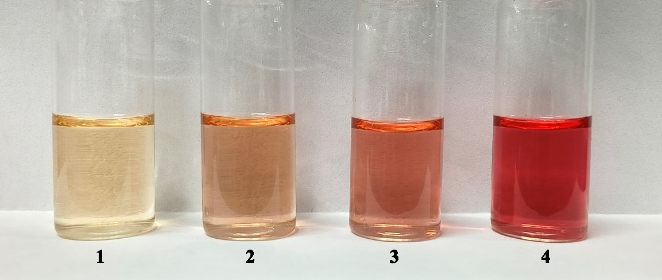
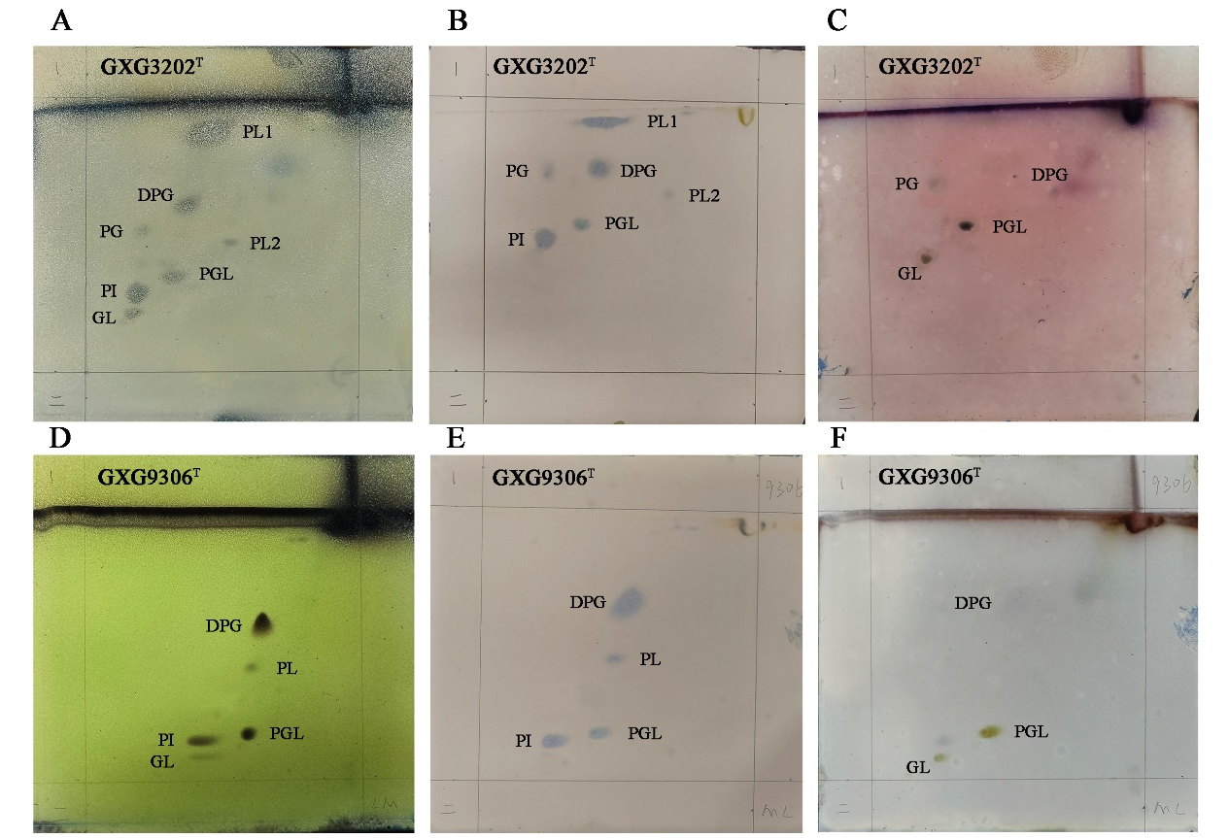
Fig. S5 Qualitative production of indole-3-acetic acid. The clearing of the solution indicates the production of IAA. “1”= LB (blank control); “2”= GXG9306^{T}+20mg/L tryptophan+LB; “3”= GXG3202^{T}+20mg/L tryptophan+LB; “4”= 40mg/mL IAA+LB (negative control).
Fig. S6 Polar lipids in GXG3202^{T} and GXG9306^{T} as determined by two-dimensional TLC and detected with the use of molybdophosphoric acid reagent (A, D), Dittmer and Lester reagent (B, E), and Anisaldehyde reagent (C, F). The analyses were conducted in the present study. DPG: diphosphatidylglycerol; PGL: phosphoglycolipids; PI: phosphatidylinositol; GL: glycolipids; PLS: phospholipids; PG: phosphatidylglycerol.
Fig. S7 Habitat preference scores for strains GXG3202^{T} and GXG9306^{T}; Spider plot visualization of the habitat distribution of strains GXG3202^{T} and GXG9306^{T}.

Table S1 Comparison of ANI, AAI and dDDH values between strain GXG3202^{T}, GXG9306^{T} and closely related species of Isoptericola.
Strain 1 | Strain 2 | ANI (%) | AAI(%) | dDDH (%) | 16S rRNA gene identity (%)
GXG3202^{T} | GXG9306^{T} | 81.1 | 79.7 | 39.1 | 98.3
GXG3202^{T} | I. halotolerans YIM 70177^{T} | 83.6 | 83.8 | 51.2 | 98.8
GXG3202^{T} | I. chiayiensis  BCRC 16888^{T} | 80.6 | 78.7 | 36.4 | 98.4
GXG9306^{T} | GXG3202^{T} | 81.1 | 79.7 | 39.1 | 98.3
GXG9306^{T} | I. halotolerans  YIM 70177^{T} | 80.6 | 79.3 | 38.6 | 97.9
GXG9306^{T} | I. chiayiensis  BCRC 16888^{T} | 82.9 | 82.3 | 53.1 | 98.6

Table S2 AntiSMASH analysis of GXG3202^{T}, GXG9306^{T}, and closely related species of Isoptericola. 1, GXG3202^{T}; 2,GXG9306^{T}; 3, I. halotolerans YIM 70177^{T}; 4, I. chiayiensis 06182M-1^{T}.
 | 1 | 2 | 3 | 4
NI-siderophore | + | + | + | +
T3PKS* | + | + | + | –
Terpene | + | + | + | +
Ectoine | + | + | + | +
Lassopeptide | + | + | – | –
Furan | – | + | – | –
Betalactone | + | – | + | –
Arylpolyene | + | – | – | –
RiPP-like | + | – | – | –
NRPS* | – | – | + | –
NAPAA* | – | – | + | –
T3PKS: Type III Polyketide synthase. NRPS: Non-ribosomal peptide synthetase. NAPAA：Non-alpha poly-amino acids like e-Polylysin.

Table S3 Cellular fatty acid composition of GXG3202^{T}, GXG9306^{T}, and closely related species of Isoptericola. Compounds occurring at percentages of 1 or higher are presented. All data were obtained in the current study in the same laboratory under standardized conditions. ND, not determined.
Fatty acids (%) | GXG3202^{T} | GXG9306^{T} | I. halotolerans  YIM 70177^{T} | I. chiayiensis  BCRC 16888^{T}
iso-C_{14:0} | 5.0 | 4.2 | 1.3 | 1.8
iso-C_{15:0} | ND | 9.8 | 4.5 | 12.1
anteiso-C_{15:0} | 48.6 | 50.5 | 53.6 | 55.1
C_{16:0} | 14.7 | 12.7 | 17.6 | 9.7
iso-C_{16:0} | 9.2 | 4.7 | 2.0 | 5.1
anteiso-C_{17:0} | 10.9 | 7.7 | 18.1 | 8.8

