Supplementary Materials for

Perovskite Solar Cell Architecture without Charge Transport Materials
Zhanhao Hu, Nao Saito, Masashi Ikegami, Naoyuki Shibayama*, Tsutomu Miyasaka*
Graduate School of Engineering, Toin University of Yokohama, Yokohama, Kanagawa Prefecture, Japan.
*Corresponding author. Email: miyasaka@toin.ac.jp; shibayama@toin.ac.jp

The PDF file includes:

Materials
Device fabrication
Characterizations
Figs. S1 to S7
Tables S1

Materials
Reagents used in this study include methylammonium iodide (MAI, TCI), methylammonium bromide (MABr, TCI), formamidinium iodide (FAI, Sigma-Aldrich), caesium iodide (CsI, TCI), methylammonium chloride (MACl, Luminescence Technology Corp.), lead iodide (PbI₂, 99.99%, TCI), rubidium chloride (RbCl), [2-(3,6-Dimethoxy-9H-carbazol-9-yl)ethyl]phosphonic acid (MeO-2PACz, TCI), 4-(1',5'-Dihydro-1'-methyl-2'H-[5,6]fullereno-C60-Ih-[1,9-c]pyrrol-2'-yl)benzoic acid (C60-SAM, Sigma-Aldrich), ethanol (Super dehydrated, Wako), isopropanol (IPA, Super dehydrated, Wako), toluene (Super Dehydrated, Wako), N,N-dimethylformamide (DMF, Super dehydrated, Wako), dimethyl sulfoxide (DMSO, Super dehydrated, Wako), chlorobenzene (CB, Sigma-Aldrich), tetrahydrofuran (THF, Super dehydrated, Wako), acetone (Wako), octane-1,8-diamine dihydroiodide (ODADI, TCI) and ethyl acetate (Super dehydrated, Wako). All reagents were used as received without further purification. ITO glass substrates (12 Ω/sq, ITO is patterned) were purchased from Yingkou OPV Tech New Energy Co., Ltd.

Device fabrication
ITO glass substrates were cleaned sequentially with detergent, deionized water, acetone and isopropanol by ultrasonic bath. Subsequently, ITO substrates were treated with UV-ozone (ASM401oz, ASUMI GIKEN) for 15 min. To deposit the p-SAM, MeO-2PACz (0.1 mM in ethanol) was spin-coated (Opticoat MS-A100, MIKASA) on the ITO substrate followed by thermal annealing at 100 ℃ for 10 min. To remove the unbonded molecules, ethanol was spin-coated on the deposited p-SAM. Similarly, to deposit the n-SAM, C60-SAM (1 mM in the mixed solvents of CB and THF (1:1 v/v)) was spin-coated on the ITO substrate followed by thermal annealing at 100 ℃ for 10 min. The film was subsequently washed by its solvent to remove unbonded molecules.
To deposit MAPbI₃, the precursor was prepared by mixing 465.6 mg PbI₂ and 159 mg MAI in 530 uL DMF and 73 uL DMSO. The precursor was spin-coated on the substrate at 3800 rpm for 40 s. At 10 s from the start of spin-coating, toluene as the anti-solvent was dropped onto the film. The resultant sample was pre-annealed at 60 ℃ for 5 min and subsequently annealed at 100 ℃ for 15 min.
For the deposition of FAPbI₃, 1.5 M of PbI₂ mixed with 5 molar% RbCl was dissolved in the mixed solvents of DMF and DMSO (9:1 v/v) and spin-coated on the substrate at 1500 rpm for 30 s. The resultant PbI₂ layer was annealed at 70 ℃ for 1 min. To form the perovskite, a solution of FAI (90 mg) and MACl (10 mg) in 1 mL IPA was spin-coated onto PbI₂ at 1800 rpm for 30 s. The resultant film was annealed at 150 °C for 15 min.
To deposit Cs_{0.05}FA_{0.85}MA_{0.1}PbI₃ (CsFAMAPbI), the precursor solution (1.5 M) was prepared by mixing CsI (19.5 mg), FAI (219.3 mg), MAI (23.8 mg) and PbI₂ (760.7 mg) in 1 mL mixed solvents of DMF:DMSO (4:1 v/v). 12.5 mol% of MACl and 0.08 mol% of ODADI was also added into the precursor. The precursor was spin-coated on the substrate at 1000 rpm for 10 s, and subsequently accelerated to 5000 rpm for 40 s. 5 s before the end of spin-coating, 200 μL ethyl acetate was dripped onto the film as the anti-solvent. The substrates were then annealed at 100 °C for 30 min.
To make the complete device, the fabricated samples were stacked together with their perovskite layers in contact, and were put on the hotplate of a hot-press (N4053-00, NPa SYSTEM Co., Ltd.). The hot-press has two hotplates at the top and bottom which press onto the sample. As shown in Extended Data Fig. 1a, to avoid adhesion of the sample onto the hotplates, polytetrafluoroethylene (PTFE) sheets (TOMBO No. 9001, NICHIAS Corporation) were placed at the top and bottom of the sample. Additionally, a piece of silicone rubber (5 mm thickness, AS ONE Corporation) was placed between the top hot-plate and the top PTFE sheet to ensure a uniform pressure on the sample. Both the top and bottom hotplates were set at 150 ℃, and the pressure was gradually increased to 1.2×10⁷ Pa. The maximum pressure was kept for 20 min, after which the pressure was released gradually and the sample was taken off from the hotplate. (Lower temperature and pressure do not consistently result in successful lamination, likely because the perovskite species require a threshold activation energy to become sufficiently mobile for fusion. Additionally, adequate pressure is needed to bring the two films into intimate contact without trapping air bubbles between them.) The same hot-press process conditions were used for fabricating MAPbI₃, FAPbI₃, and CsFAMAPbI devices. (We would like to note that the process conditions were not fine-tuned in this study, and further optimization could likely lead to improved film quality and, consequently, higher device efficiency.) The two ITO substrates used for the anode and cathode have different patterns so that when stacked, the device area (0.09 cm²) is defined by the overlapping ITO (Extended Data Fig. 1b). Device characterizations were carried out after the sample has cooled down to room temperature.
During the process above, solution preparation and thin film deposition were carried out in a dry room (at about 24 ℃ and a dewpoint of −20 ℃). Hot-press of the perovskites was carried out in the ambient air without humidity control (about 24 ℃ and 60 % RH).

Characterizations
J-V characteristics were measured in the ambient air using a source meter (Keithley 2420) and a solar simulator (PEC-L01, Peccell Technologies Inc., Xenon white light source) under 1-Sun illumination condition (AM1.5G, 100 mW/cm²) calibrated by a reference silicon cell (BS-520, Bunkoukeiki Co., Ltd.). The active area is determined by the patterned ITO (Extended Data Fig. 1b) and a photomask (0.09 cm²). All the J-V curves were measured with a scan rate of 0.10 V/s without preconditioning. The external quantum efficiency spectrum was acquired in the ambient air by PEC-S20 spectrometer (Peccell Technologies Inc.) which was calibrated by a reference silicon cell (S1337-1010BQ, Bunkoukeiki Co., Ltd.). MPPT measurement was conducted in the ambient air (25±5 ℃) using a solar simulator (PEC-L11, Peccell Technologies Inc.) and a source meter (B2901A, Keysight Technologies) operated by a home-made program. No specific measures were taken to control the device temperature.
Electroluminescence was recorded in a dark room using a near-infrared-sensitive camera (CS-W50HD, PLANEX COMMUNICATIONS Inc.). A heat-absorbing filter (S76-HA50, SURUGA SEIKI Co., Ltd.) was placed over the device to block infrared radiation caused by device heating, ensuring that only electroluminescence was detected.
For all the characterizations above, no particular encapsulation was applied to the devices.
XRD was measured by Rigaku MiniFlex 600 with Cu 3 Kα radiation (40 kV, 15 mA). SEM imaging was conducted on JSM-IT710HR (JEOL Ltd.). The UPS spectra were recorded with Kratos Nova photoelectron spectrometer (Shimadzu Co.) equipped with a He-I source (21.22 eV). The binding energy values were calibrated by measuring a clean Au surface. Kelvin-probe force microscopy images were obtained by Shimadzu SPM-9700HT operated in the ambient air. The UV-vis absorption spectra were acquired using Shimadzu UV-1800 Spectrophotometer. The photoluminescence spectra were obtained using JASCO FP-8600 Spectrometer.

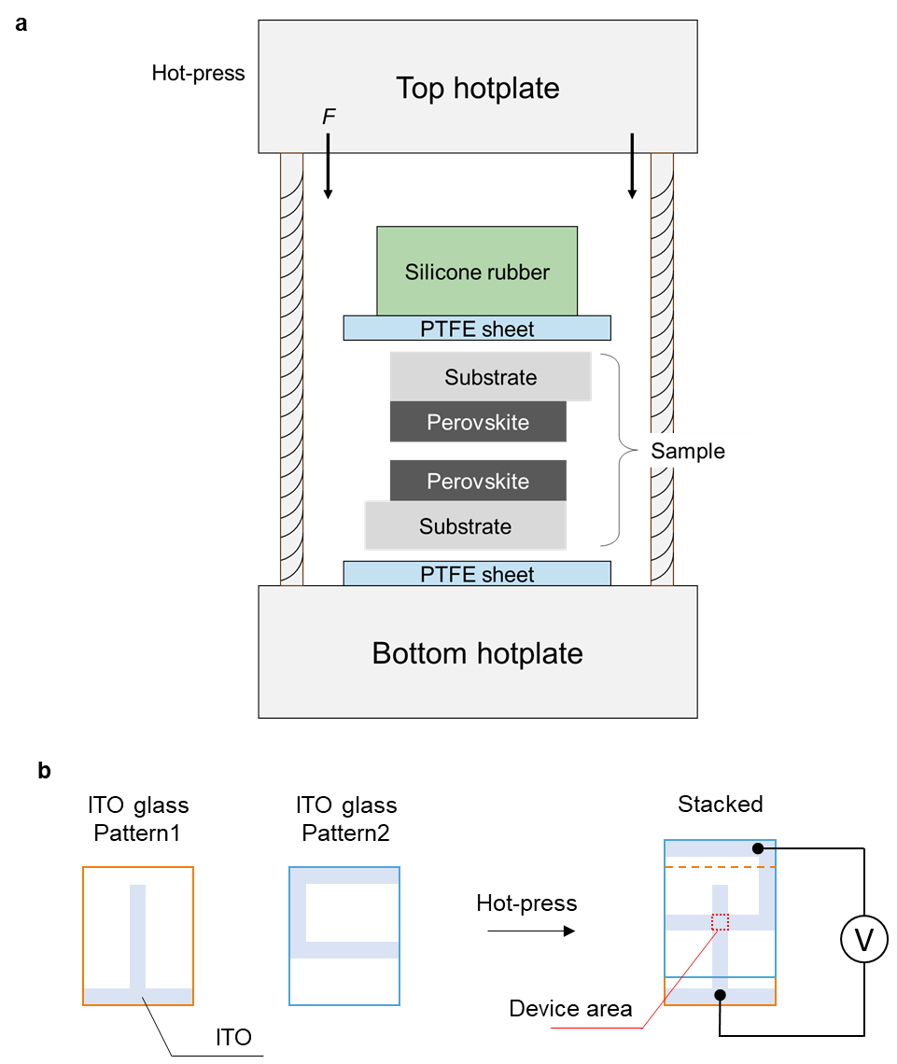

Fig. S1 | Device fabrication. (a) To fuse two perovskite layers, two perovskite samples were stacked together and placed between the two hotplates in a hot-press. PTFE sheets were placed beneath and on top of the samples, and a piece of silicone rubber was put beneath the top hotplate. (b) ITO glass substrates with two types of ITO patterns were used. The stacked samples give a device area of 0.09 cm² defined by the overlapping ITO.

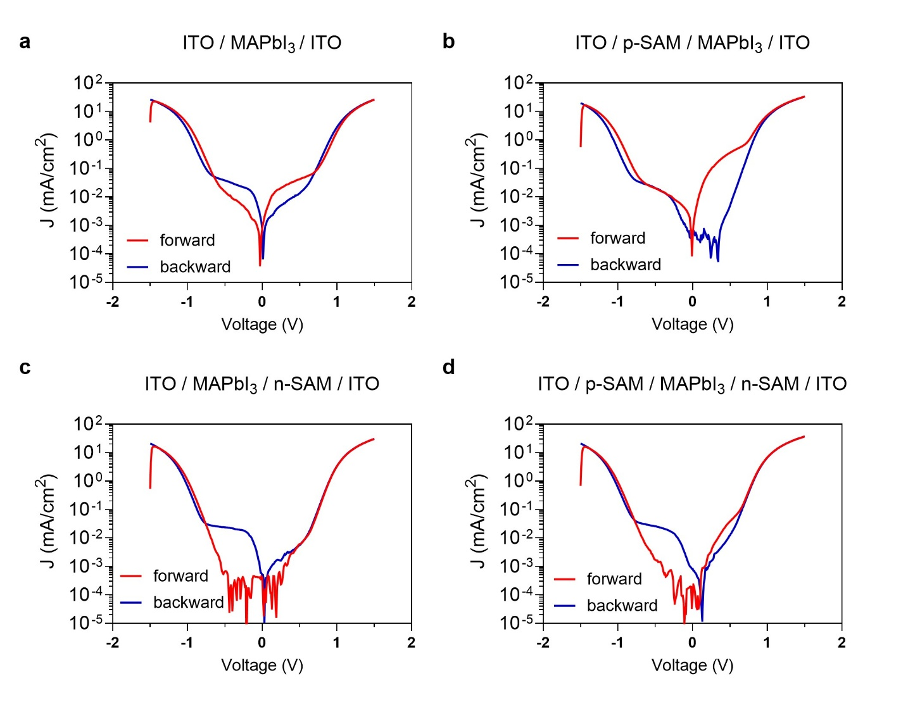

Fig. S2 | Dark J-V characteristics of the four types of devices under a voltage scan from −1.5 V to 1.5 V and subsequently from 1.5 V to −1.5 V. (a) The device with no SAMs. (b) The device incorporating only the p-SAM. (c) The device incorporating only the n-SAM. (d) The device incorporating both the p-SAM and n-SAM.

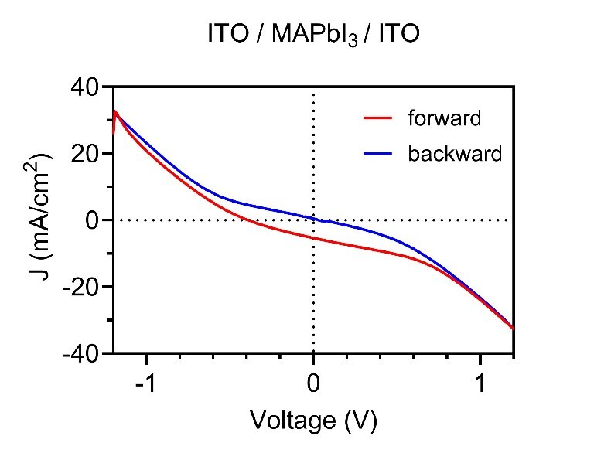

Fig. S3 | Photovoltaic J-V curves of the device ITO/MAPbI₃/ITO under 1-Sun illumination.

Fig. S4 | Statistical distribution of the device performance. (a) J_{SC}, (b) V_{OC}, (c) FF and (d) PCE of the devices incorporating only the p-SAM (ITO/p-SAM/MAPbI₃/ITO), incorporating only the n-SAM (ITO/MAPbI₃/n-SAM/ITO), and incorporating both the p-SAM and n-SAM (ITO/p-SAM/MAPbI₃/n-SAM/ITO). The boxplot shows the minimum, the maximum, the median and the first and third quartiles.

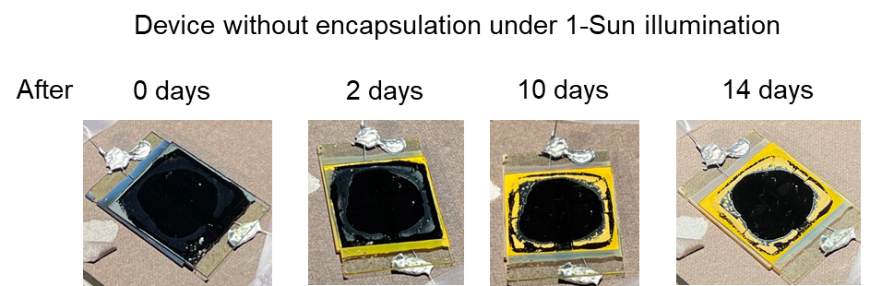

Fig. S5 | Degradation of the device (ITO/p-SAM/MAPbI₃/n-SAM/ITO) under 1-Sun illumination in a duration of 14 days. No particular encapsulation is added.

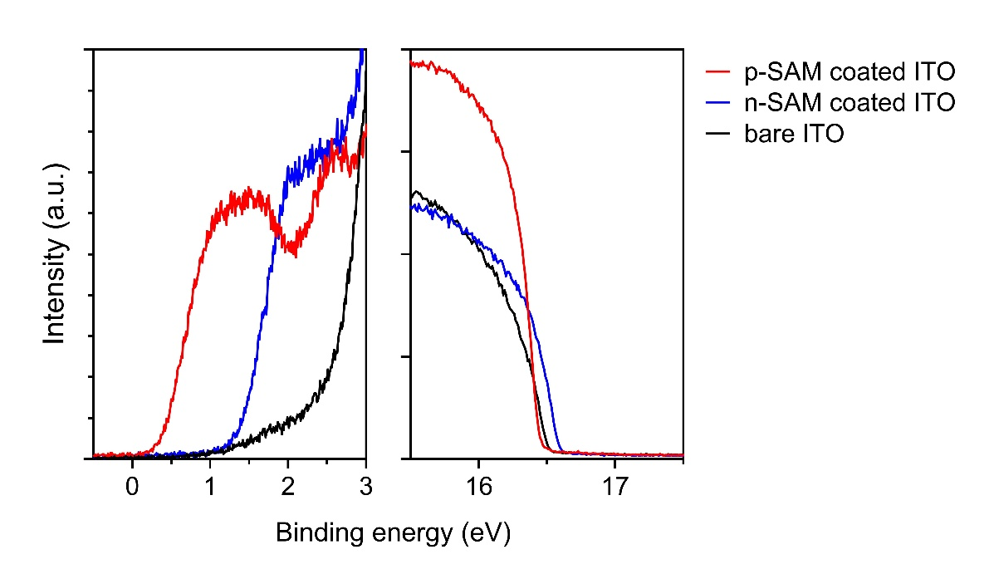

Fig. S6 | UPS spectra showing the Fermi edge and secondary electron cut-off. The binding energy (x-axis) and intensity (y-axis) are in the linear scale.

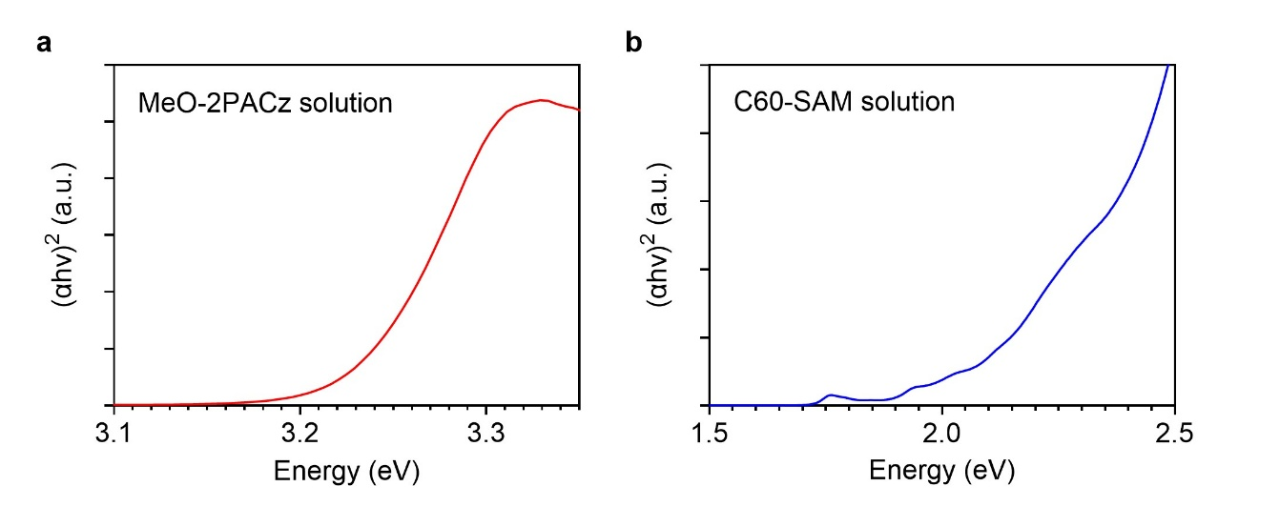

Fig. S7 | Tauc plot of the UV-vis absorption spectra. (a) The absorption spectrum of the MeO-2PACz solution. (b) The absorption spectrum of the C60-SAM solution.

Table S1 | Photovoltaic performances of the devices (ITO/p-SAM/perovskite/n-SAM/ITO) incorporating MAPBI₃, FAPbI₃ and CsFAMAPbI as the perovskite layer.

Perovskite | J_{SC} (mA/cm²) | V_{OC} (V) | FF (%) | PCE (%)
Perovskite | Forward / Reverse
MAPbI₃ | 18.9 / 19.1 | 0.96 / 0.98 | 39.0 / 45.2 | 7.06 / 8.40
FAPbI₃ | 16.8 / 16.6 | 1.01 / 1.00 | 43.3 /39.6 | 7.34 / 6.53
CsFAMAPbI | 18.8 / 18.8 | 0.93 / 0.92 | 47.0 / 48.0 | 8.22 / 8.32

