Supporting information (SI)
Ultralow-cost personal PCRstrip with volumetric heating based on broadband absorption plasmonic fabric for POCT of pathogens
Yu Luª, Chang Liuª, Qifan Zhouª, Yan Huangª, Jingwei Yi^{b}, Wei Jin^{b}, Zhonghua Liu^{b}, Bangshun He^{c,*}, Xiangwei Zhao^{a,*}
a, State Key Laboratory of Digital Medical Engineering, School of Biological Science and Medical Engineering, Southeast University, Nanjing 211189, China. E-mail: xwzhao@seu.edu.cn
b, Jiangsu Bioperfectus Technologies Co., Ltd., Shanghai 201114, China
c, Department of Laboratory Medicine, Nanjing First Hospital, Nanjing Medical University, Nanjing 210006, China. E-mail: bhe@njmu.edu.cn

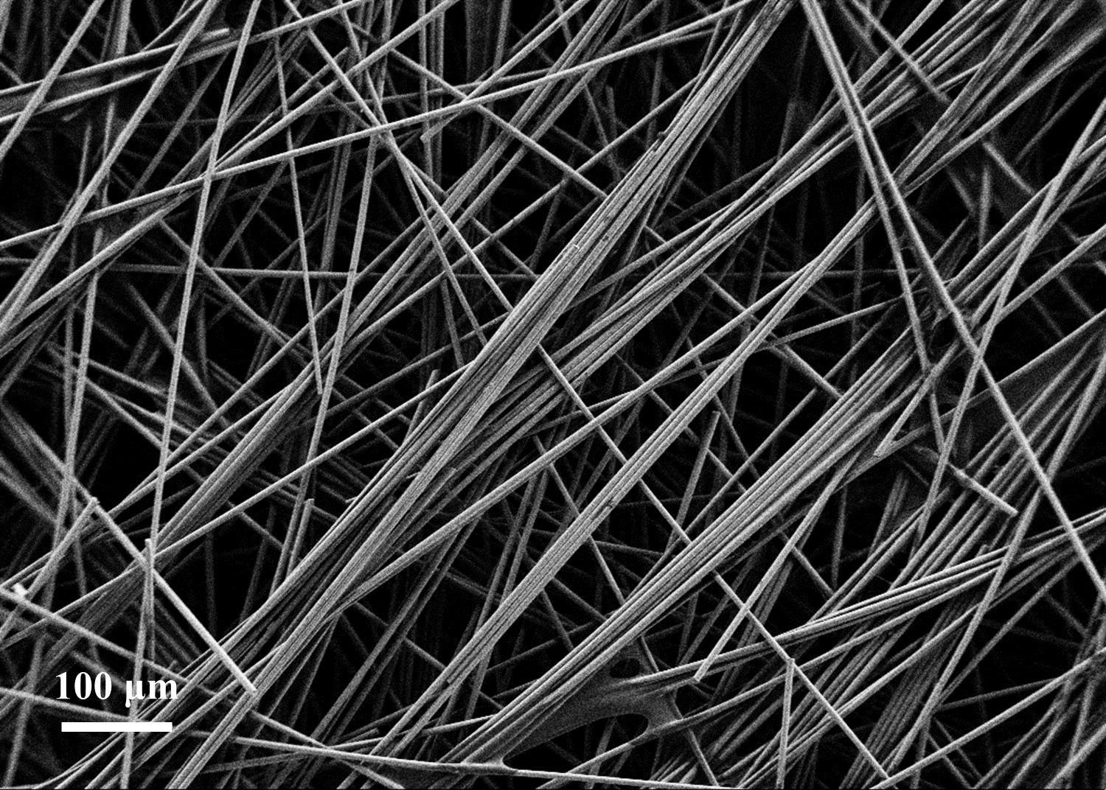
Figure S1 SEM image of GF

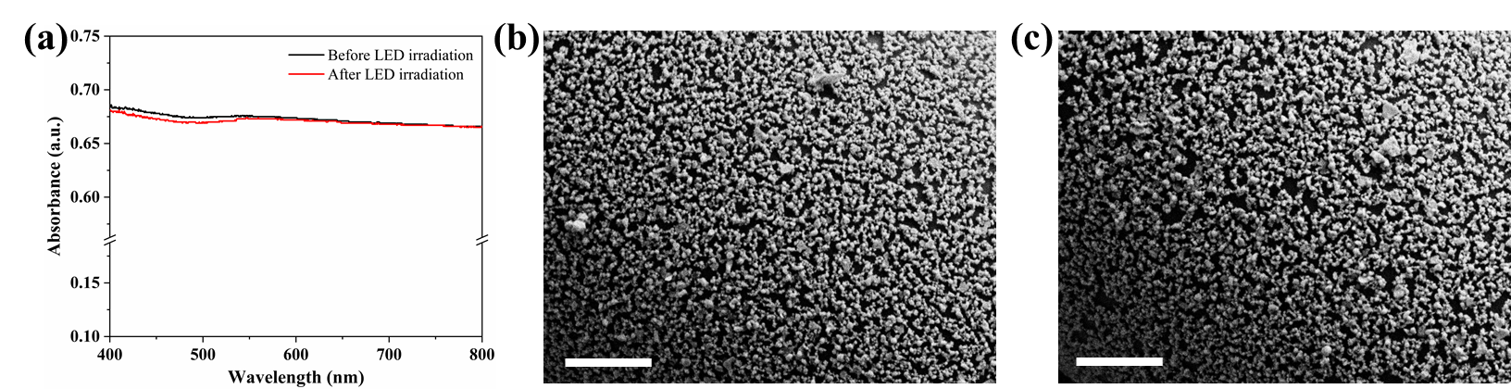
Figure S2 Thermal stability of silica coated BAPF. (a) Absorbance of silica coated BAPF before and after white LED irradiation. SEM image of silica coated BAPF before (b) and after (c) white LED irradiation. Scale bars are 1 μm.

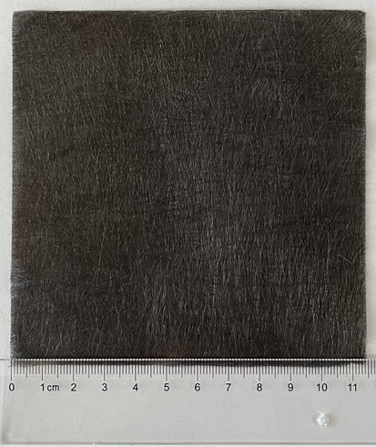
Figure S3 Digital image of BAPF with dimension of 11 cm×11 cm

Figure S4 Temperature profile of six batches of BAPF under white LED

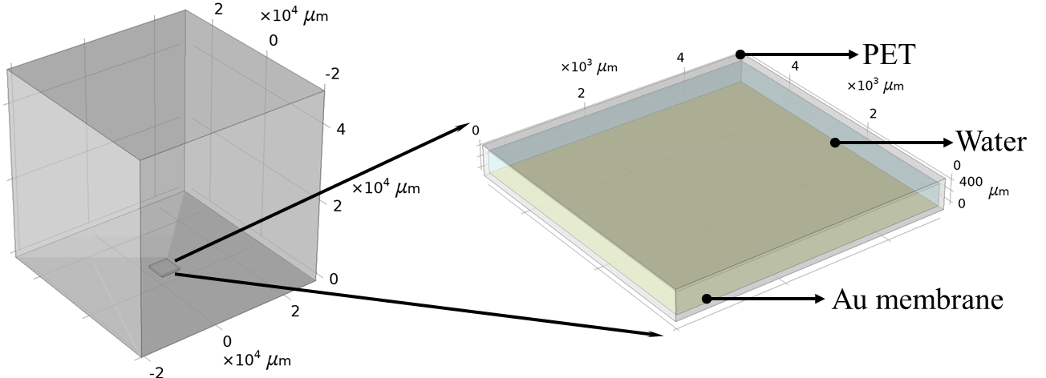
Figure S5 Detailed model structure of solution on Au membrane

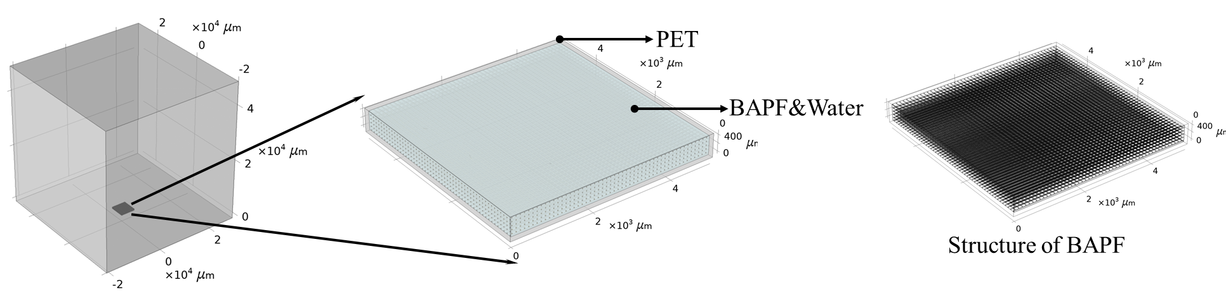
Figure S6 Detailed model structure of solution in BAPF

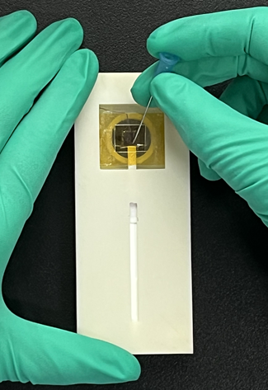
Figure S7 Digital image of the PET tape pricked by a needle after RT-PCR to release amplification products.

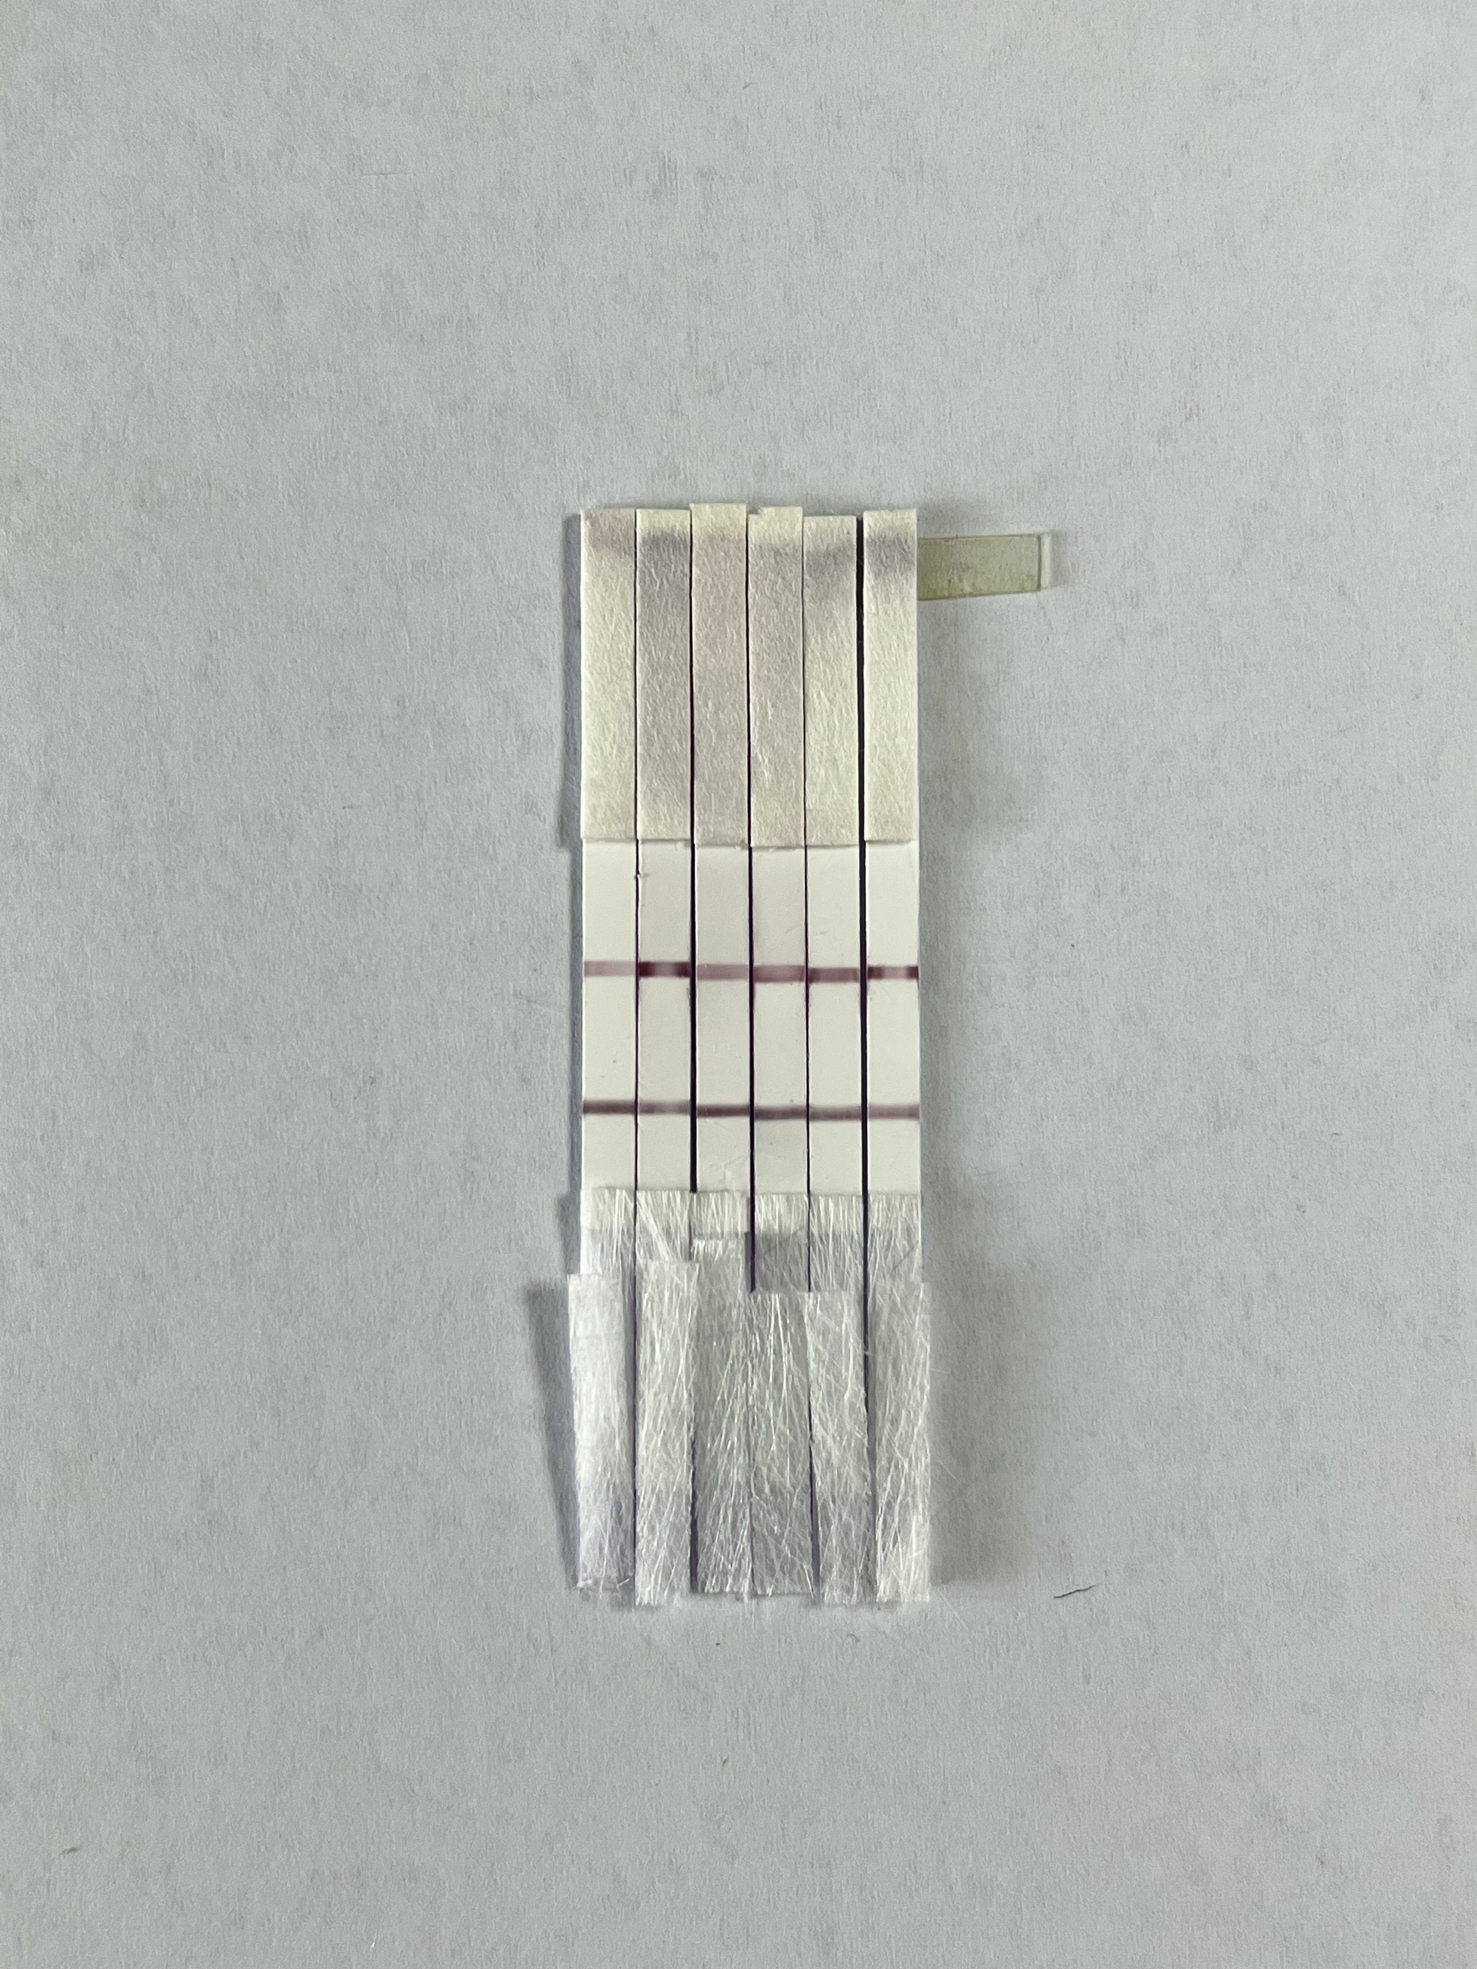
Figure S8 Test strips for six repetitions of influenza A photothermal RT-PCR products.

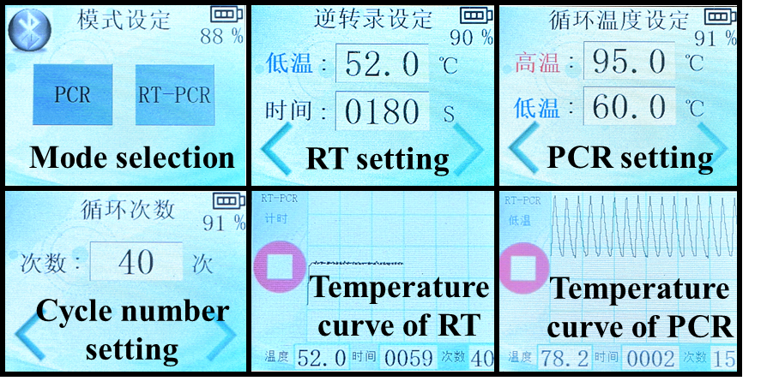
Figure S9 The graphical interface of POCT device
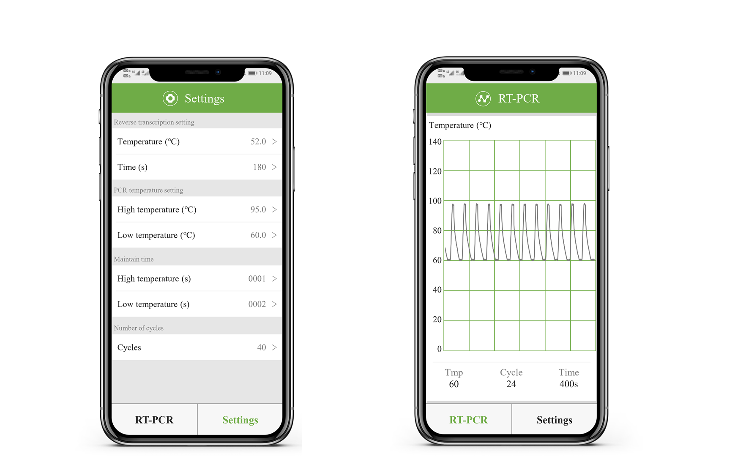
Figure S10 Application for the control of plasmonic thermocycler.

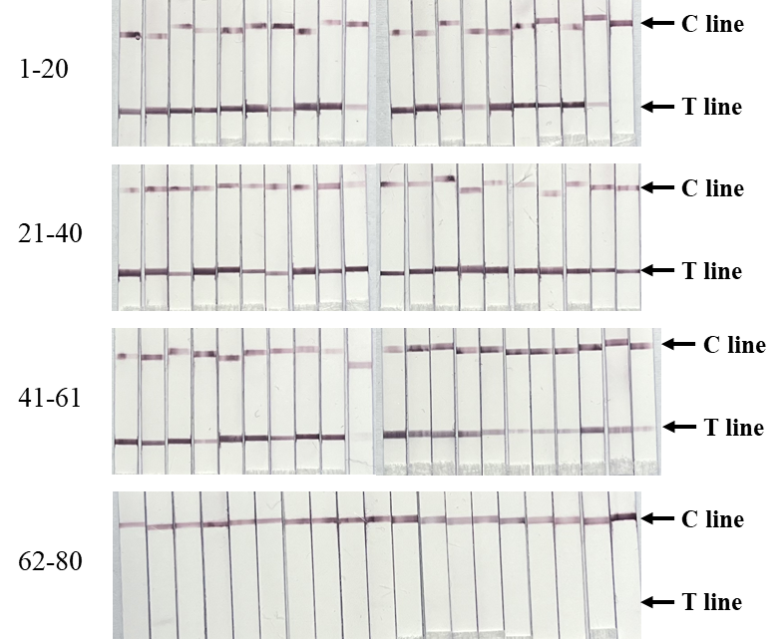
Figure S11 Images of lateral flow paper strips of 80 clinical samples

Table S1 Structure parameters in COMSOL Multiphysics
Component | Width | Depth | Height | Thickness | Diameter | Length | Additional explanation
Au membrane | 5 mm | 5 mm | 120 nm
PCR solution in Au membrane model | 5 mm | 5 mm | 400 μm |  |  |  | The volume of PCR was set to 10 μL.
PET |  |  |  | 60 μm
Glass Fiber |  |  |  |  | 20 μm | 5000μm
PCR solution in BAPF model |  |  | 450μm |  |  |  | The volume of PCR was set to 10 μL and the volume of glass fibers were considered.
Air | 50 mm | 50 mm | 50 mm

Table S2 Sequence of primer and modified primer for lambda DNA and influenza A H1N1
Specific gene | Type | Primer and probe sequence (5’-3’) | 5’ tag
Lambda DNA | Forward primer | CATCGTCTGCCTGTCATGGGCTGTTAAT | -
Lambda DNA | Reverse primer | TCGCCAGCTTCAGTTCTCTGCGATTT | -
Influenza A H1N1: matrix protein 1 | Forward primer | TAAAGACAAGACCAATCCTGTCACC | Biotin
Influenza A H1N1: matrix protein 1 | Reverse primer | TCCCATTTAGGGCATTTTGGACAAAGC | 6-FAM

Table S3 Target gene sequence of lambda DNA and influenza A
Specific gene | Target sequence
Lambda DNA (98 bp/48502 bp) | CATCGTCTGCCTGTCATGGGCTGTTAATCATTACCGTGATAACGCCATTACCTACAAAGCCCAGCGCGACAAAAATGCCAGAGAACTGAAGCTGGCGA
Influenza A H1N1: matrix protein 1 (123 bp/759 bp) | TAAAGACAAGACCAATCCTGTCACCTCTGACTAAGGGGATTTTAGGATTTGTGTTCACGCTCACCGTGCCCAGTGAGCGAGGACTGCAGCGTAGACGCTTTGTCCAAAATGCCCTTAATGGGA

Table S4 C_{t} value information of all clinical samples
Influenza A positive samples
No. | Ct | No. | Ct | No. | Ct | No. | Ct
1 | 24.01 | 17 | 25.45 | 33 | 24.18 | 49 | 23.31
2 | 21.90 | 18 | 20.40 | 34 | 21.12 | 50 | 34.15
3 | 22.85 | 19 | 31.74 | 35 | 20.60 | 51 | 21.35
4 | 22.13 | 20 | 29.96 | 36 | 22.50 | 52 | 26.16
5 | 23.37 | 21 | 21.53 | 37 | 18.96 | 53 | 25.69
6 | 18.18 | 22 | 21.20 | 38 | 21.34 | 54 | 25.49
7 | 28.09 | 23 | 25.28 | 39 | 25.47 | 55 | 28.38
8 | 21.45 | 24 | 19.80 | 40 | 26.23 | 56 | 33.18
9 | 20.15 | 25 | 21.53 | 41 | 21.05 | 57 | 30.36
10 | 31.58 | 26 | 24.70 | 42 | 24.15 | 58 | 30.72
11 | 19.95 | 27 | 26.15 | 43 | 22.07 | 59 | 24.16
12 | 20.04 | 28 | 19.23 | 44 | 28.49 | 60 | 26.29
13 | 21.64 | 29 | 25.53 | 45 | 20.76 | 61 | 34.13
14 | 27.50 | 30 | 22.80 | 46 | 21.88
15 | 20.34 | 31 | 24.77 | 47 | 26.81
16 | 22.18 | 32 | 23.40 | 48 | 24.17

Influenza A negative samples
No. | Ct | No. | Ct | No. | Ct | No. | Ct
62 | 35.81 | 67 | 36.29 | 72 | 37.12 | 77 | 37.79
63 | 35.83 | 68 | 35.83 | 73 | 35.97 | 78 | 36.61
64 | 35.87 | 69 | 36.02 | 74 | 35.96 | 79 | 36.13
65 | 36.11 | 70 | 36.57 | 75 | 36.53 | 80 | 36.30
66 | 35.65 | 71 | 35.18 | 76 | 35.48

Table S5 Main components for construction of the photothermal PCR system
Components | Model/material |  | Price (USD) | Quantity
Control board | STM32F407 |  | 4.13 | 1
Type-K thermocouple | KPS-QB-K |  | 1.10 | 1
Thermocouple module | MAX31855 |  | 4.31 | 1
White LED with focus lens | Luxeon M |  | 3.19 | 1
Cooper radiator with fan | XINYI |  | 1.84 | 1
LED driver | ZS-1208 |  | 1.52 | 1
Cooling fan with motor module | L9110 |  | 1.65 | 1
Lithium-ion batteries with charger | 12V, 3000 mAh |  | 7.35 | 1
TFT LCD touch panel | TJC3224T124 |  | 4.13 | 1
Bluetooth module | HC-05 |  | 1.54 | 1
3D printed parts (body+chip) | Homemade |  | 20.67 | 1
Lateral flow paper strip | Homemade |  | 0.69 | 1
Total price |  | 52.12 (USD)

