Supporting information

Extrapolative-machine-learning-guided discovery of multi-elemental heterogeneous catalysts for low-temperature NO reduction by H₂

Yuan Jing,^{1†} Chenyang Zhang,^{1†} Shinya Mine,^{2†} Xiupeng Zhang,¹ Chenxi He,¹ Ningqiang Zhang,¹ Xu Guo,¹ Akihiko Anzai,¹ Kohei Oka,³ Ryo Toyoshima,⁴ Hiroshi Kondoh,⁵ Ichigaku Takigawa,*^{6,7}
Ken-ichi Shimizu,*¹ Takashi Toyao*¹

¹ Institute for Catalysis, Hokkaido University, N-21, W-10, Sapporo 001-0021, Japan
² Research Institute for Chemical Process Technology, National Institute of Advanced Industrial Science and Technology (AIST), 4-2-1 Nigatake, Miyagino-ku, Sendai 983-8551, Japan
³ Isuzu Advanced Engineering Center, Ltd., 8 Tsuchidana, Fujisawa 252-0881, Japan
⁴ Department of Materials Engineering, The University of Tokyo, Bunkyo, Tokyo 113-8656, Japan
⁵ Department of Chemistry, Keio University, 3-14-1 Hiyoshi, Kohoku-ku, Yokohama 223-8522, Japan
⁶ Center for Innovative Research and Education in Data Science (CIREDS), Institute for Liberal Arts and Scieneces, Kyoto University, Kyoto 606-8315, Japan
⁷ Institute for Chemical Reaction Design and Discovery (WPI-ICReDD), Hokkaido University, N-21, W-10, Sapporo 001-0021, Japan

†These authors contributed equally to this work.

Table S1. Sources and purity of chemicals used to prepare catalysts.
AN | Symbol | Chemical formula | Purity/concentration | Company name
3 | Li | LiNO₃ | 99.99% | Kanto Chemical
11 | Na | NaNO₃ | 99.99% | Aldrich
12 | Mg | Mg(NO₃)₂ | 99.99% | Kanto Chemical
13 | Al | Al(NO₃)₃・9H₂O | 99.99% | Wako Chemical
14 | Si | Si(OCH₂CH₃)₄ | 97% | Tokyo Chemical Industry
15 | P | (NH₄)₂HPO₄ | 99% | Wako Chemical
16 | S | NH₄HSO₄ | 99.99% | Wako Chemical
19 | K | KNO₃ | 99.99% | Wako Chemical
20 | Ca | Ca(NO₃)₂・4H₂O | 98.5% | Wako Chemical
21 | Sc | Sc(OOCCH₃)₃・nH₂O | 98% | Tokyo Chemical Industry
22 | Ti | C₄H₁₀N₂O₁₀Ti | 99.99% | Alfa Aesar
23 | V | NH₄VO₃ | 99.99% | Wako Chemical
24 | Cr | Cr(NO₃)₃・9H₂O | 98.5% | Aldrich
25 | Mn | Mn(NO₃)₂・6H₂O | 99.99% | Wako Chemical
26 | Fe | Fe(NO₃)₃・9H₂O | 98% | Aldrich
27 | Co | Co(NO₃)₂・6H₂O | 99.99% | Wako Chemical
28 | Ni | Ni(NO₃)₂・6H₂O | 98% | Wako Chemical
29 | Cu | Cu(NO₃)₂・3H₂O | 99.99% | Aldrich
30 | Zn | Zn(NO₃)₂・6H₂O | 99.99% | Kanto Chemical
31 | Ga | Ga(NO₃)₃・8H₂O | 99.99% | Wako Chemical
32 | Ge | (NH₄)₂GeF₆ | 99.99% | Wako Chemical
34 | Se | H₂SeO₃ | 97% | Wako Chemical
37 | Rb | RbNO₃ | 99.99% | Wako Chemical
38 | Sr | Sr(NO₃)₂ | 98% | Kanto Chemical
39 | Y | Y(NO₃)₃・6H₂O | 99.99% | Mitsuwa Chemical
40 | Zr | Zr(NO₃)₂O・2H₂O | 99.99% | Mitsuwa Chemical
41 | Nb | Nb(HC₂O₄)₅・5H₂O | 95% | Mitsuwa Chemical
42 | Mo | (NH₄)₆Mo₇O₂₄・4H₂O | 99.99% | Wako Chemical
44 | Ru | Ru(NO)(NO₃)₃ | 1.5 wt% Ru aqueous solution | Strem Chemical
45 | Rh | Rh(NO₃)₃ | 50 g/L Rh aqueous solution | Tanaka Chemical
46 | Pd | Pd(NH₃)₂(NO₂)₂ | 50.5 g/L Pd aqueous solution | Kojima Chemical
47 | Ag | AgNO₃ | 99.99% | Wako Chemical
48 | Cd | Cd(NO₃)₂・4H₂O | 99% | Aldrich
49 | In | In(NO₃)₃・3H₂O | 99.99% | Kanto Chemical
50 | Sn | SnCl₂ | 99.99% | Kishida Chemical
51 | Sb | Sb(OOCCH₃)₃ | 99.99% | Aldrich
52 | Te | H₆TeO₆ | 99% | Mitsuwa Chemical
53 | I | HIO₃ | 99.5% | Aldrich
55 | Cs | CsNO₃ | 99.99% | Wako Chemical
56 | Ba | Ba(NO₃)₂ | 99.99% | Kanto Chemical
57 | La | La(NO₃)₃・6H₂O | 99.99% | Mitsuwa Chemical
58 | Ce | Ce(NO₃)₃・6H₂O | 99.99% | Wako Chemical
59 | Pr | Pr(NO₃)₃・6H₂O | 99.99% | Aldrich
60 | Nd | Nd(NO₃)₃・6H₂O | 99.5% | Wako Chemical
62 | Sm | Sm(NO₃)₃・6H₂O | 99.5% | Mitsuwa Chemical
63 | Eu | Eu(NO₃)₃・6H₂O | 99.99% | Alfa Aesar
64 | Gd | Gd(NO₃)₃・6H₂O | 99.5% | Wako Chemical
65 | Tb | Tb(NO₃)₃・6H₂O | 99.9% | Strem Chemicals
66 | Dy | Dy(NO₃)₃・6H₂O | 99.5% | Wako Chemical
67 | Ho | Ho(NO₃)₃・nH₂O | 99.5% | Wako Chemical
68 | Er | Er(NO₃)₃・nH₂O | 99.99% | Wako Chemical
69 | Tm | Tm(NO₃)₃・5H₂O | 99.99% | Mitsuwa Chemical
70 | Yb | Yb(NO₃)₃・nH₂O | 99.99% | Wako Chemical
71 | Lu | Lu(NO₃)₃・nH₂O | 99.99% | Wako Chemical
72 | Hf | HfCl₄ | 99.5% | Wako Chemical
73 | Ta | TaCl₅ | 99.8% | Aldrich
74 | W | (NH₄)₁₀W₁₂O₄₁・5H₂O | 99.99% | Wako Chemical
75 | Re | NH₄ReO₄ | 99.99% | Aldrich
77 | Ir | IrCl₃・3H₂O | 99.99% | Kanto Chemical
78 | Pt | Pt(NH₃)(NO₂)₂ | 50 g/L Pt aqueous solution | Tanaka Chemical
79 | Au | HAuCl₁₄・4H2O | 27.8 g/L Au aqueous solution | Wako Chemical
82 | Pb | Pb(NO₃)₂ | 99.99% | Wako Chemical
83 | Bi | Bi(NO₃)₃・5H₂O | 99.99% | Wako Chemical

Table S2. Sources and purity of chemicals used to prepare catalysts.
Support name | S_{BET}ª (m²/g) | S_{BET}^{b} (m²/g) | Company name | Code name | Comment
γ-Al₂O₃ | 142 | 162 | Sasol | Puralox | Gamma phase
Al₂O₃_AKP-G07 | 80 | 91 | Sumitomo Chemical | AKP-G07 | Theta phase
TiO₂_P25 | 43 | 41 | Evonik (formerly Degussa) | P25 | Anatase + rutile
SiO₂ | 332 | 300 | Fuji Silysia Chemical | CARiACT Q-10
ZrO₂_JRC3_RC-100 | 113 | 42 | Daiichi Kigenso Kagaku Kogyo | RC-100 (JRC-ZRO-3) | Tetragonal + monoclinic
ZrO₂_JRC4_EP | 33 | 33 | Daiichi Kigenso Kagaku Kogyo | EP (JRC-ZRO-4) | Tetragonal + monoclinic
CeO₂_JRC2 | 78 | 85 | Daiichi Kigenso Kagaku Kogyo | Type A (JRC-CEO-2)
Nb₂O₅ | 76 | 10 | Companhia Brasileira de Metalurgia e Mineração | HY-340 | Prepared by calcining (500 °C for 3 h) niobic acid (Nb₂O₅∙nH₂O, HY-340)
Co₃O₄ | 41 | 3 | US Research Nanomaterials |  | >99.5%, 30–50 nm
MgO | 94 | 36 | Ube Material Industries | 500A (JRC-MGO-4 500A)
CeO₂(50%)-ZrO₂ | 56 | 53 | Daiichi Kigenso Kagaku Kogyo | Z-1119 | CeO₂ = 50 wt.%
SiO₂-Al₂O₃_JRC-SAL-6 | 718 | 533 | Nikki-Shokubai Kasei | JRC-SAL-6 | Al₂O₃ = 13 wt.%
SiO₂-Al₂O₃_JRC-SAH-7 | 568 | 492 | Nikki-Shokubai Kasei | JRC-SAH-7 | Al₂O₃ = 28 wt.%
H-ZSM-5_11 | 402 | 340 | Tosoh | HSZ-820NHA (JRC-Z-HM20) | Si/Al ratio = 11.5
H-ZSM-5_45 | 411 | 375 | Clariant | JRC-Z-HM90 | Si/Al ratio = 45
H-Y_15 | 785 | 786 | Tosoh | HSZ-372HUA | Si/Al ratio = 15
H-BEA_20 | 556 | 631 | Tosoh | HSZ-940HOA | Si/Al ratio = 20
H-MOR_10 | 521 | 433 | Tosoh | JRC-Z-HM20 | Si/Al ratio = 10
H-CHA_11 | 707 | 207 | Tosoh |  | Si/Al ratio = 11
N₂ adsorption was performed after pretreatment at 300 °C for 1 h under vacuum. ª as received/prepared. ^{b} measured after calcination 700 °C for 1 h.
Table S3. Descriptors used in ML-based catalyst exploration and statistical analysis.ª
Type | Descriptors
PGM | ・Electronegativity according to the Allred’s definition (EN(Allred))  ・Group  ・Melting point (m.p.)  ・Electron affinity (EA)  ・Adsorption energy of H₂ on metallic surfaces (E_{ads}(H₂))
Add | ・ Electronegativity according to the Allen’s definition (EN(Allen))  ・ Thermal expansion (Therm. exp.)  ・ Group  ・ Oxidation number of the precursor (metal) salt used for catalyst preparation (Prec. ox. num.)  ・ Density in the most stable oxide form (Density oxide)  ・ Enthalpy of formation (∆H_{fus})  ・ Thermal conductivity (Therm. Cond.)  ・ Atomic radius (Atom. rad.)  ・ Adsorption energy of an O atom on metallic surfaces (E_{ads}(O))
Support | ・ Band gap energy (E_{band gap})  ・ Formation energy (E_{form})  ・ S_{BET} for the support materials calcined at 700 °C for 3 h in the air (SSA@700 °C)  ・ Peak intensities around 1550–1540 cm⁻¹, corresponding to Brønsted acid sites, observed during pyridine adsorption IR measurements for samples calcined at 700 °C (IR B-acid intensity (@700 °C))  ・ Wavenumber values around 1550-1540 cm⁻¹ observed during pyridine adsorption IR measurements of samples calcined at 700 °C (IR B-acid cm⁻¹ (@700 °C))  ・ E_{ads} of H₂ (E_{ads}(H₂))
ª Descriptors for PGMs shown in this table were used for the initial catalyst exploration (prediction of catalysts tested at iteration = 1), whereas descriptors for Add and Support shown in this table were used in the post-analysis of the final dataset, consisting of 425 points.

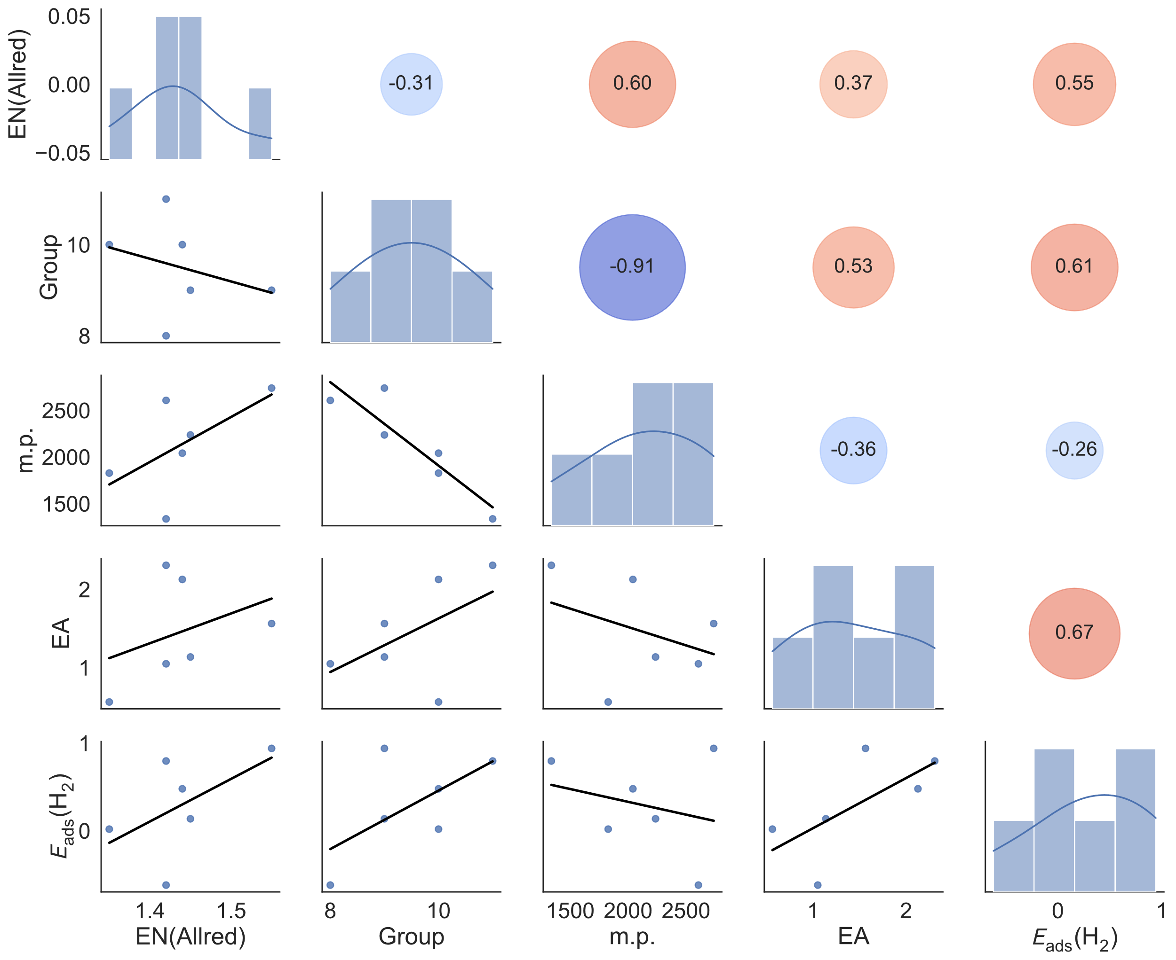
Figure S1. Correlation map for the five selected descriptors for the PGM elements.

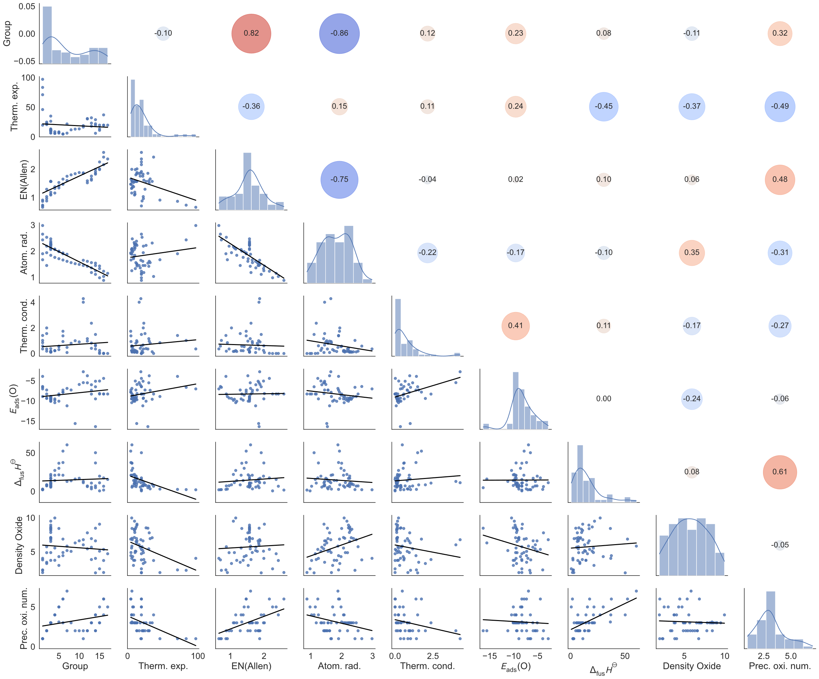
Figure S2. Correlation map for the nine selected descriptors for the Additive elements.

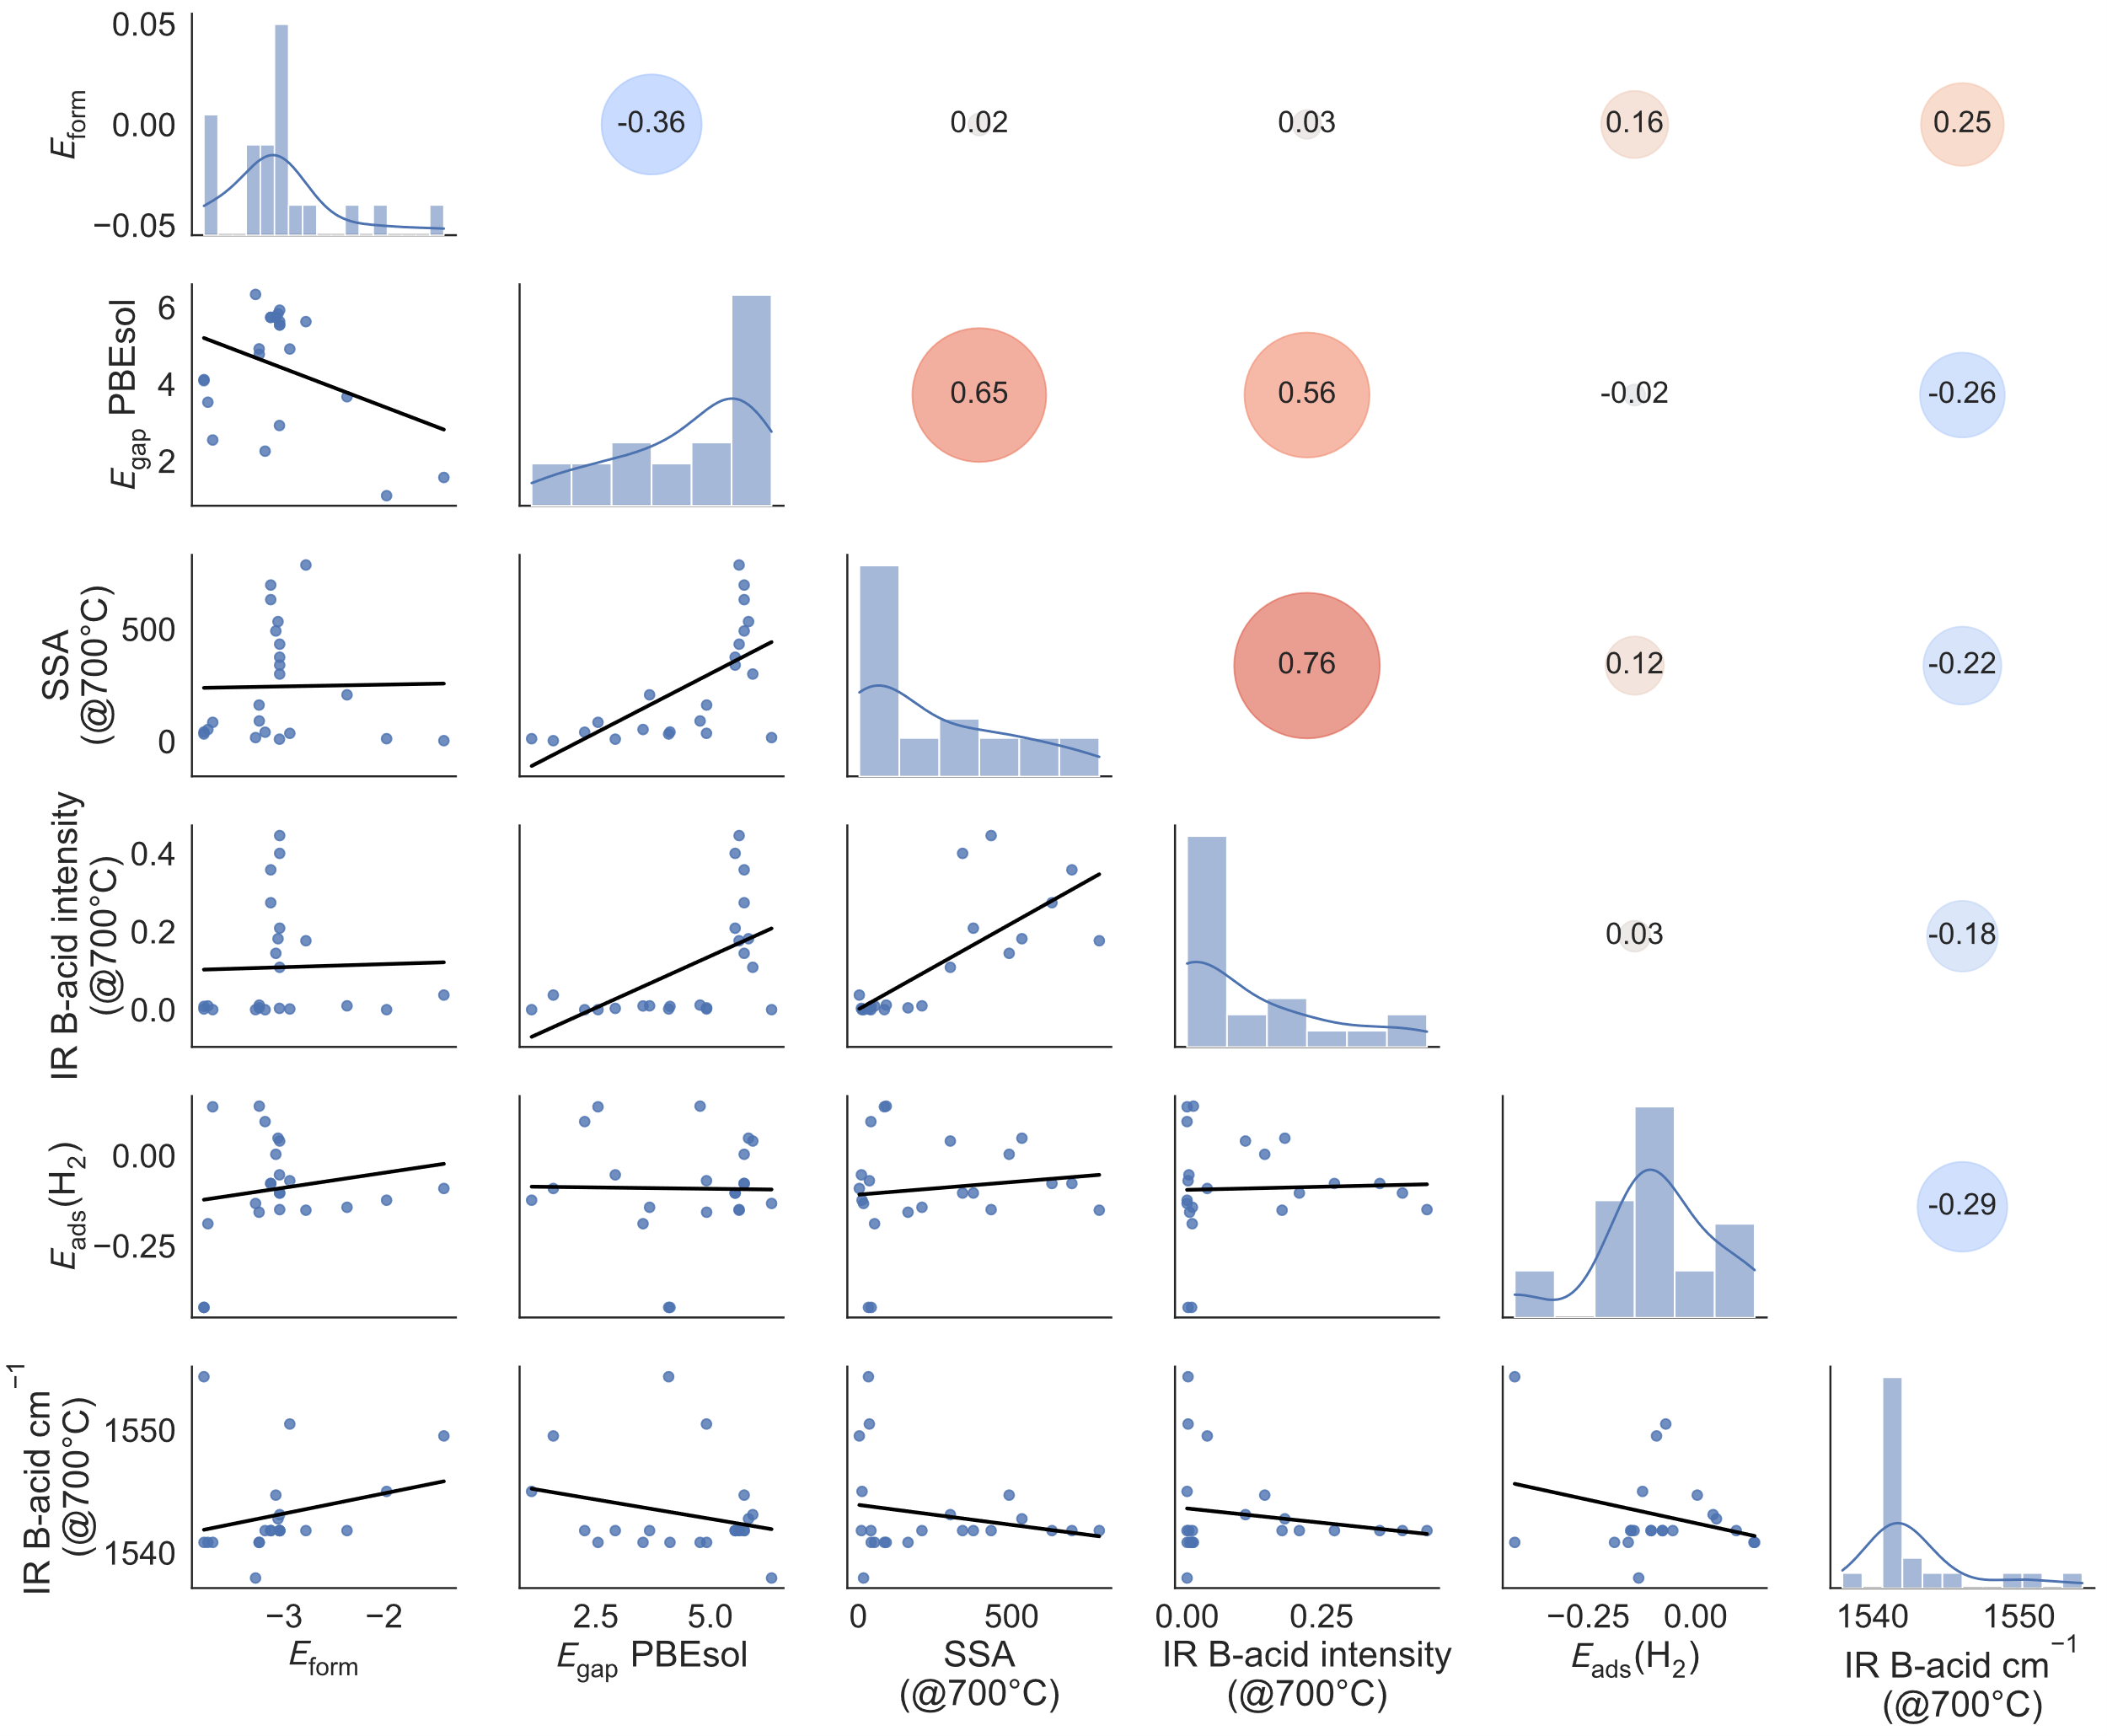
Figure S3. Correlation map for the six selected descriptors for the Supports.

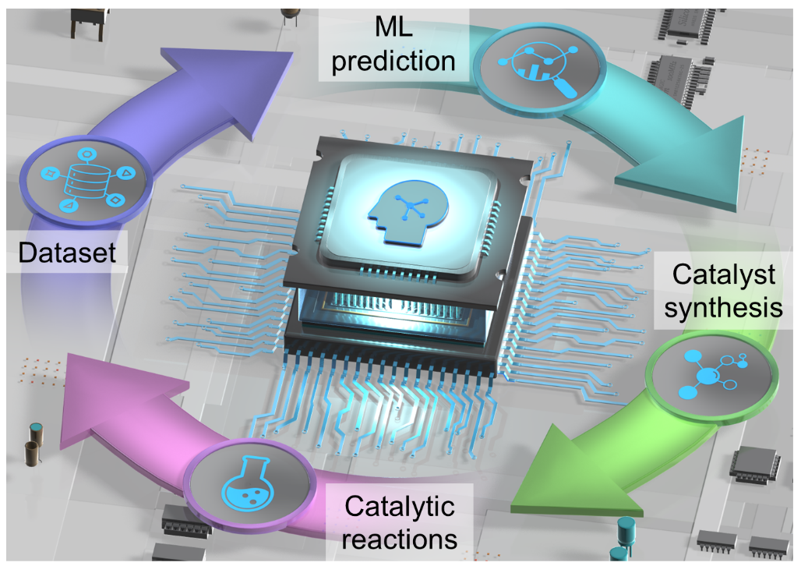
Scheme S1. Schematic representation of ML-assisted H₂-SCR catalysts discovery.

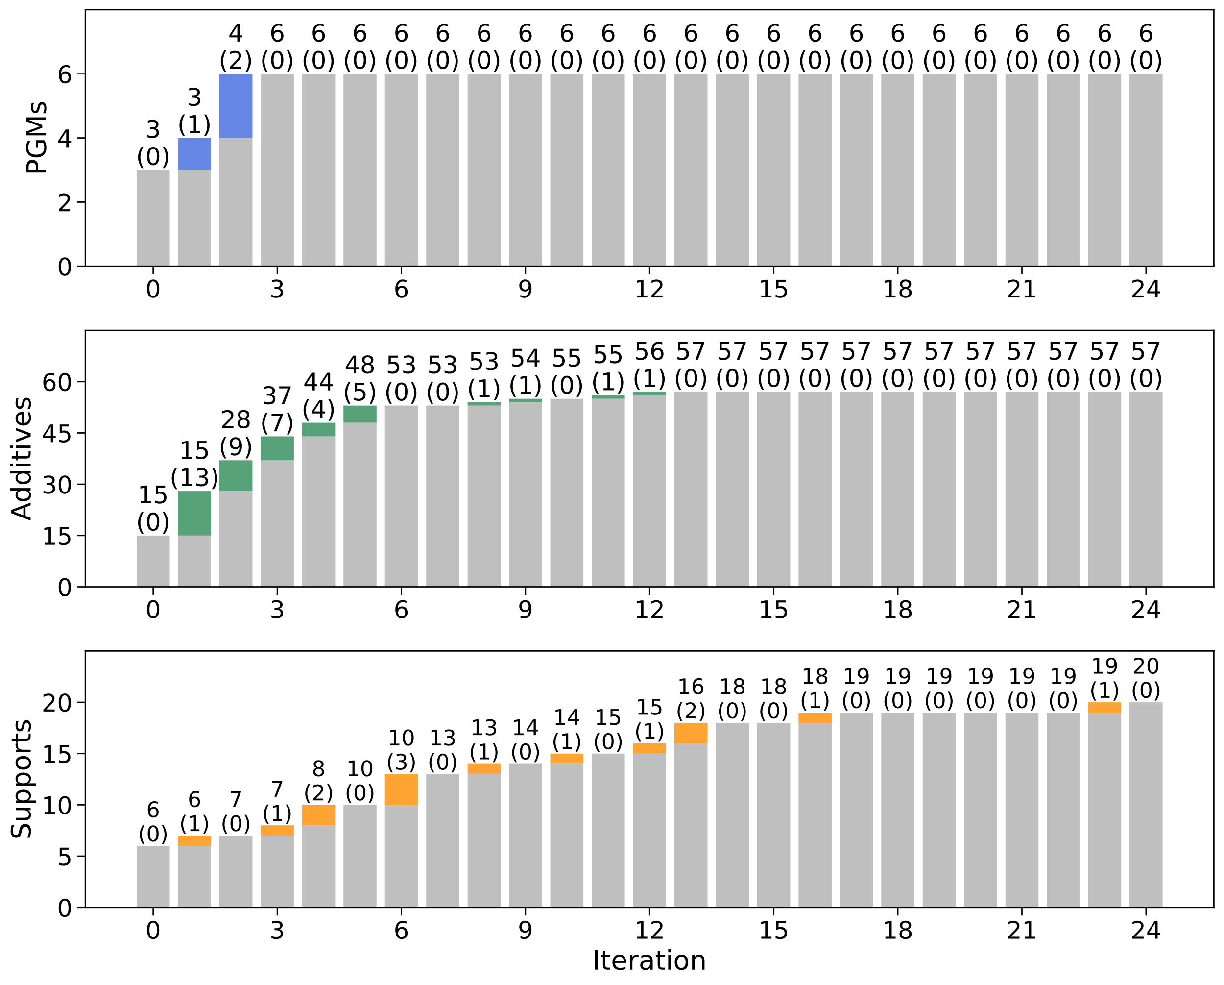
Figure S4. Visualization of the number PGMs, additives, and supports appeared for the first time in each iteration. Elements/supports appearing for the first time are shown in color, while those already present are shown in gray. The numbers above indicate the total count of elements/supports present at each iteration, while the numbers in parentheses below represent the count of elements/supports appeared for the first time in that iteration.
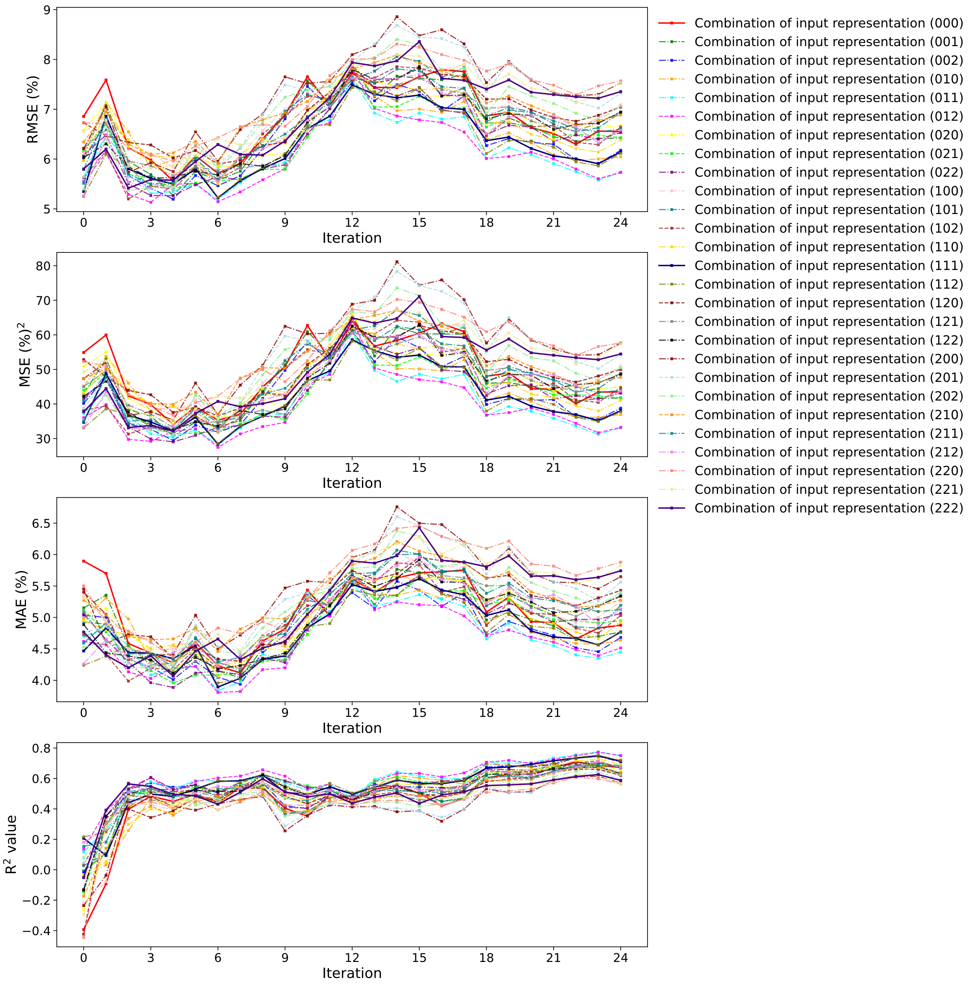
Figure S5. Comparison of prediction accuracy (RMSE, MSE, MAE, and R²) at each iteration for the H₂-SCR activity (average N₂ yield in the temperature range between 50–150 °C) using ML models based on 27 types of descriptor representation.

Supplementary text for ML-based analysis on the final dataset (425 datapoints) and comparison of the ML model
For hyperparameter tuning, we tested a reasonable range of candidate values in an exhaustive way (grid search) shown in Table S4, chose the best hyperparameter by 10-fold cross validation (CV) on the training set, and used the model for calculating the predicted values for the test set (the hyperparameters not explicitly indicated in the table were set to the scikit-learn defaults). Namely, to avoid data leakage, we strictly followed a standard practice of "nested" CV, also known as double CV, to estimate the prediction accuracies; we used 5-fold CV for the internal CV, and used Monte Carlo CV (also known as repeated random subsampling CV) with 100-times of random leave-20%-out trials for the external CV to increase the statistical reliability for validating the test prediction accuracies with fixing the number of training data.
In addition to our base ML model, Extra-Trees regression (ETR)¹, five well-established ML models were used: least absolute shrinkage and selection operator regression (Lasso)², ridge regression (Ridge)³, Gaussian process regression (GPR)⁴, support vector regression (SVR)⁵, and random forest regression (RFR)⁶. Two of these methods involve linear regression methods (Lasso, Ridge), and the other four methods including ETR involve nonlinear regression methods. More specifically, two kernel methods (GPR, SVR) and two types of decision tree ensemble methods (RFR, ETR). Among the ML models tested, the ETR combined with the 012 descriptor representation gave the best prediction accuracy to predict the average N₂ yield in the temperature range between 50-150 °C of the 425 H₂-SCR catalysts (Figures S6-8).

Table S4. Ranges used in the hyperparameter searches for the ML methods (if not specified, the default values of scikit-learn were used).
Type |  | Method | Hyperparameters [Tested range]
Linear |  | Lasso | alpha ∈ [10⁻²,10⁻¹,1.0,10¹,10²]
 |  | Ridge | alpha ∈ [10⁻²,10⁻¹,1.0,10¹,10²]
Nonlinear | Kernel methods | GPR | kernel=Matern 2.5, alpha ∈ [1, 10⁻¹, 10⁻², 10⁻³, 10⁻⁴, 10⁻⁵],  n_restarts_optimizer = 10,  normalize_y = True
Nonlinear | Kernel methods | SVR | kernel=’rbf’, C ∈ [1.0,10,10²,…, 10⁵], gamma ∈ [1, 10⁻¹, 10⁻², 10⁻³, 10⁻⁴, 10⁻⁵], epsilon ∈ [10⁻²,10⁻¹,1.0,10¹,10²]
Nonlinear | Tree ensemble  methods | RFR | n_estimators ∈ [100, 500, 1000, 1500], bootstrap ∈ [True or False]
Nonlinear | Tree ensemble  methods | ETR | n_estimators ∈ [100, 500, 1000, 1500], bootstrap ∈ [True or False]

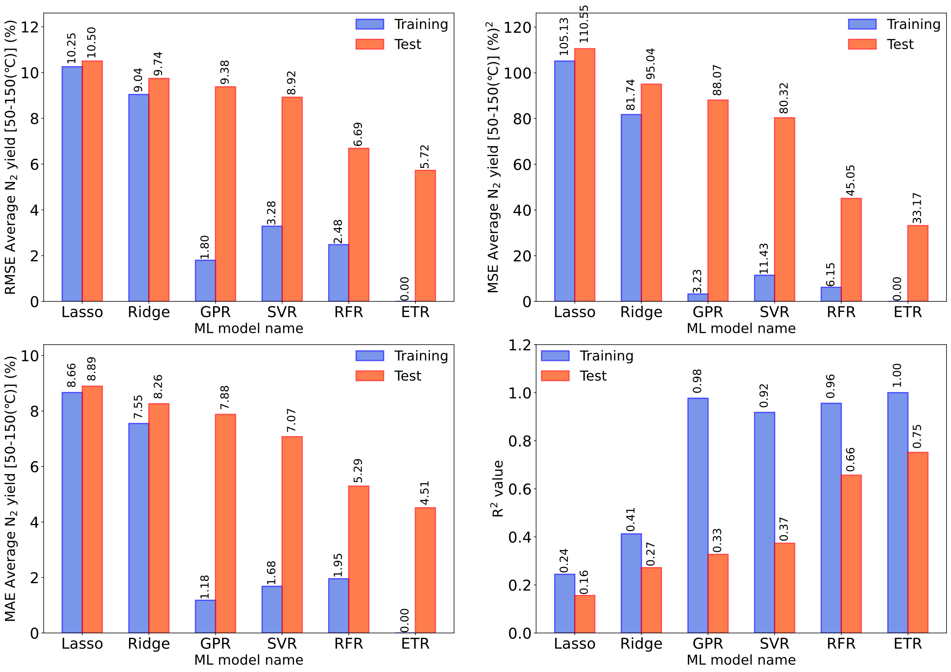
Figure S6. Comparison of the prediction accuracy for the average N₂ yield in the temperature range between 50–150 °C of the 425 H₂-SCR catalysts using ML models based on the best descriptor representation (012).
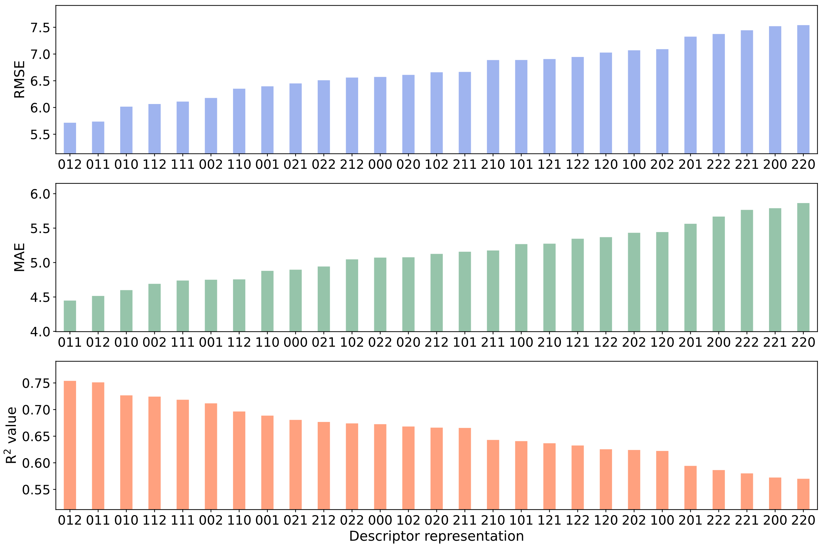
Figure S7. Effect of the descriptor representation on the prediction accuracy for the average N₂ yield in the temperature range between 50–150 °C of the 425 H₂-SCR catalysts. The three numbers in each bar graph represent the descriptor representations for PGM, Additive, and Support, respectively, from left to right. 0 represents a direct input representation, which uses only elemental compositions or support name; 1 represents an exploitative representation, which uses both elemental compositions/support name and elemental/support properties; and 2 represents an explorative representation, which uses only elemental/support properties.

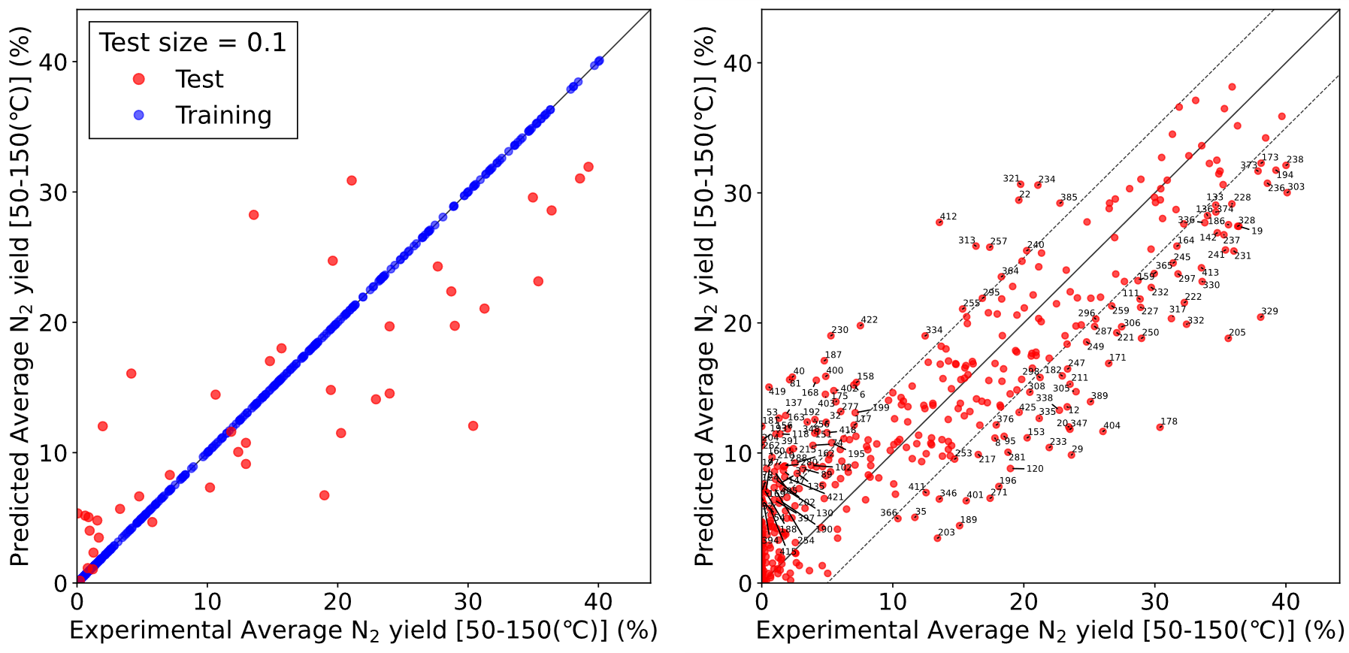
Figure S8. Experimental and predicted values of the average N₂ yield in the temperature range between 50–150 °C of the 425 H₂-SCR catalysts. Cross validation was performed using ETR combined with the best descriptor representation (012). (A) 90%/10% training-test error plots and (B) 100% test error plots. Blue points represent training data, while red points represent test data. Numbers in the right Fig. correspond to the catalyst ID.

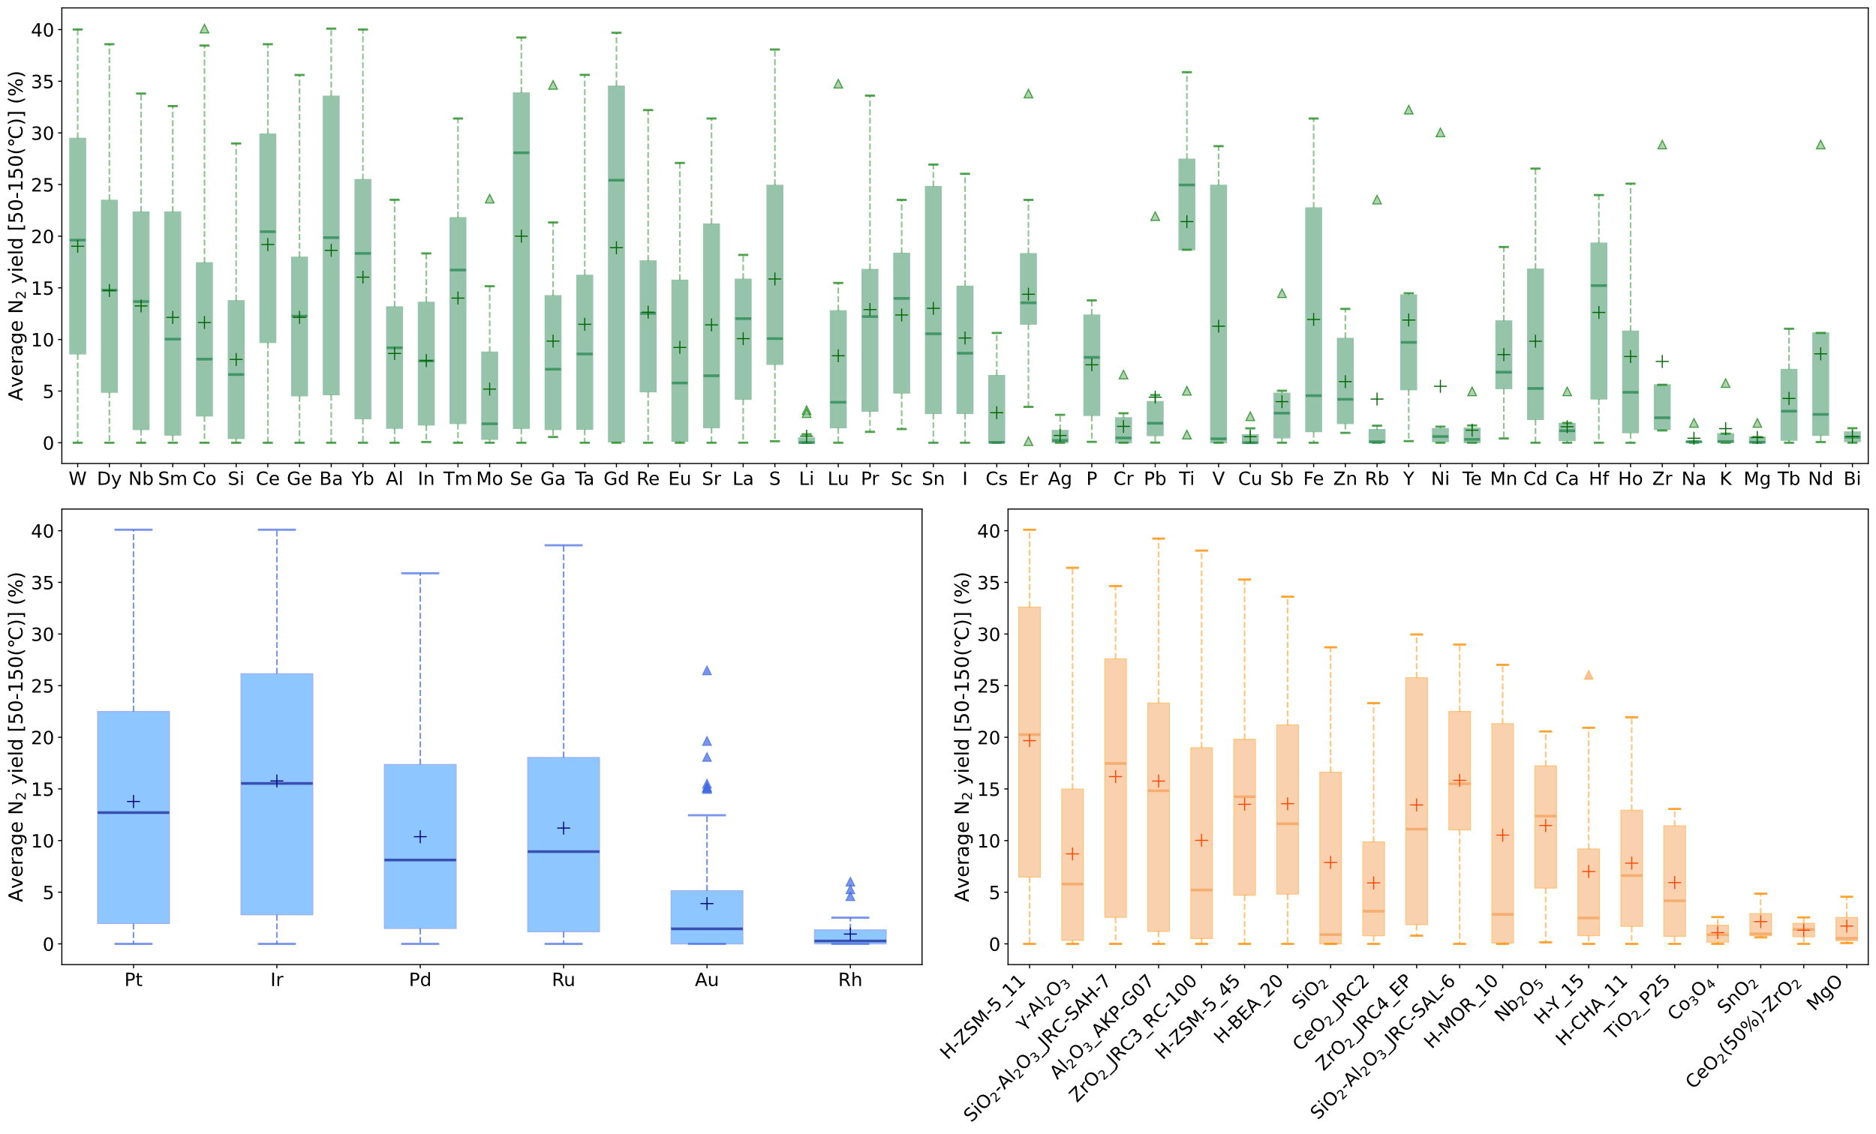
Figure S9. Visualization of H₂-SCR catalyst datasets. Boxplots for each PGM, Additive, and Support component. The boxes represent the interquartile range, spanning from the first quartile to the third quartile, with a horizontal line indicating the median. Whiskers extend up to 1.5 times the interquartile range, encompassing the largest and smallest observed data points falling within this range. Individual data points are displayed as dots.

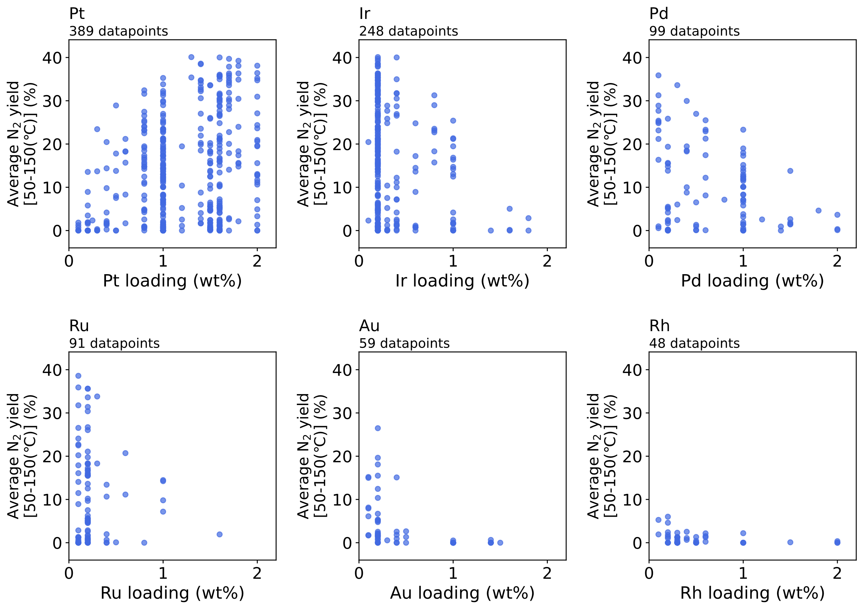
Figure S10. Effects of the loading amount of PGM elements on the average N₂ yield in the temperature range between 50–150 °C in the H₂-SCR reaction.

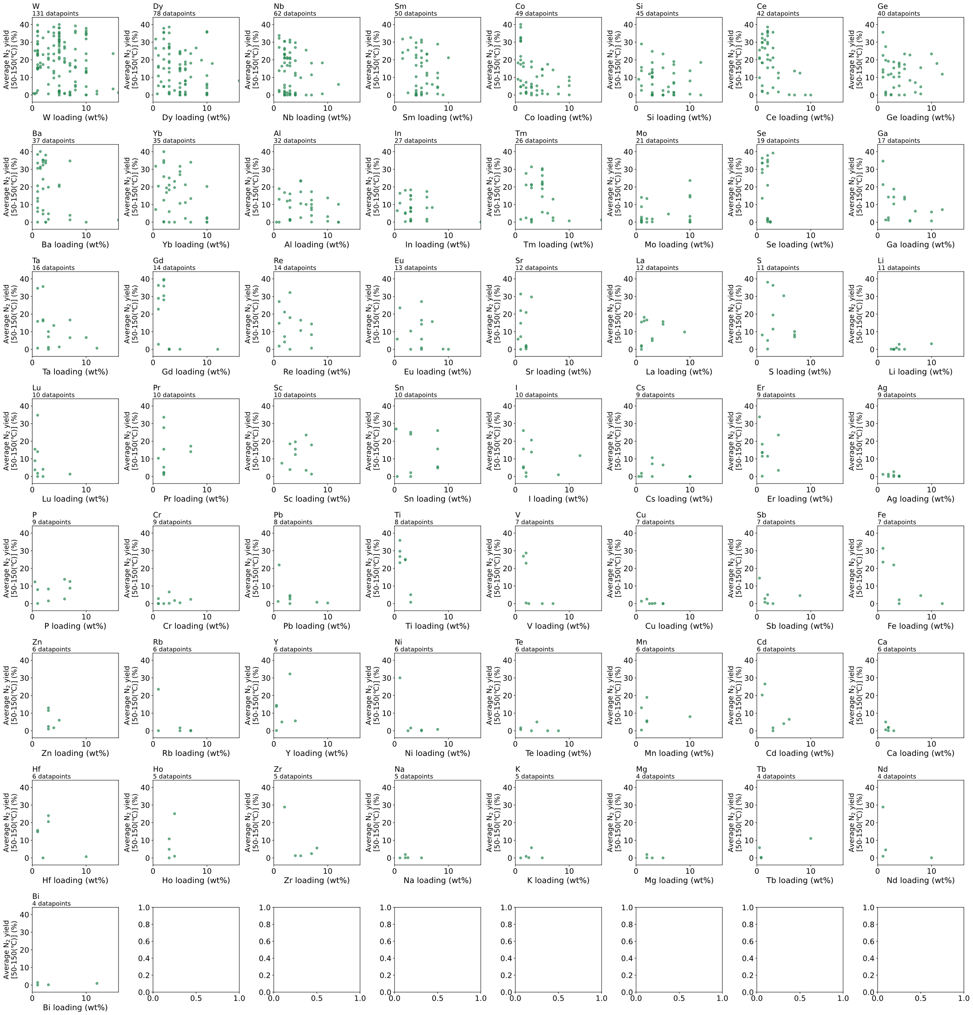
Figure S11. Effects of the loading amount of Additive elements on the average N₂ yield in the temperature range between 50–150 °C in the H₂-SCR reaction.
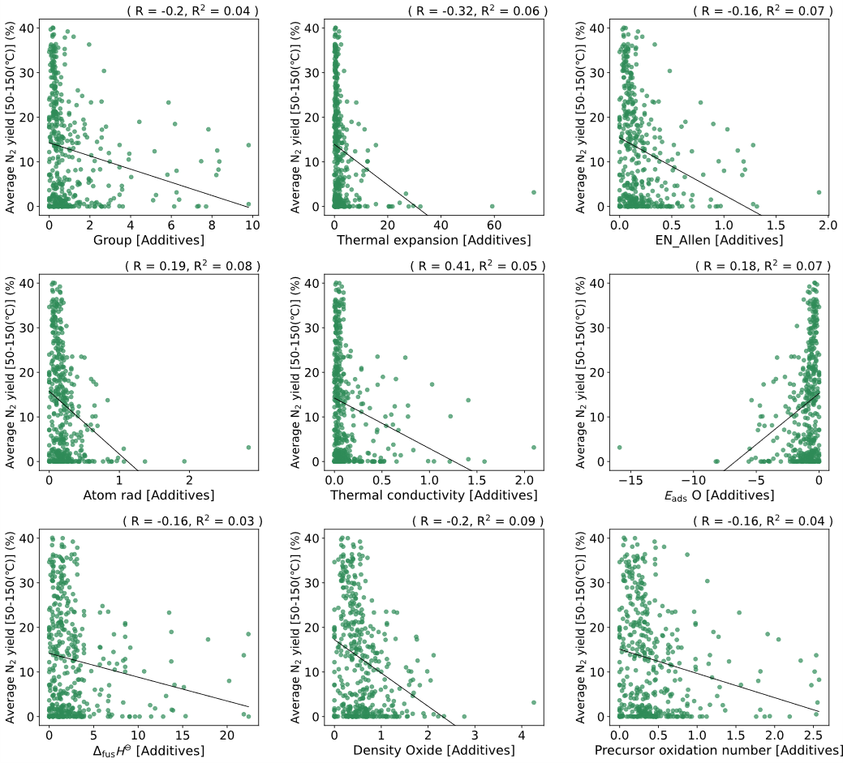
Figure S12. Correlation between the average N₂ yield in the temperature range between 50–150 °C and each descriptor value for the Additive elements.

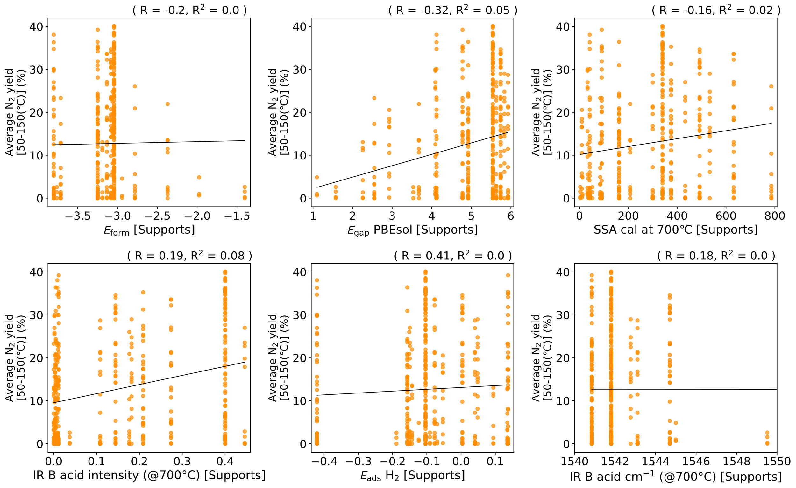
Figure S13. Correlation between the average N₂ yield in the temperature range between 50–150 °C and each descriptor value for the Supports.

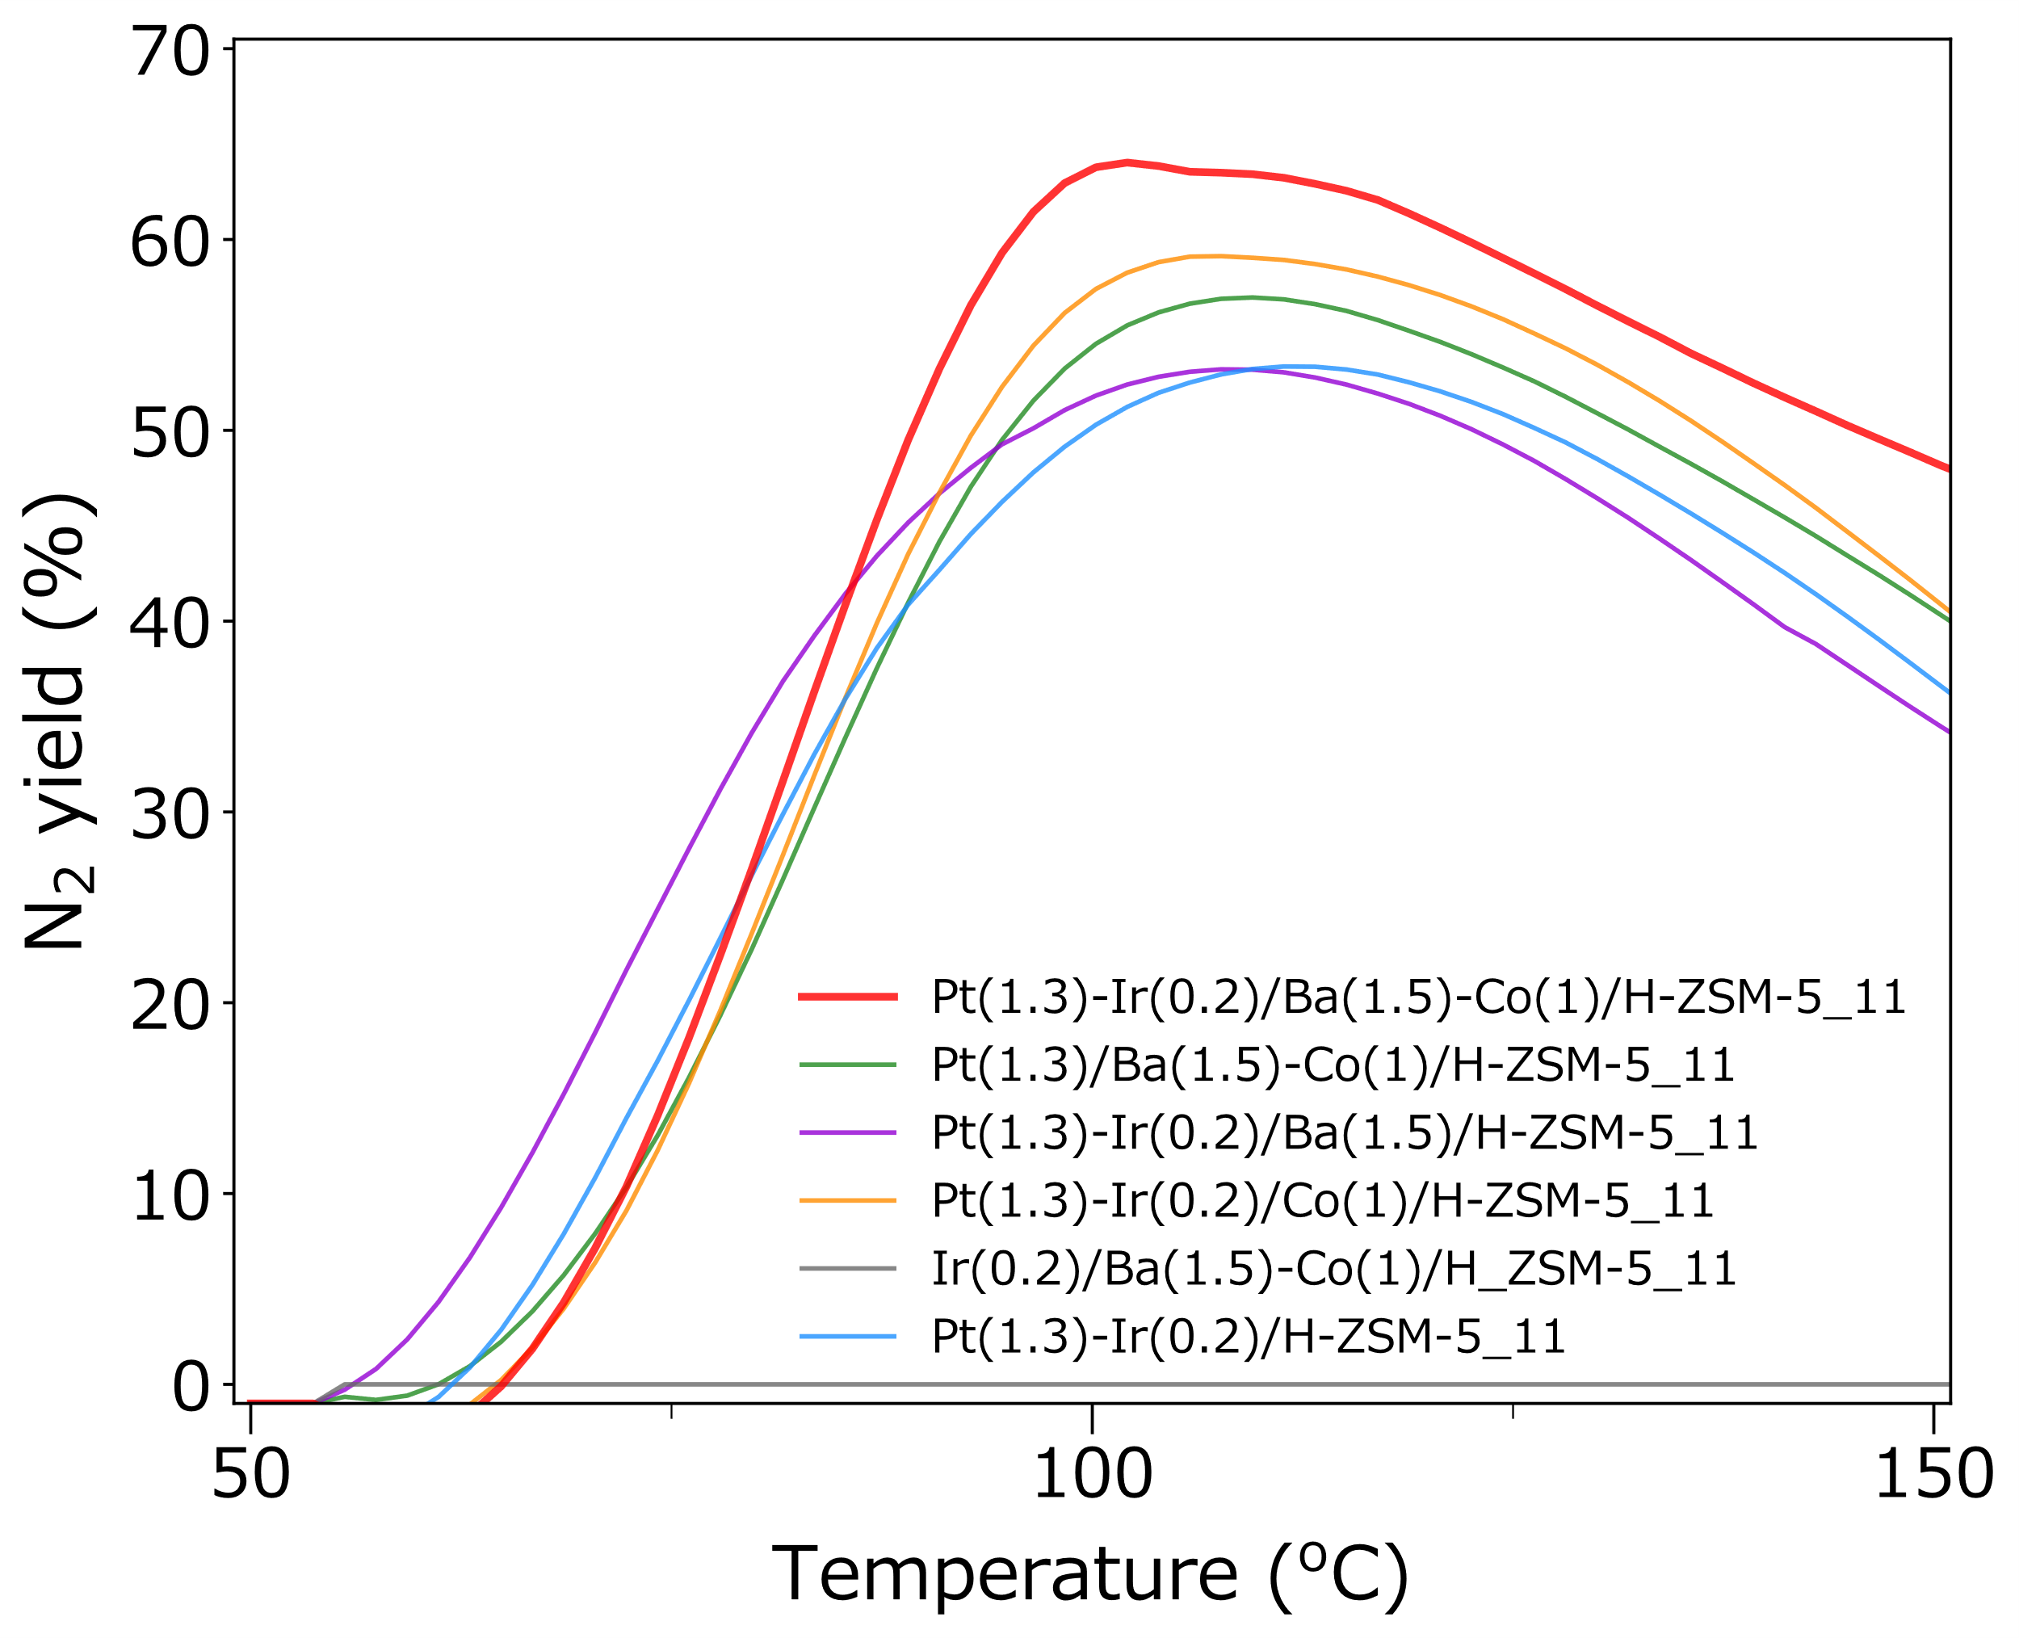
Figure S14. H₂-SCR reaction over Pt(1.3)-Ir(0.2)/Ba(1.5)-Co(1)/H-ZSM-5(11) and related catalysts for comparison. Catalyst weight: 15 mg; total flow rate: 100 mL/min; heating rate: 1 °C/min; Gas composition: 0.1% NO, 0.6% H₂, 6% O₂, 1% H₂O, 5% CO₂, He balance. The reaction was initiated at 50 °C and ramped to 200 °C at a rate of 1 °C/min after conditioning at 300 °C for 30 min under the reaction atmosphere.

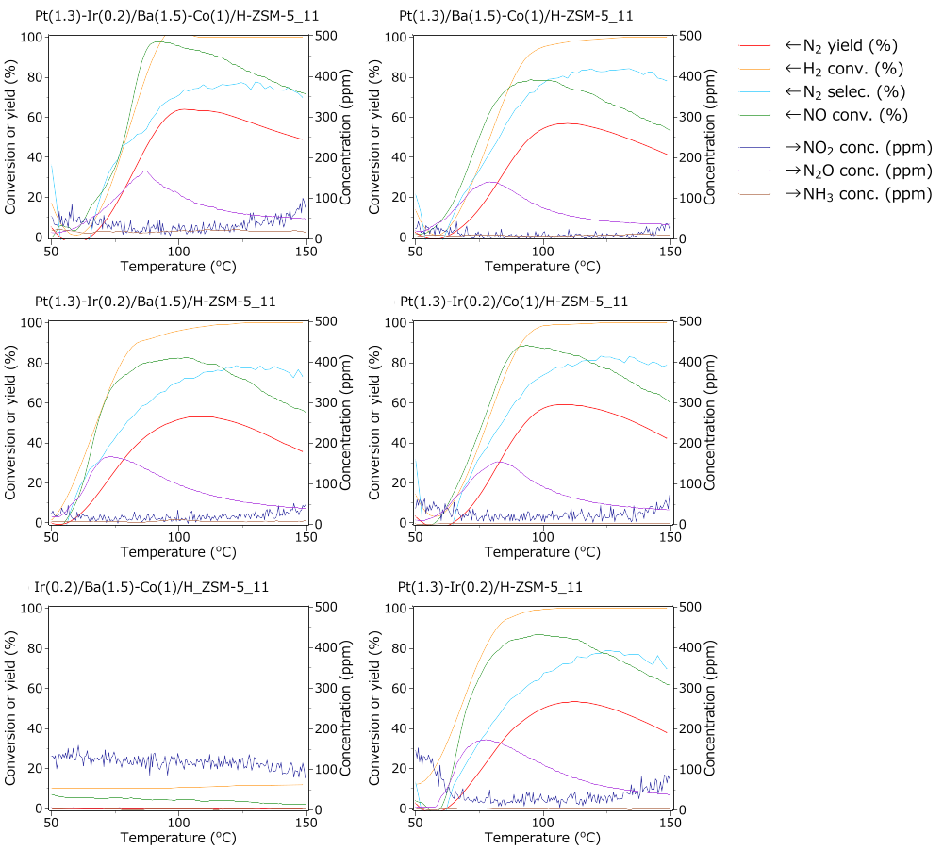
Figure S15. H₂-SCR reaction over Pt(1.3)-Ir(0.2)/Ba(1.5)-Co(1)/H-ZSM-5(11) and related catalysts for comparison. Catalyst weight: 15 mg; total flow rate: 100 mL/min; heating rate: 1 °C/min; Gas composition: 0.1% NO, 0.6% H₂, 6% O₂, 1% H₂O, 5% CO₂, He balance. The reaction was initiated at 50 °C and ramped to 200 °C at a rate of 1 °C/min after conditioning at 300 °C for 30 minutes under the reaction atmosphere.

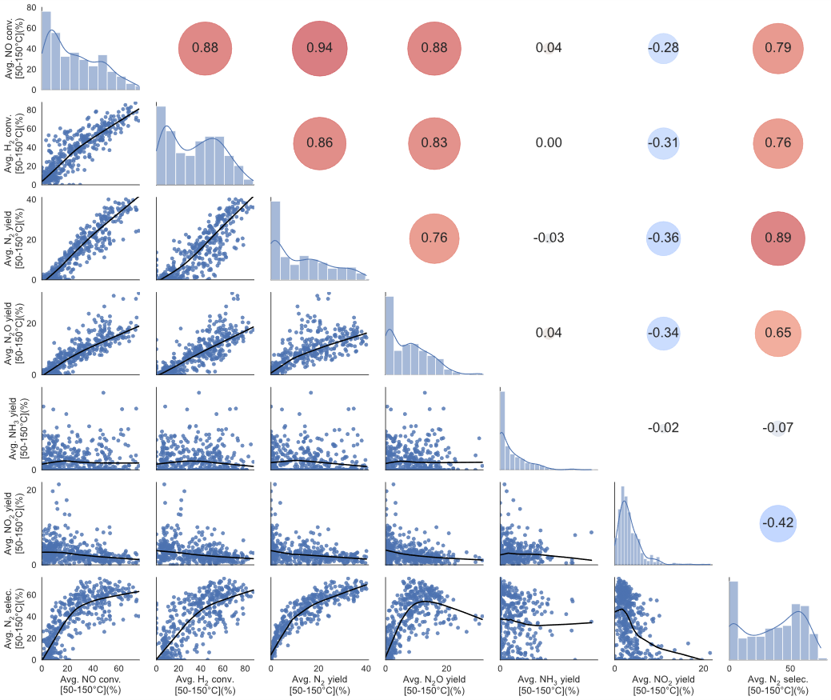
Figure S16. Correlation of the average NO conversion, H₂ conversion, N₂ yield, N₂O yield, NH₃ yield, NO₂ yield, and N₂ selectivity in the temperature range between 50–150 °C of the 425 H₂-SCR catalysts.
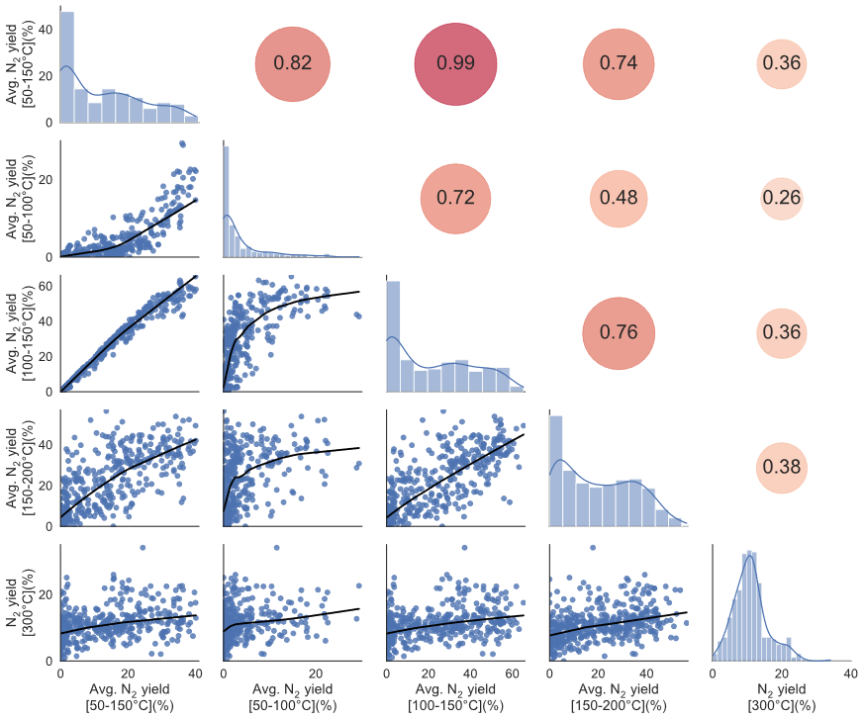
Figure S17. Correlation of the (average) N₂ yield in the different temperature range of the 425 H₂-SCR catalysts.

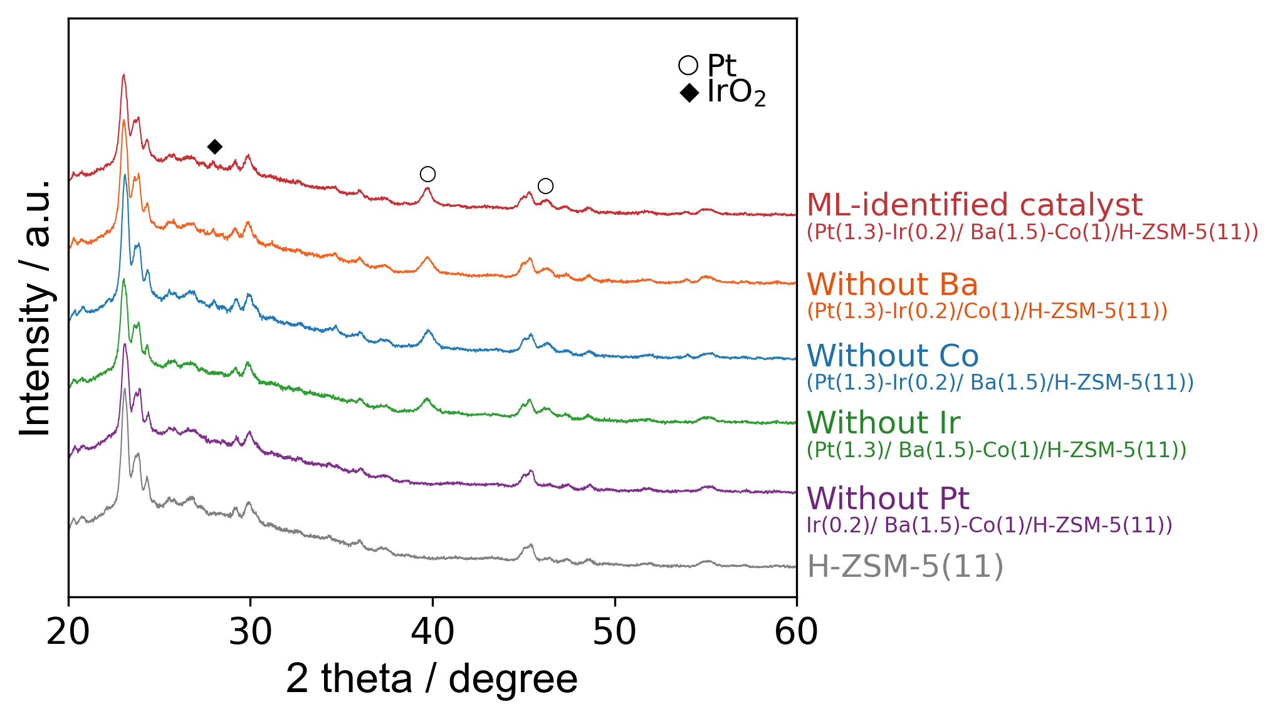
Figure S18. XRD patterns of Pt(1.3)-Ir(0.2)/Ba(1.5)-Co(1)/H-ZSM-5(11) and related catalysts for comparison.

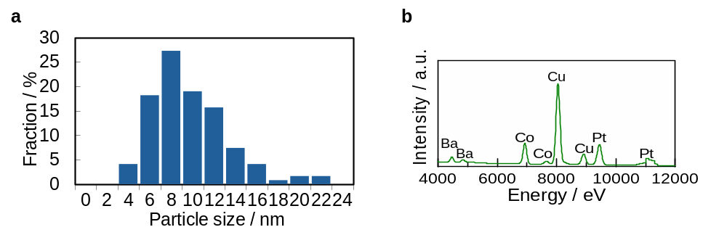
Figure S19. (a) Particle size distribution obtained from the HADDF-STEM images and the STEM EDX-spectrum of Pt(1.3)-Ir(0.2)/Ba(1.5)-Co(1)/H-ZSM-5(11).

Table S5. Results of the curve-fitting analysis of Pt L₃-edge EXAFS spectra of Pt(1.3)-Ir(0.2)/Ba(1.5)-Co(1)/H-ZSM-5(11).
Sample | shell | CNª | R (Å) ^{b} | σ² (Å²) ^{c} | R (%) ^{d}
Pt foil | Pt–Pt | 12 (fixed) | 2.77 | 0.004 | 0.1
Pt(1.3)-Ir(0.2)/Ba(1.5)-Co(1)/H-ZSM-5(11) | Pt–Pt | 11.8 | 2.75 | 0.006 | 0.2
ª Coordination number. ^{b} Bond distance. ^{c} Debye-Waller factor. ^{d} Residual factor.

Table S6. Results of the curve-fitting analysis of Ba K-edge EXAFS spectra of Pt(1.3)-Ir(0.2)/Ba(1.5)-Co(1)/H-ZSM-5(11).
Sample | shell | CNª | R (Å) ^{b} | σ² (Å²) ^{c} | R (%) ^{d}
BaO | Ba–O | 6 (fixed) | 2.80 | 0.014 | 3.2
Pt(1.3)-Ir(0.2)/Ba(1.5)-Co(1)/H-ZSM-5(11) | Ba–O | 3.8 | 2.76 | 0.014 | 2.4
ª Coordination number. ^{b} Bond distance. ^{c} Debye-Waller factor. ^{d} Residual factor.

Table S6. Results of the curve-fitting analysis of Co K-edge EXAFS spectra of Pt(1.3)-Ir(0.2)/Ba(1.5)-Co(1)/H-ZSM-5(11).
Sample | shell | CN | R(A) | σ² (Å²) ^{c} | R / %
Co₃O₄ | Co–O | 4 (fixed) | 1.92 | 0.003 | 2.3
Pt(1.3)-Ir(0.2)/Ba(1.5)-Co(1)/H-ZSM-5(11) | Co–O | 5.7 | 2.07 | 0.011 | 0.4
ª Coordination number. ^{b} Bond distance. ^{c} Debye-Waller factor. ^{d} Residual factor.

1
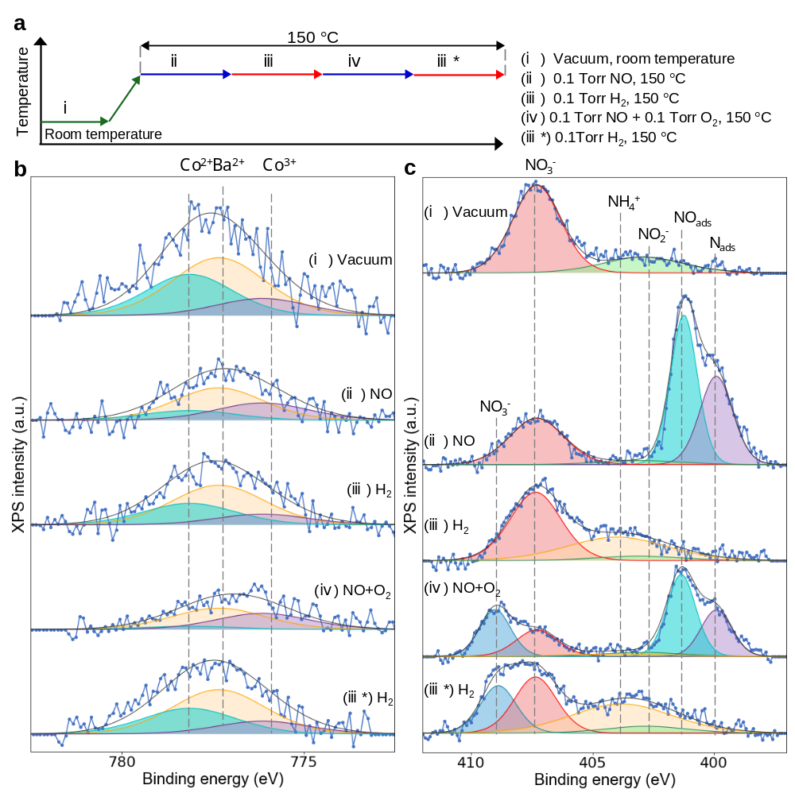
Figure S20. (a) Experimental conditions during AP-XPS studies. (b) Co 2p and (c) N 1s AP-XPS spectra of Pt(1.3)-Ir(0.2)/Ba(1.5)-Co(1)/H-ZSM-5(11) under (a) vacuum at room temperature, (ii) 0.1 Torr NO, (iii) 0.1 Torr H₂ after exposure to 0.1 Torr NO (iv) 0.1 Torr NO + 0.1 Torr O₂, and (iii*) H₂ after exposure to 0.1 Torr NO + 0.1 Torr O₂ at 150 °C. blue dots: raw spectrum; black line: sum; purple: adsorbed atomic nitrogen (N_{ads}); light blue: adsorbed molecular NO (NO_{ads}); green: nitrite species; light yellow: NH₃ adsorbed on Brønsted acid sites of zeolite (NH₄⁺); red: residual nitrate species from metal nitrate precursors used in catalyst preparation; blue: surface nitrate species (NO₃⁻).

Table S7. Peak concentration in the Co 2p AP-XPS spectra of Pt(1.3)-Ir(0.2)/Ba(1.5)-Co(1)/H-ZSM-5(11) under different conditions.
Gas condition | Co²⁺ / % | Co³⁺ / %
Vacuum | 69 | 31
0.1 Torr NO | 36 | 64
0.1 Torr H₂ | 67 | 33
0.1 Torr NO + 0.1 Torr O₂ | 17 | 83
0.1 Torr H₂ | 67 | 33

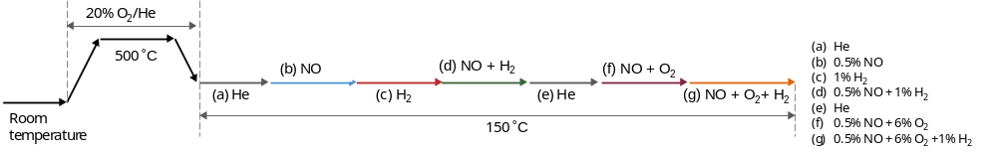
Figure S21. Experimental conditions during operando FT-IR spectroscopic studies for Figure 6a and 6b.

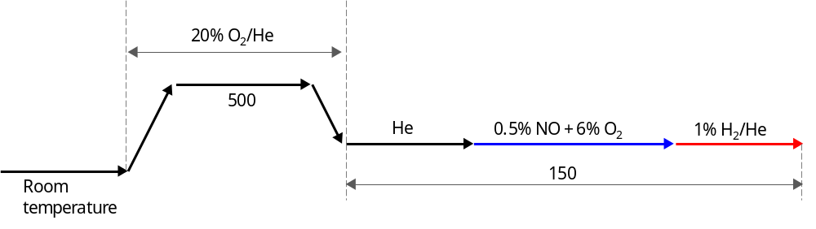
Figure S22. Experimental conditions during operando FT-IR spectroscopic studies for Figure 6c

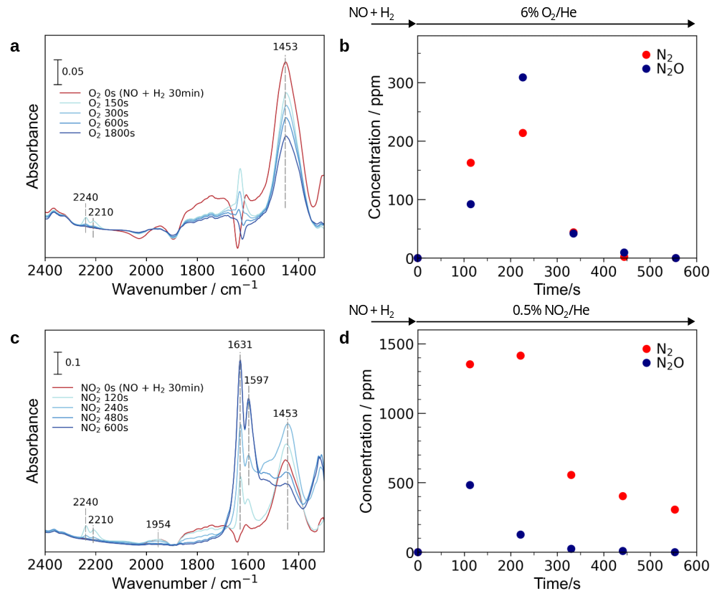
Figure S23. Operando IR spectra presenting the evolution of surface species adsorbed on Pt(1.3)-Ir(0.2)/Ba(1.5)-Co(1)/H-ZSM-5(11) after the introduction of (a) O₂ and (c) NO₂ following the introduction of 0.5% NO + 1% H₂ for 30 min at 150 °C. (b, d) Corresponding concentration of products in the effluent gases. Conditions: catalyst weight: 40 mg, total flow rate: 100 mL/min.

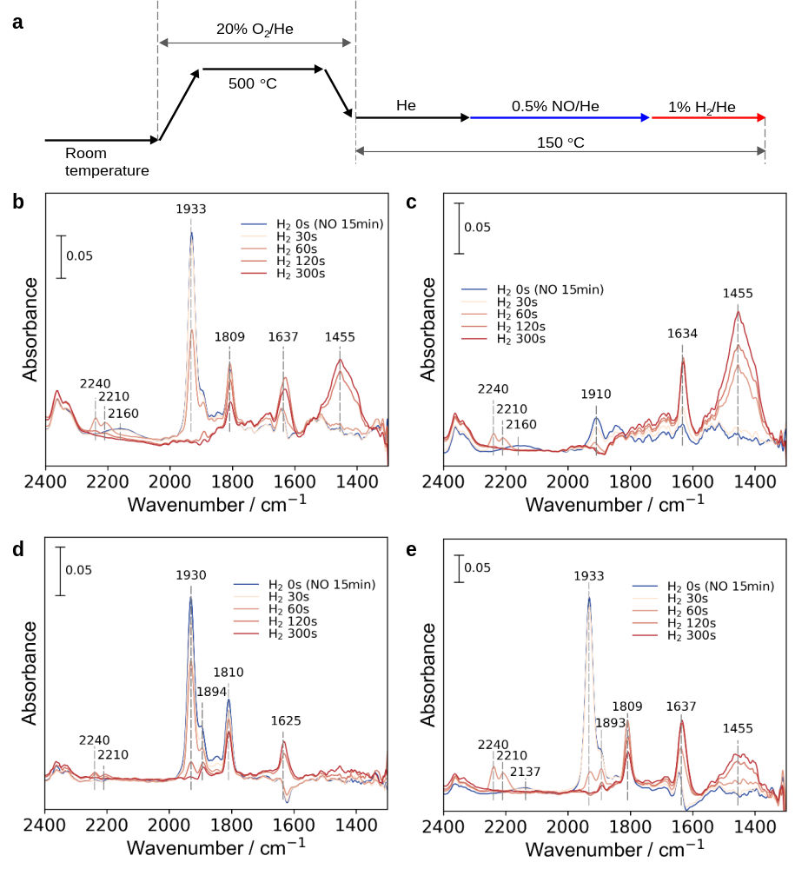
Figure S24. Experimenetal conditions during the in situ FT-IR spectroscopic measurements. (a) Experimental conditions during in situ FT-IR spectroscopic studies Evolution of the surface species after the introduction of 1% H₂ following the introduction of 0.5% NO for 15 min over various control catalysts without the addtion of (b) Ba, (c) Co, (d) Pt, and (e) Ir. Conditions: catalyst weight: 40 mg, total flow rate: 100 mL/min.

Supplementary References
(1) Geurts, P.; Ernst, D.; Wehenkel, L. Extremely Randomized Trees. Mach Learn 2006, 63, 3–42.
(2) Shrinkage, R. Regression Shrinkage and Selection via the Lasso. Journal of the Royal Statistical Society B 1996, 58 (1), 267–288.
(3) Hoerl, A. E.; Kennard, R. W. Ridge Regression: Applications to Nonorthogonal Problems. Technometrics 1970, 12 (1), 69–82.
(4) R. H. Myers, D. C. Montgomery, C. M. A.-C. Response Surface Methodology: Process and Product Optimization Using Designed Experiments; 1985; Vol. 001.
(5) Drucker, H.; Burges, C. J. C. C.; Kaufman, L.; Smola, A.; Vapnik, V. Support Vector Regression Machines. Adv Neural Inf Process Syst 1997, 9, 155–161.
(6) Breiman, L. Random Forests. Mach Learn 2001, 45, 5–32.

