Supplementary Figure 1.
(a)
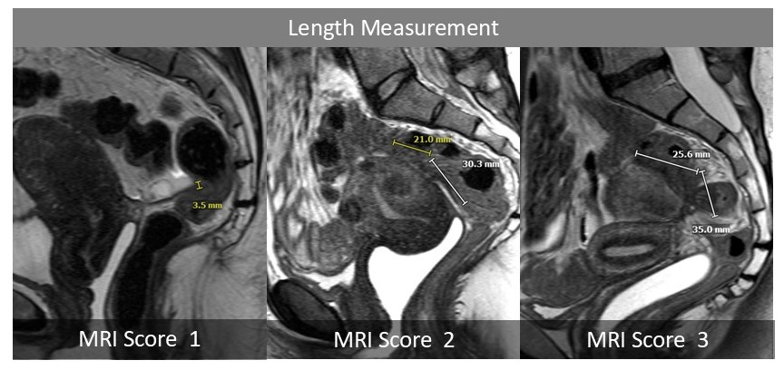
(b)
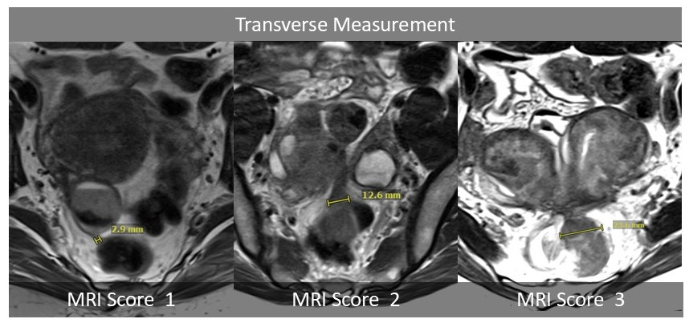

(c)
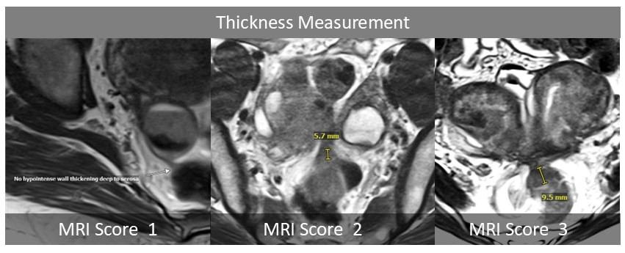
Illustrations of quantitative measurements. (a) Sagittal T2-weighted images illustrate the length measurement using a linear distance tool to emulate measurements. (b) Axial T2-weighted images illustrate the measurement of the transverse axis. (c) Axial T2-weighted images illustrate the thickness measurement. Of note, thickness in lesions with MRI score 1 was considered negligible and reported as 0. Three planes of T2 weighted images were used to obtain the maximum measurement of each parameter.

Supplementary Figure 2. A 39-year-old female with an under-call lesion.

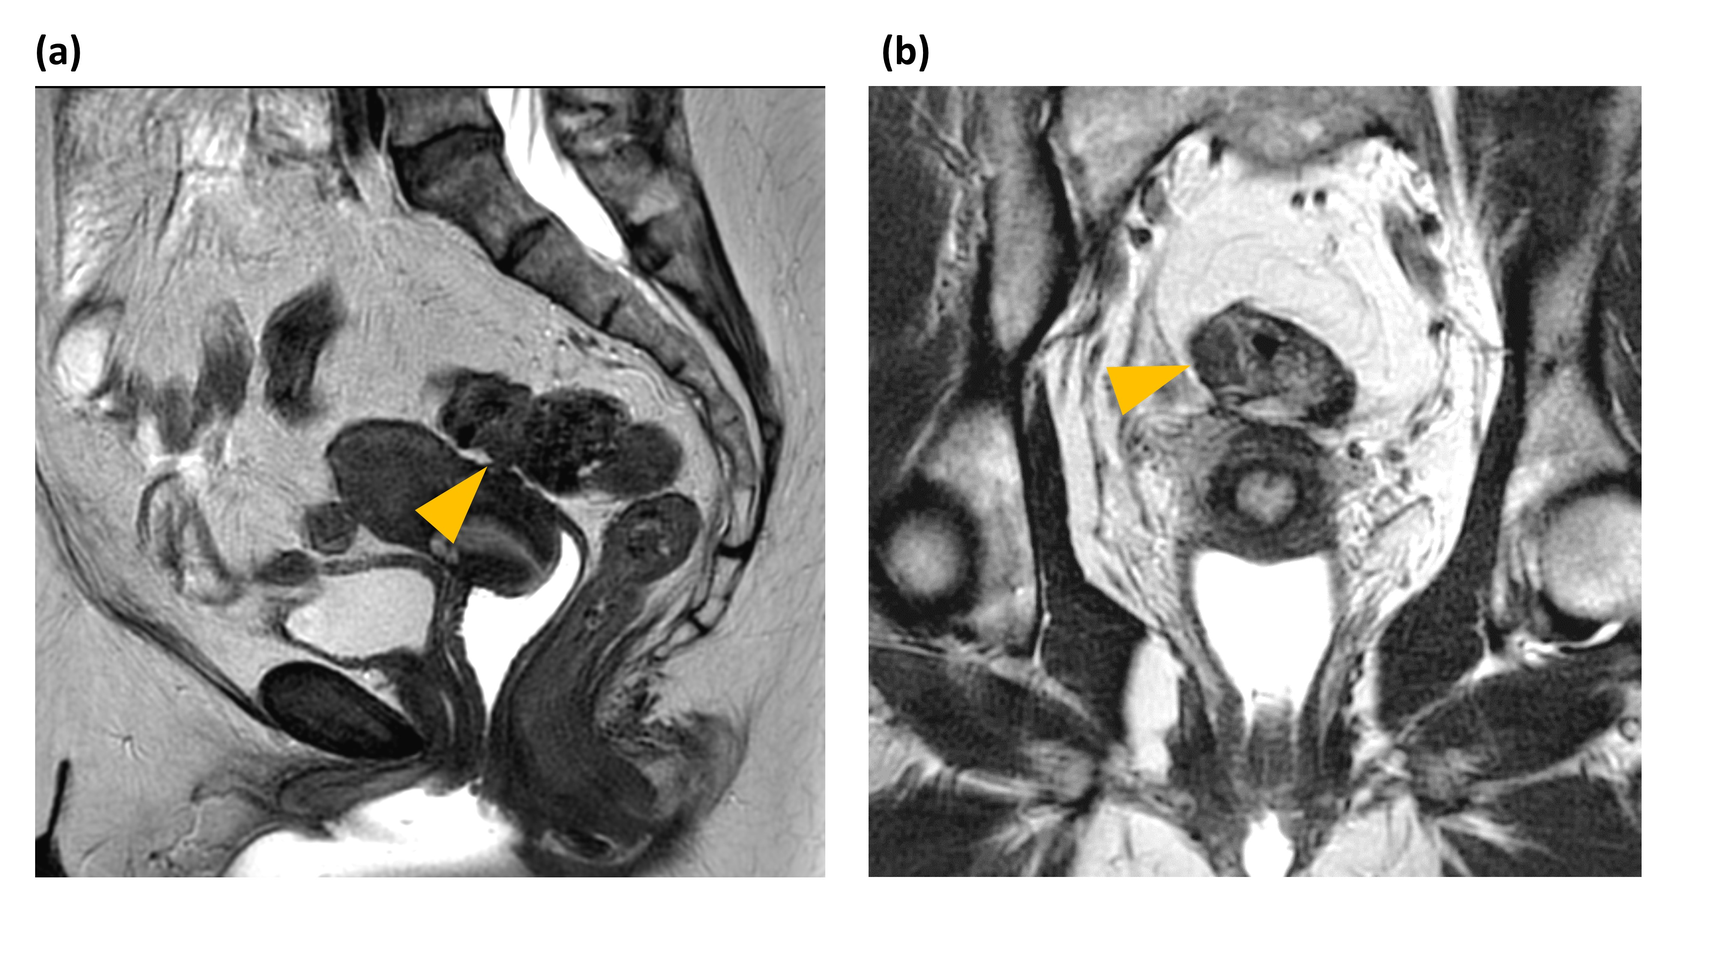
A sagittal T2-weighted image (a) and a coronal T2-weighted image (b) demonstrated a mushroom cap lesion involving the distal sigmoid colon (arrow). Patient-level MRI score was 3, 0, and 3 by the reference, reader 1, and reader 2, respectively. This lesion was undetected by reader 1 (under-call lesion). The patient underwent sigmoid resection. The surgical specimen showed muscularis propria involvement.

Supplementary Figure 3. A 39-year-old female with an over-call lesion.
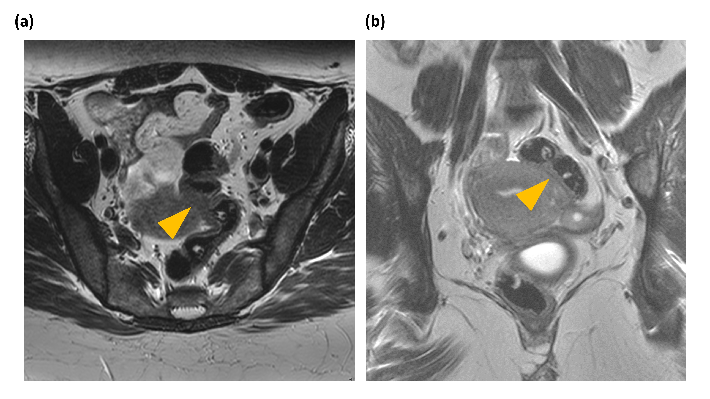
An axial T2-weighted image (a) and a coronal T2-weighted image (b) demonstrate the rectosigmoid colon abutting the left side of the uterus. Partial volume effect in the axial image mimicked soft tissue thickening along the sigmoid colon wall (arrow), which was seen on the coronal image. MRI score was 0, 1, and 2 by the reference, reader 1, and reader 2, respectively. The artifact was regarded as a rectosigmoid endometriosis (RSE) lesion by reader 1 (over-call lesion). No RSE was identified during the surgery.

