Supplementary Information

Successes and limitations of pretrained YOLO detectors applied to unseen time-lapse images for automated pollinator monitoring

Valentin Ștefan^{1,2,3,*}, Thomas Stark⁴, Michael Wurm⁴, Hannes Taubenböck^{4,5}, Tiffany M. Knight^{1,2,3,6}

¹Department of Species Interaction Ecology, Helmholtz Centre for Environmental Research - UFZ, Leipzig, Germany.
²German Centre for Integrative Biodiversity Research (iDiv) Halle-Jena-Leipzig, Leipzig, Germany.
³Institute of Biology, Martin Luther University Halle-Wittenberg, Halle (Saale), Germany. ⁴German Remote Sensing Data Center (DFD), German Aerospace Center (DLR), Oberpfaffenhofen, Germany.
⁵Department of Global Urbanisation and Remote Sensing, University of Würzburg, Würzburg, Germany.
⁶Department of Science and Conservation, National Tropical Botanical Garden, Kalāheo, USA
*Corresponding author: valentin.stefan@idiv.de

Abstract
Pollinating insects provide essential ecosystem services, and using time-lapse photography to automate their observation could improve monitoring efficiency. Computer vision models, trained on clear citizen science photos, can detect insects in similar images with high accuracy, but their performance in images taken using time-lapse photography is unknown. We evaluated the generalisation of three lightweight YOLO detectors (YOLOv5-nano, YOLOv5-small, YOLOv7-tiny), previously trained on citizen science images, for detecting ~1,300 flower-visiting arthropod individuals in nearly 24,000 time-lapse images captured with a fixed smartphone setup. These field images featured unseen backgrounds and smaller arthropods than the training data. YOLOv5-small, the model with the highest number of trainable parameters, performed best, localising 91.21% of Hymenoptera and 80.69% of Diptera individuals. However, classification recall was lower (80.45% and 66.90%, respectively), partly due to Syrphidae mimicking Hymenoptera and the challenge of detecting smaller, blurrier flower visitors. This study reveals both the potential and limitations of such models for real-world automated monitoring, suggesting they work well for larger and sharply visible pollinators but need improvement for smaller, less sharp cases.

Supplementary Materials

Model | NMS-IoU | NMS confidence | Max. F1 | Max. AUC | Nr. parameters (million)
YOLOv5-small | 0.3 | 0.2019 | 0.7019 | 0.6497 | 7.2
YOLOv7-tiny | 0.3 | 0.2236 | 0.6617 | 0.6294 | 6.2
YOLOv5-nano | 0.1 | 0.1648 | 0.6539 | 0.6111 | 1.9

Table S1. Optimal values for the NMS hyperparameters IoU and confidence that maximised F1 score (Max. F1) and area under the precision-recall curve (Max. AUC) for each YOLO model. Results correspond to the bounding box localisation task (localisation of arthropod instances in independent frames). Optimisation was run with a NMS confidence score of 0.001 to obtain the F1 curves.

Arthropod category | N. ind. | Localisation |  | Classification |  |  |  | Predictions - % and (counts)
Arthropod category | N. ind. | N | R | P | R | F1 | Acc. | Hym. | Dip. | OtherT | Bg./FN
Hymenoptera | 1,013 | 941 | 0.9289 | 0.9762 | 0.8105 | 0.8857 | 0.8345 | 81.05%  (821) | 8.79%  (89) | 3.06%  (31) | 7.11%  (72)
Diptera | 145 | 123 | 0.8483 | 0.5260 | 0.6966 | 0.5994 | 0.8946 | 6.90%  (10) | 69.66%  (101) | 8.28%  (12) | 15.17%  (22)
OtherT | 123 | 72 | 0.5854 | 0.5825 | 0.4878 | 0.5310 | 0.9173 | 8.13%  (10) | 1.63%  (2) | 48.78%  (60) | 41.46%  (51)
Overall | 1,281 | 1,136 | 0.8868 | 0.8874 | 0.7666 | 0.8226 | 0.8493 | - | - | - | -

Table S2. Performance metrics of the best-selected model for individual arthropod localisation and classification at eval-IoU of 0.1. See Table 2 in the manuscript for abbreviations.

Arthropod category |  | N. miscl. Instances | Total miscl. instances | % miscl. | N. miscl. expected | p-value
Ground truth | Misclassified to:
Diptera | Araneae | 2 | 467 | 0.43 | 67 | 1.0000
Diptera | Coleoptera | 67 | 467 | 14.35 | 67 | 0.5050
Diptera | Hemiptera | 19 | 467 | 4.07 | 67 | 1.0000
Diptera | Hymenoptera | 303 | 467 | 64.88 | 67 | < 0.0001
Diptera | Hymenoptera - Formicidae | 11 | 467 | 2.36 | 67 | 1.0000
Diptera | Lepidoptera | 65 | 467 | 13.92 | 67 | 0.6096
Hymenoptera | Araneae | 10 | 1,710 | 0.58 | 244 | 1.0000
Hymenoptera | Coleoptera | 172 | 1,710 | 10.06 | 244 | 1.0000
Hymenoptera | Diptera | 1,316 | 1,710 | 76.96 | 244 | < 0.0001
Hymenoptera | Hemiptera | 16 | 1,710 | 0.94 | 244 | 1.0000
Hymenoptera | Hymenoptera - Formicidae | 120 | 1,710 | 7.02 | 244 | 1.0000
Hymenoptera | Lepidoptera | 74 | 1,710 | 4.33 | 244 | 1.0000
Hymenoptera | Orthoptera | 2 | 1,710 | 0.12 | 244 | 1.0000

Table S3. Misclassification frequencies of Diptera and Hymenoptera ground truth instances (bounding boxes) in independent frames, showing the observed count and percentage of misclassifications (miscl.) compared to the expected values under random chance. Expected probability = 1/7, with seven possible misclassifications per category. The one-tailed exact binomial test assessed whether these misclassifications occurred significantly more often than expected by chance, specifically testing for a higher frequency. Significant misclassifications (p < 0.05) are highlighted in bold.

Type | # | Variables | Apis mellifera | Bombus red tail | Not mimicked
N. individuals and binomial test of misclassification rates | 1 | N. individuals in dataset | 185 | 301 | 259
N. individuals and binomial test of misclassification rates | 2 | N. localised | 177 | 291 | 229
N. individuals and binomial test of misclassification rates | 3 | N. correctly classified | 131 | 265 | 205
N. individuals and binomial test of misclassification rates | 4 | N. misclassified, total (from those localised) | 46 | 26 | 24
N. individuals and binomial test of misclassification rates | 5 | N. misclassified as Diptera | 43 | 23 | 16
N. individuals and binomial test of misclassification rates | 6 | N. misclassified as OtherT | 3 | 3 | 8
N. individuals and binomial test of misclassification rates | 7 | % misclassified as Diptera from #4 | 93.48 | 88.46 | 66.67
N. individuals and binomial test of misclassification rates | 8 | N. misclassified as Diptera, expected | 23 | 13 | 12
N. individuals and binomial test of misclassification rates | 9 | p-value, binomial test for #5 & #7 | < 0.001 | < 0.001 | 0.0758
N. individuals and binomial test of misclassification rates | 10 | p-value, is significant, for #9 (< 0.05?) | yes | yes | no
Relative bounding box area | 11 | Mean relative b.box area for #5 | 0.1477 | 0.1871 | 0.0711
Relative bounding box area | 12 | S.D. for #11 | 0.0966 | 0.0734 | 0.1234
Relative bounding box area | 13 | Mean relative b.box area for #3 | 0.1556 | 0.2385 | 0.1036
Relative bounding box area | 14 | S.D. for #13 | 0.0748 | 0.0923 | 0.0949
Relative bounding box area | 15 | Difference means #13 - #11 | 0.0079 | 0.0514 | 0.0325
Relative bounding box area | 16 | Permutation quantile conf. interval for #15 | -0.0301:0.0279 | -0.0421:0.0349 | -0.0538:0.0458
Relative bounding box area | 17 | p-value, permutations for #15 | 0.611 | 0.005 | 0.219
Relative bounding box area | 18 | p-value is significant, for #15 (< 0.05?) | no | yes | no
Relative bounding box area | 19 | Median relative b.box area for #5 | 0.127 | 0.1927 | 0.0274
Relative bounding box area | 20 | Median relative b.box area for #3 | 0.1366 | 0.2269 | 0.0733
Relative bounding box area | 21 | Difference medians #20 - #19 | 0.0096 | 0.0343 | 0.0459
Relative bounding box area | 22 | Permutation quantile conf. interval for #21 | -0.0363:0.0322 | -0.0486:0.0425 | -0.0699:0.0397
Relative bounding box area | 23 | p-value, permutations for #21 | 0.565 | 0.122 | 0.083
Relative bounding box area | 24 | p-value is significant, for #21 (< 0.05?) | no | no | no
Normalised sharpness (Sobel - Tenengrad operator) | 25 | Mean normalised sharpness for #5 | 0.1487 | 0.2412 | 0.0702
Normalised sharpness (Sobel - Tenengrad operator) | 26 | S.D. for #25 | 0.0833 | 0.165 | 0.0812
Normalised sharpness (Sobel - Tenengrad operator) | 27 | Mean normalised sharpness for #3 | 0.1263 | 0.2036 | 0.1061
Normalised sharpness (Sobel - Tenengrad operator) | 28 | S.D. for #27 | 0.0564 | 0.1055 | 0.0951
Normalised sharpness (Sobel - Tenengrad operator) | 29 | Difference means #27 - #25 | -0.0224 | -0.0377 | 0.0359
Normalised sharpness (Sobel - Tenengrad operator) | 30 | Permutation quantile conf. interval for #29 | -0.0239:0.0222 | -0.0483:0.0440 | -0.0521:0.0429
Normalised sharpness (Sobel - Tenengrad operator) | 31 | p-value, permutations for #29 | 0.057 | 0.110 | 0.145
Normalised sharpness (Sobel - Tenengrad operator) | 32 | p-value significant, for #29 (< 0.05?) | no | no | no
Normalised sharpness (Sobel - Tenengrad operator) | 33 | Median normalised sharpness for #5 | 0.1321 | 0.2175 | 0.042
Normalised sharpness (Sobel - Tenengrad operator) | 34 | Median normalised sharpness for #3 | 0.118 | 0.1827 | 0.0749
Normalised sharpness (Sobel - Tenengrad operator) | 35 | Difference medians #34 - #33 | -0.0141 | -0.0348 | 0.0329
Normalised sharpness (Sobel - Tenengrad operator) | 36 | Permutation quantile conf. interval for #35 | -0.0272:0.0250 | -0.0491:0.0450 | -0.0531:0.0322
Normalised sharpness (Sobel - Tenengrad operator) | 37 | p-value, permutations for #35 | 0.390 | 0.125 | 0.124
Normalised sharpness (Sobel - Tenengrad operator) | 38 | p-value is significant, for #35 (< 0.05?) | no | no | no
YOLO confidence | 39 | Mean YOLO confidence for #5 | 0.7028 | 0.7219 | 0.5111
YOLO confidence | 40 | S.D. for #39 | 0.1706 | 0.1279 | 0.1706
YOLO confidence | 41 | Mean YOLO confidence for #3 | 0.7316 | 0.7443 | 0.7894
YOLO confidence | 42 | S.D. for #41 | 0.1361 | 0.1149 | 0.1186
YOLO confidence | 43 | Difference means #41 - #39 | 0.0287 | 0.0224 | 0.2783
YOLO confidence | 44 | Permutation quantile conf. interval for #43 | -0.0455:0.0495 | -0.0476:0.0518 | -0.0675:0.0805
YOLO confidence | 45 | p-value, permutations for #43 | 0.235 | 0.384 | < 0.001
YOLO confidence | 46 | p-value is significant, for #43 (< 0.05?) | no | no | yes
YOLO confidence | 47 | Median YOLO confidence for #5 | 0.7472 | 0.7496 | 0.465
YOLO confidence | 48 | Median YOLO confidence for #3 | 0.7669 | 0.7798 | 0.8222
YOLO confidence | 49 | Difference medians #48 - #47 | 0.0197 | 0.0301 | 0.3571
YOLO confidence | 50 | Permutation quantile conf. interval for #49 | -0.0461:0.0501 | -0.0309:0.0620 | -0.0525:0.0934
YOLO confidence | 51 | p-value, permutations for #49 | 0.487 | 0.128 | < 0.001
YOLO confidence | 52 | p-value is significant, for #49 (< 0.05?) | no | no | yes

Table S4. Quantitative comparison of correctly classified Hymenoptera and those misclassified as Diptera. The “Not mimicked” category includes 8 Halictidae cases, 2 Halictus (Halictidae), 3 Cynipidae, 1 Andrenidae, 1 Megachile (Megachilidae), and 1 identified only to Cynipoidea superfamily. Metrics were computed using values from the predicted boxes with the highest confidence, as these determined the final classification of an individual pollinator across frames.

Type | # | Variables | Syrphidae | Coarsely identified
N. individuals and binomial test of misclassification rates | 1 | N. individuals in dataset | 92 | 53
N. individuals and binomial test of misclassification rates | 2 | N. localised | 84 | 33
N. individuals and binomial test of misclassification rates | 3 | N. correctly classified | 75 | 22
N. individuals and binomial test of misclassification rates | 4 | N. misclassified, total (from those localised) | 9 | 11
N. individuals and binomial test of misclassification rates | 5 | N. misclassified as Hymenoptera | 6 | 5
N. individuals and binomial test of misclassification rates | 6 | N. misclassified as OtherT | 3 | 6
N. individuals and binomial test of misclassification rates | 7 | % misclassified as Hymenoptera from #4 | 66.67 | 45.45
N. individuals and binomial test of misclassification rates | 8 | N. misclassified as Hymenoptera, expected | 4 | 6
N. individuals and binomial test of misclassification rates | 9 | p-value, binomial test for #5 & #7 | 0.2539 | 0.7256
N. individuals and binomial test of misclassification rates | 10 | p-value, is significant, for #9 (< 0.05?) | no | no
Relative bounding box area | 11 | Mean relative b.box area for #5 | 0.129 | 0.0078
Relative bounding box area | 12 | S.D. for #11 | 0.0932 | 0.0048
Relative bounding box area | 13 | Mean relative b.box area for #3 | 0.1557 | 0.0346
Relative bounding box area | 14 | S.D. for #13 | 0.1115 | 0.0243
Relative bounding box area | 15 | Difference means #13 - #11 | 0.0266 | 0.0268
Relative bounding box area | 16 | Permutation quantile conf. interval for #15 | -0.1103:0.0798 | -0.0285:0.0181
Relative bounding box area | 17 | p-value, permutations for #15 | 0.575 | 0.030
Relative bounding box area | 18 | p-value is significant, for #15 (< 0.05?) | no | yes
Relative bounding box area | 19 | Median relative b.box area for #5 | 0.1192 | 0.0052
Relative bounding box area | 20 | Median relative b.box area for #3 | 0.1149 | 0.0274
Relative bounding box area | 21 | Difference medians #20 - #19 | -0.0043 | 0.0222
Relative bounding box area | 22 | Permutation quantile conf. interval for #21 | -0.1385:0.0574 | -0.0307:0.0145
Relative bounding box area | 23 | p-value, permutations for #21 | 0.924 | 0.036
Relative bounding box area | 24 | p-value is significant, for #21 (< 0.05?) | no | yes
Normalised sharpness (Sobel-Tenengrad operator) | 25 | Mean normalised sharpness for #5 | 0.1381 | 0.0168
Normalised sharpness (Sobel-Tenengrad operator) | 26 | S.D. for #25 | 0.1056 | 0.0133
Normalised sharpness (Sobel-Tenengrad operator) | 27 | Mean normalised sharpness for #3 | 0.1797 | 0.0751
Normalised sharpness (Sobel-Tenengrad operator) | 28 | S.D. for #27 | 0.1396 | 0.0592
Normalised sharpness (Sobel-Tenengrad operator) | 29 | Difference means #27 - #25 | 0.0416 | 0.0584
Normalised sharpness (Sobel-Tenengrad operator) | 30 | Permutation quantile conf. interval for #29 | -0.1299:0.0902 | -0.0609:0.0497
Normalised sharpness (Sobel-Tenengrad operator) | 31 | p-value, permutations for #29 | 0.522 | 0.037
Normalised sharpness (Sobel-Tenengrad operator) | 32 | p-value significant, for #29 (< 0.05?) | no | yes
Normalised sharpness (Sobel-Tenengrad operator) | 33 | Median normalised sharpness for #5 | 0.1308 | 0.0134
Normalised sharpness (Sobel-Tenengrad operator) | 34 | Median normalised sharpness for #3 | 0.1337 | 0.0567
Normalised sharpness (Sobel-Tenengrad operator) | 35 | Difference medians #34 - #33 | 0.0029 | 0.0433
Normalised sharpness (Sobel-Tenengrad operator) | 36 | Permutation quantile conf. interval for #35 | -0.1149:0.0551 | -0.0866:0.0370
Normalised sharpness (Sobel-Tenengrad operator) | 37 | p-value, permutations for #35 | 0.916 | 0.127
Normalised sharpness (Sobel-Tenengrad operator) | 38 | p-value is significant, for #35 (< 0.05?) | no | no
YOLO confidence | 39 | Mean YOLO confidence for #5 | 0.5417 | 0.5622
YOLO confidence | 40 | S.D. for #39 | 0.2848 | 0.0858
YOLO confidence | 41 | Mean YOLO confidence for #3 | 0.8034 | 0.7896
YOLO confidence | 42 | S.D. for #41 | 0.1077 | 0.1228
YOLO confidence | 43 | Difference means #41 - #39 | 0.2618 | 0.2274
YOLO confidence | 44 | Permutation quantile conf. interval for #43 | -0.0889:0.1345 | -0.1244:0.1466
YOLO confidence | 45 | p-value, permutations for #43 (< 0.05?) | < 0.001 | 0.002
YOLO confidence | 46 | p-value is significant, for #43 | yes | yes
YOLO confidence | 47 | Median YOLO confidence for #5 | 0.5331 | 0.5252
YOLO confidence | 48 | Median YOLO confidence for #3 | 0.8231 | 0.8266
YOLO confidence | 49 | Difference medians #48 - #47 | 0.2899 | 0.3014
YOLO confidence | 50 | Permutation quantile conf. interval for #49 | -0.0722:0.1054 | -0.0724:0.2088
YOLO confidence | 51 | p-value, permutations for #49 | 0.001 | 0.003
YOLO confidence | 52 | p-value is significant, for #49 (< 0.05?) | yes | yes

Table S5. Quantitative comparison of correctly classified Diptera and those misclassified as Hymenoptera. The “Coarsely identified” category includes 4 cases identified only to order level, and 1 identified only to Muscomorpha infraorder. Metrics were computed using values from the predicted boxes with the highest confidence, as these determined the final classification of an individual pollinator across frames.

Detection mode | TP | FP | FN | P | R | F1 | AUC | Conf. | IoU | Overlap | Detection time, sec.
YOLOv5s + SAHI | 15,282 | 2,912 | 9,556 | 0.8399 | 0.6153 | 0.7103 | 0.5849 | 0.5 | 0.5 | 0.2 | 951
YOLOv5s + SAHI | 15,920 | 5,413 | 8,918 | 0.7463 | 0.6410 | 0.6896 | 0.6046 | 0.2019 | 0.3 | 0.0 | 918
YOLOv5s + SAHI | 15,921 | 5,428 | 8,917 | 0.7457 | 0.6410 | 0.6894 | 0.6045 | 0.2019 | 0.3 | 0.1 | 937
YOLOv5s + SAHI | 15,931 | 5,450 | 8,907 | 0.7451 | 0.6414 | 0.6894 | 0.6047 | 0.2019 | 0.3 | 0.2 | 957
YOLOv5s + SAHI | 15,933 | 5,489 | 8,905 | 0.7438 | 0.6415 | 0.6888 | 0.6030 | 0.2019 | 0.3 | 0.3 | 1,033
YOLOv5s | 14,655 | 2,265 | 10,183 | 0.8661 | 0.5900 | 0.7019 | 0.5792 | 0.2019 | 0.3 | - | 164

Table S6. Class-agnostic arthropod localisation performance metrics for the optimised YOLOv5-small model (YOLOv5s) alone and for the combined results of YOLOv5s with SAHI enhancement applied to images where the YOLOv5s model did not detect arthropods (YOLOv5s + SAHI). The SAHI hyperparameters were: inference slice size (640 x 640 pixels to match training image size), confidence (Conf.), intersection over union (IoU), and slice overlap ratio (Overlap). Metrics include: true positives (TP), false positives (FP), false negatives (FN), precision (P), recall (R), harmonic mean of P and R (F1), and area under the P-R curve (AUC). The SAHI results are sorted by F1 in descending order.

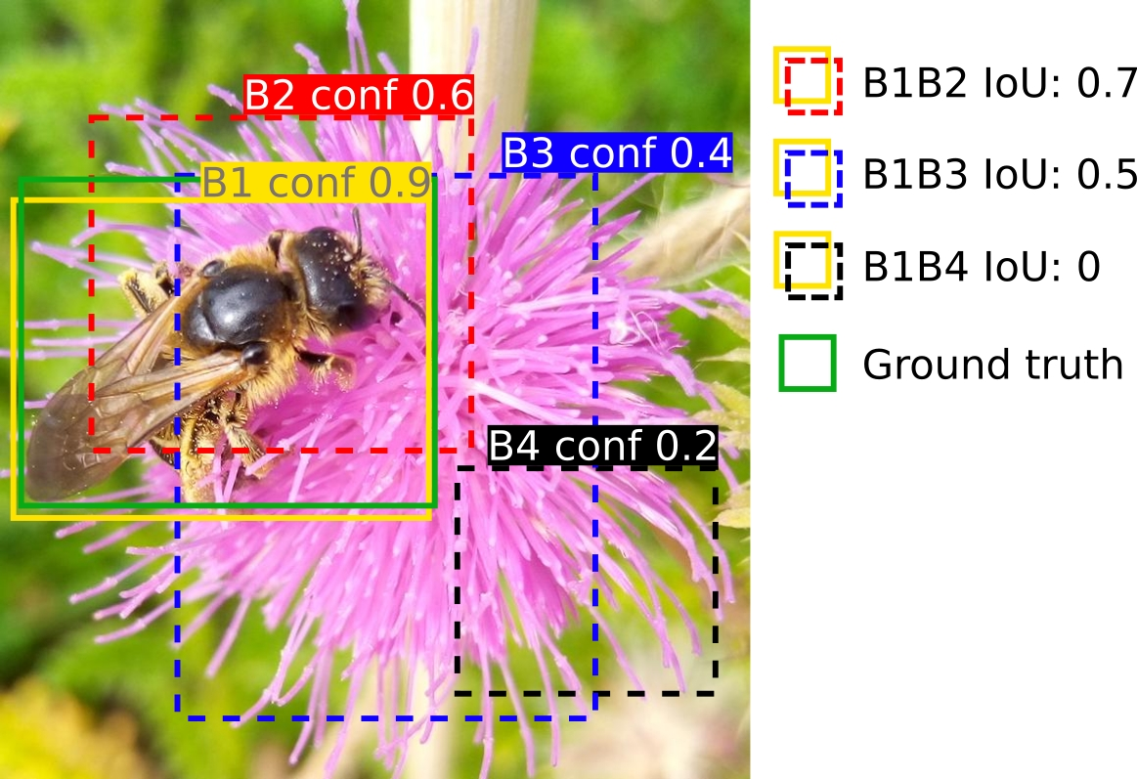

Figure S1. Illustration of Non-Maximum Suppression (NMS) with a confidence (NMS-conf) threshold of 0.3 and an Intersection-over-Union (NMS-IoU) threshold of 0.4. NMS operates independently of the ground truth (GT) box, processing only predicted bounding boxes (B1-B4). First, predicted boxes with confidence below the NMS-conf of 0.3 are discarded (e.g., B4 conf 0.2) irrespective of whether they overlap or not. The highest-confidence box (e.g., B1 conf 0.9) is selected, and boxes with IoU ≥ NMS-IoU 0.4 relative to B1 are suppressed (e.g., B1-B2 IoU: 0.7, B1-B3 IoU: 0.5), removing redundant predicted boxes for the same GT box. This process would iterate with the next highest-confidence box among any remaining predictions that were not discarded by the IoU ≥ NMS-IoU filter. For example, at an NMS-IoU of 0.6, B1 and B3 are retained, while only B2 is discarded. Next, after the NMS algorithm, if the GT overlaps well with the predicted box B1 (IoU ≥ eval-IoU 0.5), B1 is classified as a true positive (TP) and B3 as a false positive (FP). Note that B1 could be marked as a FP if it overlapped insufficiently with the GT, and the GT would then be marked as a false negative (FN). So, a higher NMS-IoU threshold permits overlapping predictions, aiding localisation of closely spaced arthropods, though it may increase false positives (FPs). Conversely, a lower NMS-IoU threshold is more aggressive in discarding predictions and is better suited for solitary arthropods. Operating after the NMS, the eval-IoU threshold impacts performance metrics by defining TPs, FPs and FNs. The IoU overlaps of the predicted bounding boxes are approximate and intended for illustration purposes only.

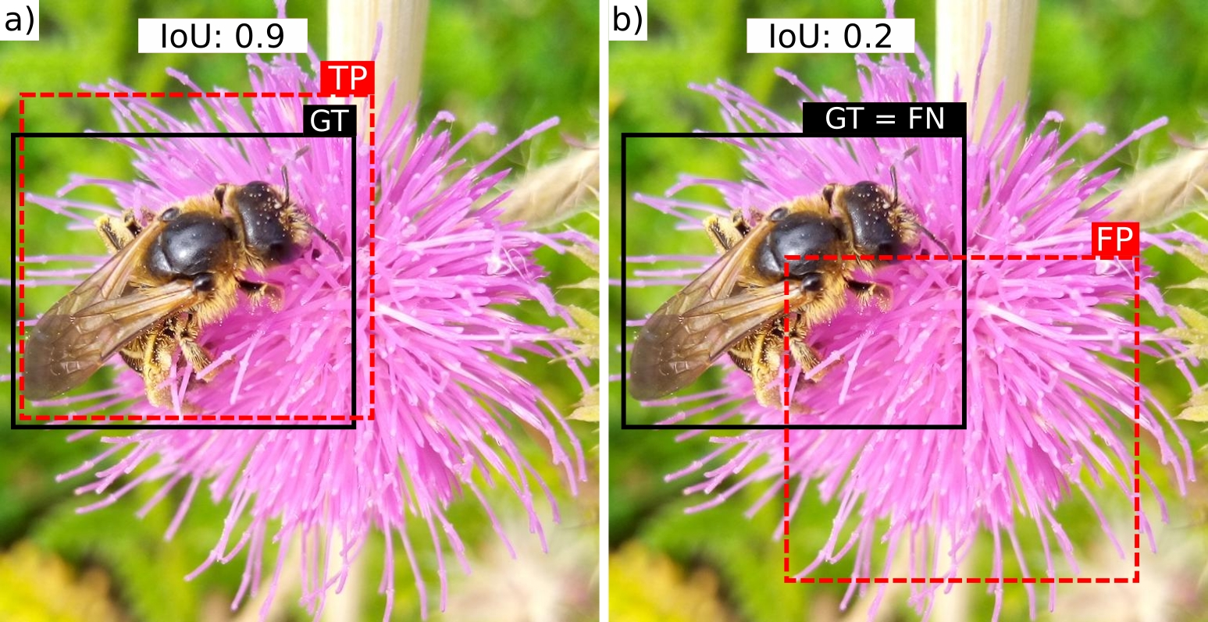

Figure S2. Illustration of the concepts of true positive (box-TP), false positive (box-FP), and false negative (box-FN) using an eval-IoU threshold of 0.5. True negatives (TN) are not applicable in this object localisation context. Panel a) shows an IoU of 0.9 between the predicted box and the ground truth (GT), classifying it as a TP. Panel b) shows an IoU of 0.2, resulting in the prediction being labelled as a FP and the GT as a FN. The IoU overlaps of the bounding boxes are approximate and intended for illustration purposes only.

