Appendix

Appendix 1: STROBE checklist

Appendix 2: Original Survey in Swedish

Appendix 3: Selected Questions Translated to English

Appendix 4: Additional Analyses

Appendix 4. Additional analyses

Socio-demographic characteristics and health status
Most respondents resided in Stockholm Region (18.18%), followed by Western Götaland (12.36%), and Scania (10.18%), see Figure 1.
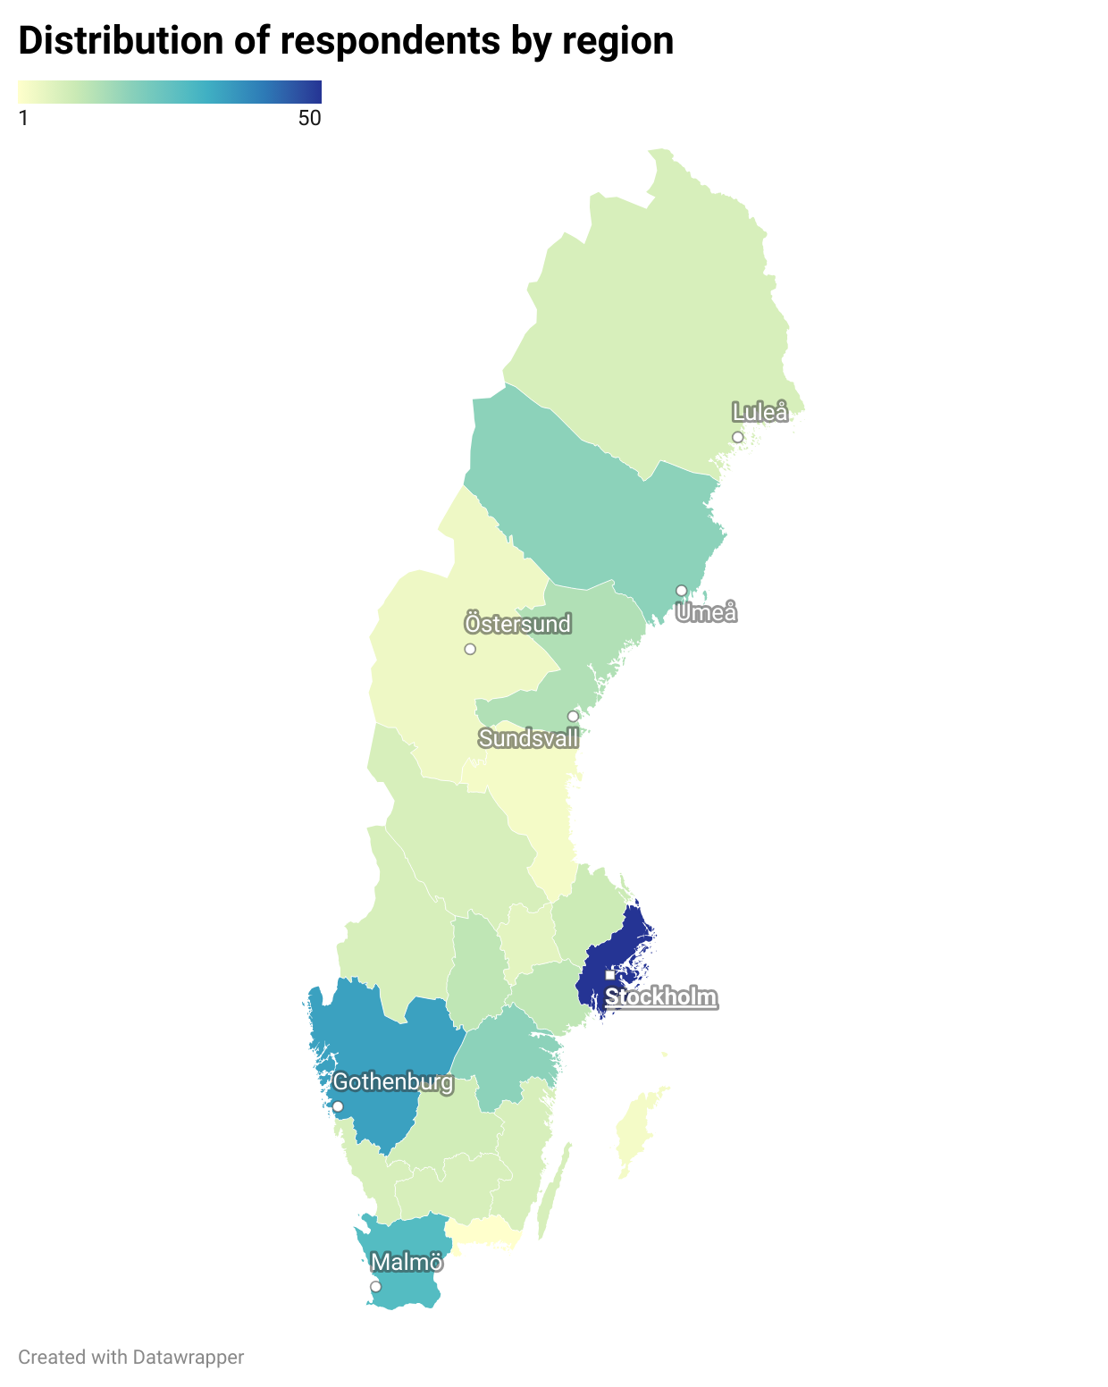
Figure 1. Distribution of Respondents by Region.

Diagnostic Journey

Genetic Testing
Table 1. Genetic testing in care settings.
 | Count | %
Out of those who received testing, who informed about genetic testing, (n = 41) *
MD in primary care | 3 | 7.32
MD in other specialty care | 14 | 34.15
MD in genetics care | 16 | 39.02
RN in primary care | 0 | 0
RN in specialty care | 2 | 4.88
RN in genetics care | 2 | 4.88
No one | 4 | 9.76
Don’t know | 2 | 4.88
Prefer not to specify | 3 | 7.32
Out of those who received testing, who interpreted the results *
MD in primary care | 2 | 4.88
MD in other specialty care | 14 | 34.15
MD in genetics care | 17 | 41.46
RN in primary care | 0 | 0
RN in specialty care | 1 | 2.44
RN in genetics care | 1 | 2.44
No one | 9 | 21.95
Other | 4 | 9.76
* Multiple-choice question, so percentages will not add up to 100%.

Healthcare Utilization and Experience

General Care

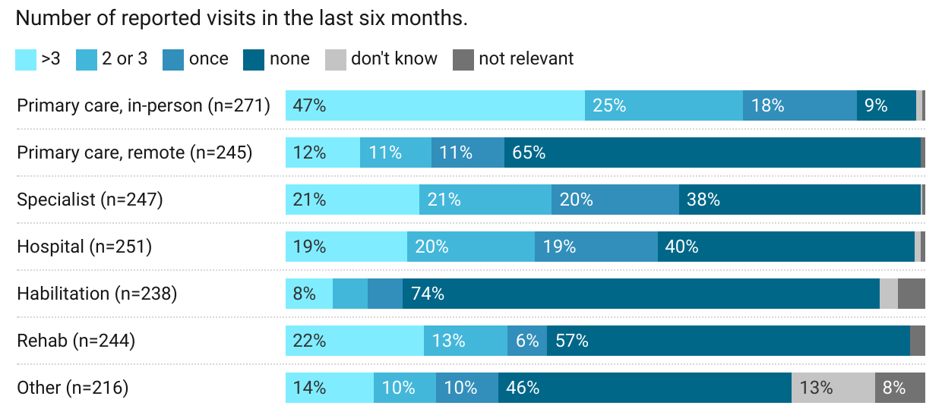
Figure 2. Care in the last 6 months.

Care Needs
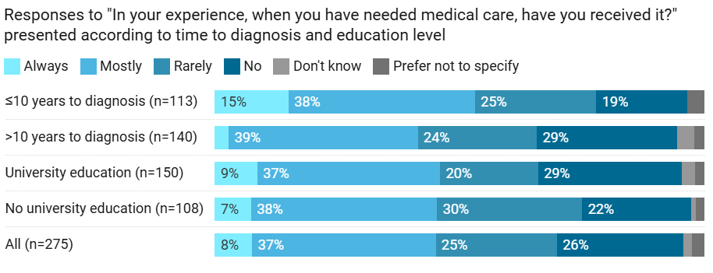
Figure 3. Distribution of responses on whether care needs were met based on diagnosis duration and university education.

Perceptions and Trust for Healthcare

Trust for Healthcare
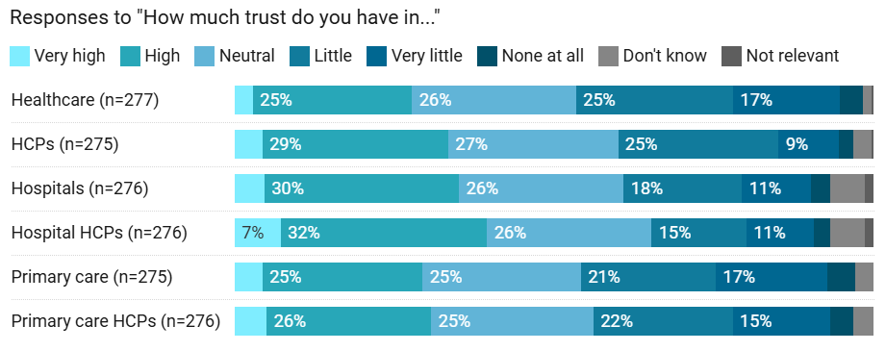
Figure 4. Patients’ trust in healthcare professionals.

EDS Outside of Healthcare

Public Services
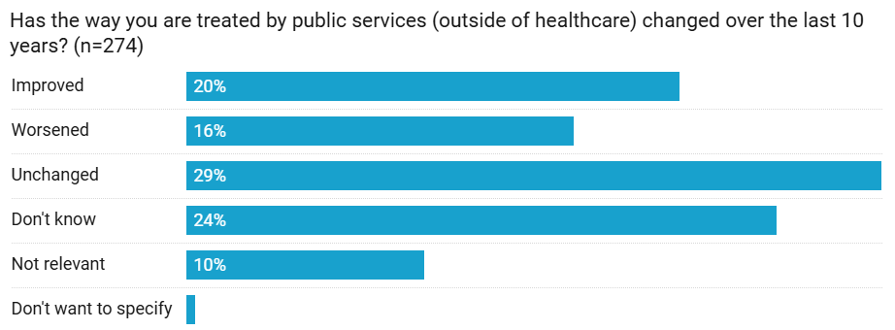
Figure 5. Opinions about Public Services and EDS.

Work and School
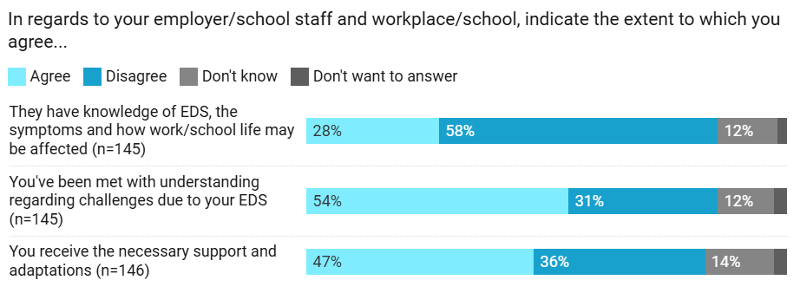
Figure 6. Opinions about Employer/School Knowledge and Support

