Supplement: Evaluation of an IgG deficiency rapid screening test among Pakistani children with primary immunodeficiency (PID)
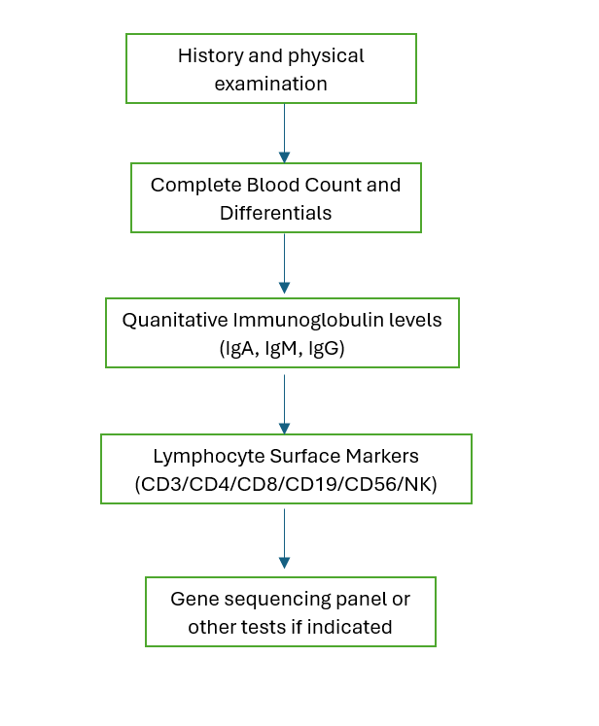
Supplement Figure S1. Flow Chart to Determine PI Status

Description of clinical workup procedures to diagnose types of PID at AKU
Hypogammaglobulinemias:
Agammaglobulinemia:
- B lymphocyte count (LcB) ≤ 1%
AND
- Serum IgG levels ≤ 500 mg/dl
AND
- Onset of recurrent infections before 5 years of age.

Combined immunodeficiency:
At least one of:
- one or more severe infections (requiring hospitalization)
- one manifestation of immune dysregulation (autoimmunity, IBD, severe eczema, lymphoproliferation, granuloma)
- malignancy
- affected family member
AND
- 2 of 4 T cell criteria fulfilled:
  - reduced CD3 or CD4 or CD8 T cells (using age-related reference values)
  - reduced naïve CD4 and/or CD8 T cells
  - reduced proliferation to mitogen or TCR stimulation
AND
- HIV excluded

Common variable immunodeficiency (CVID):
At least one of the following:
- Increased susceptibility to infections.
- Autoimmune manifestations.
- Granulomatous disease.
- Unexplained polyclonal lymphoproliferation.
- A family member with antibody deficiency.
AND
- Marked decrease in IgG associated with marked decrease in IgA and/or IgM (<2 SD of normal levels for age).
AND
- Diagnosis is made after the fourth year of life (but symptoms may be present earlier).
*Accessory inclusion criteria:
- The presence of at least one of the following is highly supportive of the diagnosis of CVID but is not a mandatory inclusion criterion.
- Low humoral response to vaccines.
- Low rate of switched memory B cells.

Immune Dysregulations:
Hyper IgM syndrome (HIGM):
At least one of the following:
- increased susceptibility to infections (recurrent and/or opportunistic, including cryptosporidium)
- immune dysregulation (autoimmunity, lymphoproliferation, sclerosing cholangitis)
- cytopenia (neutropenia or autoimmune)
- malignancy (lymphoma)
- affected family member
AND
- marked decrease of IgG (measured at least twice)
AND
- normal or elevated IgM (measured at least twice)
AND
- defined causes of hypogammaglobulinemia have been excluded
AND
- no evidence of profound T-cell deficiency, defined as 2/3 of the following (mo=month, y=year of life):
- CD4 numbers/microliter: 0-6mo <1000, 6mo-1y <800, 1-2y <500, 2-6y <300, 6-12y <250, >12y <200
- % naive CD4: 0-2y <30%, 2-6y <25%, 6-16y <20%, >16y 10%
- T cell proliferation absent

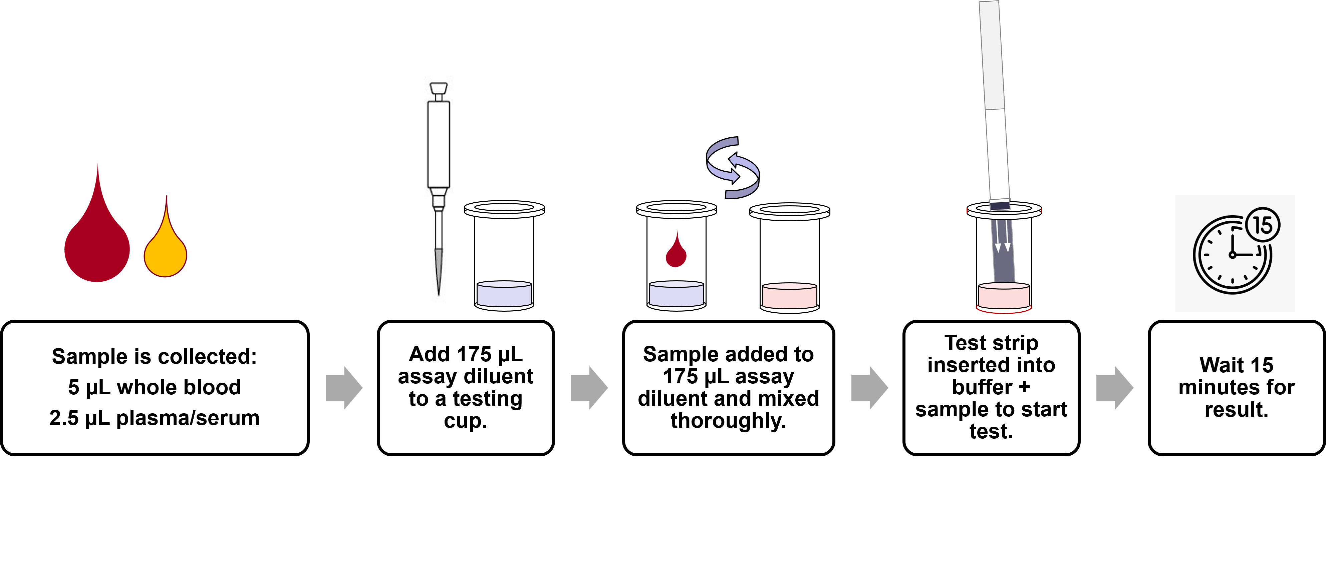
Figure S2. Workflow of IgG Total Test for whole blood or plasma/serum samples.

