Supplementary Information

- Method supplement 2
- Supplementary Table 1. Histological diagnoses of ovarian masses in the internal and external datasets 4
- Supplementary Table 2. The performance of 15 combined modalities across 5 tasks in the internal datasets 5
- Supplementary Table 3. The 5-fold performance of selected modality by OVUCM system assessed through 5×4 nested cross-validation in the internal datasets 6
- Supplementary Fig. 1: Calibration curves of the OVUCM system for 5 tasks in the internal datasets 7
- Supplementary Table 4. Clinical characteristics of 35 patients for the comparative performance study between the OVUCM system, MDT and individual gynecologists 8
- Supplementary Fig. 2: Composition of 35 patients for the comparative performance study between the OVUCM system, MDT and individual gynecologists 10
- Supplementary Table 5. Diagnostic performance comparison between the OVUCM system, MDT and individual gynecologists 11
- Supplementary Fig. 3: Radar maps of comparison between the OVUCM system, MDT and individual gynecologists 12
Method supplement

Software versions and links
ITK-SNAP software, version 3.8.0 (open source, http://www.itksnap.org)

3D Slicer software, version 5.4.0 (open source, http://www.slicer.org)

Steps for feature selection
First, we initially applied ANOVA to eliminate features with low variance, as these features typically lack discriminatory power and can be removed without significant loss of information. Second, to address redundancy and potential multicollinearity issues, the Spearman correlation was used to identify and remove features with a correlation coefficient greater than 0.9 between groups. This step ensured that only non-redundant features were retained for further analysis. The third step was to apply statistical tests with the Relief algorithm to assess the relevance of each feature to the target labels. Features with low relevance scores were excluded from the model. Finally, LASSO regularization was applied to shrink the coefficients of less important features to zero, effectively performing feature selection. This step also provided an importance ranking of the remaining features, aiding in the interpretation of the model.

5×4 nested cross-validation
To ensure robust model evaluation and hyperparameter tuning, we employed a nested cross-validation strategy in the internal datasets, consisting of an outer loop (5-Fold Stratified Cross-Validation) and an inner loop (4-Fold Stratified Cross-Validation). In the outer loop, the dataset was randomly split into five stratified folds, ensuring that each fold maintained the same class distribution as the original dataset. In each iteration, four folds were used for training, and the remaining fold was used for testing. Within each outer loop iteration, the inner loop was used for hyperparameter tuning and model selection. A grid search was performed over a predefined set of hyperparameters, including the number of features, classifier settings. The final model performance was averaged across five folds in the outer loop.

Clinical data preprocessing
String replacement rule: To ensure consistency and usability of the clinical data, we standardized string format of clinical data as follows:
“Yes” → 1

“No” → 0
Missing data completion strategy: When the proportion of missing data in tumor markers was less than 20%, we employed a median imputation strategy. The median value of each feature was used to fill in missing data. This approach preserved integrity and minimized the impact of missing data on model training and prediction.

Model performance evaluation indicators
The following metrics were used to evaluate the performance of the classification model:
AUC (Area under the Curve) was calculated using the Receiver Operating Characteristic (ROC) curve, providing a measure of the model's overall classification performance.
Accuracy represented the proportion of correctly classified samples out of the total number of samples:

$$ACC=\frac{TP+TN}{TP+TN+FP+FN}$$
where TP = true positives, TN = true negatives, FP = false positives, and FN = false negatives.
Sensitivity evaluated the model's ability to correctly identify positive samples, indicating how well the model identifies true positives.

$$SENS=\frac{TP}{TP+FN}$$
Specificity evaluated the model's performance in correctly identifying negative samples, indicating how well the model identifies true negatives.

$$SPEC=\frac{TN}{TN+FP}$$
Precision quantifies the proportion of true positive predictions among all positive predictions, reflecting the accuracy of the positive predictions.
$$Precision=\frac{TP}{TP+FP}$$
F1 Score balanced precision and sensitivity, providing a comprehensive performance assessment.
$$F1 Score=2×\frac{PPV×SENS}{PPV+SENS}$$

Randomized sampling 35 patients for the comparative performance study

We employed a randomized sampling strategy using Microsoft Excel. We used Excel's =RAND () function to generate random numbers for each patient in the dataset. The generated random numbers were used to sort the dataset in random order. The =RANK () function was applied to ensure that each sample had a unique rank, preventing duplicates in the selection process. Starting from task 5, we extracted ten cases from the high-pulped dataset, five from the non-high-pulped dataset, and added five more cases per task to other datasets. This process balanced the data across tasks while maintaining randomness and representativeness.

Supplementary Table 1. Histological diagnoses of ovarian masses in the internal and external datasets
 | Benign tumors (n=1109) |  | Borderline tumors (n=192) |  | Malignant tumors (n=543)
 | Internal (n=1064) | External (n=45) | Internal (n=173) | External (n=19) | Internal (n=505) | External (n=38)
Epithelial tumors | - Serous tumors, n=164  - Mucinous tumors, n=157  - Endometrioid tumors, n=1  - Seromucinous tumors, n=19  - Brenner tumors, n=9 | - Serous tumors, n=11  - Mucinous tumors, n=5 | - Serous tumors, n=87  - Mucinous tumors, n=27  - Endometrioid tumors, n=4  - Clear cell tumors, n=2  - Seromucinous tumors, n=28  - Brenner tumors, n=2 | - Serous tumors, n=11  - Mucinous tumors, n=5  - Endometrioid tumors, n=1  - Seromucinous tumors, n=2 | - Serous tumors, n=300  - Mucinous tumors, n=26  - Endometrioid tumors, n=38  - Clear cell tumors, n=53  - Brenner tumors, n=4  - Other carcinomas, n=13 | - Serous tumors, n=24  - Mucinous tumors, n=3  - Endometrioid tumors, n=1  - Clear cell tumors, n=1
Sex cord-stromal tumors | - Pure stromal tumors, n=130 | - Pure stromal tumors, n=5 | - Pure stromal tumors, n=5  - Pure sex cord tumors, n=11  - Mixed sex cord-stromal tumors, n=6 | - | - Pure stromal tumors, n=1  - Pure sex cord tumors, n=36 | - Pure sex cord tumors, n=7
Germ cell  tumors | - Germ cell tumors, n=162  - Monodermal teratoma and somatic-type tumors arising from a dermoid cyst, n=18 | - Germ cell tumors, n=2  - Monodermal teratoma and somatic-type tumors arising from a dermoid cyst, n=3 | - Monodermal teratoma and somatic-type tumors arising from a dermoid cyst, n=1 | - | - Germ cell tumors, n=28  - Monodermal teratoma and somatic-type tumors arising from a dermoid cyst, n=1 | - Germ cell tumors, n=2
Others | - Mesenchymal tumors, n=4  - Tumor-like lesions, n=229  - Ovarian endometriotic cysts, n=171 | - Tumor-like lesions, n=10  - Ovarian endometriotic cysts, n=9 | - | - | - Mesothelioma, n=1  - Miscellaneous tumors, n=4 | -

Supplementary Table 2. The performance of 15 combined modalities across 5 tasks in the internal datasets
Modality | Task 1 (Benign vs. non-benign) |  | Task 2 (Borderline vs. Malignant) |  | Task 3 (Non-epithelial vs. Epithelial) |  | Task 4 (FIGO I-II vs. FIGO III-IV) |  | Task 5 (Non-HGSOC vs. HGSOC)
Modality | Classifierª | AUC^{b} | Classifierª | AUC^{b} | Classifierª | AUC^{b} | Classifierª | AUC^{b} | Classifierª | AUC^{b}
US | XGB | 0.852 | XGB | 0.771 | NB | 0.698 | SVC | 0.609 | LogR | 0.699
CECT | XGB | 0.876 | LogR | 0.728 | XGB | 0.680 | SVC | 0.818 | NB | 0.795
DWI | SVC | 0.845 | LogR | 0.814 | SVC | 0.678 | XGB | 0.752 | NB | 0.794
T2WI | XGB | 0.836 | XGB | 0.713 | LogR | 0.681 | LogR | 0.734 | LogR | 0.837
US, CECT | XGB | 0.900 | SVC | 0.777 | XGB | 0.743 | SVC | 0.812 | NB | 0.760
US, DWI | XGB | 0.902 | SVC | 0.846 | NB | 0.724 | LogR | 0.725 | LogR | 0.785
US, T2WI | LogR | 0.890 | XGB | 0.788 | LogR | 0.718 | LogR | 0.716 | LinR | 0.779
CECT, DWI | SVC | 0.879 | XGB | 0.836 | LogR | 0.738 | LogR | 0.835 | NB | 0.791
CECT, T2WI | XGB | 0.859 | XGB | 0.752 | LogR | 0.696 | LogR | 0.834 | XGB | 0.787
DWI, T2WI | SVC | 0.868 | SVC | 0.828 | SVC | 0.726 | SVC | 0.760 | NB | 0.792
US, CECT, DWI | XGB | 0.916 | LogR | 0.845 | XGB | 0.804 | SVC | 0.822 | NB | 0.783
US, CECT, T2WI | XGB | 0.908 | XGB | 0.816 | LogR | 0.740 | SVC | 0.829 | LogR | 0.777
US, DWI, T2WI | XGB | 0.900 | LogR | 0.844 | XGB | 0.757 | LogR | 0.743 | NB | 0.784
CECT, DWI, T2WI | SVC | 0.881 | XGB | 0.823 | XGB | 0.765 | SVC | 0.842 | NB | 0.784
US, CECT, DWI, T2WI | XGB | 0.909 | NB | 0.839 | XGB | 0.773 | SVC | 0.825 | LogR | 0.786
The bold font represents the optimal multi-modal fusion architecture, including modality combination, classifiers and hyperparameter settings. AUC, area under the curve; CECT, contrast-enhanced computed tomography; DWI, MRI diffusion-weighted imaging; FIGO, International Federation of Gynecology and Obstetrics; HGSOC, High-grade serous ovarian cancer; LogR, Logistic Regression; LinR, Linear Regression; NB, Naive Bayes; SVC, Support Vector Classifier; T2WI, MRI-T2-weighted imaging; US, ultrasound; XGB, eXtreme Gradient Boost.
.

Supplementary Table 3. The 5-fold performance of selected modality by OVUCM system assessed through 5×4 nested cross-validation in the internal datasets
Task | Fold | AUC (95% CI) | Accuracy | Sensitivity | Specificity | Precision | F1-score
1.Benign vs. Non-benign  Modality: Clinical, US, CECT, DWI | 0 | 0.919 (0.888-0.945) | 0.845 | 0.801 | 0.873 | 0.801 | 0.801
1.Benign vs. Non-benign  Modality: Clinical, US, CECT, DWI | 1 | 0.943 (0.919-0.964) | 0.862 | 0.890 | 0.845 | 0.786 | 0.834
1.Benign vs. Non-benign  Modality: Clinical, US, CECT, DWI | 2 | 0.937 (0.909-0.961) | 0.874 | 0.933 | 0.836 | 0.783 | 0.851
1.Benign vs. Non-benign  Modality: Clinical, US, CECT, DWI | 3 | 0.934 (0.908-0.975) | 0.839 | 0.919 | 0.789 | 0.734 | 0.816
1.Benign vs. Non-benign  Modality: Clinical, US, CECT, DWI | 4 | 0.913 (0.884-0.941) | 0.839 | 0.875 | 0.816 | 0.753 | 0.810
2.Borderline vs. Malignant  Modality: Clinical, US, DWI, T2WI | 0 | 0.877 (0.813-0.930) | 0.794 | 0.762 | 0.886 | 0.951 | 0.846
 | 1 | 0.922 (0.870-0.966) | 0.868 | 0.851 | 0.914 | 0.966 | 0.905
 | 2 | 0.875 (0.810-0.930) | 0.772 | 0.733 | 0.886 | 0.949 | 0.827
 | 3 | 0.902 (0.836-0.958) | 0.889 | 0.911 | 0.824 | 0.939 | 0.925
 | 4 | 0.869 (0.794-0.932) | 0.852 | 0.881 | 0.765 | 0.918 | 0.899
3.Non-epithelial vs. Epithelial  Modality: Clinical, US, CECT, DWI | 0 | 0.964 (0.920-0.995) | 0.881 | 0.874 | 0.929 | 0.987 | 0.927
 | 1 | 0.865 (0.761-0.953) | 0.782 | 0.759 | 0.929 | 0.985 | 0.857
 | 2 | 0.898 (0.778-0.993) | 0.950 | 0.977 | 0.786 | 0.966 | 0.971
 | 3 | 0.913 (0.837-0.975) | 0.901 | 0.920 | 0.786 | 0.964 | 0.941
 | 4 | 0.845 (0.725-0.941) | 0.842 | 0.860 | 0.733 | 0.949 | 0.902
4.FIGO I-II vs. FIGO III-IV  Modality: Clinical, CECT, DWI, T2WI | 0 | 0.851 (0.768-0.926) | 0.828 | 0.872 | 0.775 | 0.820 | 0.845
 | 1 | 0.851 (0.765-0.922) | 0.793 | 0.702 | 0.900 | 0.892 | 0.786
 | 2 | 0.866 (0.782-0.931) | 0.782 | 0.739 | 0.829 | 0.829 | 0.782
 | 3 | 0.863 (0.778-0.934) | 0.828 | 0.804 | 0.854 | 0.860 | 0.831
 | 4 | 0.834 (0.742-0.910) | 0.802 | 0.978 | 0.600 | 0.738 | 0.841
5.Non-HGSOC vs. HGSOC  Modality: Clinical, T2WI | 0 | 0.782 (0.604-0.936) | 0.766 | 0.775 | 0.714 | 0.939 | 0.849
5.Non-HGSOC vs. HGSOC  Modality: Clinical, T2WI | 1 | 0.825(0.682-0.939) | 0.681 | 0.625 | 1.000 | 1.000 | 0.769
5.Non-HGSOC vs. HGSOC  Modality: Clinical, T2WI | 2 | 0.872 (0.696-0.989) | 0.913 | 0.949 | 0.714 | 0.949 | 0.949
5.Non-HGSOC vs. HGSOC  Modality: Clinical, T2WI | 3 | 0.842 (0.659-0.971) | 0.870 | 0.872 | 0.857 | 0.971 | 0.919
5.Non-HGSOC vs. HGSOC  Modality: Clinical, T2WI | 4 | 0.913 (0.796-0.992) | 0.870 | 0.875 | 0.833 | 0.972 | 0.921
AUC, area under the curve; CECT, contrast-enhanced computed tomography; DWI, MRI diffusion-weighted imaging; FIGO, International Federation of Gynecology and Obstetrics; HGSOC, High-grade serous ovarian cancer; T2WI, MRI-T2-weighted imaging; US, ultrasound.

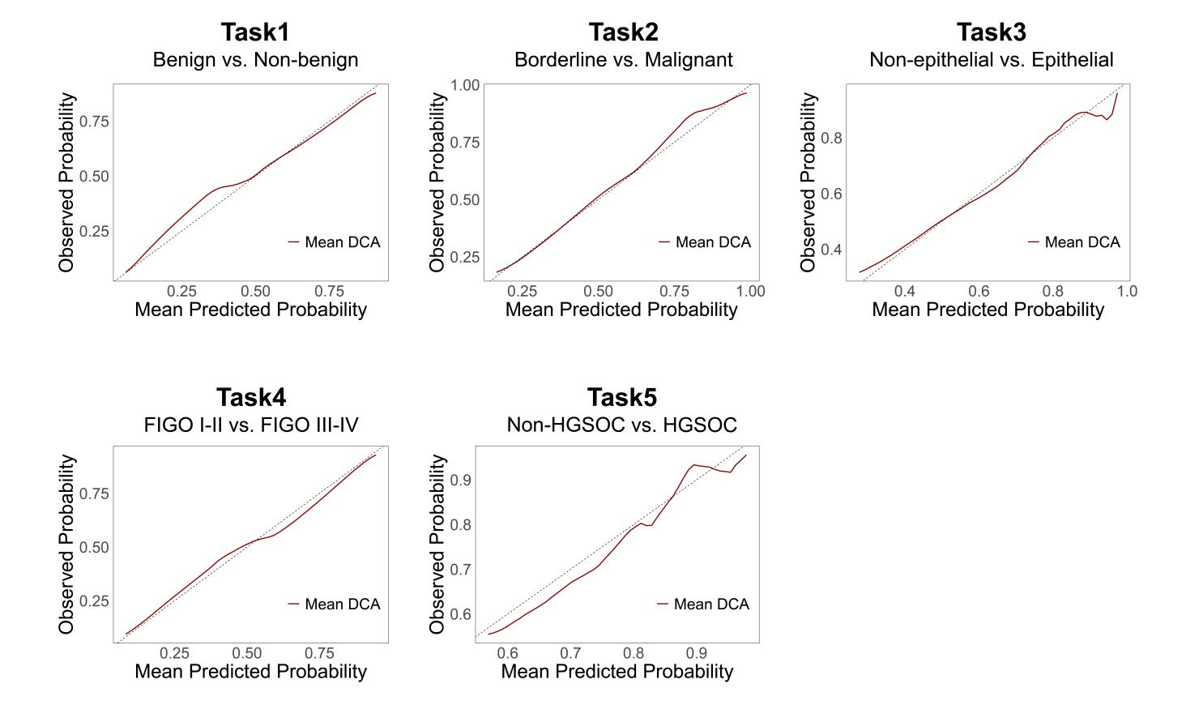
Supplementary Fig. 1: Calibration curves of the OVUCM system for 5 tasks in the internal datasets
FIGO, International Federation of Gynecology and Obstetrics; HGSOC, High-grade serous ovarian cancer.

Supplementary Table 4. Clinical characteristics of 35 patients for the comparative performance study between the OVUCM system, MDT and individual gynecologists
Variables | n=35
Age (years) | 51 (43-57)
BMI (kg/m2) | 22.48 (20.57-24.61)
Menopausal status
Postmenopausal | 17 (48.57%)
Premenopausal | 18 (51.43%)
Gravida | 2 (1-3)
0 | 4 (11.43%)
1 | 5 (14.29%)
≥2 | 26 (74.29%)
Parity | 1 (1-2)
0 | 5 (14.29%)
1 | 19 (63.33%)
≥2 | 11 (36.67%)
CA125 | 44.70 (19.10-243.50)
≤25.0U/mL | 9 (25.71%)
>25.0U/mL | 24 (68.57%)
N.A. | 2 (5.71%)
CA199 | 9.50 (7.15-22.70)
≤30.0U/mL | 28 (80.00%)
>30.0U/mL | 5 (14.29%)
N.A. | 2 (5.71%)
AFP | 2.30 (1.75-3.35)
≤7.0ng/mL | 29 (82.86%)
>7.0ng/mL | 3 (8.57%)
N.A. | 3 (8.57%)
CEA | 1.30 (0.60-2.00)
≤5.0ng/mL | 29 (82.86%)
>5.0ng/mL | 3 (8.57%)
N.A. | 3 (8.57%)
CA153 | 14.40 (7.15-25.25)
≤24.0U/mL | 23 (65.71%)
>24.0U/mL | 9 (25.71%)
N.A. | 3 (8.57%)
SCC | 0.90 (0.65-1.25)
<2.7ng/mL | 29 (82.86%)
≥2.7ng/mL | 1 (2.86%)
N.A. | 5 (14.29%)
Histological diagnoses
Benign | 5 (14.29%)
Borderline | 5 (14.29%)
Malignant | 25 (71.43%)
Histological subtypes
Epithelial tumors | 26 (74.29%)
Serous tumors | 17 (48.57%)
Mucinous tumors | 4 (11.43%)
Endometrioid tumors | 0 (0.00%)
Clear cell tumors | 3 (8.57%)
Other ª | 1 (2.86%)
Non-epithelial | 9 (25.71%)
Sex cord-stromal tumors | 4 (11.43%)
Germ cell tumors | 4 (11.43%)
Tumor-like lesions | 1 (2.86%)
Ovarian endometriotic cysts | 0 (0.00%)
Other ^{b} | 0 (0.00%)
Continuous data are given as median (IQR) and categorical data as n (%). ª Other epithelial tumor types, such as seromucinous tumors, brenner tumors, and other carcinomas. ^{b} Other non-epithelial tumor types, such as mesothelioma, miscellaneous, mesenchymal. AFP, alpha-fetoprotein; BMI, body mass index; CEA, carcinoembryonic antigen; SCC, squamous cell carcinoma antigen.

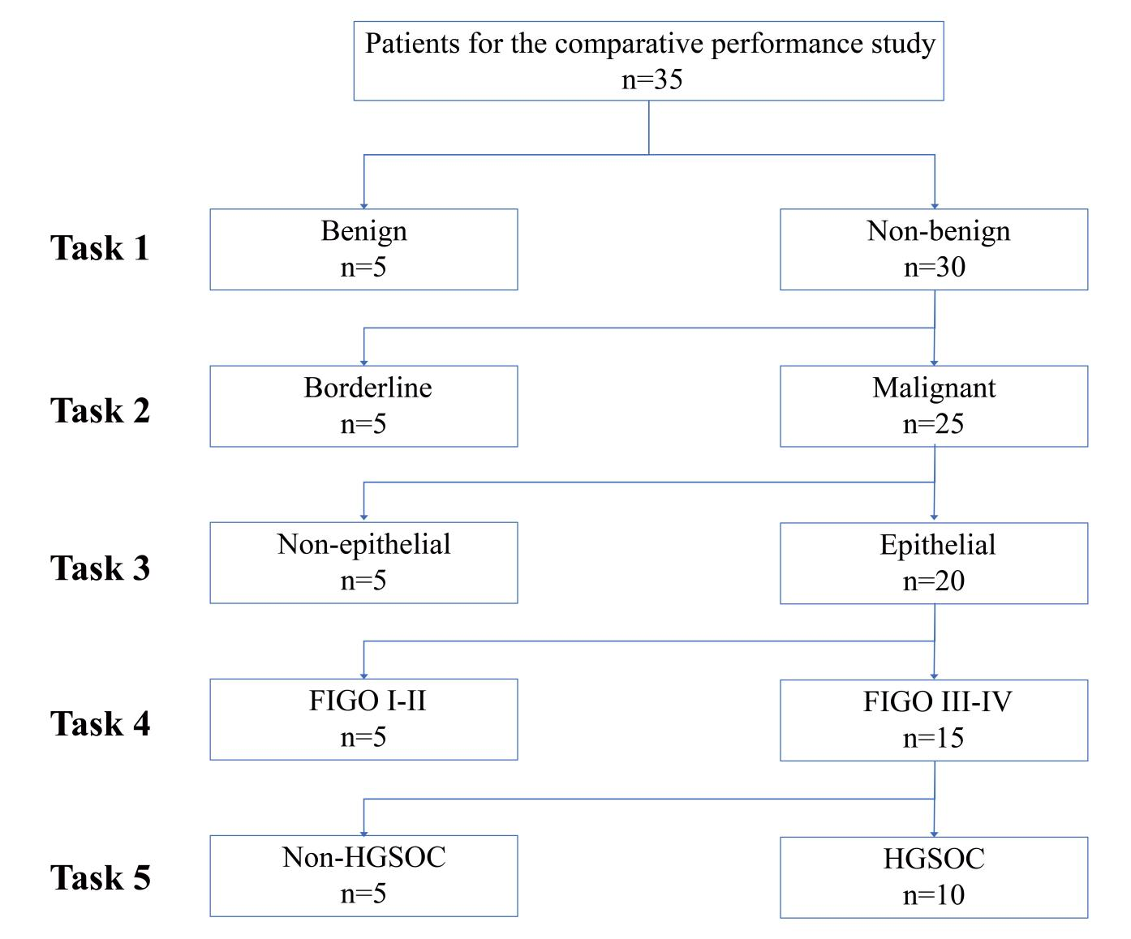
Supplementary Fig. 2: Composition of 35 patients for the comparative performance study between the OVUCM system, MDT and individual gynecologists

FIGO, International Federation of Gynecology and Obstetrics; HGSOC, High-grade serous ovarian cancer.

Supplementary Table 5. Diagnostic performance comparison between the OVUCM system, MDT and individual gynecologists
Task | Group | AUC | ΔAUC | p-valueª | Accuracy | Sensitivity | Specificity | Precision | F1-score
Benign vs. Non-benign | OVUCM | 0.850 | - | - | 0.886 | 0.900 | 0.800 | 0.964 | 0.931
Benign vs. Non-benign | MDT | 0.900 | 0.05 | 0.756 | 0.971 | 1.000 | 0.800 | 0.968 | 0.984
Benign vs. Non-benign | Clinician A | 0.817 | 0.033 | 0.838 | 0.829 | 0.833 | 0.800 | 0.962 | 0.893
Benign vs. Non-benign | Clinician B | 0.667 | 0.183 | 0.153 | 0.857 | 0.933 | 0.400 | 0.903 | 0.918
Benign vs. Non-benign | Clinician C | 0.800 | 0.05 | 0.255 | 0.800 | 0.800 | 0.800 | 0.960 | 0.873
Borderline vs. Malignant | OVUCM | 0.840 | - | - | 0.867 | 0.880 | 0.800 | 0.957 | 0.917
Borderline vs. Malignant | MDT | 0.860 | 0.02 | 0.569 | 0.900 | 0.920 | 0.800 | 0.958 | 0.939
Borderline vs. Malignant | Clinician A | 0.600 | 0.240 | 0.056 | 0.733 | 0.800 | 0.400 | 0.870 | 0.833
Borderline vs. Malignant | Clinician B | 0.400 | 0.440 | <0.001 | 0.667 | 0.800 | 0.000 | 0.800 | 0.800
Borderline vs. Malignant | Clinician C | 0.620 | 0.220 | 0.044 | 0.633 | 0.640 | 0.600 | 0.889 | 0.744
Non-Epithelial vs. Epithelial | OVUCM | 0.975 | - | - | 0.960 | 0.950 | 1.000 | 1.000 | 0.974
Non-Epithelial vs. Epithelial | MDT | 0.975 | 0 | 1.000 | 0.960 | 0.950 | 1.000 | 1.000 | 0.974
Non-Epithelial vs. Epithelial | Clinician A | 0.700 | 0.275 | 0.033 | 0.760 | 0.800 | 0.600 | 0.889 | 0.842
Non-Epithelial vs. Epithelial | Clinician B | 0.725 | 0.250 | 0.049 | 0.800 | 0.850 | 0.600 | 0.895 | 0.872
Non-Epithelial vs. Epithelial | Clinician C | 0.525 | 0.450 | 0.001 | 0.600 | 0.650 | 0.400 | 0.813 | 0.722
FIGO I-II vs. FIGO III-IV | OVUCM | 0.900 | - | - | 0.850 | 0.800 | 1.000 | 1.000 | 0.889
FIGO I-II vs. FIGO III-IV | MDT | 0.833 | 0.067 | 0.566 | 0.850 | 0.867 | 0.800 | 0.929 | 0.897
FIGO I-II vs. FIGO III-IV | Clinician A | 0.467 | 0.433 | <0.001 | 0.700 | 0.933 | 0.000 | 0.737 | 0.824
FIGO I-II vs. FIGO III-IV | Clinician B | 0.733 | 0.167 | 0.189 | 0.800 | 0.867 | 0.600 | 0.867 | 0.867
FIGO I-II vs. FIGO III-IV | Clinician C | 0.600 | 0.300 | 0.033 | 0.700 | 0.800 | 0.400 | 0.800 | 0.800
Non-HGSOC vs. HGSOC | OVUCM | 0.950 | - | - | 0.933 | 0.900 | 1.000 | 1.000 | 0.947
Non-HGSOC vs. HGSOC | MDT | 0.700 | 0.250 | 0.059 | 0.800 | 1.000 | 0.400 | 0.769 | 0.870
Non-HGSOC vs. HGSOC | Clinician A | 0.450 | 0.500 | 0.001 | 0.533 | 0.700 | 0.200 | 0.636 | 0.667
Non-HGSOC vs. HGSOC | Clinician B | 0.500 | 0.450 | 0.007 | 0.467 | 0.400 | 0.600 | 0.667 | 0.500
Non-HGSOC vs. HGSOC | Clinician C | 0.550 | 0.350 | 0.001 | 0.667 | 0.900 | 0.200 | 0.692 | 0.783
ªThe P value was derived from the Delong test, comparing the AUCs of the OVUCM system with those of MDT and gynecologists. AUC, area under the curve; FIGO, International Federation of Gynecology and Obstetrics; HGSOC, High-grade serous ovarian cancer; MDT, multidisciplinary team; OVUCM, a multitask system for OVarian cancer through integration of Ultrasound, CECT and MRI imaging.

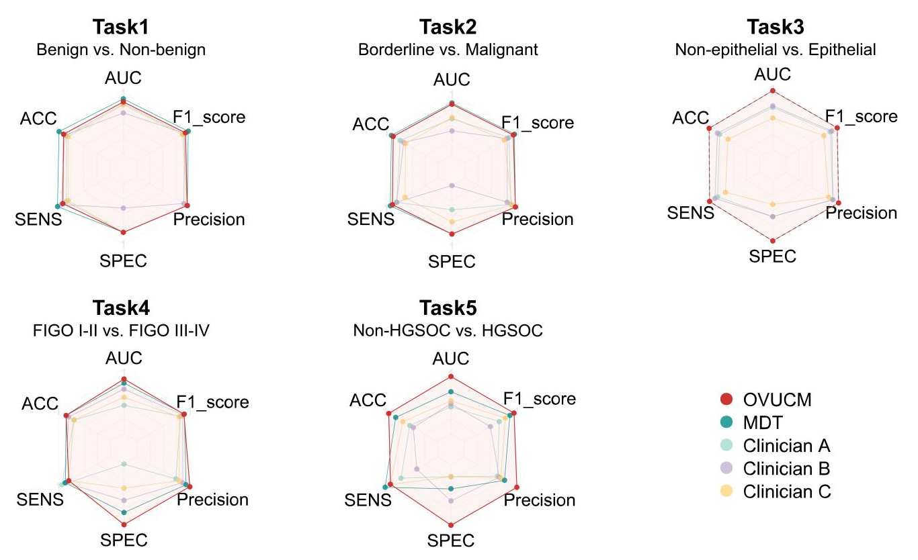
Supplementary Fig. 3: Radar maps of comparison between the OVUCM system, MDT and individual gynecologists
The size of the enclosed area within the radar chart reflects the overall performance—a larger area indicates better overall capability, while a smaller area suggests weaker performance. All the above demonstrate that the OVUCM system, which can be compared to MDT, outperform the other three gynecologists. AUC, area under the curve; ACC, accuracy; FIGO, The International Federation of Gynecology and Obstetrics; HGSOC, High-grade serous ovarian cancer; MDT, multidisciplinary team; SENS, sensitivity; SPEC, specificity.

