Supplementary Material A
Avatar Profiles

Transgender-Embodied Woman
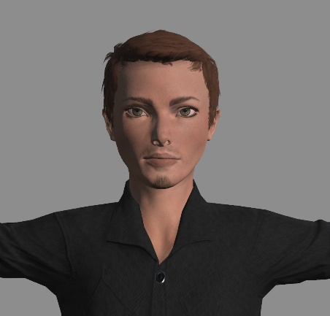
You will be playing the role of Alex today. You graduated from university and then worked in the information technology field as a programmer for five years before seeking new employment. You identify as a transgender man and have a masculine appearance. Your pronouns are he/him. According to your previous supervisor at Research Technology Labs, you have demonstrated a great degree of technical knowledge but have been passed over for regular promotions, mostly due to your lack of managerial skills.

Transgender-Embodied Man
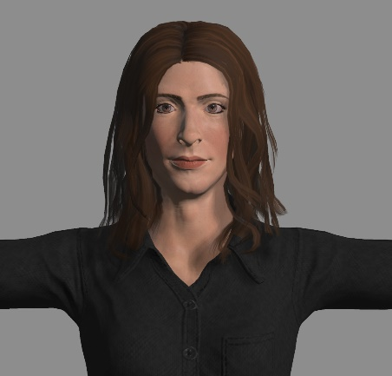
You will be playing the role of Alex today. You graduated from university and then worked in the information technology field as a programmer for five years before seeking new employment. You identify as a transgender woman and have a feminine appearance. Your pronouns are she/her. According to your previous supervisor at Research Technology Labs, you have demonstrated a great degree of technical knowledge but have been passed over for regular promotions, mostly due to your lack of managerial skills.

Cisgender-Embodied Woman
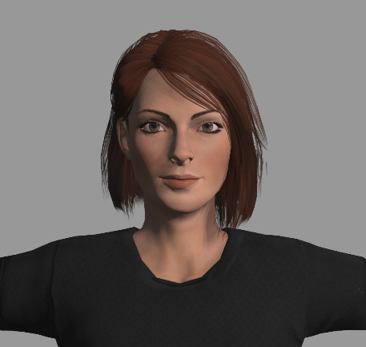
You will be playing the role of Alex today. You graduated from university and then worked in the information technology field as a programmer for five years before seeking new employment. You identify as a cisgender woman and have a feminine appearance. Your pronouns are she/her. According to your previous supervisor at Research Technology Labs, you have demonstrated a great degree of technical knowledge but have been passed over for regular promotions, mostly due to your lack of managerial skills.

Cisgender-Embodied Man
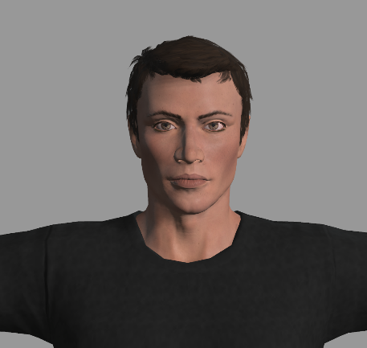
You will be playing the role of Alex today. You graduated from university and then worked in the information technology field as a programmer for five years before seeking new employment. You identify as a cisgender man and have a masculine appearance. Your pronouns are he/him. According to your previous supervisor at Research Technology Labs, you have demonstrated a great degree of technical knowledge but have been passed over for regular promotions, mostly due to your lack of managerial skills.

Note. Avatar profile descriptions were adapted from Dray et al. (2020).
Dray, K. K., Smith, V. R. E., Kostecki, T. P., Sabat, I. E., & Thomson, C. R. (2020). Moving beyond the gender binary: Examining workplace perceptions of nonbinary and transgender employees. Gender, Work & Organization, 1-11. https://doi.org/10.1111/gwao.12455
Supplementary Material B
Interview Questions and Disclosure

The simulated interview task was administered twice in the experiment. Thus, two question sets were created using an item from each of three topic areas (diversity, equity, inclusion; allyship; gender identity), and question set presentation was counterbalanced across participants.

{QUESTION SET A}
QSA1: Please share with me what the terms diversity, equity, and inclusion mean to you?
QSA2: Do you think that workplace policies should include statements on allyship, such as how to respond to sexist, racist, or homophobic behaviours? Why or why not?
QSA3: In your opinion, should sharing gender pronouns be incorporated in workplace settings? Why or why not?

{QUESTION SET B}
QSB1: In your opinion, what is the most challenging aspect of working in a diverse, equitable, and/or inclusive environment?
QSB2: Allyship refers to members of privileged in-groups making efforts to advance the interests of marginalised groups. Do you think allyship is important in the workplace? Why or why not?
QSB3: Do you think it is important to understand gender diversity? Why or why not?

*DISCLOSURE*
Welcome back to the interview Alex. As you may or may not know, gender-diversity, gender identity and gender expression are becoming more visible in society through for instance, social and traditional media, policy initiatives, and workplace inclusion and diversity strategies. In recognition of this, I wanted to share with you my own experience of being a transgender woman in the workplace before we continue. I too was previously passed over for regular promotions in my previous job. Employers cited insufficient leadership skills as the reason, however, I believe the lack of promotion was at least in part due to my appearance and use of she/her pronouns. I’m grateful to now work here at The Diversity and Inclusion Council where this challenge is no longer present.

