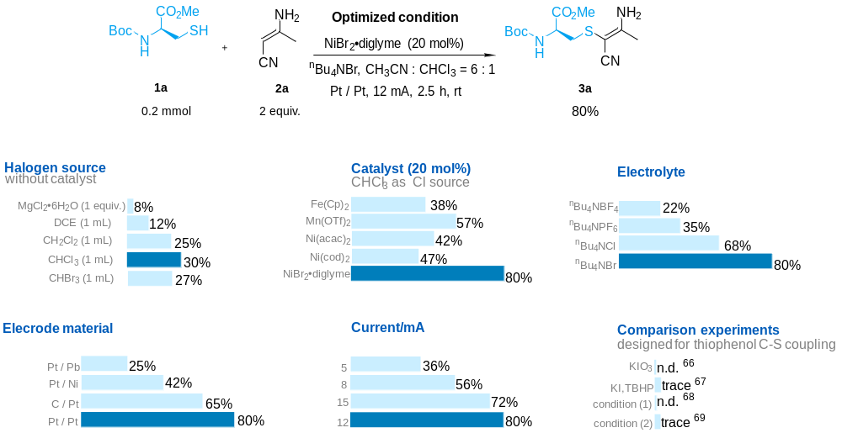
Table 1. Investigation of the reaction conditionsª. ª Standard conditions: platinum plate anode, platinum plate cathode (15 mm x 15 mm x 0.3 mm), constant current = 12 mA, 1a (0.2 mmol), 2a (2 equiv.), ^{n}Bu₄NBr (1 equiv.), NiBr₂•diglyme (20 mol%), 6 mL MeCN, 1 mL CHCl_{3,} undivided cell, 2.5 h. Isolated yields were shown. Condition (1) : C (Cloth) | Fe (-), 3 mA, ^{n}Bu₄NBF₄ , CH₃CN, rt , 5 h. Condition (2) : Pt | Pt, 5 mA, NH₄I (20 mol%), NH₄BF₄, rt, 6 h, CH₃CN.

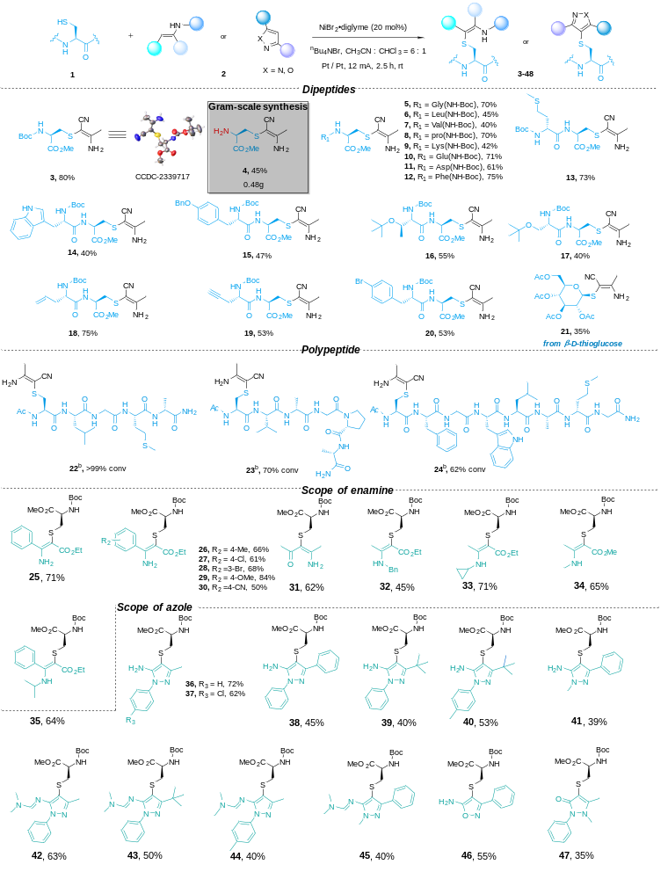
Table 2. Scope of cysteine-containing peptides and enamines and azolesª. ª Standard conditions as shown in Table 1. ^{b} Reaction conditions: platinum plate anode, platinum plate cathode (15 mm x 15 mm x 0.3 mm), constant current = 4 mA, polypeptides (0.01 mmol), 2a (2 equiv.), ^{n}Bu₄NBr (2 equiv.), NiBr₂•diglyme (20 mol%), MeCN (6 mL), CHCl₃ (1 mL), undivided cell, room temperature, 15 min. Conversion of products are shown, as determined by HPLC.

