Life’s Essential 8 for carotid artery stenosis prevention: stratified risk reduction by family cardiovascular history in the UK Biobank
Supplementary materials
Table S1. Disease definitions used in the UK Biobank study
Table S2. Covariate definitions
Table S3. The percentages of participants with missing covariates
Table S4. Detailed description of the 8 components in LE8
Table S5. Stratified analysis of the association between the Life’sEssential8 score and Carotid Artery Stenosis incidence
Table S6. The result of Population Attributable Risk (PAR), representing the proportion of outcomes attributable to the exposure
Table S7. The result of Logistic Regression Analysis for Family Risk Score Development
Table S8. Main analysis on the association of the Family Risk Score and Carotid Artery Stenosis incidence
Table S9. Sensitivity analysis 1 on the association of the Life’sEssential8 score and Carotid Artery Stenosis incidence by excluding events that occurred within the first two years of follow-up
Table S10 Sensitivity analysis 2 on the association between the Life’s Essential 8 score and Carotid Artery Stenosis incidence among participants, excluding Family Risk Score (revised inclusion and exclusion criteria)
Table S11. Sensitivity analysis 3 on the association between the Life’s Essential 8 score and Carotid Artery Stenosis incidence among participants, excluding those with missing values in covariates
Figure S1. Selection of study participants in the UK Biobank Cohort
Figure S2. Distribution of Life’s Essential 8 (LE8) Overall Scores and Individual Components in 270,695 UK Biobank Participants
Figure S3.Frequency of Family Risk Scores by Risk Category
Figure S4.Association of total LE8, behavior subscale score and biological subscale score with Carotid Artery Stenosis: Hazard Ratios and 95% Confidence Intervals
Figure S5.Crude cumulative incidence of CAS by different family risk level

Table S1. Disease definitions used in the UK Biobank study
 | ICD-9 (Field ID: 41271) | ICD-10 (Field ID: 41270)
CVD | 390-459 | I00-I99
CAS | 433.10 | I65.2
Variable definitions constructed using ICD-9 and ICD-10 fields with choice-, disease- or procedure-specific codes between brackets are shown.CVD, cardiovascular disease; CAS, Carotid Artery Stenosis;

Table S2. Covariate definitions
Variable | Definition | UK Biobank field ID
Age | Continuous | 21022
Sex | Female/Male | 31
Ethnicity | White/Other | 21000
Townsend deprivation index | Continuous | 22189
Alcohol drinker status | Never/Previous/Current | 20117
Education level | No qualification/Any other qualification/Degree or above | 6138
Income level | ≥£18,000/<£18000 | 738
Employment | Employed/Unemployed | 6142
Use of medication | Yes/No | 6177,6153
Sedentary time | Continuous;hour | 1070,1080,1090

Table S3. The percentages of participants with missing covariates
Covariates | Percentage of missing data
Sex | 0.94%
Age | 0.00%
Ethnicity | 0.25%
Townsend deprivation index | 0.12%
Alcohol drinker status | 0.04%
Education level | 0.58%
Income level | 11.45%
Employment | 0.71%
Medication use | 0.44%
Sedentary time | 0.01%
Overall 3.47%

Table S4. Detailed description of the 8 components in LE8.
Health factors | Method of measurement | Quantification of CVH metric
DASH diet | Self-reported daily intake of a DASH-style eating pattern.Self-reported healthy eating pattern: enough intake of fruit, vegetable, whole grains, fish, dairy, and vegetable oils, small proportion of refined grains, processed meats, unprocessed meats, sugar sweetened beverages, industrial trans-fat, and added sodium. | Points | DASH diet score ((Population)
DASH diet |  | 100 | 95th percentile (top/ideal diet)
DASH diet |  | 80 | 75th-94th percentile
DASH diet |  | 50 | 50th-74th percentile
DASH diet |  | 25 | 25th-49th percentile
DASH diet |  | 0 | 1st-24th percentile (bottom/least ideal quartile)
Physical activity | Self-reported minutes of moderate or vigorous physical activity per week. One minute of vigorous physical activity is equivalent to two minutes of moderate physical activity. | Points | Minutes of moderate- (or greater) intensity activity per week
Physical activity |  | 100 | ≥150 minutes
Physical activity |  | 90 | 120-149 minutes
Physical activity |  | 80 | 90-119 minutes
Physical activity |  | 60 | 60-89 minutes
Physical activity |  | 40 | 30-59 minutes
Physical activity |  | 20 | 1-29 minutes
Physical activity |  | 0 | 0 minutes
Nicotine exposure | Self-reported use of cigarettes, secondhand smoke exposure. | Points | Combustible tobacco uses or secondhand smoke exposure
Nicotine exposure | Self-reported use of cigarettes, secondhand smoke exposure. | 100 | Never smoker
Nicotine exposure | Self-reported use of cigarettes, secondhand smoke exposure. | 80 | Former smokers with quit years ≥ 5
Nicotine exposure | Self-reported use of cigarettes, secondhand smoke exposure. | 50 | Former smokers with quit years 1-5
Nicotine exposure | Self-reported use of cigarettes, secondhand smoke exposure. | 25 | Former smokers with quit years < 1
Nicotine exposure | Self-reported use of cigarettes, secondhand smoke exposure. | 0 | Current smoker
Nicotine exposure | Self-reported use of cigarettes, secondhand smoke exposure. | Subtract 20 points (unless score is 0) for secondhand smoke exposures.
Sleep health | Self-reported average hours of sleep per night. | Points | Average hours of sleep per night
Sleep health | Self-reported average hours of sleep per night. | 100 | ≥ 7 and < 9 hours
Sleep health | Self-reported average hours of sleep per night. | 90 | ≥ 9 and < 10 hours
Sleep health | Self-reported average hours of sleep per night. | 70 | ≥ 6 and < 7 hours
Sleep health | Self-reported average hours of sleep per night. | 40 | ≥ 5 and < 6 or ≥ 10 hours
Sleep health | Self-reported average hours of sleep per night. | 20 | ≥ 4 and < 5 hours
Sleep health | Self-reported average hours of sleep per night. | 0 | < 4 hours
Body mass index | Body weight (kilograms) divided by height squared (meters squared). | Points | BMI
Body mass index |  | 100 | <25 kg/m²
Body mass index |  | 70 | 25.0-29.9 kg/m2
Body mass index |  | 30 | 30.0-34.9 kg/m2
Body mass index |  | 15 | 35.0-39.9 kg/m2
Body mass index |  | 0 | ≥40 kg/m²
Blood lipids | Non-HDL cholesterol was calculated by total cholesterol minus HDL cholesterol. Serum cholesterol was measured enzymatically | Points | Non-HDL-cholesterol
Blood lipids |  | 100 | <130 mg/dL
Blood lipids |  | 60 | 130-159 mg/dL
Blood lipids |  | 40 | 160-189 mg/dL
Blood lipids |  | 20 | 190-219 mg/dL
Blood lipids |  | 0 | ≥220 mg/dL
Blood lipids |  | If drug-treated level, subtract 20 points (unless score is 0).
Blood glucose | HbA1c was measured by high-performance liquid chromatography methods. | Points | HbA1c
Blood glucose |  | 100 | Diabetes with HbA1c <7.0 %
Blood glucose |  | 75 | Diabetes with HbA1c 7.0%-7.9%
Blood glucose |  | 50 | Diabetes with HbA1c 8.0%-8.9%
Blood glucose |  | 25 | Diabetes with HbA1c 9.0%-9.9%
Blood glucose |  | 0 | Diabetes with HbA1c ≥10%
Blood pressure | The average of all available BP measurements was used to calculate systolic and diastolic BP. | Points | Systolic and diastolic BPs
Blood pressure |  | 100 | SBP < 120 and DBP < 80 mm Hg
Blood pressure |  | 75 | 120 ≤ SBP < 130 and DBP<80 mm Hg
Blood pressure |  | 50 | 130 ≤ SBP < 140 or 80 ≤ DBP < 90 mm Hg
Blood pressure |  | 25 | 140 ≤ SBP < 150 or 90 ≤ DBP < 100 mm Hg
Blood pressure |  | 0 | SBP ≥ 150 or DBP ≥ 100 mm Hg
Blood pressure |  | Subtract 20 points (unless score is 0) if treated level

Table S5. Stratified analyses for association between Life’s Essential 8 and hazard of CAS among participants ª
Subgroup | HR (95% CI) |  |  | P for trend | P for interaction^{c}
Subgroup | Low-CVH | Moderate-CVH | High-CVH | P for trend | P for interaction^{c}
Overall | 1.00(reference) | 0.64 (0.55-0.76)^{b} | 0.40 (0.30-0.55) | <0.001
Age |  |  |  |  | 0.001
≤50 years | 1.00 (reference) | 0.52 (0.30, 0.90) | 0.18 (0.05, 0.64) | 0.006
51–60 years | 1.00 (reference) | 0.49 (0.37, 0.65) | 0.30 (0.16, 0.55) | <0.001
>60 years | 1.00 (reference) | 0.79 (0.63, 0.98) | 0.55 (0.37, 0.80) | 0.005
Sex |  |  |  |  | 0.592
Male | 1.00 (reference) | 0.66 (0.54, 0.80) | 0.36 (0.24, 0.55) | <0.001
Female | 1.00 (reference) | 0.62 (0.47, 0.83) | 0.48 (0.30, 0.77) | 0.003
Ethnicity |  |  |  |  | 0.668
White | 1.00 (reference) | 0.63 (0.54, 0.75) | 0.40 (0.29, 0.55) | <0.001
Other | 1.00 (reference) | 0.96 (0.40, 2.29) | 0.51 (0.10, 2.61) | 0.418
Townsend deprivation index |  |  |  |  | 0.701
≥ median | 1.00 (reference) | 0.67 (0.54, 0.83) | 0.47 (0.31, 0.71) | <0.001
＜median | 1.00 (reference) | 0.61 (0.47, 0.80) | 0.35 (0.22, 0.55) | <0.001
Education |  |  |  |  | 0.212
No qualification | 1.00 (reference) | 0.62 (0.47, 0.82) | 0.18 (0.07, 0.51) | 0.002
Any other qualification | 1.00 (reference) | 0.64 (0.50, 0.80) | 0.41 (0.26, 0.64) | <0.001
Degree or above | 1.00 (reference) | 0.81 (0.52, 1.27) | 0.60 (0.34, 1.09) | <0.001
Income |  |  |  |  | 0.716
<18,000 | 1.00 (reference) | 0.68 (0.56, 0.84) | 0.40 (0.26, 0.61) | <0.001
≥18,000 | 1.00 (reference) | 0.59 (0.44, 0.78) | 0.41 (0.26, 0.65) | <0.001
Employment |  |  |  |  | 0.513
Employed | 1.00 (reference) | 0.64 (0.49, 0.84) | 0.29 (0.17, 0.51) | <0.001
Unemployed | 1.00 (reference) | 0.65 (0.53, 0.80) | 0.49 (0.34, 0.72) | <0.001
Use of medication |  |  |  |  | 0.714
No | 1.00 (reference) | 0.53 (0.41, 0.70) | 0.32 (0.21, 0.50) | <0.001
Yes | 1.00 (reference) | 0.72 (0.59, 0.88) | 0.52 (0.33, 0.83) | 0.013
Alcohol drinker status |  |  |  |  | 0.809
Never | 1.00 (reference) | 1.01 (0.39, 2.59) | 0.43 (0.08, 2.28) | 0.257
Previous | 1.00 (reference) | 0.80 (0.43, 1.50) | 0.36 (0.08, 1.65) | 0.242
Current | 1.00 (reference) | 0.62 (0.52, 0.74) | 0.40 (0.29, 0.56) | <0.001
Family risk level |  |  |  |  | 0.315
Low risk | 1.00 (reference) | 0.87 (0.59, 1.29) | 0.59 (0.32, 1.07) | 0.133
Medium risk | 1.00 (reference) | 0.71 (0.52, 0.96) | 0.42 (0.24, 0.73) | 0.002
High risk | 1.00 (reference) | 0.54 (0.43, 0.67) | 0.33 (0.20, 0.54) | <0.001
ª Obtained by using multivariable Cox regression model.
^{b}Hazard ratios (95% confidence interval) (all such values).
^{c}P for interaction was calculated by adding the cross-product terms in the multivariable Cox model.
Model was additionally adjusted adjusted for age, sex, ethnicity, Townsend deprivation index, alcohol drinker status, sedentary time,average household income, education levels,medication use and family risk level.

Table S6. The result of Population Attributable Risk (PAR), representing the proportion of outcomes attributable to the exposure.
Variable | Total No. of Participants | Incidence rate per person-years | PAR
LE8 scoreª | 270,695 | 1158/3,596,976 | 57.6%
Biological subscale score^{b} | 270,695 | 1158/3,596,976 | 27.9%
Behavior subscale score^{c} | 270,695 | 1158/3,596,976 | 31.9%
ª PAR for the LE8 score was adjusted for age, sex, ethnicity, Townsend deprivation index, alcohol drinker status, sedentary time,average household income, education levels,medication use and family risk level.
^{b} PAR for the biological subscale score score was adjusted for age, sex, ethnicity, Townsend deprivation index, alcohol drinker status, sedentary time,average household income, education levels,medication use ,family risk level and behavior subscale score .
^{c} PAR for the behavior subscale score was adjusted for age, sex, ethnicity, Townsend deprivation index, alcohol drinker status, sedentary time,average household income, education levels,medication use, family risk level and biological subscale score
Table S7. Logistic Regression Analysis for Family Risk Score Development.
Variable _{i} | OR (95%CI) | P-value | Weight _{i}
Father heart disease history | 1.27 (1.17, 1.38) | <0.001 | 1
Father stroke history | 1.11 (1.00, 1.24) | 0.046 | 1
Father high blood pressure history | 0.95 (0.86, 1.04) | 0.266 | 0
Father diabetes history | 0.83 (0.72, 0.95) | 0.01 | 1
Mother heart disease history | 1.49 (1.37, 1.63) | <0.001 | 1
Mother stroke history | 1.27 (1.15, 1.41) | <0.001 | 1
Mother high blood pressure history | 0.88 (0.80, 0.95) | 0.002 | 1
Mother diabetes history | 0.83 (0.72, 0.95) | 0.008 | 1
Siblings heart disease history | 2.44 (2.20, 2.70) | <0.001 | 2
Siblings stroke history | 2.44 (2.08, 2.85) | <0.001 | 2
Siblings high blood pressure history | 1.59 (1.45, 1.74) | <0.001 | 2
Siblings diabetes history | 1.52 (1.34, 1.71) | <0.001 | 2
Table S8. Main analysis on the association of the Family Risk Score and Carotid Artery Stenosis incidence
 |  | Family Risk Score |  |  | P for  trend
 |  | Low family risk | Medium family risk | High family risk
Total No. of participants | 270,695 | 94,978 | 88,197 | 87,520
Incidence rate per person-years | 1158/3,596,975 | 286/1,266,454 | 362/1,172,410 | 510/1,158,111
Crude model |  | 1.00(reference) | 1.37 (1.19,1.56) | 1.96 (1.77,2.17) | <0.0001
Model1 |  | 1.00 (reference) | 1.19 (1.02,1.39) | 1.56 (1.34,1.80) | <0.0001
Model2 |  | 1.00(reference) | 1.10 (0.94,1.28) | 1.25 (1.08,1.46) | <0.0001
Model3 |  | 1.00(reference) | 1.09 (0.93,1.28) | 1.24 (1.07,1.44) | <0.0001
Crude model was unadjusted.
Model 1 was adjusted for age, sex, and ethnicity.
Model 2 was additionally adjusted for Townsend deprivation index, alcohol drinker status, medication using-sedentary time-average household income and education levels.
Model 3 was adjusted for age, sex, ethnicity, Townsend deprivation index, alcohol drinker status, sedentary time, average household income, education levels, medication use and LE8 score.

Table S9. Sensitivity analysis1 on the association of the Life’sEssential8 score and Carotid Artery Stenosis incidence by excluding events that occurred within the first two years of follow-up
 |  | LE8 score |  |  | P for  trend
 |  | Low-CVH | Moderate-CVH | High-CVH
Total No. of Participants | 270,614 | 21,210 | 213,008 | 36,369
Incidence rate per person-years | 1077/3596894 | 158/275,464 | 868/2,831,141 | 51/490,289
Crude model |  | 1.00(reference) | 0.53 (0.45,0.63) | 0.18 (0.13,0.24) | <0.0001
Model1 |  | 1.00 (reference) | 0.53 (0.45,0.63) | 0.27 (0.20,0.37) | <0.0001
Model2 |  | 1.00(reference) | 0.66 (0.55,0.78) | 0.40 (0.29,0.56) | <0.0001
Model3 |  | 1.00(reference) |  | 0.41 (0.29,0.56) | <0.0001
  0.66 (0.55,0.78)
Model 1was adjusted for age, sex, and ethnicity.
Model 2 was additionally adjusted for Townsend deprivation index, alcohol drinker status, Medication using-sedentary time-average household income and education levels.
Model3was adjusted for age, sex, ethnicity, Townsend deprivation index, alcohol drinker status, sedentary time,average household income, education levels,medication use and family risk level.

Table S10. Sensitivity analysis 2 on the association between the Life’s Essential 8 score and Carotid Artery Stenosis incidence among participants, excluding Family Risk Score (revised inclusion and exclusion criteria）
 |  | LE8 score |  |  | P for  trend
 |  | Low-CVH | Moderate-CVH | High-CVH | P for  trend
Total No. of Participants | 362,997 | 30,353 | 287,134 | 45,510
Incidence rate per person-years | 1684/4811548 | 271/392,402 | 1341/ 3,806,688 | 72/612,458
Crude model |  | 1.00(reference) | 0.51 (0.44, 0.58) | 0.17 (0.13, 0.22) | <0.0001
Model1 |  | 1.00 (reference) | 0.51 (0.45, 0.58) | 0.25 (0.19, 0.33) | <0.0001
Model2 |  | 1.00(reference) | 0.62 (0.54,0.71) | 0.37 (0.28,0.48) | <0.0001
Crude model was unadjusted for any covariant.
Model 1 was adjusted for age, sex, and ethnicity.
Model 2 was additionally adjusted for Townsend deprivation index, alcohol drinker status, Medication using-sedentary time-average household income, and education levels.

Table S11. Sensitivity analysis 3 on the association between the Life’s Essential 8 score and Carotid Artery Stenosis incidence among participants, excluding those with missing values in covariates
 |  | LE8 score |  |  | P for  trend
 |  | Low-CVH | Moderate-CVH | High-CVH | P for  trend
Total No. of Participants | 222,943 | 17,425 | 175,118 | 30,400
Incidence rate per person-years | 932/2967146 | 149/226,576 | 735/2,330,745 | 48/409,825
Model1 |  | 1.00(reference) | 0.48 (0.40, 0.57) | 0.18 (0.13, 0.24) | <0.0001
Model2 |  | 1.00 (reference) | 0.59 (0.49, 0.70) | 0.39 (0.28, 0.55) | <0.0001
Model3 |  | 1.00(reference) | 0.59 (0.49, 0.70) |  | <0.0001
  0.39 (0.28, 0.55)
Model 1 was adjusted for age, sex, and ethnicity.
Model 2 was additionally adjusted for Townsend deprivation index, alcohol drinker status, Medication using-sedentary time-average household income, and education levels.
Model 3was adjusted for age, sex, ethnicity, Townsend deprivation index, alcohol drinker status, sedentary tim e,average household income, education levels,medication use and family risk level.

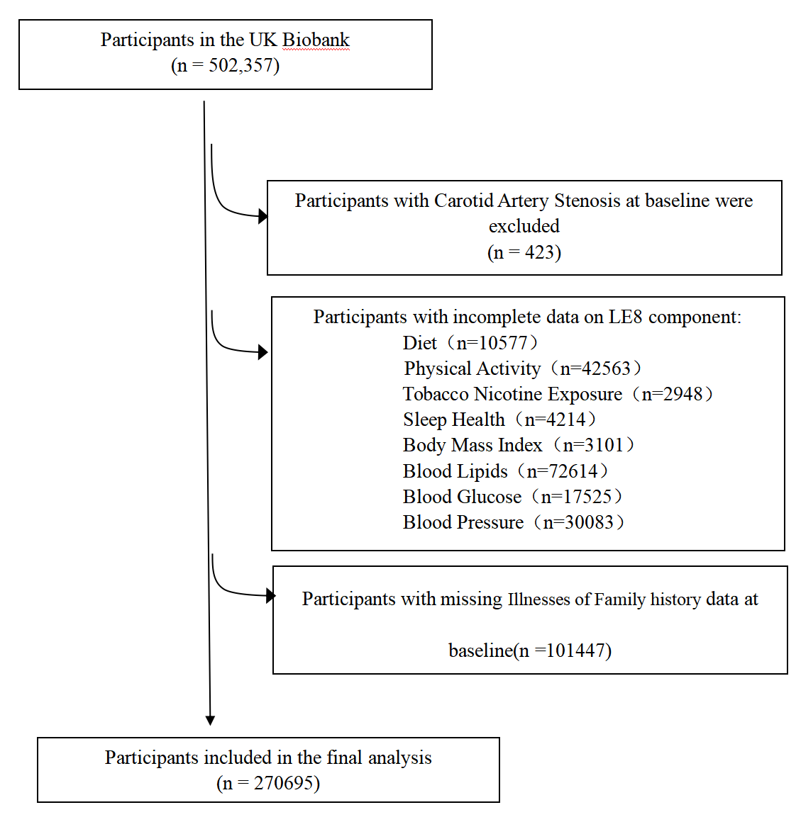
Figure S1. Selection of study participants in the UK Biobank cohort.

A B
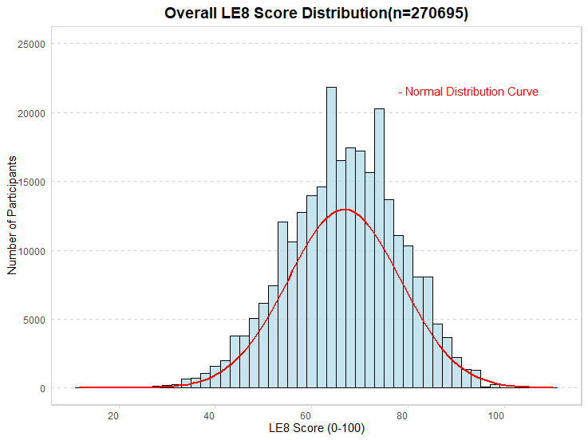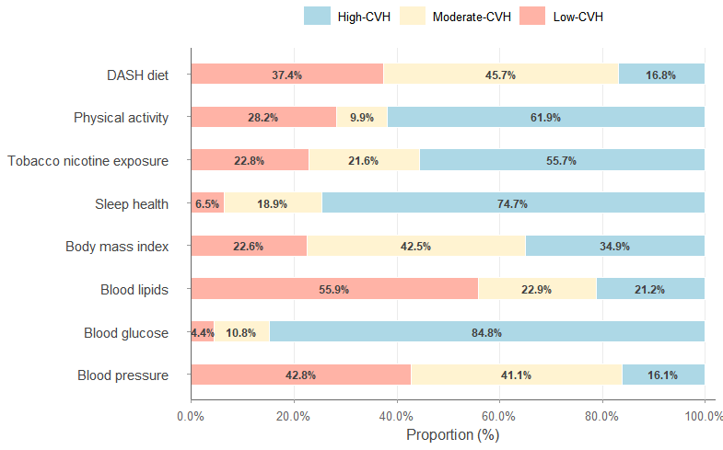
Figure S2. Distribution of Life’s Essential 8 (LE8) Overall Score(A) and Individual
Components(B）in 270,695UK Biobank Participants

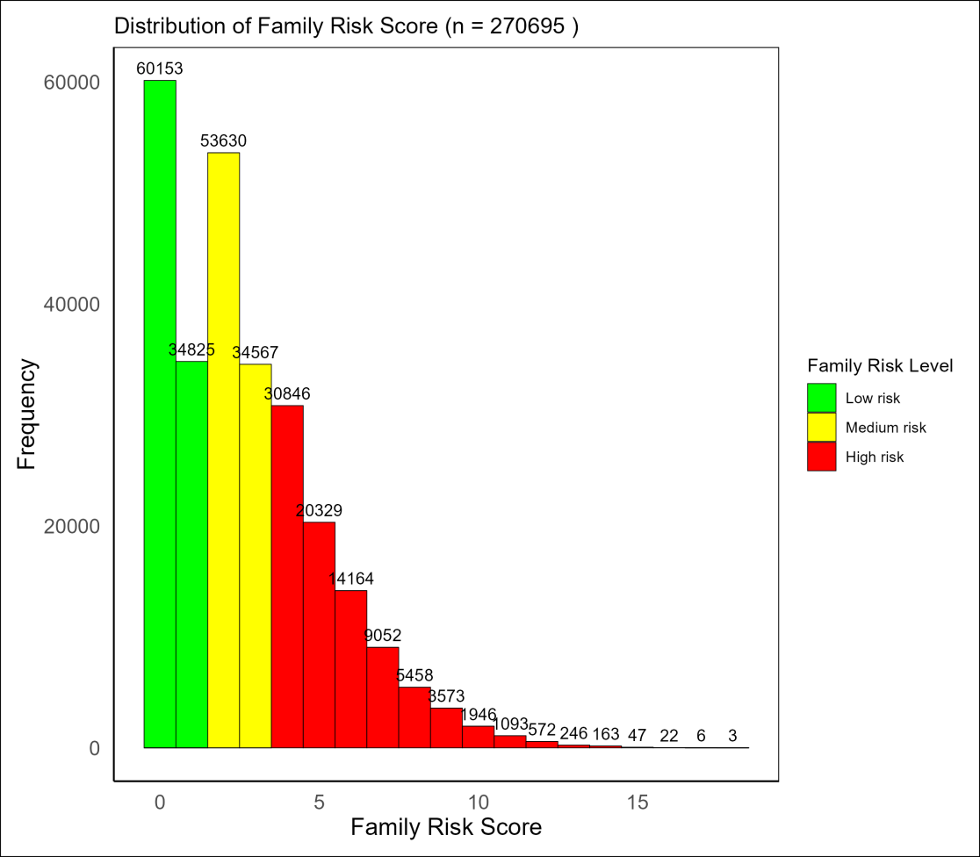

Figure S3.Frequency of Family Risk Scores by Risk Category

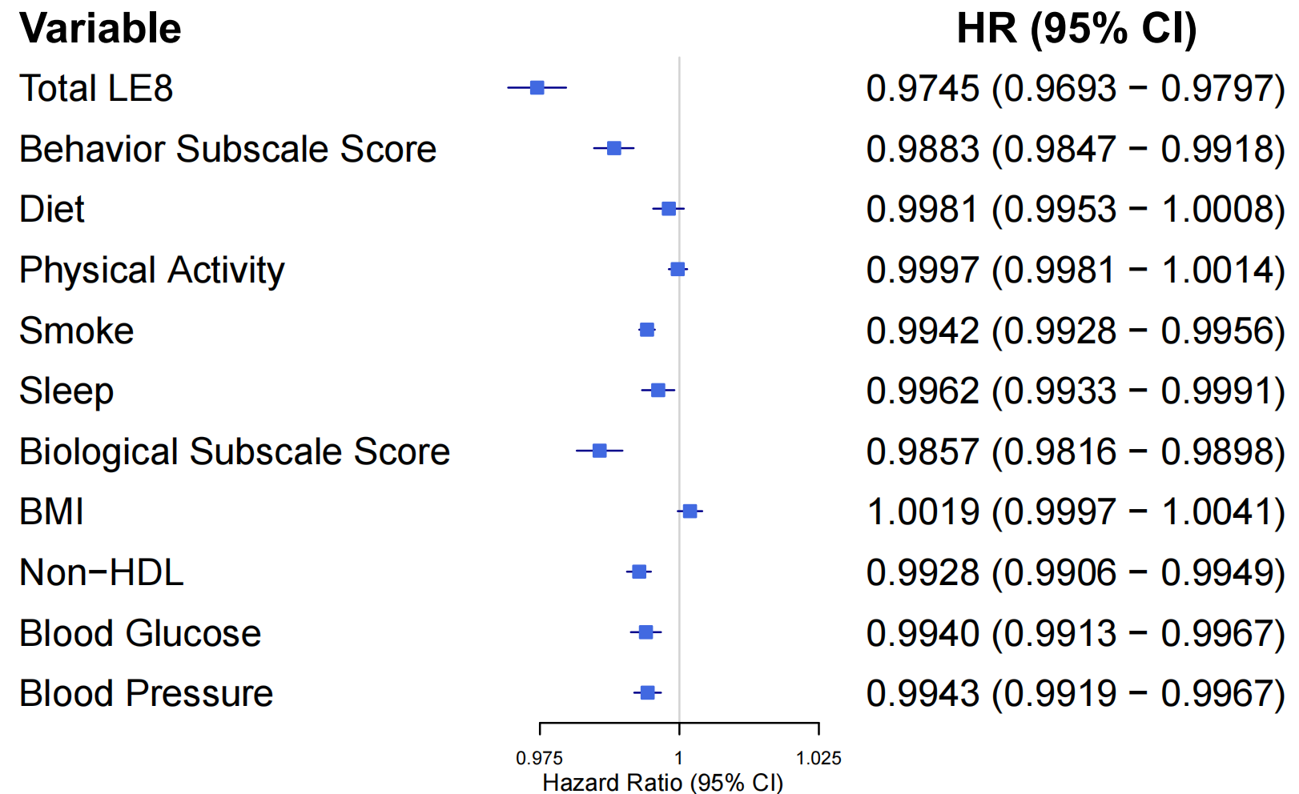
Figure S4.Association of total LE8 score, behavior subscale score and biological subscale score with CAS: Hazard Ratios and
95% Confidence Intervals.

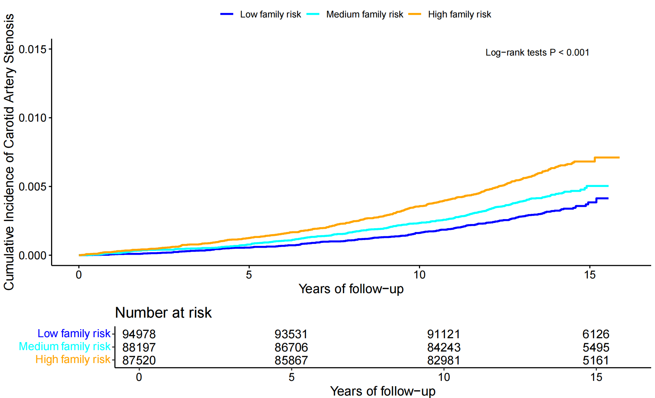
Figure S5.Crude cumulative incidence of CAS by different family risk level . CAS, Carotid Artery Stenosis;

