Supplementary information

Multi-country multi-city study on heterogeneous impacts of urbanicity
on heat-related mortality
Jieun Oh†, Yoorim Bang†, Cinoo Kang, Jieun Min, Dohoon Kwon, Francesco Sera, Michelle L Bell, Masahiro Hashizume, Eun Mee Kim, Eric Lavigne, Susanne Breitner, Francesca de'Donato, Yoonhee Kim, Chris Fook Sheng Ng, Lina Madaniyazi, Ben Armstrong, Pierre Masselot, Yasushi Honda, Aurelio Tobias, Aleš Urban, Ana Maria Vicedo-Cabrera, Antonio Gasparrini, Eunhee Ha***, Ho Kim**, and Whanhee Lee* on behalf of the Multi-Country Multi-City Collaborative Research Network

Table of contents
Additional information on MCC dataset 2
Supplementary Table 1. Descriptive statistics of urbanicity by region and country. 4
Supplementary Table 2. Descriptive statistics of urbanicity-related characteristics by region and country. 5
Supplementary Table 3. Percentage change in RR (95% CI) per IQR increase in overall population density by region with varying modelling choices. 6
Supplementary Table 4. Percentage change in RR (95% CI) per IQR increase in built-up population density by region with varying modelling choices. 7
Supplementary Fig. 1. Association between urbanicity-related characteristics and heat-related mortality risk by region in separate models for each characteristic. 8
Supplementary Table 5. Descriptive statistics of GDP and the Gini index for each country during the study period. 9
Supplementary Table 6. Meta-regression results on spatial heterogeneities. Cochran Q-tests for heterogeneity (p-value), and I² statistics (%) in random-effects meta-regression models. 10

Additional information on MCC dataset
The Multi-Country Multi-City (MCC) Collaborative Research Network collected and updated daily time-series data on mortality counts and environmental variables (e.g., mean temperature and air pollution). It is an international research program on the associations between environmental stressors, climate, and health (http://mccstudy.lshtm.ac.uk/).
The latest version of dataset included 1674 cities from 91 countries with different study periods. In this study, we restricted the study periods to start from 1990 and selected countries with sufficient numbers of cities (i.e., countries with more than nine cities) for a reliable estimation at a later analysis stage. Also, the dataset that were able to be linked with the Global Human Settlement Layer Urban Centres Database (GHS-UCDB) were selected for each country. A total 392 cities in 12 countries are finally included in the analysis: Brazil (15 cities during 1997–2011), Mexico (9 cities during 1998–2014), Canada (20 cities during 1990–2015), the United States (137 cities during 1990–2006), China (14 cities during 1996–2015), Japan (37 cities during 2011–2015), South Korea (19 cities during 2000–2018), Italy (16 cities during 2001–2010), France (18 cities during 2000–2014), Germany (12 cities during 1993–2015), Spain (41 cities during 1990–2014), the United Kingdom (59 cities during 1990–2016).
Brazil Daily mortality is represented by counts of deaths for non-external causes (ICD-9: 0-799; ICD-10 codes: A00–R99) obtained from Ministry of Health, Brazil. Daily mean temperature was computed from the 24-h average of hourly measurements collected from National Institute of Meteorology of Brazil. A single weather station located within the urban area was selected for each city.
Mexico Daily mortality is represented by counts of all-cause deaths obtained from the National Institute of Statistics, Geography and Informatics. Daily mean temperature was calculated using hourly data, with a minimum of adequacy of information of 50%, collected from Servicio Meteorológico Nacional (SMN) and the Instituto Nacional de Ecología y Cambio Climático (INECC).
Canada Daily mortality is represented by counts of all-cause deaths obtained from Statistics Canada through access to the Canadian Mortality Database. Daily mean temperature was computed as the 24-hour average based on hourly measurements collected from the Environment Canada using the airport monitoring station located closest to the census metropolitan area centre.
United States Daily mortality is represented by counts of deaths for non-external causes (ICD-9: 0-799; ICD-10: A00-R99) obtained from the National Center for Health Statistics (NCHS). Daily mean temperature was computed as the 24-hour average based on hourly measurements collected from the National Climatic Data Center (NCDC) of the National Oceanic and Atmospheric Administration (NOAA). A single weather station was selected for each city in the land-based station data or NCDC, based on the proximity to the city’s population centre. In 6 cities where multiple observations were missing from all the nearby monitors, hourly data from the Integrated Surface Database Lite of NCDC were converted in daily values.
China Daily mortality is represented by counts of deaths for non-external causes (ICD-9: 0-799; ICD-10: A00-R99) obtained from National Statics Office of China. Daily mean temperature was computed as the 24-hour average based on hourly measurements obtained through China Meteorological Data Sharing Service System (http://data.cma.cn/). Data on temperature was collected from the weather station located within each city
Japan Daily mortality is represented by counts of all-cause deaths obtained from computerized death certificate data from the Ministry of Health, Labour and Welfare. Daily mean temperature was computed as the 24-hour average based on hourly measurements obtained from the Japan Meteorology Agency. A single weather station located within the urban area of the capital city was selected for each prefecture.
South Korea Daily mortality is represented by counts of all-cause deaths obtained from Korea National Statistics Office. Daily mean temperature was computed as the 24-hour average based on hourly measurements obtained from the Korea Meteorological Office.
Italy Daily mortality is represented by counts of all-cause deaths obtained from computerized death certificate data from the Ministry of Health, Labour and Welfare since 2004. Daily mean temperature was computed as the 24-hour average based on hourly measurements obtained from Meteorological Service of the Italian Air Force. A single weather station was selected for each city, using the airport monitoring station located closest to the city centre.
France Daily mortality is represented by counts of all-cause deaths obtained from the French National Institute of Health and Medical Research (CepiDC). Daily mean temperature was computed as the 24-hour average based on hourly measurements obtained from the Meteo France. A single weather station was selected for each city, while two cities (Lille and lens) have the same temperature seies from the same weather station.
Germany Daily mortality is represented by counts of all-cause deaths obtained from the Research Data Centres of the Federation and the Federal States of Germany (Forschungsdatenzentrum der Statistischen Ämter des Bundes und der Länder).
Spain Daily mortality is represented by counts of deaths for non-external causes (ICD-9: 0-799; ICD-10: A00-R99) obtained from the Spain National Institute of Statistics. Daily mean temperature was computed as the 24-hour average based on hourly measurements obtained from the Spain National Meteorology Agency though the European Climate Assessment & Dataset.
United Kingdom Daily mortality is represented by counts of all-cause deaths obtained from the Office of National Statistics. Daily mean temperature was obtained from meteorological stations across England and Wales (held at the Met Office) and interpolated onto a uniform 5km grid resolution (HadUk-Grid).

Supplementary Table 1. Descriptive statistics of urbanicity by region and country.
 | Number of cities | Period | Urbanicity
 | Number of cities | Period | Overall population density (people/km²) |  | Built-up population density (people/km²)
 | Number of cities | Period | Mean | IQR | Mean | IQR
Latin America | 24 |  | 425 | 411 | 12165 | 4206
Brazil | 15 | 1997-2011 | 67 | 58 | 13534 | 3696
Mexico | 9 | 1998-2014 | 1021 | 957 | 9884 | 4514
North America | 157 |  | 160 | 123 | 2237 | 856
Canada | 20 | 1990-2015 | 129 | 134 | 2998 | 465
United States | 137 | 1990-2006 | 164 | 111 | 2126 | 636
East Asia | 70 |  | 857 | 674 | 8858 | 7219
China | 14 | 2000-2015 | 525 | 411 | 15866 | 3081
Japan | 37 | 2011-2015 | 887 | 625 | 4694 | 2081
South Korea | 19 | 2000-2018 | 1024 | 1184 | 11804 | 4483
Europe | 146 |  | 688 | 576 | 6840 | 3244
France | 18 | 2000-2014 | 303 | 143 | 4988 | 1374
Germany | 12 | 1993-2015 | 719 | 537 | 5525 | 908
Italy | 16 | 2001-2010 | 642 | 562 | 7571 | 3132
Spain | 41 | 1990-2014 | 418 | 195 | 10304 | 4208
UK | 59 | 1990-2016 | 1000 | 653 | 5066 | 604

Supplementary Table 2. Descriptive statistics of urbanicity-related characteristics by region and country.
 | Number of cities | Period | Urbanicity-related characteristics
 | Number of cities | Period | NDVI |  | PM_{2.5} concentration |  |  | CO₂ emission  (industry sector) |  | CO₂ emission  (residential sector) |  | CO₂ emission  (transport sector) |  | CO₂ emission  (urban-related sectors) |  | Urban heat island intensity
 | Number of cities | Period | Mean | IQR |  | Mean | IQR | Mean | IQR | Mean | IQR | Mean | IQR | Mean | IQR | Mean | IQR
Latin America | 24 |  | 0.33 | 0.10 |  | 14.3 | 6.6 | 5220325 | 4500128 | 1046250 | 664351 | 1031698 | 909918 | 7298273 | 5600240 | 0.82 | 0.30
Brazil | 15 | 1997-2011 | 0.36 | 0.04 |  | 11.7 | 3.9 | 5454039 | 4542448 | 488565 | 337077 | 575123 | 458237 | 6517727 | 5260532 | 0.78 | 0.30
Mexico | 9 | 1998-2014 | 0.28 | 0.05 |  | 18.5 | 12.6 | 4830803 | 3505203 | 1975725 | 1135804 | 1792656 | 1652046 | 8599184 | 5873107 | 0.89 | 0.44
North America | 157 |  | 0.44 | 0.06 |  | 11.5 | 3.6 | 3643680 | 3064088 | 2537280 | 1873565 | 975753 | 679226 | 7156713 | 5625607 | 0.86 | 0.58
Canada | 20 | 1990-2015 | 0.44 | 0.07 |  | 8.2 | 3.6 | 3749590 | 2914886 | 2416165 | 1774392 | 597762 | 573011 | 6763517 | 5573123 | 0.79 | 0.48
United States | 137 | 1990-2006 | 0.44 | 0.06 |  | 12.0 | 3.2 | 3628219 | 3184898 | 2554961 | 1858917 | 1030935 | 670771 | 7214114 | 5625607 | 0.87 | 0.59
East Asia | 70 |  | 0.33 | 0.04 |  | 26.9 | 13.5 | 9207519 | 3777785 | 3043145 | 1553198 | 1224876 | 861427 | 13475539 | 5010714 | 1.05 | 0.64
China | 14 | 2000-2015 | 0.31 | 0.04 |  | 55.9 | 9.1 | 30686261 | 10257492 | 4818696 | 3379662 | 2518466 | 2933498 | 38023423 | 14829277 | 1.25 | 0.69
Japan | 37 | 2011-2015 | 0.34 | 0.04 |  | 15.9 | 1.7 | 4353625 | 1177191 | 2998521 | 628731 | 1023585 | 351233 | 8375731 | 2402356 | 0.90 | 0.54
South Korea | 19 | 2000-2018 | 0.33 | 0.05 |  | 26.8 | 3.3 | 2833395 | 1070467 | 1821744 | 612189 | 663692 | 520729 | 5318831 | 2704944 | 1.18 | 0.59
Europe | 146 |  | 0.39 | 0.13 |  | 14.8 | 2.6 | 1031885 | 662787 | 882742 | 428066 | 351842 | 203527 | 2266469 | 1363912 | 0.95 | 0.69
France | 18 | 2000-2014 | 0.42 | 0.03 |  | 15.5 | 2.3 | 1723714 | 822599 | 1911333 | 826169 | 449365 | 282987 | 4084412 | 1815588 | 1.40 | 0.92
Germany | 12 | 1993-2015 | 0.46 | 0.03 |  | 16.5 | 0.6 | 4179056 | 3040797 | 2897180 | 2419593 | 964223 | 930393 | 8040459 | 6514628 | 1.18 | 0.33
Italy | 16 | 2001-2010 | 0.35 | 0.08 |  | 19.8 | 6.8 | 1221459 | 1482943 | 1194941 | 1036159 | 380551 | 191963 | 2796951 | 2864330 | 1.64 | 1.15
Spain | 41 | 1990-2014 | 0.27 | 0.06 |  | 13.6 | 2.4 | 495333 | 256902 | 199146 | 69249 | 164713 | 81408 | 859192 | 376326 | 1.00 | 0.63
UK | 59 | 1990-2016 | 0.45 | 0.03 |  | 13.8 | 1.5 | 502164 | 195081 | 549596 | 218521 | 319791 | 137914 | 1371551 | 612310 | 0.57 | 0.35

Supplementary Table 3. Percentage change in RR (95% CI) per IQR increase in overall population density by region with varying modelling choices.
 | Main | Sensitivity analysis
 | Main | Knots in the quadratic B-spline function for exposure-response domain |  | The number of df in natural cubic B-spline function for days of the year |  | The days of lag period in distributed lag non-linear model
 | Main | 50th and 75th | 25th, 50th, and 75th | 5 | 6 | 8 | 12
Total | 0.7 (0.2 to 1.2) | 1 (0.5 to 1.5) | 1.1 (0.6 to 1.6) | 0.7 (0.1 to 1.3) | 0.8 (0.1 to 1.5) | 1.1 (0.6 to 1.6) | 0.9 (0.3 to 1.5)
Latin America | -0.4 (-1.8 to 1) | -0.3 (-1.7 to 1.1) | -0.3 (-1.7 to 1.1) | -0.5 (-2.1 to 1.1) | -0.8 (-2.6 to 1) | -0.6 (-1.8 to 0.6) | -0.3 (-1.9 to 1.3)
North America | 4.8 (3 to 6.6) | 5.7 (3.8 to 7.6) | 5.5 (3.6 to 7.6) | 5.4 (3.5 to 7.6) | 5.9 (3.7 to 8.1) | 5.1 (3.5 to 6.7) | 6.4 (4.2 to 8.7)
East Asia | 0 (-0.7 to 0.6) | 0 (-0.7 to 0.7) | 0 (-0.7 to 0.8) | -0.5 (-1.3 to 0.4) | -0.4 (-1.4 to 0.5) | 0.3 (-0.4 to 0.9) | 0 (-0.8 to 0.8)
Europe | 1.4 (0.5 to 2.4) | 2.3 (1.4 to 3.4) | 2.4 (1.4 to 3.4) | 1.8 (0.7 to 2.9) | 1.9 (0.7 to 3.1) | 2.1 (1.3 to 3) | 2 (0.9 to 3.1)

Supplementary Table 4. Percentage change in RR (95% CI) per IQR increase in built-up population density by region with varying modelling choices.
 | Main | Sensitivity analysis
 | Main | Knots in the quadratic B-spline function for exposure-response domain |  | The number of df in natural cubic B-spline function for days of the year |  | The days of lag period in distributed lag non-linear model
 | Main | 50th and 75th | 25th, 50th, and 75th | 5 | 6 | 8 | 12
Total | 1.2 (-0.2 to 2.6) | 2 (0.6 to 3.5) | 2 (0.6 to 3.5) | 1.4 (-0.2 to 3) | 1.4 (-0.4 to 3.2) | 2.2 (1 to 3.5) | 2 (0.4 to 3.7)
Latin America | -2.4 (-4.5 to -0.2) | -2.3 (-4.5 to 0) | -2.1 (-4.3 to 0.2) | -3 (-5.4 to -0.5) | -3 (-5.7 to -0.1) | -2.2 (-4.1 to -0.2) | -2.3 (-4.8 to 0.3)
North America | 29.4 (19.2 to 40.5) | 35 (23.9 to 47.1) | 34.4 (23.1 to 46.7) | 33.5 (21.5 to 46.5) | 36.2 (23.1 to 50.8) | 30.5 (21 to 40.5) | 37.3 (24.5 to 51.4)
East Asia | -0.4 (-2.5 to 1.7) | -0.7 (-2.9 to 1.4) | -0.3 (-2.5 to 1.8) | -1.9 (-4.3 to 0.5) | -2.6 (-5.2 to 0.1) | -0.2 (-2 to 1.7) | -0.5 (-2.9 to 2)
Europe | 12.7 (8.4 to 17.1) | 17.9 (13.5 to 22.5) | 17.4 (12.9 to 22.1) | 20.4 (15.4 to 25.7) | 19.8 (14.5 to 25.5) | 18.6 (14.8 to 22.6) | 16.9 (12 to 22)

Supplementary Fig. 1. Association between urbanicity-related characteristics and heat-related mortality risk by region in separate models for each characteristic. Results are presented as percentage change in RR (95% CI) per IQR increase in each urbanicity-related characteristic. CO₂ emissions in urban-related sectors include those from the industry, residential, and transport sectors.

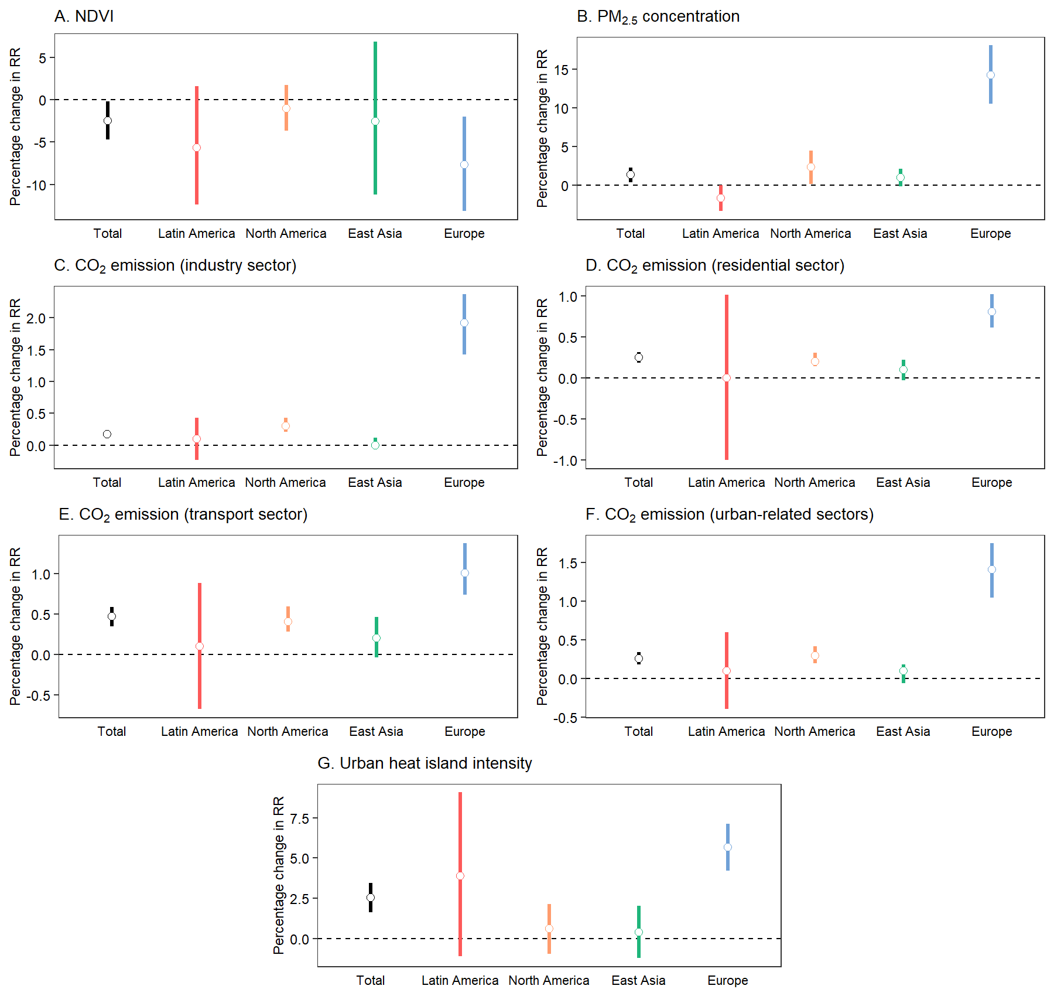

Supplementary Table 5. Descriptive statistics of GDP and the Gini index for each country during the study period.
 | Study period | Annual averages during the study period
 | Study period | GDP per capitaª | GDP PPP per capitaª | Gini index^{b}
Latin America
Brazil | 1997-2011 | 6404 | 11663 | 57
Mexico | 1998-2014 | 8467 | 13572 | 50
North America
Canada | 1990-2015 | 32805 | 32333 | 33
United States | 1990-2006 | 33386 | 33386 | 40
East Asia
China | 2000-2015 | 3103 | 6607 | 41
Japan | 2011-2015 | 41988 | 38317 | 33
South Korea | 2000-2018 | 21445 | 28889 | 32
Europe
France | 2000-2014 | 36193 | 33124 | 32
Germany | 1993-2015 | 35169 | 33257 | 30
Italy | 2001-2010 | 31612 | 31493 | 34
Spain | 1990-2014 | 21882 | 24084 | 34
UK | 1990-2016 | 33602 | 29480 | 35
Abbreviation: GDP, gross domestic product. PPP, purchasing power parity.
ªGDP per capita and GDP PPP per capita was obtained from the OECD database.
^{b}Gini index was obtained from the World Bank database.

Supplementary Table 6. Meta-regression results on spatial heterogeneities. Cochran Q-tests for heterogeneity (p-value), and I² statistics (%) in random-effects meta-regression models.
Model |  | Q | p-value | I²
Intercept only |  | 1650.70 | <0.0001 | 76.0
Regional indicators included | Model 1ª | 1454.78 | <0.0001 | 73.1
 | Model 2^{b} | 995.93 | <0.0001 | 61.0
 | Full model^{c} | 950.19 | <0.0001 | 59.7
ªModel 1 includes average temperature, temperature range, and climate zone as fixed effects.
^{b}Model 2 includes average temperature, temperature range, climate zone, and region as fixed effects, and country as a random effect.
^{c}Full model includes average temperature, temperature range, climate zone, region, population density, and interaction term of region and population density as fixed effects, and country as a random effect.

