Appendix

Global Trend and Cross-country Inequalities in the Burden of Colorectal Cancer Among Adults Aged 65 Years and Older, 1990–2021: A Systematic Analysis of the Global Burden of Disease Study 2021
Wenwen Lv, Shihan Wang, Lei Duan, Xia Tian, Zhongxun Dong, Mingze Li, Bingshun Wang, Shuhua Xu

Catalogue
Figure S1. Trends in the burden of colorectal cancer among adults aged 65 and older by sex, 1990-2021. 1
Figure S2. Distribution of incidence (A), mortality (B) and DALYs rate (C) of total colorectal cancer among adults aged 65 years and older across 204 countries and territories in 2021. 2
Figure S3. Distribution of incidence (A), mortality (B) and DALYs rate (C) of total colorectal cancer among adults aged 65 years and older across 204 countries and territories in 2021. 3
Table S1. Age-standardized incidence, deaths, and DALYs rate of CRC in 1990 and 2021. 5
Table S2. Incidence, deaths, and DALYs number of CRC in 1990 and 2021. 8
Table S3. Age-standardized incidence, deaths, and DALYs rate of CRC in 1990 and 2021 by different genders groups. 10
Table S4. Age-standardized incidence, deaths, and DALYs rate of CRC in 1990 and 2021 across national trends. 13

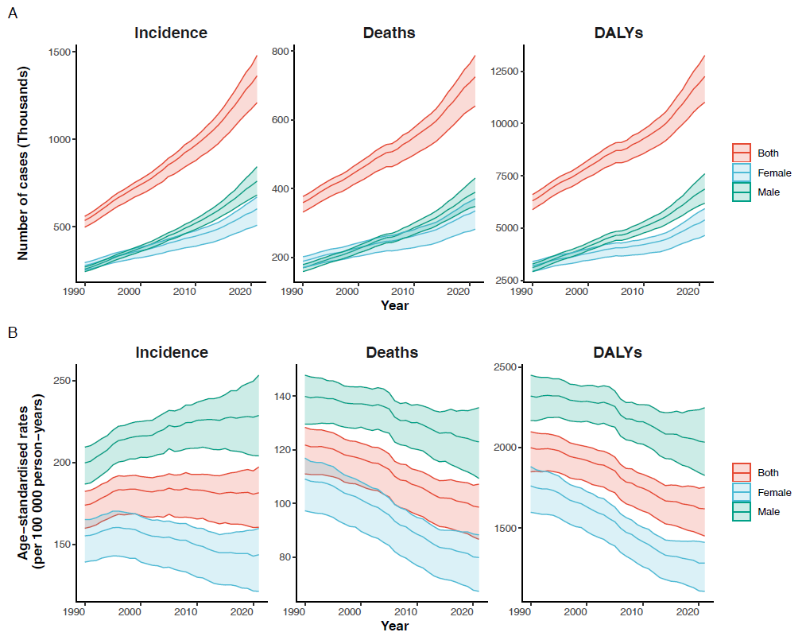

Figure S1. Trends in the burden of colorectal cancer among adults aged 65 and older by sex, 1990-2021.

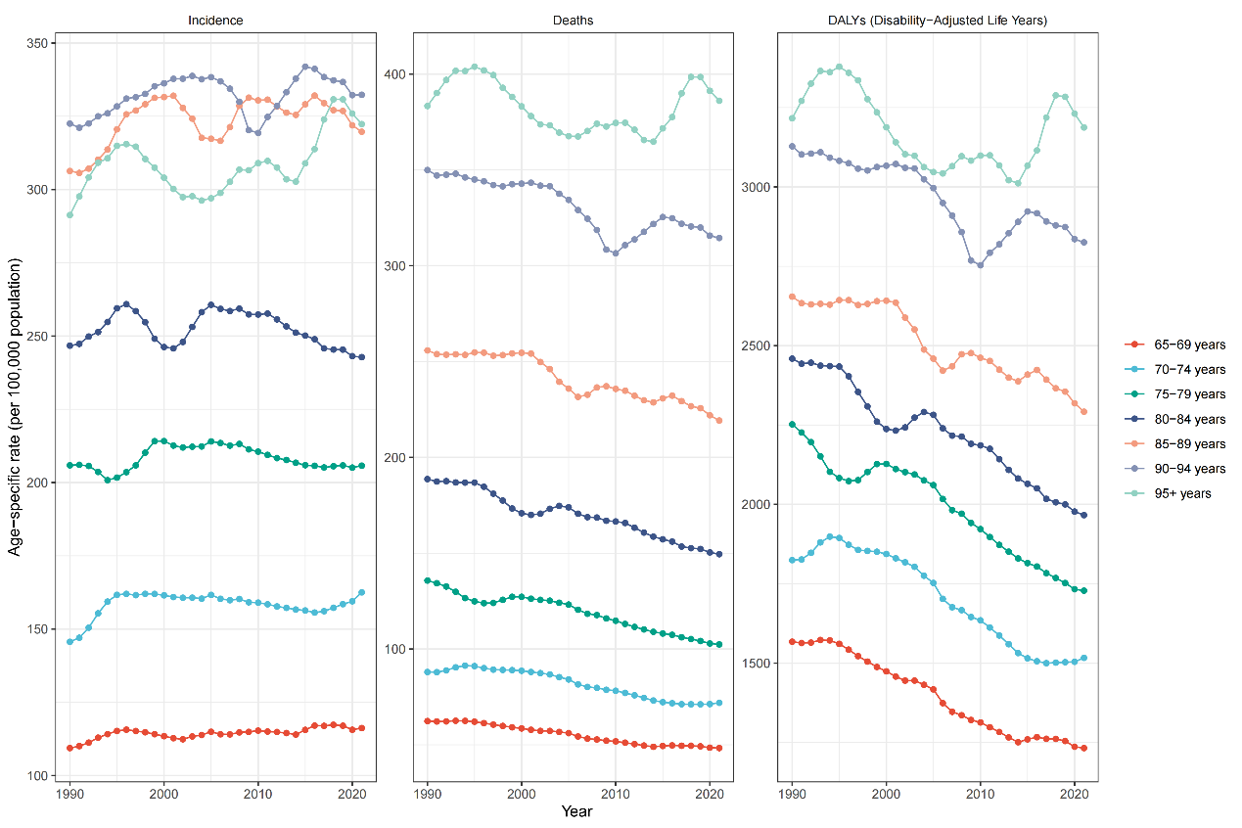

Figure S2. Distribution of incidence (A), mortality (B) and DALYs rate (C) of total colorectal cancer among adults aged 65 years and older across 204 countries and territories in 2021.

A
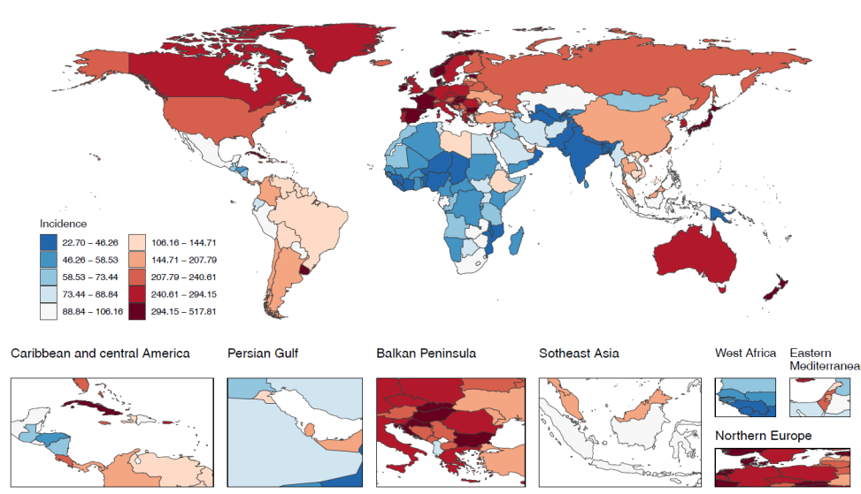
B
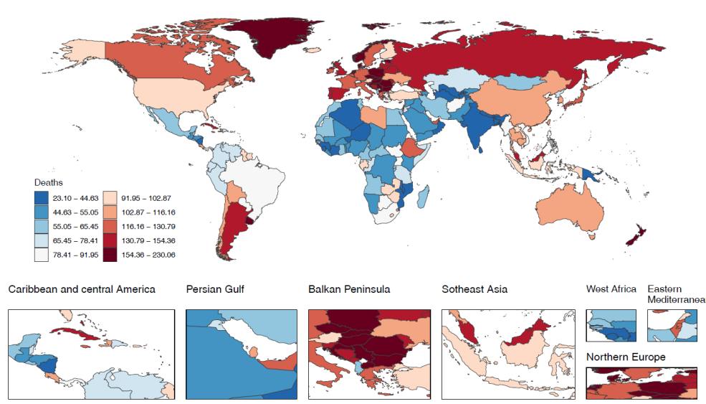
C
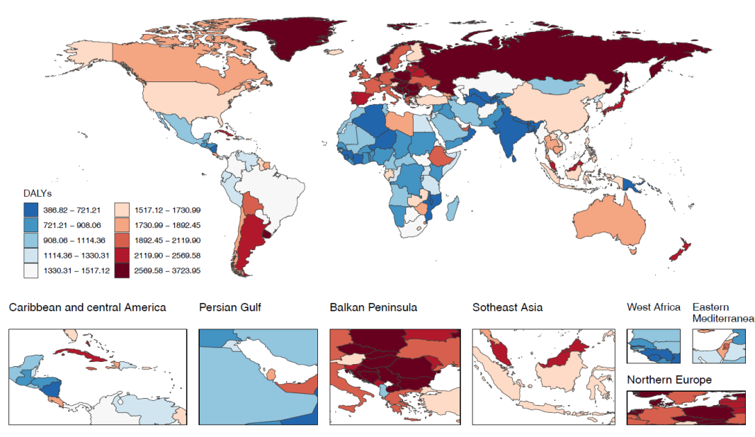

Figure S3. Distribution of incidence (A), mortality (B) and DALYs rate (C) of total colorectal cancer among adults aged 65 years and older across 204 countries and territories in 2021.

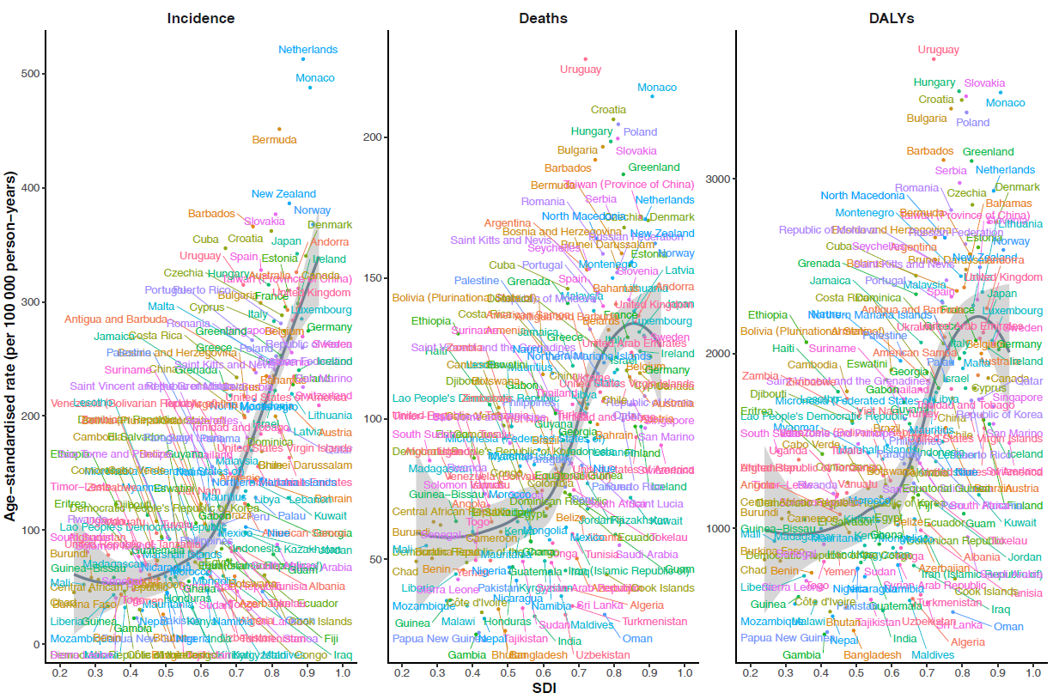
Figure S4. Age-standardized rates for colorectal cancer among adults aged 65 years and older globally in 2021. Shown are the age-standardized colorectal cancer rates of (A) incidence, (B) death, and (C) DALY in both sexes from 204 countries and territories. Each point represents the observed age-standardized incidence rate, mortality rate, and DALY rate for a specific country or territory in 2021. The black line indicates the expected values based on the sociodemographic index and disease rates in all locations.

Table S1. Age-standardized incidence, deaths, and DALYs rate of CRC in 1990 and 2021.
 | Age-standardized incidence rate |  |  |  | Age-standardized mortality rate |  |  |  | Age-standardized DALY rate
 | per 100,000 population (95% UI) |  | EAPC (95% CI) |  | per 100,000 population (95% UI) |  | EAPC (95% CI) |  | per 100,000 population (95% UI) |  | EAPC (95% CI)
Location | 1990 year | 2021 year | 1990-2021 |  | 1990 year | 2021 year | 1990-2021 |  | 1990 year | 2021 year | 1990-2021
Global | 173.94 (159.79, 182.34) | 181.49 (160.38, 197.22) | 1.48(-9.67,14.01) |  | 121.73 (110.97, 128.28) | 98.60 (86.63, 107.17) | 0.70(-10.33,13.08) |  | 1998.49 (1848.82, 2097.89) | 1618.61 (1449.70, 1752.72) | 0.59(-10.48,13.03)
High SDI | 306.68 (281.18, 321.61) | 280.66 (247.55, 300.91) | 0.74(-8.86,11.35) |  | 176.66 (160.78, 185.82) | 122.42 (106.03, 132.13) | -0.07(-9.61,10.48) |  | 2933.32 (2722.91, 3069.21) | 2008.51 (1789.43, 2153.26) | -0.23(-9.73,10.27)
High-middle SDI | 169.52 (156.15, 178.82) | 229.36 (200.73, 255.84) | 2.25(-7.24,12.72) |  | 134.42 (123.41, 142.09) | 124.63 (109.43, 137.68) | 1.02(-8.32,11.32) |  | 2267.01 (2107.97, 2391.22) | 2088.42 (1856.95, 2310.42) | 0.86(-8.53,11.20)
Middle SDI | 78.99 (70.51, 87.13) | 126.59 (108.75, 144.14) | 3.38(-6.27,14.02) |  | 74.69 (66.69, 82.31) | 79.08 (68.42, 88.85) | 1.96(-7.50,12.38) |  | 1260.12 (1126.56, 1390.03) | 1338.84 (1165.19, 1507.01) | 1.89(-7.65,12.42)
Low-middle SDI | 36.00 (30.97, 40.86) | 49.06 (44.22, 53.83) | 2.58(-6.23,12.23) |  | 37.41 (32.08, 42.56) | 44.75 (40.27, 49.26) | 2.18(-6.56,11.73) |  | 654.43 (562.77, 744.42) | 773.95 (701.79, 849.80) | 2.06(-6.76,11.72)
Low SDI | 45.86 (36.83, 52.40) | 49.46 (43.57, 55.38) | 1.51(-5.79,9.37) |  | 49.52 (39.91, 56.68) | 51.23 (45.11, 57.36) | 1.38(-5.86,9.17) |  | 874.98 (701.94, 999.85) | 848.40 (751.04, 950.27) | 1.13(-6.21,9.04)
Andean Latin America | 68.45 (56.86, 81.32) | 102.70 (79.07, 129.75) | 3.44(-1.25,8.35) |  | 69.93 (58.07, 82.63) | 80.35 (62.40, 101.19) | 2.59(-2.04,7.44) |  | 1153.03 (956.28, 1363.17) | 1324.61 (1028.20, 1672.70) | 2.49(-2.16,7.36)
Australasia | 344.67 (301.31, 384.73) | 307.23 (254.42, 360.07) | 0.89(-3.87,5.89) |  | 191.73 (167.27, 213.90) | 121.01 (100.84, 140.00) | -0.19(-4.91,4.77) |  | 3265.62 (2889.58, 3629.82) | 1970.79 (1663.22, 2281.55) | -0.49(-5.18,4.43)
Caribbean | 169.63 (152.60, 187.47) | 243.44 (205.26, 282.31) | 2.55(-2.26,7.59) |  | 110.57 (99.77, 121.26) | 116.20 (99.30, 133.25) | 1.60(-3.16,6.59) |  | 1811.73 (1646.36, 1981.17) | 1949.31 (1673.35, 2235.40) | 1.61(-3.16,6.61)
Central Asia | 72.36 (66.10, 78.35) | 69.54 (61.64, 76.74) | 1.07(-4.12,6.54) |  | 65.97 (60.17, 71.35) | 57.42 (51.00, 63.33) | 0.74(-4.41,6.16) |  | 1224.03 (1122.12, 1322.04) | 1032.35 (920.08, 1138.05) | 0.51(-4.67,5.96)
Central Europe | 192.23 (179.89, 202.74) | 268.00 (243.42, 291.70) | 1.85(-5.09,9.31) |  | 169.94 (159.04, 178.82) | 182.96 (165.59, 197.56) | 1.05(-5.82,8.41) |  | 2891.64 (2724.57, 3038.49) | 3115.94 (2842.46, 3360.49) | 0.92(-5.97,8.31)
Central Latin America | 66.18 (61.51, 70.03) | 114.36 (99.80, 128.65) | 3.80(-2.78,10.82) |  | 56.39 (52.13, 59.76) | 67.09 (58.51, 75.29) | 2.68(-3.81,9.60) |  | 911.91 (852.03, 964.15) | 1146.86 (1007.72, 1286.39) | 2.76(-3.76,9.72)
Central Sub-Saharan Africa | 49.35 (37.68, 64.35) | 52.88 (38.63, 74.18) | 1.54(-2.65,5.90) |  | 53.92 (41.10, 70.66) | 55.10 (39.91, 78.93) | 1.41(-2.71,5.71) |  | 931.20 (712.67, 1205.63) | 939.84 (690.11, 1310.50) | 1.30(-2.96,5.75)
East Asia | 115.33 (99.06, 131.42) | 201.14 (162.98, 239.44) | 3.79(-5.68,14.21) |  | 107.20 (91.85, 122.40) | 104.85 (85.18, 124.36) | 1.74(-7.45,11.85) |  | 1767.98 (1516.20, 2018.19) | 1745.48 (1419.09, 2077.26) | 1.66(-7.64,11.90)
Eastern Europe | 158.95 (149.32, 167.78) | 219.82 (199.87, 238.67) | 1.38(-6.21,9.60) |  | 126.71 (119.10, 133.33) | 140.36 (126.75, 152.83) | 0.66(-6.86,8.79) |  | 2295.60 (2168.43, 2413.32) | 2462.97 (2241.39, 2682.61) | 0.40(-7.14,8.54)
Eastern Sub-Saharan Africa | 71.04 (56.50, 82.28) | 80.09 (68.62, 92.30) | 1.50(-4.29,7.63) |  | 77.22 (61.63, 89.53) | 84.43 (72.22, 97.40) | 1.41(-4.32,7.48) |  | 1363.83 (1083.19, 1580.98) | 1367.05 (1175.70, 1577.25) | 1.09(-4.75,7.28)
High-income Asia Pacific | 266.19 (240.46, 284.14) | 323.49 (273.05, 361.93) | 2.34(-5.43,10.74) |  | 142.11 (128.07, 150.87) | 125.94 (104.50, 138.92) | 1.56(-6.17,9.92) |  | 2355.27 (2163.51, 2487.97) | 2070.70 (1785.67, 2259.60) | 1.25(-6.43,9.56)
High-income North America | 339.65 (306.89, 359.62) | 241.41 (212.61, 259.40) | -0.41(-8.43,8.31) |  | 165.16 (147.61, 175.31) | 96.06 (82.98, 103.69) | -0.97(-8.96,7.74) |  | 2808.99 (2573.96, 2971.45) | 1605.72 (1434.28, 1724.17) | -1.06(-9.02,7.59)
North Africa and Middle East | 64.31 (54.38, 75.15) | 93.45 (78.83, 108.99) | 3.19(-4.04,10.96) |  | 64.01 (53.91, 75.07) | 69.27 (58.46, 80.55) | 2.22(-4.89,9.85) |  | 1064.01 (900.20, 1240.50) | 1151.20 (976.37, 1336.57) | 2.07(-5.11,9.80)
Oceania | 42.63 (35.67, 50.26) | 40.63 (34.13, 47.68) | 1.36(-0.09,2.82) |  | 44.88 (37.57, 52.95) | 40.03 (33.43, 46.95) | 1.19(-0.18,2.58) |  | 741.34 (619.89, 877.30) | 665.65 (557.16, 783.60) | 1.13(-0.39,2.66)
South Asia | 26.04 (21.68, 30.25) | 32.55 (28.76, 36.57) | 2.35(-6.43,11.96) |  | 27.38 (22.71, 31.94) | 30.35 (26.82, 34.21) | 1.99(-6.71,11.50) |  | 490.96 (410.48, 569.70) | 533.12 (472.46, 600.36) | 1.85(-6.95,11.48)
Southeast Asia | 67.57 (57.18, 77.78) | 110.19 (93.21, 126.97) | 3.16(-4.60,11.55) |  | 69.11 (58.33, 79.46) | 92.36 (78.62, 106.08) | 2.51(-5.15,10.78) |  | 1194.09 (1009.01, 1370.54) | 1578.61 (1350.66, 1809.53) | 2.43(-5.31,10.80)
Southern Latin America | 176.52 (153.94, 199.45) | 198.17 (167.51, 229.01) | 1.70(-3.83,7.53) |  | 162.70 (142.24, 183.56) | 145.12 (122.74, 167.42) | 1.05(-4.44,6.84) |  | 2674.73 (2348.91, 3015.56) | 2387.07 (2042.42, 2746.04) | 0.93(-4.55,6.73)
Southern Sub-Saharan Africa | 63.64 (53.67, 80.96) | 89.57 (78.51, 100.24) | 2.31(-2.33,7.16) |  | 66.54 (56.06, 84.78) | 85.91 (75.45, 96.17) | 2.01(-2.57,6.80) |  | 1057.42 (894.65, 1346.72) | 1411.55 (1242.16, 1578.51) | 2.15(-2.52,7.05)
Tropical Latin America | 75.46 (68.37, 81.27) | 106.68 (93.72, 117.09) | 3.08(-3.53,10.14) |  | 72.64 (65.50, 78.33) | 82.55 (72.02, 90.59) | 2.48(-4.06,9.47) |  | 1197.23 (1094.49, 1285.26) | 1399.65 (1242.48, 1526.51) | 2.43(-4.16,9.46)
Western Europe | 304.95 (279.48, 323.43) | 291.36 (255.94, 316.37) | 0.69(-8.04,10.25) |  | 191.36 (174.44, 203.28) | 128.52 (110.60, 140.16) | -0.35(-9.02,9.16) |  | 3123.48 (2892.85, 3296.04) | 2099.57 (1854.66, 2275.08) | -0.49(-9.11,8.95)
Western Sub-Saharan Africa | 36.87 (31.36, 42.52) | 46.51 (39.66, 53.42) | 2.07(-4.02,8.54) |  | 40.18 (34.23, 46.38) | 48.38 (41.42, 55.39) | 1.93(-4.10,8.34) |  | 672.24 (574.28, 777.08) | 787.66 (669.02, 907.79) | 1.81(-4.32,8.33)
EAPC, estimated annual percentage change; CI, confidence interval; UI, uncertainty interval.

Table S2. Incidence, deaths, and DALYs number of CRC in 1990 and 2021.
 | Number, 95%UI, 1990 |  |  |  | Number, 95%UI, 2021
Locations | Incidence | Death | DALYs |  | Incidence | Death | DALYs
Global | 535608 (497245, 559487) | 359399 (331812, 377258) | 6306073 (5880684, 6602238) |  | 1362270 (1208839, 1479202) | 724698 (639865, 786902) | 12249262 (11012192, 13254409)
High SDI | 318820 (293123, 333969) | 593357 (518872, 638256) | 3046972 (2836070, 3184710) |  | 593357 (518872, 638256) | 270236 (231328, 293073) | 4235836 (3739978, 4557250)
High-middle SDI | 136240 (126412, 143332) | 413987 (362984, 461859) | 1856558 (1736666, 1954874) |  | 413987 (362984, 461859) | 220523 (194178, 243562) | 3787374 (3374084, 4189885)
Middle SDI | 57341 (51274, 63359) | 282036 (242851, 321388) | 956221 (855747, 1056519) |  | 282036 (242851, 321388) | 168486 (146399, 189398) | 3022522 (2637363, 3403729)
Low-middle SDI | 15356 (13251, 17428) | 54432 (49283, 59633) | 292246 (251668, 332554) |  | 54432 (49283, 59633) | 47831 (43304, 52547) | 883232 (803613, 968694)
Low SDI | 7153 (5711, 8172) | 16829 (14906, 18824) | 144658 (115453, 165269) |  | 16829 (14906, 18824) | 16628 (14729, 18589) | 303508 (269577, 339866)
Andean Latin America | 1066 (886, 1267) | 5100 (3926, 6449) | 18241 (15125, 21569) |  | 5100 (3926, 6449) | 3958 (3074, 4988) | 66033 (51249, 83434)
Australasia | 7574 (6648, 8436) | 16438 (13596, 19270) | 72191 (64147, 80113) |  | 16438 (13596, 19270) | 6662 (5537, 7718) | 105263 (88706, 121891)
Caribbean | 3750 (3386, 4138) | 11587 (9765, 13439) | 40225 (36674, 43912) |  | 11587 (9765, 13439) | 5579 (4761, 6400) | 92888 (79679, 106541)
Central Asia | 2537 (2320, 2747) | 4091 (3628, 4517) | 43011 (39463, 46446) |  | 4091 (3628, 4517) | 3283 (2919, 3622) | 61943 (55246, 68331)
Central Europe | 24825 (23325, 26141) | 59767 (54294, 65049) | 378768 (358086, 397478) |  | 59767 (54294, 65049) | 40685 (36834, 43926) | 695088 (634221, 749631)
Central Latin America | 4076 (3805, 4307) | 24017 (20965, 27022) | 57046 (53516, 60230) |  | 24017 (20965, 27022) | 13882 (12110, 15579) | 241750 (212506, 271176)
Central Sub-Saharan Africa | 681 (522, 874) | 1696 (1254, 2312) | 13994 (10735, 17918) |  | 1696 (1254, 2312) | 1679 (1235, 2324) | 32097 (23795, 43767)
East Asia | 70106 (60326, 79933) | 391052 (317009, 466444) | 1132367 (971680, 1293370) |  | 391052 (317009, 466444) | 191989 (156137, 228216) | 3418703 (2780147, 4077511)
Eastern Europe | 37694 (35498, 39756) | 72644 (66052, 78878) | 546024 (516852, 573699) |  | 72644 (66052, 78878) | 46115 (41643, 50221) | 818900 (745172, 892078)
Eastern Sub-Saharan Africa | 3670 (2901, 4255) | 8520 (7339, 9814) | 74847 (59076, 86843) |  | 8520 (7339, 9814) | 8582 (7387, 9891) | 153536 (132614, 177157)
High-income Asia Pacific | 45046 (40973, 47959) | 161700 (133810, 182320) | 401018 (370916, 422481) |  | 161700 (133810, 182320) | 69845 (56207, 77954) | 1035855 (871930, 1140746)
High-income North America | 117068 (105944, 123879) | 155363 (136660, 167044) | 966576 (886898, 1021965) |  | 155363 (136660, 167044) | 62656 (53918, 67725) | 1036021 (923583, 1113218)
North Africa and Middle East | 7350 (6240, 8554) | 30227 (25584, 35206) | 127338 (107974, 148144) |  | 30227 (25584, 35206) | 21296 (18053, 24707) | 380179 (323232, 440817)
Oceania | 73 (61, 86) | 181 (153, 213) | 1372 (1142, 1633) |  | 181 (153, 213) | 168 (140, 198) | 3130 (2621, 3700)
South Asia | 10251 (8595, 11862) | 37925 (33585, 42566) | 203021 (170599, 234868) |  | 37925 (33585, 42566) | 34017 (30129, 38281) | 641015 (568770, 721264)
Southeast Asia | 12000 (10181, 13796) | 54169 (45952, 62329) | 220382 (186361, 252762) |  | 54169 (45952, 62329) | 43405 (37088, 49724) | 795881 (682003, 911314)
Southern Latin America | 7010 (6134, 7910) | 16205 (13692, 18728) | 108038 (95121, 121673) |  | 16205 (13692, 18728) | 11923 (10077, 13758) | 194603 (166413, 223897)
Southern Sub-Saharan Africa | 1244 (1053, 1581) | 3733 (3280, 4175) | 21438 (18184, 27292) |  | 3733 (3280, 4175) | 3428 (3021, 3833) | 61196 (53952, 68396)
Tropical Latin America | 5058 (4625, 5433) | 23456 (20654, 25732) | 82881 (76350, 88772) |  | 23456 (20654, 25732) | 17929 (15682, 19663) | 309753 (275572, 337653)
Western Europe | 172232 (158042, 182576) | 278561 (241780, 303834) | 1753285 (1626212, 1849386) |  | 278561 (241780, 303834) | 131773 (111716, 144488) | 2002145 (1745716, 2179955)
Western Sub-Saharan Africa | 2297 (1958, 2654) | 5839 (4955, 6737) | 44009 (37637, 50989) |  | 5839 (4955, 6737) | 5843 (4977, 6716) | 103281 (87256, 119520)
UI, uncertainty interval.

Table S3. Age-standardized incidence, deaths, and DALYs rate of CRC in 1990 and 2021 by different genders groups.
Sex | Location | Age-standardized incidence rate |  | Age-standardized mortality rate |  | Age-standardized DALY rate
Sex | Location | per 100,000 population (95% UI) |  | per 100,000 population (95% UI) |  | per 100,000 population (95% UI)
Sex | Location | 2021 year |  | 2021 year |  | 2021 year
Male | Global | 228.74 (204.06, 253.35) |  | 122.88 (109.3, 135.63) |  | 2032.99 (1826.38, 2247.32)
Male | High SDI | 353.94 (323.02, 377.4) |  | 152.56 (138.21, 162.44) |  | 2546.2 (2347.11, 2706.61)
Male | High-middle SDI | 304.32 (261.55, 353.22) |  | 166.24 (144.93, 189.46) |  | 2765.34 (2416.16, 3164.04)
Male | Middle SDI | 164.37 (135.79, 198.06) |  | 101.64 (84.8, 120.41) |  | 1713.82 (1431.35, 2034.21)
Male | Low-middle SDI | 54.41 (48.38, 60.95) |  | 48.85 (43.38, 54.96) |  | 855.42 (760.95, 962.25)
Male | Low SDI | 57.03 (49.01, 65.72) |  | 59.41 (51.06, 68.55) |  | 979.76 (843.88, 1133.05)
Male | Andean Latin America | 101.21 (75.19, 132.27) |  | 76.52 (57.54, 99.9) |  | 1278.06 (957.25, 1670.32)
Male | Australasia | 369.2 (302.86, 443.25) |  | 146.18 (123.03, 170.51) |  | 2426.2 (2046.01, 2833.73)
Male | Caribbean | 257.02 (211.52, 304.83) |  | 118.38 (99.2, 138.33) |  | 2028.62 (1700.46, 2372.64)
Male | Central Asia | 86.65 (77.11, 96.12) |  | 71.83 (64.02, 79.49) |  | 1289.86 (1152.07, 1428.49)
Male | Central Europe | 382.95 (345.92, 417.69) |  | 260.7 (236.92, 281.87) |  | 4460.07 (4068.3, 4811.49)
Male | Central Latin America | 155.19 (133.68, 178.91) |  | 72.68 (62.85, 82.78) |  | 1276.76 (1106.06, 1457.94)
Male | Central Sub-Saharan Africa | 64.95 (46.76, 96.99) |  | 67.71 (48.42, 103.67) |  | 1155.11 (831.22, 1732.37)
Male | East Asia | 271.28 (210.39, 345.67) |  | 146.68 (114.59, 186.12) |  | 2369.18 (1839.81, 3034.54)
Male | Eastern Europe | 280.46 (248.68, 310.85) |  | 187.28 (165.37, 207.93) |  | 3310.97 (2931.77, 3687.19)
Male | Eastern Sub-Saharan Africa | 104.66 (85.59, 125.69) |  | 111.21 (90.53, 133.67) |  | 1773.95 (1453.43, 2131.76)
Male | High-income Asia Pacific | 440.11 (382.47, 490.24) |  | 163.17 (144.93, 175.76) |  | 2766.35 (2497.56, 2976.45)
Male | High-income North America | 282.42 (255.35, 302.64) |  | 112.56 (100.84, 120.46) |  | 1915.37 (1751.72, 2042.66)
Male | North Africa and Middle East | 102.64 (83.41, 123.05) |  | 77.17 (62.88, 92.17) |  | 1309.23 (1070.38, 1561.61)
Male | Oceania | 40.34 (32.54, 48.83) |  | 40.45 (32.4, 49.4) |  | 661.57 (532.73, 808.73)
Male | South Asia | 37.36 (31.49, 43.89) |  | 34.81 (29.42, 41.07) |  | 611.86 (516.19, 720.02)
Male | Southeast Asia | 138 (111.86, 165.65) |  | 115.95 (95.1, 138.93) |  | 2006.48 (1649.41, 2401.56)
Male | Southern Latin America | 249.35 (207.99, 293.78) |  | 181.4 (152.31, 213.05) |  | 3045.21 (2570.56, 3568.27)
Male | Southern Sub-Saharan Africa | 109.23 (91.33, 126.52) |  | 103.94 (87.51, 120.03) |  | 1732.72 (1467.54, 2003.4)
Male | Tropical Latin America | 124.47 (110.28, 137.61) |  | 93.66 (83.01, 102.95) |  | 1607.71 (1443.15, 1761.38)
Male | Western Europe | 373.14 (335.38, 404.49) |  | 165.64 (147.77, 179.54) |  | 2726.25 (2471.93, 2945.76)
Male | Western Sub-Saharan Africa | 51.28 (42.69, 61.02) |  | 53.06 (44.25, 63.14) |  | 879.66 (731.35, 1049.05)
Female | Global | 143.62 (121.23, 159.7) |  | 79.85 (67.25, 88.29) |  | 1281.91 (1105.61, 1410.29)
Female | High SDI | 221.06 (183.76, 243.21) |  | 98.8 (80.43, 109.13) |  | 1566.83 (1322.95, 1711.06)
Female | High-middle SDI | 175.31 (147.17, 200.09) |  | 96.3 (81.28, 108.33) |  | 1592.76 (1363.98, 1791.52)
Female | Middle SDI | 95.6 (78.82, 112.79) |  | 61.28 (51.25, 70.95) |  | 1026.93 (868.85, 1190.02)
Female | Low-middle SDI | 44.34 (38.85, 49.66) |  | 41.16 (35.89, 46.17) |  | 701.12 (615.69, 784.02)
Female | Low SDI | 42.73 (36.81, 48.94) |  | 44.05 (37.87, 50.59) |  | 729.59 (631.9, 834.01)
Female | Andean Latin America | 103.79 (76.16, 135.94) |  | 83.47 (61.22, 108.31) |  | 1363.29 (999.33, 1770.53)
Female | Australasia | 252.15 (193.88, 309.32) |  | 99.36 (77, 120.58) |  | 1566.07 (1240.52, 1880.85)
Female | Caribbean | 231.46 (188.82, 276.09) |  | 113.82 (94.5, 132.91) |  | 1875.42 (1564.1, 2191.71)
Female | Central Asia | 58.34 (51.28, 64.79) |  | 48.31 (42.53, 53.51) |  | 860.12 (760, 951.31)
Female | Central Europe | 190.28 (168.99, 210.26) |  | 132.86 (117.9, 145.33) |  | 2192.27 (1964.82, 2394.19)
Female | Central Latin America | 80.54 (69.09, 92.39) |  | 62.38 (53.45, 71.3) |  | 1037.3 (898.34, 1187.22)
Female | Central Sub-Saharan Africa | 44.9 (29.81, 67.56) |  | 46.96 (31.06, 72.45) |  | 792.71 (531.81, 1195.68)
Female | East Asia | 146.33 (110.24, 185.9) |  | 74.97 (56.79, 94.78) |  | 1253.93 (954.93, 1586.92)
Female | Eastern Europe | 188.66 (167.35, 207.91) |  | 117.22 (103.43, 129.88) |  | 2018.52 (1793.46, 2238.55)
Female | Eastern Sub-Saharan Africa | 60.74 (50.25, 72.22) |  | 63.76 (52.61, 76.02) |  | 1038.77 (864.8, 1234.83)
Female | High-income Asia Pacific | 228.22 (173.68, 269.44) |  | 96.22 (72.35, 110.88) |  | 1491.8 (1170.74, 1692.18)
Female | High-income North America | 207.23 (174.56, 226.79) |  | 82.85 (68.54, 90.92) |  | 1348.42 (1154.89, 1468.1)
Female | North Africa and Middle East | 84.52 (68.68, 102.29) |  | 61.6 (50.15, 74.32) |  | 996.41 (820.21, 1188.87)
Female | Oceania | 41.22 (33.15, 50.8) |  | 39.97 (32.11, 49.45) |  | 673.7 (540.97, 835.73)
Female | South Asia | 28.2 (23.55, 33.25) |  | 26.41 (22.01, 31.25) |  | 460.95 (385.75, 544.5)
Female | Southeast Asia | 88.56 (72.16, 105.94) |  | 74.48 (60.94, 88.79) |  | 1241.68 (1026.9, 1470.11)
Female | Southern Latin America | 160.23 (131.7, 190.72) |  | 118.89 (97.07, 140.89) |  | 1890.34 (1567.39, 2221.79)
Female | Southern Sub-Saharan Africa | 77.66 (66.2, 90.34) |  | 75.28 (64.17, 87.31) |  | 1211.03 (1035.96, 1408.27)
Female | Tropical Latin America | 92.98 (79.04, 104.36) |  | 74.13 (62.7, 83.09) |  | 1237.61 (1068.02, 1378.62)
Female | Western Europe | 225.69 (187.93, 251.86) |  | 100.43 (81.76, 112.35) |  | 1595.4 (1344.85, 1769.5)
Female | Western Sub-Saharan Africa | 42.2 (34.4, 50.21) |  | 44.17 (36.24, 52.4) |  | 704.51 (572.55, 841.43)
UI, uncertainty interval.

Table S4. Age-standardized incidence, deaths, and DALYs rate of CRC in 1990 and 2021 across national trends.
Location | Age-standardized incidence rate |  | Age-standardized mortality rate |  | Age-standardized DALY rate
Location | per 100,000 population (95% UI) |  | per 100,000 population (95% UI) |  | per 100,000 population (95% UI)
Location | 2021 year |  | 2021 year |  | 2021 year
Afghanistan | 78.23 (41.63, 117.61) |  | 79.14 (43.27, 118.63) |  | 1391.65 (735.45, 2108.72)
Albania | 84.44 (61.59, 114.49) |  | 64.78 (47.63, 87.06) |  | 1018.65 (749.45, 1374.71)
Algeria | 47.74 (33.87, 65.87) |  | 40.04 (28.56, 55.37) |  | 595 (425.89, 822.57)
American Samoa | 123.34 (93.47, 160.62) |  | 115.35 (87.51, 150.84) |  | 1863.68 (1418.89, 2441.54)
Andorra | 325.97 (209.28, 469.55) |  | 136.54 (91.02, 193.02) |  | 2259.56 (1487.84, 3203.16)
Angola | 60.95 (41.16, 87.43) |  | 63.33 (42.48, 91.77) |  | 1078.58 (727.86, 1545.14)
Antigua and Barbuda | 240.61 (204.71, 279.43) |  | 127.07 (110.73, 144.1) |  | 2093.61 (1833.13, 2364.91)
Argentina | 198.69 (163.21, 236.5) |  | 152.87 (126.68, 180.35) |  | 2535.11 (2110.22, 2983.8)
Armenia | 137.58 (117.4, 158.94) |  | 105.63 (90.6, 121.66) |  | 1843.85 (1587.19, 2130.35)
Australia | 292.93 (236.82, 349.62) |  | 114.82 (94.36, 134.83) |  | 1875.82 (1551.39, 2205.55)
Austria | 208.45 (171.66, 246.86) |  | 101 (83.82, 118.33) |  | 1646.89 (1390.63, 1914.89)
Azerbaijan | 59.64 (43.19, 77.11) |  | 50.31 (36.23, 65.37) |  | 920.69 (668.98, 1192.86)
Bahamas | 235.21 (185.78, 291.95) |  | 140.67 (113.26, 172.9) |  | 2378.46 (1912.38, 2942.04)
Bahrain | 144.71 (104.73, 203.52) |  | 97.98 (71.59, 137.83) |  | 1574.36 (1146.41, 2250.3)
Bangladesh | 26.3 (17.94, 38.64) |  | 24.61 (16.88, 36.05) |  | 412.56 (279.06, 616.11)
Barbados | 366.04 (281.99, 463.92) |  | 191.99 (150.65, 237.99) |  | 3108.88 (2424.6, 3898.27)
Belarus | 235.1 (178.53, 298.93) |  | 131.55 (101.22, 164.85) |  | 2359.2 (1809.83, 2977.59)
Belgium | 268.13 (216.51, 325.05) |  | 122.29 (98.37, 146.17) |  | 2000.17 (1646.69, 2355.72)
Belize | 105.3 (87.03, 125.54) |  | 68.13 (56.4, 79.91) |  | 1133.94 (940.04, 1335.76)
Benin | 43.8 (30.75, 60.32) |  | 46.27 (32.85, 63.96) |  | 743.95 (523.14, 1031.31)
Bermuda | 451.37 (353.27, 576.33) |  | 158.7 (124.17, 202.61) |  | 2569.58 (2024.07, 3259.93)
Bhutan | 34.19 (22.67, 47.9) |  | 32.32 (21.14, 45.35) |  | 546.93 (363.4, 764.9)
Bolivia (Plurinational State of) | 122.97 (76.98, 178.99) |  | 115.75 (72.46, 168.96) |  | 1906.55 (1180.14, 2800.5)
Bosnia and Herzegovina | 217.15 (164.64, 277.13) |  | 154.36 (118.24, 195.7) |  | 2664.83 (2026.06, 3389.3)
Botswana | 80.45 (57.09, 112.11) |  | 80.67 (57.15, 112.95) |  | 1331.05 (940.08, 1857.83)
Brazil | 106.79 (93.72, 117.52) |  | 82.56 (72.01, 90.73) |  | 1400.42 (1242.48, 1529.33)
Brunei Darussalam | 199.79 (151.39, 257.49) |  | 153.56 (117.45, 198.11) |  | 2480.9 (1909.07, 3190.05)
Bulgaria | 299.15 (240.61, 367.61) |  | 196.61 (159.58, 236.11) |  | 3402.94 (2770.21, 4075.31)
Burkina Faso | 46.97 (32.75, 64.62) |  | 50.35 (35.17, 69.4) |  | 811.59 (563.52, 1120.8)
Burundi | 58.48 (39.68, 83.8) |  | 63.34 (42.97, 91.33) |  | 1053.09 (713.02, 1524.66)
Cabo Verde | 87.35 (60.49, 117.35) |  | 81.14 (55.99, 109.38) |  | 1227.58 (852.4, 1657.99)
Cambodia | 107.87 (75.4, 147.65) |  | 103.91 (72.37, 142.41) |  | 1783.07 (1238.14, 2437.24)
Cameroon | 57.54 (38.66, 82.36) |  | 59.77 (40.15, 85.61) |  | 974.58 (649.1, 1405.27)
Canada | 294.15 (237.46, 349.03) |  | 116.19 (95.15, 136.52) |  | 1859.57 (1542.2, 2171.26)
Central African Republic | 56.65 (37.02, 84) |  | 62.2 (40.51, 92.69) |  | 1089.96 (715.69, 1611.67)
Chad | 45.52 (31.96, 62.34) |  | 49.28 (34.89, 67.33) |  | 819.25 (577.77, 1121.01)
Chile | 169.07 (137.41, 202.3) |  | 107.04 (87.72, 126.07) |  | 1744.93 (1443.84, 2051.92)
China | 200.38 (161.32, 239.88) |  | 103.68 (83.57, 123.89) |  | 1730.4 (1394.19, 2073.29)
Colombia | 149.18 (116.04, 186.08) |  | 78.41 (62.14, 97.04) |  | 1350 (1079.22, 1665.63)
Comoros | 73.44 (48.75, 103.77) |  | 77.14 (51.24, 109.47) |  | 1261.34 (839.9, 1789.36)
Congo | 72.2 (51.97, 97.46) |  | 73.8 (53.14, 99.95) |  | 1248.47 (903.61, 1673.36)
Cook Islands | 60.74 (43.38, 83.02) |  | 44.63 (32.35, 60.36) |  | 709.8 (517.62, 957.14)
Costa Rica | 233.85 (187.29, 284.15) |  | 112.09 (91, 134.86) |  | 1892.45 (1546.12, 2275.47)
Croatia | 362.09 (296.01, 433.2) |  | 206.35 (171.77, 244.04) |  | 3452.5 (2895.6, 4054.79)
Cuba | 346.99 (276.94, 428.33) |  | 146.17 (119.16, 175.35) |  | 2446.11 (2006.71, 2925.98)
Cyprus | 274.42 (202.49, 362.42) |  | 117.16 (87.96, 154.06) |  | 1801.89 (1364.11, 2354.9)
Czechia | 288.26 (230.67, 352.59) |  | 167.91 (135.33, 202.28) |  | 2852.2 (2309.41, 3423.39)
Côte d’Ivoire | 30.52 (21.74, 42.83) |  | 31.15 (22.22, 43.4) |  | 521.25 (370.09, 730.77)
Democratic People's Republic of Korea | 81.29 (52.08, 125.12) |  | 67.04 (42.59, 105.18) |  | 1178.95 (758.97, 1831.16)
Democratic Republic of the Congo | 46.6 (29.17, 73.66) |  | 48.91 (30.37, 78.56) |  | 834.22 (525.01, 1307.51)
Denmark | 340.24 (278.18, 405.07) |  | 170.46 (141.79, 198.34) |  | 2753.67 (2311.35, 3207.83)
Djibouti | 94.3 (63.77, 136.5) |  | 97.51 (66.45, 139.73) |  | 1614.15 (1092.02, 2336.81)
Dominica | 180.95 (137.43, 233.59) |  | 126.03 (96.26, 162.74) |  | 2057.24 (1576.09, 2659.94)
Dominican Republic | 99.86 (71.38, 140.59) |  | 69 (49.51, 96.68) |  | 1127.35 (815.76, 1575.93)
Ecuador | 88.84 (67.17, 114.53) |  | 73.78 (56.62, 94.1) |  | 1173.13 (892.24, 1509.34)
Egypt | 78.91 (59.48, 103.19) |  | 65.45 (49.13, 84.53) |  | 1117.19 (840.98, 1452.66)
El Salvador | 89.84 (67.62, 117.17) |  | 56.47 (42.77, 73.06) |  | 953.26 (722.05, 1237.4)
Equatorial Guinea | 83.8 (54.33, 121.61) |  | 80.14 (52.39, 116.05) |  | 1343.67 (871.02, 1946.02)
Eritrea | 79.62 (54.77, 109.98) |  | 86 (59.39, 118.89) |  | 1424.13 (986.58, 1961.43)
Estonia | 309.89 (243.91, 380.87) |  | 154.52 (123.96, 184.34) |  | 2608.34 (2081.9, 3121.18)
Eswatini | 106.16 (66.1, 152.78) |  | 107.73 (66.91, 154.16) |  | 1848.86 (1150.73, 2646.76)
Ethiopia | 122.85 (98.12, 151.6) |  | 130.2 (104.4, 160.44) |  | 2064.78 (1656.13, 2548.09)
Fiji | 73.73 (51.34, 100.64) |  | 72.98 (50.78, 99.59) |  | 1189.45 (825.28, 1628.47)
Finland | 227.67 (182.34, 274.84) |  | 97.23 (78.15, 115.17) |  | 1619.74 (1319.54, 1912.23)
France | 295.61 (236.43, 355.34) |  | 128.94 (102.96, 153.7) |  | 2074.78 (1678.91, 2467.65)
Gabon | 104.28 (71.78, 142.34) |  | 101.85 (69.87, 140.41) |  | 1720.7 (1182.36, 2367.42)
Gambia | 22.93 (16.2, 31.73) |  | 23.33 (16.52, 32.37) |  | 390.73 (277.35, 542.02)
Georgia | 122.12 (102.41, 144.42) |  | 98.74 (83.26, 116.36) |  | 1801.73 (1519.23, 2128.7)
Germany | 274.59 (224.76, 324.25) |  | 121.99 (100.13, 142.29) |  | 2023.04 (1694.89, 2344.86)
Ghana | 55.16 (39.09, 75.86) |  | 56.31 (39.79, 76.7) |  | 908.06 (643.27, 1229.97)
Greece | 246.85 (204.63, 289.39) |  | 121.05 (101.86, 138.53) |  | 1971.39 (1683.5, 2256.83)
Greenland | 252.89 (188.64, 339.44) |  | 186.81 (138.54, 248.64) |  | 3103.27 (2318.2, 4119.57)
Grenada | 223.73 (177.3, 277.4) |  | 141.01 (113.02, 171.25) |  | 2339.9 (1867.81, 2850.59)
Guam | 78.89 (59.19, 99.52) |  | 58.85 (43.93, 73.99) |  | 1082.32 (818.48, 1357.69)
Guatemala | 64.39 (53.18, 77.49) |  | 51.07 (42.6, 60.85) |  | 836.01 (693.74, 1001.07)
Guinea | 33.62 (23.31, 47.15) |  | 35.51 (24.56, 49.76) |  | 606.52 (415.26, 853.54)
Guinea-Bissau | 58.53 (41.01, 79.63) |  | 63.52 (44.84, 86.52) |  | 1049.06 (737.39, 1419.51)
Guyana | 120.72 (90.29, 157.04) |  | 94.5 (71.61, 121.73) |  | 1597.55 (1204.03, 2069.9)
Haiti | 113.25 (74.61, 163.36) |  | 104.98 (69.82, 150.23) |  | 1781.23 (1177.09, 2563.13)
Honduras | 57.48 (40.33, 79.87) |  | 47.34 (33.07, 66.08) |  | 803.08 (568.23, 1120.09)
Hungary | 314.98 (256.62, 378.42) |  | 198.51 (164.67, 238.63) |  | 3502.96 (2927.03, 4191.44)
Iceland | 240.16 (191.7, 291.69) |  | 97.17 (77.48, 117.24) |  | 1595.99 (1304.66, 1917.04)
India | 32.33 (28.24, 36.87) |  | 29.79 (26.05, 34.08) |  | 527.69 (462.66, 602.79)
Indonesia | 98.05 (74.19, 122.16) |  | 92.3 (69.94, 114.8) |  | 1559.94 (1177.53, 1947.53)
Iran (Islamic Republic of) | 82.75 (68.59, 96.03) |  | 57.01 (47.37, 65.09) |  | 950.86 (792.7, 1080.25)
Iraq | 59.98 (41.9, 80.42) |  | 46.03 (32.38, 60.9) |  | 785.29 (547.77, 1044.18)
Ireland | 298.5 (235.4, 361.57) |  | 123.96 (98.54, 148.8) |  | 2031.42 (1644.1, 2423.02)
Israel | 222.43 (172.7, 270.43) |  | 117.42 (90.75, 141.66) |  | 1801.25 (1424.52, 2160.32)
Italy | 283.12 (237.73, 321.34) |  | 121.86 (102.84, 134.34) |  | 2004.32 (1739.39, 2192.41)
Jamaica | 217.98 (161.41, 286.46) |  | 118.78 (89.82, 155.47) |  | 2063.12 (1552.17, 2711.37)
Japan | 342.21 (288.35, 382.62) |  | 130.79 (108.65, 143.49) |  | 2181.98 (1881.67, 2368.42)
Jordan | 98.17 (67.71, 139.48) |  | 67.94 (47.1, 95.75) |  | 1135.48 (785.01, 1611.56)
Kazakhstan | 97.16 (80.65, 114.74) |  | 76.97 (64.44, 90.1) |  | 1381.61 (1155.73, 1619.05)
Kenya | 51.98 (41.68, 64.09) |  | 52.85 (42.1, 65.44) |  | 900.42 (723.44, 1114.32)
Kiribati | 59.04 (42.95, 79.71) |  | 63.39 (45.93, 85.68) |  | 1055.37 (763.98, 1427.05)
Kuwait | 128.32 (97.18, 164.62) |  | 71.93 (55.21, 91.23) |  | 1190.55 (916.41, 1515.66)
Kyrgyzstan | 58.11 (45.48, 73.84) |  | 49.41 (38.91, 62.54) |  | 886.53 (698.17, 1121.1)
Lao People's Democratic Republic | 92.85 (62.66, 128.06) |  | 93.09 (63.18, 128.36) |  | 1601.27 (1080.17, 2214.15)
Latvia | 207.79 (163.46, 256.37) |  | 132.95 (105.5, 161.77) |  | 2274.88 (1811.47, 2773.68)
Lebanon | 142.45 (102.93, 194.57) |  | 92.79 (67.5, 125.82) |  | 1495.24 (1094.42, 2025.93)
Lesotho | 92.16 (61.57, 135.81) |  | 97.2 (65.04, 143.52) |  | 1672.1 (1124.04, 2460.07)
Liberia | 43.37 (26.14, 67.4) |  | 44.76 (26.97, 69.19) |  | 726.22 (433.76, 1128.63)
Libya | 134.3 (92.9, 191.25) |  | 105.14 (72.84, 149.26) |  | 1776.75 (1233.61, 2534.49)
Lithuania | 219.51 (178.15, 266.13) |  | 138.16 (112.19, 166.08) |  | 2352.16 (1924.34, 2825.15)
Luxembourg | 285.08 (234.59, 337.64) |  | 129.52 (107.78, 148.99) |  | 2073.87 (1742.68, 2385.96)
Madagascar | 56.42 (39.07, 77.44) |  | 59.82 (41.27, 82.39) |  | 997.18 (690.6, 1366.64)
Malawi | 32.35 (23.21, 45.42) |  | 33.51 (24.02, 47.19) |  | 574.87 (412.5, 813.66)
Malaysia | 169.82 (129.6, 219.29) |  | 138.32 (105.25, 178.53) |  | 2298.26 (1760.84, 2939.25)
Maldives | 47.42 (34.27, 63.7) |  | 36.94 (26.63, 48.72) |  | 584.99 (420.66, 779.26)
Mali | 52.48 (37.09, 71.9) |  | 54.88 (38.9, 75.42) |  | 925.33 (652.7, 1270.12)
Malta | 248.11 (199.07, 299.79) |  | 116.41 (93.15, 137.72) |  | 1915.23 (1564.2, 2253.36)
Marshall Islands | 81.11 (57.34, 110.53) |  | 83.68 (59.36, 113.96) |  | 1395.03 (987.52, 1906)
Mauritania | 59.54 (40.49, 84.33) |  | 58.72 (40.05, 82.83) |  | 938.88 (636.02, 1327.78)
Mauritius | 128.85 (110.93, 145.9) |  | 102 (88.23, 115.14) |  | 1734.56 (1510.4, 1954.25)
Mexico | 100.48 (88.12, 113.7) |  | 61.35 (54.18, 68.42) |  | 1051.84 (930.1, 1181.08)
Micronesia (Federated States of) | 88.51 (59.98, 125.63) |  | 88.93 (60.58, 125.65) |  | 1473.31 (1007.4, 2087.25)
Monaco | 487.71 (359.07, 639.06) |  | 214.52 (158.26, 277.88) |  | 3495.79 (2612.69, 4489.63)
Mongolia | 61.61 (47.12, 78.97) |  | 56.93 (43.53, 72.47) |  | 1017.7 (778.48, 1291.92)
Montenegro | 224.31 (172.56, 279.42) |  | 149.99 (116.14, 184.48) |  | 2443.18 (1901.86, 3004.83)
Morocco | 70.69 (49.78, 98.31) |  | 61.27 (42.95, 85) |  | 1039.8 (729.29, 1441.94)
Mozambique | 32.28 (22.11, 44.61) |  | 35.31 (23.95, 48.51) |  | 565.23 (384.46, 772.59)
Myanmar | 86.45 (58.97, 118.74) |  | 83.12 (57.11, 113.76) |  | 1430.05 (983.69, 1950.99)
Namibia | 47.31 (33.36, 62.86) |  | 45.59 (32.27, 60.24) |  | 788.35 (555.75, 1038)
Nauru | 117.34 (70.54, 163.42) |  | 116.16 (69.45, 161.19) |  | 1957.95 (1159.75, 2727.94)
Nepal | 29.83 (20.84, 42.11) |  | 28.93 (20.19, 40.96) |  | 494.4 (345.99, 699.55)
Netherlands | 512.68 (430.97, 590.98) |  | 170.89 (142.02, 198.21) |  | 2931.85 (2482.35, 3360.52)
New Zealand | 386.31 (308.8, 465.77) |  | 155.6 (126.26, 184.33) |  | 2494.25 (2039.77, 2936.14)
Nicaragua | 64.41 (47.45, 85.41) |  | 42.48 (31.38, 56.15) |  | 721.21 (537.96, 950.58)
Niger | 37.82 (25.62, 53.93) |  | 41.02 (27.88, 58.85) |  | 661.82 (447.5, 954.21)
Nigeria | 45.49 (36.94, 54.8) |  | 47.17 (38.66, 56.34) |  | 765.51 (616.98, 927.23)
Niue | 102.81 (76.68, 135.91) |  | 91.95 (68.38, 121.23) |  | 1502.88 (1124.31, 1975.78)
North Macedonia | 213.81 (166.79, 266.62) |  | 163.98 (129.55, 201.96) |  | 2663.71 (2087.31, 3311.38)
Northern Mariana Islands | 144.95 (109.67, 187.47) |  | 119.89 (90.99, 154.55) |  | 1947.3 (1486.79, 2498.94)
Norway | 367.8 (310.35, 417.69) |  | 162.26 (137.48, 179.2) |  | 2593.73 (2271.27, 2838.24)
Oman | 46.26 (31.87, 63.64) |  | 30.37 (20.63, 41.69) |  | 518.71 (358.4, 709.16)
Pakistan | 44.43 (34.99, 56.42) |  | 45.32 (35.82, 57.65) |  | 770.05 (608.7, 977.92)
Palau | 128.5 (88.56, 179.16) |  | 115.97 (80.64, 160.54) |  | 1844.7 (1288.58, 2543.14)
Palestine | 155.51 (117.79, 203.39) |  | 121.49 (92.77, 157.78) |  | 1999.87 (1523.88, 2594.68)
Panama | 172.61 (128.69, 216.56) |  | 83.4 (62.99, 102.39) |  | 1420.38 (1080.97, 1752.17)
Papua New Guinea | 23.15 (16.42, 31.11) |  | 23.93 (17.06, 32.31) |  | 404.29 (288.76, 543.97)
Paraguay | 102.03 (72.9, 139.15) |  | 82.2 (59.29, 112.14) |  | 1368.39 (989.9, 1865.38)
Peru | 105.29 (74.04, 143.51) |  | 75.73 (53.75, 101.72) |  | 1256.75 (889.41, 1693.48)
Philippines | 96.16 (81.11, 112.91) |  | 88.93 (75.13, 104.16) |  | 1556.98 (1313.34, 1825.76)
Poland | 252.5 (221.97, 279.11) |  | 204.62 (181.23, 224.24) |  | 3381.25 (3023.61, 3698.49)
Portugal | 266.42 (215.81, 317.2) |  | 141.83 (115.56, 167.52) |  | 2291.2 (1902.4, 2685.34)
Puerto Rico | 281.17 (218.92, 350.94) |  | 99.4 (78.88, 122.07) |  | 1730.99 (1376.86, 2129.34)
Qatar | 187.91 (130.55, 266.94) |  | 104.93 (73.71, 151.02) |  | 1737.51 (1218.79, 2498.39)
Republic of Korea | 259.91 (193.37, 334.49) |  | 108.02 (81.68, 137.1) |  | 1695.82 (1303.86, 2128.48)
Republic of Moldova | 204.22 (167.41, 246.23) |  | 131.74 (108.76, 157.2) |  | 2516.18 (2084.46, 2996.63)
Romania | 251.6 (202.52, 311.24) |  | 158.57 (131.39, 190.81) |  | 2822.01 (2335.86, 3392.41)
Russian Federation | 240.56 (217.97, 261.06) |  | 151.95 (137.08, 165.28) |  | 2626.84 (2389.05, 2851.63)
Rwanda | 69.99 (45.5, 100.44) |  | 73.27 (47.81, 105.66) |  | 1197.95 (779.56, 1734.66)
South Sudan | 80.9 (53.56, 112.85) |  | 85.11 (57.2, 118.54) |  | 1439.79 (964.89, 2008.72)
Saint Kitts and Nevis | 237.99 (192.35, 285.83) |  | 144.86 (120.39, 170.27) |  | 2419.94 (1995.78, 2868.27)
Saint Lucia | 140.76 (111.26, 174.57) |  | 88.77 (71.49, 107.85) |  | 1392.71 (1111.48, 1708.12)
Saint Vincent and the Grenadines | 149.8 (126.51, 176.06) |  | 102.94 (88.29, 119.29) |  | 1624.06 (1387.44, 1895.89)
Samoa | 75.31 (55.78, 99.96) |  | 69.86 (51.84, 92.33) |  | 1169.95 (869.11, 1547.75)
San Marino | 225.4 (143.8, 330.05) |  | 96.65 (61.6, 139.56) |  | 1597.07 (1013.26, 2315)
Sao Tome and Principe | 93.48 (66.97, 127.6) |  | 91.32 (65.76, 125.27) |  | 1482.48 (1064.52, 2035.16)
Saudi Arabia | 87.45 (63.83, 116.7) |  | 55.05 (40.31, 73.15) |  | 948.29 (690.82, 1258.91)
Senegal | 54.07 (37.98, 75.28) |  | 56.28 (39.64, 78.2) |  | 907.4 (637.92, 1265.01)
Serbia | 234.23 (178.2, 305) |  | 171.33 (131.79, 219.55) |  | 2977.75 (2287.51, 3816.62)
Seychelles | 181.08 (138.58, 232.52) |  | 153.28 (117.44, 196.03) |  | 2514.29 (1938.74, 3201.86)
Sierra Leone | 40.62 (27.95, 57.3) |  | 42.87 (29.7, 60.52) |  | 697.75 (480.58, 990.23)
Singapore | 255.59 (206.09, 311.77) |  | 105.15 (85.2, 126.1) |  | 1742.26 (1435.88, 2082.43)
Slovakia | 376.76 (285.72, 482.65) |  | 199.54 (152.35, 255.62) |  | 3473.99 (2668.25, 4438.12)
Slovenia | 245.76 (193.91, 305.87) |  | 142.25 (112.65, 174.67) |  | 2308.61 (1840.36, 2841.45)
Solomon Islands | 64.31 (44.39, 89.55) |  | 67.12 (46.51, 93.93) |  | 1114.36 (767.63, 1560.79)
Somalia | 63.91 (39.55, 97.47) |  | 69.93 (42.93, 106.78) |  | 1209.16 (747.6, 1843.58)
South Africa | 89.3 (77.87, 100.98) |  | 84.15 (73.3, 95.09) |  | 1371.64 (1200.27, 1550.14)
Spain | 327.87 (262.92, 392.17) |  | 139.99 (113.39, 165.7) |  | 2325.98 (1919.28, 2726.15)
Sri Lanka | 46.51 (29.45, 67.14) |  | 33.64 (21.49, 47.72) |  | 572.8 (362.65, 817.1)
Sudan | 53.8 (35.81, 79.21) |  | 49.23 (32.2, 72.43) |  | 842.81 (552.47, 1239.59)
Suriname | 143.49 (99.91, 198.58) |  | 102.87 (71.19, 141.71) |  | 1737.75 (1209.56, 2380.1)
Sweden | 269.64 (217.09, 325.87) |  | 128.92 (103.59, 155.19) |  | 2053.14 (1680.43, 2458.62)
Switzerland | 209.37 (165.9, 252.87) |  | 90.54 (71.72, 108.44) |  | 1488.11 (1205.37, 1765.9)
Syrian Arab Republic | 64.24 (45.15, 89.55) |  | 48.8 (34.78, 67.16) |  | 790.12 (555.9, 1098.4)
Taiwan (Province of China) | 311.8 (255.36, 371.71) |  | 171.63 (141.69, 203.37) |  | 2751.93 (2305.43, 3227)
Tajikistan | 34.19 (23.75, 45.33) |  | 32.65 (22.23, 43.28) |  | 590.31 (416.12, 779.27)
Thailand | 149.5 (106.31, 203.02) |  | 105.09 (74.17, 142.56) |  | 1793.83 (1268.15, 2435.29)
Timor-Leste | 69.41 (49.38, 96.3) |  | 69.1 (49.16, 96.21) |  | 1180.3 (837.98, 1639.67)
Togo | 47.72 (31.37, 68.65) |  | 49.69 (32.67, 71.56) |  | 807.8 (528.58, 1160.3)
Tokelau | 81.53 (58.03, 111.16) |  | 74.7 (53.45, 101) |  | 1220.89 (876.63, 1649.04)
Tonga | 59.55 (42.38, 80.98) |  | 55.77 (39.79, 75.7) |  | 886.18 (637.42, 1194.26)
Trinidad and Tobago | 184.27 (138.67, 236.97) |  | 106.21 (81.5, 134.63) |  | 1797.37 (1370.73, 2299.42)
Tunisia | 84.43 (57.59, 120.33) |  | 59.02 (40.17, 84.06) |  | 987.15 (671.08, 1413.69)
Turkey | 147.65 (108.82, 196.37) |  | 101.7 (75.13, 134.45) |  | 1693.05 (1253.84, 2236.99)
Turkmenistan | 37.81 (28.55, 48.97) |  | 33.42 (25.81, 43.13) |  | 617.98 (476.29, 801.46)
Tuvalu | 79.8 (58.04, 107.89) |  | 78.93 (57.45, 106.85) |  | 1301.21 (948.48, 1756.04)
Uganda | 76.83 (55.1, 104.98) |  | 79.11 (56.5, 107.91) |  | 1330.31 (947.71, 1816.21)
Ukraine | 155.84 (116.6, 206.21) |  | 109.44 (81.74, 142.65) |  | 2026.04 (1500.18, 2668.72)
United Arab Emirates | 163.53 (110.66, 240.31) |  | 123.54 (84.29, 183.54) |  | 2086.76 (1435.85, 3084.77)
United Kingdom | 283.79 (253.95, 302.17) |  | 134.04 (118.24, 142.57) |  | 2119.9 (1913.8, 2244.97)
United Republic of Tanzania | 69.83 (48.6, 96.25) |  | 72.35 (50.25, 100.39) |  | 1193.18 (831.97, 1663.6)
United States of America | 234.68 (206.34, 252.15) |  | 93.43 (80.63, 100.83) |  | 1572.72 (1396.09, 1686.76)
United States Virgin Islands | 187.75 (131.74, 259.53) |  | 105.7 (74.68, 143.97) |  | 1652.98 (1172.35, 2259.07)
Uruguay | 314.89 (264.93, 368.03) |  | 227.78 (191.38, 266.25) |  | 3687.08 (3134.63, 4270.75)
Uzbekistan | 34.29 (26.87, 42.73) |  | 30.34 (23.91, 37.34) |  | 558.07 (439.54, 689.74)
Vanuatu | 69.49 (49.88, 95.2) |  | 72.3 (51.98, 99.12) |  | 1201.41 (864.89, 1637.24)
Venezuela (Bolivarian Republic of) | 118.2 (86.13, 156.93) |  | 74.45 (55.28, 98.02) |  | 1271.55 (942.62, 1688.55)
Viet Nam | 113.7 (80.02, 149.9) |  | 86.03 (61.58, 113.19) |  | 1517.12 (1080.14, 1993.44)
Yemen | 51.56 (33.13, 76.13) |  | 49.58 (31.83, 73.35) |  | 849.28 (547.1, 1254.39)
Zambia | 94.18 (60.82, 156.67) |  | 97.27 (63.27, 159.56) |  | 1641.41 (1053.76, 2808.62)
Zimbabwe | 97.46 (71.35, 128.84) |  | 101.83 (74.87, 135.58) |  | 1741.27 (1285.5, 2313.9)
UI, uncertainty interval.

