Effects of Crystal Defects on the Electronic and Magnetic properties of Bulk and 2D monolayer MoS₂: A Density Functional Theoretical study
ªOlha Shyiko, ªVenkateswara Rao Penugonda, ^{b}Peter Nattaniel Nelson*

ªDepartment of Physics, The University of the West Indies Mona, Kingston 7, St. Andrew, Jamaica
^{b}Department of Chemistry, The University of the West Indies Mona, Kingston 7, St. Andrew, Jamaica

Supporting Information

Table S1. Formulae for calculating defect formation energies.
Type of defect | Formation energy formula
$Mo_{V}$ Mo-rich | $$E_{form}=E_{def}-E_{\left(MoS_{2}\right)}+μ_{Mo}+qE_{F}+E_{corr}$$
$Mo_{V}$ S-rich | $$E_{form}=E_{def}-E_{\left(MoS_{2}\right)}+μ_{Mo}+∆μ_{Mo}+qE_{F}+E_{corr}$$
$S_{V}$ Mo-rich | $$E_{form}=E_{def}-E_{\left(MoS_{2}\right)}+μ_{S}+∆μ_{S}+qE_{F}+E_{corr}$$
$S_{V}$ S-rich | $$E_{form}=E_{def}-E_{\left(MoS_{2}\right)}+μ_{S}+qE_{F}+E_{corr}$$
$Mo_{S}$ Mo-rich | $$E_{form}=E_{def}-E_{\left(MoS_{2}\right)}+μ_{S}+∆μ_{S}-μ_{Mo}+qE_{F}+E_{corr}$$
$Mo_{S}$ S-rich | $$E_{form}=E_{def}-E_{\left(MoS_{2}\right)}+μ_{S}-μ_{Mo}+qE_{F}+E_{corr}$$
$S_{Mo}$ Mo-rich | $$E_{form}=E_{def}-E_{\left(MoS_{2}\right)}+μ_{Mo}-μ_{S}+qE_{F}+E_{corr}$$
$S_{Mo}$ S-rich | $$E_{form}=E_{def}-E_{\left(MoS_{2}\right)}+μ_{Mo}+∆μ_{Mo}-μ_{S}+qE_{F}+E_{corr}$$
$S_{inter}$ Mo-rich | $$E_{form}=E_{def}-E_{\left(MoS_{2}\right)}-\left(μ_{S}+∆μ_{S}\right)+qE_{F}+E_{corr}$$
$S_{inter}$ S-rich | $$E_{form}=E_{def}-E_{\left(MoS_{2}\right)}-μ_{S}+qE_{F}+E_{corr}$$
$Mo_{inter}$ Mo-rich | $$E_{form}=E_{def}-E_{\left(MoS_{2}\right)}-μ_{Mo}+qE_{F}+E_{corr}$$
$S_{inter}$ S-rich | $$E_{form}=E_{def}-E_{\left(MoS_{2}\right)}-\left(μ_{Mo}+∆μ_{Mo}\right)+qE_{F}+E_{corr}$$

Where $μ_{Mo}$ and $μ_{S}$ are chemical potentials of isolated Mo and S respectively. To calculate these chemical potentials, consideration was given to stable cubic structure of Mo with 2 atoms, and stable $α$ structure of S, which consists of 16 S clusters each having 8 atoms of S. For Mo-rich case, $∆μ_{Mo}=0$, $∆μ_{S}=∆H_{f}(MoS_{2})/2$. For S-rich case $∆μ_{Mo}=∆H_{f}(MoS_{2})$ and $∆μ_{S}=0$. The energy needed to form monolayer $MoS_{2}$, $∆H_{f}(MoS_{2})$ ,is calculated as:
$∆H_{f}\left(MoS_{2}\right)=\frac{E_{tot}(MoS_{2})}{unit formula}-\frac{E_{tot}\left(Mo\right)}{number of atoms}-2×\frac{E_{tot}(S)}{number of atoms}$
Where $E_{tot}(MoS_{2})$ is the total energy of unit cell monolayer $MoS_{2}$ obtained from SCF calculations, $E_{tot}\left(Mo\right)$ $E_{tot}\left(S\right)$ and are the total energies of unit cell $Mo$ and S respectively obtained from SCF calculations.

Table S2. Calculated defect formation energies.
Type of defect | Charge state | Formation energy of defect with correction term included for Mo-rich condition, eV |  | Formation energy of defect with correction term included for S-rich condition, eV | Correction term, eV
Vacancy S | -1 | 2.67 |  | 4.30 | -1.15
Vacancy S | 0 | 1.32 |  | 2.95 | 0.00
Vacancy S | 1 | 4.03 |  | 5.66 | -1.19
Vacancy S | 2 | 10.87 |  | 12.50 | -4.79
Vacancy Mo | -3 | 4.55 |  | 1.29 | -10.70
Vacancy Mo | -2 | 7.53 |  | 4.27 | -4.99
Vacancy Mo | -1 | 8.68 |  | 5.42 | -1.15
Vacancy Mo | 0 | 7.89 |  | 4.63 | 0.00
Vacancy Mo | 1 | 10.70 |  | 7.44 | -0.91
Mo in S | 0 | 3.96 |  | 8.85 | 0.00
Mo in S | 1 | 5.59 |  | 10.48 | -1.08
Mo in S | 2 | 11.61 |  | 16.50 | -4.47
Mo in S | 3 | 22.24 |  | 27.12 | -10.17
S in Mo | -2 | 9.49 |  | 4.61 | -4.67
S in Mo | -1 | 10.07 |  | 5.18 | -1.23
S in Mo | 0 | 9.04 |  | 4.15 | 0.00
S in Mo | 1 | 11.71 |  | 6.83 | -0.92
S in Mo | 2 | 18.78 |  | 13.90 | -4.03
Mo interstitial | -2 | 4.63 |  | 7.89 | -4.63
 | -1 | 4.91 |  | 8.16 | -1.17
 | 0 | 3.31 |  | 6.57 | 0.00
 | 1 | 5.45 |  | 8.71 | -1.11
 | 2 | 8.81 |  | 12.06 | -7.41
 | 3 | 17.70 |  | 20.96 | -14.69
S interstitial | -2 | 5.16 |  | 3.53 | -4.31
 | -1 | 5.45 |  | 3.82 | -1.06
 | 0 | 4.32 |  | 2.69 | 0.00
 | 1 | 6.41 |  | 4.78 | -1.17
 | 2 | 12.51 |  | 10.88 | -4.55
V in Mo | -2 | 0.35 |  | -2.90 | -4.49
 | -1 | 1.05 |  | -2.21 | -1.14
 | 0 | 0.42 |  | -2.83 | 0.00
 | 1 | 3.30 |  | 0.04 | -1.10
 | 2 | 10.41 |  | 7.16 | -4.45
 | 3 | 21.87 |  | 18.62 | -10.03
V in S | -1 | 4.13 |  | 5.76 | -1.20

Table S2 Continued
Type of defect | Charge state | Formation energy of defect with correction term included for Mo-rich condition, eV | Formation energy of defect with correction term included for S-rich condition, eV | Correction term, eV
 | 0 | 2.63 | 4.26 | 0.00
 | 1 | 4.21 | 5.84 | -1.12
 | 2 | 10.75 | 12.38 | -4.57
 | 3 | 21.45 | 23.08 | -10.34
V interstitial 1 | -2 | 3.47 | 3.47 | -4.41
 | -1 | 3.92 | 3.92 | -1.08
 | 0 | 2.78 | 2.78 | 0.00
 | 1 | 4.98 | 4.98 | -1.16
 | 2 | 11.38 | 11.38 | -4.57
 | 3 | 22.05 | 22.05 | -10.22
V interstitial 2 | -2 | 4.42 | 4.43 | -4.76
 | -1 | 4.77 | 4.77 | -1.22
 | 0 | 3.37 | 3.37 | 0.00
 | 1 | 4.77 | 4.77 | -1.08
 | 2 | 10.39 | 10.39 | -4.47
 | 3 | 20.14 | 20.14 | -10.17
 | 0 | 2.63 | 4.26 | 0.00

S3
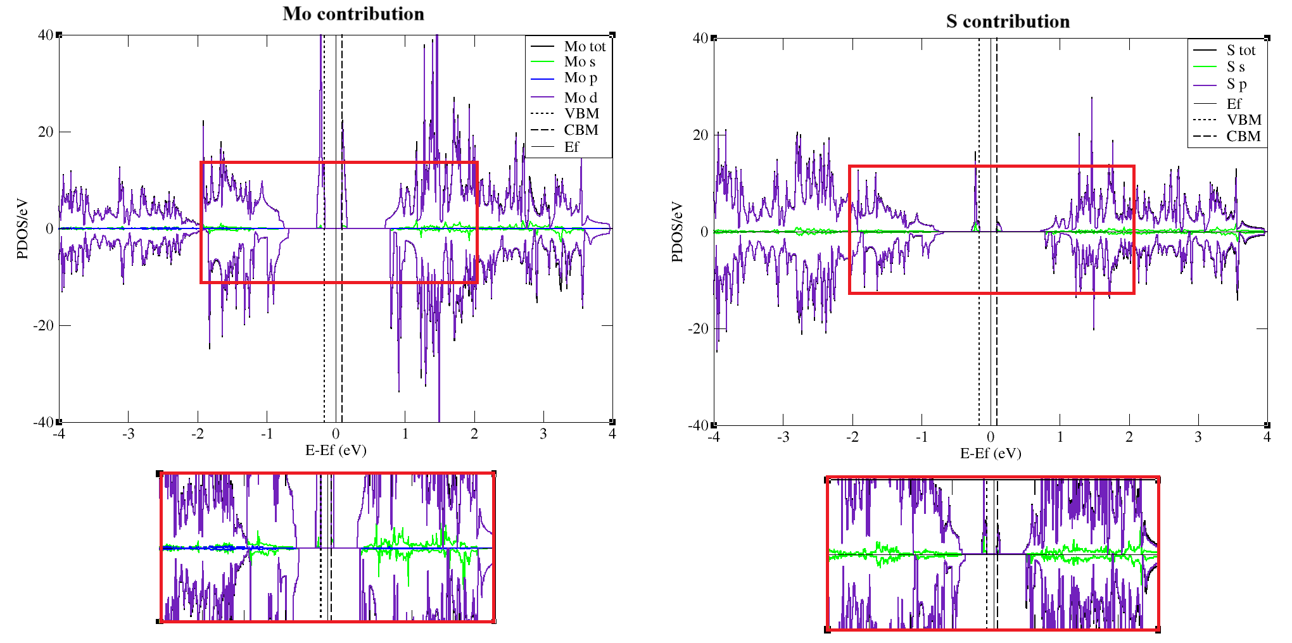
PDOS of substitutional defect Mo in position of S with the contribution of Mo and S atomic orbitals.

S4
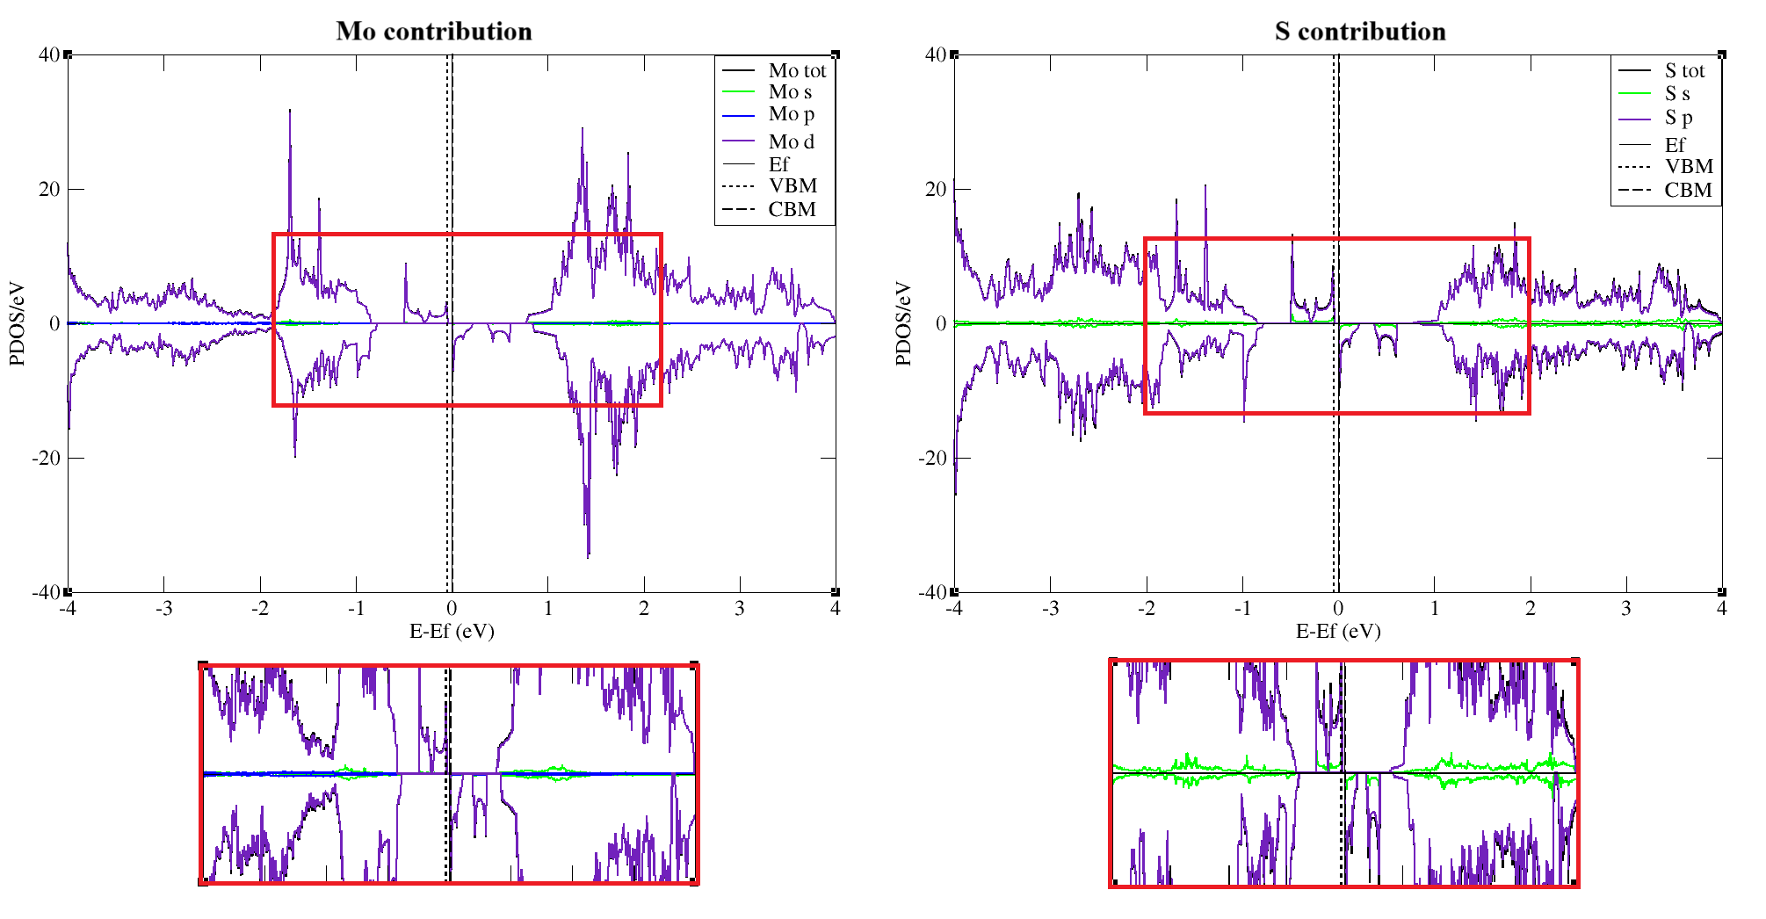
PDOS of S interstitial defect with the contribution of Mo and S atomic orbitals.

S5
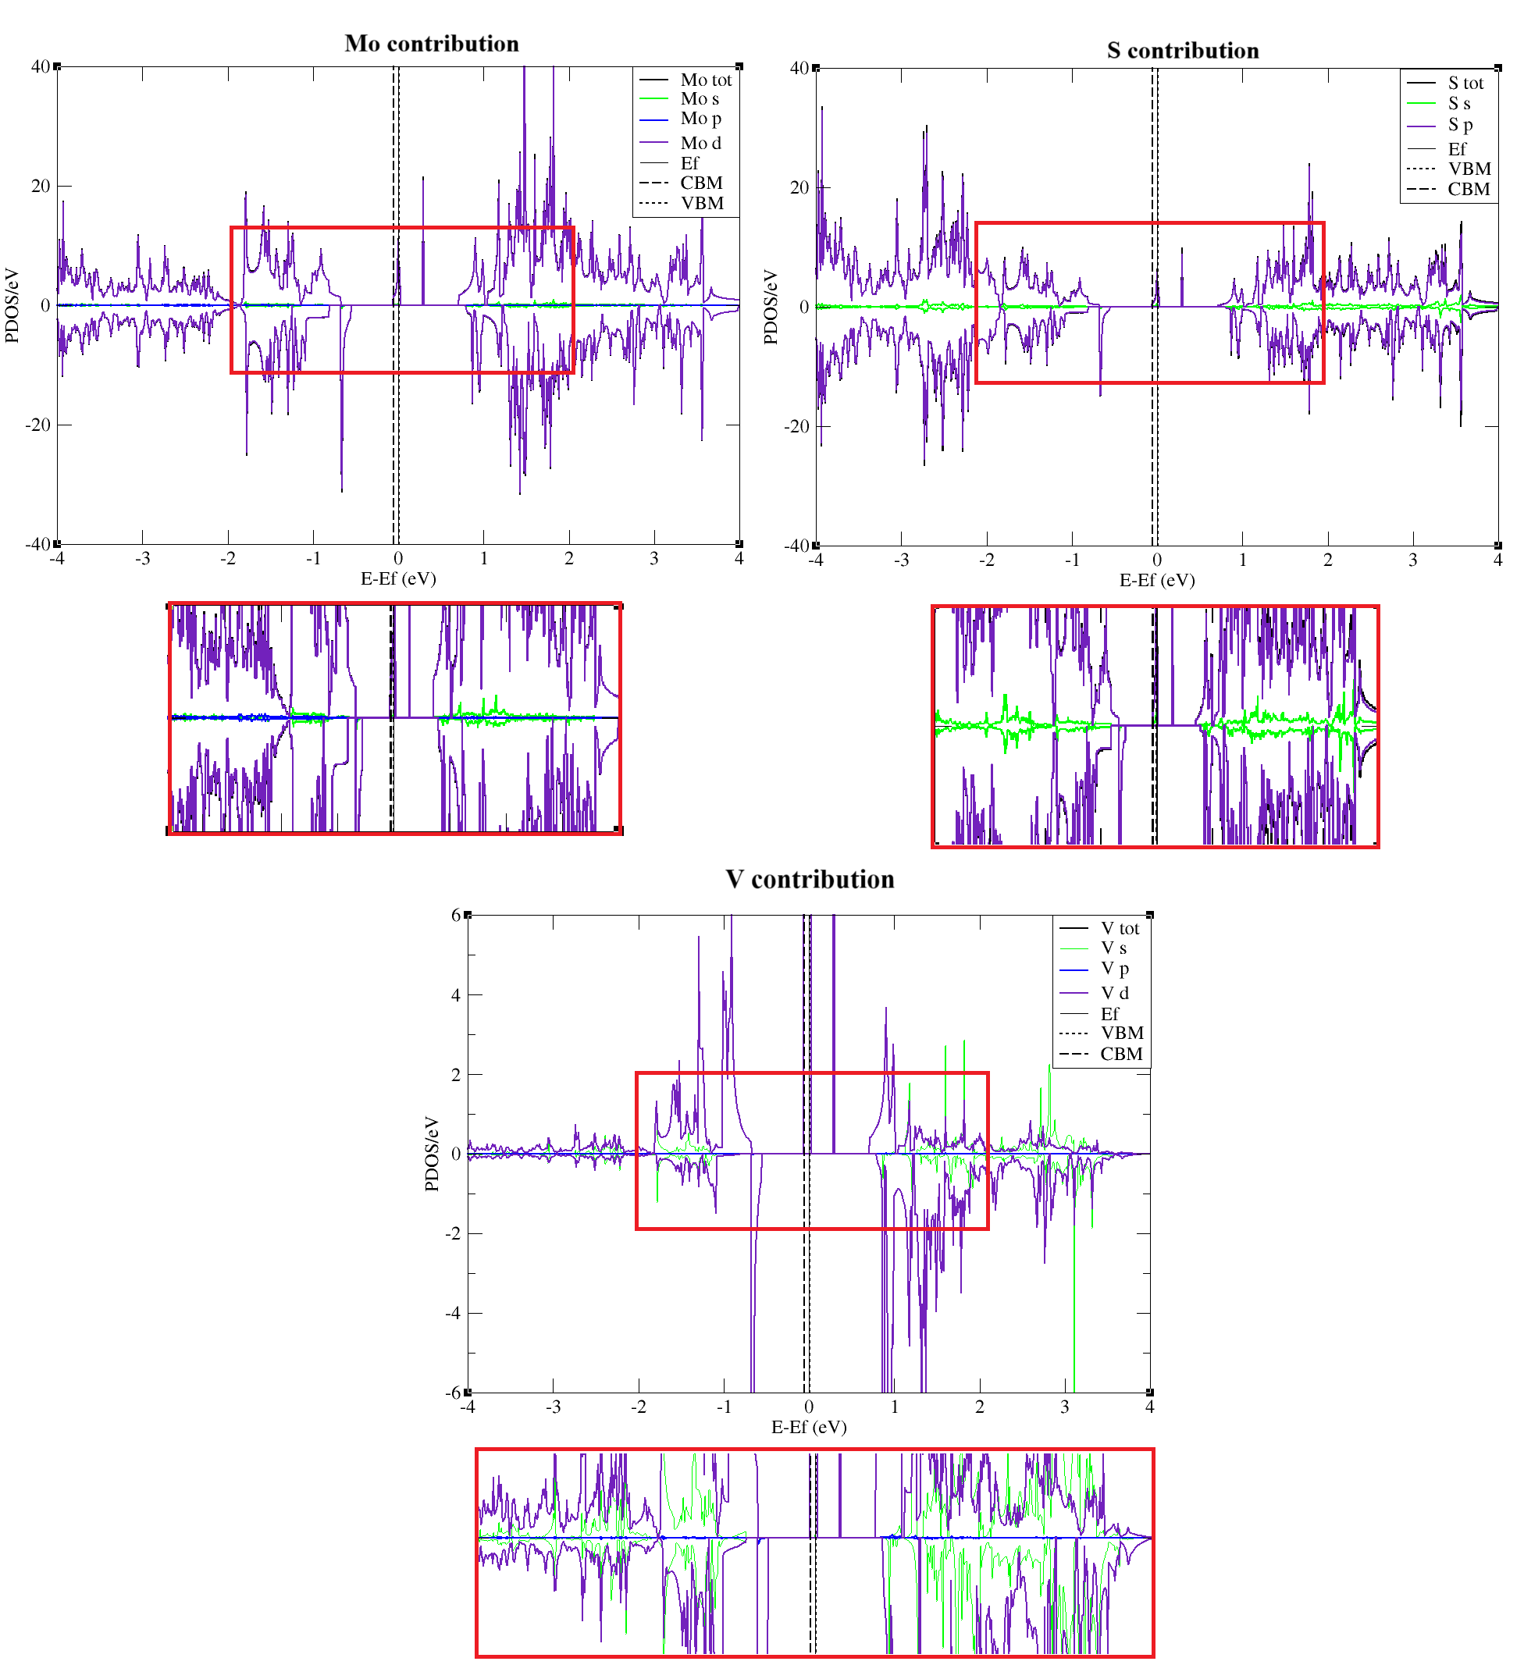
PDOS of substitutional defect V in position of S with the contribution from Mo, S and V atomic orbitals.

S6
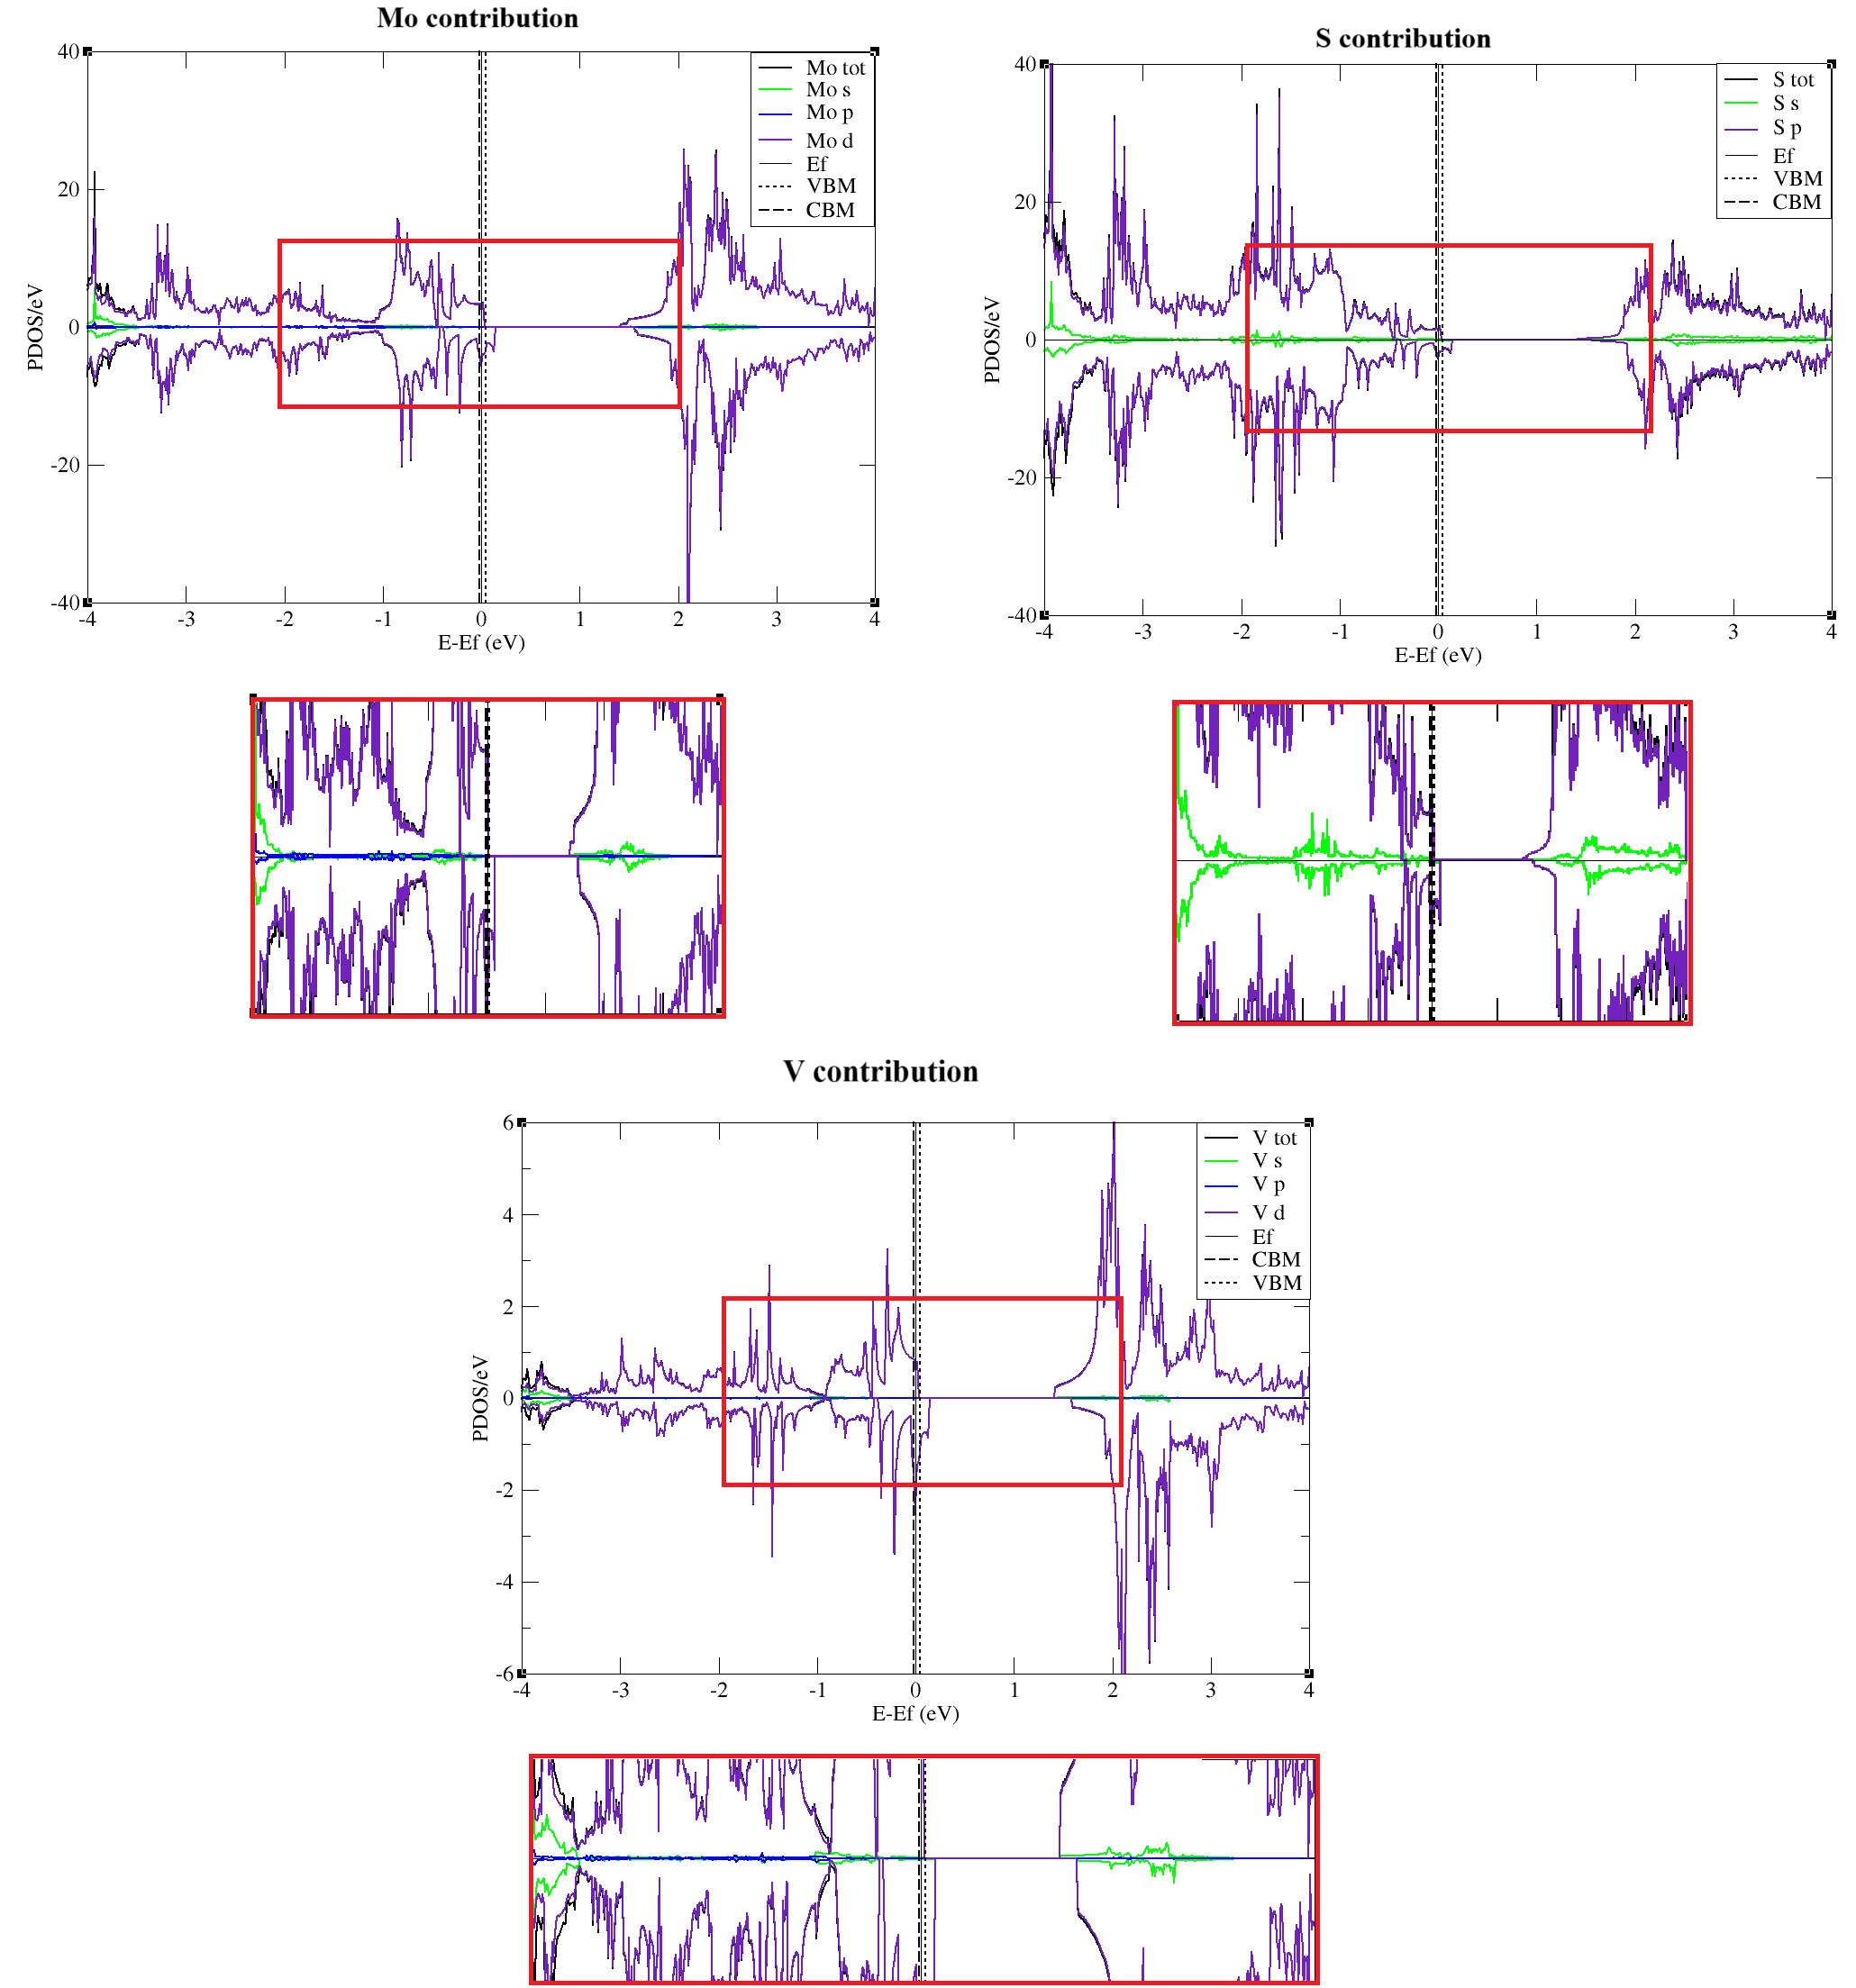
PDOS of substitutional defect V in position of Mo with the contribution from Mo, S and V atomic orbitals.

S7
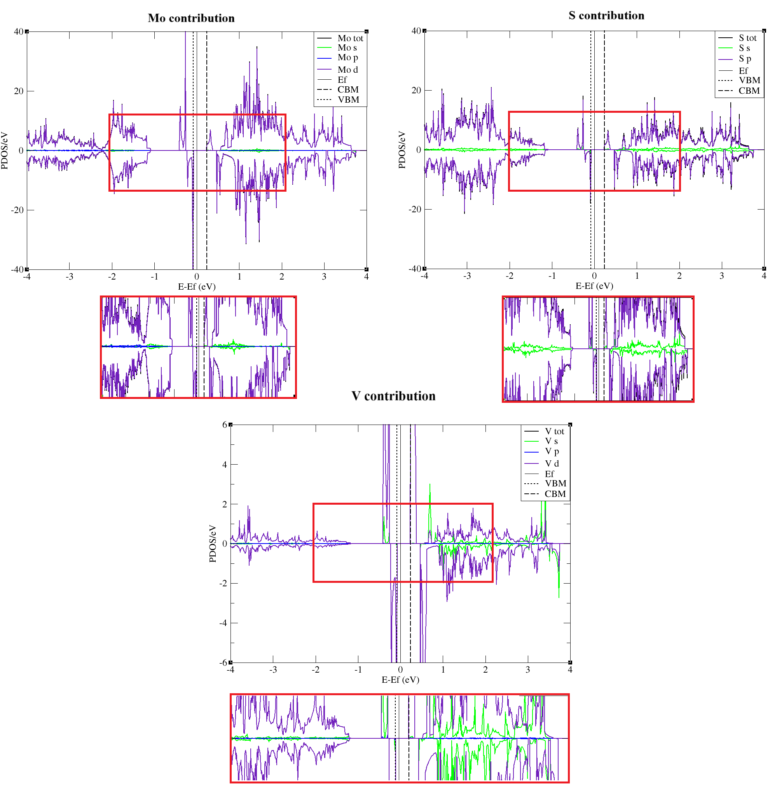
PDOS of V interstitial defect in atomic position #2 with the contribution from Mo, S and V atomic orbitals.

S8
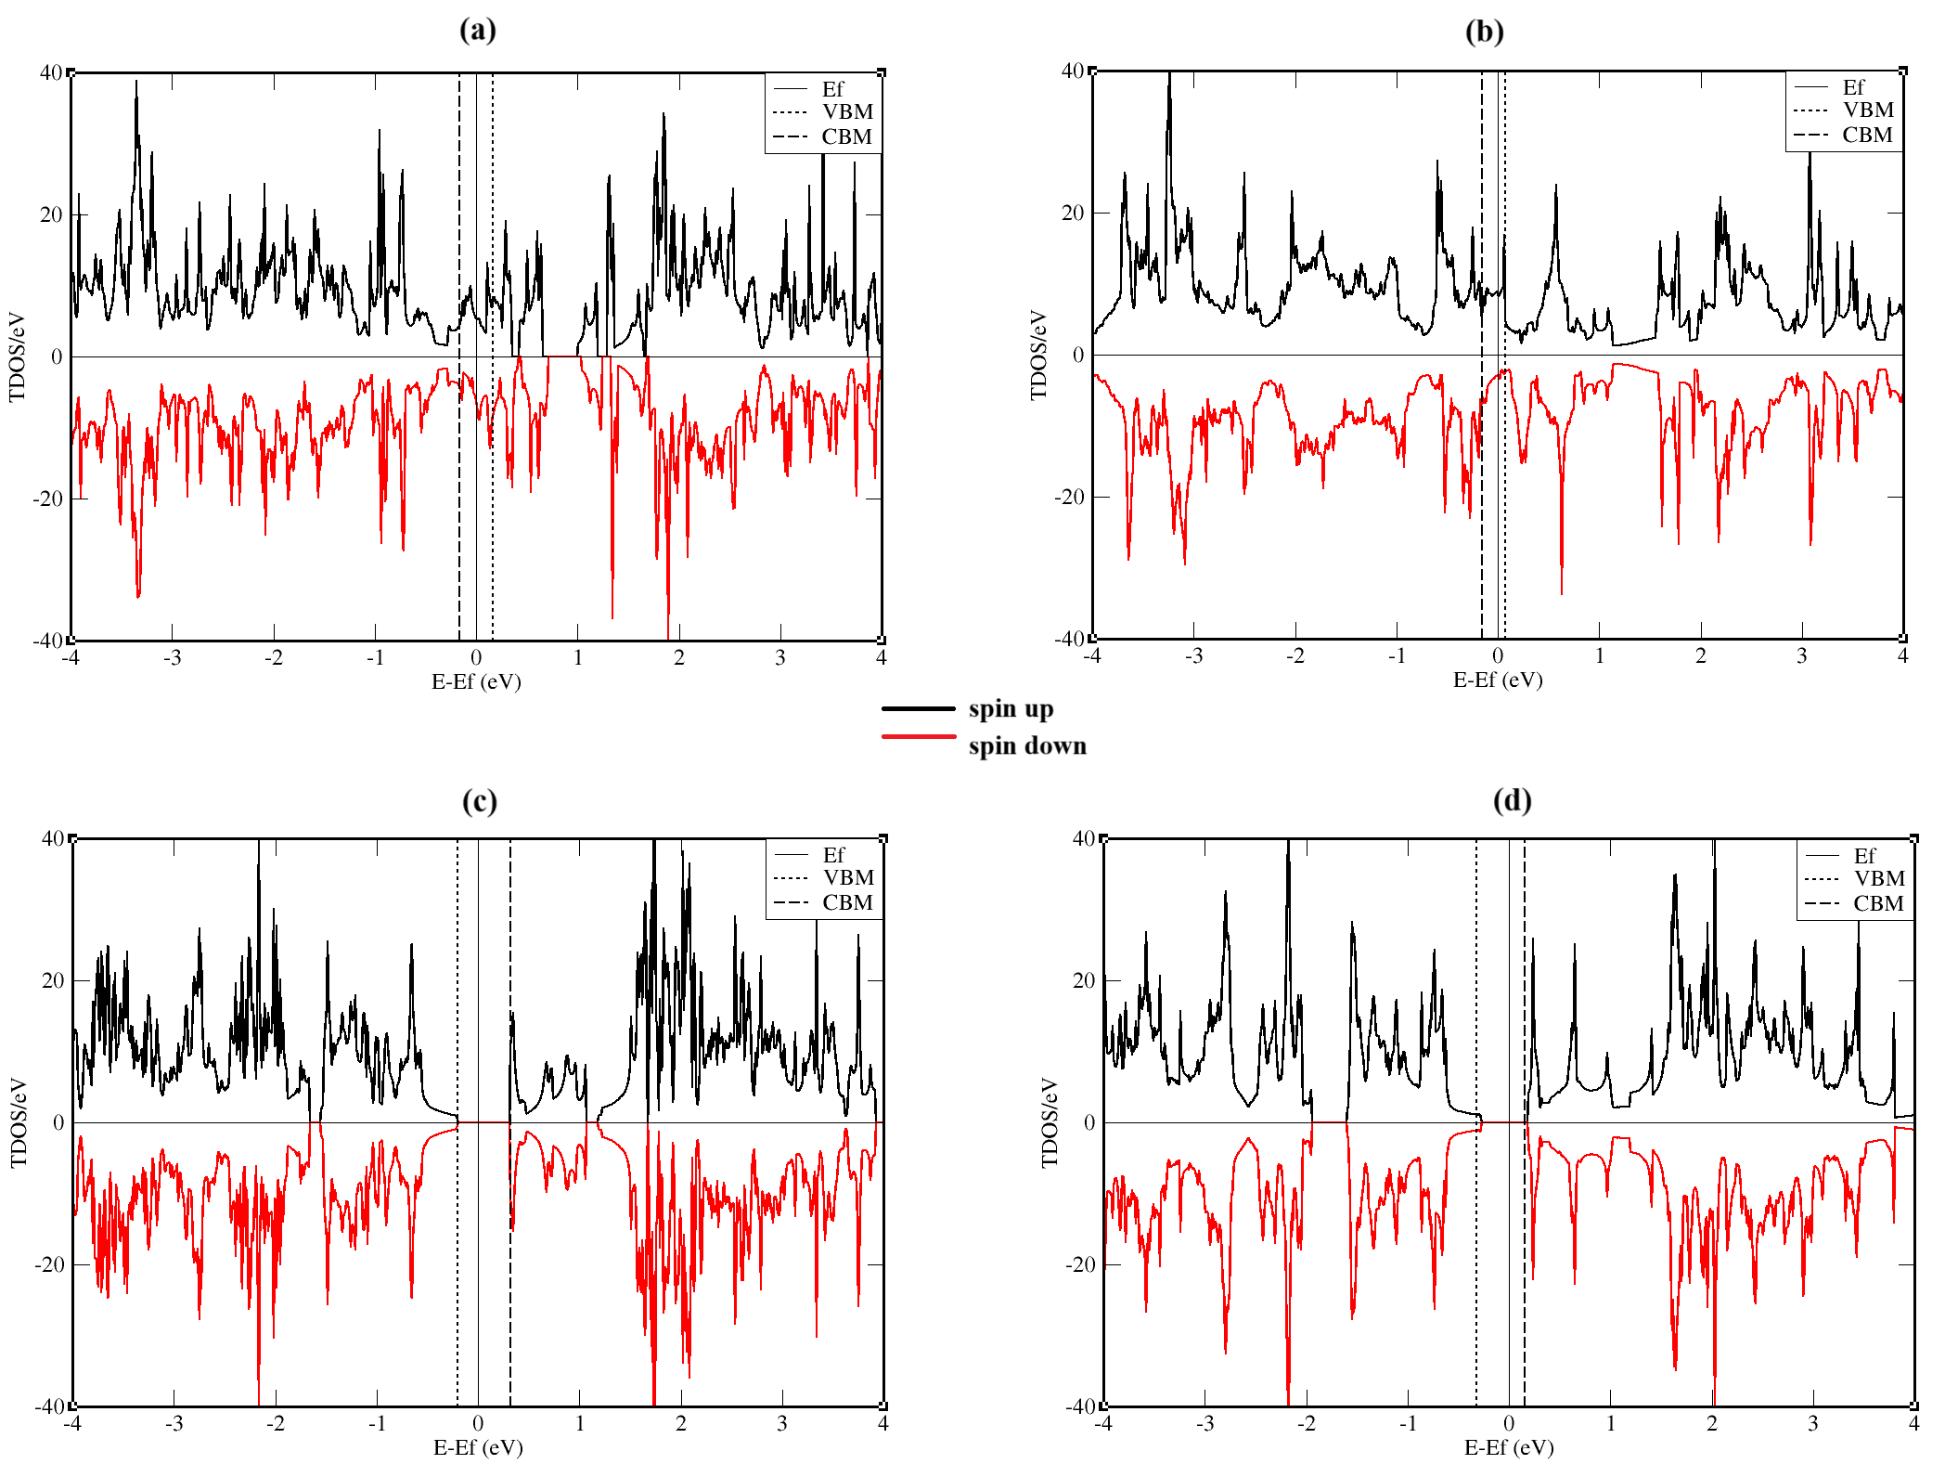
TDOS of Mo and S vacancies: (a) divacancy of Mo (b) three vacancies of Mo (c) divacancy of S (d) three vacancies of S

S9
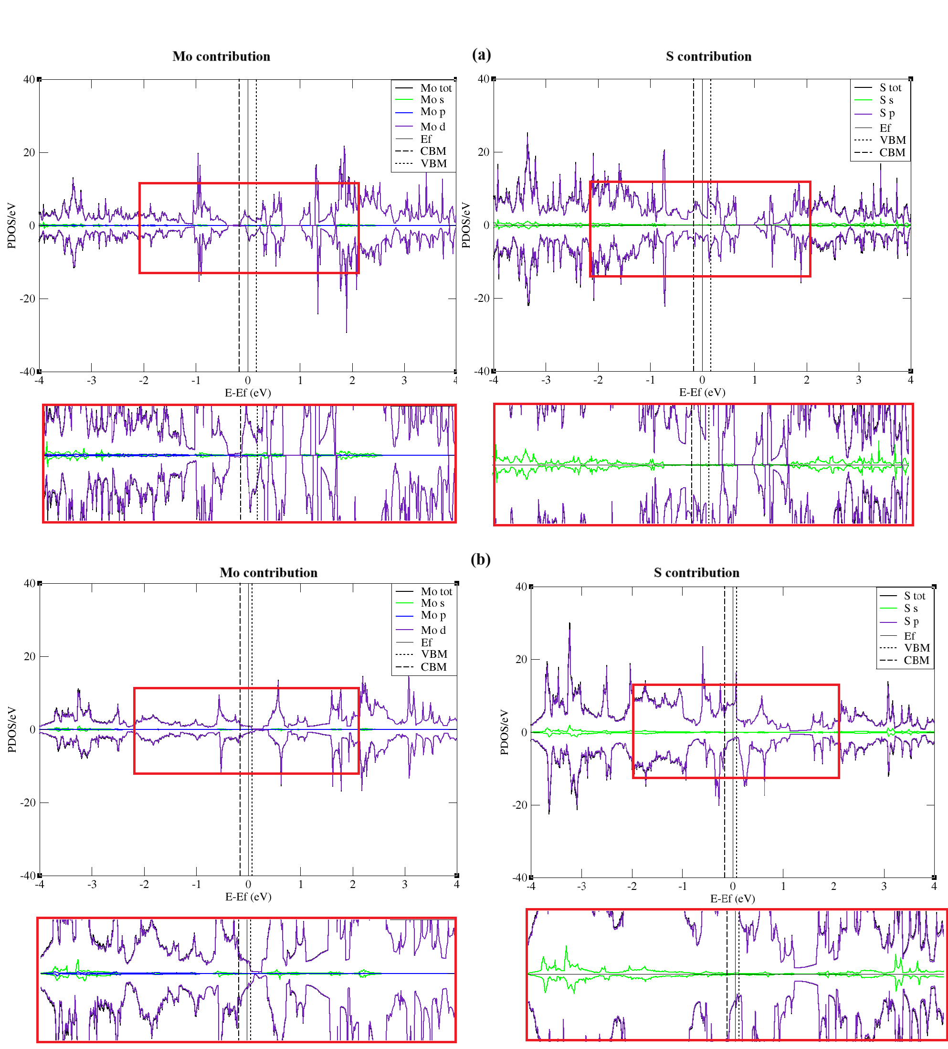
PDOS of Mo vacancies with the contribution from Mo and S atomic orbitals: (a) divacancy (b) three vacancies.

