Supporting information

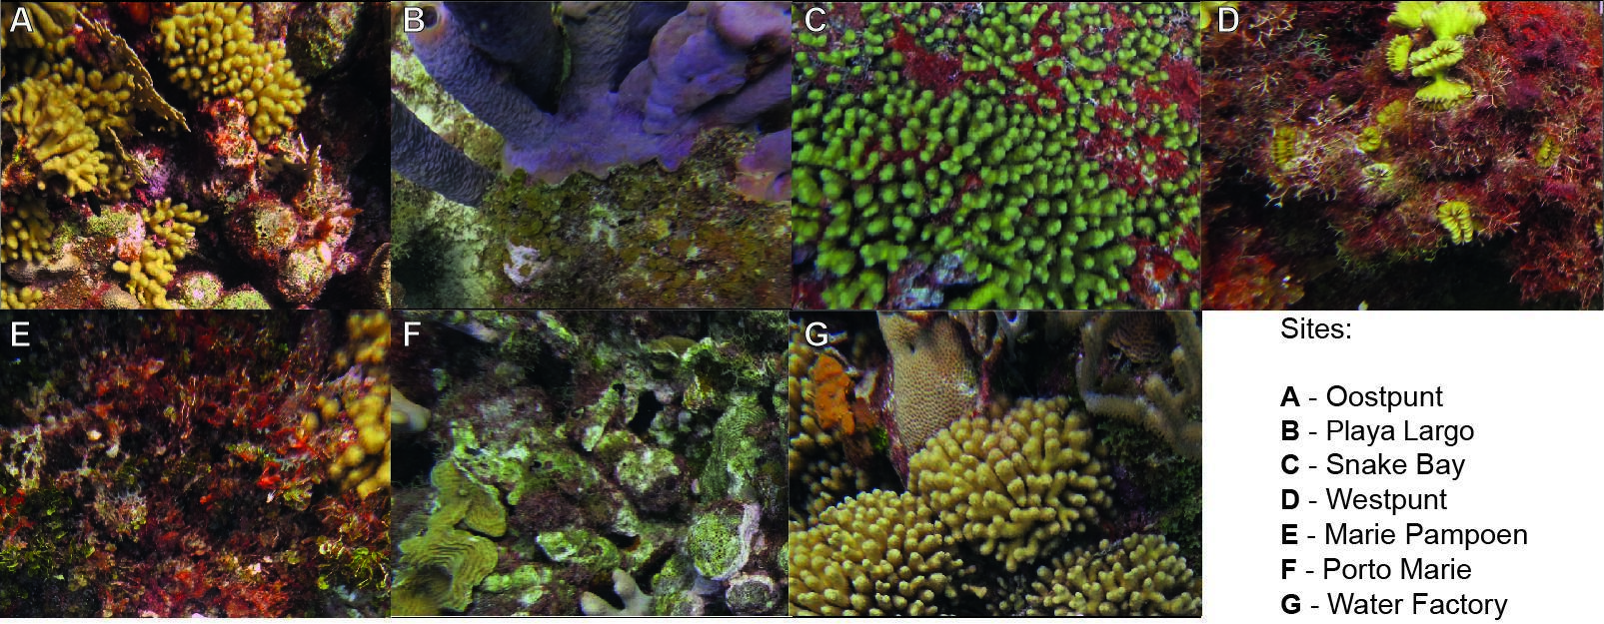
Figure S1. Benthos coverage along the seven sites at Curaçao Island, Caribbean: A) Oostpunt; B) Playa Largo; C) Snake Bay; D) Westpunt; E) Marie Pampoen; F) Porto Marie; G) Water Factory.

Table S1 Species nestedness contribution in the fish-benthos feeding network and species centrality degree in the agonistic network.
Species | Nestedness contribution | Centrality Degree
Abudefduf saxatilis |  | 0.957
Acanthurus coeruleus | 0.88 | 1.4
Acanthurus tractus | 1.90
Canthigaster rostrata | 0.90 | 0.1
Cephalopholis cruentata | 1.97 | 2.024
Chaetodon capistratus | 1.51
Chromis cyanea |  | 1.335
Chromis multilineata |  | 0.55
Clepticus parrae |  | 0.75
Haemulon flavolineatum |  | 0.2
Halichoeres garnoti | 1.50 | 0.077
Halichoeres maculipinna | 1.11
Holacanthus tricolor | 1.53
Hypoplectrus unicolor | 1.45
Microspathodon crysurus | 1.51 | 0.126
Pomacanthus paru | 1.39
Scarus iseri | 1.01 | 0.126
Scarus taeniopterus | 1.31 | 1
Sparisoma aurofrenatum | 1.71 | 0.23
Sparisoma viride | 0.91 | 0.222
Stegastes adustus | 0.93 | 10.077
Stegastes leucostictus | 1.21 | 0.789
Stegastes partitus | 0.32 | 8.999
Stegastes planifrons | 1.48 | 5.151
Thalassoma bifasciatum | 1.65

Table S2 Results of the NODF from the null model regarding the nestedness of the feeding network.

NODF | SES | Mean | 97.5% | p-value
69.073 | 0.573 | 68.278 | 70.140 | 0.628

Table S3 Comparison of the feeding interactions nested models using the Likelihood Ratio Test. The models were compared based on their explanatory variables, degrees of freedom (Df), log-likelihood values (LogLik), chi-squared statistics (Chisq), p-values (Pr(>Chisq)), and Akaike Information Criterion (AIC).

Model number | Model | Df | LogLik | Chisq | p-value | AIC
1 | Number of feeding interactions ~ Maxn | 3 | -2058.1 |  |  | 4122.26
2 | Number of feeding interactions ~ Maxn + Trophic groups | 6 | -2038.7 | 38.872 | < 0.001 | 4089.39
3 | Number of feeding interactions ~ Maxn + Trophic groups + Benthic coverage proportions | 10 | -2029.6 | 18.238 | 0.001 | 4079.15
4 | Number of feeding interactions ~ Maxn + Trophic groups + Benthic coverage proportions + Coverage origin | 11 | -2027.9 | 3.2869 | 0.06 | 4077.87

Table S4 Comparison of the agonistic interactions (out-degree centrality) nested models using the Likelihood Ratio Test. The models were compared based on their explanatory variables, degrees of freedom (Df), log-likelihood values (LogLik), chi-squared statistics (Chisq), p-values (Pr(>Chisq)), and Akaike Information Criterion (AIC).

Model number | Model | Df | LogLik | Chisq | p-value | AIC
1 | Out-degree centrality ~ Maxn | 3 | -1797.2 |  |  | 3600.427
2 | Out-degree centrality ~ Maxn + Trophic groups + Body size + Mobility | 10 | -1643.4 | 307.55 | < 0.001*** | 3306.881
3 | Out-degree centrality ~ Maxn + Trophic groups + Body size + Mobility + Benthic coverage proportions | 14 | -1629.1 | 28.719 | <0.001*** | 3286.162

