Supporting Information
Design and catalytic performance of a novel 2D copper MOF for green synthesis of tetrahydrobenzo[b]pyrans
Ehsan Joukar Bahaderaniª, Khosro Mohammadi^{*a}, Payam Hayati^{*b}, Jan Janczak^{c}
ª Chemistry Department, Faculty of Nano and Bio Sciences and Technology, Persian Gulf University, Bushehr 75169, Iran
^{b} Department of Biotechnology and Life Sciences, University of Insubria, Via Jean Henry Dunant, 3, 21100 Varese, Italy
^{c} Institute of Low Temperature and Structure Research, Polish Academy of Sciences, P. O. Box 1410, Okólna 2 Str., 50-422 Wroclaw, Poland
Email: khmohammadi@pgu.ac.ir; khmohammadi@yahoo.com

Table S1. Crystallographic data for (1).

Compound | [Cu(H₂O)(m-PO₃CH₂C₆H₄CO₂H)]_{n} (1)
Chemical formula | C₈H₉CuO₆P
M_{r} | 295.66
Crystal system, space group | Monoclinic, P2₁/n
Temperature (K) | 295(2)
a, b, c (Å) | 5.7362 (5), 4.7509 (4), 34.635 (3)
β (°) | 92.327 (7)
V (Å³) | 943.09 (14)
Z | 4
D_{calc} (g·cm^{–3}) | 2.082
Radiation type, wavelength, λ (Å) | Mo Kα , 0.71073
µ (mm⁻¹) | 2.50
F(000) | 596
Crystal size (mm) | 0.24 × 0.20 × 0.15
Tmin, Tmax | 0.794, 1.000
θ range(°) | 3.5-27.4
Absorption correction | multi-scan
Reflections collected / unique / observed | 26181, 2167, 1913
Rint | 0.064
Refinement on | F²
R[F² > 2σ(F²)] | 0.0745
wR(F² all reflections) | 0.1655
Goodness-of-fit, S | 1.001
Δρ_{max}, Δρ_{min} (e Å⁻³) | +1.442, -0.844
wR={Σ [w(F_{o}²–F_{c}²)²]/ΣwF_{o}⁴}^{½}; w = 1/[σ²(F_{o}²) + (0.0549P)² + 16.5039P] where P = (F_{o}² + 2F_{c}²)/3

Figure S1
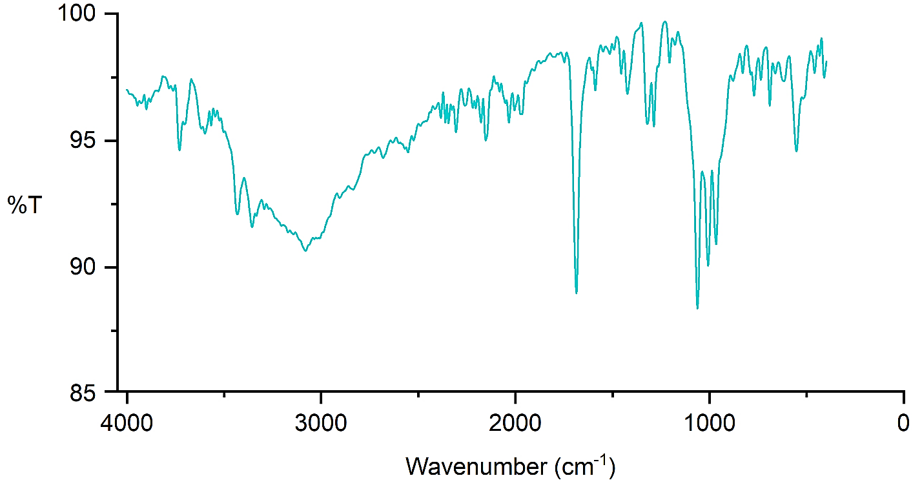
Figure S1. IR spectrum of nanoparticle (1′).

Figure S2

Figure S2. TGA/DTA of nanoparticle (1′).

