Supplementary Materials

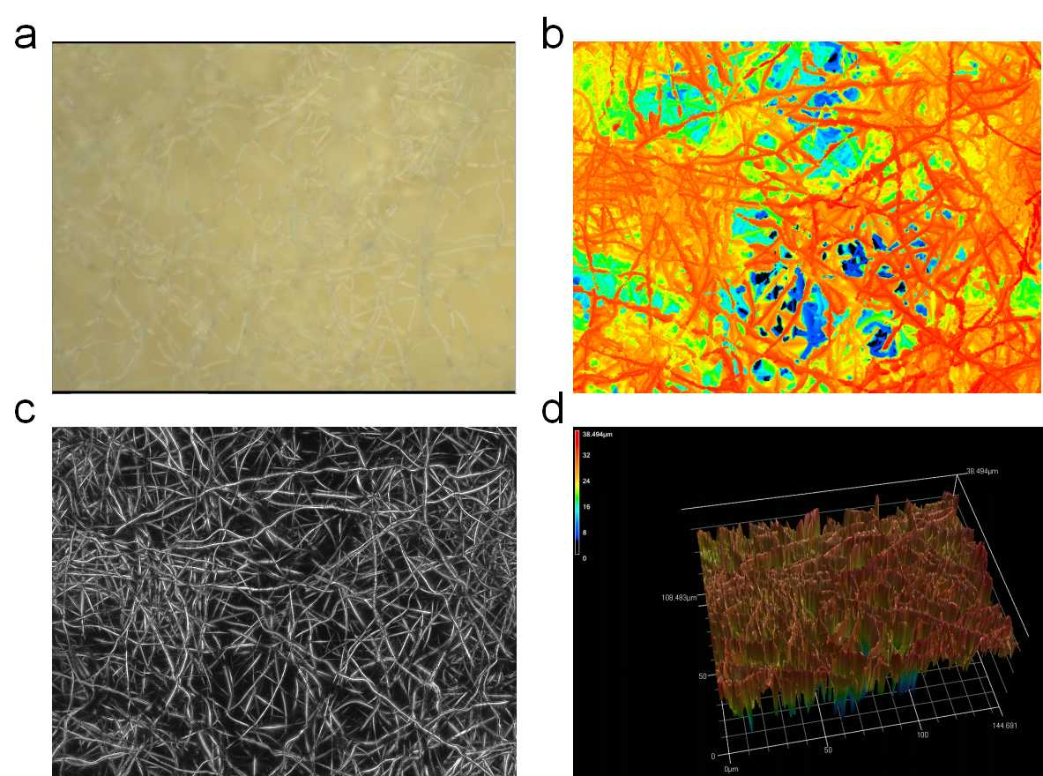
Figure S1. (a) The optical image of PI fiber fabric. (b,c) The 2D view of PI fiber fabric. (d) The 3D stereoscopic topography of the PI fiber fabric.

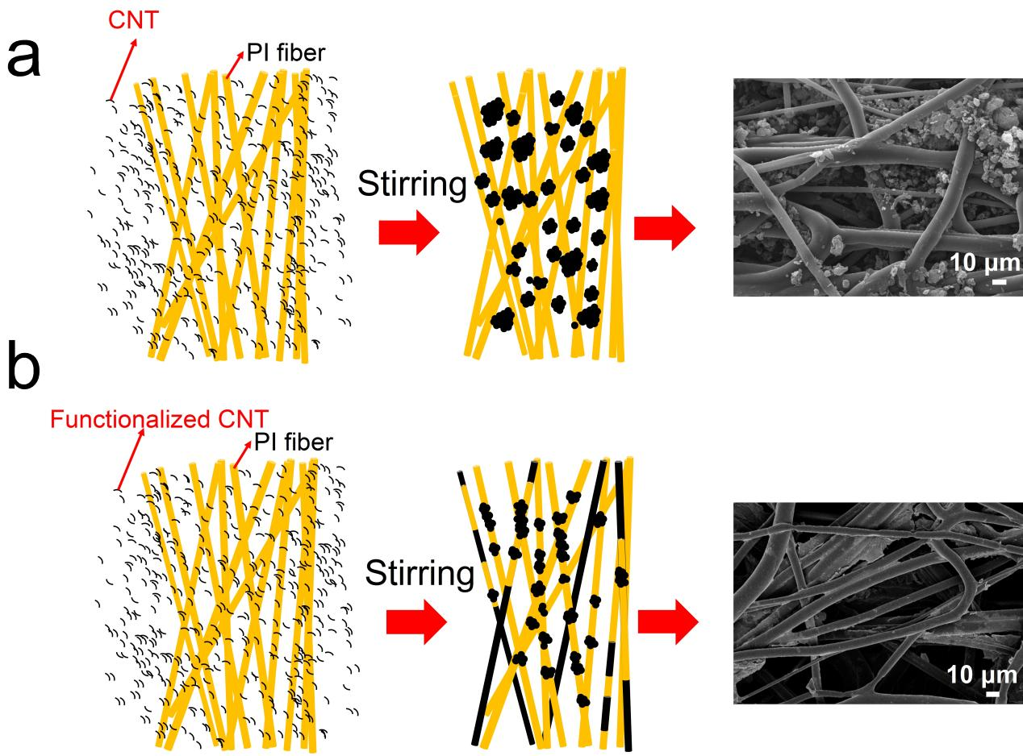
Figure S2. PI/CNT(Stirring) and PI/FCNT(Stirring) pressure sensors. (a)Schematic illustration of the doping mechanism for PI/CNT (Stirring) pressure sensors and the corresponding top-view SEM images of the PI/CNT(Stirring). (b) Schematic illustration of the doping mechanism for PI/FCNT (Stirring) pressure sensors and the corresponding top-view SEM images of the PI/FCNT(Stirring).
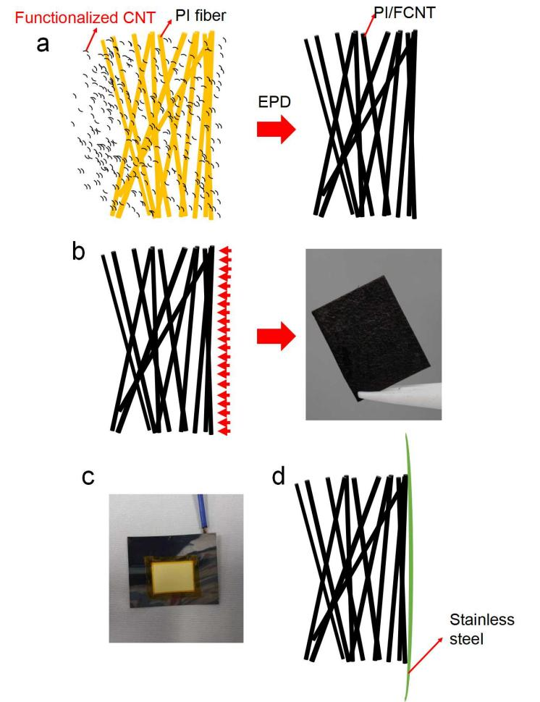
Figure S3. PI/FCNT(EPD) pressure sensor. (a)Schematic illustration of the doping mechanism for PI/FCNT (EPD) pressure sensor. (b) Optical image of the surface of the PI/FCNT(EPD). The FCNT is uniformly coated onto the fiber surface, even for the fibers adhered to the anode. (c-d) Image of the PI fiber fabric glued on the stainless steel anode, and the tape is rounded the edges of PI fiber fabric. After immersing the PI fiber fabric into the solution, most of the PI fiber fabric areas are exposed to the FCNT solution. During the EPD process, the FCNT can still be uniformly deposited onto the back surface of the PI fiber fabric.
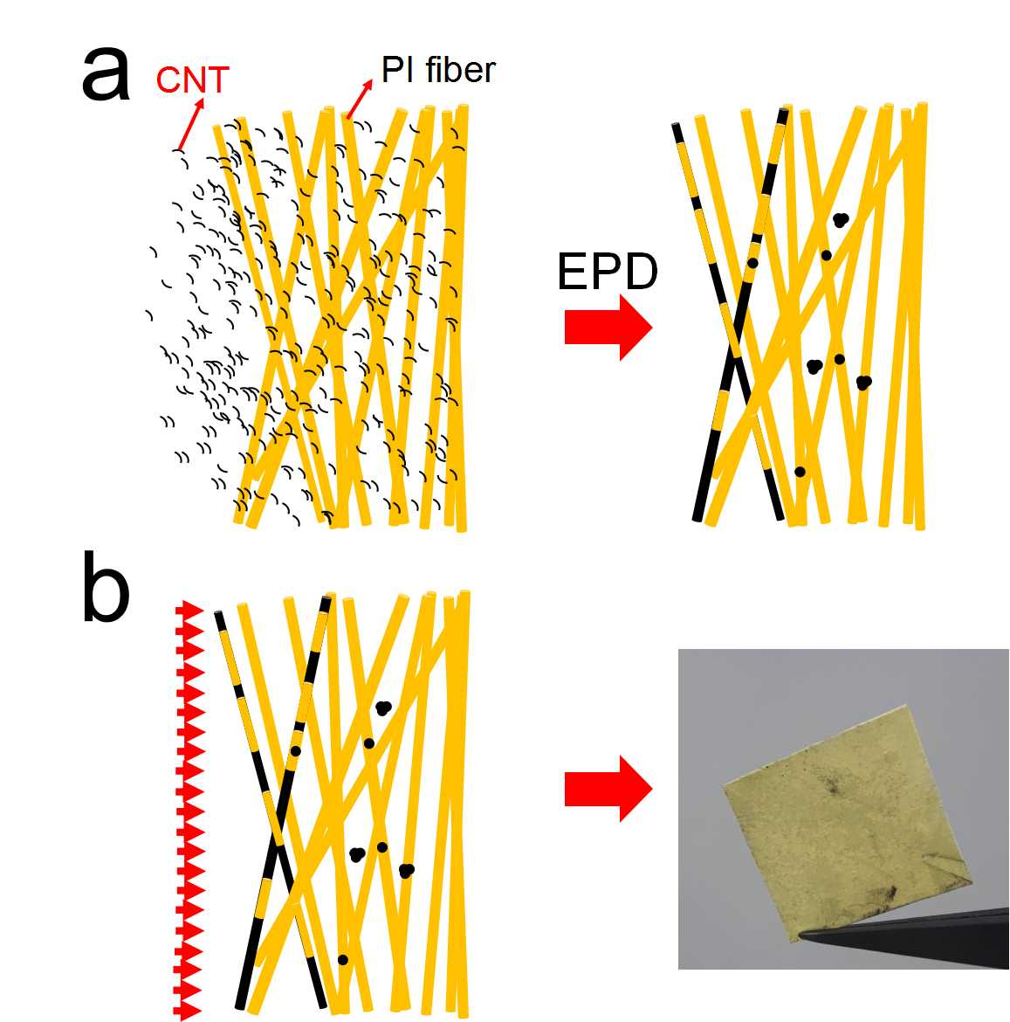
Figure S4. PI/CNT(EPD) pressure sensor. (a)Schematic illustration of the doping mechanism for PI/CNT (EPD) pressure sensor. (b) Optical image of the surface of the PI/CNT(EPD). We only observed a thin layer of CNT adhered to one surface (away from the anode) of the PI fiber fabric.
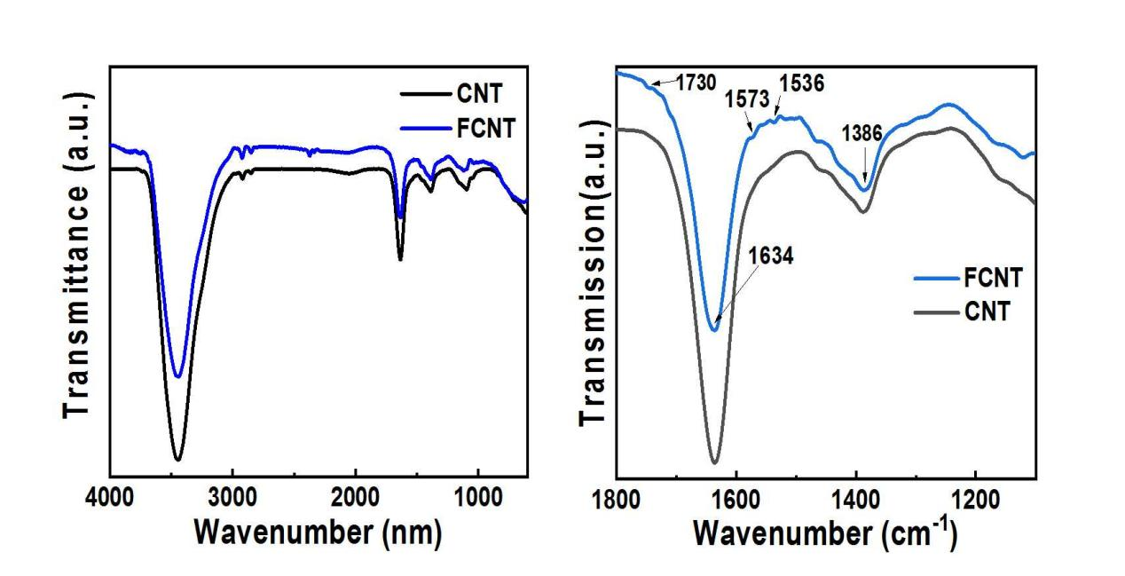
Figure S5. FT-IR spectra of CNT and FCNT.
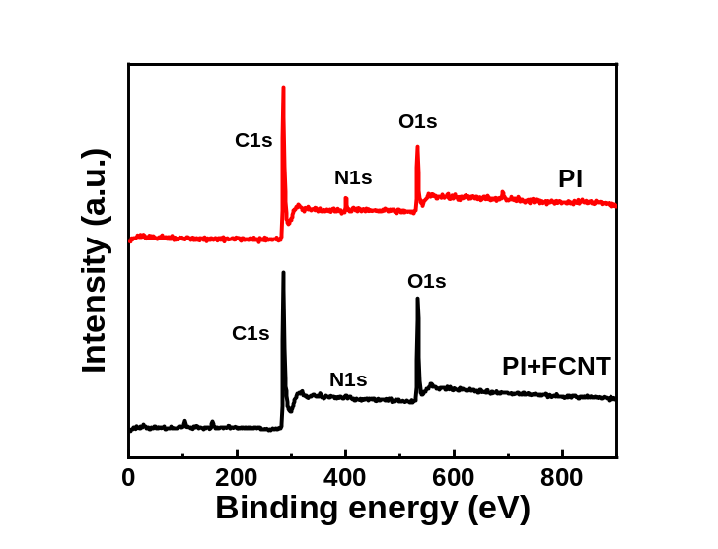
Figure S6. XPS survey spectra of PI and PI/FCNT(EPD).
FEM Simulation
In order to better explain the pressure mechanism of the sensor and theoretically explain the working principle of the pressure sensor, we adopted finite element simulation to simulate the experimental results. We built the geometric models using the Workbench Geometry model, as shown in Figure S7 (PI/FCNT(EPD)). Fourteen fibers with diameter of five microns are used to form a three-layer structure. At the same time, two plates were established to facilitate the application of boundary conditions. We used the “Static Structure” analysis system to carry out mechanical simulation for this geometric structure. The details of Static Structural is presented in Figure S8, showing the added fixed support in the bottom plate and a displacement condition of the top plate to apply static force to the intermediate fibers. Figure S9 shows the details of the contact situation we set. We used the time-contact area to describe some functions, because the displacement of the top plate is moving constantly with time. The function is displacement=2 μm × time (0<time<1s). The inputs are the displacement and applied force, and the outputs are the contacting area between the CNTs. The element was a hexagon grid. We adopted the Normal Lagrange Formulation to solve the contacting issues (Figure S9). In the Normal Lagrange Method, the contacting pressure was viewed as one degree of freedom, and no penetrating between the fibers was assumed, the calculated results had higher precision. For PI/FCNT(EPD), the contacting area change was calculated between the PI/FCNT fibers to PI/FCNT fibers. For PI/CNT(stirring), the contacting area change was calculated between the CNT cluster to CNT cluster. For PI/FCNT(stirring), the contacting area change was calculated between the CNT cluster to PI/FCNT fibers. In the simulation, the CNT cluster was modeled as a semisphere attached to the PI fibers (Figure S10), and the quantity of CNT clusters (semisphere) for PI/CNT (stirring) was more than that of PI/FCNT(stirring), according to the SEM observations (Figure 1).
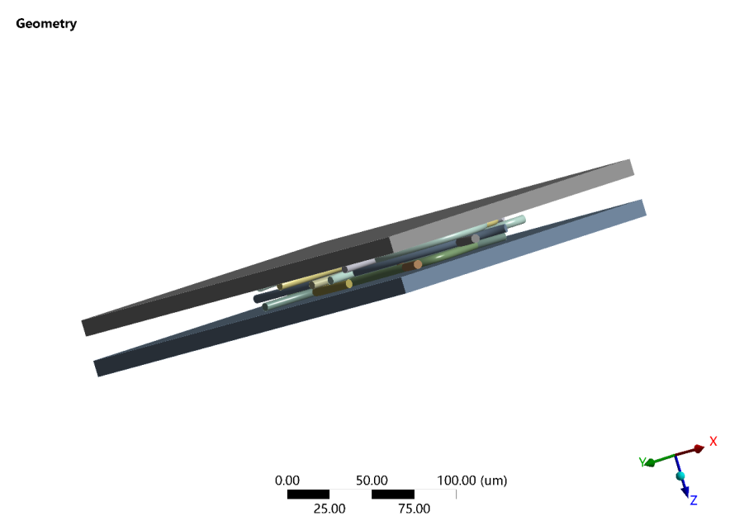
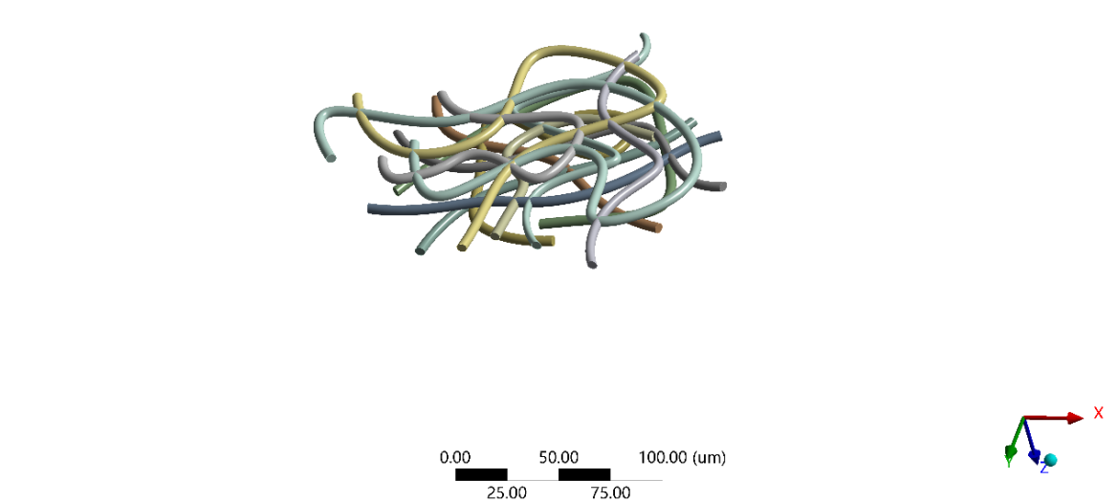
Figure S7. Geometry model of fibers for simulation.
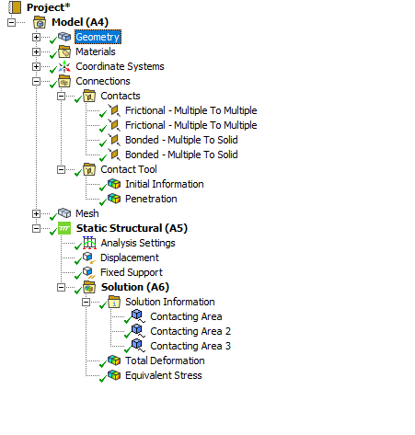
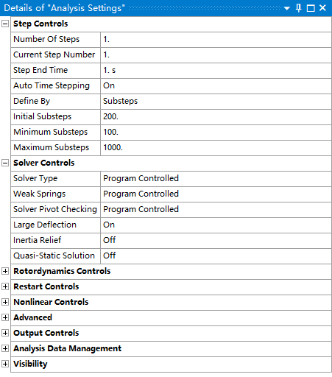
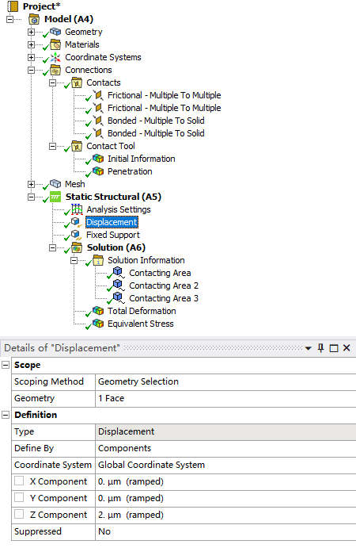

Figure S8. Parameter display regarding the boundary conditions in ANSYS software.

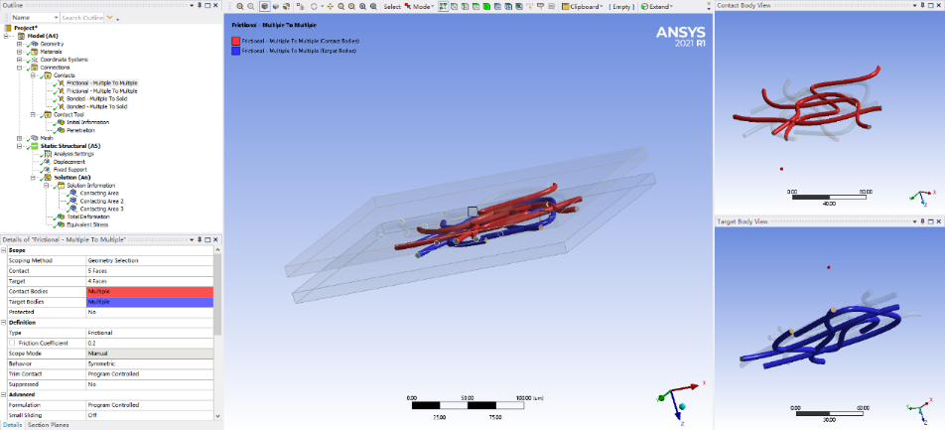
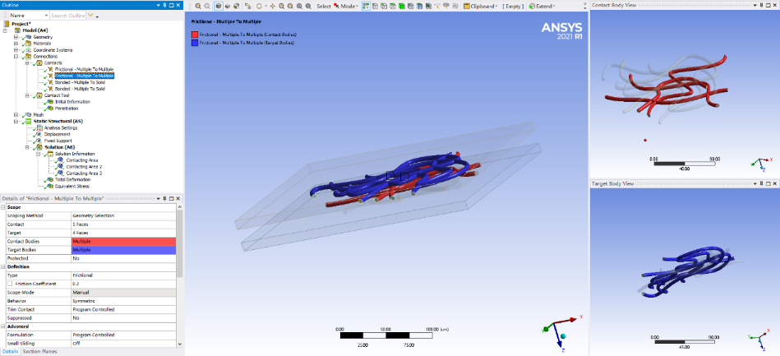
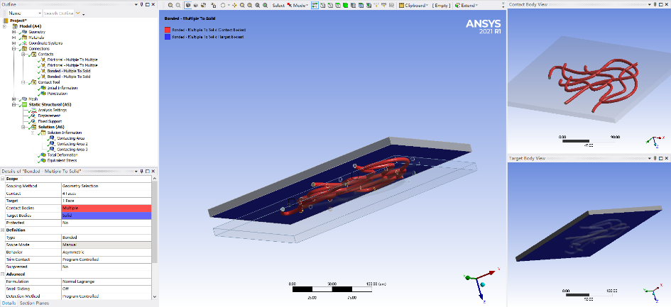
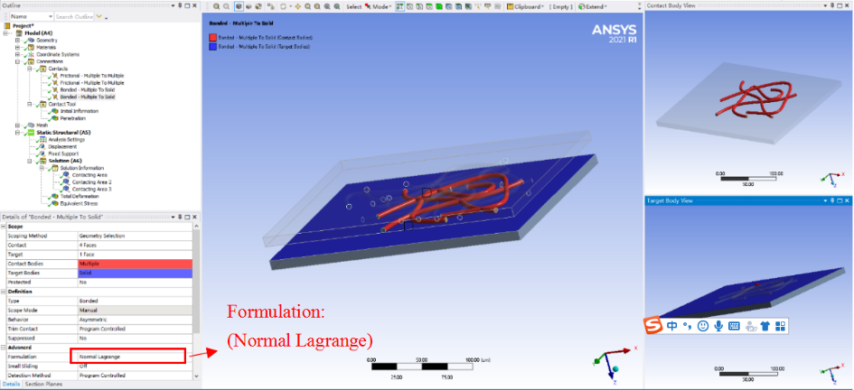
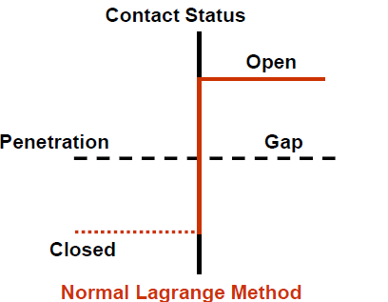
Figure S9. Contact conditions and the adopted formulation for the geometry model.

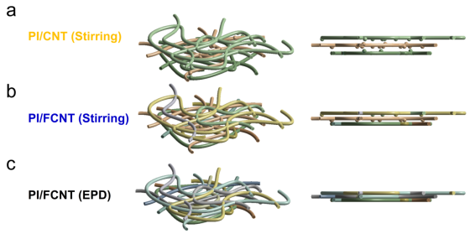
Figure S10. Established models for PI/CNT(stirring), PI/FCNT(stirring) and PI/FCNT(EPD).

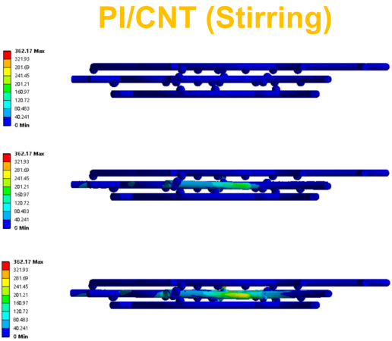
Figure S11. Dynamic microscopic deformation process for PI/CNT (Stirring) model.
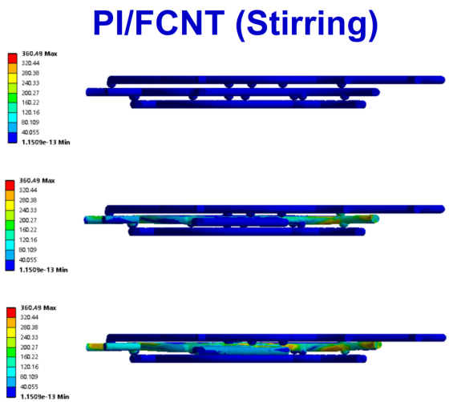
Figure S12. Dynamic microscopic deformation process for PI/FCNT (Stirring) model.
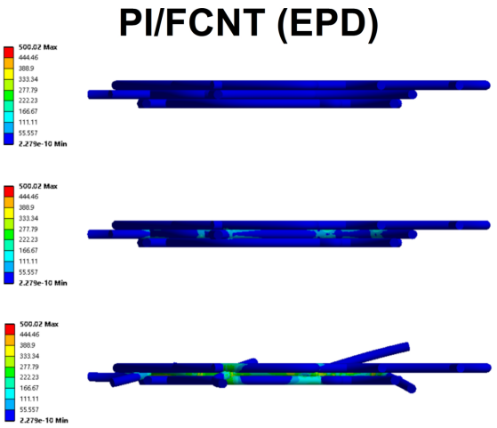
Figure S13. Dynamic microscopic deformation process for PI/FCNT (EPD) model.
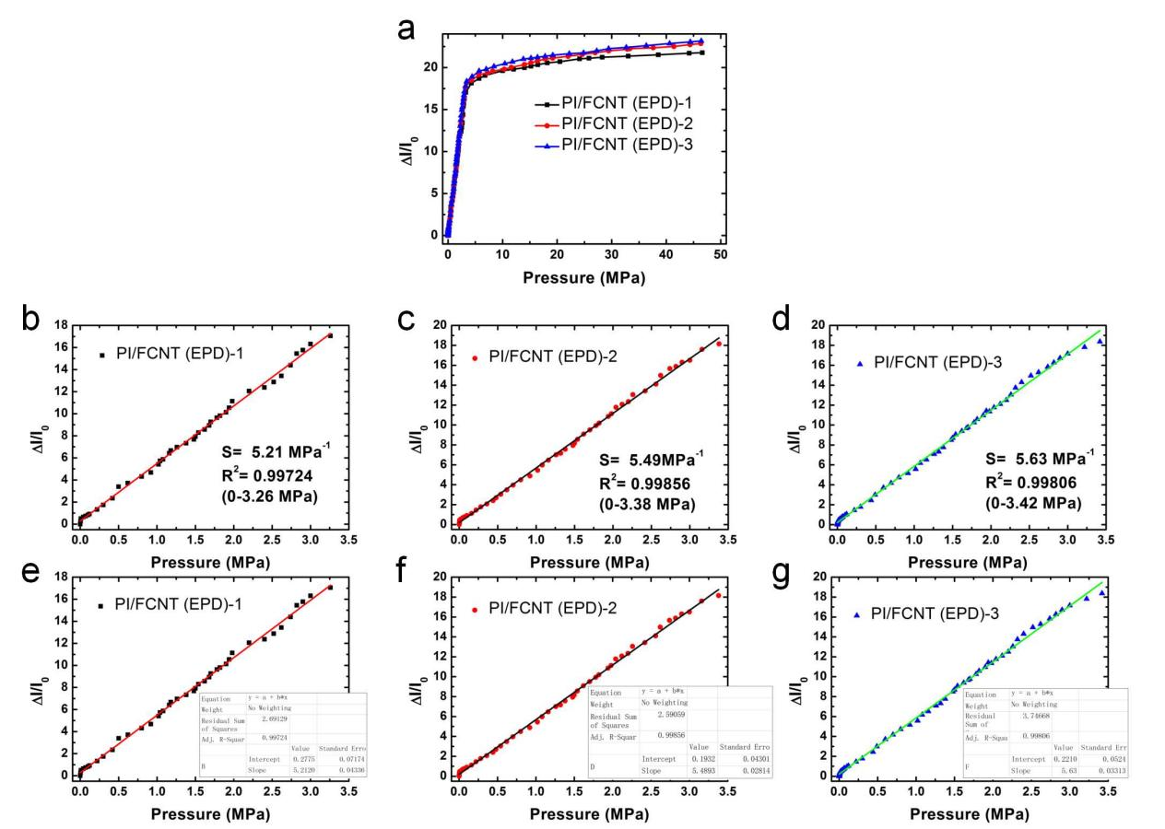
Figure S14. (a) Current response of three PI/FCNT(EPD) pressure sensors (PI fiber fabric thickness: 210 μm). (b, e) Plots of current variation versus pressures up to 3.26 MPa, and the corresponding sensitivity for PI/FCNT (EPD)-1. (c, f) Plots of current variation versus pressures up to 3.38 MPa and the corresponding sensitivity for PI/FCNT (EPD)-2. (d, g) Plots of current variation versus pressures up to 3.42 MPa and the corresponding sensitivity for PI/FCNT (EPD)-3.

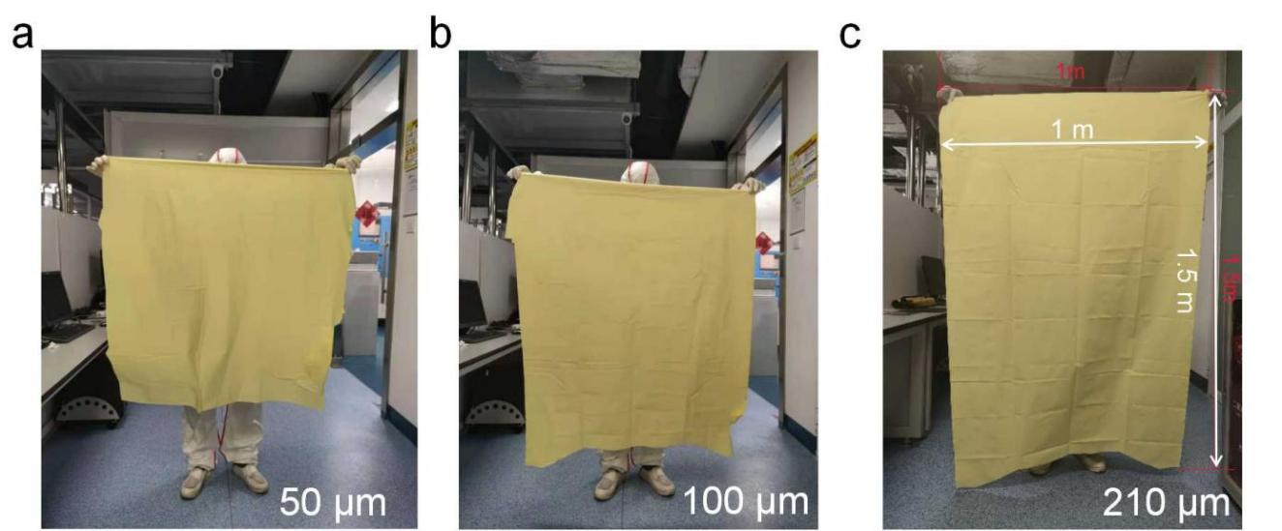
Figure S15. Fabrication of large-area PI fiber fabrics with different thicknesses. (a) 50 μm, (b) 100 μm, and (c) 210 μm.
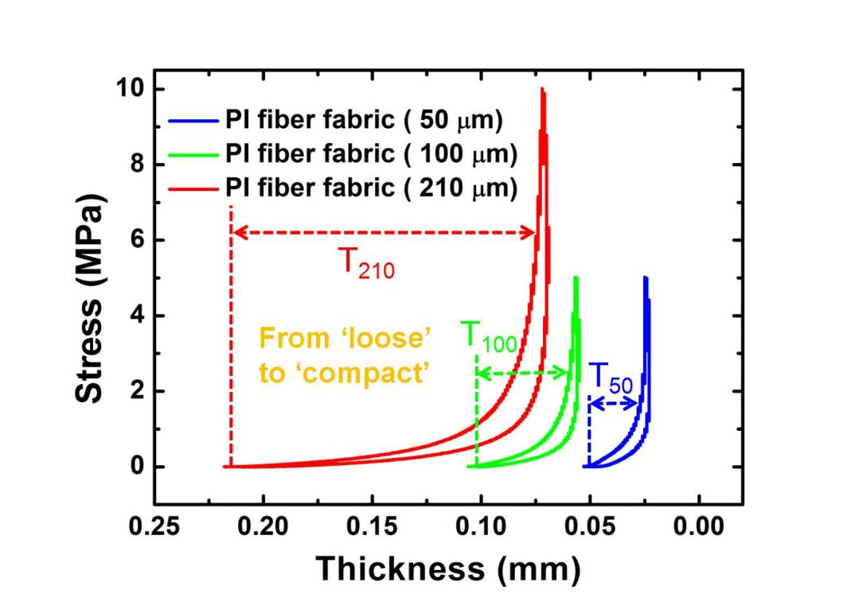
Figure S16. Compressive stress-strain curve for PI fiber fabrics with different thicknesses.
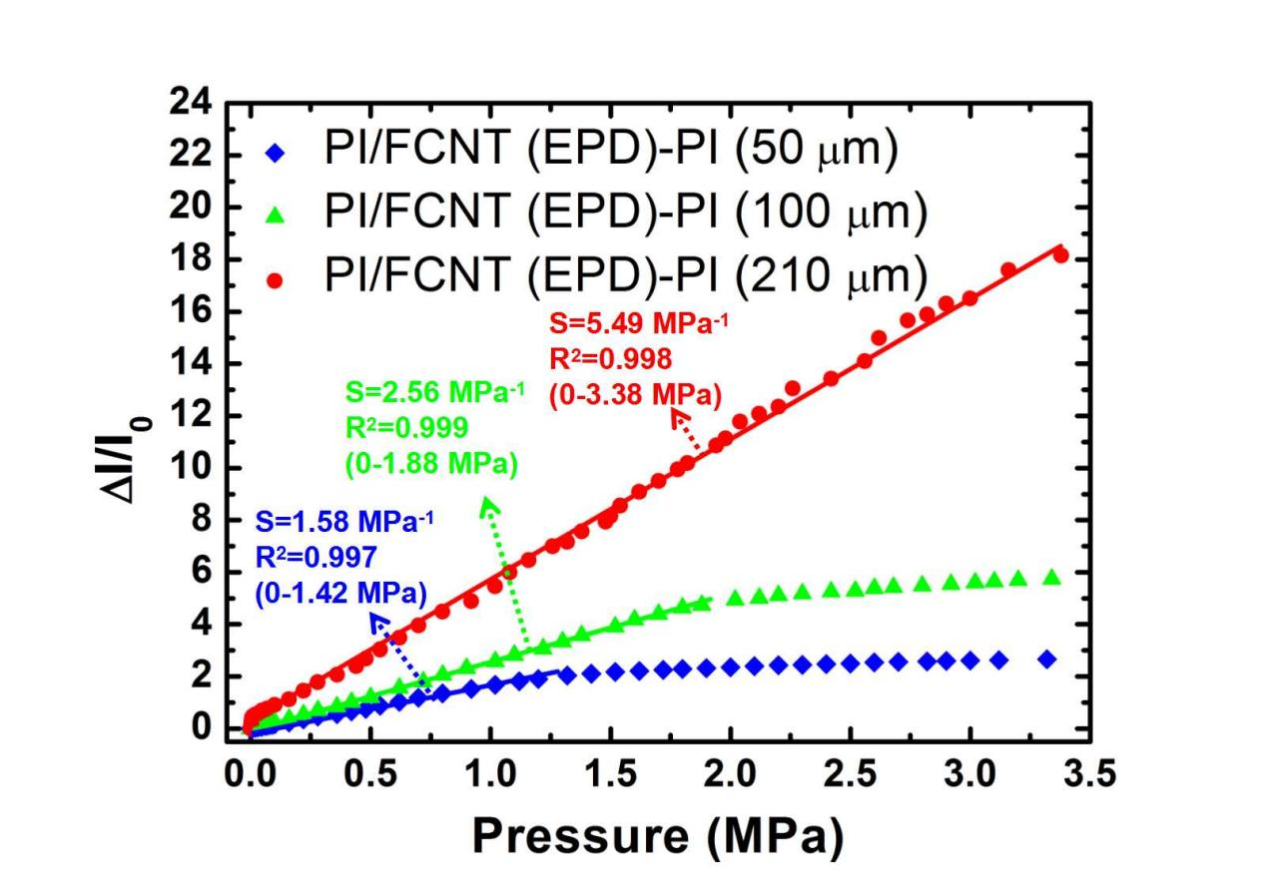
Figure S17. Relative current change vs. the pressure applied to the PI/FCNT(EPD) pressure sensors with the PI fiber fabric thickness of 50 μm, 100 μm and 210 μm, respectively.
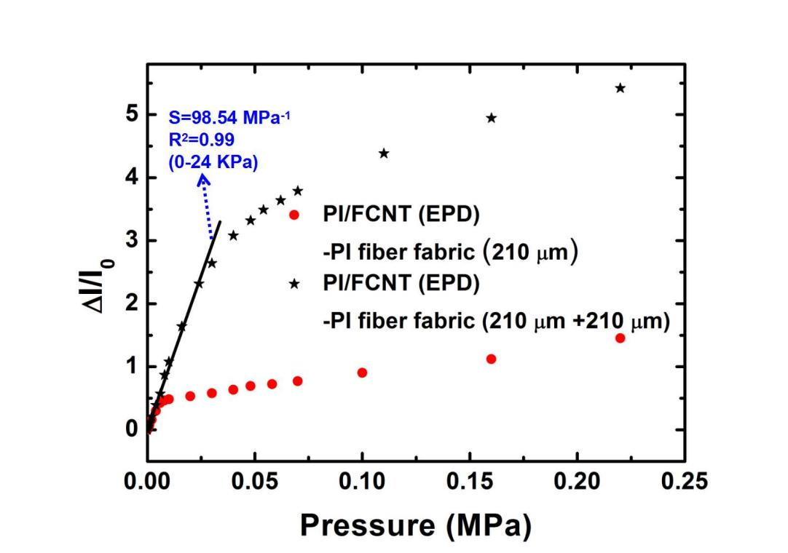
Figure S18. Relative current change vs. the pressure applied to the PI/FCNT (EPD) (210 μm) and PI/FCNT (EPD) (210 μm + 210 μm).
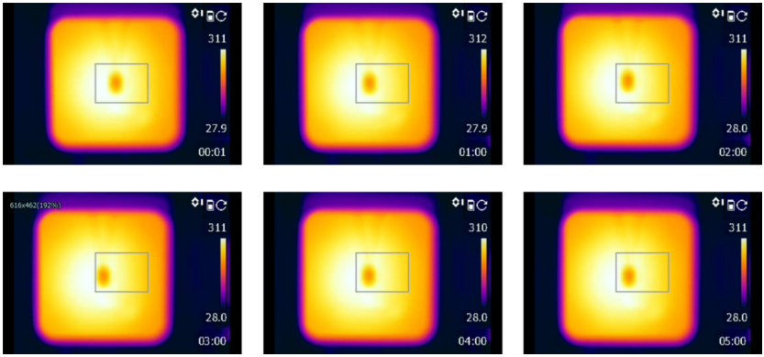
Figure S19. Infrared thermal imaging images of the PI/FCNT (EPD) pressure sensor during a heating period of 5 min.
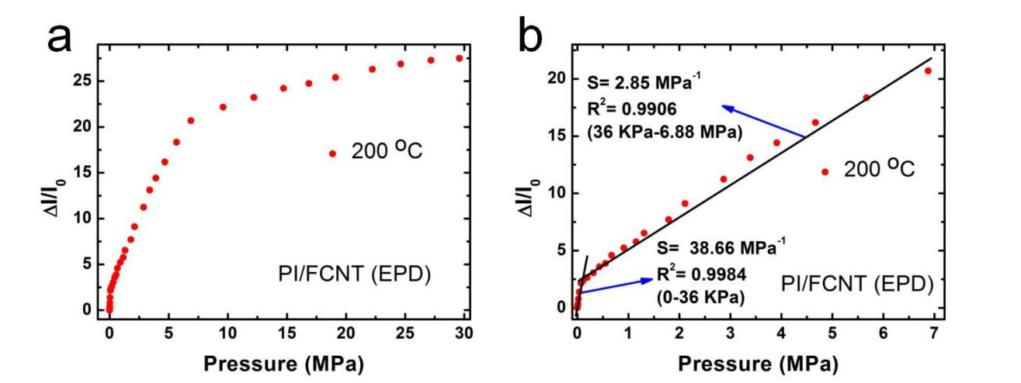
Figure S20. (a) Current response of the PI/FCNT(EPD) pressure sensors under 200 ºC. (b) Plots of current variation versus pressures from 0 to 6.88 MPa.
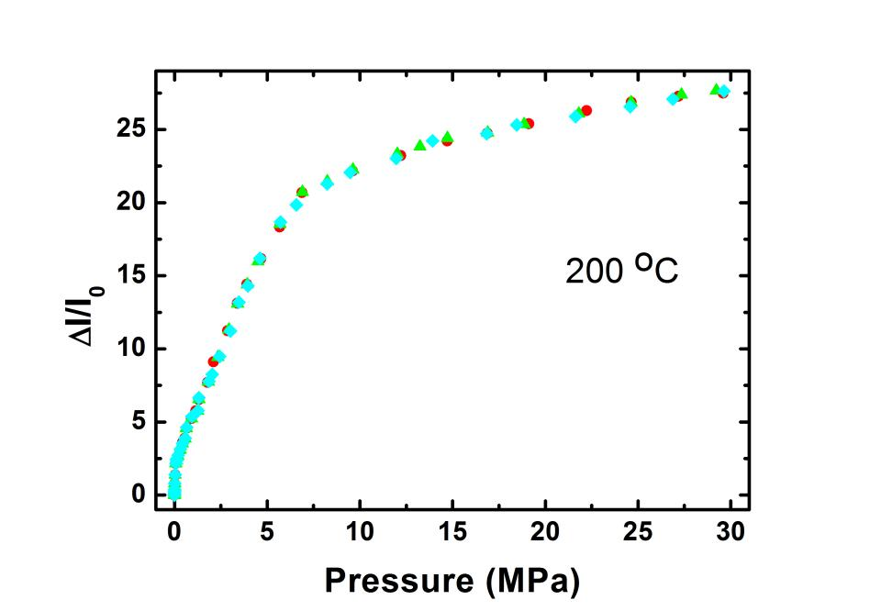
Figure S21. Current response of the PI/FCNT(EPD) pressure sensors under 200 ºC (three times).

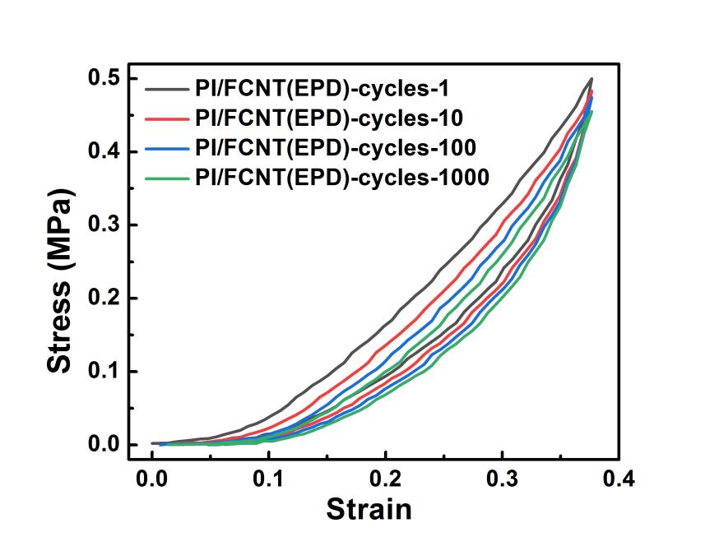
Figure S22. Cyclic compressive stress-strain curves of PI/FCNT(EPD) (room temperature).
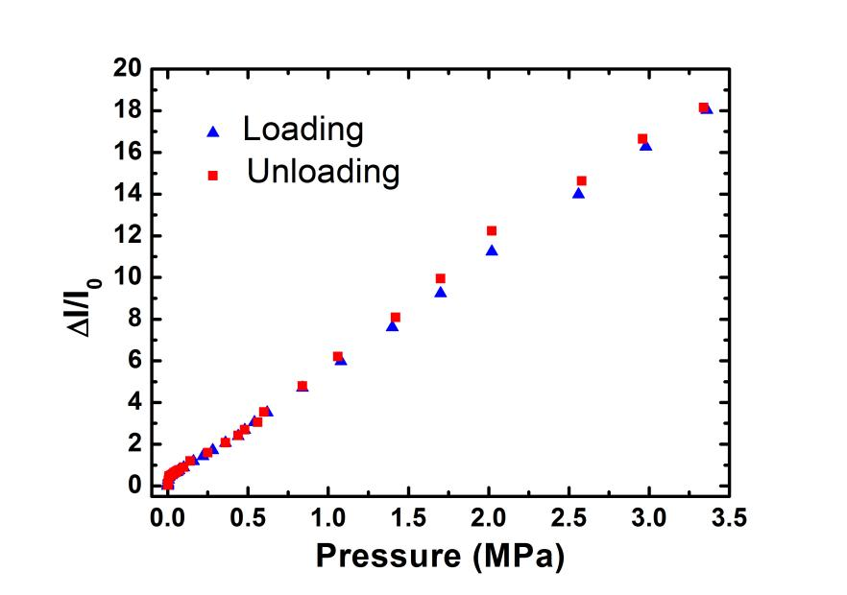
Figure S23. Electrical hysteresis of the fabricated PI/FCNT (EPD) pressure sensor obtained during its continuous loading and unloading process.
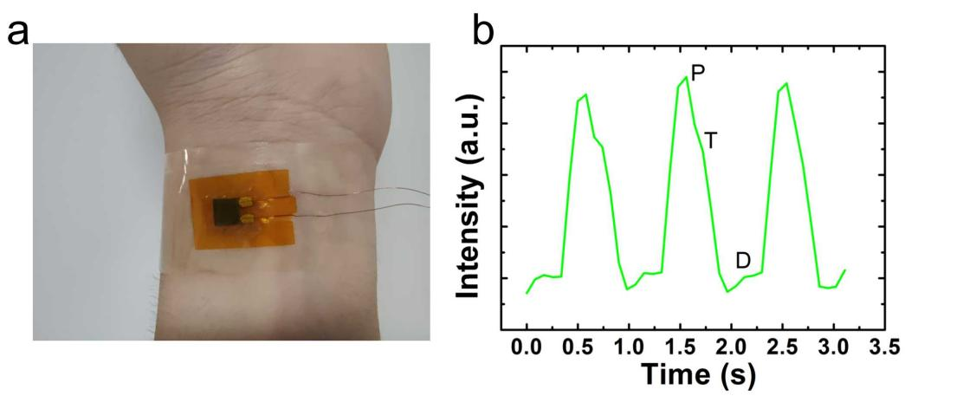
Figure S24. (a) Photograph of the PI/FCNT (EPD) pressure sensor attached to the wrist dermal area for monitoring the pulse pressure. (b) Real-time recording of the radial artery blood pressure waveform.

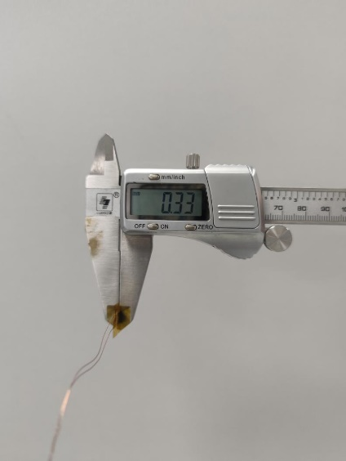
Figure S25. Optical image of the encapsulated PI/FCNT (EPD) pressure sensor. The thickness is 0.33 mm.

Table 1. Comprehensive performance comparison of the recently reported high-performance pressure sensors and our proposed PI/FCNT(EPD) pressure sensor.

