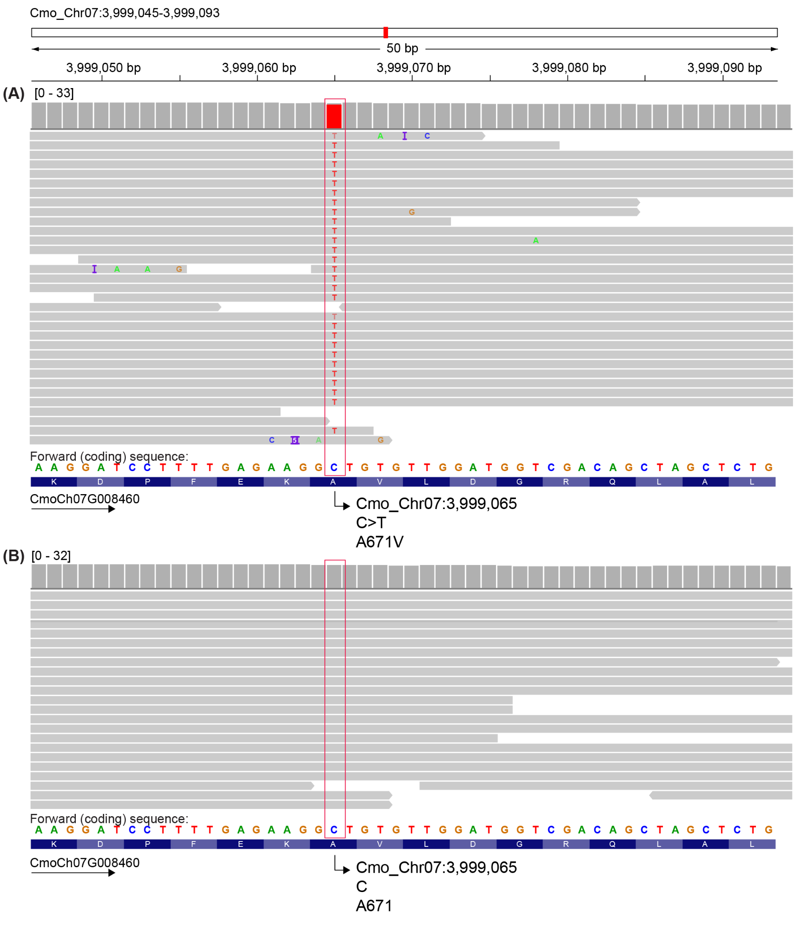
Figure S1: An Integrative Genomics Viewer (IGV) screenshot of whole genome resequencing reads (horizontal grey bars) from C. moschata accession (A) PVR-1343 (SRR19413398) which is resistant to SLCCNV and ToLCNDV and (B) P-135 (SRR19413397), which is susceptible, aligned to the C. moschata variety Rifu (v1) genome, zoomed in on CmPOLD1.
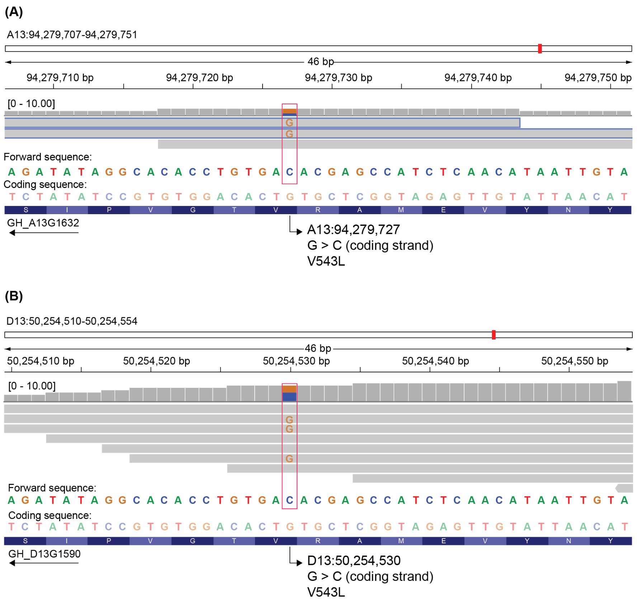
Figure S2: An Integrative Genomics Viewer (IGV) screenshot of RNA-seq reads (horizontal grey bars) from G. hirsutum accession Mac7 (SRR3067747) aligned to version 2 of the TM-1 reference genome, zoomed in on GhPOLD1 on (A) chromosome A13 and (B) chromosome D13. The heterozygous polymorphism C>G on the forward strand (G>C on the coding strand) at position A13:94,279,727 and D13:50,254,530 is highlighted with a red box. The two reads outlined in blue in (A) definitively align to A13 while the remaining reads match both copies. The mutation results in an amino acid change of V543L.
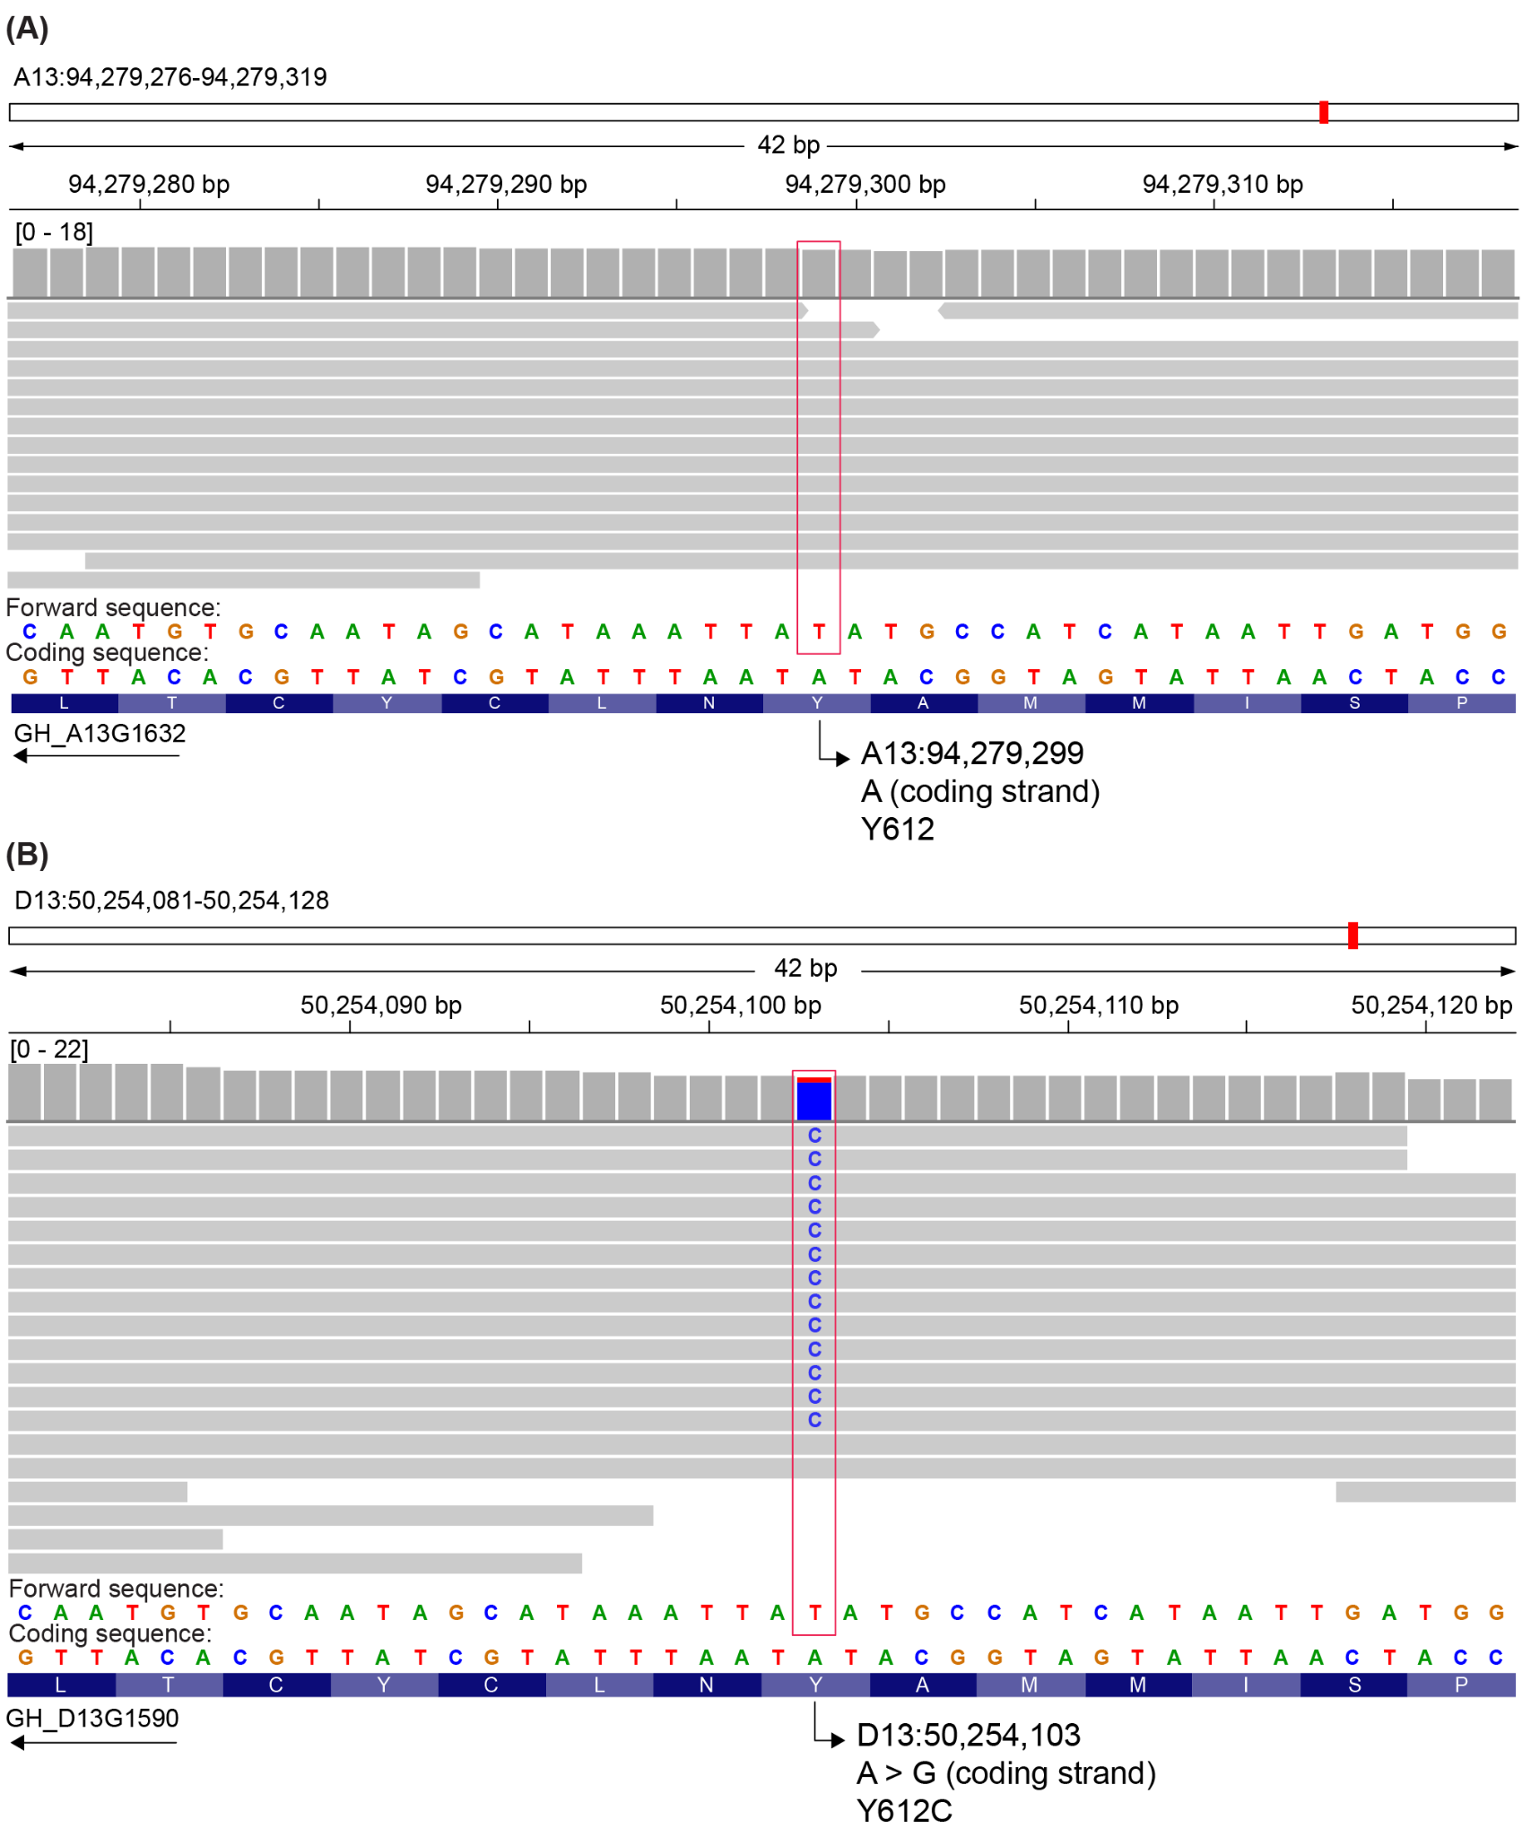
Figure S3: An Integrative Genomics Viewer (IGV) screenshot of whole genome resequencing reads (horizontal grey bars) from G. hirsutum accession NN-3 (SRR22581629) aligned to version 2 of the TM-1 reference genome, zoomed in on GhPOLD1 on (A) chromosome A13 and (B) chromosome D13.

