accuracy of information collection[16-22].

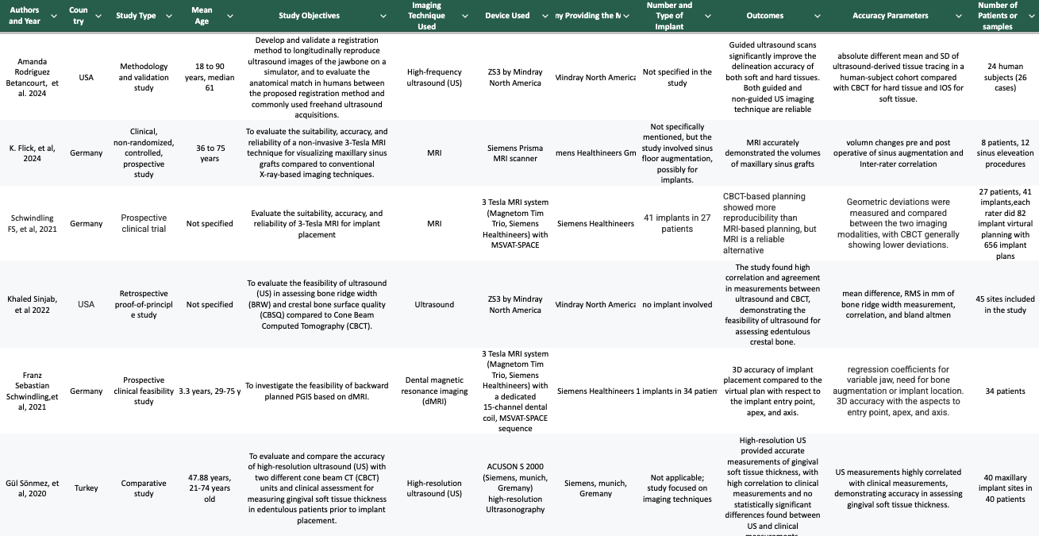

Table 1: Characteristics of included studies
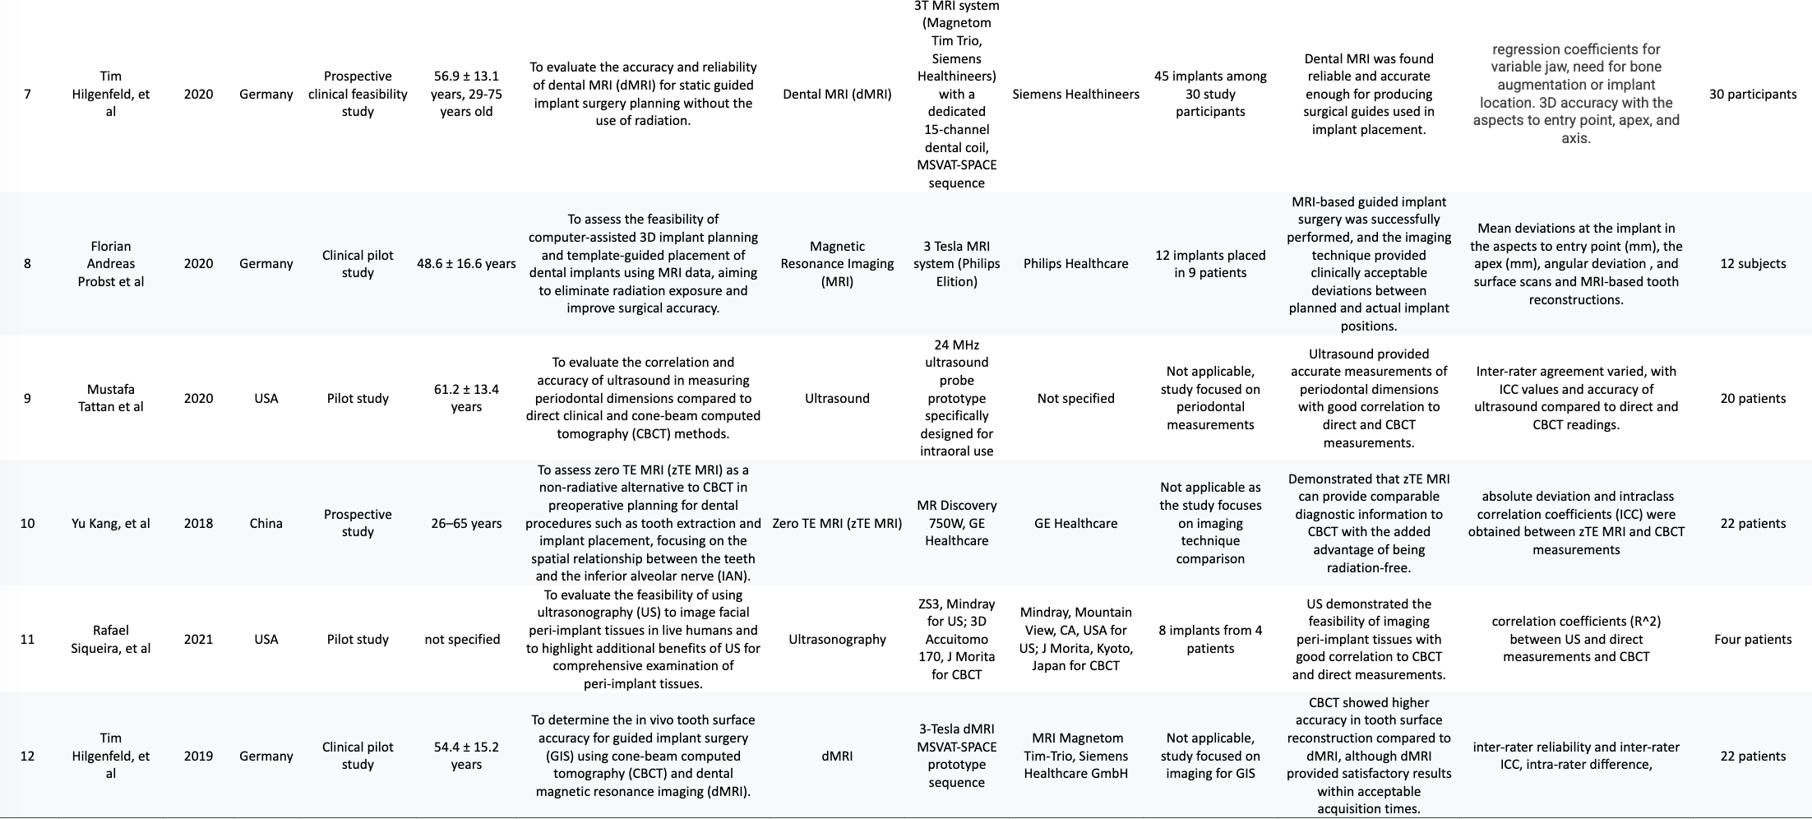
Table 1: Characteristics of included studies

