Supplementary material
Supplementary Table 1: List of the genotypes used, including their corresponding anonymization number, country-specific registration, associated breeder, registration type, and annuality. Wibo = Winter faba bean, Hvc = high vicin content, NPZ =Norddeutsche Pflanzenzucht Hans-Georg Lembke KG. Additional information regarding the genotypes was provided by the NPZ. “Not available” refers to missing information in the EU Database of Registered Plant Varieties (2024).
Anonymization | Country of registration | Breeder | Registration | Annuality | Additional Information
13 | not available | not available | not available | not available | not available
44 | not available | not available | not available | not available | not available
12 | not available | not available | not available | not available | not available
24 | not available | not available | not available | not available | not available
40 | not available | not available | not available | not available | not available
49 | not available | not available | not available | not available | not available
33 | not available | not available | not available | not available | not available
19 | not available | not available | not available | not available | not available
29 | not available | not available | not available | not available | not available
11 | not available | not available | not available | not available | not available
41 | not available | not available | not available | not available | not available
10 | not available | NPZ | not available | not available. | 1980er
8 | Switzerland | not available | Expired | Spring | Elite 1980er
42 | Germany | NPZ | Registered | Spring | not available
39 | Germany | not available | Expired | Spring | Elite DDR
7 | Germany | not available | Registered | Spring | not available
31 | Germany | NPZ | Registered | Spring | not available
55 | not available | not available | not available | not available | not available
38 | not available | not available | not available | not available | Elite
21 | not available | NPZ | not available | not available | Elite
17 | Germany | NPZ | Registered | No Annuality | not available
47 | Germany | not available | not available | not available | DDR-Elite
20 | Germany | NPZ | Expired | Spring | Elite
43 | Germany | NPZ | Expired | Spring | not available
6 | not available | not available | not available | not available | Elite
26 | Germany | not available | not available | not available | Elite Wibo
37 | Germany | not available | not available | not available | Elite, HVC
52 | Germany | not available | not available | not available | Elite
54 | Germany | not available | Registered | Winter | Sublinie
1 | Ireland | NPZ | Expired | Spring | not available
56 | not available | not available | Expired | Spring | 1980er
2 | not available | not available | not available | not available | Elite 1970er
9 | not available | not available | Registered | No Annuality | not available
34 | Danmark | NPZ | Registered | Spring | not available
53 | Germany | NPZ | Registered | Spring | not available
36 | Germany | NPZ | Registered | Spring | not available
25 | Germany | NPZ | Expired | Spring | not available
15 | not available | not available | Expired | Spring | not available
51 | not available | not available | not available | not available | not available
23 | not available | not available | not available | not available | Elite
48 | not available | not available | not available | not available | Wibo
22 | not available | not available | not available | not available | Elite
3 | not available | NPZ | not available | not available | Elite
16 | not available | NPZ | not available | not available | Elite, HVC
5 | not available | NPZ | not available | not available | Elite Wibo
30 | not available | not available | Registered | No Annuality | not available
46 | Germany | NPZ | Expired | Spring | not available
50 | not available | not available | not available | not available | not available
18 | not available | not available | Registered | Spring | not available
28 | Germany | NPZ | Registered | Spring | not available
4 | not available | not available | Registered | Winter | Elite Winter
35 | not available | not available | not available | not available | Cebeco Elite 1990
32 | France | NPZ | Registered | Spring | not available
45 | not available | not available | not available | not available | not available
14 | Germany | NPZ | Registered | Spring | not available
27 | not available | not available | not available | not available | not available
Supplementary Table 2: List of nutrient salts applied per container for the first (19 days after sowing) and second fertilization event (35 days after sowing)
 | First application (19 DAS) |  |  | Second application (35 DAS)
Nutrient Salt | Nutrient Salt for 310 Container [g] | Nutrient Salt per Container [g] | Nutrient [%] | Nutrient Salt for 310 Container [g] | Nutrient Salt per Container [g] | Nutrient [%]
Ammonium molybdate | 3,04 | 0,01 | 54,44
Mangansulfat monohydrat | 50,87 | 0,16 | 32,5
Zinc sulfate | 145,41 | 0,47 | 22,74
Copper sulfate | 32,48 | 0,10 | 25,45
Boric acid | 18,92 | 0,06 | 17,48
Potassium dihydrogen phosphate | 953,41 | 3,08 | 22,76 | 953,41 | 3,08 | 22,76
Magnesium sulfate | 767,62 | 2,48 | 20,19
Potassium chloride |  |  |  | 851,16 | 2,74 | 52,45

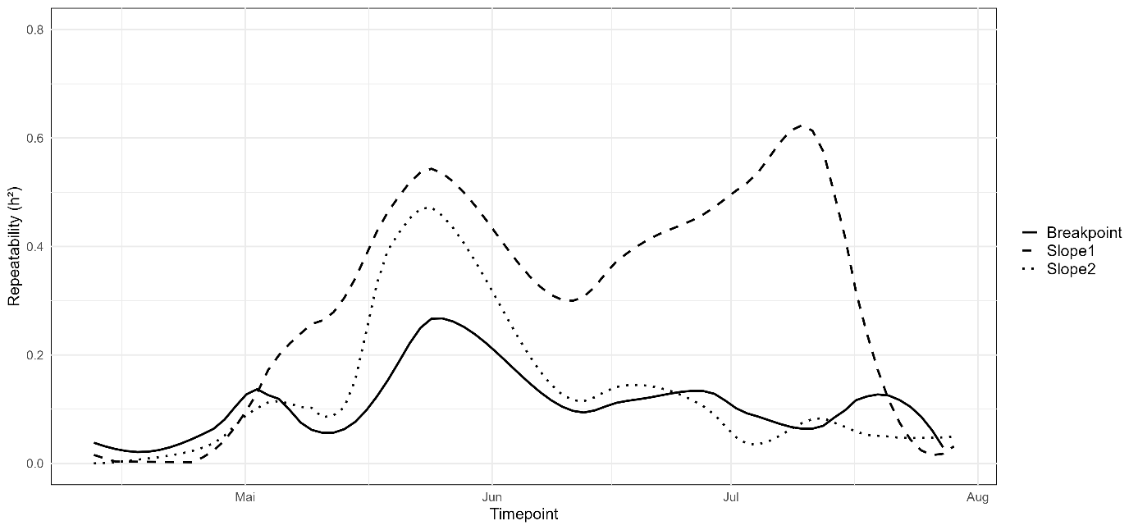
Supplementary Figure 1: Temporal variation in repeatability (h²) for the breakpoint, slope1, and slope2 parameters. The curves were generated using ggplot2 with a local smoothing function (geom_smooth, se = FALSE, span = 0.3)
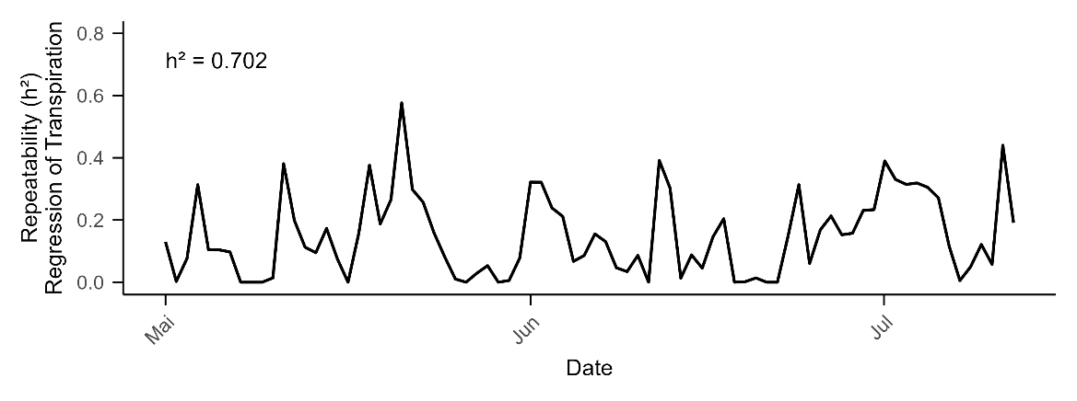
Supplementary Figure 2: Temporal variation in repeatability (h²) for the regression of transpiration during nighttime. The curve was generated using ggplot2 with a local smoothing function (geom_smooth, se = FALSE, span = 0.1)

