Supplementary information
Land use and mineral type jointly control stability of newly formed mineral-associated organic matter
De Shorn E. Bramble^{1,2*}, Ingo Schöning¹, Luise Brandt³, Christian Poll³, Ellen Kandeler³, Susanne Ulrich⁴, Robert Mikutta⁴, Christian Mikutta⁵, Whendee L. Silver⁶, Kai Uwe Totsche², Klaus Kaiser⁴, Marion Schrumpf^{1*}
¹ Max Planck Institute for Biogeochemistry, Jena, Germany
² Department of Hydrogeology, Institute for Geosciences, Friedrich Schiller University Jena, Jena, Germany
³ Department of Soil Biology, Institute of Soil Science and Land Evaluation, University of Hohenheim, Stuttgart, Germany
⁴ Soil Science and Soil Protection, Martin Luther University Halle-Wittenberg, Halle (Saale), Germany
⁵ Soil Mineralogy, Institute of Earth System Sciences, Gottfried Wilhelm Leibniz University Hannover, Hannover, Germany
⁶ Department of Environmental Science, Policy, and Management, University of California Berkeley,
Berkeley, CA, United States of America

Correspondence

*De Shorn E. Bramble (dbramble@bgc-jena.mpg.de ; debramble@gmail.com)

*Marion Schrumpf (mschrumpf@bgc-jena.mpg.de)

S1: Supplementary data

Table S1 Concentration of carbon, nitrogen, and phosphorus and the C: N ratios and C: P ratios on the field-exposed minerals as affected by study region (‘blocking factor’), land use, mineral type, and the interaction between land use and mineral type. Values are means with standard deviations. OC (organic C); TN (total nitrogen); TP (total phosphorus); NA (not applicable). Statistically significant effects (P < 0.05) are bold. Marginally significant effects (0.05 > P < 0.1) effects are in italics. Within each mineral type, different lowercase letters indicate significant differences (P < 0.05) between land use.
Treatments |  | Parameter
 |  | g kg⁻¹ dry sample
Mineral | Land use | #OC | #TN | #TP | #C:N ratio | #C:P ratio
Goethite | Forest | 2.51±1.2a | 0.19±0.05b | 0.13±0.03b | 13.2±3.9a | 19.4±8.5a¥
Goethite | Grassland mineral | 2.31±0.6a | 0.23±0.05a | 0.17±0.07a | 10.3±1.4b | 14.4±3.5b
Goethite | Grassland organic | 2.24±1.0a | 0.22±0.07ab | 0.14±0.03b | 9.98±1.5b | 15.9±6.0ab
Illite | Forest | 0.74±0.3a | 0.11±0.02b | 0.12±0.01a | 6.55±1.8a¥ | 6.20±2.2a
Illite | Grassland mineral | 0.73±0.1a | 0.13±0.02a | 0.13±0.02a | 5.79±0.7b | 5.90±1.4a
Illite | Grassland organic | 0.69±0.2a | 0.11±0.02ab | 0.13±0.01a | 5.92±1.1b | 5.52±1.9a
F-value
Region |  | 1.57 | §1.032 & 0.487 | 9.92 | §2.69 & 1.65 | 0.611
Land use (L) |  | 1.63 | §3.980 & 5.55 | 12.2 | §11.3 & 3.60 | 2.35
Mineral (M) |  | 368 | NA | 22.2 | NA | 288
L:M interaction |  | 0.128 | NA | 2.68 | NA | 1.40
P-value
Region |  | 0.212 | §0.362 & 0.617 | <0.001 | §0.076 & 0.200 | 0.544
Land use (L) |  | 0.200 | §0.024 & 0.006 | <0.001 | §<0.001 & 0.033 | 0.099
Mineral (M) |  | <0.001 | NA | <0.001 | NA | <0.001
L:M interaction |  | 0.880 | NA | 0.072 | NA | 0.251
§A separate ANOVA was performed for each mineral. P values are quoted for goethite and illite, respectively.
¥ Denotes a marginally significant effect (0.05 > P < 0.1)
#Variables were log transformed before running the ANOVA. Note, however, that the untransformed data are presented in the table.
Degrees of freedom for when minerals are analysed together—region: 2, land use (L): 2, Mineral (M): 1, L:M interaction: 2, Residuals: 128
Degrees of freedom for when minerals are analysed separately—region: 2, land use (L): 2, Residuals: 63
Means are quoted with standard devitations

It should be noted that unlike goethite, where the concentration of inorganic N was negligible, illite samples likely contained inorganic N in the form of NH₄⁺ fixed in the mineral’s interlayer. For this reason, we caution using the C:N ratio to indicate potential differences in the quality of OM that accumulated on the two minerals

Table S2 ANOVA F values, P values and effect sizes for the effects of region, land use, mineral type, and the interaction between land use and mineral type on various properties of the field-exposed mineral samples. Statistically significant effects (P < 0.05) are bold. Marginally (0.05 >P < 0.1) significant effects are in italics. MAOM-C (mineral-associated organic C); GP:GN ratio (gram-positive:gram-negative bacteria ratio); qCO₂ (PLFA-normalised CO₂ release; metabolic quotient).
 | Factor
 | Region |  |  |  | Land use |  |  | Mineral |  |  | L:M interaction
Parameter | F | P-value | Cohen's F | F | P-value | Cohen's F | F | P-value | Cohen's F | F | P-value | Cohen's F
MAOM-C accumulation | 1.44 | 0.243 | 0.15 | 1.29 | 0.276 | 0.14 | 366 | <0.001 | 1.69 | 0.317 | 0.718 | 0.07
Mineralisability | 2.76 | 0.067 | 0.21 | 40.5 | <0.001 | 0.80 | 117 | <0.001 | 0.96 | 3.66 | 0.028 | 0.24
Extractability | 43.9 | <0.001 | 0.83 | 29.3 | <0.001 | 0.68 | 40.5 | <0.001 | 0.56 | 4.58 | 0.012 | 0.27
PLFA:MAOC | 4.35 | 0.015 | 0.26 | 10.5 | <0.001 | 0.41 | 87.1 | <0.001 | 0.83 | 0.967 | 0.383 | 0.12
Fungi:bacteria | 12.8 | <0.001 | 0.45 | 9.53 | <0.001 | 0.39 | 0.185 | 0.668 | 0.04 | 2.91 | 0.058 | 0.21
GP:GN bacteria | 8.94 | <0.001 | 0.37 | 26.9 | <0.001 | 0.65 | 0.428 | 0.514 | 0.06 | 1.02 | 0.365 | 0.13
qCO2 | 1.41 | 0.249 | 0.15 | 50.7 | <0.001 | 0.89 | 1.54 | 0.217 | 0.11 | 0.485 | 0.617 | 0.09
Vector length | 0.038 | 0.963 | 0.02 | 70.9 | <0.001 | 1.05 | 0.047 | 0.828 | 0.02 | 5.43 | 0.005 | 0.29
Vector angle | 6.68 | 0.002 | 0.32 | 15.4 | <0.001 | 0.49 | 58.6 | <0.001 | 0.68 | 10.7 | <0.001 | 0.41
Degrees of freedom—region: 2, land use (L): 2, Mineral (M): 1, L:M interaction : 2, Residuals: 128
Interpretation of Cohen’s F (partial) effect sizes:
0.10 = Small effect size, 0.25 = Medium effect size, and 0.40 = Large effect size¹ .
#Variables were log-transformed before running the ANOVA.

Table S3 Extracellular enzyme activity on the field-exposed mineral samples as affected by study region, land use, mineral type, and the interaction between land use and mineral type. Statistically significant effects (P < 0.05) are bold. Values are means with standard deviations. Marginally significant effects (0.05 > P < 0.1) effects are in italics. Within each mineral type, different lowercase letters indicate significant differences (P < 0.05) between land use. BG (β-glucosidase); XYL (β-xylosidase); NAG (N-acetyl-β-glucosaminidase); AP (acid phosphatase).
Treatments |  | Parameter
 |  | nmol g⁻¹ dry sample h⁻¹
Mineral | Land use | #BG | XYL | #NAG | AP
Goethite | Forest | 41.8±31b | 19.4±17b | 76.9±73a | 629±268a
Goethite | Grassland mineral | 84.5±60a | 40.1±18a | 71.6±57a | 481±195b
Goethite | Grassland organic | 87.7±42a | 48.9±23a | 72.0±32a | 508±194b
Illite | Forest | 10.3±5.5ab | 1.52±1.3a | 24.6±26a | 75.5±38a
Illite | Grassland mineral | 13.4±4.0a | 3.37±2.2a | 11.1±5.1b | 39.7±25.2a
Illite | Grassland organic | 11.0±17b | 1.52±1.7a | 6.24±2.4b | 7.92±10.6a
F-value
Region |  | 1.31 | 2.88 | 2.71 | 0.106
Land use (L) |  | 12.8 | 13.4 | 7.21 | 5.08
Mineral (M) |  | 244 | 176 | 172 | 302
L:M interaction |  | 7.66 | 13.0 | 6.53 | 1.65
P-value
Region |  | 0.273 | 0.060 | 0.071 | 0.899
Land use (L) |  | <0.001 | <0.001 | 0.001 | 0.008
Mineral (M) |  | <0.001 | <0.001 | <0.001 | <0.001
L:M interaction |  | <0.001 | <0.001 | 0.002 | 0.197

Degrees of freedom—region: 2, land use (L): 2, Mineral (M): 1, L:M interaction : 2, Residuals: 128
#Variables were log transformed before running the ANOVA. Note, however, that the untransformed data are presented in the table.
Means are quoted with standard devitations

Table S4 Microbial biomass (PLFA) standardised extracellular enzyme activity on the field-exposed mineral samples as affected by study region, land use, mineral type, and the interaction between land use and mineral type. Values are means with standard deviations. Statistically significant effects (P < 0.05) are bold. Marginally significant effects (0.05 > P < 0.1) effects are in italics. Within each mineral type, different lowercase letters indicate significant differences (P < 0.05) between land use. BG (β-glucosidase); XYL (β-xylosidase); NAG (N-acetyl-β-glucosaminidase); AP (acid phosphatase); PLFA (phospholipid fatty acids)

Treatments |  | Parameter
 |  | h⁻¹
Mineral | Land use | #BG:PLFA | #XYL:PLFA | #NAG:PLFA | AP:PLFA
Goethite | Forest | 9.78±4.6c | 4.70±3.2c | 18.9±15b | 431±171ab
Goethite | Grassland mineral | 23.4±18b | 11.4±8.5b | 23.2±34ab | 311±174b
Goethite | Grassland organic | 64.4±59a | 33.7±29a | 50.6±47a¥ | 651±299a
Illite | Forest | 4.43±2.2a | 0.65±0.6a | 10.0±9.2a | 23.2±13.0a
Illite | Grassland mineral | 5.82±2.3a | 1.64±1.7a | 4.64±2.3b | 12.8±8.22a
Illite | Grassland organic | 8.97±14a | 1.25±1.3a | 5.16±1.8ab | 4.65±6.17a
F-value
Region |  | 4.04 | 3.19 | 5.85 | 2.04
Land use (L) |  | 20.8 | 19.2 | 2.51 | 3.52
Mineral (M) |  | 128 | 49.0 | 88.3 | 140
L:M interaction |  | 9.76 | 20.1 | 7.83 | 5.46
P-value
Region |  | 0.020 | 0.045 | 0.004 | 0.135
Land use (L) |  | <0.001 | <0.001 | 0.085 | 0.033
Mineral (M) |  | <0.001 | <0.001 | <0.001 | <0.001
L:M interaction |  | <0.001 | <0.001 | <0.001 | 0.005

Degrees of freedom—region: 2, land use (L): 2, Mineral (M): 1, L:M interaction : 2, Residuals: 128
¥ Denotes a marginally significant effect (0.05 > P < 0.1)
#Variables were log transformed before running the ANOVA. Note, however, that the untransformed data are presented in the table.
Means are quoted with standard devitations

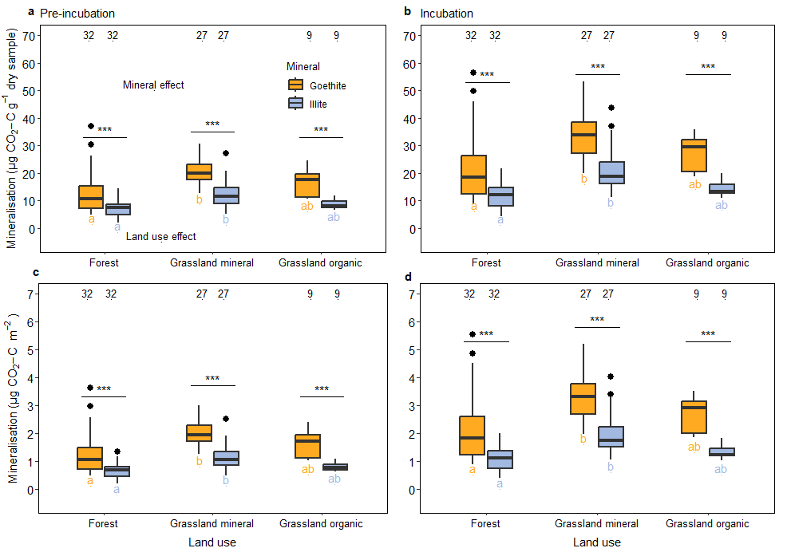

Fig. S1: Mineralisation of organic matter that accumulated on two different pristine minerals (goethite and illite) buried for five years at 5 cm depth in the topsoil of forests and grasslands in three regions across Germany. Values in Fig.s c and d are normalised to the specific surface area of the minerals. The number of replicates of independent samples is given at the top of each box plot. The horizontal line within the box plot represents the median. The ends of the boxes represent the first and third quartiles, and the whiskers show the interquartile range (IQR) from the first and third quartiles. Black dots outside the whisker (i.e., 1.5 × IQR) of the plot represent outliers. Statistical significance for the individual and interactive effect of land use and mineral type was tested using analysis of variance (ANOVA). Study region was considered as a ‘blocking’ factor in the ANOVA. ANOVA results : plot a) Region (df = 2), F = 2.00; Land use (df = 2), F = 22.7; Mineral (df = 1), F = 54.7; Land use:mineral interaction (df = 2), F = 0.894; residual df = 128; plot b) Region (df = 2), F = 2.18; Land use (df = 2), F = 24.5; Mineral (df = 1), F = 62.5; Land use:mineral interaction (df = 2), F = 0.427; residual df = 128; plot c) Region (df = 2), F = 1.95; Land use (df = 2), F = 22.4; Mineral (df = 1), F = 66.9; Land use:mineral interaction (df = 2), F = 1.13; residual df = 128; plot d) Region (df = 2), F = 2.17; Land use (df = 2), F = 23.9; Mineral (df = 1), F = 75.8; Land use:mineral interaction (df = 2), F = 0.625; residual df = 128. Statistical significance between means was determined using Tukey’s honest significant difference test . *** denotes a significant (P ≤ 0.001) difference between the two minerals with a given land use treatment. Within the same mineral type, different lowercase letters indicate a significant (P < 0.05) difference between land use treatments. Grassland mineral (grasslands on mineral soils); Grassland organic (grasslands on organic soils).

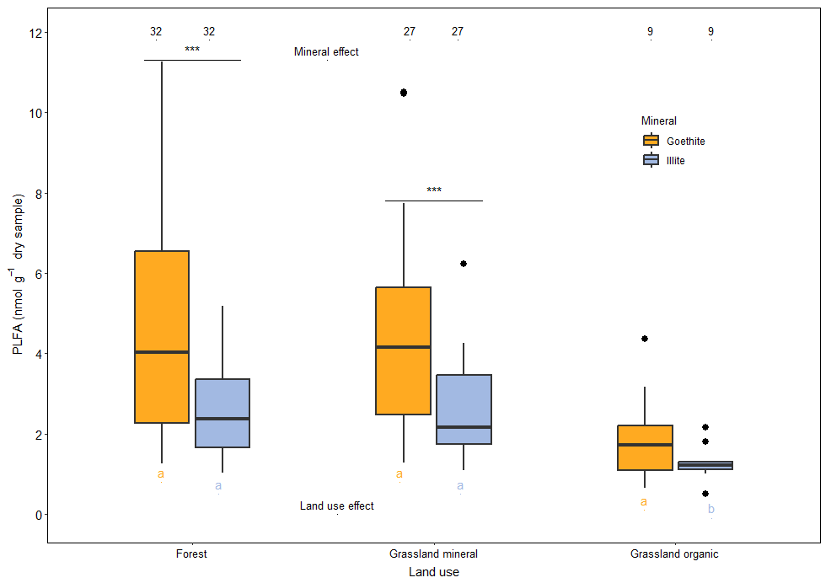

Fig. S2: Concentration of phospholipid fatty acids (PLFAs) on two different pristine minerals (goethite and illite) buried for five years at 5 cm depth in the topsoil of forests and grasslands in three regions across Germany. The horizontal line within the box plot represents the median. The ends of the boxes represent the first and third quartiles, and the whiskers show the interquartile range (IQR) from the first and third quartiles. Black dots outside the whisker (i.e., 1.5 × IQR) of the plot represent outliers. Statistical significance for the individual and interactive effect of land use and mineral type was tested using analysis of variance (ANOVA). Study region was considered as a ‘blocking’ factor in the ANOVA. ANOVA results : Region (df = 2), F = 1.08; Land use (df = 2), F = 15.9; Mineral (df = 1), F = 24.0; Land use:mineral interaction (df = 2), F = 0.169; residual df = 128 Statistical significance between means was determined using Tukey’s honest significant difference test . *** denotes a significant (P ≤ 0.001) difference between the two minerals with a given land use treatment. Within the same mineral type, different lowercase letters indicate a significant (P < 0.05) difference between land use treatments. Grassland mineral (grasslands on mineral soils); Grassland organic (grasslands on organic soils).

S2: Plot identification numbers, site conditions and experimental design

Table S5: Identification numbers and locations (latitude, longitude in decimal degrees) of plots from the Biodiversity Exploratories used in the current study

Study region | Land use | PlotID | Latitude | Longitude
ALB | Grassland | AEG1 | 48.39800501 | 9.34198675
ALB | Grassland | AEG2 | 48.37685727 | 9.47278412
ALB | Grassland | AEG3 | 48.40888148 | 9.53237875
ALB | Grassland | AEG4 | 48.38088845 | 9.41888912
ALB | Grassland | AEG5 | 48.39587586 | 9.43920071
ALB | Grassland | AEG6 | 48.40126215 | 9.44167811
ALB | Grassland | AEG7 | 48.39142098 | 9.37684713
ALB | Grassland | AEG8 | 48.42264028 | 9.49212459
ALB | Grassland | AEG9 | 48.39467093 | 9.50279238
ALB | Forest | AEW1 | 48.47807317 | 9.33441016
ALB | Forest | AEW2 | 48.37999048 | 9.35145064
ALB | Forest | AEW3 | 48.41226250 | 9.35559078
ALB | Forest | AEW4 | 48.39909865 | 9.24482734
ALB | Forest | AEW5 | 48.41961847 | 9.41468180
ALB | Forest | AEW6 | 48.39405132 | 9.44593671
ALB | Forest | AEW8 | 48.38258955 | 9.38238449
ALB | Forest | AEW9 | 48.36934576 | 9.41521762
ALB | Forest | AEW50 | 48.39211717 | 9.25444834
HAI | Grassland | HEG1 | 50.97164834 | 10.4053629
HAI | Grassland | HEG2 | 51.00074892 | 10.4300100
HAI | Grassland | HEG3 | 50.99809149 | 10.4329489
HAI | Grassland | HEG4 | 51.11336235 | 10.4361804
HAI | Grassland | HEG6 | 51.21493506 | 10.3912209
HAI | Grassland | HEG7 | 51.27358256 | 10.4104126
HAI | Grassland | HEG8 | 51.27125747 | 10.4179446
HAI | Grassland | HEG9 | 51.22389737 | 10.3807873
HAI | Grassland | HEG47 | 51.28420033 | 10.3719165
HAI | Forest | HEW1 | 51.18535508 | 10.3236211
HAI | Forest | HEW3 | 51.27164770 | 10.3107385
HAI | Forest | HEW4 | 51.36948156 | 10.5333275
HAI | Forest | HEW5 | 51.26387813 | 10.2409579
HAI | Forest | HEW6 | 51.26771983 | 10.2393783
HAI | Forest | HEW7 | 51.13109242 | 10.3854489
HAI | Forest | HEW8 | 51.35579218 | 10.5169674
HAI | Forest | HEW9 | 51.13024193 | 10.3811497
HAI | Forest | HEW10 | 51.08998735 | 10.4624339
HAI | Forest | HEW11 | 51.10283444 | 10.4008543
HAI | Forest | HEW12 | 51.10068810 | 10.4551830
HAI | Forest | HEW13 | 51.24264396 | 10.3129467
SCH | Grassland | SEG1 | 53.08742012 | 13.9696436
SCH | Grassland | SEG2 | 53.08930690 | 13.980047
SCH | Grassland | SEG3 | 53.10283431 | 13.9856996
SCH | Grassland | SEG4 | 53.11375419 | 14.0018711
SCH | Grassland | SEG5 | 53.10745266 | 14.0005237
SCH | Grassland | SEG6 | 53.10349527 | 13.6228333
SCH | Grassland | SEG7 | 53.08838274 | 13.9770687
SCH | Grassland | SEG8 | 53.11397068 | 14.0170996
SCH | Grassland | SEG9 | 53.09818193 | 13.6125669
SCH | Grassland | SEG 18 | 53.13730516 | 13.8756098
SCH | Grassland | SEG 30 | 53.14814127 | 13.8306805
SCH | Grassland | SEG 31 | 53.14908648 | 13.8354379
SCH | Grassland | SEG 33 | 52.98578547 | 13.8425130
SCH | Grassland | SEG 37 | 53.13492781 | 13.8760305
SCH | Grassland | SEG 39 | 52.98092391 | 13.8232870
SCH | Grassland | SEG 42 | 52.87067320 | 13.9688289
SCH | Grassland | SEG 46 | 52.97843781 | 13.8263321
SCH | Grassland | SEG 48 | 53.09720511 | 13.6066414
SCH | Forest | SEW1 | 52.90084729 | 13.8463669
SCH | Forest | SEW2 | 52.95172886 | 13.7780281
SCH | Forest | SEW3 | 52.92070744 | 13.6430016
SCH | Forest | SEW4 | 52.91734663 | 13.8473114
SCH | Forest | SEW5 | 53.05703356 | 13.8853662
SCH | Forest | SEW6 | 52.90744279 | 13.8416880
SCH | Forest | SEW7 | 53.10734802 | 13.6944189
SCH | Forest | SEW8 | 53.19179716 | 13.9303379
SCH | Forest | SEW9 | 53.04453521 | 13.8103280
SCH | Forest | SEW10 | 53.09109594 | 13.6378431
SCH | Forest | SEW35 | 52.91126795 | 13.8534188
Schwäbische Alb (ALB), Hainich-Dün (HAI), Schorfheide-Chorin (SCH)

More information on these plots can be obtained from the Biodiversity Exploratories Information System, BExIS (https://www.bexis.uni-jena.de/)

Table S6 Overview of climatic and pedo-geological properties of the three study regions (mean values across the plots with standard deviation). Abbreviations: MAT (mean annual air temperature in the years 2016–2020), MAP (mean annual precipitation in the years 2016–2020) grass.min (grasslands on mineral soils); grass.org (Schorfheide-Chorin grassland plots on organic soil); WRB (World Reference Base for Soil Resources)

 | Study region
Parameter | Schwäbische Alb | Hainich-Dün | Schorfheide-Chorin
Elevation (m a.s.l.) | 460-860 | 258-500 | 3-140
MAT (°C) | 8.2±0.7 | 9.2±0.7 | 9.7±0.6
MAP (mm) | 902±49 | 485±48 | 581±29
Parent material | Jurassic shell | Loess over triassic | Glacial till covered by glacio-fluvial
 | limestone | limestone | /aeolian sand
Typical soils (WRB) | Leptosols, Cambisols | Cambisols, Stagnosols | Histo- and Luvisols in grasslands
 |  | Luvisols | Cambisols in forest
#Clay (%) | 48.7±10 (forest) | 31.8±12 (forest) | 5.28±10(forest)
 | 54.2±11 (grass.min) | 47.4±9.2 (grass.min) | 12.2±6.1 (grass.min)
 |  |  | 17.0±5.0 (grass.org
#Sand (%) | 3.77±2.2 (forest) | 6.70±2.3 (forest) | 85.1±18(forest)
 | 6.63±5.5 (grass.min) | 5.34±1.4 (grass.min) | 57.4±21.5 (grass.min
 |  |  | 31.4±16 (grass.org)
Soil OC (g kg⁻¹) | 57.1±13(forest) | 37.6±17(forest) | 21.5±11(forest)
 | 75.0±17 (grass.min) | 40.9±12 (grass.min) | 27.6±5.7 (grass.min)
 |  |  | 152±103 (grass.org)
Soil C: N ratio  (-) | 13.5±1.4(forest) | 13.6±2.2(forest) | 18.5±2.8(forest)
 | 10.5±1.2 (grass.min) | 9.73±0.4 (grass.min) | 10.5±0.5 (grass.min)
 |  |  | 10.4±1.0 (grass.org)
#Soil pH | 5.44±1.0(forest) | 5.1±0.8(forest) | 3.69±0.7(forest)
 | 6.42±0.6 (grass.min) | 6.87±0.5 (grass.min) | 6.04±1 (grass.min)
 |  |  | 7.19±0.7 (grass.org)
#Mineralisation | 72.9±24 (forest) | 51.4±23(forest) | 23.0 ± 2.1(forest)
(µg CO₂-C g⁻¹) | 120±42 (grass.min) | 112±38 (grass.min) | 46.7±18.6(grass.min)
 |  |  | 150±57.3(grass.org)
#Mineralisability | 1.12±0.2 (forest) | 1.31±0.4(forest) | 1.11±0.1(forest)
(mg CO₂-C g SOC⁻¹) | 1.60±0.4 (grass.min) | 2.62±0.9(grasss.min) | 2.45±0.8 (grass.min)
 |  |  | 1.0±0.2 (grass.org)
# See below for details on the measurement of these properties
Means are quoted with standard deviations.

#Soil texture, potential soil OM Mineralisation, and soil pH measurement

Mineral soil samples in each site were taken in May 2011 and 2017. In the forest, 14 core samples of the upper 10 cm of the mineral soil were also taken along two 40 m transects with a split tube auger (diameter of 5 cm). In grasslands, we also took 14 core samples at 10 cm depth along 20 m transects. One composite sample was prepared for each plot in forests and grasslands. These samples were air-dried and sieved to <2 mm after the removal of visible roots. Soil textural, using the air-dried samples, was performed using the pipette method (DIN ISO 11277, 2002) on samples collected in 2011 (see Herold et al., 2014² for more details). Potential soil OM mineralisation was also determined on fresh samples taken during the 2011 sampling campaign. To do so, samples (70 g for each plot) were filled in 250-ml glass beakers and placed in 1-l glass jars with airtight lids and two stopcocks. The samples were adjusted to 60% water holding capacity and then pre-incubated for 4 days. After pre-incubation, the CO₂ concentration in the jar headspace was determined and it was purged with CO₂ free air. The relative humidity in the CO₂ free air was adapted to an ambient level by adding 5 ml of deionized water to the bottom of the glass jars. Soil samples were then incubated for 14 days at a constant temperature of 20 °C. The CO₂ release from soil was measured after 14 days on 0.6-1 ml aliquots headspace air by a LI-6262 CO₂/H₂O infrared gas analyzer (LI-COR-Environmental, Lincoln, Nebraska USA). Soil OM mineralisability was calculated by normalizing the cumulative CO₂ released over the 14-day incubation to the concentration of OC in the soil sample.

The pH of the mineral soil sample taken during the 2017 sampling campaign measured on 1:2.5 soil: 0.01 M CaCl₂ slurries using a calibrated pH meter (pH meter 538, WTW, Weilheim, Germany) after shaking for 1 h.
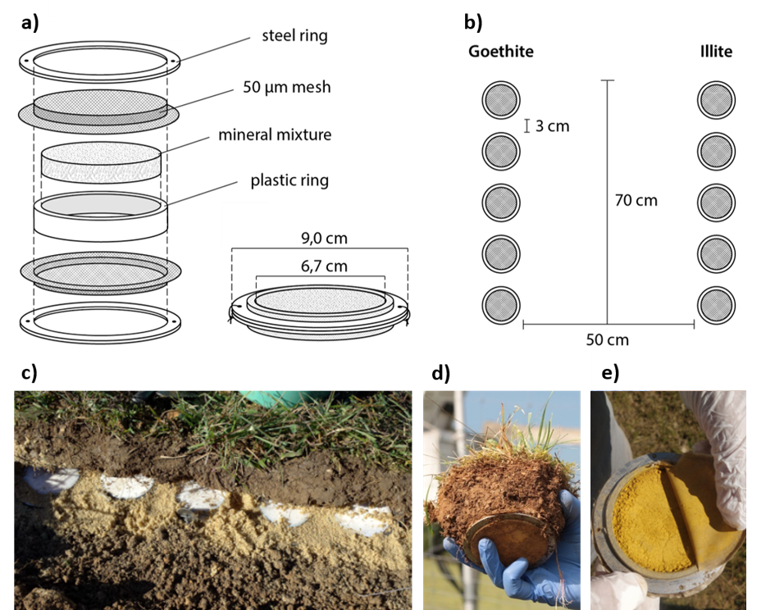

Fig. S3: (a) Setup and dimensions of a mineral container; (b) schematic top view of the mineral container placement in 5 cm soil depth; (c) photo of a row of minerals container on a sand bed during installation in 2015; (d) photo of sampling a mineral container and the surrounding soil; (e) photo of an opened mineral container (reprinted from Brandt et al., 2023^{.3} with the permission from Elsevier).

S3: Characterization of pristine minerals

Reactions

For pH determination, 10 g of pristine mineral was suspended in 25 ml of 0.01 M CaCl₂. The suspension was agitated for 1 hour on a horizontal shaker and centrifuged for 10 minutes at 2500 g, and the pH of the supernatant was then measured potentiometrically⁴. The concentration of acid oxalate extractable Al, Fe, Mn, and Si was determined according to Schwertmann (1964)^{.5} This entailed the extraction of 100 mg of material in 100 ml of 0.2 M NH₄ oxalate (pH 7) for 2 hours in the dark, followed by centrifugation at 2500 g for 20 minutes. The supernatants were passed through ash-free paper filters (Rotilabo 114A, Carl Roth GmbH, Karlsruhe, Germany), and Al, Fe, Mn, Si in the extracts were analysed by inductively coupled plasma−optical emission spectrometry (ICP−OES, Ultima 2, Horiba Jobin-Yvon, Longjumeau, France). The concentration of Al, Fe, and Mn in dithionite−citrate−bicarbonate extracts was also analysed by ICP-OES. For this extraction, 100 mg of material (for goethite 20 mg) was mixed with 40 ml 0.3 M Na citrate buffered to pH 8.3 with 10 ml 1 M NaHCO₃. One gram of Na₂S₂O₄ was then added to the suspension, before heating to 80 °C for 15 minutes. The suspension was centrifuged at 2500 g for 20 minutes and the supernatant was passed through an ash-free filter paper (Rotilabo 114A). The procedure was repeated with half the chemicals, and finally the residues (if any) were extracted with 25 ml of 0.05 M MgCl₂⁶. The specific surface area (SSA) of the minerals and quartz sand were calculated by applying the Brunnauer−Emmett−Teller (BET) to N₂ adsorption at 77 K at the relative pressure p/p₀ range of 0.05 to 0.35 (Autosorb IQ MP, Quantachrome Instruments, Boynton Beach, USA). Since N₂ gas cannot access the interlayer spaces of phyllosilicate clays, the BET method estimates the SSA of the external surfaces^{7, 8}. The point of zero charge (isoelectric point) of goethite was estimated by determining the electrophoretic mobility of suspended minerals by dynamic light scattering at different pH (Zetasizer Nano ZS, Malvern Panalytical, Malvern, UK).

Element concentrations

Total carbon and nitrogen concentrations of 800 mg sample aliquots was determined by dry combustion elemental analyser (Vario Max Cube, Elementar Analysensysteme GmbH, Langenselbold, Germany). Samples were also tested for inorganic carbon by treating ground 200 mg sample aliquots with 50 ml 2 M HCl at 50 °C and subsequent detection of the released CO₂ (soliTIC modul interfaced to Vario Max Cube, Elementar Analysensysteme GmbH, Langenselbold, Germany). Since none of the samples had detectable contents of inorganic carbon, total carbon was considered to represent exclusively organic carbon (organic C). Total element concentrations were determined by sequential wave length-dispersive X-ray fluorescence spectroscopy (S8 Tiger Series 2, Bruker AXS, Karlsruhe, Germany) using fused beads prepared with 1 g sample aliquots ashed at 1000 °C; analyses were corrected for loss of ignition (including losses of organic C) during ashing.

Cation exchange capacity (CEC) and exchangeable cations

Total cation exchange capacity was determined according to Hendershot et al. (2008). All binding sites available to cations at pH 7 were saturated by equilibrating 500 mg aliquots in 20 ml of 1 M NH₄ acetate (pH 7) solution for 1 hour. Excess NH₄⁺ was removed by rinsing with 20 ml of isopropanol. Ammonium ions bound to the mineral surfaces were then extracted by agitation for 1 hour with 20 ml 1 M KCl. Each of the aforementioned steps were repeated three times, with suspensions being centrifuged at 2500 g for 20 minutes, and supernatants passed through ash-free paper filters (Rotilabo 114A). The concentration of extracted NH₄⁺ was determined photometrically with a continuous flow analyser (SANplus, Skalar Analytical B.V., Breda, The Netherlands). Exchangeable cations were extracted by suspending 1 g aliquots of mineral material in 100 ml 1 M NH₄Cl; shaking horizontally for 60 minutes; and centrifuging at 2500 g for 20 minutes. The supernatants were passed through ash-free paper filters (Rotilabo 114A), and Al, Fe, Mn, Ca, Mg, K, Na in the extracts were analysed by inductively coupled plasma−optical emission spectrometry (ICP−OES, Ultima 2, Horiba Jobin-Yvon, Longjumeau, France). We calculated the Ca, Mg, K, Na saturation by dividing the sum of exchangeable Ca, Mg, K, Na by the total cation exchange capacity. Exchangeable ammonium was extracted by suspending 4 g aliquots of mineral material in 20 ml 1 M KCl; shaking horizontally for 60 minutes; and centrifuging at 2500 g for 20 minutes. The supernatants were then passed through ash-free paper filters (Rotilabo 114A), and NH₄⁺ in the extracts was analysed photometrically with a continuous flow analyser (SANplus, Skalar Analytical B.V., Breda, The Netherlands).

Table S7 Selected properties of pristine minerals goethite, illite, and sea sand: a) Reaction (pH in CaCl₂ solution); oxalate- and dithionite−citrate−bicarbonate (DCB)-extractable Al, Fe, and Mn (Al_{o}, Fe_{o}, Mn_{o} and Al_{d}, Fe_{d}, Mn_{d}, respectively), no oxalate-soluble Si and Mn detectable; specific surface area (SSA); point of zero charge (PZC); b) Element concentration (C:N analyser; X-ray fluorescence spectrometry), since no inorganic carbon was detectable, C represents organic C; c) Cation exchange capacity (CEC) and exchangeable cations; n.d. = not detectable; n.a.= not analysed.
a)
Sample | pH (CaCl₂) | Al_{o}  g kg^{–1} | Fe_{o}  g kg^{–1} | Al_{d}  g kg^{–1} | Fe_{d}  g kg^{–1} | Mn_{d}  g kg^{–1} | SSA (N₂-BET)  m² g^{–1} | PZC
Goethite | 7.3 | 0.17 | 1.82 | 1.36 | 614.52 | 0.28 | 20.4 | 7.8
Illite | 7.0 | 0.26 | 0.12 | n.d. | 0.25 | n.d. | 40.7 | n.a.
Sea sand | 6.7 | n.d. | n.d. | n.d. | n.d. | n.d. | 1.1 | n.a.

b)
Sample | C  g kg^{–1} | N  g kg^{–1} | C:N | Fe  g kg^{–1} | Mn  g kg^{–1} | Al  g kg^{–1} | Si  g kg^{–1} | K  g kg^{–1} | Mg  g kg^{–1} | Ca  g kg^{–1} | P  g kg^{–1}
Goethite | 0.40 | 0.19 | 2.1 | 613.49 | 0.46 | 2.15 | 0.24 | 1.00 | 0.28 | 0.36 | 0.12
Illite | 0.42 | 0.38 | 1.1 | 4.07 | 0.07 | 149.33 | 265.58 | 70.24 | 7.50 | 2.31 | 0.21
Sea sand | 0.10 | 0.04 | 2.5 | n.d. | 0.02 | 5.02 | 460.59 | 1.24 | 0.56 | 0.29 | 0.03

c)
Sample | CEC (pH 7)  mmol_{c} kg^{–1} | Al³⁺  mmol_{c} kg^{–1} | Fe³⁺  mmol_{c} kg^{–1} | Ca²⁺  mmol_{c} kg^{–1} | Mg²⁺  mmol_{c} kg^{–1} | K⁺  mmol_{c} kg^{–1} | Na⁺  mmol_{c} kg^{–1} | NH₄⁺  mmol_{c} kg^{–1} | Ca, Mg, K, Na saturation of CEC (pH 7)  %
Goethite | n.a. | n.a. | n.a. | n.a. | n.a. | n.a. | n.a. | n.a. | n.a.
Illite | 165.5 | <0.01 | 3.7 | 110.4 | 33.2 | 14.5 | 2.6 | 0.03 | >97
Sea sand | 4.8 | n.d. | n.d. | 3.5 | 0.4 | 0.5 | 0.4 | n.d. | 100

DOC sorption capacity

Sorption of dissolved organic C (DOC) was tested with leachate solutions (membrane-filtered to <0.45 µm, SUPOR-450, Pall Corp., Port Washington, NY, USA) from different source material (i.e., spruce Oa DOC, beech litter DOC, and ryegrass DOC). Increasing amounts of mineral material were added to pH-adjusted 50 ml aliquots of leachate solutions, suspensions were horizontally shaken for 18 hours, centrifuged at 2500 g for 20 minutes, and then passed through 0.45-µm membrane filters (SUPOR-450). Solutions were analysed for DOC using a multi N/C 3100 analyser (Analytik Jena AG, Jena, Germany), and sorbed amounts were calculated by the difference in concentrations of initial and equilibrium solutions. The results of this sorption experiment are presented in Fig. S4. In a similar manner we determined the DOC sorption capacity to goethite and illite across a pH gradient by adding DOC (spruce Oa) solutions that were adjusted to different pH. These results are presented in Fig. S5.

X-ray diffraction (XRD)

Powder diffractograms were collected in Bragg-Brentano geometry on a Bruker D8 Advance instrument equipped with a LYNXEYE XE-T detector. Scans (q-q) were collected at 0.006°2θ step size and 0.9 s/step measuring time using Cu K_{a} radiation (tube settings: 40 kV and 20 mA for illite and goethite, and 40 kV and 40 mA for sea sand). Samples were rotated (30 rpm) during measurements to minimise preferential orientation effects. Prior to measurements, illite and sea sand samples were ground (10 min) to <5 mm particle size using a McCrone micronizing mill. Diffractograms were background-corrected, stripped of K_{a2}, and analysed by the Match! v. 3.12 software utilizing the crystallographic open database (COD). These results are presented in Fig. S6.
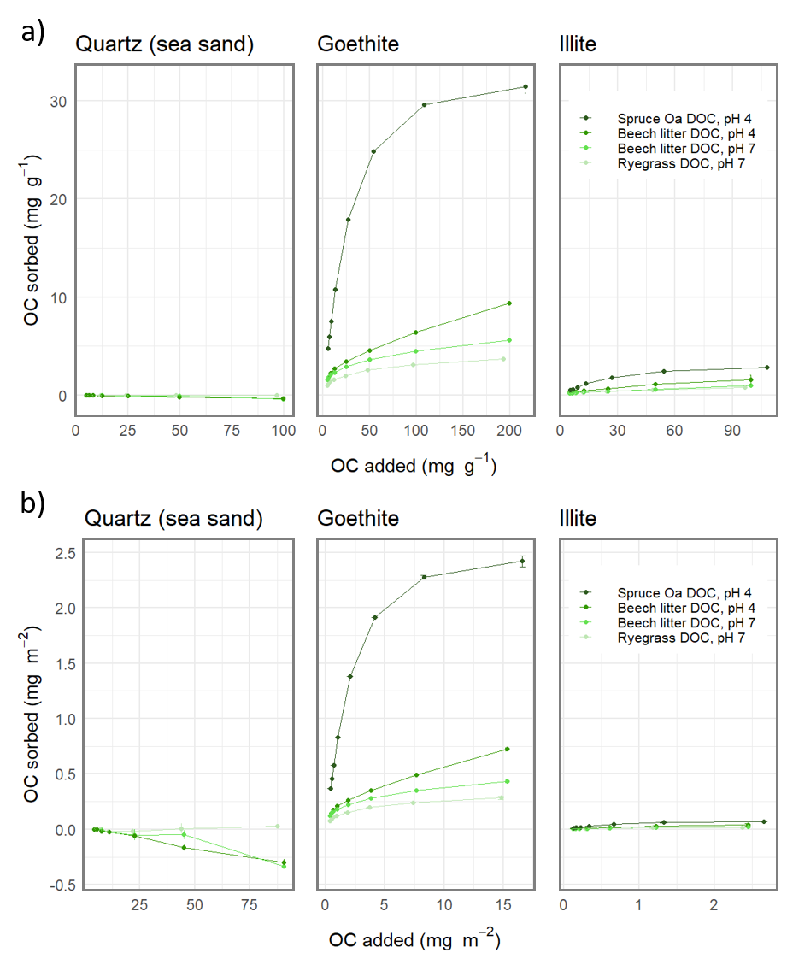
  - Fig. S4: Sorption of DOC from different sources to sea sand, goethite, and illite at different pH normalised to a) the weight, b) the specific surface area (SSA) of the respective mineral. Since the SSA of the sea sand is very small, values fluctuating around zero when normalised to the weight appear improbably large when normalised to the SSA.
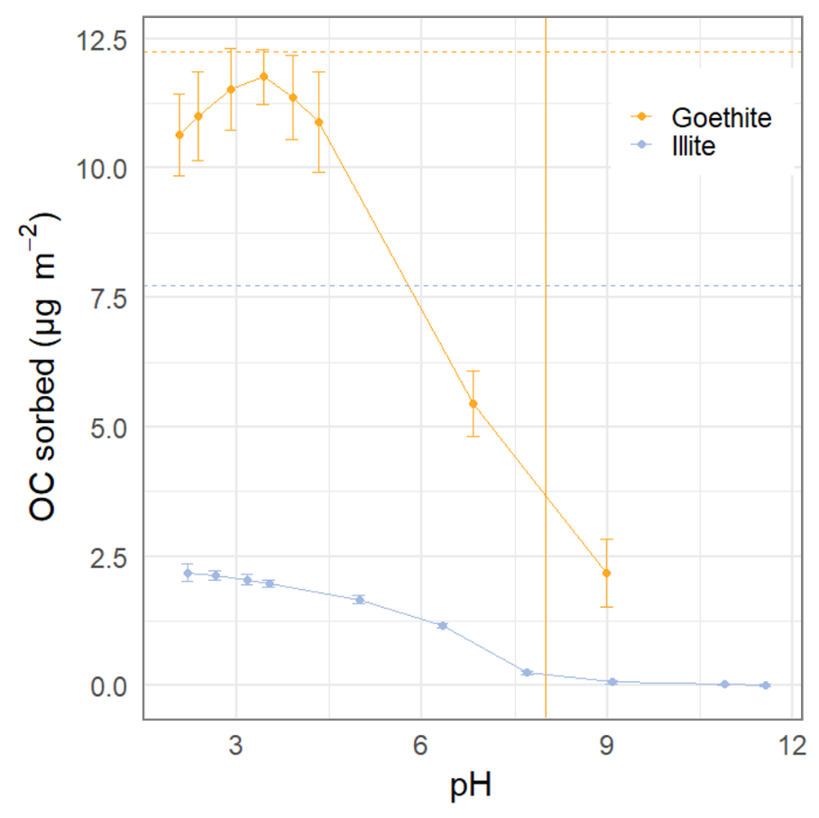
  - Fig. S5: Sorption of DOC from the Oa horizon of a spruce forest to goethite and illite at differing pH. The orange vertical line depicts the point of zero charge (PZC) of goethite.
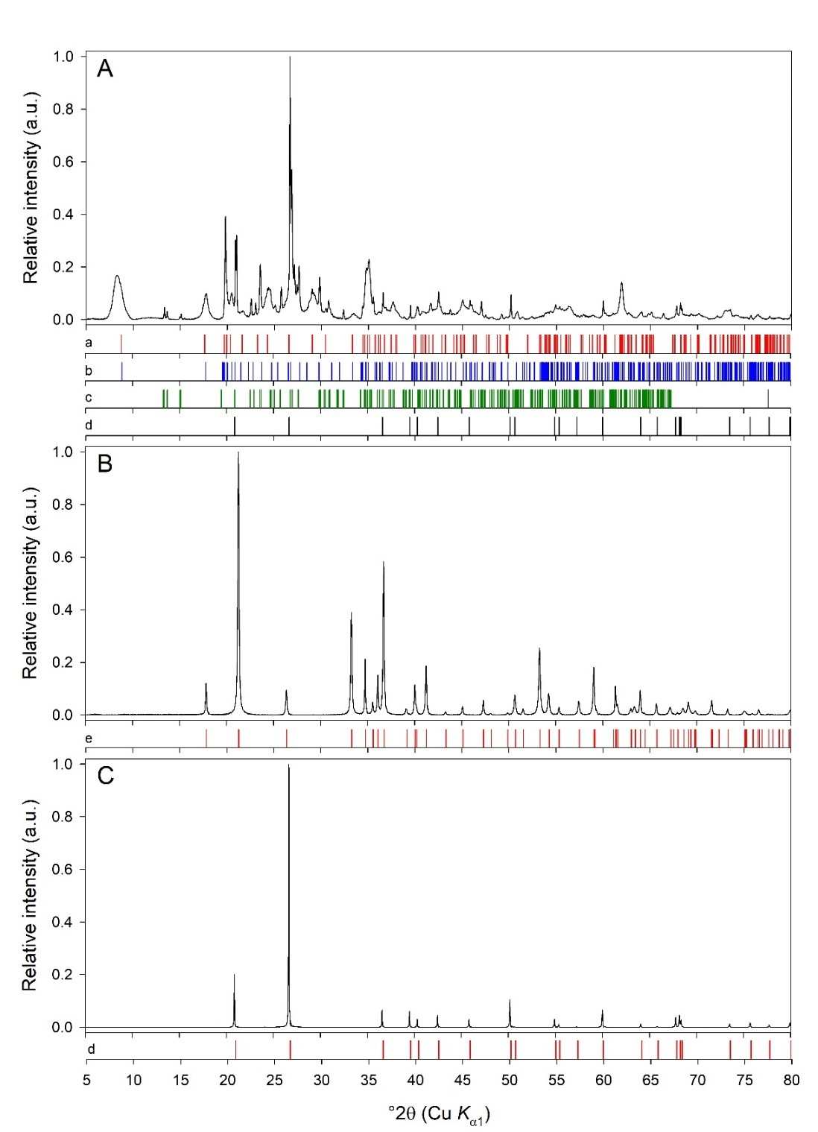
  - Fig. S6: Normalised and background-corrected powder X-ray diffractograms of (A) illite, (B) goethite, and (C) sea sand. Reference patterns are (a) illite (COD entry: 96-901-3720), (b) phengite (COD entry: 96-900-5488), (c) microcline (COD entry: 96-900-0702), (d) low-quartz (α-SiO2) (COD entry: 96-101-1098), and (e) goethite (COD entry: 96-221-1653). Goethite is phase pure and the sea sand is phase-pure α-quartz. The illite sample contains micaceous minerals (illite and phengite – a series between muscovite and caledonite; dioctahedral micas), K-feldspar (microcline), and α-quartz.

References

1. Cohen J. Statistical power analysis for the behavioural sciences. 2nd edn. Hillsdale, NJ: Lawrence Erlbaum. (1988).

2. Herold N, Schöning I, Michalzik B, Trumbore S, Schrumpf M. Controls on soil carbon storage and turnover in German landscapes. Biogeochemistry 119, 435-451 (2014).

3. Brandt L, et al. Mineral type and land-use intensity control composition and functions of microorganisms colonizing pristine minerals in grassland soils. Soil Biology and Biochemistry 182, 109037 (2023).

4. Hendershot W, Lalande H, Duquette M. Soil reaction and exchangeable acidity. Soil Sampling and Methods of Analysis, Second Edition, (2007).

5. Schwertmann U. Differenzierung der eisenoxide des bodens durch extraktion mit ammoniumoxalat‐Lösung. Zeitschrift für Pflanzenernährung, Düngung, Bodenkunde 105, 194-202 (1964).

6. Mehra O, Jackson M. Iron oxide removal from soils and clays by a dithionite–citrate system buffered with sodium bicarbonate. In: Clays and clay minerals). Elsevier (2013).

7. Saidy A, Smernik R, Baldock JA, Kaiser K, Sanderman J. The sorption of organic carbon onto differing clay minerals in the presence and absence of hydrous iron oxide. Geoderma 209, 15-21 (2013).

8. Baham J, Sposito G. Adsorption of dissolved organic carbon extracted from sewage sludge on montmorillonite and kaolinite in the presence of metal ions.). Wiley Online Library (1994).

