Supplemental 1. Definition of NBTs provided to the survey participants.
New Breeding Techniques (NBTs) include a collection of advanced molecular breeding tools that enable precise and targeted modifications to an organism’s genome (plants, animals, etc), without necessarily introducing foreign DNA. These technologies include; site-directed nucleases such as CRISPR-Cas9, TALENs (Transcription Activator-Like Effector Nucleases), and Zinc Finger Nucleases (ZFNs), as well as Oligonucleotide-Directed Mutagenesis (ODM). By inducing specific changes in the DNA, such as small deletions, insertions, or single nucleotide substitutions, NBTs allow for modifications that are often indistinguishable from those resulting from conventional breeding or naturally occurring modifications. Unlike traditional genetic modification, that generates Genetically Modified Organisms (plants, animals, etc) and which generally involves transgene (foreign gen) insertion, NBTs can generate organisms that do not contain foreign genes in the genome. NBTs offer numerous advantages over conventional techniques, including greater precision, faster development timelines, and the potential to enhance traits such as yield, pest and disease resistance, abiotic stress tolerance, and nutritional content. Their broader application in agriculture and plant breeding is considered crucial to improving food security, sustainability, and adaptability to climate change.

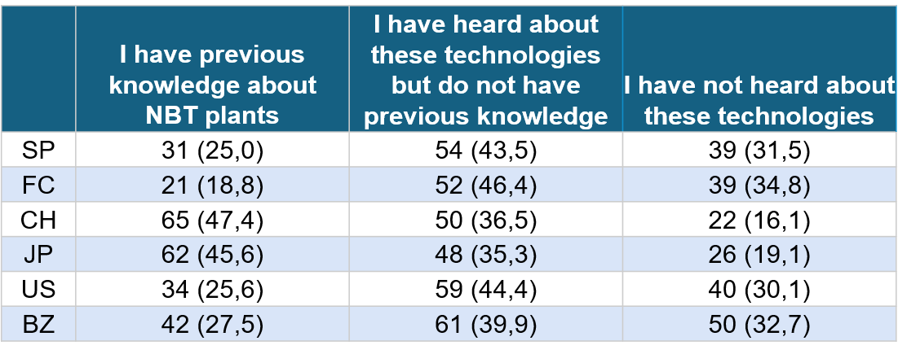
Supplemental 2. Comparison of participants previous knowledge about NBT plants. The data is represented as n(%).

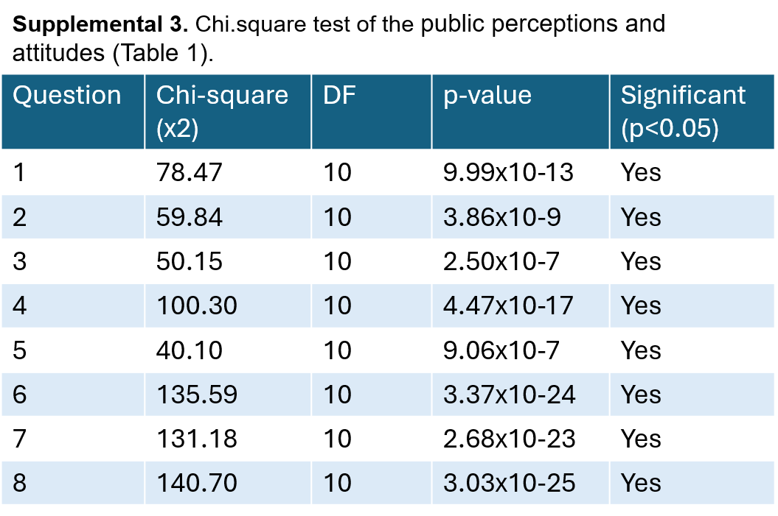

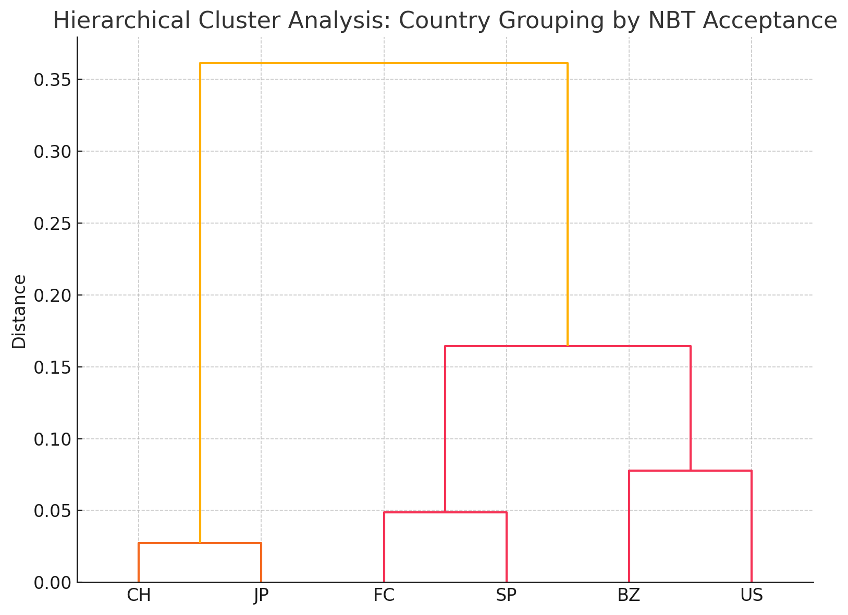
Supplemental 4. Hierarchical Cluster Analysis (Ward’s method) identified distinct country groupings based on response profiles.

