Journal: Plant and Soil

Winter rye root growth and plasticity in response to N and P omission under field conditions.
By Hadir et al.

Supplementary Material
Table S1. Average ± standard deviation of root biomass in the topsoil 30 cm layer in g m⁻² as affected by N and P omission treatments over five sampling dates (16/03/2022 (2-4 tillers detectable ), 04/04/2022 (beginning of stem elongation), 29/04/2022 (early to mid-boot stage), 27/05/2022 (60-80% of inflorescence emerged) and 5: 21/06/2022 (end of flowering)). Treatments: Fully fertilized plus manure (NPKCa+m+s), fully fertilized with mineral fertilizer only (NPKCa), N omission fertilized (_PKCa) and P omission fertilized (N_KCa).
Sampling date | NPKCa+m+s | NPKCa | _PKCa | N_KCa
16/3/2022 | 23.50+19.41 | 26.49±7.15 | 16.86±3.95 | 24.72±5.78
04/04/2022 | 51.87±10.43 | 33.91±4.59 | 28.41±5.26 | 32.03±2.48
29/04/2022 | 78.87±16.24 | 50.38±34.07 | 42.13±13.12 | 49.51±15.54
27/05/2022 | 126.50±25.7 | 95.37±10.24 | 36.51±13.13 | 73.84±14.13
21/06/2022 | 84.33±9.52 | 100.05±19.27 | 45.78±11.53 | 98.83±35.80

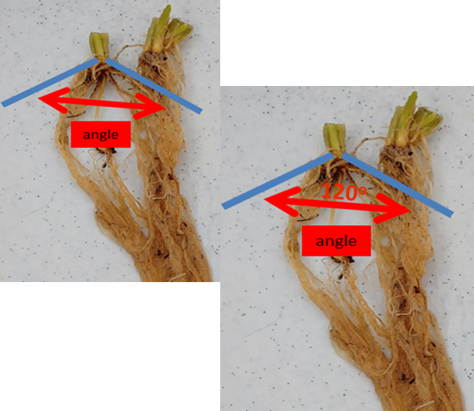
Figure S1. Depiction of root angle measurements (blue line) in rye plants, root angle is measured in the nodal roots.

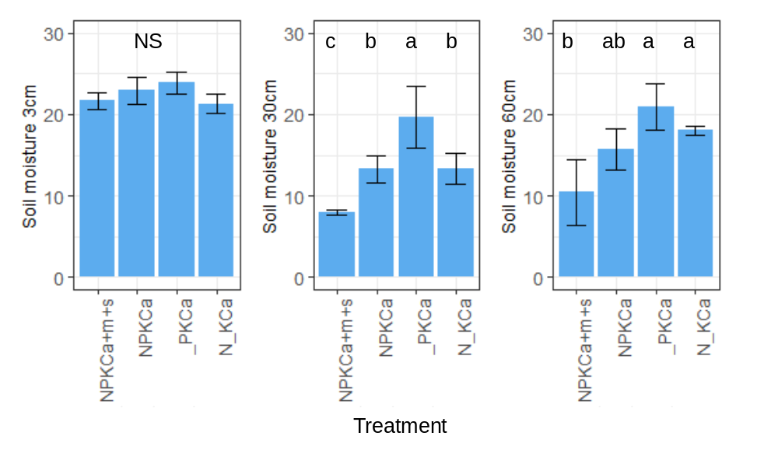
Figure S2. Soil moisture content (%) at 3, 30, and 60 cm soil depth on 27/05/2022, around flowering as affected by N and P omission treatments during the 2022 season, over five sampling dates (1: 16/03/2022, 2: 04/04/2022, 3: 29/04/2022,4: 27/5/2022 and 21/06/2022). Treatments: Fully fertilized plus manure (NPKCa+m+s), fully fertilized with mineral fertilizer only (NPKCa), N omission (_PKCa) and P omission (N_KCa). Values followed by the same letter do not differ according to Tukey high significant difference at 5% confidence level. NS= not significant at 5% confidence level.

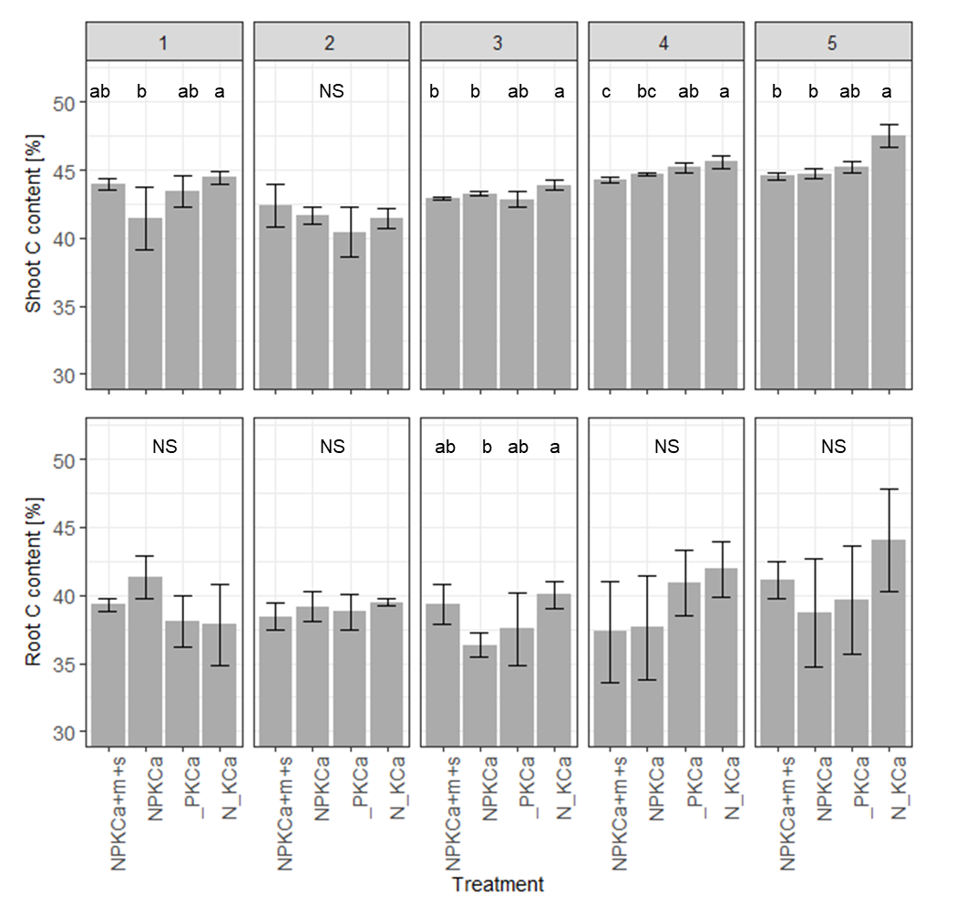
Figure S3. Shoot (a) and root (b) C content (%) as affected by N and P omission treatments during the 2022 season, over five sampling dates (1: 16/03/2022, 2: 04/04/2022, 3: 29/04/2022,4: 27/5/2022 and 21/06/2022). Treatments: Fully fertilized plus manure (NPKCa+m+s), fully fertilized with mineral fertilizer only (NPKCa), N omission (_PKCa) and P omission (N_KCa). Values followed by the same letter do not differ according to Tukey high significant difference at 5% confidence level. NS= not significant at 5% confidence level. For shoot N content in date 5, an Aligned rank transform for nonparametric factorial ANOVA was implemented.

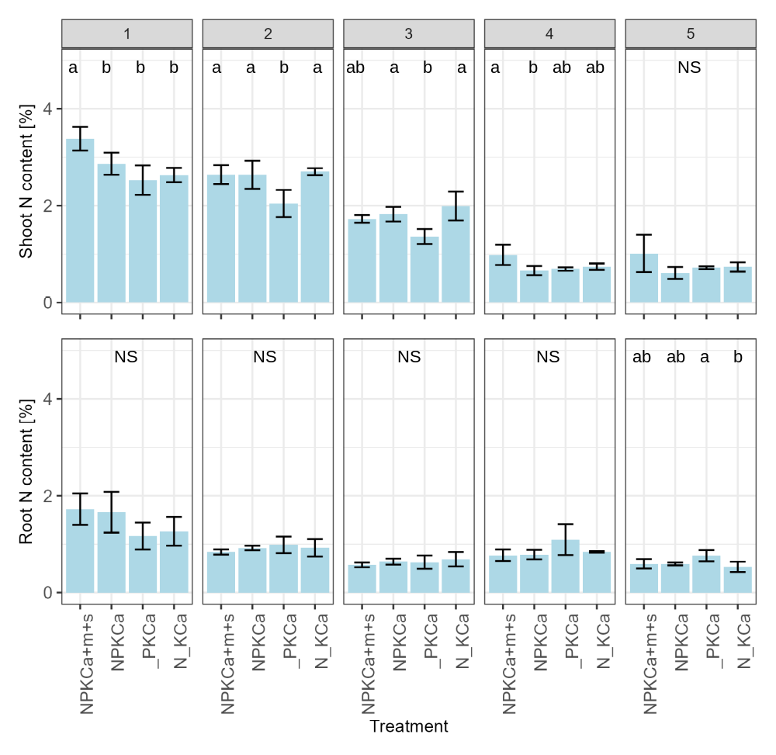
Figure S4. Shoot (a) and root (b) N content (%) as affected by N and P omission treatments during the 2022 season, over five sampling dates (1: 16/03/2022, 2: 04/04/2022, 3: 29/04/2022,4: 27/5/2022 and 21/06/2022). Treatments: Fully fertilized plus manure (NPKCa+m+s), fully fertilized with mineral fertilizer only (NPKCa), N omission (_PKCa) and P omission (N_KCa). Values followed by the same letter do not differ according to Tukey high significant difference at 5% confidence level. NS= not significant at 5% confidence level. For root N content in date 4, an Aligned rank transform for nonparametric factorial ANOVA was implemented.

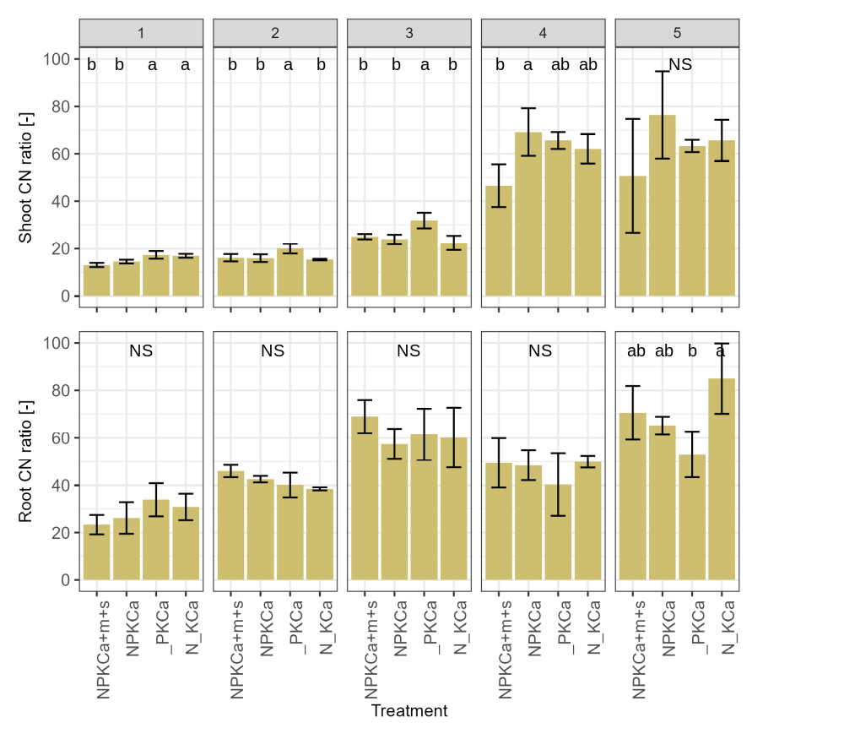
Figure S5. Shoot (a) and root (b) C:N ratio as affected by N and P omission treatments during the 2022 season, over five sampling dates (1: 16/03/2022, 2: 04/04/2022, 3: 29/04/2022,4: 27/5/2022 and 21/06/2022). Treatments: Fully fertilized plus manure (NPKCa+m+s), fully fertilized with mineral fertilizer only (NPKCa), N omission (_PKCa) and P omission (N_KCa). Values followed by the same letter do not differ according to Tukey high significant difference at 5% confidence level. NS= not significant at 5% confidence level.

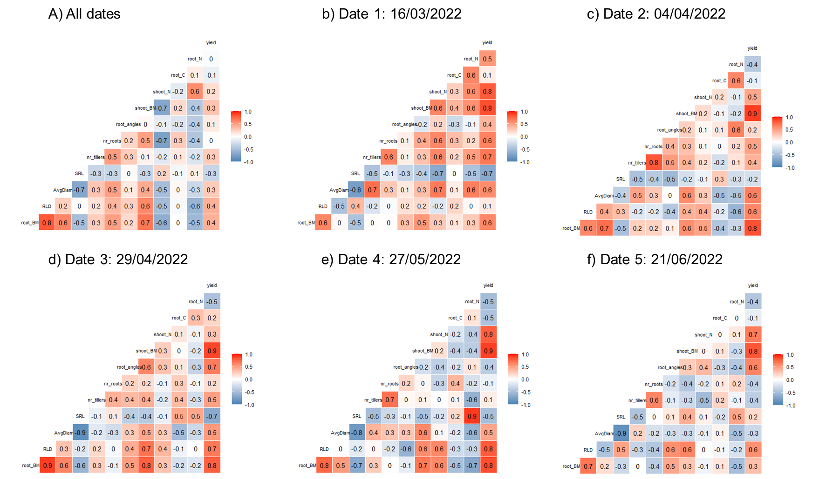
Figure S6: Correlation coefficients for different root and shoot variables for a) all five sampling dates (1: 16/03/2022, 2: 04/04/2022, 3: 29/04/2022,4: 27/05/2022 and 21/06/2022) and, b to f) by sampling date. Abbreviations= nr_tillers= number of tillers (no.), shoot_BM= shoot biomass (g m⁻²), shoot_N= shoot nitrogen content (%), shootCN= Shoot C:N ratio (-), nr_roots= number of seminal roots (no.), root_angle= root angle (no.), root_BM= root biomass (g m⁻²), root_C= root C content (%), root_N= root N content (%), root_CN (%), yield (g m⁻²).

