Reduced life cycle climate impact from manure through catalytic methane conversion and carbon dioxide removal

Supplementary material

Emma Bromark^{a,c} *, Devesh Sathya Sri Sairam Sirigina^{b,d}, Shareq Mohd Nazir^{b,e}, Pernilla Tidåker^{a,f}, Åke Nordberg^{a,g} , Per-Anders Hanssonª
Submitted: 2025-xx-yy
ª Department of Energy and Technology, Swedish University of Agricultural Sciences, Lennart Hjelms väg 9, 756 51 Uppsala, Sweden
^{b} Department of Chemical Engineering, KTH Royal Institute of Technology, Teknikringen 42, 11428 Stockholm, Sweden
^{c} https://orcid.org/0000-0003-3135-8315
^{d} https://orcid.org/0000-0002-4702-8081
^{e} https://orcid.org/0000-0002-4056-0454
^{f} https://orcid.org/0000-0002-4108-4680
^{g} https://orcid.org/0000-0002-1662-9730
* Corresponding author
E-mail addresses: emma.bromark@slu.se , sirigina@kth.se , smnazir@kth.se , pernilla.tidaker@slu.se , ake.nordberg@slu.se , per-anders.hansson@slu.se
Table of contents

Part A 3
Background 3
Additional results from the study 4
Manufacturing 7
Net climate impact 9
Sensitivity analysis 10
Best & worst case 10
Part B: Process model 12
Stream data 12
Aspen output: Energy and material demand for the treatment process 14
Dimensioning of plant 15
Dimensioning of the reactor 18
CO₂ Capture by absorption 18
References 21

Part A

Background
Methane is prevalent at a variety of concentrations. Due to the biological origin of CH₄ emissions from food systems, it is often emitted over large unconfined areas and is quickly diluted in the atmosphere. The emission rate of biological sources may vary due to conditions such as moisture and temperature. In sum, the emissions are great and pose a noticeable impact on the climate. However, due to these characteristics, they may be hard to address (Abernethy et al, 2023). Hence, it is hard to give a robust answer to how high CH₄ concentrations are at different emission sources, but to give some form of reference, we present conditions at some different emission sources in Table A.
Table A. Some CH₄ concentrations for reference. Many measurements of CH₄ emissions focus on the amounts/volume flow of CH₄ and do not report concentration as the CH₄ disperse quickly in the atmosphere.
Emission source | CH₄ concentration | Referencs
Coal mine ventilation | 0.1-1%v | Ursueguia et al., 2021
Liquid manure storage | 760-8400 ppmv | Melse & van der Werf, 2005
Naturally ventilated stable | 15-152 ppmv | Tabase et al., 2023
Biogas | 40-75%mol | Poblete et al., 2020
Diluted landfill gas | 7 % | Fjelsted et al., 2020
Natural gas infrastructure | 100-50,000 ppm | Jia et al., 2025
Rice field | 7 ppm | Pazhanivelan et al., 2024
Digestate | 200-900 ppm | Gålfalk et al., 2024
Atmosphere | 1.9 ppm | NOAA, 2024

Figure A and Table B describe the assumptions behind the thermal catalytic treatment process and resulting CO₂ flows.
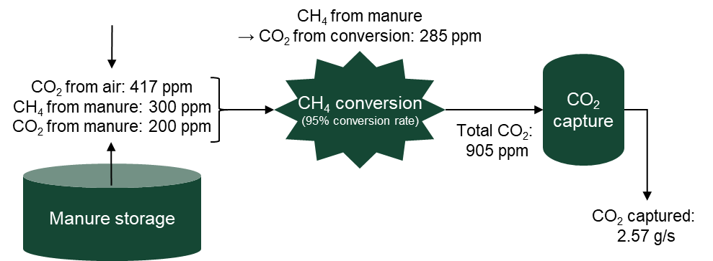
Figure A. Schematic illustration of CO₂ flows with data for the 300 ppmv scenario presented in the figure.
Table B. Concentrations of GHG (ppmv) at the four studied CH₄ concentrations.
CH₄ concentration | 300 | 1000 | 3000 | 10 000
CO₂ from air | 417 | 417 | 417 | 417
CO₂ from manure | 200 | 667 | 2000 | 6667
CO₂ from oxidation | 285 | 950 | 2850 | 9500
CO₂ entering capture unit | 905 | 2034 | 5267 | 16 584
CO₂ captured (g/s) | 2.57 | 1.74 | 1.50 | 1.42

Additional results from the study
This section presents some results that didn’t fit in the main text though the following figures:
Figure B. The share of primary energy demand for the treatment of GHG emissions from manure storage at the four studied CH₄ concentrations, divided between manufacturing (mainly raw material extraction and processing) and operation. Emissions related to end of life are included in the manufacturing as they were too small to be clearly displayed in the figure.
Figure C. The share of primary energy demand for running the CH4 oxidation process at the four studied CH4 concentrations. Divided over the energy using components used in the process. The contribution of the cooling pump is too small to view in the figure.
Figure D. The share of the additional emissions causing the positive contribution to the system climate effect at the four studied CH4 concentrations for the co-removal scenario. The GHG emissions from the system can be attributed to either the manufacturing step (mainly raw material extraction and processing), the operations phase (energy related emissions) or managing the captured CO2.
Figure E. Primary energy demand for producing the necessary components for the CH4 conversion process.
Figure F. The share of the climate effect from producing necessary components for the CH4 conversion process.
Figure G. The share of the climate effect from producing necessary components for the co-removal process. The absolute values for the CH4 conversion are identical to Figure F.
Figure H. Net climate effect for the co-removal process with subsequent CO2 capture at the four studied CH4 concentrations.
Figure I. Sensitivity analysis of the impact of the emissions factor for electricity on the net climate effect for co-removal at the four studied CH4 concentrations. The data labels show the relative increase/decrease compared to the main scenario (European mix).
Figure J. Net climate effect of CH4 conversion for the four modelled CH4 concentrations. The data labels show the relative increase/decrease compared to the main scenario (GWP100 and European mix).
Figure K. Net climate effect of co-removal for the four modelled CH4 concentrations. The data labels show the relative increase/decrease compared to the main scenario (GWP100 and European mix).
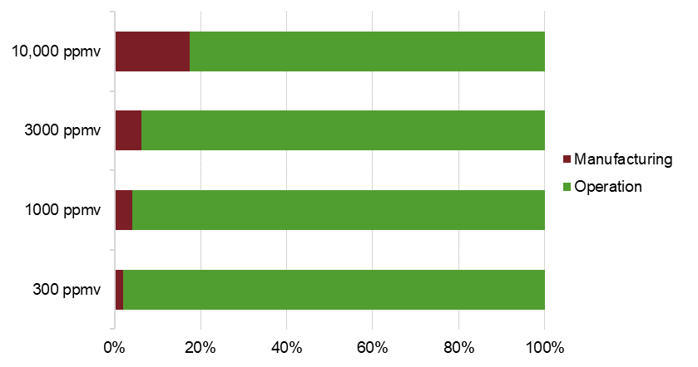
Figure B. The share of primary energy demand for the treatment of GHG emissions from manure storage at the four studied CH₄ concentrations, divided between manufacturing (mainly raw material extraction and processing) and operation. Emissions related to end of life are included in the manufacturing as they were too small to be clearly displayed in the figure.
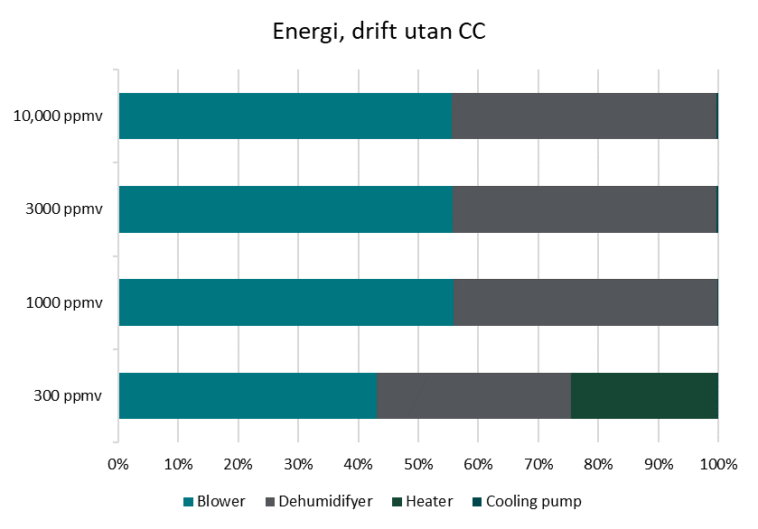
Figure C. The share of primary energy demand for running the CH₄ oxidation process at the four studied CH₄ concentrations. Divided over the energy using components used in the process. The contribution of the cooling pump is too small to view in the figure.

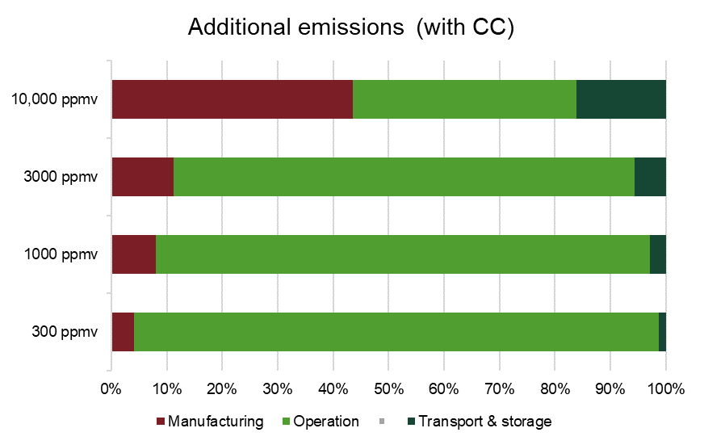
Figure D. The share of the additional emissions causing the positive contribution to the system climate effect at the four studied CH₄ concentrations for the co-removal scenario. The GHG emissions from the system can be attributed to either the manufacturing step (mainly raw material extraction and processing), the operations phase (energy related emissions) or managing the captured CO₂.

Manufacturing
At the lowest concentrations, additional heat was required to reach a high enough temperature for oxidation to initiate, but at 1000 ppmv CH₄ and above, the heat transfer in the recuperator is sufficient to sustain the reaction.
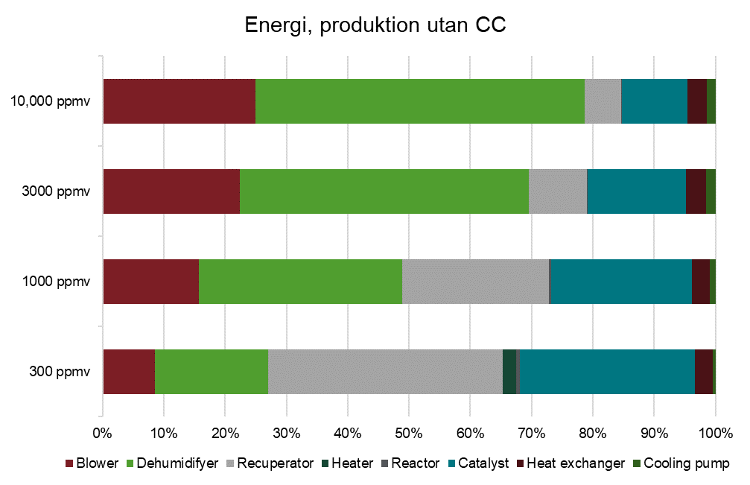
Figure E. Primary energy demand for producing the necessary components for the CH₄ conversion process.
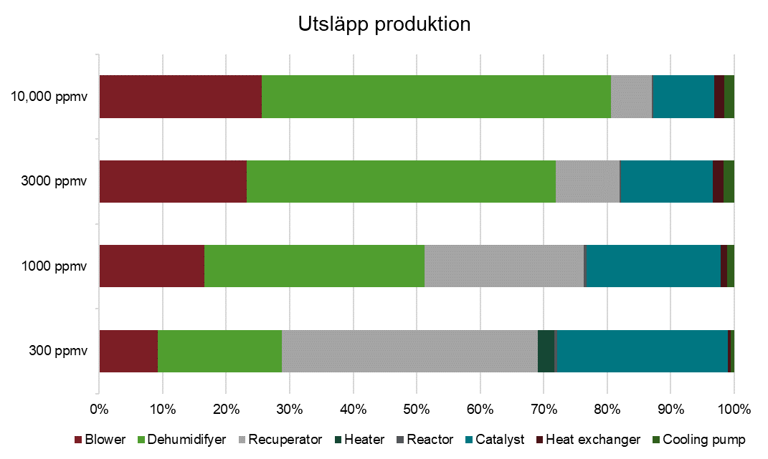
Figure F. The share of the climate effect from producing necessary components for the CH₄ conversion process.
The impact of the carbon capture unit is largely due to the sorbent (Figure G).
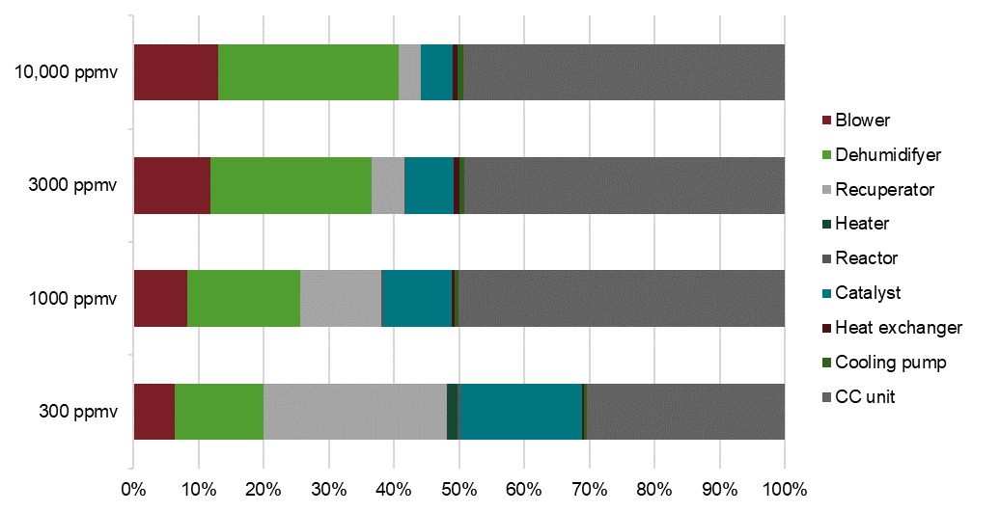
Figure G. The share of the climate effect from producing necessary components for the co-removal process. The absolute values for the CH₄ conversion are identical to Figure F.

Net climate impact
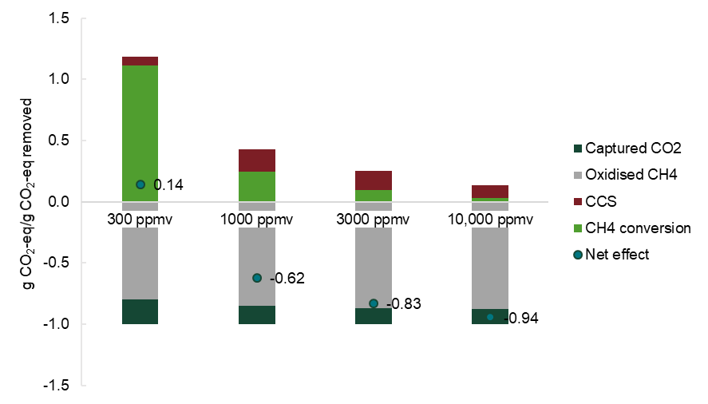
Figure H. Net climate effect for the co-removal process with subsequent CO₂ capture at the four studied CH₄ concentrations.

Sensitivity analysis
This section presents the same sensitivity analysis as was presented in the article text but for the co-removal scenario.
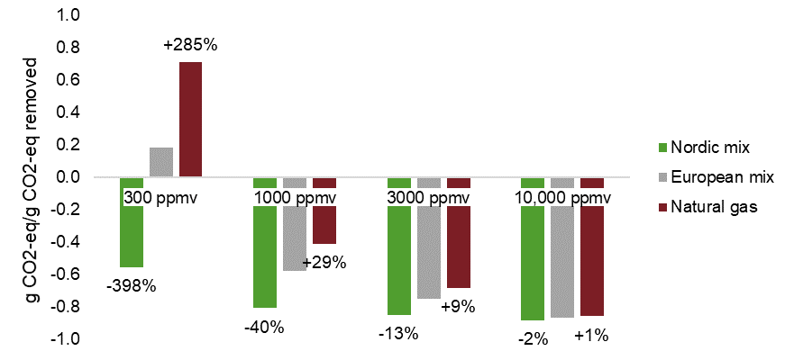
Figure I. Sensitivity analysis of the impact of the emissions factor for electricity on the net climate effect for co-removal at the four studied CH₄ concentrations. The data labels show the relative increase/decrease compared to the main scenario (European mix).

Best & worst case
To show the full range of possible results, we put together scenarios which give the maximum and minimum net climate effect. “Best” and “worst” refers to the quantitative value and does not reflect any qualitative valuation of the authors.
The “best case” scenario is a combination of GWP20 and Nordic electricity mix.
The “worst case” scenario is a combination of GWP500 and natural gas power.
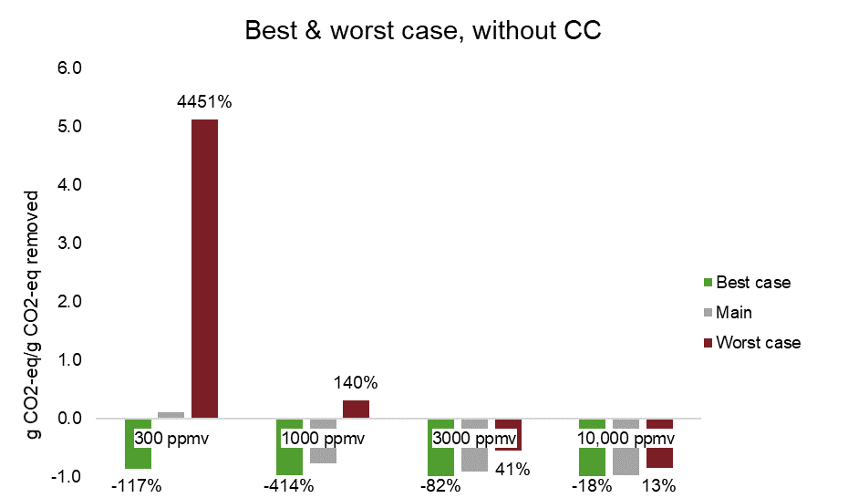
Figure J. Net climate effect of CH₄ conversion for the four modelled CH₄ concentrations. The data labels show the relative increase/decrease compared to the main scenario (GWP100 and European mix).
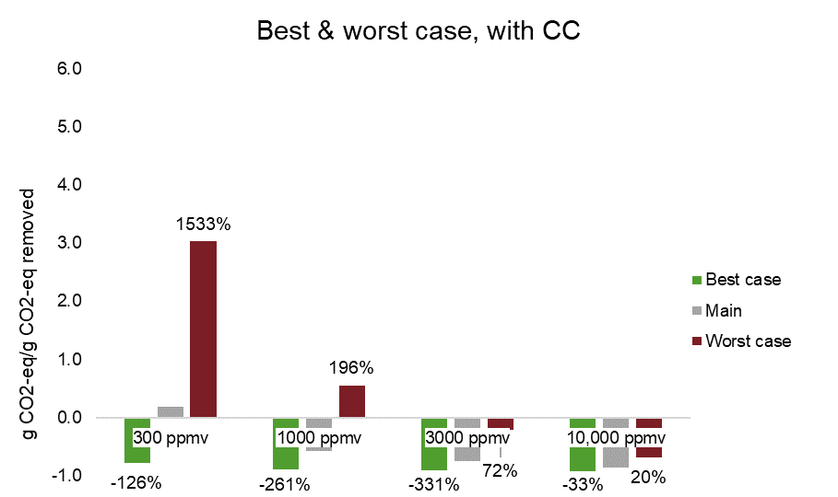
Figure K. Net climate effect of co-removal for the four modelled CH₄ concentrations. The data labels show the relative increase/decrease compared to the main scenario (GWP100 and European mix).

Part B: Process model
The following modifications were made to the process model for CH₄ conversion presented in Sirigina et al. (2023)
- The gas compositions and the volumetric flow rates corresponding to the three scenarios were considered.
- The conversion of CH₄ in the reactor was set to 95%.
- Adiabatic conditions were assumed in the reactor.
- a MEA based absorption process for CO₂ capture was considered for higher CO₂ concentrations in contrast to amine-based adsorption at lower CO₂ concentrations.

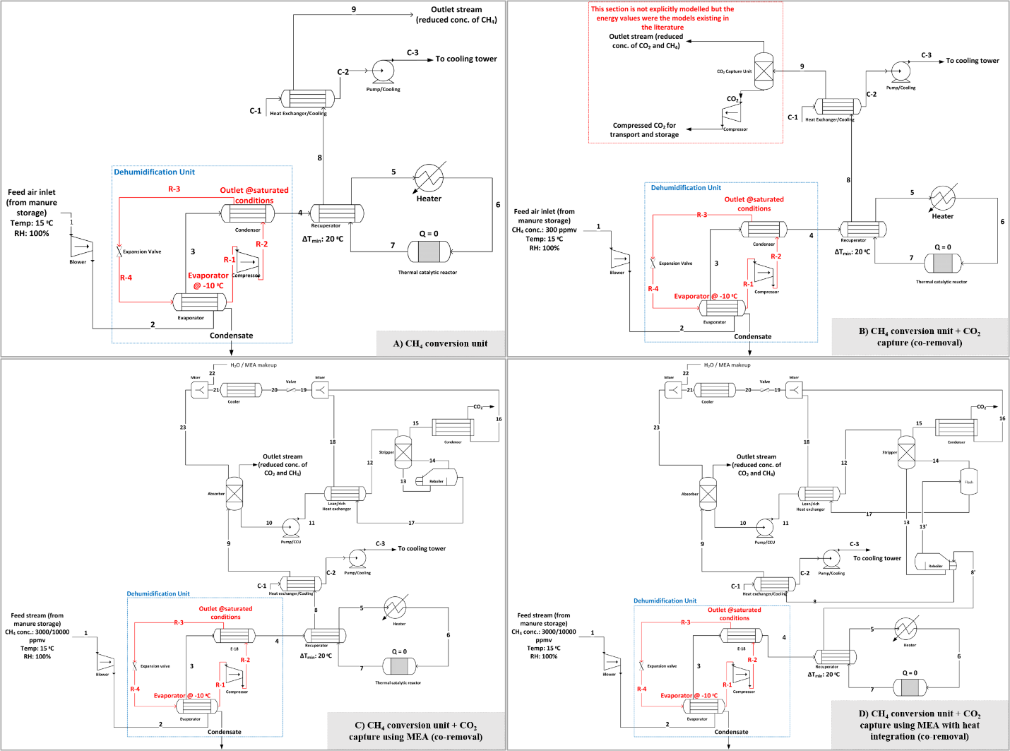
Figure L. Process schematics for different cases considered in this study: A) CH₄ conversion unit, B) CH₄ Conversion unit with CO₂ capture for the case with 300 ppmv inlet CH₄ concentration (co-removal), C) CH₄ conversion with CO₂ capture using MEA absorption (co-removal) for 3000 ppmv, and 10,000 ppmv CH₄ concentrations, and D) Includes heat integration between CH₄ conversion and CO2 capture for cases with 3000 ppmv and 10,000 ppmv CH₄ concentrations.

Stream data
Table C. Stream data at process boundaries for the case with 300 ppmv CH₄ concentration (adapted from Sirigina et al., 2023)
Boundary Stream | Volumetric flow (cum/hr) | Mass flow (kg/hr) | Temperature (K) | Pressure (bar) | CO₂ mol% | CH₄ mol% | H₂O mol% | Rem. mol%
1 | 6890.00 | 8384.03 | 288.15 | 1.01 | 0.06 | 0.03 | 1.01 | 98.89
Condensate | 0.02 | 25.35 | 274.15 | 1.24 | 0.00 | 0.00 | 100.00 | 0.00
9 | 6627.29 | 8358.68 | 293.15 | 1.07 | 0.09 | 0.00 | 0.59 | 99.32

Table D. Stream data at process boundaries for the case with 1000 ppmv CH₄ concentration
Boundary Stream | Volumetric flow (cum/hr) | Mass flow (kg/hr) | Temperature (K) | Pressure (bar) | CO₂ mol% | CH₄ mol% | H₂O mol% | Rem. mol%
1 | 2067.00 | 2514.69 | 288.15 | 1.01 | 0.11 | 0.10 | 1.02 | 98.78
Condensate | 0.01 | 7.45 | 274.15 | 1.22 | 0.00 | 0.00 | 100.00 | 0.00
9 | 1988.42 | 2507.35 | 293.15 | 1.07 | 0.20 | 0.01 | 0.74 | 99.05

Table E. Stream data at process boundaries for the case with 3000 ppmv CH₄ concentration
Boundary Stream | Volumetric flow (cum/hr) | Mass flow (kg/hr) | Temperature (K) | Pressure (bar) | CO₂ mol% | CH₄ mol% | H₂O mol% | Rem. mol%
1 | 689.00 | 838.16 | 288.15 | 1.01 | 0.24 | 0.30 | 1.01 | 98.44
Condensate | 0.00 | 2.46 | 274.15 | 1.22 | 0.00 | 0.00 | 100.00 | 0.00
Outlet stream | 720.07 | 839.64 | 298.423 | 1.01 | 0.09 | 0.01 | 2.91 | 96.99
CO₂ | 1.77 | 5.71 | 308.15 | 1.90 | 96.80 | 0.00 | 3.03 | 0.18
H₂O/MEA Makeup | 0.01 | 9.64 | 300 | 1.03 | 0.00 | 0.00 | 99.96 | 0.04

Table F. Stream data at process boundaries for the case with 10,000 ppmv CH₄ concentration
Boundary Stream | Volumetric flow (cum/hr) | Mass flow (kg/hr) | Temperature (K) | Pressure (bar) | CO₂ mol% | CH₄ mol% | H₂O mol% | Rem. mol%
1 | 207.00 | 251.64 | 288.15 | 1.01 | 0.71 | 1.00 | 1.03 | 97.27
Condensate | 0.00 | 0.76 | 274.15 | 1.22 | 0.00 | 0.00 | 100.00 | 0.00
Outlet stream | 228.64 | 252.43 | 313.91 | 1.03 | 0.18 | 0.05 | 6.85 | 92.93
CO₂ | 1.76 | 5.87 | 308.15 | 1.96 | 96.99 | 0.00 | 2.95 | 0.07
H₂O/MEA Makeup | 0.01 | 7.00 | 313.50 | 1.03 | 0.00 | 0.00 | 100.00 | 0.00

Table G. The heat transfer coefficient and material data used in the CH₄ conversion unit.
Equipment | Heat transfer coefficient (W / m² K) | Material
Evaporator | 138 | 304 Stainless steel
Condenser | 122 (Condensing refrigerant / Vapor)  30 (Vapor refrigerant /Vapor) | 304 Stainless steel
Recuperator | 30 | 304 Stainless steel
Heat exchanger – Cooling | 170 | 304 Stainless steel

Table H. The heat transfer coefficient and material data used in the CO₂ Capture unit (only for the 3000 ppmv and 10,000 ppmv CH₄ cases)
Equipment | Heat transfer coefficient (W / m² K) | Material
Rich-lean heat exchanger | 500 | 316 Stainless steel
Cooler | 204 | 316 Stainless steel
Reboiler (for heat integration between CH₄ conversion and CO₂ capture) | 100 | 316 Stainless steel

Aspen output: Energy and material demand for the treatment process
The results of energy demand for the three scenarios are presented in Table I. The presented data includes both methane conversion and co-removal (of methane and carbon dioxide) for the scenarios.
The energy demand presented in the table includes process heat integration between the CH₄ conversion and CO₂ capture units. The specific reboiler duty is 7.3 GJ/t-CO₂ for the 10,000 ppmv CH₄ case and 8.3 GJ/t-CO₂ for the 3000 ppmv CH₄ case. The heat integration is maximum at a 10,000 ppmv CH₄ concentration with all the energy requirements of the reboiler being met by waste heat from CH₄ conversion. Around 18% of reboiler duty was met by waste heat from the CH₄ conversion unit for the case with 3000 ppmv of CH₄ concentration. Heat integration was not possible for the cases with 300 ppmv and 1000 ppmv due to the low quality of the waste heat stream from the CH₄ conversion unit.
Table I. Energy demand (GJ/tonne CO₂-eq mitigated) for the three manure storage scenarios. The energy demand for 3000 ppmv and 10,000 ppmv CH₄ concentrations includes process heat integration. CH₄ conversion is denoted as Scenario A and Co-removal as Scenario B to decrease cluttering due to limited space.
Concentration | 300 ppmv |  |  | 1000 ppmv |  |  | 3000 ppmv |  |  | 10,000 ppmv
Scenario | A | B | A |  | B | A |  | B | A |  | B
Blower | 6.04 | 4.49 | 1.64 |  | 1.33 | 0.55 |  | 0.47 | 0.16 |  | 0.14
Dehumidifier | 4.56 | 3.39 | 1.30 |  | 1.05 | 0.43 |  | 0.37 | 0.13 |  | 0.11
Heater | 3.42 | 2.55 | 0.00 |  | 0.00 | 0.00 |  | 0.00 | 0.00 |  | 0.00
Cooler Pump | 0.02 | 0.01 | 0.01 |  | 0.00 | 0.00 |  | 0.00 | 0.00 |  | 0.00
CO₂ Capture Unit | - | 2.83 | - |  | 2.08 | - |  | 1.01 | - |  | 0.04
Total | 14.03 | 13.27 | 2.94 |  | 4.47 | 0.98 |  | 1.85 | 0.30 |  | 0.30

The material requirement for CH₄ conversion and CO₂ capture is shown in Table K. As described above, the CO₂ capture technology differs with inlet CH₄ concentration; an adsorption-based capture technology was considered for 300 ppmv, whereas an absorption-based process was considered for 3000 ppmv and 1% inlet CH₄ concentrations. The catalyst estimation for CH₄ conversion was based on the kinetic model presented in Alyani and Smith (2016). The catalyst amount was obtained assuming 95% conversion in the reactor. The amount of adsorbent for CO₂ capture at 300 ppmv was based on data presented in Sabatino et al. (2021). For CO₂ capture by MEA absorption, the makeup corresponding to the loss of MEA through the gas stream from the top of absorber is presented.
Table J. Material requirements for CH₄ conversion and CO₂ capture.
Material | 300 ppmv |  | 1000 ppmv |  | 3000 ppmv |  | 10 000 ppmv
Catalyst for CH₄ conversion  (6.5 wt% Pd/Al₂O₃) | 46755 g | 16064 g |  | 7098 g |  | 3966 g
Adsorbent/absorbent  for CO₂ capture | 47124 g | 31843 g |  | 11 g/hr |  | 8.4 g/hr

Dimensioning of plant
Process components were sized automatically in Aspen Plus in accordance with the following tables.
Table K. Sizing of equipment from the process model for the case with 300 ppm CH₄.
Unit | Specification (kW) | Equipment Weight** (kg) | Installed weight*** (kg) | Other installations
Inlet blower (Capacity) | 56.47 | 3632.00 | 12794.17 | 9162.17
Dehumidifier - Evaporator (Duty) | 107.35 | 908.00 | 2891.98 | 1983.98
Dehumidifier - Condenser (Duty) | 149.96 | 1816.00 | 4436.03 | 2620.03
Dehumidifier - Compressor (Capacity) | 42.62 | 6174.40 | 11474.40 | 5300.00
Recuperator - Heat exchanger (Duty) | 606.67 | 19295.00 | 32031.52 | 12736.52
Heater (Duty) | 32.02 | 444.92 | 7387.03 | 6942.11
Reactor (Volume of reactor*) | 0.03 | 251.37 | 402.19 | 150.82
Cooler - Heat exchanger (Duty) | 155.62 | 1180.40 | 4434.22 | 3253.82
Pump (capacity) | 0.16 | 81.72 | 1559.04 | 1477.32
Sum | 1150.87 | 33783.81 | 77410.58 | 43626.77

Table L. Sizing of equipment from the process model for the case with 1000 ppm CH₄.
Unit | Specification (kW) | Equipment Weight** (kg) | Installed weight*** (kg) | Other installations
Inlet blower (Capacity) | 15 | 2905.6 | 9711 | 6805
Dehumidifier - Evaporator (Duty) | 31 | 354 | 1904 | 1550
Dehumidifier - Condenser (Duty) | 43 | 636 | 2621 | 1986
Dehumidifier - Compressor (Capacity) | 12 | 5766 | 10865 | 5099
Recuperator - Heat exchanger (Duty) | 194 | 4767 | 11940 | 7173
Heater (Duty) | 0 | 0 | 0 | 0
Reactor (Volume of reactor*) | 0.0108 | 80 | 128 | 48
Cooler - Heat exchanger (Duty) | 48 | 400 | 2788 | 2388
Pump (capacity) | 0.05 | 77 | 1422 | 1345
Sum | 342 | 14985 | 41378 | 26394

Table M. Sizing of equipment from the process model for the case with 3000 ppm CH₄.
Unit | Specification (kW) | Equipment Weight** (kg) | Installed weight*** (kg) | Other installations
Inlet blower (Capacity) | 5 | 2679 | 8360 | 5681.36
Dehumidifier - Evaporator (Duty) | 10 | 213 | 1597 | 1383.34
Dehumidifier - Condenser (Duty) | 14 | 277 | 1835 | 1557.67
Dehumidifier - Compressor (Capacity) | 4 | 5584 | 10583 | 4998.99
Recuperator - Heat exchanger (Duty) | 65 | 1044 | 8225 | 7180.46
Heater (Duty) | 0 | 0 | 0 | 0.00
Reactor (Volume of reactor*) | 0.00 | 38 | 61 | 22.90
Cooler - Heat exchanger (Duty) | 28 | 232 | 2531 | 2299.51
Pump (capacity) | 0.03 | 77 | 1111 | 1034.21
Sum | 126.64 | 10144.20 | 34302.65 | 24158.44
CCU - Absorber | - | 7264.00 | 11890.71 | 4627
CCU - Stripper | - | 2406.20 | 6595.71 | 4190
CCU - Rich/lean Heat Exchanger | 44.25 | 222.46 | 1497.75 | 1275
CCU - Stripper Reboiler flash vessel | 13.00 | 862.60 | 4554.98 | 3692
CCU - Stripper Condenser flash vessel | - | 862.60 | 4471.90 | 3609
CCU - Cooler | 0.40 | 81.72 | 883.48 | 802
CCU - Pump | 0.01 | 77.18 | 760.45 | 683

Table N. Sizing of equipment from the process model for the case with 10,000 ppm CH₄, the largest concentration requiring the smallest plant.
Unit | Specification (kW) | Equipment Weight** (kg) | Installed weight*** (kg) | Other installations
Inlet blower (Capacity) | 2 | 2588 | 6973 | 4385
Dehumidifier - Evaporator (Duty) | 3 | 132 | 1270 | 1139
Dehumidifier - Condenser (Duty) | 4 | 204 | 1595 | 1391
Dehumidifier - Compressor (Capacity) | 1 | 5448 | 10319 | 4871
Recuperator - Heat exchanger (Duty) | 20 | 209 | 4912 | 4703
Heater (Duty) | 0 | 0 | 0 | 0
Reactor (Volume of reactor*) | 0.00 | 21 | 34 | 13
Cooler - Heat exchanger (Duty) | 21 | 182 | 2396 | 2214
Pump (capacity) | 0.02 | 77 | 1111 | 1034
Sum | 51.21 | 8860.38 | 28610.12 | 19749.74
CCU - Absorber | - | 4358 | 8897 | 4539
CCU - Stripper | - | 3042 | 7328 | 4287
CCU - Stripper Reboiler - HX | 11.80 | 132 | 2492
CCU - Rich/lean Heat Exchanger | - | 132 | 1180 | 1048
CCU - Stripper Reboiler flash vessel | 0.00 | 863 | 4493 | 3631
CCU - Stripper Condenser flash vessel | - | 863 | 4305 | 3443
CCU - Cooler | - | 132 | 947 | 815
CCU - Pump | 0.02 | 77.18 | 932.06 | 854.88

3000 & 10,000 ppm are high enough concentrations of CH₄ that the amount of heat released from the CH₄ oxidation gives a temperature high enough for the catalyst to operate without preheating.

Dimensioning of the reactor
The design of the reactor under adiabatic conditions is carried out by considering the reactor as a pressure vessel. The minimum wall thicknesses under the design conditions for 3 cases were estimated using the design equations presented in Table 12-10 by Peter et al. (2003). With an outer diameter of 0.0508 m, the inner diameter is estimated to be 0.0194 m. Considering a tube length of 3 m for the case with a 1% vol CH₄ concentration, the amount of stainless steel 304 required for the pressure vessel was estimated. The density of the stainless steel 304 was considered to be 8000 kg/m³. For the case with 3000 ppmv of CH₄ concentration, the same diameter values were assumed with a tube length of 4.1 m. The weight of two heads and nozzles was not factored into the calculation because it is observed that the weight of the reactor is insignificant compared to other process equipment.

CO₂ Capture by absorption
The CO₂ capture for the cases with 3000 ppmv and 10,000 ppmv CH₄ was considered through monoethanolamine (MEA) absorption. The modelling of CO₂ capture done by aqueous MEA solution was carried out in Aspen Plus. The CO₂ capture model was then coupled to the CH₄ conversion unit. MEA absorption is well studied and among the most common technologies for post combustion CO₂ capture (Wang et al. 2023, Madeddu et al. 2018). However, the technology was not well researched for CO₂ capture from ambient air. Kiani et al. (2020) presented a study on the application of MEA absorption for the CO₂ capture from ambient air. For the base case design (with a 50% capture rate), the reboiler duty and total electricity consumption were reported as 10.7 GJ/tCO₂ and 1.452 MWh/tCO₂. Although the energy demand at lower capture rates was reported to be low, a higher capital cost was reported due to the need for processing large amounts of air, suggesting the use of an alternative design for the absorber. In a comparative assessment of different direct air capture technologies, Sabatino et al. (2021) reported reboiler duty for CO₂ capture by MEA absorption to be between 18.01 GJ/tCO₂ and 48.16 GJ/tCO₂ for the cases with minimum energy demand and maximum productivity, respectively. Both studies reveal a greater requirement of low-grade heat at higher CO₂ capture rates. Therefore, in the current study, for the case with the lowest CH₄ concentrations (resulting in a low CO₂ concentration to the capture unit), CO₂ capture using a solid sorbent technology with a much lower energy demand was considered. However, for the other cases with higher CH₄ concentrations (resulting in a higher CO₂ concentration to the capture unit), CO₂ capture by MEA absorption was considered.
The modelling of CO₂ capture in aqueous MEA solution was carried out following the standard process design for MEA absorption processes in post combustion CO₂ capture. The inlet flue stream with CO₂ flows countercurrent to the lean solution and CO₂ is chemically absorbed into the solution. The CO₂ rich stream from the bottom of the absorber is pumped to the stripper pressure and is later heated in the lean-rich heat exchanger. The rich solution is stripped of CO₂ in the stripper unit and the hot lean solution flows through the lean-rich heat exchanger, exchanging heat with the cold rich stream from the absorber. The cold lean solution flows to the top of the absorber, completing the cycle. The gaseous stream from the top of stripper is sent to the condenser, where the water present in the stream is condensed. The concentrated CO₂ stream from the condenser is sent for compression for further transport and permanent storage. The values for compression, transport, and storage were taken from the literature. The process schematics for CO₂ capture by MEA absorption integrated to CH₄ conversion is shown in Figure L. A rate-based model for CO₂ capture was developed in Aspen Plus to simulate the absorption process. The property evaluation was based on the ENTRL method present in Aspen Plus v12. Absorption and stripping were simulated using RadFrac models present in Aspen Plus. A structured packing type, Sulzer Mellapak 252 Y, was chosen as the packing type for both the columns. The correlations to estimate parameters corresponding to material and energy transfer for the packing type are readily available in Aspen Plus. The values for the rate-based model setup in Aspen Plus were obtained from Madeddu et al. (2018). The main assumptions behind the model are shown in Table O. The modelling of CO₂ capture and its integration with the CH₄ conversion unit was performed separately for both the cases because of differences in concentrations, flow rates, and configuration. Complete heat integration was possible in the case with 10,000 ppmv CH₄ concentration, with the waste heat from CH₄ conversion unit utilized in the reboiler for CO₂ regeneration. In the case with 3000 ppmv of CH₄ concentration, about 18% of waste heat from CH₄ conversion could be utilized in the reboiler.
Table O. Modelling assumptions and results of CO₂ capture by MEA absorption for the case with 10,000 ppmv CH₄ concentration.
 | Parameter | Value
Inlet CO₂ | Volume fraction | 1.7%
Lean solvent characterization | Temperature | 313.5 K
Lean solvent characterization | Pressure | 1 atm
Lean solvent characterization | CO₂ loading (CO₂ mole fraction / MEA mole fraction) | 0.3
Absorber | Stages | 20
Absorber | Height | 9 m
Absorber | Diameter | 0.25 m
Stripper | Pressure | 1.96 bar
Stripper | Stages | 15
Stripper | Height | 3 m
Stripper | Diameter (max.) | 0.077 m
Reboiler | Temperature | 393 K
Reboiler | Duty | 11.8 kW
Condenser | Temperature | 308.15 K
Lean-rich heat exchanger | ∆T_{min} | 10 K
Performance | CO₂ capture rate | 89%
Performance | CO₂ purity | 97%

Table P. Modelling assumptions and results of CO₂ capture by MEA absorption for the case with 3000 ppmv CH₄ concentration.
 | Parameter | Value
Inlet CO₂ | Volume fraction | 5290 ppmv
Lean solvent characterization | Temperature | 300 K
Lean solvent characterization | Pressure | ~1 atm
Lean solvent characterization | CO₂ loading (CO₂ mole fraction / MEA mole fraction) | 0.281
Absorber | Stages | 20
Absorber | Height | 11 m
Absorber | Diameter | 0.27 m
Stripper | Pressure | 1.9 bar
Stripper | Stages | 20
Stripper | Height | 3 m
Stripper | Diameter | 0.089 m
Reboiler | Temperature | 394 K
Reboiler | Duty | 13 kW
Condenser | Temperature | 308.15 K
Lean-rich heat exchanger | ∆T_{min} | 10 K
Performance | CO₂ capture rate | 83%
Performance | CO₂ purity | 97%
For the 3000 ppmv CH₄ concentration case, it is observed that about 18% of reboiler energy demand was met using the thermal energy from the CH₄ conversion unit.

References
Abernethy, S., Kessler, M.I. & Jackson, R.B. (2023). Assessing the potential benefits of methane oxidation technologies using a concentration-based framework. Environmental Research Letters, 18(9), 094064. h
ttps://doi.org/10.1088/1748-9326/acf603
Fjelsted, L., Scheutz, C., Christensen, A.G., Larsen J.E., Kjeldsen, P. (2020). Biofiltration of diluted landfill gas in an active loaded open-bed compost filter. Waste management 103 , 1-11 https://doi.org/10.1016/j.wasman.2019.12.005
Gålfalk, M., Nilsson Påledal, S., Yngvesson, J., & Bastviken, D. (2024). Measurements of Methane Emissions from a Biofertilizer Storage Tank Using Ground-Based Hyperspectral Imaging and Flux. Environmental Science & Technology, 58(8), 3766-3775. https://doi.org/10.1021/acs.est.3c06810
Kiani, A., Jiang, K., & Feron, P. (2020). Techno-Economic Assessment for CO2 Capture From Air Using a Conventional Liquid-Based Absorption Process [Original Research]. Frontiers in Energy Research, 8. https://doi.org/10.3389/fenrg.2020.00092
Jia, W., Jia, P., Gu, L., Ren, L., Zhang, Y., Chen, H., Wu, X., Feng, W., Cai, J. (2025). Quantification of methane emissions from typical natural gas stations using on-site measurement technology. Journal of Pipeline Science and Engineering, 5(2), 100229. https://doi.org/10.1016/j.jpse.2024.100229
Madeddu, C., Errico, M., & Baratti, R. (2018). CO₂ capture by reactive absorption-stripping: modeling, analysis and design. Springer.
Melse, R. W., & van der Werf, A. W. (2005). Biofiltration for Mitigation of Methane Emission from Animal Husbandry. Environmental Science & Technology, 39 (14), 5460-5468 https://doi.org/10.1021/es048048q
NOAA. (2024). Trends in Atmospheric Methane (CH₄). National Oceanic & Atmospheric Administration Global Monitoring Laboratory. https://gml.noaa.gov/ccgg/trends_ch4/ (Accessed: 2025-03-01)
Pazhanivelan, S., Sudarmanian, N. S., Geethalakshmi, V., Deiveegan, M., Ragunath, K., Sivamurugan, A. P., & Shanmugapriya, P. (2024). Assessing Methane Emissions from Rice Fields in Large Irrigation Projects Using Satellite-Derived Land Surface Temperature and Agronomic Flooding: A Spatial Analysis. Agriculture, 14(3), 496. https://doi.org/10.3390/agriculture14030496
Poblete, I.B.S., Araujo, O.d.Q.F. & de Medeiros, J.L. (2020). Dynamic analysis of 804 sustainable biogas-combined-cycle plant: Time-varying demand and 805 bioenergy with carbon capture and storage. Renewable and Sustainable 806 Energy Reviews, 131. https://doi.org/10.1016/j.rser.2020.109997
Sabatino, F., Grimm, A., Gallucci, F., van Sint Annaland, M., Kramer, G. J., & Gazzani, M. (2021). A comparative energy and costs assessment and optimization for direct air capture technologies. Joule, 5(8), 2047-2076. https://doi.org/10.1016/j.joule.2021.05.023
Sirigina, D.S.S.S., Goel, A. & Nazir, S.M. (2023). Process concepts and analysis for co-removing methane and carbon dioxide from the atmosphere. Scientific Reports, 13(1), 17290. https://doi.org/10.1038/s41598-023-44582-w
Tabase, R.K., Næss, G., Larring, Y. (2023). Ammonia and methane emissions from small herd cattle buildings in a cold climate. Science of the total environment, 903, 166046
Ursueguía, D., Marín, P, Díaz, E., Ordóñez, S. (2021) A new strategy for upgrading ventilation air methane emissions combining adsorption and combustion in a lean-gas turbine. Journal of Natural Gas Science and Engineering, 88, 103808
Wang, M., Lawal, A., Stephenson, P., Sidders, J., & Ramshaw, C. (2011). Post-combustion CO2 capture with chemical absorption: A state-of-the-art review. Chemical Engineering Research and Design, 89(9), 1609-1624. https://doi.org/10.1016/j.cherd.2010.11.005

