One Pot Bio-Synthesis of Palladium Nanoneedles and Its Bioavailability

Supporting Information
Table of Contents:
- S1: X-ray powder diffraction analysis.
- S2: Fluorescence quenching measurement.
- S3: Binding mechanisms between BSA and PdNNs.
- S4: Binding forces between PdNNs and BSA protein.
- S5: Circular dichroism spectroscopy(CD).
- S6: Energy transfer between BSA and PdNNs.
- Figure S1: Fluorescence spectra of BSA interaction with PdNNs at 293 K.
- Figure S2: Fluorescence spectra of BSA in interaction with PdNNs at 298 K.
- Figure S3: Fluorescence spectra of BSA interaction with PdNNs at 310 K.
- Figure S4: Synchronous fluorescence spectra of BSA and PdNNs at Δλ = 15nm.
- Figure S5: Synchronous fluorescence spectra of BSA and PdNNs at Δλ = 60nm.
- Figure S6: EDAX spectrum of biosynthesized palladium nanoparticles.
- Figure S7: Absorption spectra of BSA in absence and in presence of PdNNs.
- Table S1: Particle size of PdNNs calculated using ImageJ Software
- Table S2: Summary of Anticancer activity against PdNPs reported as in literature
- Table S3: Binding parameters of biosynthesized PdNNs with BSA at different temperatures
- Table S4: Thermodynamic parameters of biosynthesized PdNNs -BSA interaction
- Table S5: The change in % of α- helix of BSA upon interaction with biosynthesized PdNNs
- Table S6: Different FRET parameters calculated from the spectra and life time values for FRET between Bovine serum albumin (BSA) and different concentrations of PdNNs
- Table S7: Shapes and nanoparticles size reported in literature.
- Table S8 : Anticancer activity of biosynthesized PdNNs
- References

S1: X-ray powder diffraction analysis: These observations indicated that PdNNs were in Face- centered cubic lattice form can also be confirmed by using formula [1]:
$\sin^{2}{θ}=\left(\frac{λ^{2}}{4a^{2}}\right)(h^{2}+k^{2}+l^{2})$ (1)
Whereas the unit-cell parameters for patterns 3.9411 A⁰ were calculated using formula:
$a= \frac{λ}{2\sqrt{K}}$ (2)
Where K = lowest common quotient.
S2: Fluorescence quenching measurement
Stern-Volmer equation [2]:
(3)
where, F₀ is the steady-state fluorescence intensity in the absence of PdNNs and F is the fluorescence intensity in the presence of quenching agent (PdNNs). K_{SV} and kq are the Stern-Volmer quenching, bimolecular quenching rate constants respectively. [Q] Represents concentration of quencher PdNNs, $τ₀$ is the unquenched fluorescence lifetime. The Stern-Volmer plot of F₀/F vs [Q] and the Stern-Volmer constant can calculated from slope. The value of quenching constant decreases with increasing temperature; this indicated that binding between PdNNs and BSA by complex formation resulted in successful quenching.
S3: Binding mechanisms between BSA and PdNNs
Fluorescence quenching provides information about the binding constant (K) and the number of binding sites (n) between the quencher and BSA was calculated accordingly to following the equation [2]:
(4)
By plotting a curve of log [(F₀- F)/F)] vs log [Q] slope and intercept gives the values of n and K respectively.The values of binding constant (K) as a function of temperature.
S4: Binding forces between PdNNs and BSA protein
These parameters can be obtained by the Van’t Hoff equation:
(5)
Where, K is the binding constant at the different temperature (295, 298 and 310 K) and R is the gas constant. ΔH° and ΔS° are determined from the linear relationship between Van’t Hoff plots. The Gibbs free energy (ΔG°) was estimated from the following equation [3]:
(6)
The linear plot of ln(K) vs 1/T gives the values of ΔS° and ΔH° and equation show above give the value of ΔG°.
S5: Circular dichroism spectroscopy(CD)
CD spectral measurements at room temperature were carried out with addition of various concentrations of PdNNs. PdNNs binds to the amino acid residue present in the polypeptide chain of BSA and effects on hydrogen bonding which resulted in decrease of the α-helical content. This indicated that, the basic structure of the protein was remained intact even after binding with Pd NPs, suggested that the binding of PdNNs continued to predominate α –helical structure of BSA. Intensity of these bands decreases which representative that decrease in the amount of helicity of the BSA protein. The following equation expressed in terms of mean residue ellipticity (MRE) in deg cm² d mol⁻¹ of CD data:
$MRE =\frac{Intensity of CD \left(m deg\right) }{10 Cp nl }$ (7)
Where, Cp is molar concentration of the protein, n is the number of amino acid residues, l path length. The α -helical content of free BSA as well as bound BSA were calculated by using MRE values of 208 nm and 222 giving as following equation [4]:
$- Helix\left(\%\right)= \frac{-MRE208 -4000}{33,000 – 4000} x 100$ (8)

S6: Energy transfer between BSA and PdNNs
Fluorescence emission spectrum of BSA was well overlapped to absorption spectrum of PdNNs, which indicated as an energy transfer from excited state of BSA to PdNNs. The efficiency (E) of FRET was inversely proportional to the sixth power of distance between donor and acceptor [5], i.e.
$E=1-\frac{F}{F_{0}}= \frac{R_{0}^{6}}{R_{0}^{6}+ r^{6}}$ (9)
R₀ is the critical distance when the transfer efficiency is 50% and
given by,
$R_{0}=0.2108 {[K^{2}n^{-4}φ J]}^{\frac{1}{6}}$ (10)
Where, ϕ is the fluorescence quantum yield of the donor, n is the refractive index of the medium, K² is the spatial orientation factor for absorption of BSA in absence and in presence of PdNNs at different concentrations. Inset shows the absorption intensity as a function of Pd concentrations. The error bar corresponds to the standard deviation for n = 3. Overlap of fluorescence emission spectrum of BSA with absorption spectrum of PdNNs studies with concentration 4.84 x 10⁻⁶ M to 9.69 x 10⁻⁷M of the dipole, J is the overlap integral of the fluorescence emission spectrum of the donor and the absorption spectrum of the acceptor, which is given by equation;
$J=\frac{\int_{0}^{∞}{F \left(λ\right)∈\left(λ\right)λ^{4 }dλ}}{\int_{0}^{∞}{F \left(λ\right)}dλ}$ (11)
Where, F(λ) is the fluorescence intensity of the donor and ε(λ) is the molar absorptivity of the acceptor when the wavelength is λ. Using Eqs. (9)-(10), and the values for ϕ = 0.118, K² = 2/3 and n = 1.33 [5].

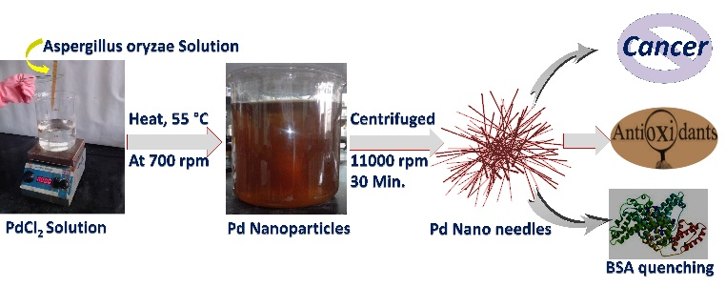
Scheme 1: Bio-synthesis of Palladium Nano needles.

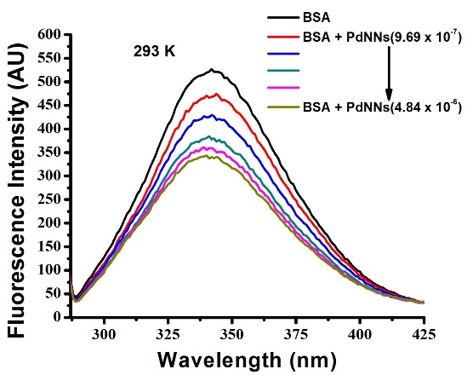
Figure S1. Fluorescence spectra of BSA interaction with PdNNs at 293 K.
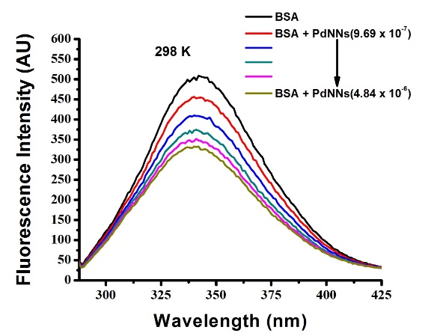
Figure S2. Fluorescence spectra of BSA in interaction with PdNNs at 298 K.

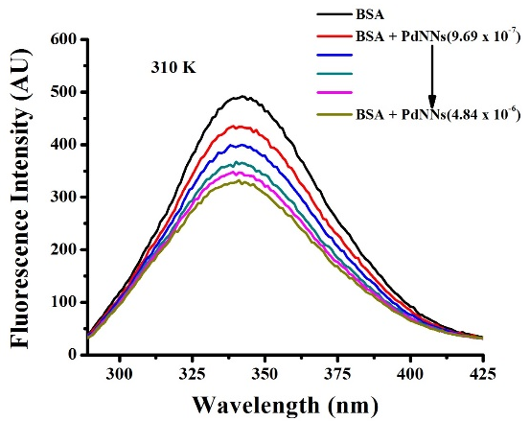
Figure S3. Fluorescence spectra of BSA interaction with PdNNs at 310 K.

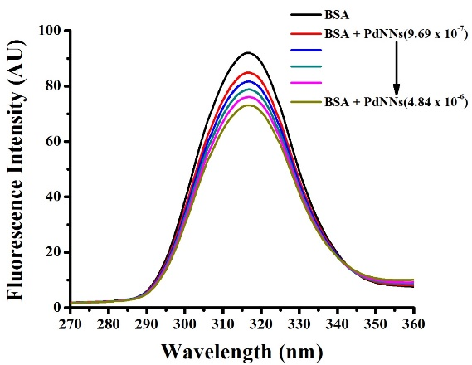
Figure S4. Synchronous fluorescence spectra of BSA and PdNNs at Δλ = 15nm.

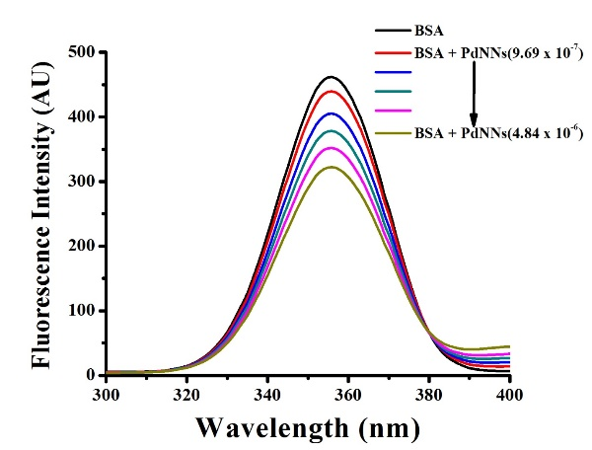
Figure S5. Synchronous fluorescence spectra of BSA and PdNNs at Δλ = 60nm.

Figure S6: EDAX spectrum of biosynthesized palladium nanoparticles.

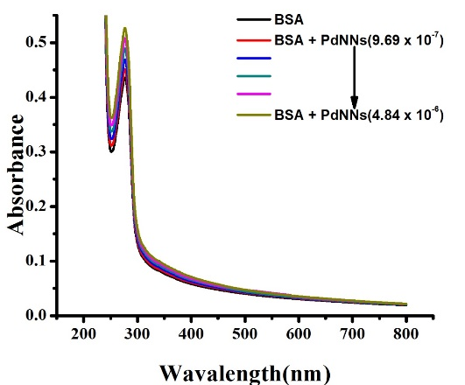
Figure S7: Absorption spectra of BSA in absence and in presence of PdNNs
Table S1: Particle size of PdNNs calculated using ImageJ Software
Particle sizes (nm) | Average Particle size = 513.5 nm (length)  Width = ~2.23 nm
1.99 | Average Particle size = 513.5 nm (length)  Width = ~2.23 nm
2.41 | Average Particle size = 513.5 nm (length)  Width = ~2.23 nm
2.50 | Average Particle size = 513.5 nm (length)  Width = ~2.23 nm
1.85 | Average Particle size = 513.5 nm (length)  Width = ~2.23 nm
2.58 | Average Particle size = 513.5 nm (length)  Width = ~2.23 nm
2.08 | Average Particle size = 513.5 nm (length)  Width = ~2.23 nm
1.93 | Average Particle size = 513.5 nm (length)  Width = ~2.23 nm
2.25 | Average Particle size = 513.5 nm (length)  Width = ~2.23 nm
2.66 | Average Particle size = 513.5 nm (length)  Width = ~2.23 nm
2.00 | Average Particle size = 513.5 nm (length)  Width = ~2.23 nm
2.08 | Average Particle size = 513.5 nm (length)  Width = ~2.23 nm
2.25 | Average Particle size = 513.5 nm (length)  Width = ~2.23 nm
2.58 | Average Particle size = 513.5 nm (length)  Width = ~2.23 nm
2.25 | Average Particle size = 513.5 nm (length)  Width = ~2.23 nm
2.33 | Average Particle size = 513.5 nm (length)  Width = ~2.23 nm
2.00 | Average Particle size = 513.5 nm (length)  Width = ~2.23 nm
1.90 | Average Particle size = 513.5 nm (length)  Width = ~2.23 nm
2.87 | Average Particle size = 513.5 nm (length)  Width = ~2.23 nm

Table S2: Summary of Anticancer activity against PdNPs reported as in literature
Types of method | Reducing agent | Amount of PdNPs for activity | Cell line | References
Biological | Evolvulus alsinoides leaf extract | 0-10 μg/ml | Human ovarian A2780 cancer cell | 6
Biological | Chitosane | 0.01–10 μM | DU145, MCF-7, H460, M14, HT-29, HuTu80, K526. | 7
Chemical | Diacid chloride and diamine | 10 mg/ml | HEPG2, MCF-7, HCT 116 | 8
Biological | Dioscorea bulbifera | 10 μg/mL | HeLa cell line (human epithelial cervical cancer | 9
Biological | white tea (W.tea; Camellia sinensis) extract | 1×10⁵ cells/mL | Acute human T-lymphoblastic leukemia (MOLT-4) | 10
Chemical | Polyvinylpyrrolidone,  KBr | 0.1, 0.5, 1.0, 5.0, and 10.0 µg  mL⁻¹ | Hela cells | 11
Biological | Barleria prionitis leaf extract | 200 μg/ml | human breast adenocarcinoma (MCF-7) cell lines | 12
Biological | Gloriosa superba | 200 μg/mL | MCF-7 | 13
Biological | fungal biomass Aspergillus oryzae | 1 x 10⁻⁷ - 1 x10⁻⁴ M | MCF-7, COLO-205, K562 | Present work

Table S3: Binding parameters of biosynthesized PdNNs with BSA at different temperatures
T  (K) | Ksv  (M⁻¹) | Kq  (M⁻¹s⁻¹) | K  (LM⁻¹) | n
293 | 1.12×10⁵ | 1.12×10¹³ | 13.26×10⁴ | 1.01
298 | 1.07×10⁵ | 1.07×10¹³ | 6.48×10⁴ | 0.95
310 | 0.91×10⁵ | 0.91×10¹³ | 1.14×10⁴ | 0.82

Table S4: Thermodynamic parameters of biosynthesized PdNNs -BSA interaction
Temperature (K) | ∆H° (KJmol⁻¹) | ∆S°(Jmol⁻¹K⁻¹) | ∆G°(KJmol⁻¹)
293 | -109.29 | 2.74.83 | -28.77
298 | -109.29 | 2.74.83 | -27.40
310 | -109.29 | 2.74.83 | -24.10

Table S5: The change in % of α- helix of BSA upon interaction with biosynthesized PdNNs
BSA | MRE at 208 nm (deg cm² dmol⁻¹) | MRE at 222 nm (deg cm² dmol⁻¹) | α-Helix (%) at 208 nm | α-Helix (%) at 222 nm
1 | -18123.31 | -16928.64 | 59.79 |  | 51.10
2 | -17929.22 | -16458.60 | 59.27 |  | 49.89
3 | -17740.06 | -16115.13 | 58.76 |  | 49.01
4 | -17509.28 | -15655.95 | 58.13 |  | 47.84
5 | -17264.36 | -15205.71 | 57.47 |  | 46.68

Table S6: Different FRET parameters calculated from the spectra and life time values for FRET between Bovine serum albumin (BSA) and different concentrations of PdNNs
Conc. of PdNNs (M) | J( m⁻¹cm¹nm⁴) | R₀ (nm) | R (nm) | FRET efficiency (E%)
4.84E-06 | 3.04E+14 | 2.958036 | 3.280199 | 34.97
3.87E-06 | 3.652E+14 | 3.049765 | 3.474542 | 31.38
2.91E-06 | 4.657E+14 | 3.175841 | 3.747698 | 27.024
1.94E-06 | 6.70E+14 | 3.374409 | 4.330979 | 18.28
9.69E-07 | 1.28E+15 | 3.76075 | 5.435002 | 9.89

Table S7: Shapes and nanoparticles size reported in literature.
Sr. No. | Shape of Nanoparticles | Size of Nanoparticles | References
1 | Spherical | 10.4 ± 2.7 nm | 14
2 | Spherical | 27 ± 2 nm | 6
3 | Spherical | 6-10 nm | 15
4 | Spherical | 27 ± 2 nm | 16
5 | spherical and non-spherical | 2 ± 4 nm | 17
6 | Spherical | 15–20 nm | 18
7 | Spherical, rod, and three-dimensional polyhedra | 3–5 nm | 19
8 | Spherical | 15 nm | 20
9 | Irregular | 6 nm | 21
10 | Spherical | 100 nm | 22
11 | Spherical | 20–25 | 23, 24
12 | Spherical | 2-4 nm | 25
13 | Spherical | 3.8 ± 0.2 | 26
14 | Spherical and Irregular | 5-7 | 12
15 | Needle | ̴ 3.0 nm | Present work

Table S8 : Anticancer activity of biosynthesized PdNNs
Conc. | 10⁻⁷ | 10⁻⁶ | 10⁻⁵ | 10⁻⁴
MCF-7
PdNNs | 17.5 | 15.5 | 13.0 | 11.5
ADR | 27.9 | 17.6 | 3.0 | -45.8
COLO-205
PdNNs | 25.2 | 28.4 | 54 | 63.3
ADR | 42.4 | 24.2 | 37 | 45.5
K562
PdNNs | 17.8 | 26 | 44 | 38.5
ADR | 23.3 | 22.3 | 30.6 | 29.6
ADR = Adriamycin, Positive control compound

References
- Lab1_2009 base, Indexing Diffraction Patterns From Cubic Materials.
- Y. L. Wei, J. Q. Li, C. Dong, S. M. Shuang, D. S. Liu and C. W. Huie, Talanta. 70 (2006) 377-382.
- X. L. Lu, J. J. Fan, Y. Liu and A. X. Hou, J. Mol. Struct., 934 (2009) 1-8.
- P. Yang and F.Gao Science Press, Beijing, (2002) p. 349.
- K. Ghosh, S. Rathi, D. Arora, J. Lumin. 175 (2016)135-140.
- S. Gurunathan, E. Kim, J. W. Han, J. H. Park and J.-H. Kim, Molecules 20 (2015) 22476-22498.
- W. Hernandez, A. J. Vaisberg, M. Tobar, M. Alvarez, J. Manzur, Y. Echevarríad, E. Spodine, New J Chem. 40(2) (2016) 1853-1860.
- A. F. Elhusseiny, H. H.A.M. Hassan, SPECTROCHIM ACTA A. 103 (2013) 232–245.
- S. Ghosh, R. Nitnavare, , A. Dewle, G. B. Tomar, R. Chippalkatti, P. More, R. Kitture, S. Kale, J. Bellare, B. A. Chopade, Int. J. Nanomed. 10 (2015) 7477-7490.
- S. Azizi, M. M. Shahri, H. S. Rahman, R. A. Rahim, A. Rasedee, R. Mohamad, Int J Nanomedicine. 12 (2017) 8841–8853.
- L. Zhang, X. Chen, J. Wu, S. Ding, X. Wang, Q. Lei and W. Fang, RSC Adv. 8 (2018) 4130-4141.
- S. S. Rokade, K. A. Joshi, K. Mahajan, G. Tomar, D. S. Dubal, V. S. Parihar, R. Kitture, J. Bellare and S. Ghosh, Glob J Nano. 2(5) (2017) 555600
- S. S. Rokade, K. A. Joshi, K. Mahajan, S. Patil, G. Tomar, D. S. Dubal, V. S. Parihar, R. Kitture, J. R. Bellare, and S. Ghosh, BIOINORG CHEM APPL. (2018) 4924186/1-4924186/9.
- K. E. Wilkinson, L. Palmberg, E. Witasp, M. Kupczyk, N. Feliu, P. Gerde, G. A. Seisenbaeva, B. Fadeel, S. E. Dahlen, V. G. Kessler, ACS Nano. 5 (2011) 5312-5324.
- J. Ji, A. Hedelin, M. Malmlof, V. Kessler, G. Seisenbaeva, P. Gerde, L. Palmberg, PLoS ONE. 12 (2017) e0170428.
- T. V. Surendra, S. M. Roopan, M. V. Arasu, N. A. Al-Dhabi, G. M. Rayalu, J. Photochem. Photobiol. B. 162 (2016) 550-557.
- M. Hazarika, D. Borah, P. Bora, A. R. Silva, P. Das, PLoS ONE. 12 (2017) e0184936.
- M. Sathishkumar, K. Sneha, and Y. S. Yun, Int. J. Mater. Sci. 4 (1) (2009) 11–17.
- L. Jia, Q. Zhang, Q. Li, and H. Song, Nanotechnology. 20(38) (2009) 385601.
- R. K. Petla, S. Vivekanandhan, M. Misra, A. K. Mohanty, and N. Satyanarayana, J Biomater Nanobiotechnol. 3 (1) (2012) 14-19.
- X. Yang, Q. Li, H. Wang, J. Huang, L. Lin, W. Wang, D. Sun, Y. Su, J. B. Opiyo, H. Luwei, Y. Wang, N. He, L. Jia, J Nanopart Res. 12 (5) (2010) 1589-1598.
- S. M. Roopan, A. Bharathi, R. Kumar, V. G. Khanna, and A. Prabhakarn, COLLOID SURFACE B. 92 (2012) 209-212.
- P. Dauthal and M. Mukhopadhyay, J Ind Eng Chem. 22 (2015) 185-191.
- M. Khan, M. Khan, M. Kuniyil, S. F. Adil, A. Al-Warthan, H. Z. Alkhathlan, W. Tremel, M. N. Tahir and M. R. H. Siddiqui, Dalton Trans. 43 (24) (2014) 9026-9031.
- P. Dauthal and M.Mukhopadhyay, Ind. Eng. Chem. Res. 52 (51) (2013) 18131-18139.
- P. Rajasekharreddy and P. U. Rani, J. Clust. Sci. 25 (5) (2014) 1377-1388.

