Remoteness classification of British Columbia’s census subdivisions

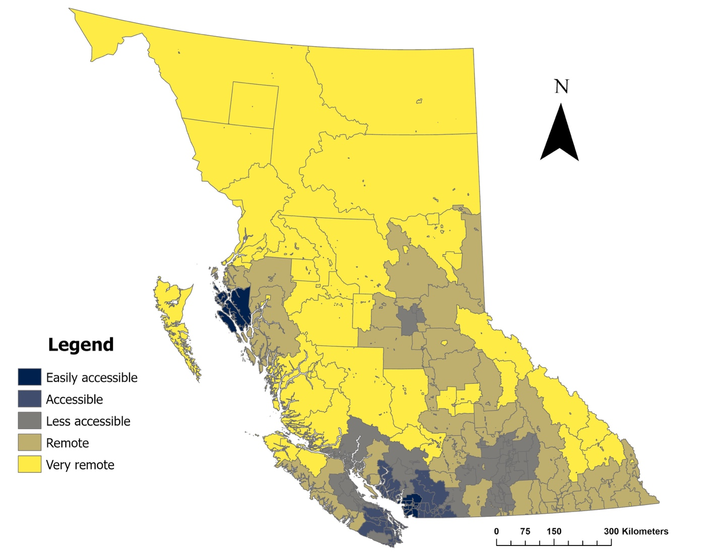
This map illustrates the classification of British Columbia's census subdivisions into five levels of remoteness based on Statistics Canada's 2021 Census data. The classification uses the Index of Remoteness (IR), a continuous measure ranging from 0 to 1, where 0 represents the least remote areas and 1 represents the most remote areas. The IR considers both the distance to population centres and the population size of these centres.

The five categories of remoteness are defined as follows:
- Easily Accessible: IR < 0.1500
- Accessible: IR 0.1500 - 0.2766
- Less Accessible: 0.2767 - 0.4033
- Remote: 0.4034 - 0.5531
- Very Remote: IR > 0.5532

