Supporting information for
Rapid and sensitive on-site detection of Clothianidin in surface waters with a reusable fiber-embedded optofluidic biochip

Note S1. Anti-CLO antibody Labeled by Cy5.5.
The anti-CLO antibodies were conjugated with Cy5.5 using an ultrafiltration technique. Initially, the antibodies were loaded into a 3 kDa molecular weight cutoff ultrafiltration device and centrifuged at low temperature in a refrigerated centrifuge, repeating this process three times to thoroughly replace the antibody solution with a carbonate buffer. Following this, NHS-Cy5.5 was introduced to the mixture, which was then protected from light and agitated on an orbital shaker for 60 min. To eliminate any unbound fluorescent dye, the ultrafiltration process was performed five times, utilizing ultrapure water as the buffer. The resulting Cy5.5-anti-CLO antibodies were subsequently characterized using a UV spectrophotometer, which facilitated the measurement of absorbance at 280 nm and 678 nm. These measurements were crucial for determining both the concentration of the Cy5.5-anti-CLO antibodies and the efficiency of the fluorescence labeling.

Note S2. Reusable functionalized fiber nano-biosensor.
The process began with the preparation of the silica fiber, which had a diameter of 600 μm and a numerical aperture (NA) of 0.22. It was trimmed to a length of 5.5 cm, and the outer 3.5 cm of the coating layer was meticulously removed to expose the biosensing region. Next, the exposed biosensing region underwent in-situ etching using a hydrofluoric acid (HF) tube-etching technique. By fine-tuning the etching parameters, such as temperature and HF concentration, a tapered fiber nanoprobe featuring a nanopore layer was successfully crafted. The functionalization of the fiber nano-biosensor with CLO-OVA was carried out according to a previously published method, with minor adjustments. The biosensing section was first immersed in a piranha solution, a mixture of sulfuric acid (H₂SO₄) and hydrogen peroxide (H₂O₂) in a 3:1 ratio, to introduce hydroxyl groups onto the surface. After being thoroughly washed with ultrapure water and dried with nitrogen (N₂), the fiber biosensor was then immersed in a 2% MTS toluene solution to facilitate the formation of sulfhydryl groups. Following a rinse with toluene to remove any excess MTS, the fiber nano-biosensor was immersed in a 0.02 M GMBS solution to covalently link with the sulfhydryl groups. Once the surplus GMBS was washed away, the fiber nnao-biosensor was placed in a 0.5 mg/mL solution of CLO-OVA to achieve a CLO-OVA functionalized fiber nano-biosensor. To reduce non-specific adsorption, the remaining active sites on the fiber nano-biosensor were blocked by incubating it overnight with a 2.0 mg/mL bovine serum albumin (BSA) solution. The resulting CLO-OVA functionalized fiber nano-biosensor was then stored at 4ºC until ready for use.

Note S3. HPLC analysis
The HPLC system included an LC-10ATvp pump (Shimadzu, Japan) with a UV–vis detector (238 nm), a C-R6A integrator, an SPD-M10A detector, and a Shim-pack VP-ODS column (4.6 mm × 250 mm, Shimadzu, Japan). The sample was separated using a mobile phase comprising MeOH: 0.05 mol/L phosphate buffer (60:40, pH 3.0) and 0.05 % trifluoroacetic acid with a 1.0 mL/min flow rate. The CLO concentration of the samples was quantified against a standard CLO solution.

Note S4. Fitness of Dose-response curve.
The dose-response curve of CLO, plotted against the logarithm of the concentration of CLO using a four-parameter logistic equation as following.
$y=\frac{A_{1}-A_{2}}{1+{\left({\left[C\right]}/{{\left[C\right]}_{0}}\right)}^{p}}+A_{2}$ (1)
where [C] is the concentration of CLO; A₁ and A₂ are the upper and lower asymptote (background signal) to the dose-response curve; [C]₀ is the CLO concentration at inflection; and p is the slope at the inflection point.

Figure S1. (A) Surface water sampling sites in the Haihe River Basin, the ten locations are labeled with the serial numbers 1 - Convention and Exhibition Center, 2 - Entrance to the Sea, 3 - Second Gate, 4 - Xingyue Park, 5 - Grand Canal, 6 - North Canal, 8 - Chunyi Bridge, 9 - Haihe Park, and 10 - Jingang Bridge. (B) Picture of on-site water sampling. (C) Picture of on-site detection of CLO.
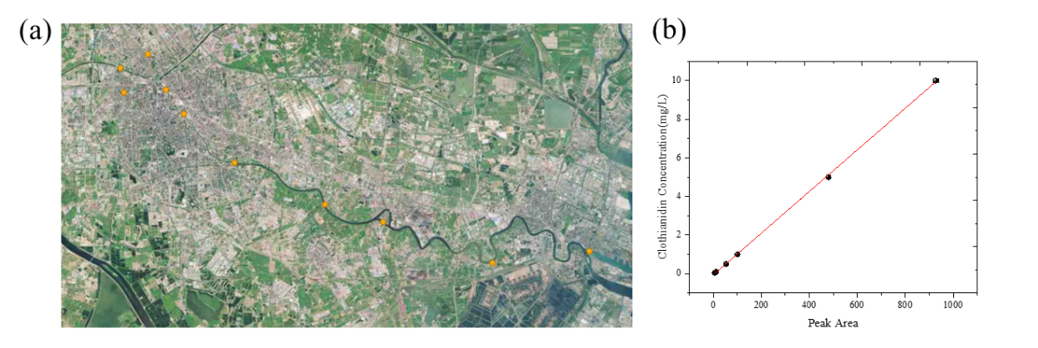
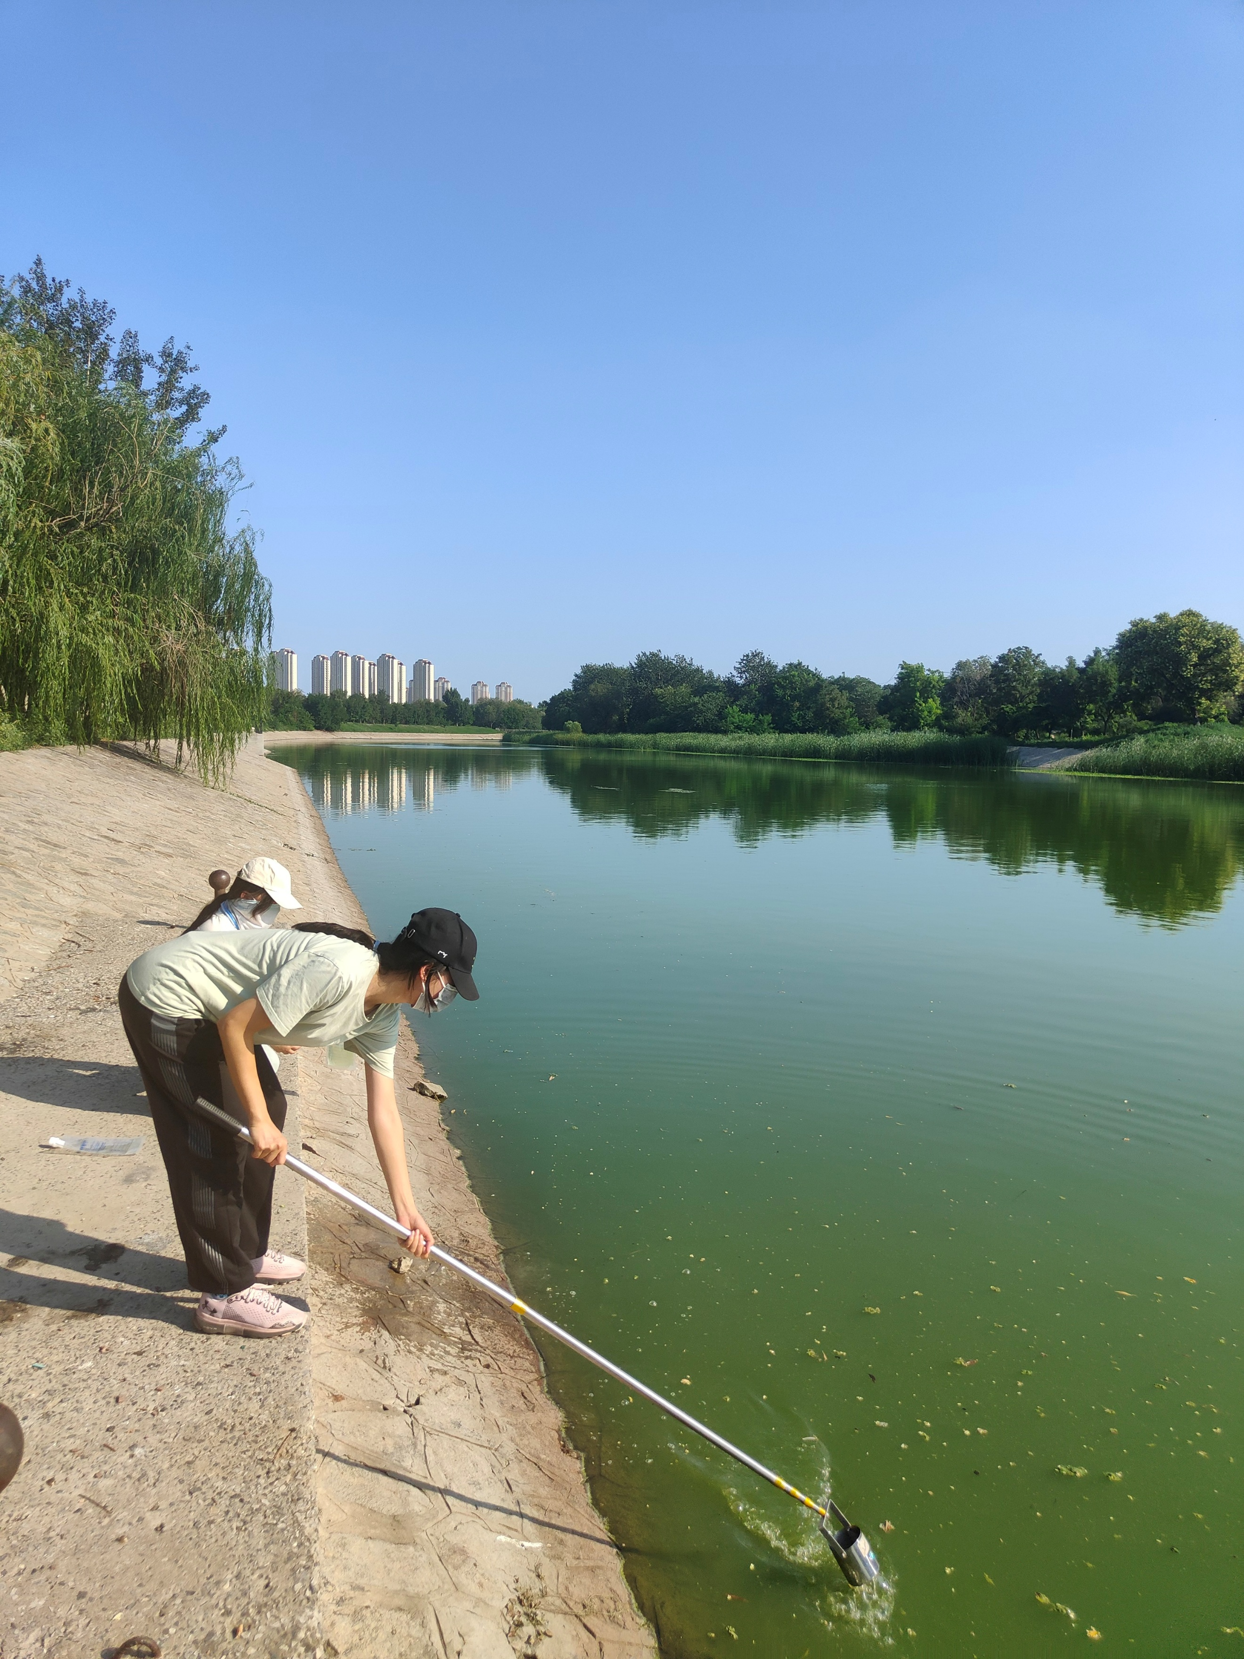
A
B
C

Figure S2. Comparison of the detection results of real samples between the fiber-embedded optofluidic biochip and HPLC.

Table S1 Comparison with fiber-embedded microfluidic biochip with other methods.

Method | Samples | Detection range(μg/L) | Limit of Detection (μg/L) | Detection time  (min) | Ref.
Gas chromatography (GC) | Tomatoes, soil | / | 10 | 4h | [1]
High performance liquid chromatography (HPLC) | grains | 7-18 | 2-5 | 4h | [2]
Liquid chromatography with tandem mass spectrometry (LC-MS/MS) | Okra | 1-1000 | 0.7 | 6h | [3]
Label-free fluorescent aptasensor | Cabbage, Pear, Tomato | 20-600 | 5.527 | / | [4]
non-competitive surface plasmon resonance (SPR) | river water, soil, tomatoes, and oranges | / | 2.5 | 10 | [5]
fluorescence polarization immunoassay (FPIA) | water, soil, rice, apple, and cabbage | / | 5.53 | 12 | [6]
surface enhanced Raman spectroscopy(SERS) | / | / | 1 | / | [7]
Fiber-embedded microfluidic biochip | surface water, Cabbage, Milk | 5-500 | 1 | 12 | This work

Table S2. Water samples from the Haihe River basin detected by Fiber-embedded microfluidic biochip and HPLC
Sampling locations | Fiber-embedded microfluidic biochip |  |  | HPLC
Sampling locations | March | April | May | March | April | May
1 | ND | ND | ND | ND | ND | ND
2 | ND | ND | ND | ND | ND | ND
3 | ND | ND | ND | ND | ND | ND
4 | ND | ND | ND | ND | ND | ND
5 | ND | ND | ND | ND | ND | ND
6 | ND | ND | ND | ND | ND | ND
7 | ND | ND | ND | ND | ND | ND
8 | ND | ND | ND | ND | ND | ND
9 | ND | ND | ND | ND | ND | ND
10 | ND | ND | ND | ND | ND | ND
ND：not detected

References
[1] Li, L., Jiang, G., Liu, C., et al., 2012. Clothianidin dissipation in tomato and soil, and distribution in tomato peel and flesh. Food Control 25, 265-269.
[2] Wang, P., Yang, X., Wang, J., et al., 2012. Multi-residue method for determination of seven neonicotinoid insecticides in grains using dispersive solid-phase extraction and dispersive liquid–liquid micro-extraction by high performance liquid chromatography. Food Chem. 134, 1691-1698.
[3] Kabir, M.H., Yasmin, S., Islam, S., et al., 2024. Residue determination of thiamethoxam and its metabolite clothianidin in okra using the modified QuEChERS method with d-SPE clean-up coupled with LC-MS/MS. Food Chemistry Advances 5, 100754.
[4] Yang, H., Xia, L., Zheng, J., et al., 2023. Screening and identification of a DNA aptamer to construct the label-free fluorescent aptasensor for ultrasensitive and selective detection of clothianidin residue in agricultural products. Talanta 262, 124712.
Chang, Y., Chen, Y., Jiao, S., et al., 2022. A Novel Full-length IgG Recombinant Antibody Highly Specific to Clothianidin and Its Application in Immunochromatographic Assay, Biosensors.
[6] Li, M., Liu, X.F., Hua, X.D., et al., 2014. Fluorescence polarization immunoassay for highly efficient detection of clothianidin in agricultural samples. ANALYTICAL METHODS 6, 6541-6547.
[7] Creedon, N., Lovera, P., Moreno, J.G., et al., 2020. Highly sensitive SERS detection of neonicotinoid pesticides. complete raman spectral assignment of clothianidin and imidacloprid. J. Phys. Chem. A 124, 7238-7247.

