Severity of Psychopathy in a Community-Recruited Sample is Indexed by Increased Social Discounting

Supplemental Files

Supplemental
AUC results
In addition to examining the relationship with logk, we ran analyses using the area under the hyperbolic curve (AUC), which revealed very similar results. A bivariate association between psychopathy group and AUC was observed, t(692.49) = 8.42, p < .001, Cohen’s d=0.62, which persisted after controlling for age, gender, income, and fluid intelligence, B = -0.27, 95% CI [-0.35, -0.19], p < .001, F(5,709) = 18.21 (Table S14). Similar results were observed when the relationship between AUC and psychopathy was assessed as a continuous measure, B = -0.26, 95% CI [-.34, -.18], p < .001, F(5,709) = 17.06 (Table S15; Figure S3). To identify whether the variance associated with one or more subscales of psychopathy was driving this association, we conducted a multiple linear regression including meanness, disinhibition, and boldness subscale scores as predictors of AUC. Meanness was the only subscale that predicted AUC, B = -.43, 95% CI [-0.56, -0.30], p < .001, F(7,707) = 16.46 (Table S16), and the bivariate association between meanness and AUC was also significant, r(713) = -0.33, p < .001.

There was a significant bivariate association between AUC and antisocial behavior, r(713) = -0.24, p<.001, which persisted when controlling for covariates, B= -0.20 , 95% CI [-0.27, -0.13], p < .001, F(5,709) = 24.25. Mediation models were run to see if AUC explained group differences in antisocial behavior. AUC did not mediate the association between group and antisocial behavior (total effect p < .001, direct effect p < .001, indirect effect p = .51; Table S17), or when considering psychopathy as a continuous variable (total effect p < .001, direct effect p < .001, indirect effect p = .53; Table S18). AUC did not mediate the relationship between psychopathy and antisocial behavior within the high psychopathy group (total effect: p < .001, direct effect: p < .001, indirect effect: p = 0.11) or within the control group (total effect: p < .001, direct effect: p < .001, indirect effect: p = .91).

We observed a significant moderating effect such that as AUC increased, antisocial behavior decreased in the high psychopathy group, but there was no association between AUC and antisocial behavior in controls, Psychopathy Group x AUC B = -0.07, 95% CI [-0.13, -0.01], p = 0.02, F(7,707) = 103.2 (Table S19; Figure S4). However, there was no moderating effect when examing psychopathy as a continuous measure, B = 0.01, 95% CI [-0.04, 0.06], p = .79, F(7,707)=187 (Table S20).

Lastly, regression models were run to see if age moderated the relationship between psychopathic traits and AUC. Similar to logk, there was no significant interaction when psychopathy was treated either dichotomously, B = -0.04, 95% CI [-0.13, 0.04], p = .29, F(6,708) = 15.37 (Table S21), or continuously, B = -0.05, 95% CI [-0.13, 0.03], p = .23, F(6,708) = 14.48 (Table S22).

Analyses dropping participants outside of their recruited groups’ range
We reran analyses excluding participants recruited for the high psychopathy group whose summed TriPM score was not above the cutoff and excluding participants recruited for the control group whose summed TriPM score was above the cutoff. This was to verify that results stayed consistent as when we reassigned group membership based on TriPM score. This resulted in 627 total participants (n = 349 control; n = 278 high psychopathy; Table S24). The mean psychopathy score for participants in our high psychopathy group was 122.78 (SD = 16.93, range = 91-165), which was significantly higher than the mean psychopathy score in the control group (M = 51.85, SD =17.65, range = 19-104, t(603.9) = -51.15, p < .001, Cohen’s d = -4.09). Groups did not differ in gender composition or race/ethnicity. However, the control group was older, t(624.71) = 12.42, p < .001, Cohen’s d = 0.97; more educated, t(577.1) = 6.77, p < .001, Cohen’s d =.55; and had higher income, t(552.65) = -2.18, p = .03, Cohen’s d = -0.18. Age, gender (female/other as the reference), income, and fluid intelligence were included as covariates in all the following analyses. (14 participants who reported not knowing their household income were recoded as being in the mean income bracket of the full sample.) Group differences in TriPM score persisted when controlling for age, gender, fluid intelligence, and income, B = 0.88, 95% CI [0.84, 0.91], p < .001, F(5,621) = 560.1. Consistent with their psychopathy scores, high-psychopathy participants also reported significantly more antisocial behavior (M = 95.02, SD = 18.24, range = 52-155) than controls (M = 57.05, SD = 18.01, range = 32-138), t(590.76) = -26.04, p < .001, Cohen’s d = -2.10 (Table S24). Group differences persisted when controlling for age, gender, fluid intelligence, and income, B = 0.71, 95% CI [0.65, 0.77], p < .001, F(5,621) = 141.3.

Before analyzing the difference in discounting across social distances in both groups, we checked to see if the hyperbolic model was the best fit model by examining AIC values. The hyperbolic model yielded the lowest AIC value (40406.3), indicating a superior fit compared to the exponential (AIC: 42889.3) and linear (AIC: 42338.8) models. A hyperbolic discounting curve was thus modeled to estimate discounting rates for each participant.

While controlling for age, gender, fluid intelligence, and income the hyperbolic model indicated significant increases in social discounting (higher logk) among high-psychopathy participants compared to controls, b = 1.63, 95% CI [1.27, 1.98], t = 8.95, p < .001 (Table S26).

Individual logk values were extracted for each participant. A bivariate association between psychopathy group and logk was also observed, t(594.78) = -12.32, p < .001, Cohen’s d = -0.99, which persisted after controlling for age, gender, income, and fluid intelligence, B = 0.40, 95% CI [0.33, 0.48], p < .001, F(5,621) = 32.64 (Table S27), indicating that high-psychopathy participants show a significantly steeper hyperbolic decay in generosity as social distance increases relative to controls. No main effects of gender, income, or fluid intelligence were observed. However, a main effect of age was observed, such that social discounting decreased as age increased, B = -0.10, 95% CI [-0.18, -0.02], p = .01. Similar results were observed when the relationship between discounting (logk) and psychopathy was assessed as a continuous measure, with social discounting again increasing as psychopathy increased, B = 0.41, 95% CI [0.33, 0.49], p < .001, F(5,621) = 33.42 (Table S28), with the bivariate association also being significant, r(625) = 0.44, p < .001.

Similar results were observed with the relationship between AUC and psychopathy. A bivariate association between psychopathy group and AUC was observed, t(624.47) = 8.28, p < .001, Cohen’s d=0.65, as well as a significant bivariate association between psychopathic traits and AUC, r(625) = -.29, p < .001. Both of these associations persisted after controlling for age, gender, fluid intelligence, and income (dichotomous: B = -0.28, 95% CI [-0.37, -0.19], p < .001, F(5,621) = 15.37, Table S29; continuous: B = -0.26, 95% CI [-.34, -.17], p < .001, F(5,621) = 13.60; Table S30), indicating a negative relationship between psychopathy and AUC.

To identify whether the variance associated with one or more subscales of psychopathy was driving these associations between psychopathy and logk/AUC, we conducted a multiple linear regression including meanness, disinhibition, and boldness subscale scores as predictors of logk and AUC, respectively. Only the meanness subscale significantly predicted logk while controlling for the other subscales (B =.44, 95% CI [0.30, 0.58], p < .001, F(7,619) = 27.31; Table S31). The bivariate association between meanness and logk was significant (r(625) = 0.47, p < .001). Meanness was the only subscale that predicted AUC, B = -.42, 95% CI [-0.57, -0.27], p < .001, F(7,619) = 12.91 (Table S32), and the bivariate association between meanness and AUC was also significant, r(625) = -.33, p < .001.

Do Differences in Social Discounting Correspond to Differences in Antisocial Behavior?
We found a bivariate association between logk and antisocial behavior across the full sample, r(625) = .37, p < .001, which remained statistically significant after controlling for age, gender, fluid intelligence, and income (B = 0.30 , 95% CI [0.23, 0.37], p < .001, F(5,621) = 33.60). Similar results were found for the relationship between AUC and antisocial behavior, r(625) = -.24, p < .001, which remained statistically significant after controlling for demographic variables, B = -.18, 95% CI [-0.26, -0.11], p < .001, F(5,621) = 23.94.

Mediation analysis completed using the mediation package in R (Tingley, 2014) found that social discounting (logk) did not mediate group differences in antisocial behavior (total effect: p < .001, direct effect: p < .001, indirect effect: p = 0.068; Table S33). Logk also did not mediate the relationship between psychopathy, as a continuous variable, and antisocial behavior (total effect: p < .001, direct effect: p < .001, indirect effect: p = .68; Table S34). AUC did not mediate group differences in antisocial behavior (total effect: p < .001, direct effect: p<.001, indirect effect: p = .58; Table S35) or the relationship between psychopathic traits and antisocial behavior (total effect: p < .001, direct effect: p < .001, indirect effect: p = .69; Table S36).

We further investigated whether discounting mediated the relationship between psychopathic traits and antisocial behavior within each group. This revealed that both logk and AUC partially mediated the relationship between psychopathic traits and antisocial behavior within the high psychopathy group (logk - total effect: p < .001, direct effect: p < .001, indirect effect: p = .004, proportion mediated: b = 0.07, p = 0.004; AUC - total effect: p < .001, direct effect: p < .001, indirect effect: p = 0.012, proportion mediated: b = 0.03, p = 0.012). However, there was not a significant mediation in the control group (logk - total effect: p < .001, direct effect: p < .001, indirect effect: p = .81; AUC - total effect: p < .001, direct effect: p < .001, indirect effect: p = .44)

We also observed significant moderating relationships between discounting (logk) and psychopathy group in predicting antisocial behavior, B = 0.13, 95% CI [0.07, 0.19], p < .001, F(7,619) = 107.8 (Table S37), such that as social discounting (logK) increases, antisocial behavior increases at a higher rate in the high-psychopathy group relative to controls. However, this was not seen when psychopathy was measured continuously, B = 0.02, 95% CI [-0.03, -0.7], p = .37, F(7,619) = 179.7 (Table S38). AUC did not moderate group differences in antisocial behavior, B = -0.01, 95% CI [-0.06, 0.04], p = .75, F(7,619) = 179.4; Table S39) . However, AUC did significantly moderate the relationship between psychopathic traits and antisocial behavior (B = -0.11, 95% CI [-0.17, -0.06], p < .001, F(7,619) = 105; Table S40)

Does Age Moderate the Relationship Between Psychopathic Traits and Social Discounting?
We replicated the negative association between antisocial behavior and age across the full sample, B = -.34, 95% CI [-.42, -.27], p < .001, F(4,622) = 23.07). However, when examining if there were group differences in the relationship between age and antisocial behavior, the high psychopathy group exhibited a positive association between age and antisocial behavior, whereas the opposite association was observed in controls when controlling for gender, income, and fluid intelligence (Age x Group B = .10, 95% CI [0.04, 0.16], p = .002, F(6,620) = 121). We therefore conducted a multiple regression analysis to determine whether age moderates the relationship between psychopathic traits and discounting. Results indicated that age does not moderate the relationship between psychopathy (treated either dichotomously or continuously) and discounting indexed by logk (dichotomous: B = 0.04, 95% CI [-0.04, 0.13], p = .32, F(6,620) = 27.37, Table S41; continuously: B = 0.03, 95% CI [-0.05, 0.11], p = .40, F(6,620) = 27.96, Table S42). There was also no moderating effect of age on the relationship between psychopathy and AUC when modeling psychopathic traits dichotomously, B = -0.05, 95% CI [-0.14, 0.04], p=.25 (Table S43), or continuously, B = -0.06, 95% CI [-0.14, 0.03], p = .20 (Table S44)

Supplemental Tables/Figures
The following are supplemental tables for the logk analyses where participants in the high psychopathy group who were below the 95th percentile cutoff for their gender were transferred to controls and controls above the cutoff were transferred to the high psychopathy group (as reported in the main text).

Figure S1
Social Discounting Task

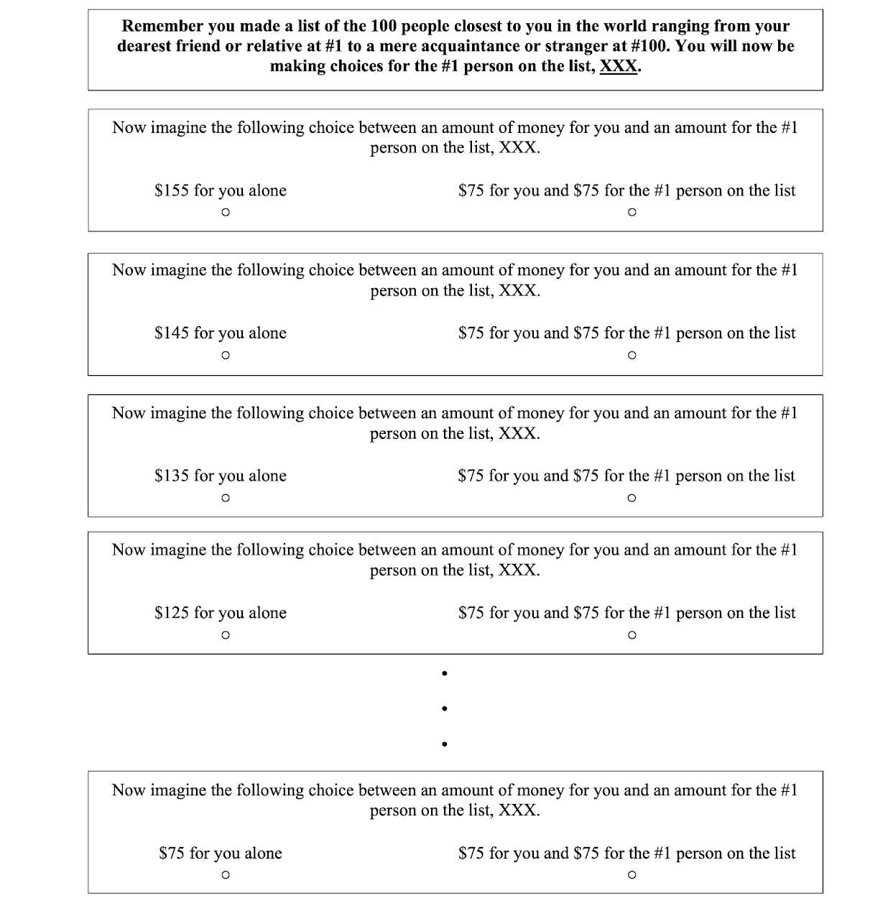
Note. An example of one block of the social discounting task where the participant makes a series of monetary decisions between them and their N = 1 on the list they previously provided. The names of the social distances were inserted into each question. This is then repeated for the 6 other social distances (N = 1, 2, 5, 10, 20 50, 100) (Jones & Rachlin, 2006).
Table S1
Descriptive Statistics of Main Variables
 |  | Full Sample |  |  |  | Control (N=427) |  |  |  | High Psychopathy (N=278)
Variable | M  (SD) |  | Range | Skewness | Kurtosis | M  (SD) | Range | Skewness | Kurtosis | M  (SD) | Range | Skewness | Kurtosis
Total Psychopathy (TriPM) | 82.60 (37.59) |  | 19 - 165 | 0.21 | 1.80 | 55.86 (19.90) | 19 - 104 | 0.44 | 2.33 | 122.25 (16.92) | 91 - 165 | 0.31 | 2.55
Meanness | 23.60 (16.64) |  | 0 - 57 | 0.24 | 1.73 | 12.12 (9.34) | 0 - 40 | 0.77 | 2.78 | 40.62 (8.52) | 17 - 57 | -0.23 | 2.38
Boldness | 33.53 (11.81) |  | 2 - 57 | -0.29 | 2.47 | 28.04 (10.52) | 2 - 53 | -0.11 | 2.65 | 41.67 (8.44) | 14 - 57 | -0.54 | 2.77
Disinhibition | 25.47 (15.74) |  | 0 - 58 | 0.16 | 1.81 | 15.70 (10.76) | 0 - 50 | 0.70 | 2.76 | 39.96 (9.60) | 8 - 58 | -0.44 | 2.68
STAB | 73.50 (25.60) |  | 32 - 155 | 0.49 | 2.53 | 58.81 (18.07) | 32 - 138 | 1.23 | 5.23 | 95.27 (18.67) | 44 - 155 | 0.37 | 3.11
Fluid IQ | 5.41 (2.05) |  | 0 - 13 | 0.72 | 3.42 | 5.57 (2.09) | 1 - 13 | 0.82 | 3.50 | 5.16 (1.96) | 0 - 10 | 0.50 | 3.00
AUC | 0.30 (0.35) |  | -0.06- 0.99 | 0.87 | 2.34 | 0.38 (0.36) | -0.06 - 0.99 | 0.56 | 1.80 | 0.17 (0.29) | -0.06 - 0.99 | 1.52 | 4.32
logk | -2.04 (2.03) |  | -5.77 - 1.81 | -0.15 | 2.27 | -2.72 (1.85) | -5.77 - 1.36 | -0.01 | 2.30 | -1.03 (1.86) | -5.46 - 1.81 | -0.56 | 2.80

Table S2
Group Differences in Antisocial Behavior
Variable | b (se) | CI | Std. B (se) | Std. CI | p
(Intercept) | 66.68 (3.48) | 59.85 , 73.50 | 0.00 (0.03) | -0.05, 0.05 | <.001
High Psychopathy > Control | 35.62 (1.51) | 32.65, 38.59 | 0.68 (0.03) | 0.63, 0.74 | <.001
Age | -0.10 (0.06) | -0.23, 0.02 | -0.05 (0.03) | -0.10, 0.01 | .11
Gender (Male > Female/Other) | 3.31 (1.38) | 0.60, 6.01 | 0.06 (0.03) | 0.01, 0.12 | .02
Income | -0.76 (0.33) | -1.41, -0.11 | -0.06 (0.03) | -0.12, -0.01 | .02
Fluid Intelligence | -0.45 (0.34) | -1.12, 0.22 | -0.04 (0.03) | -0.09, 0.02 | .18
Adjusted R2 = 0.497

*p < .05 in bold

Table S3. Group Differences in Likelihood of Committing at Least 1 Crime
Variable | Odds Ratio |  | CI |  | p
(Intercept) | 0.15 |  | 0.06, 0.35 |  | <.001
High Psychopathy > Control | 12.99 |  | 8.48, 20.39 |  | <.001
Age | 1.03 |  | 1.01, 1.05 |  | .001
Gender (Male > Female/Other) | 1.15 |  | 0.81, 1.63 |  | .42
Income | 0.94 |  | 0.86, 1.02 |  | .12
Fluid Intelligence | 1.11 |  | 1.02, 1.22 |  | .01
AIC = 797.37
R2 = 0.224

Table S4. Group Differences in Likelihood of Being Charged with at Least 1 Crime
Variable | Odds Ratio |  | CI |  | p
(Intercept) | 0.09 |  | 0.04, 0.23 |  | <.001
High Psychopathy > Control | 3.87 |  | 2.61, 5.79 |  | <.001
Age | 1.04 |  | 1.02, 1.06 |  | <.001
Gender (Male > Female/Other) | 1.57 |  | 1.11, 2.24 |  | .01
Income | 0.85 |  | 0.77, 0.93 |  | <.001
Fluid Intelligence | 0.94 |  | 0.86, 1.03 |  | .19
AIC = 782.8
R2 = 0.093

Table S5. Group Differences in Likelihood of Being Convicted of at Least 1 Crime
Variable | Odds Ratio |  | CI |  | p
(Intercept) | 0.13 |  | 0.05, 0.34 |  | <.001
High Psychopathy > Control | 3.09 |  | 2.06, 4.67 |  | <.001
Age | 1.03 |  | 1.01, 1.05 |  | .001
Gender (Male > Female/Other) | 1.53 |  | 1.06, 2.21 |  | .02
Income | 0.87 |  | 0.79, 0.96 |  | .004
Fluid Intelligence | 0.91 |  | 0.83, 1.00 |  | .06
AIC = 736.13
R2 = 0.067
Table S6.
Hyperbolic Model Predicting Maximum Amount Willing to Forgo for each Social Distance in High Psychopathy and Control Group

Variable | b | SE | CI | p
(Intercept) | 86.22 | 0.72 | 84.80, 87.63 | <.001
logk, mean discounting rate for controls | -2.2 | 0.39 | -2.97, -1.43 | <.001
High Psychopathy > Controls | 1.56 | 0.17 | 1.23, 1.90 | <.001
Age | -0.02 | 0.01 | -0.04, -0.01 | .003
Gender (Male > Female/Other) | 0.12 | 0.16 | -0.18, 0.43 | .43
Household Income | -0.07 | 0.04 | -0.14, 0.01 | .08
Fluid Intelligence | 0.1 | 0.04 | 0.02, 0.17 | .01

*p < .05 in bold

Figure S2
Psychopathic Traits Predicting Social Discounting Rate (logk)
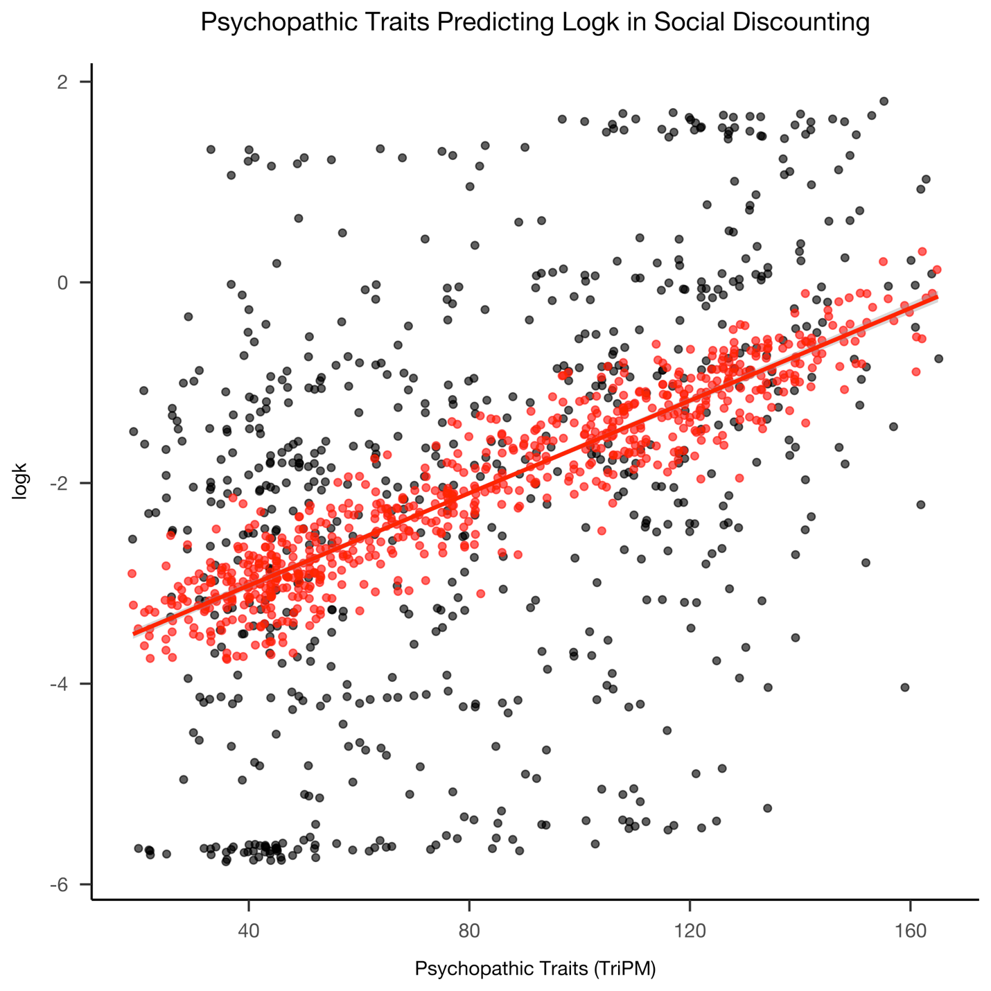

Note. The positive association between psychopathic traits and logk with black representing raw logk values, and red representing predict logk values from the linear regression model controlling for age, gender, and income.

Table S7
Boldness, Meanness, and Disinhibition Predicting Social Discounting Rate (logK)

Variable | b (se) | CI | Std. B (se) | Std. CI | p
(Intercept) | -3.05 (0.41) | -3.86, -2.24 | 0.00 (0.03) | -0.06, 0.06 | <.001
Meanness (TriPM) | 0.05 (0.01) | 0.04, 0.07 | 0.41 (0.06) | 0.29, 0.54 | <.001
Disinhibition (TriPM) | 0.01 (0.01) | -0.01, 0.02 | 0.04 (0.05) | -0.06, 0.15 | .41
Boldness (TriPM) | 0.00 (0.01) | -0.02, 0.01 | -0.03 (0.04) | -0.11, 0.05 | .51
Age | -0.01 (0.01) | -0.03, -0.001 | -0.08 (0.04) | -0.15, -0.004 | .04
Male > Female/Other | -0.03 (0.14) | -0.30, 0.24 | -0.01 (0.03) | -0.07, 0.06 | .82
Income | -0.06 (0.03) | -0.13, 0.01 | -0.06 (0.03) | -0.13, 0.01 | .08
Fluid Intelligence | 0.10 (0.03) | 0.04, 0.17 | 0.10 (0.03) | 0.04, 0.17 | .003
Adjusted R2 = 0.22
*p < .05 in bold

Table S8
logk Mediating the Relationship Between Psychopathy Group and Antisocial Behavior
Variable | logk (M) |  |  |  | STAB (Y)
 | path | b (se) | Std. B (se) | p | path | b (se) | Std. B (se) | p
(Intercept) | im | -2.20 (0.35) | 0  (0.03) | <.001 | iy | 68.68 (3.56) | 0  (0.03) | <.001
High Psychopathy > Controls | a | 1.56 (0.15) | 0.38 (0.04) | <.001 | c' | 34.19 (1.61) | 0.66 (0.03) | <.001
logk |  |  |  |  | b | 0.91 (0.37) | 0.07 (0.03) | .01
Age |  | -0.02 (0.01) | -0.12 (0.04) | .001 |  | -0.08 (0.07) | -0.04 (0.03) | .19
Gender (Male > Female/Other) |  | 0.12 (0.14) | 0.03 (0.03) | .04 |  | 3.91 (1.37) | 0.06 (0.03) | .02
Income |  | -0.07 (0.03) | -0.07 (0.03) | .05 |  | -0.70 (0.33) | -0.06 (0.03) | .04
Fluid Intelligence |  | 0.10 (0.03) | 0.10 (0.03) | .005 |  | -0.54 (0.34) | -0.04 (0.03) | .11
 | Adjusted R2 = 0.191 |  |  |  | Adjusted R2 = 0.50
Note. The value of the indirect effect was b = 1.42, p = .018; the value of the direct effect (path c) was b = 34.19, p < .001 and the value of the total effect was b = 35.62, p < .001. logk partially mediated the relationship between psychopathy group and STAB score with the proportion mediated being b = 0.04 (p = .018)

*p < .05 in bold

Table S9
logk Does Not Mediate the Relationship Between Psychopathic Traits and Antisocial Behavior
Variable | logk (M) |  |  |  |  |  | STAB (Y)
 | path | b (se) | Std. B (se) |  | p |  | path | b (se) | Std. B (se) | p
(Intercept) | im | -3.41 (0.40) | 0  (0.03) |  | <.001 |  | iy | 31.19 (3.59) | 0  (0.02) | <.001
Psychopathic Traits | a | 0.022 (0.002) | 0.40  (0.04) |  | <.001 |  | c' | 0.55 (0.02) | 0.81 (0.03) | <.001
logk |  |  |  |  |  |  | b | 0.16 (0.31) | 0.01 (0.03) | .62
Age |  | -0.02 (0.01) | -0.10 (0.04) |  | .01 |  |  | 0.06 (0.06) | 0.03 (0.02) | .26
Gender (Male > Female/Other) |  | -0.04 (0.14) | -0.01 (0.03) |  | .76 |  |  | -0.82 (1.16) | -0.02 (0.02) | .48
Income |  | -0.07 (0.03) | -0.08  (0.03) |  | .03 |  |  | -1.06 (0.28) | -0.09 (0.02) | <.001
Fluid Intelligence |  | 0.10 (0.03) | 0.10  (0.03) |  | .003 |  |  | -0.22 (0.29) | -0.02 (0.02) | .45
 | Adjusted R2 = 0.16 |  |  |  |  |  | Adjusted R2 = 0.64
Note: The value of the indirect effect was b = 0.003, p = .67; the value of the direct effect (path c) was b = .55, p < .001 and the value of the total effect was b = .56, p < .001. logk did not mediate the relationship between psychopathic traits and antisocial behavior (STAB).
*p < .05 in bold

Table S10
Interaction Between Psychopathy Group and logk Predicts Antisocial Behavior (STAB)
Variable | b (se) |  | CI | Std. B (se) |  | Std. CI | p
(Intercept) | 65.99 (3.65) |  | 58.83, 73.16 | -0.04 (0.03) |  | -0.09, 0.02 | <.001
High Psychopathy > Controls | 38.06 (2.05) |  | 34.04, 42.08 | 0.64 (0.03) |  | 0.58, 0.70 | <.001
logk | -0.03 (0.48) |  | -0.97, 0.92 | 0.07 (0.03) |  | 0.01, 0.13 | .96
Age | -0.09 (0.06) |  | -0.22, 0.03 | -0.04 (0.03) |  | -0.09, 0.01 | .15
Male | 3.56 (1.37) |  | 0.87, 6.25 | 0.07 (0.03) |  | 0.02, 0.12 | .01
Income | -0.70 (0.33) |  | -1.35, -0.05 | -0.06 (0.03) |  | -0.11, -0.004 | .03
Fluid Intelligence | -0.47 (0.34) |  | -1.14, 0.20 | -0.04 (0.03) |  | -0.09, 0.02 | .17
High Psychopathy > Controls × logk | 2.27 (0.75) |  | 0.80, 3.73 | 0.09 (0.03) |  | 0.03, 0.15 | .002
Adjusted R2 = 0.51
*p < .05 in bold

Table S11
Interaction Between Psychopathic Traits and logk Predicts Antisocial Behavior (STAB)
Variable | b (se) | CI |  | Std. B (se) |  | Std. CI | p
(Intercept) | 30.97 (3.79) | 23.54, 38.41 |  | 0.00 (0.02) |  | -0.05, 0.05 | <.001
Psychopathic Traits (TriPM) | 0.56 (0.02) | 0.51, 0.59 |  | 0.81 (0.03) |  | 0.76, 0.86 | <.001
logk | 0.03 (0.75) | -1.43, 1.49 |  | 0.01 (0.03) |  | -0.04, 0.06 | .97
Age | 0.06 (0.06) | -0.05, 0.17 |  | 0.03 (0.02) |  | -0.02, 0.08 | .27
Male | -0.79 (1.16) | -3.08, 1.49 |  | -0.02 (0.02) |  | -0.06, 0.03 | .49
Income | -1.06 (0.28) | -1.61, -0.51 |  | -0.09 (0.02) |  | -0.13, -0.04 | <.001
Fluid Intelligence | -0.22 (0.29) | -0.78, 0.35 |  | -0.02 (0.02) |  | -0.06, 0.03 | .46
Psychopathic Traits × logk | 0.00 (0.01) | -0.01, 0.02 |  | 0.00 (0.02) |  | -0.04, 0.05 | .85
Adjusted R2 = 0.65
*p < .05 in bold

Table S12
No Interaction Between Psychopathy Group and Age in Predicting logk
Variable | b (se) | CI | Std. B (se) | Std. CI | p
(Intercept) | -2.03 (0.39) | -2.79, -1.27 | 0.02 (0.04) | -0.06, 0.09 | <.001
High Psychopathy > Controls | 1.07 (0.51) | 0.07, 2.07 | 0.39 (0.04) | 0.31, 0.46 | .04
Age | -0.03 (0.01) | -0.04, -0.01 | -0.11 (0.04) | -0.19, -0.04 | .001
Male | 0.12 (0.14) | -0.15, 0.39 | 0.03 (0.03) | -0.04, 0.10 | .37
Income | -0.07 (0.03) | -0.14, -0.004 | -0.07 (0.03) | -0.14, -0.004 | .04
Fluid Intelligence | 0.10 (0.03) | 0.03, 0.16 | 0.10 (0.03) | 0.03, 0.17 | .005
High Psychopathy > Controls × Age | 0.01 (0.01) | -0.01, 0.04 | 0.04 (0.04) | -0.04, 0.12 | .31
Adjusted R2 = 0.191
*p < .05 in bold

Table S13
No Interaction Between Psychopathic Traits and Age in Predicting logk
Variable | b (se) | CI |  | Std. B (se) |  | Std. CI |  | p
(Intercept) | -2.98 (0.64) | -4.24, -1.72 |  | 0.01 (0.04) |  | -0.06, 0.09 |  | <.001
Psychopathic Traits (TriPM) | 0.02 (0.01) | 0.003, 0.03 |  | 0.40 (0.04) |  | 0.33, 0.48 |  | .01
Age | -0.03 (0.01) | -0.06, -0.001 |  | -0.10 (0.04) |  | -0.17, -0.02 |  | .04
Male | -0.05 (0.14) | -0.32, 0.23 |  | -0.01 (0.03) |  | -0.08, 0.06 |  | .74
Income | -0.08 (0.03) | -0.14, -0.01 |  | -0.08 (0.03) |  | -0.15, -0.01 |  | .02
Fluid Intelligence | 0.10 (0.03) | 0.03, 0.1 |  | 0.10 (0.03) |  | 0.03, 0.17 |  | .003
Psychopathic Traits × Age | 0.00 (0.00) | -0.0002, 0.0005 |  | 0.03 (0.04) |  | -0.04, 0.11 |  | .39
Adjusted R2 = 0.20
*p < .05 in bold
These are supplemental tables for the AUC analyses where participants in the high psychopathy group who were below the 95th percentile cutoff for their gender were transferred to controls and controls above the cutoff were transferred to the high psychopathy group

Table S14
Variable | b (se) | CI | Std. B (se) | Std. CI | p
(Intercept) | 0.38 (0.06) | 0.26, 0.50 | 0.00 (0.04) | -0.07, 0.07 | <.001
High Psychopathy > Controls | -0.19 (0.03) | -0.25, -0.14 | -0.27 (0.04) | -0.35, -0.19 | <.001
Age | 0.00 (0.00) | 0.001, 0.01 | 0.09 (0.04) | 0.02, 0.17 | .02
Gender (Male > Female/Other) | -0.05 (0.03) | -0.10, -0.003 | -0.07 (0.04) | -0.14, -0.005 | .04
Income | 0.01 (0.01) | -0.005, 0.02 | 0.04 (0.04) | -0.03, 0.11 | .25
Fluid Intelligence | -0.02 (0.01) | -0.03, -0.01 | -0.12 (0.04) | -0.19, -0.05 | .001

Adjusted R2 = 0.108
Psychopathy Group Predicting AUC

*p < .05 in bold

Figure S3
Psychopathic Traits Predicting AUC
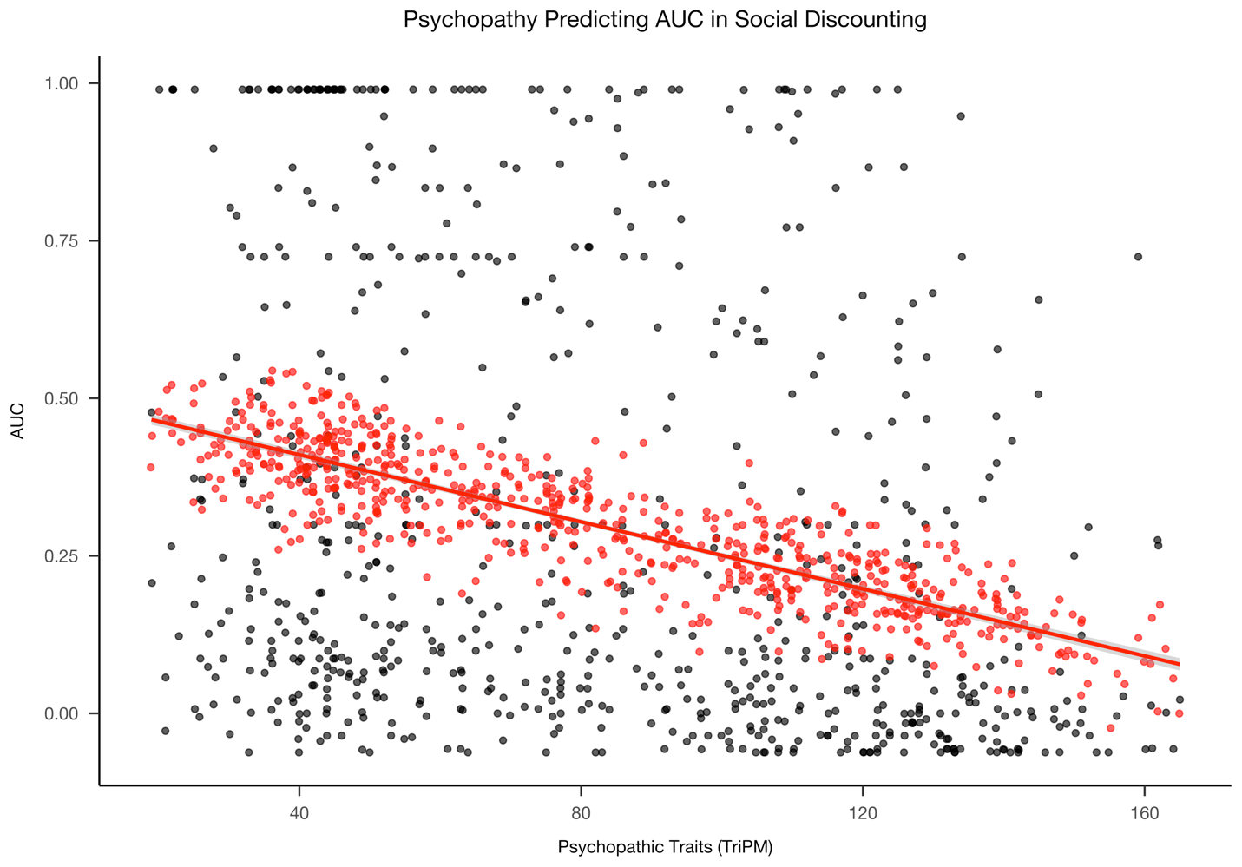

Note. The relationship between psychopathic traits and area under the curve with black representing raw AUC values, and red representing predicted AUC values from the linear regression model controlling for age, gender, fluid intelligence, and income.

Table S15
Variable | b (se) | CI | Std. B (se) | Std. CI | p
(Intercept) | 0.50 (0.07) | 0.35, 0.64 | 0.00 (0.04) | -0.07, 0.07 | <.001
Psychopathy (TriPM) | 0.00 (0.00) | -0.003, -0.002 | -0.26 (0.04) | -0.34, -0.18 | <.001
Age | 0.00 (0.00) | 0.0003, 0.005 | 0.09 (0.04) | 0.01, 0.16 | .03
Gender (Male > Female/Other) | -0.03 (0.03) | -0.08, 0.02 | -0.05 (0.04) | -0.12, 0.02 | .19
Income | 0.01 (0.01) | -0.005, 0.02 | 0.04 (0.04) | -0.03, 0.12 | .22
Fluid Intelligence | -0.02 (0.01) | -0.03, -0.01 | -0.12 (0.04) | -0.19, -0.05 | .001

Adjusted R2 = 0.101
Psychopathic Traits Predicting AUC
*p < .05 in bold

Table S16
Variable | b (se) | CI | Std. B (se) | Std. CI | p
(Intercept) | 0.42 (0.07) | 0.28, 0.57 | 0.00 (0.03) | -0.07, 0.07 | <.001
Meanness (TriPM) | -0.01 (0.00) | -0.01, -0.01 | -0.43 (0.07) | -0.56, -0.30 | <.001
Disinhibition (TriPM) | 0.00 (0.00) | -0.001, 0.004 | 0.09 (0.06) | -0.02, 0.20 | .12
Boldness (TriPM) | 0.00 (0.00) | -0.0001, 0.005 | 0.08 (0.04) | -0.01, 0.17 | .07
Age | 0.00 (0.00) | -0.001, 0.004 | 0.06 (0.04) | -0.02, 0.13 | .14
Male > Female/Other | -0.03 (0.02) | -0.08, 0.02 | -0.05 (0.04) | -0.12, 0.02 | .19
Income | 0.01 (0.01) | -0.01, 0.02 | 0.03 (0.04) | -0.04, 0.11 | .36
Fluid Intelligence | -0.02 (0.01) | -0.03, -0.01 | -0.12 (0.04) | -0.19, -0.05 | .001

Adjusted R2 = 0.13
Meanness Predicting AUC
*p < .05 in bold

Table S17
AUC Does Not Mediate the Relationship Between Psychopathy Group and Antisocial Behavior

Variable | AUC (M) |  |  |  | STAB (Y)
 | path | b (se) | Std. B (se) | p | path | b (se) | Std. B (se) | p
(Intercept) | im | 0.38  (0.06) | 0  (0.04) | <.001 | iy | 67.69  (3.56) | 0  (0.03) | <.001
High Psychopathy > Controls | a | -0.19  (0.03) | -0.27  (0.04) | <.001 | c' | 35.11  (1.56) | 0.67  (0.03) | <.001
AUC |  |  |  |  | b | -2.66  (2.07) | -0.04  (0.03) | .20
Age |  | 0.003  (0.001) | 0.09  (0.04) | .02 |  | -0.10  (0.06) | -0.04  (0.03) | .14
Gender (Male > Female/Other) |  | -0.05  (0.03) | -0.07  (0.04) | .04 |  | 3.17  (1.38) | 0.06  (0.03) | .02
Income |  | 0.007 (0.006) | 0.04  (0.04) | .252 |  | -0.74  (0.33) | -0.06  (0.03) | .03
Fluid Intelligence |  | -0.02 (0.006) | -0.12 (0.04) | .001 |  | -0.51  (0.34) | -0.04  (0.03) | .14
 | Adjusted R2 = 0.108 |  |  |  | Adjusted R2 = 0.497

Note. The value of the indirect effect was b = 0.51, p = .21; the value of the direct effect (path c) was b = 35.11, p < .001 and the value of the total effect was b = 35.62, p < .001. AUC did not mediate the relationship between psychopathy group and STAB score.

*p < .05 in bold

Table S18
AUC Does Not Mediate the Relationship Between Psychopathic Traits and Antisocial Behavior
Variable | AUC (M) |  |  |  | STAB (Y)
 | path | b (se) | Std. B (se) | p | path | b (se) | Std. B (se) | p
(Intercept) | im | 0.50 (0.07) | 0  (0.04) | <.001 | iy | 31.27 (3.50) | 0  (0.02) | <.001
Psychopathic Traits | a | -0.002 (0.0004) | -0.26 (0.04) | <.001 | c' | 0.55 (0.02) | 0.81 (0.03) | <.001
AUC |  |  |  |  | b | -1.22 (1.73) | -0.02 (0.02) | .48
Age |  | 0.003 (0.001) | 0.09 (0.04) | .03 |  | 0.06 (0.06) | 0.03 (0.02) | .26
Gender (Male > Female/Other) |  | -0.03 (0.03) | -0.05 (0.04) | .19 |  | -0.86 (1.16) | -0.02 (0.02) | .46
Income |  | 0.007 (0.006) | 0.04 (0.04) | .22 |  | -1.06 (0.28) | -0.09 (0.02) | <.001
Fluid Intelligence |  | -0.02 (0.006) | -0.11 (0.04) | .001 |  | -0.23 (0.29) | -0.02 (0.02) | .43
 | Adjusted R2 = 0.101 |  |  |  | Adjusted R2 = 0.646

Note: The value of the indirect effect was b = 0.003, p = .53; the value of the direct effect (path c) was b = 0.55, p < .001 and the value of the total effect was b = 0.56, p < .001. AUC did not mediate the relationship between psychopathic traits and antisocial behavior (STAB).

*p < .05 in bold

Figure S4
AUC Predicting Antisocial Behavior in High Psychopathy and Controls
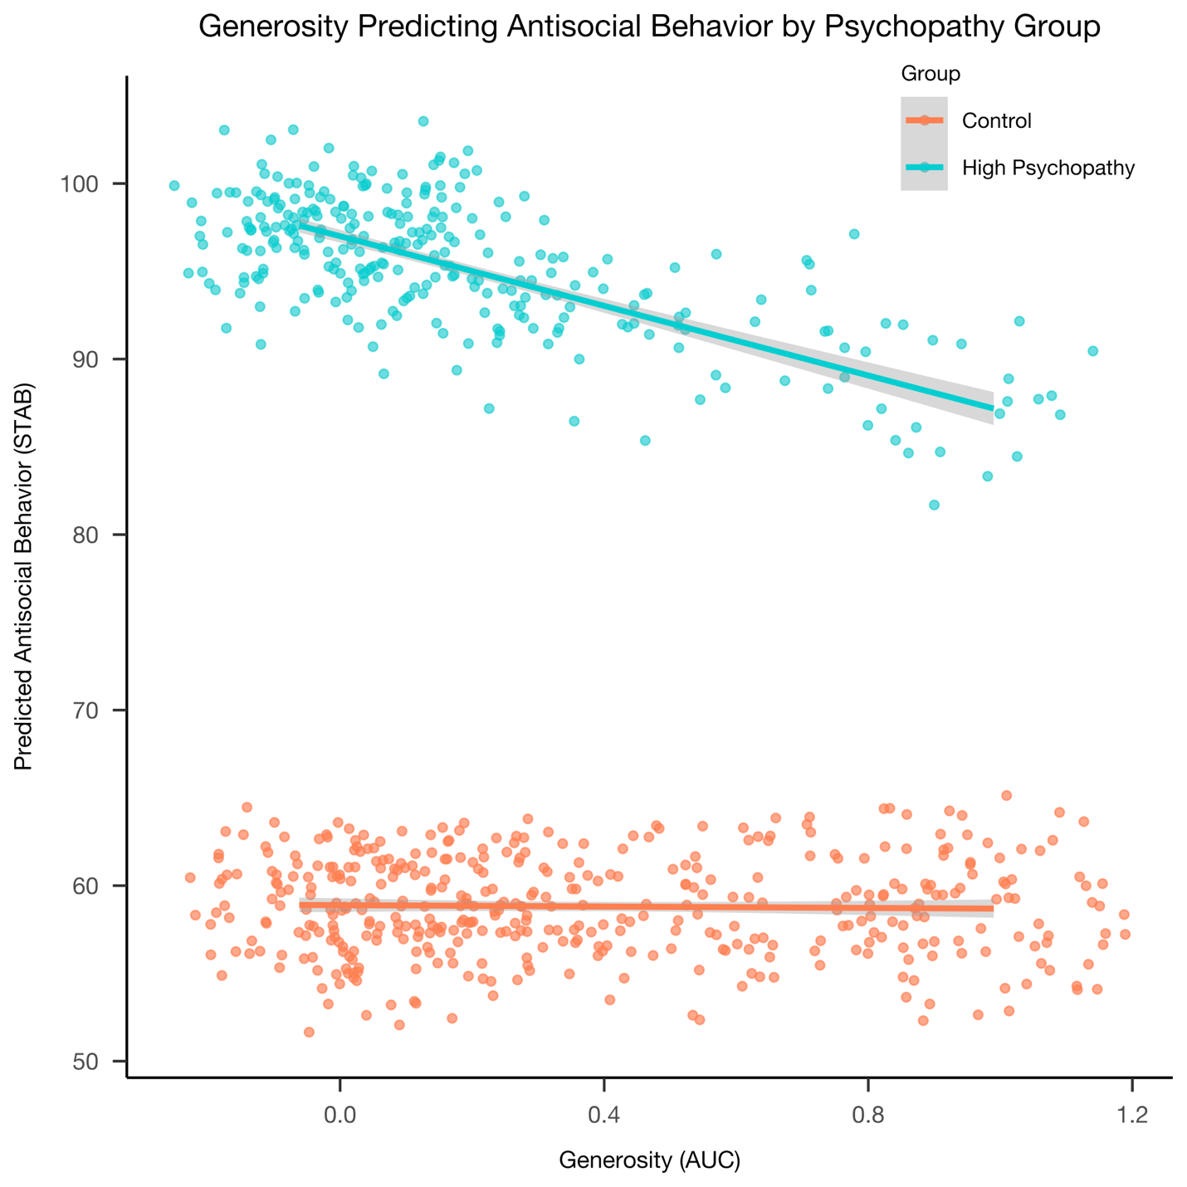
Note. This figure shows predicted antisocial behavior values from the regression model as a function of AUC for each psychopathy group. As AUC increases, antisocial behavior decreases for the high psychopathy group, but not controls.

Table S19
Variable | b (se) | CI | Std. B (se) | Std. CI | p
(Intercept) | 63.41 (3.58) | 59.48, 73.56 | -0.02 (0.03) | -0.07, 0.03 | <.001
High Psychopathy > Controls | 37.35 (1.86) | 33.86, 41.21 | 0.66 (0.03) | 0.60, 0.72 | <.001
AUC | -1.90 (2.44) | -4.32, 5.36 | -0.05 (0.03) | -0.11, 0.01 | .83
Age | -0.05 (0.06) | -0.23, 0.03 | -0.05 (0.03) | -0.10, 0.01 | .11
Male | 1.89 (1.38) | 0.61, 6.03 | 0.06 (0.03) | 0.01, 0.12 | .02
Income | -0.18 (0.33) | -1.39, -0.09 | -0.06 (0.03) | -0.11, -0.01 | .02
Fluid Intelligence | -0.44 (0.34) | -1.16, 0.19 | -0.04 (0.03) | -0.09, 0.02 | .16
High Psychopathy > Controls × AUC | -9.24 (4.46) | -19.07, -1.69 | -0.07 (0.03) | -0.13, -0.01 | .02

Adjusted R2 = 0.50
Interaction Between Psychopathy Group and AUC Predicting Antisocial Behavior (STAB)
*p < .05 in bold

Table S20
Variable | b (se) | CI | Std. B (se) | Std. CI | p
(Intercept) | 29.78 (3.59) | 24.37, 38.57 | 0.00 (0.02) | -0.04, 0.05 | <.001
Psychopathic Traits (TriPM) | 0.57 (0.02) | 0.51, 0.59 | 0.81 (0.03) | 0.76, 0.87 | <.001
AUC | 7.10 (4.03) | -10.07, 5.72 | -0.02 (0.02) | -0.06, 0.03 | .59
Age | 0.02 (0.05) | -0.04, 0.17 | 0.03 (0.02) | -0.02, 0.08 | .25
Gender (Male > Female/Other) | -0.68 (1.16) | -3.16, 1.40 | -0.02 (0.02) | -0.06, 0.03 | .45
Income | -0.38 (0.28) | -1.61, -0.51 | -0.09 (0.02) | -0.13, -0.04 | <.001
Fluid Intelligence | -0.41 (0.28) | -0.79, 0.34 | -0.02 (0.02) | -0.06, 0.03 | .43
Psychopathic Traits × AUC | -0.11 (0.05) | -0.08, 0.11 | 0.01 (0.02) | -0.04, 0.06 | .79

Adjusted R2 = 0.646
Interaction Between Psychopathic Traits and AUC Predicting Antisocial Behavior (STAB)
*p < .05 in bold

Table S21
Variable | b (se) | CI | Std. B (se) | Std. CI | p
(Intercept) | 0.35 (0.07) | 0.21, 0.49 | -0.02 (0.04) | -0.09, 0.06 | <.001
High Psychopathy > Controls | -0.10 (0.09) | -0.28, 0.08 | -0.28 (0.04) | -0.36, -0.20 | .28
Age | 0.00 (0.00) | 0.001, 0.01 | 0.08 (0.04) | 0.002, 0.16 | .01
Male | -0.05 (0.03) | -0.10, -0.003 | -0.07 (0.04) | -0.14, -0.005 | .036
Income | 0.01 (0.01) | -0.004, 0.02 | 0.04 (0.04) | -0.03, 0.11 | .22
Fluid Intelligence | -0.02 (0.01) | -0.03, -0.01 | -0.12 (0.04) | -0.19, -0.05 | .001
High Psychopathy > Controls × Age | 0.00 (0.00) | -0.01, 0.002 | -0.04 (0.04) | -0.13, 0.04 | .29

Adjusted R2 = 0.108
No Interaction Between Psychopathy Group and Age in Predicting AUC
*p < .05 in bold

Table S22
Variable | b (se) | CI | Std. B (se) | Std. CI | p
(Intercept) | 0.39 (0.12) | 0.16, 0.62 | -0.02 (0.04) | -0.10, 0.06 | .001
Psychopathic Traits (TriPM) | 0 (0) | -0.003, 0.001 | -0.27 (0.04) | -0.35, -0.19 | .38
Age | 0.01 (0) | 0.0004, 0.01 | 0.08 (0.04) | -0.003, 0.15 | .04
Male | -0.03 (0.03) | -0.08, 0.02 | -0.05 (0.04) | -0.11, 0.02 | .2
Income | 0.01 (0.01) | -0.004, 0.02 | 0.05 (0.04) | -0.02, 0.12 | .18
Fluid Intelligence | -0.02 (0.01) | -0.03, -0.01 | -0.12 (0.04) | -0.19, -0.05 | .001
Psychopathic Traits × Age | 0.00 (0.00) | -0.0001, 0.00 | -0.05 (0.04) | -0.13, 0.03 | .23

Adjusted R2 = 0.102
No Interaction Between Psychopathic Traits and Age in Predicting AUC
*p < .05 in bold

The following are the results excluding participants who were outside the cutoff for their recruited group

Table S23. Characteristics of High Psychopathy and Control Participants
 | Control | High Psychopathy
N | 349 | 278
Age (SD), range | 41.20 (11.30), 20-77 | 31.23 (8.80), 18-68
Gender
Male | 161 (46.13%) | 120 (43.17%)
Female | 182 (52.15%) | 140 (50.36%)
Other | 6 (1.72%) | 18 (6.47%)
Education
High School or equivalent | 39 (11.17%) | 64 (23.02%)
Some College | 67 (19.20%) | 102 (36.69%)
College degree | 184 (52.72%) | 86 (30.94%)
Graduate degree | 59 (16.91%) | 26 (9.35%)
Household Income
Under $25,000 | 40 (11.46%) | 36 (12.95%)
$25-49,999 | 98 (28.08%) | 63 (22.66%)
$50-74,999 | 84 (24.07%) | 55 (19.78%)
$75-99,999 | 51 (14.61%) | 29 (10.43%)
$100-124,999 | 22 (6.30%) | 26 (9.35%)
$125-149,999 | 15 (4.30%) | 9 (3.24%)
$150-174,999 | 13 (3.72%) | 19 (6.83%)
Over $175,000 | 23 (6.59%) | 30 (10.79%)
Don't Know | 3 (0.86%) | 11 (3.97%)
Race
White, non-Hispanic | 222 (63.61%) | 175 (62.95%)
Black/African American, non-Hispanic | 28 (8.02%) | 15 (5.39%)
Hispanic | 49 (14.04%) | 45 (16.19%)
Other | 50 (14.33%) | 43 (15.47%)
Note. In all models, those who selected “Don’t know” for Income were recoded to the mean income bracket of the sample.

Table S24
Descriptive Statistics of Sample without Transfers

 | Full Sample |  |  |  | Control (n = 349) |  |  |  | High Psychopathy (n = 278)
Variable | M (SD) | Range | Skewness | Kurtosis | M (SD) | Range | Skewness | Kurtosis | M (SD) | Range | Skewness | Kurtosis
Total Psychopathy (TriPM) | 83.30 (39.29) | 19 - 165 | 0.19 | 1.65 | 51.85 (17.65) | 19 - 104 | 0.65 | 2.96 | 122.78 (16.93) | 91 - 165 | 0.28 | 2.54
Meanness | 24.17 (17.16) | 0 - 57 | 0.19 | 1.64 | 10.89 (8.53) | 0 - 37 | 0.84 | 3.01 | 40.84 (8.53) | 17 - 57 | -0.27 | 2.40
Boldness | 33.62 (12.05) | 2 - 57 | -0.30 | 2.43 | 26.93 (10.25) | 2 - 53 | -0.11 | 2.67 | 42.01 (8.31) | 14 - 57 | -0.60 | 2.97
Disinhibition | 25.51 (16.16) | 0 - 58 | 0.17 | 1.74 | 14.03 (9.86) | 0 - 44 | 0.87 | 3.19 | 39.92 (9.68) | 8 - 58 | -0.44 | 2.66
STAB | 73.89 (26.15) | 32 - 155 | 0.45 | 2.42 | 57.05 (18.01) | 32 - 138 | 1.55 | 6.51 | 95.02 (18.24) | 52 - 155 | 0.44 | 3.15
Fluid IQ | 5.37 (2.00) | 0 - 13 | 0.680 | 3.470 | 5.50 (2.04) | 1 - 13 | 0.81 | 3.65 | 5.21 (1.94) | 0 - 10 | 0.48 | 3.04
AUC | 0.28 (0.34) | -0.06 - 0.99 | 0.95 | 2.52 | 0.38 (0.36) | -0.06 - 0.99 | 0.59 | 1.84 | 0.17 (0.28) | -0.06 - 0.99 | 1.56 | 4.53
logk | -1.96 (2.00) | -5.71 - 1.75 | -0.16 | 2.32 | -2.75 (1.80) | -5.71 - 1.34 | 0.00 | 2.38 | -0.98 (1.80) | -5.39 - 1.75 | -0.54 | 2.86

Table S25
Criminal History in Order of Prevalence of Crimes Committed in the High Psychopathy Group
 | Control (n = 349) |  |  | High Psychopathy (n = 278)
 | Committed | Charged | Convicted | Committed | Charged | Convicted
Any | 133 (38.11%) | 68 (19.48%) | 60 (17.19%) | 239 (85.97%) | 101 (36.33%) | 85 (30.58%)
Drug Possession | 57 (16.33%) | 13 (3.72%) | 14 (4.01%) | 181 (65.11%) | 43 (15.47%) | 33 (11.87%)
DUI | 60 (17.19%) | 19 (5.44%) | 23 (6.59%) | 174 (62.59%) | 28 (10.07%) | 27 (9.71%)
Reckless Driving | 47 (13.47%) | 13 (3.72%) | 15 (4.30%) | 168 (60.43%) | 31 (11.15%) | 22 (7.91%)
Vandalism | 31 (8.88%) | 3 (0.86%) | 1 (0.29%) | 158 (56.83%) | 12 (4.32%) | 12 (4.32%)
Larceny | 32 (9.17%) | 11 (3.15%) | 9 (2.58%) | 153 (55.04%) | 22 (7.91%) | 15 (5.40%)
Assault | 16 (4.58%) | 11 (3.15%) | 7 (2.01%) | 120 (43.17%) | 31 (11.15%) | 20 (7.19%)
Intent to Sell Drugs | 21 (6.02%) | 5 (1.43%) | 2 (0.57%) | 111 (39.93%) | 14 (5.04%) | 11 (3.96%)
Truancy | 27 (7.74%) | 3 (0.86%) | 1 (0.29%) | 105 (37.77%) | 14 (5.04%) | 12 (4.32%)
Weapons Possessions | 10 (2.87%) | 3 (0.86%) | 4 (1.15%) | 93 (33.45%) | 0 | 10 (3.6%)
Running Away | 17 (4.87%) | 5 (1.43%) | 4 (1.15%) | 86 (30.94%) | 16 (5.76%) | 13 (4.68%)
Burglary | 7 (2.01%) | 2 (0.57%) | 3 (0.86%) | 80 (28.78%) | 7 (2.52%) | 6 (2.16%)
Arson | 2 (0.57%) | 1 (0.29%) | 1 (0.29%) | 58 (20.86%) | 5 (1.8%) | 2 (0.72%)
Robbery | 6 (1.72%) | 6 (1.72%) | 5 (1.43%) | 55 (19.78%) | 8 (2.88%) | 6 (2.16%)
Prostitution | 2 (0.57%) | 0 (0.00%) | 2 (0.57%) | 49 (17.63%) | 1 (0.36%) | 1 (0.36%)
Autotheft | 4 (1.15%) | 4 (1.15%) | 5 (1.43%) | 26 (9.35%) | 5 (1.8%) | 5 (1.8%)
Rape | 2 (0.57%) | 4 (1.15%) | 5 (1.43%) | 13 (4.68%) | 0 | 0
Murder | 3 (0.86%) | 1 (0.29%) | 3 (0.86%) | 5 (1.80%) | 2 (0.72%) | 0
Gun Violence
Shoot | 3 (0.86%) |  |  | 15 (5.4%)
Rob | 3 (0.86%) |  |  | 14 (5.04%)
Gang | 4 (1.15%) |  |  | 13 (4.68%)
Kill | 1 (0.29%) |  |  | 9 (3.24%)
Carjack | 6 (1.72%) |  |  | 1 (0.36%)

Table S26
Hyperbolic Model Predicting Maximum Willing to Forgo for each Social Distance in High Psychopathy and Control Group

Variable | b | SE | CI | p
(Intercept) | 86.58 | 0.79 | 85.04, 88.12 | <.001
logk, mean discounting rate for controls | -2.26 | 0.42 | -3.09, -1.44 | <.001
High Psychopathy > Controls | 1.63 | 0.18 | 1.27, 1.98 | <.001
Age | -0.02 | 0.01 | -0.03, -0.002 | .02
Gender (Male > Female/Other) | -0.003 | 0.16 | -0.32, 0.32 | .99
Household Income | -0.03 | 0.04 | -0.10, 0.05 | .52
Fluid Intelligence | 0.06 | 0.04 | -0.02, 0.14 | .13

*p < .05 in bold

Table S27
Psychopathy Group Predicting logk

Variable | b (se) | CI | Std. B (se) | Std. CI | p
(Intercept) | -2.26 (0.37) | -2.99, -1.53 | 0.00 (0.04) | -0.07, 0.07 | <.001
High Psychopathy > Controls | 1.63 (0.16) | 1.30, 1.94 | 0.40 (0.04) | 0.33, 0.48 | <.001
Age | -0.02 (0.01) | -0.03, -0.004 | -0.10 (0.04) | -0.18, -0.02 | .01
Gender (Male > Female/Other) | -0.003 (0.15) | -0.29, 0.28 | 0.00 (0.04) | -0.07, 0.07 | .99
Income | -0.03 (0.04) | -0.10, 0.04 | -0.03 (0.04) | -0.10, 0.05 | .47
Fluid Intelligence | 0.06 (0.04) | -0.01, 0.13 | 0.06 (0.04) | -0.01, 0.13 | .09
Adjusted R2 = 0.20

*p < .05 in bold

Table S28
Psychopathic Traits Predicting logk

Variable | b (se) | CI | Std. B (se) | Std. CI | p
(Intercept) | -3.26 (0.43) | -4.10, -2.42 | 0.00 (0.04) | -0.07, 0.07 | <.001
Psychopathic Traits (TriPM) | 0.02 (0.00) | 0.016, 0.024 | 0.41 (0.04) | 0.33, 0.49 | <.001
Age | -0.02 (0.01) | -0.03, -0.005 | -0.10 (0.04) | -0.18, -0.03 | .01
Gender (Male > Female and Other) | -0.17 (0.14) | -0.45, 0.12 | -0.04 (0.04) | -0.11, 0.03 | .25
Income | -0.03 (0.04) | -0.10, 0.04 | -0.03 (0.04) | -0.11, 0.04 | .37
Fluid Intelligence | 0.08 (0.04) | 0.01, 0.15 | 0.08 (0.04) | 0.01, 0.15 | .03
Adjusted R2 = 0.21

*p < .05 in bold

Table S29
Psychopathy Group Predicting AUC

Variable | b (se) | CI | Std. B (se) | Std. CI | p
(Intercept) | 0.39 (0.07) | 0.26, 0.53 | 0.00 (0.04) | -0.07, 0.07 | <.001
High Psychopathy > Controls | -0.19 (0.03) | -0.25, -0.14 | -0.28 (0.04) | -0.37, -0.19 | <.001
Age | 0.002 (0.00) | -0.0004, 0.005 | 0.07 (0.04) | -0.01, 0.15 | .10
Gender (Male > Female/Other) | -0.04 (0.03) | -0.09, 0.01 | -0.05 (0.04) | -0.13, 0.02 | .16
Income | -0.003 (0.01) | -0.02, 0.01 | -0.02 (0.04) | -0.09, 0.06 | .66
Fluid Intelligence | -0.01 (0.01) | -0.03, -0.002 | -0.08 (0.04) | -0.16, -0.01 | .03
Adjusted R2 = 0.103
*p < .05 in bold

Table S30
Psychopathic Traits Predicting AUC

Variable | b (se) | CI | Std. B (se) | Std. CI | p
(Intercept) | 0.48 (0.08) | 0.32, 0.63 | 0.00 (0.04) | -0.07, 0.07 | <.001
Psychopathic Traits (TriPM) | -0.002 (0.00) | -0.003, -0.002 | -0.26 (0.04) | -0.34, -0.17 | <.001
Age | 0.003 (0.00) | 0.0001, 0.005 | 0.09 (0.04) | 0.002, 0.17 | .05
Gender (Male > Female/Other) | -0.02 (0.03) | -0.07, 0.03 | -0.03 (0.04) | -0.10, 0.05 | .49
Income | -0.003 (0.01) | -0.02, 0.01 | -0.02 (0.04) | -0.09, 0.06 | .68
Fluid Intelligence | -0.02 (0.01) | -0.03, -0.003 | -0.09 (0.04) | -0.17, -0.02 | .02
Adjusted R2 = 0.091
*p < .05 in bold

Table S31
Meanness and Disinhibition Predicting Social Discounting Rate (logK)

Variable | b (se) | CI | Std. B (se) | Std. CI | p
(Intercept) | -2.88 (0.43) | -3.73, -2.03 | 0.00 (0.04) | -0.07, 0.07 | <.001
Meanness | 0.05 (0.01) | 0.04, 0.07 | 0.44 (0.07) | 0.30, 0.58 | <.001
Disinhibition | 0.01 (0.01) | -0.01, 0.02 | 0.04 (0.06) | -0.08, 0.16 | .509
Boldness | -0.01 (0.01) | -0.02, 0.01 | -0.04 (0.05) | -0.13, 0.04 | .32
Age | -0.01 (0.01) | -0.03, 0.001 | -0.07 (0.04) | -0.15, 0.005 | .07
Gender (Male > Female and Other) | -0.15 (0.14) | -0.43, 0.13 | -0.04 (0.04) | -0.11, 0.03 | .30
Income | -0.02 (0.04) | -0.09, 0.05 | -0.02 (0.04) | -0.09, 0.05 | .60
Fluid Intelligence | 0.08 (0.04) | 0.004, 0.15 | 0.08 (0.04) | 0.004, 0.15 | .04
Adjusted R2 = 0.23
*p < .05 in bold

Table S32
Meanness Predicting AUC

Variable | b (se) | CI | Std. B (se) | Std. CI | p
(Intercept) | 0.41 (0.08) | 0.25, 0.56 | 0.00 (0.04) | -0.07, 0.07 | <.001
Meanness | -0.01 (0.00) | -0.01, -0.01 | -0.42 (0.08) | -0.57, -0.27 | <.001
Disinhibition | 0.001 (0.00) | -0.001, 0.004 | 0.07 (0.07) | -0.06, 0.20 | .30
Boldness | 0.003 (0.00) | 0, 0.01 | 0.09 (0.05) | 0.0001, 0.19 | .05
Age | 0.002 (0.00) | -0.001, 0.004 | 0.05 (0.04) | -0.03, 0.14 | .20
Gender (Male > Female and Other) | -0.02 (0.03) | -0.07, 0.03 | -0.03 (0.04) | -0.10, 0.05 | .44
Income | -0.004 (0.01) | -0.02, 0.01 | -0.03 (0.04) | -0.10, 0.05 | .51
Fluid Intelligence | -0.02 (0.01) | -0.03, -0.003 | -0.09 (0.04) | -0.17, -0.02 | .02
Adjusted R2 = 0.12
*p < .05 in bold

Table S33
logk Does Not Mediate the Relationship Between Psychopathy Group and Antisocial Behavior

 | logk (M) |  |  |  | STAB (Y)
Variable | path | b (se) | Std. B (se) | p | path | b (se) | Std. B (se) | p
(Intercept) | im | -2.26 (0.37) | 0.00 (0.04) | <.001 | iy | 66.01 (3.86) | 0.00 (0.03) | <.001
High Psychopathy > Controls | a | 1.63 (0.16) | 0.40 (0.04) | <.001 | c' | 36.23 (1.75) | 0.69 (0.03) | <.001
logk |  |  |  |  | b | 0.82 (0.40) | 0.06 (0.03) | .05
Age |  | -0.02 (0.01) | -0.10 (0.04) | .01 |  | -0.05 (0.07) | -0.02 (0.03) | .513
Gender (Male > Female/Other) |  | -0.003 (0.15) | -0.001 (0.04) | .99 |  | 3.33 (1.45) | 0.06 (0.03) | .02
Income |  | -0.03 (0.04) | -0.03 (0.04) | .47 |  | -0.75 (0.36) | -0.06 (0.03) | .04
Fluid Intelligence |  | 0.06 (0.04) | 0.06 (0.04) | .09 |  | -0.69 (0.37) | -0.05 (0.03) | .06
 | Adjusted R2 = 0.202 |  |  |  | Adjusted R2 = 0.53

Note: the value of the indirect effect was b = 1.33, p = .068; the value of the direct effect (path c) was b = 36.23, p < .001 and the value of the total effect was b = 37.56, p < .001. logk did not mediate the relationship between psychopathy group and antisocial behavior.

*p < .05 in bold

Table S34
logk Does Not Mediate the Relationship Between Psychopathic Traits and Antisocial Behavior

 | logk (M) |  |  |  | STAB (Y)
Variable | path | b (se) | Std. B (se) | p | path | b (se) | Std. B (se) | p
(Intercept) | im | -3.26 (0.43) | 0.00 (0.04) | <.001 | iy | 32.04 (3.80) | 0.00 (0.02) | <.001
Psychopathic Traits | a | 0.02 (0.00) | 0.41 (0.04) | <.001 | c' | 0.55 (0.02) | 0.82 (0.03) | <.001
logk |  |  |  |  | b | 0.16 (0.34) | 0.01 (0.03) | .64
Age |  | -0.02 (0.01) | -0.10 (0.04) | .01 |  | 0.04 (0.06) | 0.02 (0.03) | .54
Gender (Male > Female/Other) |  | -0.17 (0.14) | -0.04 (0.04) | .25 |  | -0.63 (1.23) | -0.01 (0.02) | .61
Income |  | -0.03 (0.04) | -0.03 (0.04) | .37 |  | -1.10 (0.30) | -0.09 (0.02) | <.001
Fluid Intelligence |  | 0.08 (0.04) | 0.08 (0.04) | .03 |  | -0.13 (0.31) | -0.01 (0.02) | .68
 | Adjusted R2 = 0.206 |  |  |  | Adjusted R2 = 0.666

Note: The value of the indirect effect was b = 0.003, p = .68; the value of the direct effect (path c) was b = 0.55, p < .001 and the value of the total effect was b = 0.55, p < .001. Logk did not significantly mediate the relationship between psychopathic traits and antisocial behavior (STAB).

*p < .05 in bold

Table S35
AUC Does Not Mediate the Relationship Between Psychopathy Group and Antisocial Behavior
 | AUC (M) |  |  |  | STAB (Y)
Variable | path | b (se) | Std. B (se) | p | path | b (se) | Std. B (se) | p
(Intercept) | im | 0.39 (0.07) | 0.00 (0.04) | <.001 | iy | 64.73 (3.86) | 0.00 (0.03) | <.001
High Psychopathy > Controls | a | -0.19 (0.03) | -0.28 (0.04) | <.001 | c' | 37.28 (1.68) | 0.71 (0.03) | <.001
AUC |  |  |  |  | b | -1.45 (2.23) | -0.02 (0.03) | .52
Age |  | 0.002 (0.001) | 0.07 (0.04) | .10 |  | -0.06 (0.07) | -0.03 (0.03) | .41
Gender (Male > Female/Other) |  | -0.04 (0.03) | -0.05 (0.04) | .16 |  | 3.28 (1.46) | 0.06 (0.03) | .03
Income |  | 0.00 (0.01) | -0.02 (0.04) | .66 |  | -0.78 (0.36) | -0.06 (0.03) | .03
Fluid Intelligence |  | -0.01 (0.01) | -0.08 (0.04) | .02 |  | -0.66 (0.37) | -0.05 (0.03) | .07
 | Adjusted R2 = 0.103 |  |  |  | Adjusted R2 = 0.528

Note: the value of the indirect effect was b = 0.28, p = .58; the value of the direct effect (path c) was b = 37.28, p < .001 and the value of the total effect was b = 37.56, p < .001. AUC did not mediate the relationship between psychopathy group and antisocial behavior (STAB).

*p < .05 in bold

Table S36
AUC Does Not Mediate the Relationship Between Psychopathic Traits and Antisocial Behavior
 | AUC (M) |  |  |  | STAB (Y)
Variable | path | b (se) | Std. B (se) | p | path | b (se) | Std. B (se) | p
(Intercept) | im | 0.48 (0.08) | 0.00 (0.04) | <.001 | iy | 31.90 (3.74) | 0.00 (0.02) | <.001
Psychopathic Traits | a | 0.00 (0.00) | -0.26 (0.04) | <.001 | c' | 0.55 (0.02) | 0.83 (0.03) | <.001
AUC |  |  |  |  | b | -0.79 (1.86) | -0.01 (0.02) | .67
Age |  | 0.003 (0.00) | 0.09 (0.04) | .05 |  | 0.04 (0.06) | 0.02 (0.03) | .55
Gender (Male > Female/Other) |  | -0.02 (0.03) | -0.03 (0.04) | .49 |  | -0.67 (1.22) | -0.01 (0.02) | .58
Income |  | 0.00 (0.01) | -0.02 (0.04) | .68 |  | -1.11 (0.30) | -0.09 (0.02) | <.001
Fluid Intelligence |  | -0.02 (0.01) | -0.09 (0.04) | .02 |  | -0.13 (0.31) | -0.01 (0.02) | .68
 | Adjusted R2 = 0.091 |  |  |  | Adjusted R2 = 0.666

Note: the value of the indirect effect was b = 0.002, p = .69; the value of the direct effect (path c) was b = 0.55, p < .001 and the value of the total effect was b = 0.55, p < .001. AUC did not mediate relationship between psychopathic traits and antisocial behavior (STAB).

*p < .05 in bold

Table S37
Interaction Between Psychopathy Group and logk Predicting Antisocial Behavior (STAB)

Variable | b (se) | CI | Std. B (se) | Std. CI | p
(Intercept) | 61.39 (3.94) | 53.64, 69.13 | -0.06 (0.03) | -0.12, -0.0001 | <.001
High Psychopathy > Controls | 42.32 (2.21) | 37.99, 46.65 | 0.67 (0.03) | 0.61, 0.74 | <.001
logk | -0.76 (0.53) | -1.81, 0.29 | 0.06 (0.03) | 0.002, 0.12 | .16
Age | -0.06 (0.07) | -0.19, 0.07 | -0.03 (0.03) | -0.09, 0.03 | .37
Male | 3.92 (1.44) | 1.09, 6.74 | 0.07 (0.03) | 0.02, 0.13 | .01
Income | -0.70 (0.35) | -1.39, -0.004 | -0.05 (0.03) | -0.11, -0.0003 | .05
Fluid Intelligence | -0.60 (0.36) | -1.31, 0.11 | -0.05 (0.03) | -0.10, 0.01 | .10
High Psychopathy > Controls × logk | 3.53 (0.80) | 1.96, 5.10 | 0.13 (0.03) | 0.07, 0.19 | <.001
Adjusted R2 = 0.54
*p < .05 in bold

Table S38
Interaction Between Psychopathic Traits and logk Predicting Antisocial Behavior (STAB)

Variable | b (se) | CI | Std. B (se) | Std. CI | p
(Intercept) | 30.92 (4.00) | 23.05, 38.78 | -0.01 (0.03) | -0.06, 0.04 | <.001
Psychopathic Traits (TriPM) | 0.56 (0.02) | 0.52, 0.60 | 0.82 (0.03) | 0.76, 0.88 | <.001
logk | -0.48 (0.79) | -2.03, 1.07 | 0.01 (0.03) | -0.04, 0.06 | .54
Age | 0.03 (0.06) | -0.09, 0.15 | 0.01 (0.03) | -0.04, 0.06 | .61
Gender (Male > Female/Other) | -0.51 (1.23) | -2.93, 1.91 | -0.01 (0.02) | -0.06, 0.04 | .68
Income | -1.09 (0.30) | -1.69, -0.49 | -0.09 (0.02) | -0.13, -0.04 | <.001
Fluid Intelligence | -0.12 (0.31) | -0.73, 0.49 | -0.01 (0.02) | -0.06, 0.04 | .69
Psychopathic Traits × logk | 0.01 (0.01) | -0.01, 0.02 | 0.02 (0.03) | -0.03, 0.07 | .37
Adjusted R2 = 0.67

*p < .05 in bold

Table S39
No Interaction Between Psychopathy Group and AUC Predicting Antisocial Behavior (STAB)

Variable | b (se) | CI | Std. B (se) | Std. CI | p
(Intercept) | 31.66 (3.82) | 24.16, 39.17 | 0.00 (0.02) | -0.05, 0.05 | <.001
High Psychopathy > Controls | 0.55 (0.02) | 0.51, 0.59 | 0.82 (0.03) | 0.77, 0.88 | <.001
AUC | 0.41 (4.23) | -7.89, 8.71 | -0.01 (0.03) | -0.06, 0.04 | .92
Age | 0.03 (0.06) | -0.08, 0.15 | 0.01 (0.03) | -0.04, 0.07 | .57
Male | -0.65 (1.23) | -3.06, 1.76 | -0.01 (0.02) | -0.06, 0.03 | .59
Income | -1.11 (0.30) | -1.70, -0.51 | -0.09 (0.02) | -0.13, -0.04 | <.001
Fluid Intelligence | -0.13 (0.31) | -0.74, 0.48 | -0.01 (0.02) | -0.06, 0.04 | .68
High Psychopathy > Controls × AUC | -0.02 (0.05) | -0.12, 0.08 | -0.01 (0.03) | -0.06, 0.04 | .75
Adjusted R2 = 0.66

*p < .05 in bold

Table S40
Interaction Between Psychopathic Traits and AUC Predicting Antisocial Behavior (STAB)

Variable | b (se) | CI | Std. B (se) | Std. CI | p
(Intercept) | 62.60 (3.86) | 55.02, 70.19 | -0.04 (0.03) | -0.09, 0.02 | <.001
Psychopathic Traits (TriPM) | 41.31 (1.98) | 37.43, 45.19 | 0.69 (0.03) | 0.63, 0.75 | <.001
AUC | 4.34 (2.69) | -0.94, 9.63 | -0.05 (0.03) | -0.10, 0.01 | .11
Age | -0.07 (0.07) | -0.21, 0.07 | -0.03 (0.03) | -0.09, 0.03 | .32
Gender (Male > Female/Other) | 3.51 (1.45) | 0.67, 6.36 | 0.07 (0.03) | 0.01, 0.12 | .02
Income | -0.73 (0.36) | -1.44, -0.03 | -0.06 (0.03) | -0.11, -0.003 | .04
Fluid Intelligence | -0.63 (0.36) | -1.34, 0.09 | -0.05 (0.03) | -0.10, 0.01 | .09
Psychopathic Traits × AUC | -17.70 (4.70) | -26.92, -8.48 | -0.11 (0.03) | -0.17, -0.06 | <.001
Adjusted R2 = 0.54
*p < .05 in bold

Table S41
No Interaction Between Psychopathy Group and Age in Predicting logk

Variable | b (se) | CI | Std. B (se) | Std. CI | p
(Intercept) | -2.05 (0.43) | -2.89, -1.21 | 0.02 (0.04) | -0.06, 0.10 | <.001
High Psychopathy > Controls | 1.11 (0.54) | 0.05, 2.17 | 0.41 (0.04) | 0.33, 0.49 | .04
Age | -0.02 (0.01) | -0.04, -0.01 | -0.09 (0.04) | -0.17, -0.01 | .01
Male | -0.01 (0.15) | -0.29, 0.28 | 0.00 (0.04) | -0.07, 0.07 | .96
Income | -0.03 (0.04) | -0.10, 0.04 | -0.03 (0.04) | -0.10, 0.04 | .41
Fluid Intelligence | 0.06 (0.04) | -0.01, 0.13 | 0.06 (0.04) | -0.01, 0.13 | .09
High Psychopathy > Controls × Age | 0.02 (0.02) | -0.01, 0.04 | 0.04 (0.04) | -0.04, 0.13 | .32
Adjusted R2 = 0.20

*p < .05 in bold

Table S42
No Interaction Between Psychopathic Traits and Age in Predicting logk

Variable | b (se) | CI | Std. B (se) | Std. CI | p
(Intercept) | -2.83 (0.67) | -4.14, -1.52 | 0.01 (0.04) | -0.06, 0.09 | <.001
Psychopathic Traits (TriPM) | 0.02 (0.01) | 0.003, 0.03 | 0.42 (0.04) | 0.34, 0.50 | .02
Age | -0.03 (0.02) | -0.06, -0 | -0.10 (0.04) | -0.18, -0.01 | .05
Male | -0.17 (0.14) | -0.46, 0.11 | -0.04 (0.04) | -0.11, 0.03 | .24
Income | -0.04 (0.04) | -0.11, 0.04 | -0.04 (0.04) | -0.11, 0.04 | .32
Fluid Intelligence | 0.08 (0.04) | 0.01, 0.15 | 0.08 (0.04) | 0.01, 0.15 | .03
Psychopathic Traits × Age | 0.0002 (0.00) | -0.0002, 0.001 | 0.03 (0.04) | -0.05, 0.11 | .40
Adjusted R2 = 0.21

*p < .05 in bold

Table S43
No Interaction Between Psychopathy Group and Age in Predicting AUC

Variable | b (se) | CI | Std. B (se) | Std. CI | p
(Intercept) | 0.35 (0.08) | 0.19, 0.50 | -0.02 (0.04) | -0.11, 0.06 | <.001
High Psychopathy > Controls | -0.09 (0.10) | -0.28, 0.10 | -0.29 (0.04) | -0.38, -0.21 | .37
Age | 0.003 (0.00) | 0.0001, 0.01 | 0.06 (0.04) | -0.03, 0.14 | .04
Male | -0.04 (0.03) | -0.09, 0.02 | -0.05 (0.04) | -0.13, 0.02 | .17
Income | -0.002 (0.01) | -0.01, 0.01 | -0.01 (0.04) | -0.09, 0.07 | .77
Fluid Intelligence | -0.01 (0.01) | -0.03, -0.002 | -0.09 (0.04) | -0.16, -0.01 | .03
High Psychopathy > Controls × Age | -0.003 (0.00) | -0.01, 0.002 | -0.05 (0.04) | -0.14, 0.04 | .25
Adjusted R2 = 0.1034

*p < .05 in bold

Table S44
No Interaction Between Psychopathic Traits and Age in Predicting AUC

Variable | b (se) | CI | Std. B (se) | Std. CI | p
(Intercept) | 0.36 (0.12) | 0.12, 0.59 | -0.02 (0.04) | -0.11, 0.06 | .004
Psychopathic Traits (TriPM) | -0.001 (0.00) | -0.003, 0.002 | -0.26 (0.04) | -0.35, -0.18 | .55
Age | 0.01 (0.00) | 0.0003, 0.01 | 0.07 (0.04) | -0.01, 0.16 | .04
Male | -0.02 (0.03) | -0.07, 0.03 | -0.02 (0.04) | -0.10, 0.05 | .52
Income | -0.002 (0.01) | -0.01, 0.01 | -0.01 (0.04) | -0.09, 0.07 | .79
Fluid Intelligence | -0.02 (0.01) | -0.03, -0.003 | -0.09 (0.04) | -0.17, -0.02 | .02
Psychopathic Traits × Age | 0.00 (0.00) | -0.0001, 0 | -0.06 (0.04) | -0.14, 0.03 | .20
Adjusted R2 = 0.09

*p < .05 in bold

