APPENDICES
APPENDIX A - Prior organization of statements by categories (profile, motivations, priorities, repertoires, mix).
Profile | Repertoires
I participate in other social movements | I do/would do things to draw attention to climate justice that I don't normally do in my day-to-day life (public speaking, going to marches, giving interviews)
Young people who advocate for climate justice are gaining political recognition in Brazil today | I would never risk my safety to draw attention to climate justice (going to jail, protesting by tying myself to a tree, or gluing myself to the ground)
In Brazil, climate justice is an organized social movement | I think marches for climate justice are important
The stereotype of white, middle-class, hippie environmentalists is also repeated in climate justice activism | Climate justice activism needs to be more disruptive in Brazil (consider disruptive actions that shock the public, such as interrupting meetings in a flashy way or lying on the ground pretending to be dead with some identification of your message)
Climate justice is academic and elitist | There should not be moderate and radical strands in climate justice activism in Brazil because this divides the movement, the same strategies should be used in different subgroups
Most leaders advocating for climate justice in Brazil are not white people | The Brazilian federal government has done a good job including climate justice in its environmental agenda
I identify with climate justice activists wherever they are from, because I understand that we fight for the same goals | I would express support for climate justice only on the internet (digital activism)
There are aspects of the climate justice movement that I do not support
Climate justice activism is much more a way of expressing discontent than an efficient way of achieving change
Motivations | Mix
My greatest motivation to fight for climate justice comes from experiencing climate injustices in the territory where I live/have lived | I would participate in a Conference of the Parties
My greatest motivation to fight for climate justice comes from studying the topic | I would participate in marches for climate justice
I have difficult feelings regarding the fight for climate justice (anxiety, inertia, sadness, anger) | I have already been paid for some action I have taken for climate justice
I have positive feelings regarding the fight for climate justice (inspiration, hope, belonging) | I think climate justice is radical (consider radical something that breaks social norms and seeks to transform the entire system, from values ​​to institutions)
I am inspired by environmental organizations to talk about climate justice | How much do you agree or disagree with disruptive nonviolent actions, such as throwing soup at a work of art or blocking a busy avenue?
I am inspired by actions in other countries to talk about climate justice | How much do you agree or disagree with moderate actions such as donating to environmental organizations and signing petitions?
What motivates me to continue studying and talking about climate justice is the possibility of funding for working on this topic
I don't think I will see climate justice being done in my generation
Priorities
Young people should get involved in climate justice activism
Climate justice should be discussed at the Conference of the Parties
Climate justice does not need to be explicitly described in public policies
Climate injustices are not about colonialism because they are new problems
There should be a general and global definition of what climate justice is and, based on it, each nation/place/group that wants to appropriate it, defines its own principles
I think climate justice is anti-capitalist
Intersectionality is a central theme for climate justice
Climate justice is nothing more than social justice
I would support a group of climate justice activists that did not discuss issues of race, gender or social class
I think that new terms, such as "climate justice" do not help in historical struggles against racism and social inequality
The demarcation of indigenous lands is a social issue and not a climate issue
I am in favor of the idea of ​​economic degrowth
The carbon market is a viable complementary option for reducing GHG emissions

APPENDIX B - List of statements and questions from the questionnaire applied.

List of statements (Q-set)
- I participate in other social movements
- Young people who advocate for climate justice have political recognition in Brazil today
- In Brazil, climate justice is an organized social movement
- The stereotype of hippie, white, middle-class environmentalists is also repeated in climate justice activism
- Climate justice is academic and elitist
- Most leaders advocating for climate justice in Brazil are people of color
- I identify with climate justice activists wherever they are, because I understand that we fight for the same goals
- There are aspects of the climate justice movement that I do not support
- Climate justice activism is much more a way of expressing discontent than an efficient way of achieving change
- My greatest motivation to fight for climate justice comes from experiencing climate injustices in the territory where I live/lived
- My greatest motivation to fight for climate justice comes from studies on the subject
- I have difficult feelings regarding the fight for climate justice (anxiety, inertia, sadness, anger)
- I have positive feelings regarding the fight for climate justice (inspiration, hope, belonging)
- I am inspired by environmental organizations to talk about climate justice
- I am inspired by actions in other countries to talk about climate justice
- What motivates me to continue studying and talking about climate justice is the possibility of funding for working on this topic
- I don't think I will see climate justice being done in my generation
- Young people should get involved in climate justice activism
- Climate justice should be discussed at the Conference of the Parties
- Climate justice does not need to be explicitly described in public policies
- Climate injustices have nothing to do with colonialism because they are new problems
- There should be a general and global definition of what climate justice is and, based on it, each nation/place/group that wants to appropriate it, defines its own principles
- I think climate justice is anti-capitalist
- Intersectionality is a central theme for climate justice
- Climate justice is nothing more than social justice
- I would support a group of climate justice activists that did not discuss issues of race, gender or social class
- I think that new terms, such as "climate justice" do not help in historical struggles against racism and social inequality
- The demarcation of indigenous lands is a social issue, not a climate issue
- I am in favor of the idea of ​​economic degrowth
- The carbon market is a viable complementary option for reducing GHG emissions
- I do/would do things to draw attention to climate justice that I don't normally do in my day-to-day life (public speaking, going to marches, giving interviews)
- I would never put my safety at risk to draw attention to climate justice (going to jail, protesting by tying myself to a tree, or sticking myself to the ground)
- I think marches for climate justice are important
- Climate justice activism needs to be more disruptive in Brazil (consider disruptive actions that shock the public, such as interrupting meetings in a flashy way or lying on the ground pretending to be dead with some identification of your message)
- There should not be moderate and radical strands in climate justice activism in Brazil because this divides the movement; the same strategies should be used in different subgroups
- The Brazilian federal government has done a good job including climate justice in your environmental agenda
- I would express support for climate justice only online (digital activism)
- I would participate in a Conference of the Parties
- I would participate in marches for climate justice
- I have already been paid for some action I have taken for climate justice
- I think climate justice is radical (consider radical something that breaks social norms and seeks to transform the entire system, from values ​​to institutions)
- How much do you agree or disagree with disruptive nonviolent actions, such as throwing soup at a work of art or blocking a busy avenue?
- How much do you agree or disagree with moderate actions such as donating to environmental organizations and signing petitions?

Social data
- Age
- Gender
- cis woman
- trans woman
- cis man
- trans man
- non-binary
- other
- Color or race
- black
- brown
- indigenous
- white
- yellow
- Place of birth (city/state)
- Occupation (consider your main source of income)
- Freelance professional/self-employed without ties (e.g. lawyer, psychologist, street vendor, painter)
- Employed in the public sector (e.g. teacher, civil servant)
- Employed in the private sector (e.g. marketing analyst, engineer, salesperson)
- Employed in the third sector (e.g. NGOs, OSCIPs, support entities)
- Businesswoman or owner of own business
- Student (scholarship holder, intern)
- Unemployed

Open questions
- What was the influence that made you start following/discussing climate justice? (experience, study, friends, news)
- Name five words/themes that you think should inevitably be part of any action/discussion for climate justice.
- What organizations in Brazil do you know that work with climate justice?
- Can you recommend someone from your region (i.e., North, Northeast, Midwest, South or Southeast) and within the age range of this survey (up to 30 years old) who might be interested in responding as well? Please provide this person's first and last name and contact information (email, cell phone, and/or social network, such as Instagram, LinkedIn).

Yes/No
- Would you be interested and willing to participate in another stage of this survey on another day in November/December? (interview, focus group)

APPENDIX C - Factors extracted after the principal component analysis of the correlation matrix.
 | Factor 1 | Factor 2 | Factor 3 | Factor 4 | Factor 5 | Factor 6 | Factor 7 | Factor 8
Eigenvalues | 8.7408 | 1.283 | 0.9182 | 0.786 | 0.6433 | 0.5954 | 0.5783 | 0.5092
Explained variance | 55 | 8 | 6 | 5 | 4 | 4 | 4 | 3
Cumulative variance explained | 55 | 63 | 69 | 74 | 78 | 82 | 86 | 89

Source: Author's own.
APPENDIX D - Scree Plot generated from Eigenvalues.
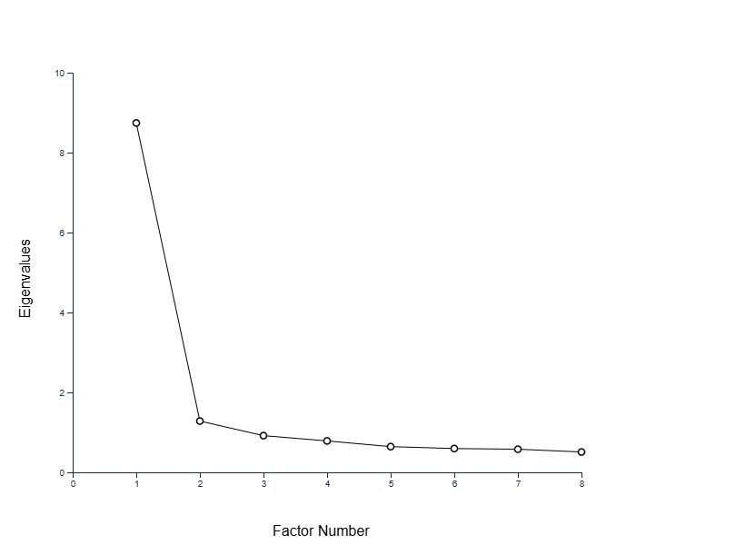
Source: Author's own.

APPENDIX E - Results of the analysis of social factors and data.

 | Number of participant | Factor 1 | Factor 2 | Color/race | Gender | Age | State | Occupation
Group 1  (n = 11) | 4 | 0,8166* | 0,2192 | white | cis woman | 27 | RJ | Employee in the third sector (e.g. NGOs, OSCIPs, support entities)
Group 1  (n = 11) | 9 | 0,7971* | 0,3689 | white | other | 24 | RS | Employee in the public sector (e.g. teacher, civil servant)
Group 1  (n = 11) | 10 | 0,758* | 0,1611 | white | cis man | 28 | SP | Employee in the third sector (e.g. NGOs, OSCIPs, support entities)
Group 1  (n = 11) | 3 | 0,7501* | 0,2407 | black | cis man | 23 | RJ | Employee in the third sector (e.g. NGOs, OSCIPs, support entities)
Group 1  (n = 11) | 6 | 0,7426* | 0,2028 | white | cis man | 21 | RJ | Employee in the third sector (e.g. NGOs, OSCIPs, support entities)
Group 1  (n = 11) | 15 | 0,6636* | 0,5289 | white | cis man | 28 | RJ | Freelance/self-employed professional without ties (e.g. lawyer, psychologist, street vendor, painter)
Group 1  (n = 11) | 16 | 0,6354* | 0,4994 | white | cis woman | 27 | SP | Employee in the private sector (e.g. marketing analyst, engineer, salesperson)
Group 1  (n = 11) | 14 | 0,6124* | 0,402 | brown | cis woman | 23 | TO | Unemployed
Group 1  (n = 11) | 2 | 0,5966* | 0,2449 | black | cis woman | 20 | RJ | Student (scholarship holder, intern)
Group 1  (n = 11) | 5 | 0,5402* | 0,4447 | black | cis woman | 24 | PA | Freelance/self-employed professional without ties (e.g. lawyer, psychologist, street vendor, painter)
Group 1  (n = 11) | 1 | 0,4908* | 0,4413 | black | cis woman | 23 | AL | Unemployed
Group 2  (n = 5) | 13 | 0,3738 | 0,8095* | indigenous | cis woman | 28 | PA | Employee in the third sector (e.g. NGOs, OSCIPs, support entities)
Group 2  (n = 5) | 7 | 0,3584 | 0,7906* | black | cis woman | 21 | MA | Student (scholarship holder, intern)
Group 2  (n = 5) | 12 | 0,1495 | 0,7604* | black | cis man | 23 | TO | Student (scholarship holder, intern)
Group 2  (n = 5) | 8 | 0,1704 | 0,7287* | black | cis woman | 26 | RJ | Employee in the private sector (e.g. marketing analyst, engineer, salesperson)
Group 2  (n = 5) | 11 | 0,602 | 0,6337* | black | cis woman | 26 | SP | Freelance/self-employed professional without ties (e.g. lawyer, psychologist, street vendor, painter)
Note: Participants are ranked according to how much their Q-sort corresponds to their factor (factor loadings), from 1 to -1, at a probability level of P < 0.05.
* represents the Q-sorts that are determinant for the factor; in this case, all participants are equally determinant for their respective factors, with P < 0.05.

APPENDIX F - “Ideal” Qsort for Factor 1.
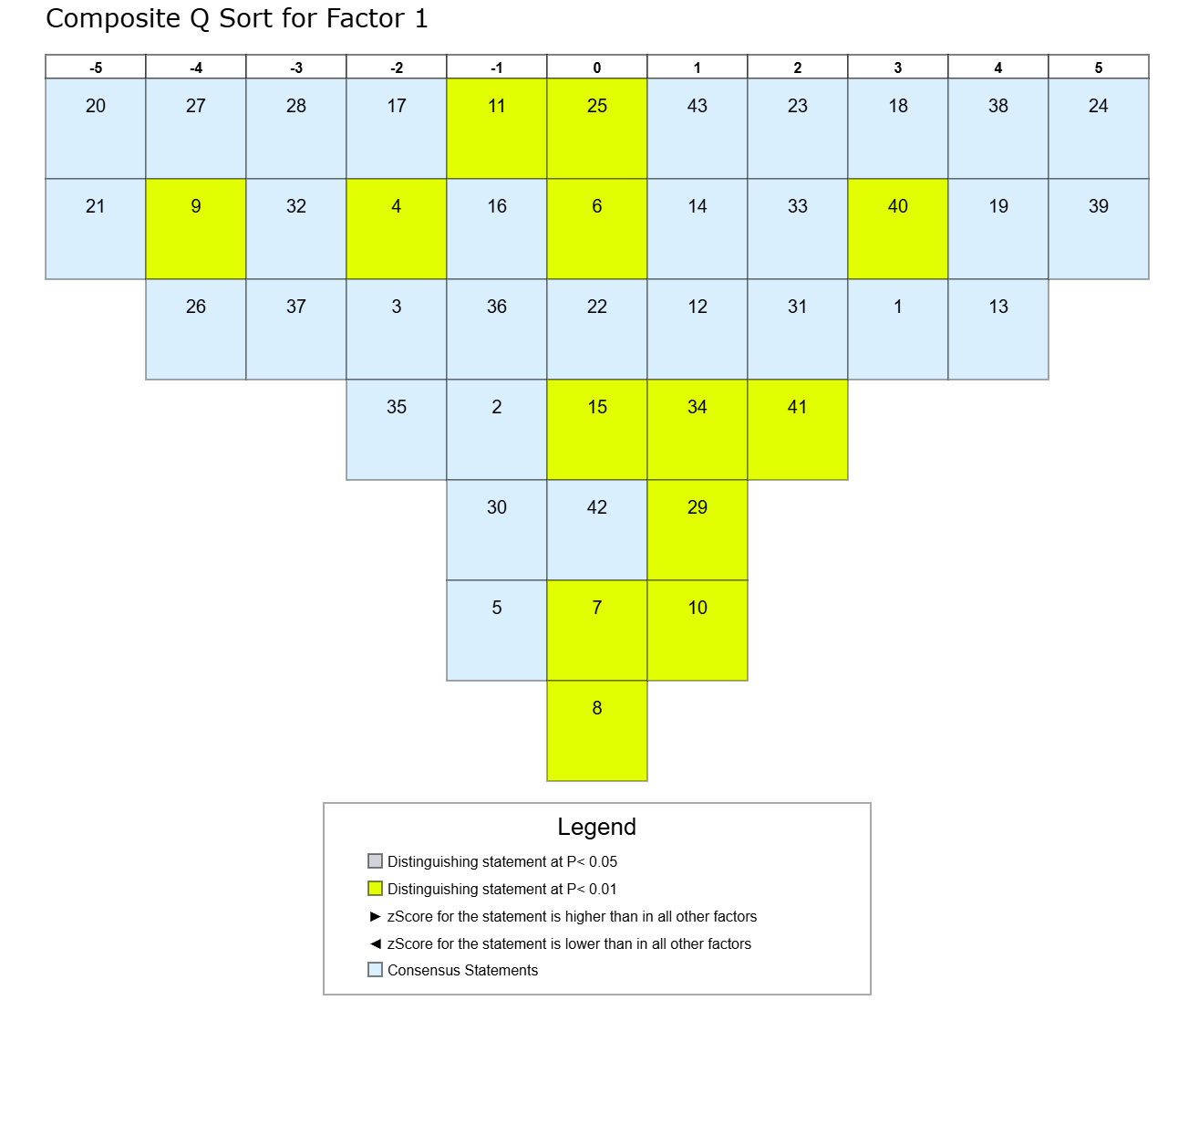

APPENDIX G - “Ideal” Qsort for Factor 2.
