Supplementary Information

Copper Catalysis with Arynes: Unlocking Site-Selective Arylation of Pyrazoles
Minghao Wang,¹ Xintong Hou,^{1,3} Stephanie A. Corio,^{2,3} Lori Digal,¹ Jennifer S. Hirschi,² Vy M. Dong¹

Affiliations:
¹Department of Chemistry, University of California, Irvine; Irvine, California 92617, United States.
²Department of Chemistry, Binghamton University; Binghamton, New York 13902, United States.
³These authors contributed equally: Xintong Hou, Stephanie A. Corio.
E-mail: dongv@uci.edu; jhirschi@binghamton.edu.

Table of Contents
1. Material and Methods 3
2. Reaction Optimization 4
2.1. Reaction Optimization to Access More Hindered Nitrogen N^{α} 4
2.2. Reaction Optimization to Access Less Hindered Nitrogen N^{β} 9
2.3. Intrinsic Regioselectivity of Unsymmetric Pyrazoles under Non-catalytic Conditions 10
3. General Procedure for Selective Addition of Unsymmetric Pyrazoles to Benzynes 12
3.1. Procedure A - Addition of Benzynes to N^{α} with Kobayashi Precursor 12
3.2. Procedure B - Addition of Benzynes to N^{β} with Kobayashi Precursor 13
3.3. Procedure C - Addition of Benzynes to N^{α} with Smith Precursor 14
4. Product Charaterization 15
5. Synthesis of CDPPB (7) and CDPPB-N-isomer (8) 34
6. Synthesis and Reactivity of Cu-pyrazolate 36
7. DFT Calculations 37
7.1 General Information 37
7.2. Analysis of the Cy-XantPhos (L1)-Controlled N^{α}-Arylation 38
7.3. Analysis of 1,10-Phenanthroline (L5)-Controlled N^{β}-Arylation 42
7.2. XYZ Files for Computational Models 45
8. X-Ray Crystallography Data 95
9. General Procedure to Prepare Aryne Precursors 114
10. NMR Spectra 116
11. References and Notes 185

Material and Methods
Commercial reagents were purchased from Combi-Block, Sigma Aldrich, Strem, Alfa Aesar, Ambeed, Synthonix, Synquest, Oakwood, or TCI and used without further purification. All pyrazole starting materials are from commercial sources without further purification. Acetonitrile (MeCN) (anhydrous >99.9% from Sigma Aldrich) were degassed and stored over 3Å MS within a N₂ filled glove box. All experiments were performed in oven-dried or flame-dried glassware under an atmosphere of N₂ or in a glove box with a N₂ atmosphere. Reactions were monitored using thin-layer chromatography (TLC; EMD Silica Gel 60 F₂₅₄ plates). Visualization of the developed plates was performed under UV light (254 nm) or with a KMnO₄ stain. Organic solutions were concentrated under reduced pressure on a Büchi rotary evaporator. Purification and isolation of products was performed via silica gel chromatography (flash column chromatography or preparative thin-layer chromatography). Column chromatography was performed with Silicycle Silia-P Flash Silica Gel using glass columns. ¹H, ¹³C, ¹⁹F NMR spectra and NOE experiments were recorded on a Bruker AVANCE-600, GN-500 or DRX-400 spectrometer. ¹H NMR spectra were internally referenced to the residual solvent signal. ¹³C NMR spectra were internally referenced to the residual solvent signal. Data for ¹H NMR are reported as follows: chemical shift (δ ppm), multiplicity (s = singlet, d = doublet, t = triplet, q = quartet, m = multiplet, br = broad), coupling constant (Hz), integration. Data for ¹³C and ¹⁹F NMR are reported in terms of chemical shift (δ ppm). Infrared (IR) spectra were obtained on a Nicolet iS5 FT-IR spectrometer equipped with an iD5 ATR accessory and are reported in terms of frequency of absorption (cm⁻¹). High resolution mass spectra (HRMS) were obtained by the University of California, Irvine Mass Spectrometry Center on a Micromass 70S-250 Spectrometer (EI) or an ABI/Sciex QStar Mass Spectrometer (ESI).

Reaction Optimization

Reaction Optimization to Access More Hindered Nitrogen N^{α}
General Procedure for Table S1-8: In a N₂ filled glovebox, to a 1-dram vial equipped with a magnetic stir bar was added Cu catalyst (2.5-10 mol%), phosphine ligand and acetonitrile. After stirring for 30 min, pyrazole 1a (0.05 mmol, 1.0 equiv.) and base (0.2-1.0 equiv.) were added. The resulting mixture was stirred for another 30 min followed by the addition of 2-(trimethylsilyl)phenyl trifluoromethanesulfonate (2a) (1.0-1.5 equiv.) and CsF (2.0-4.0 equiv.). The vial was sealed with a Teflon-lined screw cap and stirred at 30 °C for 12-24 hours. The mixture was concentrated in vacuo. Regioselectivity (rr) was determined by ¹H NMR analysis of the crude mixture. Reaction yield (%) was determined by ¹H NMR analysis of the crude mixture with internal standard trimethoxy benzene.

Table S1. Evaluation of Cu Source

Table S2. Evaluation of F Source

Table S3. Evaluation of Base Additive

Table S4. Evaluation of Ligand

Table S5. Evaluation of CsF Loading and Reaction Concentration

Table S6. Evaluation of TMG Loading and Catalyst Loading

Table S7. Evaluation of Ligand for Smaller Substituents on Pyrazoles
Table S8. Evaluation of Base Additive for Smaller Substituents on Pyrazoles

Table S9. Evaluation of Ligand for Substituted Aryne Precursors

Reaction Optimization to Access Less Hindered Nitrogen N^{β}

General Procedure for Table S10-11: In a N₂ filled glovebox, to a 1-dram vial equipped with a magnetic stir bar was added [Cu(CH₃CN)₄]PF₆ (2.5-10 mol%), ligand (3-12 mol%) and acetonitrile. After stirring for 30 min, pyrazole 1a (0.1 mmol, 1.0 equiv.), 2-(trimethylsilyl)phenyl trifluoromethanesulfonate (2a) (0.15 mmol, 1.5 equiv.) and CsF (0.2 mmol, 2.0 equiv.) were added. The vial was sealed with a Teflon-lined screw cap and stirred at 30 °C for 12-24 hours. The mixture was concentrated in vacuo. Regioselectivity (rr) was determined by ¹H NMR analysis of the crude mixture. Reaction yield (%) was determined by ¹H NMR analysis of the crude mixture with internal standard trimethoxy benzene.

Table S10. Evaluation of Ligand

Table S11. Evaluation of Catalyst Loading and Concentration

Intrinsic Regioselectivity of Unsymmetric Pyrazoles under Non-catalytic Conditions

General Procedure for Table S12: In a N₂ filled glovebox, to a 1-dram vial equipped with a magnetic stir bar was added pyrazole 1 (0.1 mmol, 1.0 equiv.), 2-(trimethylsilyl)phenyl trifluoromethanesulfonate (2a) (0.15 mmol, 1.5 equiv.), CsF (0.2 mmol, 2.0 equiv.) and acetonitrile. The vial was sealed with a Teflon-lined screw cap and stirred at 30 °C for 12-24 hours. The mixture was concentrated in vacuo. Regioselectivity (rr) was determined by ¹H NMR analysis of the crude mixture. Reaction yield (%) was determined by ¹H NMR analysis of the crude mixture with internal standard trimethoxy benzene.
Table S12. Summary of Blank Experiments

General Procedure for Selective Addition of Unsymmetric Pyrazoles to Benzynes

Procedure A - Addition of Benzynes to N^{α} with Kobayashi Precursor

In a N₂ filled glovebox, to a 1-dram vial equipped with a magnetic stir bar was added [Cu(CH₃CN)₄]PF₆ (1.9 mg, 0.005 mmol, 10 mol%), phosphine ligand (0.006 mmol, 12 mol%) and acetonitrile (1.0 mL, 0.05 M). After stirring for 30 min, pyrazole 1 (0.05 mmol, 1.0 equiv.) and 1,1,3,3-tetramethylguanidine (TMG, 2.9 mg, 0.025 mmol, 0.5 equiv.) were added. The resulting mixture was stirred for another 30 min followed by the addition of 2-(trimethylsilyl)phenyl trifluoromethanesulfonate (2) (0.075 mmol, 1.5 equiv.) and CsF (15.2 mg, 0.1 mmol, 2.0 equiv.). The vial was sealed with a Teflon-lined screw cap and stirred at 30 °C for 12 hours. If TLC shows majority of pyrazole 1 was left, 2-(trimethylsilyl)phenyl trifluoromethanesulfonate (2) (0.075 mmol, 1.5 equiv.) and CsF (15.2 mg, 0.1 mmol, 2.0 equiv.) were added again and the mixture was stirred another 12 hours at 30 °C. The mixture was concentrated in vacuo. Regioselectivity (rr) was determined by ¹H NMR analysis of the crude mixture. N^{α}- or N^{β}-arylated regioisomer was determined by ¹H NMR chemical shifts and NOE experiments. Pyrazole product 3 was isolated by preparatory TLC.

Procedure B - Addition of Benzynes to N^{β} with Kobayashi Precursor

In a N₂ filled glovebox, to a 1-dram vial equipped with a magnetic stir bar was added [Cu(CH₃CN)₄]PF₆ (1.9 mg, 0.005 mmol, 5 mol%), 1,10-phenanthroline (L5) (1.1 mg, 0.006 mmol, 6 mol%) and acetonitrile (0.4 mL, 0.25 M). After stirring for 30 min, pyrazole 2 (0.1 mmol, 1.0 equiv.), 2-(trimethylsilyl)phenyl trifluoromethanesulfonate (1) (0.15 mmol, 1.5 equiv.) and CsF (30.4 mg, 0.2 mmol, 2.0 equiv.) were added. The vial was sealed with a Teflon-lined screw cap and stirred at 30 °C for 12 hours. If TLC shows majority of pyrazole 2 was left, 2-(trimethylsilyl)phenyl trifluoromethanesulfonate (2) (0.15 mmol, 1.5 equiv.) and CsF (30.4 mg, 0.2 mmol, 2.0 equiv.) were added again and the mixture was stirred another 12 hours at 30 °C. The mixture was concentrated in vacuo. Regioselectivity (rr) was determined by ¹H NMR analysis of the crude mixture. N^{α}- or N^{β}-arylated regioisomer was determined by ¹H NMR chemical shifts and NOE experiments. Pyrazole product 4 was isolated by preparatory TLC.

Procedure C - Addition of Benzynes to N^{α} with Smith Precursor

In a N₂ filled glovebox, to a 1-dram vial equipped with a magnetic stir bar was added [Cu(CH₃CN)₄]PF₆ (1.9 mg, 0.005 mmol, 10 mol%), phosphine ligand (0.006 mmol, 12 mol%) and acetonitrile (1.0 mL, 0.05 M). After stirring for 30 min, pyrazole 1 (0.05 mmol, 1.0 equiv.) was added. The resulting mixture was stirred for another 30 min followed by the addition of smith oxonium aryne precursor (6) (0.075 mmol, 1.5 equiv.) and K₃PO₄ (21.2 mg, 0.1 mmol, 2.0 equiv.). The vial was sealed with a Teflon-lined screw cap and stirred at 30 °C for 12 hours. The mixture was concentrated in vacuo. Regioselectivity (rr) was determined by ¹H NMR analysis of the crude mixture. N^{α}- or N^{β}-arylated regioisomer was determined by ¹H NMR chemical shifts and NOE experiments. Pyrazole product 3 was isolated by preparatory TLC.

Product Charaterization
1,5-Diphenyl-1H-pyrazole (3a)
The title compound was synthesized according to general procedure A with L1 and isolated by preparatory TLC (90:10 hexanes:EtOAc) as yellow oil [10 mg, 92% yield, >20:1 N⍺:N^{β}].¹H NMR (600 MHz, CDCl₃) δ 7.73 (d, J = 1.9 Hz, 1H), 7.44 – 7.27 (m, 8H), 7.26 – 7.17 (m, 2H), 6.52 (d, J = 1.8 Hz, 1H). ¹³C NMR (151 MHz, CDCl₃) δ 143.10, 140.41, 140.23, 130.71, 128.99, 128.87, 128.55, 128.29, 127.51, 125.31, 107.95. The NMR data matches literature report.⁵¹

5-Methyl-1-phenyl-1H-pyrazole (3b)
The title compound was synthesized according to general procedure A with L2 and isolated by preparatory TLC (90:10 hexanes:EtOAc) as white solid [1.3 mg, 16% yield, 4:1 N⍺:N^{β}]. ¹H NMR (400 MHz, CDCl₃) δ 7.81 (s, 1H), 7.69 – 7.59 (m, 2H), 7.43 (t, J = 7.8 Hz, 2H), 7.25 (t, J = 7.4 Hz, 1H), 6.25 (s, 1H), 2.39 (s, 3H). ¹³C NMR (151 MHz, CDCl₃) δ 139.51, 139.30, 138.20, 129.25, 128.21, 125.14, 107.14, 12.52. The NMR data matches literature report.⁵¹

5-Cyclopropyl-1-phenyl-1H-pyrazole (3c)
The title compound was synthesized according to general procedure A with L2 and isolated by preparatory TLC (90:10 hexanes:EtOAc) as yellow oil [3.7 mg, 40% yield, 4:1 N⍺:N^{β}]. ¹H NMR (500 MHz, CDCl₃) δ 7.64 – 7.60 (m, 1H), 7.49 (t, J = 7.8 Hz, 2H), 7.40 (t, J = 7.5 Hz, 1H), 5.99 (d, J = 2.0 Hz, 1H), 1.82 (tt, J = 8.3, 5.1 Hz, 1H), 1.05 – 0.98 (m, 2H), 0.85 – 0.75 (m, 2H).¹³C NMR (151 MHz, CDCl₃) δ 146.63, 139.46, 139.38, 129.24, 128.02, 125.07, 102.95, 29.84, 9.21, 7.85. IR (ATR): 3011, 2927, 2854, 1597, 1501, 1392, 1030, 926, 763, 695 cm⁻¹. HRMS calculated for C₁₂H₁₂N₂ [M+H]⁺ 185.1079, found 185.1088.

5-Isopropyl-1-phenyl-1H-pyrazole (3d)
The title compound was synthesized according to general procedure A with L2 and isolated by preparatory TLC (90:10 hexanes:EtOAc) as white solid [4.6 mg, 49% yield, 7:1 N²:N¹]. ¹H NMR (499 MHz, CDCl₃) δ 7.58 (d, J = 1.8 Hz, 1H), 7.50 – 7.45 (m, 2H), 7.44 – 7.39 (m, 3H), 6.22 (d, J = 1.9 Hz, 1H), 3.06 (sept, J = 6.5 Hz, 1H), 1.19 (d, J = 6.8 Hz, 7H). ¹³C NMR (151 MHz, CDCl₃) δ 150.45, 140.30, 139.89, 129.26, 128.21, 126.06, 102.92, 25.58, 23.16. IR (ATR): 3065, 2966, 1598, 1502, 1395, 1007, 925, 764, 692 cm⁻¹. HRMS calculated for C₁₂H₁₄N₂ [M+Na]⁺ 209.1055, found 209.1046.

5-(Tert-butyl)-1-phenyl-1H-pyrazole (3e)
The title compound was synthesized according to general procedure A with L1 and isolated by preparatory TLC (90:10 hexanes:EtOAc) as white solid [4.5 mg, 45% yield, >20:1 N⍺:N^{β}]. ¹H NMR (600 MHz, CDCl₃) δ 7.52 (d, J = 1.9 Hz, 1H), 7.48 – 7.43 (m, 3H), 7.41 – 7.37 (m, 2H), 6.19 (d, J = 2.0 Hz, 1H), 1.19 (s, 9H). ¹³C NMR (151 MHz, CDCl₃) δ 153.29, 142.31, 138.60, 129.26, 128.80, 128.76, 103.91, 32.05, 30.90. The NMR data matches literature report.⁵²

5-Bromo-1-phenyl-1H-pyrazole (3f)
The title compound was synthesized according to general procedure A in 0.1 mmol scale of pyrazole 2 with L2 and isolated by preparatory TLC (90:10 hexanes:EtOAc) as brown solid [4.5 mg, 40% yield, 5:1 N⍺:N^{β}]. ¹H NMR (400 MHz, CDCl₃) δ 7.68 (d, J = 1.8 Hz, 1H), 7.58 – 7.53 (m, 2H), 7.52 – 7.41 (m, 3H), 6.48 (d, J = 1.8 Hz, 1H). ¹³C NMR (151 MHz, CDCl₃) δ 141.57 , 139.09 , 129.06 , 128.65, 125.82, 112.94, 110.56. IR (ATR): 3132, 2924, 2853, 1598, 1502, 1416, 1394, 1092, 967, 918, 779, 755 cm⁻¹. HRMS calculated for C₉H₇BrN₂ [M+H]⁺ 222.9871, found 222.9867.

5-Iodo-1-phenyl-1H-pyrazole (3g)
The title compound was synthesized according to general procedure A in 0.1 mmol scale of pyrazole 2 with L2 and isolated by preparatory TLC (90:10 hexanes:EtOAc) as brown oil [4.1 mg, 30% yield, 10:1 N⍺:N^{β}]. ¹H NMR (400 MHz, CDCl₃) δ 7.69 (d, J = 1.8 Hz, 1H), 7.54 – 7.42 (m, 5H), 6.63 (d, J = 1.8 Hz, 1H). ¹³C NMR (151 MHz, CDCl₃) δ 142.79, 140.24, 129.01, 128.81, 126.44, 117.58, 80.94. The NMR data matches literature report.⁵³

1-Phenyl-5-(o-tolyl)-1H-pyrazole (3h)
The title compound was synthesized according to general procedure A with L2 and isolated by preparatory TLC (90:10 hexanes:EtOAc) as colorless oil [9.8 mg, 84% yield, 13:1 N⍺:N^{β}]. ¹H NMR (600 MHz, CDCl3) δ 7.75 (d, J = 1.8 Hz, 1H), 7.28 (td, J = 7.4, 1.8 Hz, 1H), 7.26 – 7.16 (m, 8H), 6.41 (d, J = 1.8 Hz, 1H), 1.98 (s, 3H). ¹³C NMR (151 MHz, CDCl3) δ 142.31, 140.28, 140.20, 137.24, 130.95, 130.67, 130.48, 129.05, 128.88, 126.96, 125.95, 123.72, 108.90, 20.04. IR (ATR): 2923, 1599, 1497, 1451, 1380, 960, 924, 758, 690, 651 cm⁻¹. HRMS calculated for C₁₆H₁₄N₂ [M+H]⁺ 235.1235, found 235.1242.

5-(2-Fluorophenyl)-1-phenyl-1H-pyrazole (3i)
The title compound was synthesized according to general procedure A with L2 and isolated by preparatory TLC (90:10 hexanes:EtOAc) as white solid [11 mg, 95% yield, >20:1 N⍺:N^{β}]. ¹H NMR (600 MHz, CDCl₃) δ 7.77 (d, J = 1.9 Hz, 1H), 7.36 – 7.27 (m, 6H), 7.20 (td, J = 7.5, 1.8 Hz, 1H), 7.10 (td, J = 7.6, 1.2 Hz, 1H), 7.05 (ddd, J = 9.7, 8.3, 1.2 Hz, 1H), 6.57 (s, 1H). ¹³C NMR (151 MHz, CDCl₃) δ 159.50 (d, J = 249.9 Hz), 140.41, 140.27, 136.81, 131.47 (d, J = 2.4 Hz), 130.69 (d, J = 8.2 Hz), 129.01, 127.53, 124.42, 124.27 (d, J = 3.8 Hz), 118.97 (d, J = 14.9 Hz), 116.23 (d, J = 21.6 Hz), 109.51 (d, J = 2.0 Hz). ¹⁹F NMR (565 MHz, CDCl₃) δ -112.82. IR (ATR): 2925, 1598, 1499, 1385, 1229, 1217, 964, 925, 756, 692 cm⁻¹. HRMS calculated for C₁₅H₁₁FN₂ [M+H]⁺ 239.0984, found 239.0983.

5-(2-Bromophenyl)-1-phenyl-1H-pyrazole (3j)
The title compound was synthesized according to general procedure A with L2 and isolated by preparatory TLC (90:10 hexanes:EtOAc) as colorless oil [13 mg, 90% yield, >20:1 N⍺:N^{β}]. ¹H NMR (600 MHz, CDCl₃) δ 7.77 (d, J = 1.9 Hz, 1H), 7.59 (dd, J = 7.9, 1.3 Hz, 1H), 7.34 – 7.18 (m, 8H), 6.52 (d, J = 1.9 Hz, 1H). ¹³C NMR (151 MHz, CDCl₃) δ 141.37, 140.03, 133.26, 132.54, 132.35, 130.46, 130.42, 128.90, 127.42, 127.26, 124.23, 124.19, 109.48. The NMR data matches literature report.⁵⁴

5-(2-Methoxyphenyl)-1-phenyl-1H-pyrazole (3k)
The title compound was synthesized according to general procedure A with L1 and isolated by preparatory TLC (90:10 hexanes:EtOAc) as colorless oil [6.8 mg, 54% yield, 5:1 N⍺:N^{β}]. ¹H NMR (600 MHz, CDCl₃) δ 7.74 (d, J = 1.8 Hz, 1H), 7.34 (ddd, J = 8.3, 7.5, 1.8 Hz, 1H), 7.30 – 7.26 (m, 3H), 7.26 (d, J = 3.2 Hz, 2H), 7.24 – 7.18 (m, 1H), 6.97 (td, J = 7.5, 1.0 Hz, 1H), 6.79 (dd, J = 8.4, 1.0 Hz, 1H), 6.47 (d, J = 1.8 Hz, 1H), 3.36 (s, 3H). ¹³C NMR (151 MHz, CDCl₃) δ 156.59, 141.13, 140.05, 140.00, 131.37, 130.54, 128.64, 126.96, 123.73, 120.80, 120.23, 111.38, 108.84, 55.05. IR (ATR): 3200, 2928, 2365, 1499, 1385, 1261, 1248, 1024, 925, 790, 756, 691 cm⁻¹.

1-Phenyl-5-(p-tolyl)-1H-pyrazole (3l)
The title compound was synthesized according to general procedure A with L2 and isolated by preparatory TLC (90:10 hexanes:EtOAc) as white solid [11.2 mg, 96% yield, 18:1 N⍺:N^{β}]. ¹H NMR (400 MHz, CDCl₃) δ 7.73 (d, J = 1.8 Hz, 1H), 7.38 – 7.27 (m, 6H), 7.15 – 7.07 (m, 4H), 6.49 (d, J = 1.9 Hz, 1H), 2.34 (s, 3H). ¹³C NMR (151 MHz, CDCl₃) δ 143.44, 140.07, 139.99, 138.46, 129.34, 129.05, 128.76, 127.69, 127.55, 125.41, 107.71, 21.39. IR (ATR): 3125, 3063, 2921, 1597, 1498, 1384, 961, 925, 823, 785, 761, 701 cm⁻¹. HRMS calculated for C₁₆H₁₄N [M+H]⁺ 235.1235, found 235.1233.

5-(4-Chlorophenyl)-1-phenyl-1H-pyrazole (3m)
The title compound was synthesized according to general procedure A with L2 and isolated by preparatory TLC (90:10 hexanes:EtOAc) as white solid [7.6 mg, 60% yield, 15:1 N⍺:N^{β}]. ¹H NMR (400 MHz, CDCl₃) δ 7.74 (d, J = 1.9 Hz, 1H), 7.40 – 7.32 (m, 3H), 7.31 – 7.26 (m, 4H), 7.19 – 7.13 (m, 2H), 6.51 (d, J = 1.9 Hz, 1H). ¹³C NMR (151 MHz, CDCl₃) δ 142.11, 140.29, 139.72, 134.57, 130.11, 129.23, 129.05, 128.93, 127.97, 125.42, 108.08. IR (ATR): 3063, 2923, 2851, 1598, 1499, 1483, 1407, 1382, 1093, 1016, 960, 925, 690, 655, 759, 629 cm⁻¹. HRMS calculated for C₁₅H₁₁ClN₂ [M+H]⁺ 255.0689, found 255.0680. The NMR data matches literature report.⁵⁵

5-(4-Fluorophenyl)-1-phenyl-1H-pyrazole (3n)
The title compound was synthesized according to general procedure A with L2 and isolated by preparatory TLC (90:10 hexanes:EtOAc) as white solid [10.5 mg, 88% yield, >20:1 N⍺:N^{β}]. ¹H NMR (400 MHz, CDCl₃) δ 7.73 (d, J = 1.9 Hz, 1H), 7.39 – 7.27 (m, 5H), 7.24 – 7.17 (m, 2H), 7.03 – 6.96 (m, 2H), 6.49 (d, J = 1.9 Hz, 1H). ¹³C NMR (151 MHz, CDCl₃) δ 162.76 (d, J = 248.8 Hz), 142.29, 140.24, 139.81, 130.72 (d, J = 8.2 Hz), 129.16, 127.85, 126.68 (d, J = 3.4 Hz), 125.40, 115.77 (d, J = 21.6 Hz), 107.93. ¹⁹F NMR (376 MHz, CDCl₃) δ -113.18. IR (ATR): 3066, 2923, 1594, 1500, 1448, 1383, 1210, 835, 789, 768, 721, 607 cm⁻¹. HRMS calculated for C₁₅H₁₁FN₂ [M+H]⁺ 239.0984, found 239.0993. The NMR data matches literature report.⁵⁶

5-(4-Methoxyphenyl)-1-phenyl-1H-pyrazole (3o)
The title compound was synthesized according to general procedure A with L2 and isolated by preparatory TLC (90:10 hexanes:EtOAc) as colorless oil [7.0 mg, 56% yield, 15:1 N⍺:N^{β}]. ¹H NMR (600 MHz, CDCl₃) δ 7.70 (d, J = 1.8 Hz, 1H), 7.36 – 7.27 (m, 5H), 7.15 (d, J = 8.7 Hz, 2H), 6.83 (d, J = 8.7 Hz, 2H), 6.45 (d, J = 1.8 Hz, 1H), 3.80 (s, 3H). ¹³C NMR (151 MHz, CDCl₃) δ 159.64, 142.96, 140.38, 130.17, 129.00, 127.44, 125.34, 123.16, 114.03, 107.45, 55.39. The NMR data matches literature report.⁵⁵

5-(3-Methoxyphenyl)-1-phenyl-1H-pyrazole (3p)
The title compound was synthesized according to general procedure A with L1 and isolated by preparatory TLC (90:10 hexanes:EtOAc) as yellow oil [6.8 mg, 54% yield, 6:1 N⍺:N^{β}]. ¹H NMR (600 MHz, CDCl₃) δ 7.72 (d, J = 1.9 Hz, 1H), 7.39 – 7.28 (m, 5H), 7.21 (t, J = 7.9 Hz, 1H), 6.85 (ddd, J = 8.3, 2.6, 0.9 Hz, 1H), 6.82 (ddd, J = 7.6, 1.6, 0.9 Hz, 1H), 6.75 (dd, J = 2.6, 1.6 Hz, 1H), 6.52 (d, J = 1.9 Hz, 1H), 3.67 (s, 3H). ¹³C NMR (151 MHz, CDCl₃) δ 159.54, 143.03, 140.35, 140. 21, 131.88, 129.65, 129.03, 127.64, 125.41, 121.35, 114.25, 114.21, 107.94, 55.29. The NMR data matches literature report.⁵⁴

5-(Furan-2-yl)-1-phenyl-1H-pyrazole (3q)
The title compound was synthesized according to general procedure A with L1 and isolated by preparatory TLC (80:20 hexanes:EtOAc) as brown oil [8.9 mg, 85% yield, 7:1 N⍺:N^{β}]. ¹H NMR (500 MHz, CDCl₃) δ 7.69 (d, J = 1.9 Hz, 1H), 7.48 – 7.40 (m, 5H), 7.39 (dd, J = 1.8, 0.6 Hz, 1H), 6.67 (d, J = 1.9 Hz, 1H), 6.33 (dd, J = 3.4, 1.8 Hz, 1H), 5.97 (d, J = 3.4 Hz, 1H). ¹³C NMR (151 MHz, CDCl₃) δ 144.69 (s), 142.63 (s), 140.41 (s), 140.38 (s), 134.50 (s), 129.17 (s), 128.58 (s), 125.96 (s), 111.34 (s), 108.89 (s), 106.36 (s). IR (ATR): 3128, 2923, 2852, 1501, 1393, 1218, 1071, 977, 926, 763, 694 cm⁻¹. HRMS calculated for C₁₃H₁₀N₂O [M+H]⁺ 211.0871, found 211.0865.

4-(1-Phenyl-1H-pyrazol-5-yl)pyridine (3r)
The title compound was synthesized according to general procedure A with L2 and isolated by preparatory TLC (80:20 hexanes:EtOAc) as yellow oil [7.4 mg, 67% yield, >20:1 N⍺:N^{β}]. ¹H NMR (600 MHz, CDCl₃) δ 8.55 (d, J = 5.3 Hz, 2H), 7.78 (d, J = 1.9 Hz, 1H), 7.46 – 7.37 (m, 3H), 7.33 – 7.27 (m, 2H), 7.23 – 7.18 (m, 2H), 6.70 (d, J = 1.9 Hz, 1H). ¹³C NMR (151 MHz, CDCl₃) δ 148.50, 140.90, 139.73, 139.68, 139.57, 129.54, 128.62, 125.56, 123.22, 109.42. IR (ATR): 3365, 2923, 1601, 1498, 1386, 924, 763, 693cm⁻¹. HRMS calculated for C₁₄H₁₁N₃ [M+H]⁺ 222.1031, found 222.1020.

3-Methyl-1,5-diphenyl-1H-pyrazole (3s)
The title compound was synthesized according to general procedure A with L2 and isolated by preparatory TLC (90:10 hexanes:EtOAc) as colorless oil [8.7 mg, 74% yield, >20:1 N⍺:N^{β}]. ¹H NMR (400 MHz, CDCl₃) δ 7.35 – 7.17 (m, 11H), 6.32 (s, 1H), 2.40 (s, 3H). ¹³C NMR (151 MHz, CDCl₃) δ 149.35, 144.22, 139.54, 130.37, 129.10, 128.80, 128.62, 128.52, 127.67, 125.41, 107.90, 13.47. The NMR data matches literature report.⁵¹

5-(Tert-butyl)-3-methyl-1-phenyl-1H-pyrazole (3t)
The title compound was synthesized according to general procedure A with L1 and isolated by preparatory TLC (90:10 hexanes:EtOAc) as colorless oil [9.6 mg, 90% yield, >20:1 N⍺:N^{β}]. ¹H NMR (400 MHz, CDCl₃) δ 7.49 – 7.40 (m, 3H), 7.39 – 7.34 (m, 2H), 5.98 (s, 1H), 2.28 (s, 3H), 1.17 (s, 9H). ¹³C NMR (151 MHz, CDCl₃) δ 154.29, 147.47, 142.00, 129.23, 128.99, 128.79, 103.92, 32.09, 30.87, 13.40. IR (ATR): 2968, 2929, 1593, 1537, 1500, 1362, 1017, 1007, 774, 729, 696 cm⁻¹. HRMS calculated for C₁₄H₁₈N₂ [M+Na]⁺ 237.1368, found 237.1369.

5-(Tert-butyl)-3-iodo-1-phenyl-1H-pyrazole (3u)
The title compound was synthesized according to general procedure A with L1 and isolated by preparatory TLC (90:10 hexanes:EtOAc) as white solid [11.0 mg, 67% yield, >20:1 N⍺:N^{β}]. ¹H NMR (400 MHz, CDCl₃) δ 7.47 – 7.41 (m, 3H), 7.38 – 7.34 (m, 2H), 6.33 (s, 1H), 1.16 (s, 9H). ¹³C NMR (151 MHz, CDCl₃) δ 155.59, 141.49, 129.63, 128.87, 128.86, 112.99, 95.29, 32.13, 30.70. IR (ATR): 3135, 2966, 2927, 1500, 1362, 1337, 1257, 1005, 949, 785, 774, 706, 695 cm⁻¹. HRMS calculated for C₁₃H₁₅IN₂ [M+Na]⁺ 349.0178, found 349.0175.

1,5-Diphenyl-1H-pyrazol-3-amine (3v)
The title compound was synthesized according to general procedure A with L1 and isolated by preparatory TLC (80:20 hexanes:EtOAc) as white solid [6.8 mg, 58% yield, 7:1 N⍺:N^{β}]. ¹H NMR (600 MHz, CDCl₃) δ 7.31 – 7.27 (m, 5H), 7.25 – 7.19 (m, 5H), 5.93 (s, 1H), 2.86 (s, 2H). ¹³C NMR (151 MHz, CDCl₃) δ 154.37, 144.85, 139.48, 130.32, 129.08, 128.79, 128.71, 128.63, 127.13, 124.98, 96.14. IR (ATR): 3320 (br), 2923, 1594, 1557, 1500, 1383, 760, 693 cm⁻¹. HRMS calculated for C₁₅H₁₃N₃ [M+Na]⁺ 258.1007, found 258.1000.

3-Cyclopropyl-1-phenyl-5-(trifluoromethyl)-1H-pyrazole (3w)
The title compound was synthesized according to general procedure A with L2 and isolated by preparatory TLC (90:10 hexanes:EtOAc) as white solid [11.0 mg, 87% yield, >20:1 N⍺:N^{β}]. ¹H NMR (600 MHz, CDCl₃) δ 7.52 – 7.37 (m, 5H), 6.47 (s, 1H), 2.00 (dddd, J = 8.5, 6.6, 4.2, 2.5 Hz, 1H), 0.99 (tdd, J = 6.1, 4.3, 1.5 Hz, 2H), 0.87 – 0.78 (m, 2H). ¹³C NMR (151 MHz, CDCl₃) δ 155.60, 139.33, 133.06 (q, J = 39.0 Hz), 129.16, 129.11, 125.76, 119.91 (q, J = 269.0 Hz), 105.65 (q, J = 2.5 Hz), 9.05, 8.35. IR (ATR): 2927, 1597, 1483, 1387, 1240, 1169, 1125, 1104, 973, 765, 686 cm⁻¹. The NMR data matches literature report.⁵⁷

Methyl 5-ethyl-1-phenyl-1H-pyrazole-3-carboxylate (3x)
The title compound was synthesized according to general procedure A with L2 and isolated by preparatory TLC (85:25 hexanes:EtOAc) as yellow oil [9.2 mg, 80% yield, 9:1 N⍺:N^{β}]. ¹H NMR (400 MHz, CDCl₃) δ 7.49 – 7.37 (m, 5H), 6.84 (s, 1H), 3.78 (s, 3H), 2.74 (qd, J = 7.6, 0.5 Hz, 2H), 1.30 (t, J = 7.6 Hz, 3H).¹³C NMR (151 MHz, CDCl₃) δ 159.86 (s), 155.05 (s), 140.37 (s), 133.47 (s), 128.70 (s), 128.59 (s), 126.09 (s), 110.88 (s), 52.07 (s), 21.41 (s), 13.81 (s). IR (ATR): 3065, 2969, 1731, 1503, 1444, 1283, 1227, 1105, 761, 692 cm⁻¹. HRMS calculated for C₁₃H₁₄N₂O₂Na [M+Na]⁺253.0953, found 253.0947.

Methyl 4-bromo-1-phenyl-1H-pyrazole-3-carboxylate (3y)
The title compound was synthesized according to general procedure A with L1 and isolated by preparatory TLC (90:10 hexanes:EtOAc) as yellow solid [5.5 mg, 39% yield, <1:20 N⍺:N^{β}]. ¹H NMR (400 MHz, CDCl₃) δ 8.00 (s, 1H), 7.70 – 7.68 (m, 2H), 7.50 – 7.46 (m, 2H), 7.40 – 7.37 (m, 1H), 3.98 (s, 3H). ¹³C NMR (151 MHz, CDCl₃) δ 161.59, 141.73, 139.18, 130.06, 129.80, 128.43, 120.11, 98.47, 52.43. IR (ATR): 3124, 2924, 1720, 1498, 1388, 1370, 1227, 1051, 957, 810, 746, 682, 649, 619 cm⁻¹. HRMS calculated for C₁₁H₉BrN₂O₂ [M+Na]⁺ 302.9745, found 302.9738.

Ethyl 5-cyclopropyl-1-phenyl-1H-pyrazole-4-carboxylate (3z)
The title compound was synthesized according to general procedure A with L1 and isolated by preparatory TLC (85:25 hexanes:EtOAc) as yellow oil [12.2 mg, 95% yield, >20:1 N⍺:N^{β}]. ¹H NMR (400 MHz, CDCl₃) δ 8.01 (s, 1H), 7.53 – 7.46 (m, 4H), 7.44 – 7.40 (m, 1H), 4.32 (q, J = 7.1 Hz, 2H), 1.97 (tt, J = 8.6, 5.5 Hz, 1H), 1.38 (t, J = 7.1 Hz, 3H), 0.95 – 0.88 (m, 2H), 0.68 – 0.62 (m, 2H). ¹³C NMR (151 MHz, CDCl₃) δ 163.35 (s), 147.48 (s), 142.34 (s), 139.62 (s), 129.07 (s), 128.49 (s), 125.58 (s, J = 3.8 Hz), 114.22 (s), 60.17 (s), 14.57 (s), 8.58 (s), 7.51 (s). IR (ATR): 3124, 2923, 1719, 1597, 1498, 1226, 1051, 958, 832, 746, 682, 650 cm⁻¹. HRMS calculated for C₁₅H₁₆N₂O₂ [M+H]⁺ 257.1290, found 257.1281.

1-Phenyl-1H-indazole (3aa)
The title compound was synthesized according to general procedure A with dcypm ligand and isolated by preparatory TLC (90:10 hexanes:EtOAc) as yellow solid [6.4 mg, 66% yield, 15:1 N⍺:N^{β}]. ¹H NMR (600 MHz, CDCl₃) δ 8.21 (d, J = 1.0 Hz, 1H), 7.81 (dt, J = 8.1, 1.0 Hz, 1H), 7.77 (dt, J = 8.6, 0.9 Hz, 1H), 7.75 – 7.73 (m, 2H), 7.57 – 7.53 (m, 2H), 7.44 (ddd, J = 8.3, 6.9, 1.1 Hz, 1H), 7.39 – 7.35 (m, 1H), 7.24 (ddd, J = 8.0, 6.9, 0.8 Hz, 1H).¹³C NMR (151 MHz, CDCl₃) δ 140.35, 138.90, 135.54, 129.60, 127.29, 126.79, 125.47, 122.90, 121.66, 121.48, 110.57. The NMR data matches literature report.⁵⁸

1,5-Diphenyl-1H-1,2,4-triazole (3ab)
The title compound was synthesized according to general procedure A with L2 and isolated by preparatory TLC (80:20 hexanes:EtOAc) as white solid [9 mg, 80% yield, 7:1 N⍺:N^{β}]. ¹H NMR (600 MHz, CDCl₃) δ 8.10 (s, 1H), 7.51 – 7.47 (m, 2H), 7.44 – 7.38 (m, 4H), 7.38 – 7.32 (m, 4H). ¹³C NMR (151 MHz, CDCl₃) δ 154.23, 151.92, 138.52, 130.40, 129.76, 129.29, 129.23, 128.93, 128.10, 125.72. The NMR data matches literature report.⁵⁹

4-Bromo-2-phenyl-2H-1,2,3-triazole (3ac)
The title compound was synthesized according to general procedure A with L1 and isolated by preparatory TLC (90:10 hexanes:EtOAc) as colorless solid [6.2 mg, 55% yield, 3:1 N⍺:N^{β}]. ¹H NMR (600 MHz, CDCl₃) δ 8.05 – 8.01 (m, 2H), 7.76 (s, 1H), 7.49 (dd, J = 8.6, 7.4 Hz, 2H), 7.37 (t, J = 7.4 Hz, 1H). ¹³C NMR (151 MHz, CDCl₃) δ 139.58, 136.91, 129.52, 128.16, 124.12, 118.76. IR (ATR): 2924, 1597, 1496, 1445, 1371, 1130, 990, 959, 835, 753, 698, 688, 662 cm⁻¹. HRMS calculated for C₈H₆BrN₃ [M+H]⁺222.9745, found 218.9856.

1,3-Diphenyl-1H-pyrazole (4a)
The title compound was synthesized according to general procedure B and isolated by preparatory TLC (90:10 hexanes:EtOAc) as yellow oil [10 mg, 90% yield, <1:20 N⍺:N^{β}]. ¹H NMR (600 MHz, CDCl₃) δ 7.96 (d, J = 2.5 Hz, 1H), 7.95 – 7.91 (m, 2H), 7.80 – 7.76 (m, 2H), 7.50 – 7.42 (m, 4H), 7.37 – 7.33 (m, 1H), 7.31 – 7.28 (m, 1H), 6.78 (d, J = 2.5 Hz, 1H). ¹³C NMR (151 MHz, CDCl₃) δ 153.28, 140.58, 133.47, 129.77, 129.00, 128.38, 128.34, 126.69, 126.19, 119.41, 105.38. The NMR data matches literature report.⁵¹

3-Methyl-1-phenyl-1H-pyrazole (4b)
The title compound was synthesized according to general procedure B and isolated by preparatory TLC (90:10 hexanes:EtOAc) as colorless oil [11.6 mg, 73% yield, 1:9 N⍺:N^{β}]. ¹H NMR (400 MHz, CDCl₃) δ 7.81 (s, 1H), 7.65 (d, J = 7.7 Hz, 2H), 7.43 (t, J = 7.8 Hz, 2H), 7.25 (t, J = 7.4 Hz, 1H), 6.25 (s, 1H), 2.39 (s, 3H). ¹³C NMR (151 MHz, CDCl₃) δ 150.65, 140.17, 129.53, 127.68, 126.23, 119.08, 107.71, 13.80. The NMR data matches literature report.⁵¹

3-Cyclopropyl-1-phenyl-1H-pyrazole (4c)
The title compound was synthesized according to general procedure B and isolated by preparatory TLC (90:10 hexanes:EtOAc) as yellow oil [14 mg, 75% yield, 1:12 N⍺:N^{β}]. ¹H NMR (500 MHz, CDCl₃) δ 7.78 (d, J = 2.5 Hz, 1H), 7.65 (d, J = 8.7 Hz, 2H), 7.42 (dd, J = 8.6, 7.4 Hz, 2H), 7.24 (tt, J = 7.4, 1.1 Hz, 1H), 6.11 (d, J = 2.5 Hz, 1H), 2.07 (tt, J = 8.4, 5.0 Hz, 1H), 1.05 – 0.95 (m, 2H), 0.85 – 0.78 (m, 2H). ¹³C NMR (125 MHz, CDCl₃) δ 157.18, 140.12, 129.49, 127.55, 126.14, 119.04, 104.14, 9.38, 8.35. The NMR data matches literature report.⁶⁰

3-Isopropyl-1-phenyl-1H-pyrazole (4d)
The title compound was synthesized according to general procedure B and isolated by preparatory TLC (90:10 hexanes:EtOAc) as yellow oil [16.5 mg, 89% yield, <1:20 N⍺:N^{β}]. ¹H NMR (400 MHz, CDCl₃) δ 7.81 (dd, J = 2.5, 0.5 Hz, 1H), 7.68 – 7.63 (m, 2H), 7.49 – 7.38 (m, 2H), 7.26 – 7.21 (m, 1H), 6.29 (dd, J = 2.4, 0.5 Hz, 1H), 3.10 (hept, J = 6.9 Hz, 1H), 1.33 (d, J = 7.0 Hz, 6H). ¹³C NMR (151 MHz, CDCl₃) δ 161.17, 140.37, 129.47, 127.37, 126.10, 119.19, 104.59, 28.12, 22.96. IR (ATR): 3049, 2962, 1601, 1529, 1502, 1302, 1042, 751, 689 cm⁻¹. The NMR data matches literature report.⁶¹

3-(Tert-butyl)-1-phenyl-1H-pyrazole (4e)
The title compound was synthesized according to general procedure B and isolated by preparatory TLC (90:10 hexanes:EtOAc) as colorless oil [19 mg, 95% yield, <1:20 N⍺:N^{β}]. ¹H NMR (600 MHz, CDCl₃) δ 7.80 (d, J = 2.4 Hz, 1H), 7.68 (d, J = 7.1 Hz, 2H), 7.42 (t, J = 7.9 Hz, 2H), 7.23 (t, J = 7.5 Hz, 1H), 6.32 (d, J = 2.4 Hz, 1H), 1.38 (s, 9H). ¹³C NMR (151 MHz, CDCl₃) δ 163.82, 140.63, 129.43, 126.95, 125.87, 119.06, 104.31, 32.47, 30.65. The NMR data matches literature report.⁶²

1-Phenyl-3-(o-tolyl)-1H-pyrazole (4f)
The title compound was synthesized according to general procedure B and isolated by preparatory TLC (90:10 hexanes:EtOAc) as white solid [16 mg, 70% yield, <1:20 N⍺:N^{β}]. ¹H NMR (600 MHz, CDCl₃) δ 7.99 (d, J = 2.4 Hz, 1H), 7.78 (dd, J = 8.6, 1.4 Hz, 2H), 7.67 (dd, J = 5.3, 3.6 Hz, 1H), 7.47 (dd, J = 8.6, 7.4 Hz, 2H), 7.31 – 7.27 (m, 4H), 6.65 (d, J = 2.4 Hz, 1H), 2.58 (s, 3H). ¹³C NMR (151 MHz, CDCl₃) δ 153.48, 140.29, 136.36, 132.92, 131.05, 129.53, 129.40, 128.04, 127.07, 126.34, 125.97, 119.00, 108.11, 21.57. The NMR data matches literature report.⁶³

3-(2-Fluorophenyl)-1-phenyl-1H-pyrazole (4g)
The title compound was synthesized according to general procedure B and isolated by preparatory TLC (90:10 hexanes:EtOAc) as colorless oil [16 mg, 69% yield, <1:20 N⍺:N^{β}]. ¹H NMR (600 MHz, CDCl₃) δ 8.18 (td, J = 7.8, 1.9 Hz, 1H), 7.99 (d, J = 2.5 Hz, 1H), 7.78 (dd, J = 8.6, 1.2 Hz, 2H), 7.48 (dd, J = 8.6, 7.4 Hz, 2H), 7.31 (t, J = 7.5 Hz, 2H), 7.23 (td, J = 7.5, 1.2 Hz, 1H), 7.16 (ddd, J = 11.3, 8.2, 1.2 Hz, 1H), 6.94 (dd, J = 4.0, 2.5 Hz, 1H). ¹³C NMR (151 MHz, CDCl₃) δ 160.44 (d, J = 249.5 Hz), 147.71, 140.20, 129.57, 129.46 (d, J = 8.4 Hz), 128.66 (d, J = 3.7 Hz), 127.87 (d, J = 2.5 Hz), 126.65, 124.42 (d, J = 3.3 Hz), 121.07 (d, J = 11.7 Hz), 119.28, 116.20 (d, J = 22.2 Hz), 108.64 (d, J = 10.5 Hz). ¹⁹F NMR (565 MHz, CDCl₃) δ -115.88. The NMR data matches literature report.⁶³

3-(2-Bromophenyl)-1-phenyl-1H-pyrazole (4h)
The title compound was synthesized according to general procedure B and isolated by preparatory TLC (90:10 hexanes:EtOAc) as colorless oil [21 mg, 69% yield, <1:20 N⍺:N^{β}]. ¹H NMR (600 MHz, CDCl₃) δ 7.99 (d, J = 2.5 Hz, 1H), 7.82 (dd, J = 7.7, 1.8 Hz, 1H), 7.77 (d, J = 8.5 Hz, 2H), 7.68 (dd, J = 8.1, 1.3 Hz, 1H), 7.47 (dd, J = 8.5, 7.4 Hz, 2H), 7.39 (td, J = 7.5, 1.2 Hz, 1H), 7.30 (t, J = 7.5 Hz, 1H), 7.22 (td, J = 7.7, 1.8 Hz, 1H), 6.97 (d, J = 2.5 Hz, 1H). ¹³C NMR (151 MHz, CDCl₃) δ 152.23, 140.17, 134.32, 133.69, 131.42, 129.58, 129.49, 127.59, 127.13, 126.66, 122.26, 119.30, 109.07. IR (ATR): 2922, 1599, 1521, 1445, 1024, 956, 749, 686 cm⁻¹. HRMS calculated for C₁₅H₁₁BrN₂ [M+H]⁺ 299.0184, found 299.0171.

3-(2-Methoxyphenyl)-1-phenyl-1H-pyrazole (4i)
The title compound was synthesized according to general procedure B and isolated by preparatory TLC (90:10 hexanes:EtOAc) as colorless oil [20 mg, 81% yield, 1:12 N⍺:N^{β}]. ¹H NMR (600 MHz, CDCl₃) δ 8.11 (dd, J = 7.7, 1.8 Hz, 1H), 7.96 (d, J = 2.5 Hz, 1H), 7.79 (d, J = 8.7 Hz, 2H), 7.46 (t, J = 7.9 Hz, 2H), 7.33 (ddd, J = 8.7, 7.4, 1.8 Hz, 1H), 7.28 (t, J = 7.5 Hz, 1H), 7.06 (dd, J = 8.0, 6.9 Hz, 1H), 7.02 (d, J = 2.4 Hz, 1H), 7.01 (d, J = 8.3 Hz, 1H), 3.94 (s, 3H). ¹³C NMR (151 MHz, CDCl₃) δ 157.15, 150.12, 140.45, 129.50, 129.24, 129.03, 127.15, 126.29, 122.21, 121.03, 119.21, 111.46, 109.31, 55.65. The NMR data matches literature report.⁶⁰
1-Phenyl-3-(p-tolyl)-1H-pyrazole (4j)
The title compound was synthesized according to general procedure B and isolated by preparatory TLC (90:10 hexanes:EtOAc) as white solid [22.1 mg, 94% yield, <1:20 N⍺:N^{β}]. ¹H NMR (500 MHz, CDCl₃) ¹H NMR (499 MHz, CDCl₃) δ 7.94 (d, J = 2.4 Hz, 1H), 7.86 – 7.80 (m, 2H), 7.79 – 7.75 (m, 2H), 7.50 – 7.43 (m, 2H), 7.34 – 7.27 (m, 1H), 7.27 – 7.22 (m, 2H), 6.75 (d, J = 2.4 Hz, 1H), 2.40 (s, 3H). ¹³C NMR (151 MHz, CDCl₃) δ 153.08, 140.31, 137.97, 130.35, 129.52, 129.47, 128.06, 126.36, 125.84, 119.13, 104.98, 21.46. IR (ATR): 3058, 2918, 1597, 1509, 1446, 1263, 1119, 1043, 953, 938, 823, 755, 690 cm⁻¹. HRMS calculated for C₁₆H₁₄N₂ [M+H]⁺ 235.1235, found 235.1239. The NMR data matches literature report.⁶³

3-(4-Chlorophenyl)-1-phenyl-1H-pyrazole (4k)
The title compound was synthesized according to general procedure B and isolated by preparatory TLC (90:10 hexanes:EtOAc) as white solid [8.0 mg, 31% yield, <1:20 N⍺:N^{β}]. ¹H NMR (400 MHz, CDCl₃) δ 7.96 (d, J = 2.6 Hz, 1H), 7.89 – 7.83 (m, 2H), 7.79 – 7.73 (m, 2H), 7.53 – 7.45 (m, 2H), 7.42 – 7.37 (m, 2H), 7.31 (ddt, J = 8.6, 7.0, 1.2 Hz, 1H), 6.75 (d, J = 2.5 Hz, 1H). ¹³C NMR (151 MHz, CDCl₃) δ 151.94, 140.21, 133.91, 131.74, 129.61, 128.97, 128.36, 127.23, 126.69, 119.26, 105.12. IR (ATR): 3058, 1598, 1505, 1441, 1087, 1044, 1012, 953, 939, 827, 754, 690 cm⁻¹. HRMS calculated for C₁₅H₁₁ClN₂ [M+H]⁺255.0689, found 255.0678. The NMR data matches literature report.⁶³

3-(4-Fluorophenyl)-1-phenyl-1H-pyrazole (4l)
The title compound was synthesized according to general procedure B and isolated by preparatory TLC (90:10 hexanes:EtOAc) as white solid [11.9 mg, 50% yield, <1:20 N⍺:N^{β}]. ¹H NMR (400 MHz, CDCl₃) δ 7.95 (d, J = 2.5 Hz, 1H), 7.92 – 7.86 (m, 2H), 7.79 – 7.74 (m, 2H), 7.50 – 7.44 (m, 2H), 7.33 – 7.27 (m, 1H), 7.16 – 7.08 (m, 2H), 6.73 (d, J = 2.5 Hz, 1H). ¹³C NMR (151 MHz, CDCl₃) δ 162.92 (d, J = 247.3 Hz), 152.16, 140.23, 129.59, 129.43 (d, J = 3.02 Hz), 128.30, 127.68 (d, J = 8.3 Hz), 126.60, 119.22, 115.71 (d, J = 21.6 Hz), 104.96. ¹⁹F NMR (376 MHz, CDCl₃) δ -114.35. IR (ATR): 3059, 2923, 1597, 1506, 1446, 1221, 1155, 1043, 840, 751, 693, 605 cm⁻¹. HRMS calculated for C₁₅H₁₂FN₂ [M+H]⁺ 239.0984, found 239.0993. The NMR data matches literature report.⁶⁰
3-(4-Methoxyphenyl)-1-phenyl-1H-pyrazole (4m)
The title compound was synthesized according to general procedure B and isolated by preparatory TLC (90:10 hexanes:EtOAc) as white solid [20 mg, 80% yield, 1:17 N⍺:N^{β}]. ¹H NMR (600 MHz, CDCl₃) δ 7.93 (d, J = 2.4 Hz, 1H), 7.87 – 7.85 (m, 2H), 7.77 (dq, J = 7.8, 1.1 Hz, 2H), 7.50 – 7.43 (m, 2H), 7.28 (t, J = 7.4 Hz, 1H), 6.98 (d, J = 8.9 Hz, 2H), 6.71 (d, J = 2.5 Hz, 1H), 3.86 (s, 3H). ¹³C NMR (151 MHz, CDCl₃) δ 159.74, 152.90, 140.36, 129.52, 128.04, 127.24, 126.29, 126.03, 119.07, 114.18, 104.71, 55.44. The NMR data matches literature report.⁶⁰

3-(3-Methoxyphenyl)-1-phenyl-1H-pyrazole (4n)
The title compound was synthesized according to general procedure B and isolated by preparatory TLC (90:10 hexanes:EtOAc) as white solid [22 mg, 88% yield, <1:20 N⍺:N^{β}]. ¹H NMR (600 MHz, CDCl₃) δ 7.96 (d, J = 2.5 Hz, 1H), 7.81 – 7.75 (m, 2H), 7.53 – 7.45 (m, 4H), 7.35 (t, J = 7.9 Hz, 1H), 7.30 (tt, J = 7.4, 1.2 Hz, 1H), 6.91 (ddd, J = 8.3, 2.6, 1.0 Hz, 1H), 6.77 (d, J = 2.5 Hz, 1H), 3.90 (s, 3H). ¹³C NMR (151 MHz, CDCl₃) δ 160.06, 152.92, 140.33, 134.62, 129.80, 129.55, 128.12, 126.50, 118.97, 118.57, 114.12, 111.10, 105.33, 55.45. The NMR data matches literature report.⁶⁰

3-(Furan-2-yl)-1-phenyl-1H-pyrazole (4o)
The title compound was synthesized according to general procedure B with [Cu(CH₃CN)₄]PF₆ (3.8 mg, 0.01 mmol, 10 mol%). It was isolated by preparatory TLC (80:20 hexanes:EtOAc) as yellow oil [17.1 mg, 81% yield, 1:13 N⍺:N^{β}]. ¹H NMR (400 MHz, CDCl₃) δ 7.92 (d, J = 2.5 Hz, 1H), 7.77 – 7.71 (m, 2H), 7.50 (dd, J = 1.8, 0.8 Hz, 1H), 7.49 – 7.42 (m, 2H), 7.33 – 7.27 (m, 1H), 6.78 (dd, J = 3.4, 0.8 Hz, 1H), 6.70 (d, J = 2.5 Hz, 1H), 6.50 (ddd, J = 3.3, 1.8, 0.5 Hz, 1H). ¹³C NMR (151 MHz, CDCl₃) δ 148.62, 145.56, 142.31, 140.06, 129.56, 128.06, 126.73, 119.45, 111.54, 106.70, 105.10. The NMR data matches literature report.⁶⁰

5-Methyl-1,3-diphenyl-1H-pyrazole (4p)
The title compound was synthesized according to general procedure B and isolated by preparatory TLC (90:10 hexanes:EtOAc) as yellow oil [18 mg, 76% yield, 1:8 N⍺:N^{β}]. ¹H NMR (400 MHz, CDCl₃) δ 7.89 – 7.85 (m, 2H), 7.58 – 7.46 (m, 4H), 7.44 – 7.36 (m, 3H), 7.35 – 7.28 (m, 1H), 6.53 (s, 1H), 2.39 (s, 3H). ¹³C NMR (151 MHz, CDCl₃) δ 151.61, 140.36, 139.98, 133.38, 129.23, 128.70, 127.93, 127.80, 125.88, 125.16, 104.51, 12.70. The NMR data matches literature report.⁵¹

3-(Tert-butyl)-5-methyl-1-phenyl-1H-pyrazole (4q)
The title compound was synthesized according to general procedure B and isolated by preparatory TLC (90:10 hexanes:EtOAc) as yellow oil [21 mg, 98% yield, <1:20 N⍺:N^{β}]. ¹H NMR (600 MHz, CDCl₃) δ 7.46 (d, J = 4.3 Hz, 4H), 7.38 – 7.34 (m, 1H), 6.10 (d, J = 0.8 Hz, 1H), 2.31 (s, 3H), 1.37 (s, 9H). ¹³C NMR (151 MHz, CDCl₃) δ 162.17, 140.03, 139.17, 129.13, 127.37, 125.09, 103.82, 32.21, 30.65, 12.64. The NMR data matches literature report.³¹

1,3-Diphenyl-1H-pyrazol-5-amine (4r)
The title compound was synthesized according to general procedure B and isolated by preparatory TLC (80:20 hexanes:EtOAc) as white solid [13 mg, 55% yield, 1:12 N⍺:N^{β}]. ¹H NMR (600 MHz, CDCl₃) δ 7.82 (d, J = 6.9 Hz, 0H), 7.64 (d, J = 7.3 Hz, 0H), 7.50 (t, J = 7.9 Hz, 1H), 7.44 – 7.35 (m, 2H), 7.31 (t, J = 7.3 Hz, 0H), 5.97 (s, 1H), 3.86 (s, 1H). ¹³C NMR (151 MHz, CDCl₃) δ 151.65, 145.91, 138.78, 133.59, 129.65, 128.61, 127.95, 127.60, 125.76, 124.29, 88.27. The NMR data matches literature report.¹⁴

Ethyl 3-cyclopropyl-1-phenyl-1H-pyrazole-4-carboxylate (4s)
The title compound was synthesized according to general procedure B and isolated by preparatory TLC (75:25 hexanes:EtOAc) as white solid [21.5 mg, 84% yield, <1:20 N⍺:N^{β}]. ¹H NMR (400 MHz, CDCl₃) δ 8.30 (s, 1H), 7.69 – 7.60 (m, 2H), 7.50 – 7.39 (m, 2H), 7.29 (ddt, J = 8.0, 7.0, 1.2 Hz, 1H), 4.35 (q, J = 7.1 Hz, 2H), 2.59 (ddt, J = 8.4, 7.5, 5.1 Hz, 1H), 1.38 (t, J = 7.1 Hz, 3H), 1.08 – 0.97 (m, 4H). ¹³C NMR (151 MHz, CDCl₃) δ 163.85, 157.63, 139.54, 131.08, 129.58, 127.11, 119.39, 114.58, 60.22, 14.59, 8.98, 8.26. IR (ATR): 3133, 2974, 1469, 1541, 1263, 1249, 1189, 1069, 772, 750, 684 cm⁻¹. HRMS calculated for C₁₅H₁₆N₂O₂ [M+H]⁺ 257.1290, found 257.1280.

2-Phenyl-2H-indazole (4t)
The title compound was synthesized according to general procedure B and isolated by preparatory TLC (90:10 hexanes:EtOAc) as yellow solid [7.8 mg, 40% yield, 1:10 N⍺:N^{β}]. ¹H NMR (600 MHz, CDCl₃) δ 8.42 (d, J = 1.0 Hz, 1H), 7.91 (dd, J = 8.6, 1.2 Hz, 2H), 7.80 (dd, J = 8.8, 1.0 Hz, 1H), 7.72 (d, J = 8.4 Hz, 1H), 7.53 (dd, J = 8.6, 7.3 Hz, 2H), 7.44 – 7.39 (m, 1H), 7.33 (ddd, J = 8.8, 6.6, 1.1 Hz, 1H), 7.12 (ddd, J = 8.4, 6.6, 0.9 Hz, 1H). ¹³C NMR (151 MHz, CDCl₃) δ 149.95, 140.70, 133.59, 129.73, 128.07, 126.99, 122.62, 121.18, 120.58, 120.53, 118.10. The NMR data matches literature report.⁶⁴

1-(3,4-Dimethylphenyl)-5-phenyl-1H-pyrazole (5a)
The title compound was synthesized according to general procedure A with L2 and isolated by preparatory TLC (90:10 hexanes:EtOAc) as white solid [9.4 mg, 76% yield, 16:1 N⍺:N^{β}]. ¹H NMR (500 MHz, CDCl₃) δ 7.75 (d, J = 1.9 Hz, 1H), 7.33 – 7.29 (m, 3H), 7.26 – 7.23 (m, 2H), 7.20 (d, J = 2.3 Hz, 1H), 7.05 (d, J = 8.0 Hz, 1H), 6.92 (dd, J = 8.1, 2.3 Hz, 1H), 6.52 (d, J = 1.9 Hz, 1H), 2.26 (s, 3H), 2.23 (s, 3H). ¹³C NMR (151 MHz, CDCl₃) δ 143.44, 139.37, 137.79, 137.20, 136.65, 130.30, 130.03, 128.87, 128.59, 128.53, 126.43, 122.76, 107.61, 19.88, 19.59. IR (ATR): 3096, 3030, 2920, 2854, 1505, 1449, 1375, 971, 876, 786, 757, 699 cm⁻¹. HRMS calculated for C₁₇H₁₆N₂ [M+H]⁺ 249.1392, found 249.1390.

1-(3,4-Dimethoxyphenyl)-5-phenyl-1H-pyrazole (5b)
The title compound was synthesized according to general procedure A with L3 and isolated by preparatory TLC (70:30 hexanes:EtOAc) as brown solid [11.4 mg, 81% yield, 12:1 N⍺:N^{β}]. ¹H NMR (499 MHz, CDCl₃) δ 7.70 (d, J = 1.8 Hz, 1H), 7.32 – 7.28 (m, 3H), 7.26 – 7.21 (m, 2H), 6.87 (d, J = 2.1 Hz, 1H), 6.79 (d, J = 2.1 Hz, 1H), 6.78 (s, 1H), 6.50 (d, J = 1.8 Hz, 1H), 3.88 (s, 3H), 3.73 (s, 3H). ¹³C NMR (151 MHz, CDCl₃) δ 149.03, 148.40, 143.10, 140.10, 133.52, 130.83, 128.88, 128.55, 128.25, 117.59, 110.81, 109.22, 107.54, 56.14, 56.01. IR (ATR): 3184, 2924, 1599, 1518, 1247, 1224, 1176, 1125, 1022, 858, 791, 761, 702 cm⁻¹. HRMS calculated for C₁₇H₁₆N₂O₂ [M+H]⁺ 281.1290, found 281.1277.
1-(Naphthalen-2-yl)-5-phenyl-1H-pyrazole (5c)
The title compound was synthesized according to general procedure A with L3 and isolated by preparatory TLC (70:30 hexanes:EtOAc) as yellow solid [7.5mg, 50% yield, 11:1 N⍺:N^{β}]. ¹H NMR (500 MHz, CDCl₃) δ 7.85 – 7.83 (m, 2H), 7.79 – 7.74 (m, 3H), 7.51 – 7.47 (m, 2H), 7.38 (dd, J = 8.7, 2.1 Hz, 1H), 7.30 – 7.27 (m, 5H), 6.56 (d, J = 1.7 Hz, 1H). ¹³C NMR (151 MHz, CDCl₃) δ 143.31, 140.66, 137.77, 133.38, 132.34, 130.75, 128.94, 128.84, 128.65, 128.40, 128.29, 127.87, 126.81, 126.54, 123.70, 123.44, 108.15. IR (ATR): 3057, 2922, 1598, 1509, 1128, 926, 868, 830, 763, 753, 695 cm⁻¹. HRMS calculated for C₁₉H₁₄N₂ [M+Na]⁺293.1055, found 293.1050.

5-Phenyl-1-(p-tolyl)-1H-pyrazole (5d)
The title compounds was synthesized according to general procedure A with L2 and isolated by preparatory TLC (90:10 hexanes:EtOAc) as white solid [11 mg, 98% yield, >20:1 N⍺:N^{β}, 1:1 C¹:C²].
¹H NMR (600 MHz, CDCl₃) δ 7.71 (d, J = 1.8 Hz, 1H), 7.31 – 7.28 (m, 3H), 7.27 – 7.21 (m, 2H), 7.17 (t, J = 7.7 Hz, 1H), 7.11 (d, J = 7.7 Hz, 1H), 6.98 (dd, J = 8.1, 1.9 Hz, 1H), 6.50 (d, J = 1.9 Hz, 1H), 2.33 (s, 3H).¹³C NMR (151 MHz, CDCl₃) δ 143.08, 140.30, 139.20, 130.82, 128.87, 128.65, 128.53, 128.32, 125.95, 122.45, 107.83, 21.43. The NMR data matches literature report.⁶⁶
¹H NMR (600 MHz, CDCl₃) δ 7.70 (d, J = 1.8 Hz, 1H), 7.31 – 7.30 (m, 3H), 7.25 – 7.23 (m, 2H), 7.18 (d, J = 8.3 Hz, 2H), 7.12 (d, J = 8.1 Hz, 2H), 6.50 (d, J = 1.8 Hz, 1H), 2.36 (s, 3H). The NMR data matches literature report.⁶⁶

1-(4-(Methylsulfonyl)phenyl)-5-phenyl-1H-pyrazole (5e)
The title compound was synthesized according to general procedure C with L2 and isolated by preparatory TLC (90:10 hexanes:EtOAc) as yellow oil [5.1 mg, 34% yield, 7:1 N⍺:N^{β}, 2:1 C¹:C²]. ¹H NMR (600 MHz, CDCl₃) δ 7.72 (d, J = 1.7 Hz, 1H), 7.36 – 7.28 (m, 5H), 7.28 – 7.20 (m, 4H), 6.51 (d, J = 1.6 Hz, 1H). IR (ATR): 2923, 1594, 1496, 1382, 1093, 959, 923, 830, 759, 696 cm⁻¹. The NMR data matches literature report.⁶⁶

5-Phenyl-1-(m-tolyl)-1H-pyrazole (5f)
The title compound was synthesized according to general procedure A with L3 and isolated by preparatory TLC (90:10 hexanes:EtOAc) as white oil [9.8 mg, 84% yield, >20:1 N⍺:N^{β}, 1:5 C¹:C²]. ¹H NMR (499 MHz, CDCl₃) δ 7.73 (d, J = 1.9 Hz, 1H), 7.32– 7.26 (m, 1H), 7.26 – 7.21 (m, 6H), 7.18 – 7.15 (m, 2H), 6.56 (d, J = 1.9 Hz, 1H), 1.96 (s, 3H). ¹³C NMR (151 MHz, CDCl₃) δ 144.18, 140.20, 139.68, 135.75, 131.12, 130.42, 129.05, 128.54, 128.22, 128.13, 127.99, 126.71, 106.05, 17.67. IR (ATR): 3057, 2922, 1498, 1384, 1067, 960, 925, 757, 693 cm⁻¹. HRMS calculated for C₁₆H₁₄N₂ [M+H]⁺ 235.1235, found 235.1244. The NMR data matches literature report.⁶⁵

5-Phenyl-1-(2-(trimethylsilyl)phenyl)-1H-pyrazole (5g)
The title compound was synthesized according to general procedure A with L1 and isolated by preparatory TLC (90:10 hexanes:EtOAc) as colorless oil [7.2 mg, 49% yield, >20:1 N⍺:N^{β}, >20:1 C¹:C²]. ¹H NMR (600 MHz, CD₃CN) δ 7.75 (d, J = 7.5 Hz, 1H), 7.65 (t, J = 1.6 Hz, 1H), 7.43 (t, J = 7.4 Hz, 1H), 7.30 (tt, J = 7.7, 1.5 Hz, 1H), 7.28 – 7.23 (m, 3H), 7.20 – 7.16 (m, 2H), 6.89 (d, J = 7.8 Hz, 1H), 6.63 (t, J = 1.6 Hz, 1H), 0.04 (s, 9H).¹³C NMR (151 MHz, CD₃CN) δ 146.41, 144.42, 140.10, 139.12, 136.87, 131.23, 130.56, 129.40, 129.25, 129.01, 128.97, 128.66, 107.76, -0.62. IR (ATR): 3059, 2951, 1480, 1432, 1245, 1121, 925, 837, 757, 724, 694 cm⁻¹. HRMS calculated for C₁₈H₂₀N₂Si [M+H]⁺ 293.1474, found 293.1476.

1-([1,1'-Biphenyl]-2-yl)-5-phenyl-1H-pyrazole (5h)
The title compound was synthesized according to general procedure A with L1 and isolated by preparatory TLC (90:10 hexanes:EtOAc) as white solid [6.8 mg, 46% yield, 6:1 N⍺:N^{β}, >20:1 C¹:C²]. ¹H NMR (600 MHz, CD₃CN) δ 7.73 (d, J = 1.9 Hz, 1H), 7.60 (ddd, J = 7.8, 1.8, 1.0 Hz, 1H), 7.47 (t, J = 7.9 Hz, 1H), 7.45 – 7.43 (m, 3H), 7.40 (td, J = 6.6, 1.8 Hz, 2H), 7.38 – 7.29 (m, 7H), 6.60 (d, J = 1.8 Hz, 1H). ¹³C NMR (151 MHz, CDCl₃) δ 143.23, 142.09, 140.58, 140.53, 140.17, 130.89, 129.39, 129.03, 128.89, 128.69, 128.41, 127.78, 127.22, 126.12, 124.04, 123.88, 108.08. IR (ATR): 3057, 2922, 1599, 1483, 1425, 1384, 965, 924, 888, 792, 756, 696 cm⁻¹. HRMS calculated for C₂₁H₁₆N₂ [M+H]⁺ 297.1392, found 297.1378.

1-(3-Nitrophenyl)-5-phenyl-1H-pyrazole (5i)
The title compound was synthesized according to general procedure C with L1 and isolated by preparatory TLC (70:30 hexanes:EtOAc) as yellow solid [6.2 mg, 47% yield, 2:1 N⍺:N^{β}, >20:1 C¹:C²]. ¹H NMR (600 MHz, CDCl₃) δ 8.24 (t, J = 2.2 Hz, 1H), 8.14 (ddd, J = 8.2, 2.2, 1.0 Hz, 1H), 7.78 (d, J = 1.8 Hz, 1H), 7.59 (ddd, J = 8.1, 2.2, 1.0 Hz, 1H), 7.48 (t, J = 8.1 Hz, 1H), 7.41 – 7.33 (m, 3H), 7.26 – 7.21 (m, 2H), 6.55 (d, J = 1.8 Hz, 1H). ¹³C NMR (151 MHz, CDCl₃) δ 148.55, 143.59, 141.51, 141.13, 130.43, 130.05, 129.77, 129.08, 129.03, 128.98, 121.90, 119.93, 109.15. IR (ATR): 3098, 2922, 1528, 1490, 1440, 1378, 1348, 923, 893, 801, 761, 737, 697, 674, 644 cm^{-1.} HRMS calculated for C₁₅H₁₁N₃O₂ [M+H]⁺ 266.0930, found 266.0932. The NMR data matches literature report.¹⁰

1-(Naphthalen-1-yl)-5-phenyl-1H-pyrazole (5j’)
The title compounds was synthesized according to general procedure A with L4 and isolated by preparatory TLC (90:10 hexanes:EtOAc) as white solid [6.4 mg, 47% yield, 14:1 N⍺:N^{β}, 6:1 C¹:C²]. ¹H NMR (600 MHz, CDCl₃) δ 7.91 (d, J = 8.2 Hz, 2H), 7.85 (d, J = 1.5 Hz, 1H), 7.58 (d, J = 8.3 Hz, 1H), 7.51 (t, J = 7.4 Hz, 1H), 7.49 – 7.45 (m, 1H), 7.42 (t, J = 7.7 Hz, 1H), 7.32 (d, J = 7.2 Hz, 1H), 7.19 – 7.09 (m, 5H), 6.66 (d, J = 1.6 Hz, 1H). ¹³C NMR (151 MHz, CDCl₃) δ 145.29, 140.60, 136.86, 134.42, 130.74, 130.26, 129.38, 128.45, 128.19, 128.17, 128.11, 127.43, 126.73, 125.77, 125.15, 123.52, 106.46. IR (ATR): 3054, 2924, 1510, 1408, 1129, 924, 801, 773, 757, 730, 695 cm⁻¹. HRMS calculated for C₁₉H₁₄N₂ [M+H]⁺ 271.1235, found 271.1234.

Synthesis of CDPPB (7) and CDPPB-N-isomer (8)

The preparation of 3-cyano-N-(5-phenyl-1H-pyrazol-3-yl)benzamide (6) was performed using literature reported procedure.⁶⁷
5-Phenyl-1H-pyrazol-3-amine (200 mg, 1.26 mmol, 1.00 equiv.) was suspended in dry pyridine/dry THF (12/6 ml) mixture at 0 °C. A solution of 3-cyanobenzoyl chloride (196 μL, 250 mg, 1.51 mmol, 1.20 equiv.) in dry THF (2 mL) was added to this suspension dropwise via a syringe pump (1 mL/h), the suspension was stirred for 1 h at room temperature. The reaction mixture was quenched with H₂O. The precipitate was filtered off, washed with H₂O (3×) and dried in vacuo. 146 mg pink solid was isolated in 40% yield.

3-Cyano-N-(5-phenyl-1H-pyrazol-3-yl)benzamide (6)

¹H NMR (600 MHz, DMSO) δ 13.02 (s, 1H), 11.13 (s, 1H), 8.46 (s, 1H), 8.33 – 8.29 (m, 1H), 8.05 (d, J = 7.7 Hz, 1H), 7.75 (dd, J = 20.7, 7.8 Hz, 3H), 7.46 (t, J = 7.6 Hz, 2H), 7.36 (t, J = 7.4 Hz, 1H), 7.07 (s, 1H). ¹³C NMR (151 MHz, DMSO) δ 162.32, 149.21, 147.61, 141.53, 134.60, 132.13, 131.08, 129.37, 128.88, 128.62, 127.77, 124.59, 117.92, 111.12, 94.23. IR (ATR): 3329, 2235, 1662, 1609, 1540, 1507, 1466, 1418, 1296, 1192, 1072, 1027, 953, 756, 739, 693, 676, 620, 587, 580 cm⁻¹. HRMS calculated for C₁₇H₁₂N₄O [M+Na]⁺ 311.0909, found 311.0895.

3-Cyano-N-(1,3-diphenyl-1H-pyrazol-5-yl)benzamide (7, CDPPB)

The title compound was synthesized according to general procedure B with L5 and isolated by preparatory TLC (60:40 hexanes:EtOAc) as white solid [10.2 mg, 56% yield, 1:6 N⍺:N^{β}]. ¹H NMR (600 MHz, DMSO) δ 10.75 (s, 1H), 8.31 (s, 1H), 8.18 (d, J = 8.0 Hz, 1H), 8.10 (d, J = 7.8 Hz, 1H), 7.91 (d, J = 7.6 Hz, 2H), 7.76 (t, J = 7.8 Hz, 1H), 7.65 (d, J = 7.8 Hz, 2H), 7.54 – 7.49 (m, 2H), 7.46 (t, J = 7.5 Hz, 2H), 7.38 (dt, J = 14.3, 7.4 Hz, 2H), 7.02 (d, J = 1.5 Hz, 1H). ¹³C NMR (151 MHz, DMSO) δ 164.03, 149.97, 138.45, 136.47, 135.35, 133.90, 132.43, 132.17, 131.10, 129.80, 128.97, 128.50, 127.86, 127.29, 124.91, 123.09, 117.85, 111.49, 101.08. IR (ATR): 3252, 2922, 2231, 1648, 1595, 1564, 1519, 1500, 1475, 1456, 1418, 1363, 1303, 1169, 1074, 949, 914, 817, 802, 760, 747, 687, 679, 640 cm⁻¹. HRMS calculated for C₂₃H₁₆N₄O [M+H]⁺ 365.1402, found 365.1411. The NMR data matches literature report.³⁸

3-Cyano-N-(1,5-diphenyl-1H-pyrazol-3-yl)benzamide (8, CDPPB-N-Isomer)

The title compound was synthesized according to general procedure A with L2 and isolated by preparatory TLC (60:40 hexanes:EtOAc) as white solid [5.6 mg, 31% yield, 4:1 N⍺:N^{β}]. ¹H NMR (600 MHz, DMSO) δ 11.42 (s, 1H), 8.49 (s, 1H), 8.33 (d, J = 8.0 Hz, 1H), 8.07 (d, J = 7.7 Hz, 1H), 7.75 (t, J = 7.8 Hz, 1H), 7.42 (t, J = 7.6 Hz, 2H), 7.38 (t, J = 3.1 Hz, 4H), 7.29 (d, J = 6.8 Hz, 4H), 7.07 (s, 1H). ¹³C NMR (151 MHz, DMSO) δ 162.77, 147.70, 142.50, 139.20, 134.91, 134.61, 132.31, 131.32, 129.56, 129.37, 128.84, 128.42, 128.33, 128.19, 127.34, 124.85, 118.02, 111.31, 100.02. IR (ATR): 3243, 3067, 2922, 2852, 2232, 1667, 1567, 1495, 1471, 1368, 1280, 1191, 1073, 1016, 971, 913, 806, 762, 738 cm⁻¹. HRMS calculated for C₂₃H₁₆N₄O [M+Na]⁺ 387.1222, found 387.1217.

Synthesis and Reactivity of Cu-pyrazolate
Preparation of CyXant-Cu-N^{α}: In a nitrogen-filled glovebox, an oven-dried 4 mL amber-glass vial was charged with pyrazole (14.4 mg, 0.10 mmol), a stir bar, and a solution of mesitylcopper (18.3 mg, 0.10 mmol) in benzene (400 uL). The mixture was stirred for 10 min, and then a solution of L1 (60.3 mg, 0.10 mmol) in benzene (600 uL) was added. The resulting reaction mixture was stirred for 6 h, and then pentane (2.0 mL) was added dropwise. This mixture was stirred for 1 h, during which time a white precipitate formed. The white precipitate was filtered, rinsed with pentane (5 mL), and dried to give 45 mg (56% yield) of the desired product as a white powder. X-ray quality crystals were obtained by slow evaporation of solvent from a saturated solution in a mixture of benzene/ether/pentane. ²¹

¹H NMR (600 MHz, THF) δ 7.91 (d, J = 7.6 Hz, 2H), 7.58 (d, J = 7.6 Hz, 2H), 7.51 (d, J = 1.6 Hz, 1H), 7.48 – 7.44 (m, 2H), 7.21 (dt, J = 20.9, 7.6 Hz, 4H), 6.99 (t, J = 7.3 Hz, 1H), 6.42 (d, J = 1.7 Hz, 1H), 2.41 (t, J = 11.7 Hz, 4H), 2.09 (d, J = 11.3 Hz, 4H), 1.69 – 1.52 (m, 17H), 1.30 (dddd, J = 53.4, 26.6, 14.4, 7.9 Hz, 18H), 1.09 (ddt, J = 18.8, 12.9, 6.4 Hz, 4H). ¹³C NMR (151 MHz, THF) δ 138.43, 134.90, 130.92, 127.49, 126.04, 124.60, 123.88, 123.30, 98.70, 33.31, 33.25, 33.19, 29.08, 28.34, 26.97, 26.93, 26.87, 26.83, 26.80, 25.97. ³¹P NMR (243 MHz, THF) δ -15.54.

Stoichiometric reaction of CyXant-Cu-N^{α}: In a N₂ filled glovebox, to a 1-dram vial equipped with a magnetic stir bar was added CyXant-Cu-N^{α} (40.5 mg, 0.05 mmol, 1.0 equiv.) and acetonitrile (1.0 mL, 0.05 M). After stirring for 30 min, 1,1,3,3-tetramethylguanidine (TMG, 2.9 mg, 0.025 mmol, 0.5 equiv.) was added. The resulting mixture was stirred for another 30 min followed by the addition of 2-(trimethylsilyl)phenyl trifluoromethanesulfonate (2) (18.2 μL, 22.4 mg, 0.075 mmol, 1.5 equiv.) and CsF (15.2 mg, 0.1 mmol, 2.0 equiv.). The vial was sealed with a Teflon-lined screw cap and stirred at 30 °C for 12 hours. The mixture was concentrated in vacuo. Regioselectivity (rr) was determined by ¹H NMR analysis of the crude mixture (14:1 N^{α}:N^{β}). Isolated yield reported.

DFT Calculations

7.1 General Information
Density functional theory (DFT) was employed to study the regioselectivity-determining aminocupration step in the arylation of substituted pyrazoles via copper-catalysis. Pyrazole 3t and benzyne precursor 2a were chosen as the model substrate system for our theoretical study using Cu-Cy-XantPhos (L1) as the catalytic species (condition 1), while pyrazole 4q was employed for analysis using Cu-1,10-phenanthroline (L5) as the catalytic species (condition 2). All ground state and transition state optimizations as well as the calculation of vibrational frequencies were performed at the M062X/6-31G(d) level of theory in gas phase, as implemented in Gaussian 16.^{45,47,49} Single point energies were computed at the M062X/6-311+G(d,p) level of theory utilizing a polarized continuum solvation model (PCM) for acetonitrile.^{46,48} Thermal corrections to free energies at 30°C were implemented using Grimme’s quasi-rigid rotor harmonic oscillator (QRRHO) approximation.⁶⁸ Transition structures (TSs) were verified as exhibiting one sole imaginary frequency, and intrinsic reaction coordinate calculations were performed to confirm the TSs connect the minima along the potential energy surface. Conformational analysis was carried out for all TSs. Molecular graphics were generated using CYLView,⁶⁹ Multiwfn,⁷⁰ VMD,⁷¹ and ChimeraX.⁷²

7.2. Analysis of the Cy-XantPhos (L1)-Controlled N^{α}-Arylation
Two possible mechanisms of aminocupration were explored for the addition of pyrazole 3t to benzyne: a 1,2-migratory insertion pathway and a 1’,6’-migratory insertion pathway.¹⁸ The latter can be described as a 5-centered aminocupration transition state with copper remaining bound to one nitrogen of pyrazole during arylation of the other nitrogen heteroatom by 2a (Figure S1A). Transition states were located for the addition of 2a to 3t’s more sterically hindered N^{α} via metallo-tautomer Cu-Nβ-3t (TS-Nα-3t) as well as the addition of 2a to its less sterically hindered N^{β} via metallo-tautomer Cu-Nα-3t (TS-Nβ-3t). TS-Nβ-3t, leading to the minor N^{β}-regioisomer, was found to be 1.2 kcal/mol higher in energy than TS-Nα-3t, leading to the major N^{α}-regioisomer. This is consistent with the experimentally observed >20:1 N^{α}:N^{β} regioselectivity under L1 reaction conditions.
Alternatively, the 1,2-migratory insertion pathway—arylation occurring via a 4-centered transition state with the nitrogen involved in the Cu-pyrazolate complex undergoing C-N bond formation with 2a—was also explored for the addition of both the more sterically hindered N^{α} and the less hindered N^{β} (TS-MI_{Nα-3t} and TS-MI_{Nβ-3t}, respectively) (Figure S1B). However, both transition states were higher in energy than their respective 1’,6’-migratory insertion counterparts. Overall, TS-Nα-3t represents the lowest energy TS for arylation of 3t with the 1’,6’-migratory insertion pathway being favored over the 1,2-migratory pathway by 3.4-9.5 kcal/mol.

Figure S1. TSs for the favored, 5-centered 1’,6’-migratory insertion pathway (A) and the disfavored, 4-centered 1,2-migratory insertion pathway (B) for the arylation of 3t. Free energies provided are relative to TS-Nα-3t.
The relative energies of the key 5-centered aminocupration TSs (TS-Nα-3t and TS-Nβ-3t) were validated at two other levels of theory: (1) B3LYP-D3/6-311+G(d,p) PCM(MeCN) // B3LYP-D3/6-31G(d) ^{73,74} and (2) ωB97XD/def2-TZVP SMD(MeCN) // B97D/def2-SVP ⁷⁵⁻⁷⁹ (Figure S2). Despite earlier TSs being located for these two levels of theory compared to those previously discussed, similar geometries are observed. Additionally, arylation at the more sterically hindered N^{α} position (TS-Nα-3t) is energetically favored over addition at the less hindered N^{β} (TS-Nβ-3t) unanimously across all three levels of theory explored.
Figure S2. Comparison of arylation TSs at either N^{α} or N^{β} of 3t across three levels of theory: (left) TS-Nα-3t and TS-Nβ-3t for M062X/6-311+G(d,p) PCM(MeCN) // M062X/6-31G(d), (center) TS-Nα-3t_{B3LYP} and TS-Nβ-3t_{B3LYP} for B3LYP-D3/6-311+G(d,p) PCM(MeCN) // B3LYP-D3/6-31G(d), and (right) TS-Nα-3t_{B97D} and TS-Nβ-3t_{B97D} for ωB97XD/def2-TZVP SMD(MeCN) // B97D/def2-SVP. Free energies provided are relative to the lower energy N^{α}-arylation TS (either TS-Nα-3t, TS-Nα-3t_{B3LYP,} or TS-Nα-3t_{B97D}).

Using the SEQCROW^{80,81} bundle for ChimeraX, buried volume analyses were performed on the Cu(L1)-3t fragment of TS-Nα-3t and TS-Nβ-3t to gauge the steric environment faced by an incoming 2a substrate prior to aminocupration. The Cu-Nβ-3t fragment of TS-Nα-3t has an overall buried volume of 76.5%, notably lower than the 80.6% buried volume Cu-Nα-3t occupies in TS-Nβ-3t. With the t-butyl group of 3t protruding into the ligand space of TS-Nβ-3t, it is unsurprising that there exists more steric bulk in the catalytic pocket in this orientation than in TS-Nα-3t where the t-butyl substituent lies unencumbered outside the pocket. This is further illustrated in the topographic steric maps shown in Figure S3. The higher buried volume of 23.2% in the bottom right quadrant of TS-Nβ-3t reflects the effect of this t-butyl group especially in comparison to the less crowded 20.9% buried volume bottom right quadrant of TS-Nα-3t. As such, steric control is perceived to be responsible for the regioselectivity observed under L1.
Figure S3. Steric maps depicting the catalytic pocket (Cu-L1-3t) prior to coordination of aryne 2a. The orientation of the steric maps follows that of the above CYLviews with 2a entering in the upper left quadrant.

7.3. Analysis of 1,10-Phenanthroline (L5)-Controlled N^{β}-Arylation
1’,6’-migratory insertion transition states were also located for the addition of 2a to (1) 4q’s more sterically hindered N^{α} via metallo-tautomer Cu-Nβ-4q (TS-Nα-4q) and (2) 4q’s less sterically hindered N^{β} via metallo-tautomer Cu-Nα-4q (TS-Nβ-4q). TS-Nα-4q, leading to the minor N^{α}-regioisomer, was found to be 1.9 kcal/mol higher in energy than TS-Nβ-4q, leading to the minor N^{β}-regioisomer—consistent with the experimentally observed >1:20 N^{α}:N^{β} regioselectivity under L3 reaction conditions. Theoretical preference for the N^{β}-arylation pathway under L5 control was validated using two other levels of theory: (1) B3LYP-D3/6-311+G(d,p) PCM(MeCN) // B3LYP-D3/6-31G(d) and (2) ωB97XD/def2-TZVP SMD(MeCN) // B97D/def2-SVP (Figure S4). Of note geometrically is the discrepancy in the key C–N bonding forming distance across TS-Nα-4q and TS-Nβ-4q (2.19 Å v/s 2.33 Å) that is not present in the analogous TSs located across the other levels of theory—2.36 Å v/s 2.32 Å for TS-Nα-4q_{B3LYP} and TS-Nβ-4q_{B3LYP}, and 2.57 Å v/s 2.54 Å for TS-Nα-4q_{B97D} and TS-Nβ-4q_{B97D}. Regardless, across all levels of theory explored, arylation at the less sterically hindered N^{β} position of 4q (TS-Nβ-4q) is lower in energy compared to arylation at the more sterically hindered N^{α} position (TS-Nα-4q).
Figure S4. Comparison of arylation TSs at either N^{α} or N^{β} of 4q across three levels of theory: (left) TS-Nα-4q and TS-Nβ-4q for M062X/6-311+G(d,p) PCM(MeCN) // M062X/6-31G(d), (center) TS-Nα-4q_{B3LYP} and TS-Nβ-4q_{B3LYP} for B3LYP-D3/6-311+G(d,p) PCM(MeCN) // B3LYP-D3/6-31G(d), and (right) TS-Nα-4q_{B97D} and TS-Nβ-4q_{B97D} for ωB97XD/def2-TZVP SMD(MeCN) // B97D/def2-SVP. Free energies provided are relative to the lower energy N^{β}-arylation TS (either TS-Nβ-4q, TS-Nβ-4q_{B3LYP,} or TS-Nβ-4q_{B97D}).

Using Multiwfn 3.8 software, IGMH analyses⁵⁰ (independent gradient model based on Hirshfeld partition of molecular density) were performed to visualize the weak, non-covalent interactions between 4q and Cu-L3/2a in TS-Nα-4q/TS-Nβ-4q (Figure S5). The TSs leading to regioisomers N^{α} and N^{β} both exhibit T-shaped π-π interactions between phenanthroline backbone and 4q as well as CH…N interactions between the bond-forming heteroatom of pyrazole and the nearby aromatic hydrogen of 2a. However, in the favored TS (TS-Nβ-4q) only, coordination of N^{α} to Cu allows for its adjacent t-butyl group to also engage in favorable CH–π interactions with the phenanthroline backbone. As such, electronic control is perceived to be responsible for the regioselectivity observed under L5-control.
Figure S5. Non-covalent interaction plots depicting the dispersive interactions (shown in green) of pyrazole substrate 4q with Cu-L5 and aryne substrate 2a at the TSs leading to each regioisomer, TS-Nα-4q and TS-Nβ-4q (isosurface of 0.009).

7.2. XYZ Files for Computational Models

122
Cu-Nα-3t
Thermal Free Energy Correction = 1.01326
Electronic Energy = -4340.1840533
Corrected Free Energy = -4339.17079330
P 0.1963890 -2.0822590 -0.0415520
P 0.1910130 2.0813000 -0.0404360
Cu -0.8129290 -0.0015380 0.1017280
N -2.7880960 -0.0050050 0.0017300
C -3.7818050 -0.0042720 0.9156830
C -4.6496910 -0.0024760 -1.1136440
C -5.0031490 -0.0026380 0.2467190
H -5.9965640 -0.0017900 0.6734420
N -3.3180150 -0.0038170 -1.2440480
C 1.8278860 2.2327540 -0.8624500
C 2.7330920 1.1680270 -0.8319540
C 2.2359040 3.3921210 -1.5358800
C 3.9984770 1.2251010 -1.4267830
C 3.4764610 3.4706230 -2.1548270
H 1.5652110 4.2438620 -1.5889560
C 4.3538300 2.3900840 -2.0986910
H 3.7635850 4.3750400 -2.6811170
H 5.3214020 2.4621750 -2.5841670
C 1.8348870 -2.2280310 -0.8616950
C 2.7367290 -1.1604180 -0.8313320
C 2.2469050 -3.3863030 -1.5346810
C 4.0024180 -1.2136720 -1.4260260
C 3.4878240 -3.4611420 -2.1532520
H 1.5790730 -4.2402910 -1.5875150
C 4.3616790 -2.3777320 -2.0973860
H 3.7779550 -4.3648610 -2.6790890
H 5.3295580 -2.4468620 -2.5826740
O 2.3554980 0.0033680 -0.1941540
C 4.8981560 0.0072320 -1.2532200
C 0.4601250 -2.9841350 1.5611030
C 0.9825280 -4.4185070 1.4386370
C 1.3589390 -2.1442190 2.4792980
H -0.5404870 -3.0179650 2.0157820
C 1.1241920 -5.0684420 2.8193460
H 1.9648380 -4.4040460 0.9471590
H 0.3137070 -5.0165920 0.8071460
C 1.5157090 -2.8029580 3.8523240
H 2.3472220 -2.0263120 2.0099550
H 0.9404980 -1.1358800 2.5896720
C 2.0334480 -4.2371980 3.7265970
H 1.5144850 -6.0866800 2.7144220
H 0.1311920 -5.1538070 3.2819030
H 2.1864580 -2.2059000 4.4798990
H 0.5371730 -2.8146660 4.3526620
H 2.1129210 -4.7012590 4.7156170
H 3.0461980 -4.2187910 3.3002430
C -0.8973000 -3.1781100 -1.0546830
C -2.2299600 -3.4041810 -0.3196770
C -1.1353320 -2.4892460 -2.4092300
H -0.4277910 -4.1575360 -1.2236090
C -3.2085490 -4.1931650 -1.1949990
H -2.6730240 -2.4301180 -0.0723880
H -2.0606630 -3.9396430 0.6238880
C -2.1145940 -3.2879810 -3.2723490
H -1.5715720 -1.4965820 -2.2236560
H -0.1816260 -2.3471980 -2.9331500
C -3.4388650 -3.4894210 -2.5333260
H -4.1565450 -4.3164970 -0.6602400
H -2.8075560 -5.2015850 -1.3752370
H -2.2812310 -2.7626620 -4.2189720
H -1.6774010 -4.2664880 -3.5204490
H -4.1392900 -4.0636410 -3.1501480
H -3.8887060 -2.5061130 -2.3426060
C 0.4562400 2.9792270 1.5641330
C 1.3684860 2.1442780 2.4736200
C 0.9654690 4.4185410 1.4440810
H -0.5419100 3.0023380 2.0249350
C 1.5254690 2.7985200 3.8487460
H 2.3556230 2.0398450 1.9987680
H 0.9622160 1.1307120 2.5810810
C 1.1088130 5.0645520 2.8264900
H 1.9451790 4.4142940 0.9471500
H 0.2881100 5.0132530 0.8186060
C 2.0295380 4.2379330 3.7263840
H 2.2047310 2.2051670 4.4706520
H 0.5492740 2.7991140 4.3537660
H 1.4898860 6.0864650 2.7233860
H 0.1174080 5.1398010 3.2941990
H 2.1092570 4.6988890 4.7168390
H 3.0405100 4.2302890 3.2955010
C -0.9067060 3.1776350 -1.0483760
C -1.1447560 2.4934030 -2.4052460
C -2.2388750 3.3975560 -0.3105550
H -0.4400430 4.1589480 -1.2142640
C -2.1273680 3.2929820 -3.2637820
H -1.5778740 1.4987310 -2.2231690
H -0.1914140 2.3561660 -2.9311000
C -3.2206710 4.1874870 -1.1813920
H -2.6793880 2.4215650 -0.0662990
H -2.0694010 3.9296720 0.6349060
C -3.4510570 3.4882240 -2.5220580
H -2.2940880 2.7709550 -4.2122120
H -1.6930350 4.2735610 -3.5087150
H -4.1682390 4.3063340 -0.6448630
H -2.8224760 5.1975910 -1.3583400
H -4.1539010 4.0628900 -3.1357030
H -3.8980860 2.5030520 -2.3343480
C 5.4510260 0.0086500 0.1905590
H 4.6390760 0.0075790 0.9234920
H 6.0681860 -0.8805760 0.3553870
H 6.0652470 0.9000270 0.3547340
C 6.0717100 0.0088370 -2.2310000
H 5.7316820 0.0078700 -3.2715130
H 6.7016260 0.8880000 -2.0689840
H 6.7045920 -0.8680720 -2.0683180
C -3.4720380 -0.0065730 2.3974930
C -5.5301280 -0.0011860 -2.3270030
H -6.1780270 0.8819420 -2.3599850
H -4.9056360 -0.0006350 -3.2252310
H -6.1785310 -0.8838860 -2.3614480
C -2.6332510 1.2316230 2.7452520
H -1.7099010 1.2201720 2.1542430
H -3.1735190 2.1541710 2.5050500
H -2.3636470 1.2443310 3.8087590
C -2.6482020 -1.2550940 2.7443790
H -2.3819580 -1.2734040 3.8086770
H -3.1983620 -2.1707610 2.5005090
H -1.7229820 -1.2526650 2.1562750
C -4.7663580 0.0008360 3.2119320
H -5.3632300 0.8902220 2.9846270
H -5.3728150 -0.8822870 2.9855530
H -4.5441750 0.0000670 4.2850530

122
Cu-Nβ-3t
Thermal Free Energy Correction = 1.014369
Electronic Energy = -4340.18253660
Corrected Free Energy = -4339.16816760
P -0.2370990 -2.1114740 0.4365320
P -0.6566130 1.9065100 0.1274760
Cu 0.6321170 0.0205410 0.4365810
N 2.5847450 0.2171240 0.5695550
C 3.4498810 0.3654790 1.5918860
C 4.5622160 0.3224050 -0.3159330
C 4.7422830 0.4406480 1.0739030
H 5.6641910 0.5631660 1.6252620
N 3.2599890 0.1898020 -0.6001060
C -1.8149080 1.8927140 -1.2951330
C -2.4976630 0.7122780 -1.6056710
C -2.0518210 2.9993280 -2.1185880
C -3.3783920 0.5947080 -2.6833870
C -2.9066870 2.9097720 -3.2111340
H -1.5423170 3.9367020 -1.9160240
C -3.5628400 1.7133630 -3.4920650
H -3.0648570 3.7746120 -3.8470250
H -4.2278550 1.6596180 -4.3476280
C -1.3552020 -2.5624560 -0.9453440
C -2.2591520 -1.6084890 -1.4227880
C -1.3569910 -3.8108610 -1.5769810
C -3.1300750 -1.8407920 -2.4897460
C -2.1984220 -4.0686530 -2.6530140
H -0.6741820 -4.5845050 -1.2395970
C -3.0762540 -3.0872660 -3.1081530
H -2.1724090 -5.0378040 -3.1402750
H -3.7267510 -3.3037320 -3.9490490
O -2.2869630 -0.3818490 -0.7935520
C -4.1169320 -0.7310240 -2.8384050
C 1.1566710 -3.3206830 0.2979870
C 1.9405620 -2.9991570 -0.9870610
C 2.0496990 -3.1756680 1.5438860
H 0.7771030 -4.3531990 0.2648360
C 3.2391900 -3.8022490 -1.0828180
H 2.1967780 -1.9300520 -0.9840470
H 1.3120340 -3.1796550 -1.8672040
C 3.3433610 -3.9823410 1.4144560
H 2.3143950 -2.1158860 1.6641940
H 1.5015900 -3.4899410 2.4409630
C 4.1062460 -3.5730740 0.1551350
H 3.7798970 -3.5092430 -1.9891670
H 3.0115740 -4.8746020 -1.1755760
H 3.9586220 -3.8258350 2.3074150
H 3.1075410 -5.0555150 1.3700950
H 5.0459530 -4.1317480 0.0762910
H 4.3618220 -2.5051720 0.2241680
C -1.1528870 -2.6099590 1.9872830
C -0.7146840 -1.6858600 3.1389690
C -2.6785400 -2.5808080 1.8131040
H -0.8570560 -3.6420340 2.2315690
C -1.4401490 -2.0217840 4.4433710
H -0.9396610 -0.6443470 2.8605520
H 0.3717200 -1.7318820 3.2780140
C -3.3979130 -2.8959510 3.1278450
H -2.9846700 -1.5873990 1.4541390
H -2.9794070 -3.2958930 1.0401140
C -2.9559740 -1.9585050 4.2524800
H -1.1210730 -1.3340230 5.2339570
H -1.1562800 -3.0329190 4.7670980
H -4.4817680 -2.8351450 2.9797440
H -3.1752160 -3.9324400 3.4176030
H -3.4718440 -2.2114560 5.1850570
H -3.2428410 -0.9275770 3.9980660
C 0.4882500 3.3167480 -0.2157060
C 1.3533190 3.5301040 1.0406940
C 1.3543780 2.9475760 -1.4335470
H -0.0630940 4.2452370 -0.4223800
C 2.4790300 4.5351930 0.7892340
H 1.8091770 2.5707330 1.3207760
H 0.7305170 3.8601470 1.8823210
C 2.4848260 3.9553590 -1.6511270
H 1.8030320 1.9584130 -1.2664530
H 0.7278610 2.8733350 -2.3306130
C 3.3407680 4.0854380 -0.3908250
H 3.0865010 4.6344900 1.6954490
H 2.0515480 5.5261180 0.5776470
H 3.0986640 3.6341360 -2.4993190
H 2.0655710 4.9389540 -1.9104730
H 4.1636650 4.7904200 -0.5558890
H 3.7864800 3.1073720 -0.1552570
C -1.7229260 2.4672450 1.5433390
C -2.2504040 3.9017160 1.4338490
C -2.8850080 1.4847200 1.7461720
H -1.0626020 2.3943610 2.4223020
C -3.0914420 4.2745270 2.6602890
H -2.8673370 3.9827100 0.5268080
H -1.4232240 4.6118260 1.3238990
C -3.7126510 1.8524860 2.9793850
H -3.5333870 1.5097890 0.8580290
H -2.5035240 0.4609270 1.8243960
C -4.2385190 3.2858210 2.8770590
H -3.4796230 5.2929950 2.5503710
H -2.4439540 4.2761270 3.5481930
H -4.5437050 1.1470990 3.0958120
H -3.0854730 1.7568580 3.8775530
H -4.8051740 3.5512170 3.7760250
H -4.9350000 3.3510550 2.0296370
C -4.7103070 -0.9022140 -4.2359870
H -5.4316860 -0.1074010 -4.4447480
H -3.9349420 -0.8845670 -5.0083290
H -5.2548930 -1.8477470 -4.3070150
C -5.2604020 -0.7655370 -1.7980490
H -5.9693110 0.0459910 -1.9925140
H -5.7912000 -1.7214830 -1.8557580
H -4.8691910 -0.6482560 -0.7825580
C 2.9704810 0.3921670 3.0116740
H 1.9413000 0.7714110 3.0685660
H 2.9751720 -0.6067200 3.4678230
H 3.5997630 1.0370080 3.6320300
C 5.5830720 0.3390950 -1.4343480
C 6.9934730 0.4957120 -0.8622890
H 7.2351520 -0.3316880 -0.1859590
H 7.7345920 0.5052990 -1.6695720
H 7.0866770 1.4324680 -0.3017720
C 5.2798650 1.5102180 -2.3809850
H 5.3657040 2.4670760 -1.8529930
H 5.9798440 1.5193980 -3.2257220
H 4.2595940 1.4236960 -2.7679040
C 5.4931730 -0.9741930 -2.2260140
H 5.7476440 -1.8290950 -1.5888420
H 4.4743260 -1.1175110 -2.5996500
H 6.1847610 -0.9629790 -3.0775810

132
TS-Nα-3t
Thermal Free Energy Correction = 1.088364
Electronic Energy = -4571.07271827
Corrected Free Energy = -4569.98435427
P 0.0565970 -2.0366090 -0.1719090
P 0.9726110 2.0683440 0.0833790
Cu -0.6241020 0.2997140 0.1937540
N -3.3344140 0.6357010 -0.0352700
C -4.4825330 0.7623060 -0.7186320
C -2.8009760 0.7750680 -2.1604020
C -4.1932790 0.8602380 -2.0870350
H -4.8834630 0.9916160 -2.9093380
N -2.3049470 0.6408290 -0.9180180
C -2.1437670 -0.0886800 1.8605370
C -1.0265320 0.4419570 2.2003460
C -3.0203440 -0.9006940 2.5424720
H -3.9411390 -1.3114480 2.1454550
C -0.5237940 0.1555790 3.4758620
H 0.4349540 0.5228660 3.8402630
C -1.3308410 -0.6404140 4.2955310
H -1.0094350 -0.8629970 5.3096920
C -2.5501440 -1.1670000 3.8353000
H -3.1434740 -1.7958220 4.4933790
C 2.4592260 1.9574430 -0.9856470
C 3.0888250 0.7167830 -1.1413070
C 3.0365810 3.0547800 -1.6338850
C 4.2710160 0.5520630 -1.8684070
C 4.1805650 2.9103190 -2.4104120
H 2.5744700 4.0335010 -1.5406240
C 4.7965880 1.6662100 -2.5185780
H 4.6032870 3.7699250 -2.9201210
H 5.7021610 1.5705340 -3.1083060
C 1.5932920 -2.5001760 -1.0731590
C 2.6523770 -1.5890970 -1.1642820
C 1.7544050 -3.7291510 -1.7249710
C 3.8294700 -1.8595740 -1.8701780
C 2.9032780 -4.0182220 -2.4506710
H 0.9558400 -4.4637900 -1.6839230
C 3.9330900 -3.0843840 -2.5238790
H 2.9988490 -4.9717020 -2.9598330
H 4.8264910 -3.3201170 -3.0923560
O 2.5217900 -0.3763230 -0.5190010
C 4.9381170 -0.8164440 -1.8081260
C 0.2612080 -2.8781870 1.4803040
C 0.2445200 -4.4095360 1.4685090
C 1.5330640 -2.3573060 2.1614250
H -0.5983430 -2.5155010 2.0676780
C 0.3892010 -4.9663160 2.8898850
H 1.0761190 -4.7741040 0.8474140
H -0.6827470 -4.7856680 1.0217790
C 1.6763830 -2.9157700 3.5782340
H 2.4102890 -2.6474550 1.5640360
H 1.5062190 -1.2639950 2.1848490
C 1.6567150 -4.4453320 3.5696760
H 0.3893460 -6.0617650 2.8643650
H -0.4866930 -4.6602220 3.4792250
H 2.6009780 -2.5445000 4.0353090
H 0.8425270 -2.5440220 4.1895090
H 1.7291390 -4.8357490 4.5907670
H 2.5359190 -4.8148390 3.0233820
C -1.2532710 -3.0409650 -1.0228000
C -2.5840410 -2.8827040 -0.2658480
C -1.4099550 -2.5656270 -2.4730770
H -0.9825540 -4.1065310 -1.0208350
C -3.7132730 -3.6317860 -0.9780490
H -2.8464280 -1.8163240 -0.2200020
H -2.4838010 -3.2352360 0.7693430
C -2.5553460 -3.2912830 -3.1837160
H -1.6305530 -1.4932560 -2.4474720
H -0.4718010 -2.6949150 -3.0256970
C -3.8681420 -3.1298470 -2.4143770
H -4.6499670 -3.4990180 -0.4246190
H -3.4950040 -4.7098180 -0.9858060
H -2.6588810 -2.9045270 -4.2041090
H -2.3129060 -4.3604050 -3.2721030
H -4.6782860 -3.6643960 -2.9231160
H -4.1409360 -2.0644270 -2.3893890
C 1.7179170 2.5233850 1.7347580
C 2.7396760 1.4613870 2.1615670
C 2.3395990 3.9221050 1.8173230
H 0.8635420 2.4710420 2.4269070
C 3.2793120 1.7347100 3.5672980
H 3.5813230 1.4705170 1.4534920
H 2.2918570 0.4649830 2.1013390
C 2.8999690 4.1970640 3.2182350
H 3.1496930 3.9990600 1.0769220
H 1.6002080 4.6911030 1.5687040
C 3.9060230 3.1277000 3.6459050
H 4.0106550 0.9664150 3.8423910
H 2.4582590 1.6679710 4.2955010
H 3.3611650 5.1905440 3.2449670
H 2.0675660 4.2144120 3.9354520
H 4.2692240 3.3297490 4.6594420
H 4.7792020 3.1658670 2.9797320
C 0.1148550 3.6240170 -0.4455290
C -0.3992500 3.4779300 -1.8827610
C -1.0635910 3.8685080 0.5175320
H 0.7992280 4.4825240 -0.3899600
C -1.2299060 4.6897550 -2.3107920
H -1.0380960 2.5907440 -1.9120520
H 0.4311750 3.3090870 -2.5790240
C -1.8926060 5.0798340 0.0822730
H -1.7119080 2.9802980 0.5232470
H -0.7018390 4.0054540 1.5444580
C -2.4005450 4.9058200 -1.3500820
H -1.5956790 4.5422260 -3.3334850
H -0.5962050 5.5885190 -2.3253210
H -2.7317100 5.2158130 0.7730470
H -1.2765050 5.9888300 0.1428290
H -2.9918430 5.7764110 -1.6548240
H -3.0633170 4.0292630 -1.3925880
C 5.6352080 -0.9427360 -0.4332950
H 6.0978240 -1.9305400 -0.3369630
H 6.4108520 -0.1761590 -0.3336540
H 4.9161210 -0.8167990 0.3823200
C 5.9785670 -1.0053400 -2.9108940
H 6.7694720 -0.2555630 -2.8216150
H 6.4605010 -1.9824800 -2.8190220
H 5.5309200 -0.9268400 -3.9067190
C -1.9237990 0.8128080 -3.3770820
H -1.9585510 1.7899430 -3.8731240
H -0.8813890 0.6103230 -3.1069640
H -2.2355760 0.0618040 -4.1117470
C -5.8280910 0.7340170 -0.0303560
C -6.2798740 -0.7289310 0.1156810
H -7.2535170 -0.7918000 0.6168020
H -6.3633270 -1.2056050 -0.8676870
H -5.5516940 -1.3011170 0.7008490
C -5.7284670 1.3875280 1.3528490
H -5.4234600 2.4351780 1.2605650
H -6.6992280 1.3510980 1.8611220
H -4.9859750 0.8829070 1.9768830
C -6.8624450 1.4891990 -0.8725640
H -6.9968130 1.0180840 -1.8519620
H -7.8343610 1.4932850 -0.3661000
H -6.5513380 2.5266070 -1.0331080

132
TS-Nβ-3t
Thermal Free Energy Correction = 1.087835
Electronic Energy = -4571.07027409
Corrected Free Energy = -4569.98243909
P -0.2014500 -2.0525580 -0.0082890
P 0.7008860 2.0102890 0.6179200
Cu -0.8348580 0.3368530 -0.2756420
N -2.8319780 0.5381300 0.1595700
C -3.7904830 0.3618880 1.0914160
C -4.7335270 0.3311520 -0.9117560
C -5.0263970 0.2227100 0.4529470
H -5.9972260 0.0744840 0.9067140
N -3.4192260 0.5184750 -1.0666830
C 2.3516240 1.9546650 -0.1930820
C 2.9018520 0.7275870 -0.5835810
C 3.0797050 3.1076120 -0.5092410
C 4.1081820 0.6225100 -1.2849880
C 4.2713750 3.0377280 -1.2197360
H 2.6943810 4.0791750 -0.2137660
C 4.7752610 1.8005580 -1.6117450
H 4.8100310 3.9461770 -1.4686070
H 5.7058950 1.7580160 -2.1675190
C 1.2050070 -2.3662190 -1.1481910
C 2.2956220 -1.4883940 -1.1102450
C 1.2831290 -3.4444140 -2.0328620
C 3.4535600 -1.6782700 -1.8665350
C 2.3953840 -3.6225000 -2.8501840
H 0.4561280 -4.1456130 -2.0964180
C 3.4753200 -2.7501400 -2.7587240
H 2.4293130 -4.4539480 -3.5466150
H 4.3485360 -2.9186430 -3.3799830
O 2.2142150 -0.4152440 -0.2462080
C 4.6447040 -0.7758460 -1.5662290
C 0.3280330 -3.0555850 1.4965210
C 0.1535630 -4.5764620 1.3807460
C 1.7847280 -2.7491280 1.8829330
H -0.3184900 -2.6915980 2.3102320
C 0.5440410 -5.2769370 2.6884970
H 0.7880720 -4.9431980 0.5596830
H -0.8783340 -4.8421650 1.1317670
C 2.1551910 -3.4149960 3.2102560
H 2.4447870 -3.1414510 1.0959930
H 1.9569330 -1.6717250 1.9268810
C 1.9685710 -4.9303900 3.1231480
H 0.4311510 -6.3609850 2.5757920
H -0.1575130 -4.9665220 3.4754600
H 3.1906360 -3.1705880 3.4743050
H 1.5180480 -3.0117880 4.0103380
H 2.1997650 -5.4050100 4.0830690
H 2.6781900 -5.3344560 2.3878220
C -1.5927670 -3.0616640 -0.7085120
C -2.7695030 -2.9992430 0.2826030
C -2.0601970 -2.5600640 -2.0833900
H -1.2744470 -4.1095210 -0.8095630
C -3.9464980 -3.8437120 -0.2111990
H -3.0927370 -1.9536170 0.3746460
H -2.4627500 -3.3302180 1.2842450
C -3.2194070 -3.4226030 -2.5926510
H -2.4144470 -1.5267780 -1.9857510
H -1.2325420 -2.5503510 -2.8025800
C -4.3891240 -3.3953600 -1.6051480
H -4.7794770 -3.7606630 0.4961360
H -3.6510330 -4.9030360 -0.2397140
H -3.5444290 -3.0609730 -3.5746390
H -2.8786800 -4.4595790 -2.7306370
H -5.2119900 -4.0229950 -1.9658140
H -4.7669320 -2.3666240 -1.5319780
C 1.1281080 2.0911380 2.4299380
C 1.5784480 0.7006880 2.8909660
C 2.1488560 3.1587430 2.8356280
H 0.1745270 2.3132790 2.9314720
C 1.8537720 0.6658140 4.3953240
H 2.4947610 0.4262850 2.3455060
H 0.8136570 -0.0394970 2.6231900
C 2.4093450 3.1235420 4.3461740
H 3.0917450 2.9742390 2.3024950
H 1.8032020 4.1567720 2.5409310
C 2.8709670 1.7359450 4.7965530
H 2.2072020 -0.3302260 4.6866990
H 0.9114820 0.8401640 4.9336590
H 3.1550010 3.8804700 4.6135180
H 1.4843320 3.3866670 4.8777690
H 3.0342370 1.7213700 5.8796340
H 3.8372740 1.5086880 4.3249510
C 0.0802000 3.7203810 0.2380520
C -0.0704990 3.9309360 -1.2772270
C -1.2817320 3.8937510 0.9377300
H 0.7698310 4.4794190 0.6359650
C -0.6905570 5.2937860 -1.5912050
H -0.7266200 3.1518030 -1.6799140
H 0.8923040 3.8187080 -1.7869870
C -1.9129370 5.2490690 0.6065590
H -1.9560900 3.0859430 0.6140580
H -1.1687100 3.7977220 2.0251290
C -2.0492420 5.4415330 -0.9044060
H -0.7950500 5.4043690 -2.6763610
H -0.0196030 6.0955080 -1.2498290
H -2.8910710 5.3261190 1.0939960
H -1.2861060 6.0528620 1.0185610
H -2.4900400 6.4196920 -1.1263430
H -2.7339720 4.6792990 -1.3019050
C 5.3094430 -1.2970300 -0.2707120
H 5.6729860 -2.3192140 -0.4197350
H 6.1533140 -0.6553970 0.0040860
H 4.5944040 -1.3026090 0.5585900
C 5.6775010 -0.7846290 -2.6929240
H 6.5368850 -0.1612690 -2.4319070
H 6.0617010 -1.7958070 -2.8512500
H 5.2511770 -0.4199280 -3.6329280
C -0.2835070 0.4977320 -2.2320350
C -1.4767330 0.9163780 -2.4243420
C 0.6915490 0.8234450 -3.1824370
C -2.0632740 1.6260190 -3.4413740
C 0.2394210 1.5626290 -4.2816700
H 1.7360800 0.5287080 -3.1034370
C -1.1033130 1.9587860 -4.4090280
H -3.1049860 1.9185650 -3.4857540
H 0.9431470 1.8378750 -5.0626130
H -1.4082200 2.5334860 -5.2794210
C -3.5249760 0.3560580 2.5825040
C -2.0388540 0.1484970 2.8775260
H -1.8607940 0.1407920 3.9599960
H -1.6841250 -0.8010150 2.4580430
H -1.4447640 0.9530240 2.4332200
C -4.3268550 -0.7739360 3.2433860
H -4.1435200 -0.7915790 4.3243510
H -5.4017100 -0.6419090 3.0858630
H -4.0419470 -1.7465930 2.8271650
C -3.9683460 1.7037830 3.1756290
H -3.8014890 1.7267170 4.2597290
H -3.4056290 2.5261180 2.7199280
H -5.0320320 1.8780170 2.9848420
C -5.6452480 0.2818590 -2.1002490
H -6.1175430 1.2521940 -2.2920860
H -5.0774550 -0.0004310 -2.9926890
H -6.4454910 -0.4506250 -1.9576250

132
TS-Nα-3t_{B3LYP}
Thermal Free Energy Correction = 1.081245
Electronic Energy = -4572.39240232
Corrected Free Energy = -4571.31115732
P 0.3935190 -2.0794560 0.2386040
P 0.6027660 2.0308380 0.0222380
Cu -0.5344980 0.0406750 0.3173550
N -3.2877110 0.1183740 -0.3461790
C -4.2305330 0.0462970 -1.3072580
C -2.2318300 -0.0494640 -2.2848890
C -3.6039080 -0.0603570 -2.5628040
H -4.0723380 -0.1296130 -3.5350150
N -2.0623900 0.0566830 -0.9480220
C -2.3411630 0.1348640 1.9742520
C -1.0749700 0.1852600 2.2177490
C -3.4426440 0.1706180 2.7854150
H -4.4750690 0.1262160 2.4620920
C -0.6765370 0.2912540 3.5600800
H 0.3650200 0.3396400 3.8703340
C -1.7083290 0.3372400 4.5135830
H -1.4546000 0.4236140 5.5678190
C -3.0607120 0.2772440 4.1401570
H -3.8328030 0.3163730 4.9053600
C 1.9286350 2.1149670 -1.2528940
C 2.7192150 0.9768710 -1.4776560
C 2.2258490 3.2559370 -2.0128380
C 3.7625390 0.9314430 -2.4093320
C 3.2338720 3.2337670 -2.9752250
H 1.6553910 4.1665420 -1.8616700
C 3.9937930 2.0795310 -3.1721660
H 3.4378910 4.1216540 -3.5668990
H 4.7841270 2.0873720 -3.9148850
C 1.8293740 -2.4225200 -0.8692830
C 2.6799240 -1.3762250 -1.2607960
C 2.1011130 -3.6922720 -1.4042890
C 3.7358290 -1.5361440 -2.1682460
C 3.1372160 -3.8847540 -2.3147570
H 1.4810490 -4.5365370 -1.1218000
C 3.9418070 -2.8110860 -2.7000920
H 3.3207380 -4.8729330 -2.7268190
H 4.7431090 -2.9793550 -3.4112880
O 2.4579250 -0.1349150 -0.6993460
C 4.6376970 -0.3261200 -2.4337820
C 1.0048640 -2.6083460 1.9258790
C 1.4755550 -4.0642660 2.0718290
C 2.0955970 -1.6286910 2.3887570
H 0.1279940 -2.4470830 2.5690080
C 1.9365340 -4.3560190 3.5109630
H 2.3099990 -4.2448540 1.3797170
H 0.6760640 -4.7619760 1.7967850
C 2.5519460 -1.9230530 3.8235070
H 2.9585760 -1.6941530 1.7103550
H 1.7099070 -0.6100500 2.3099190
C 3.0266720 -3.3757510 3.9675210
H 2.2962650 -5.3904070 3.5838730
H 1.0725560 -4.2743990 4.1867860
H 3.3480740 -1.2248390 4.1134290
H 1.7099930 -1.7461360 4.5088870
H 3.3170120 -3.5846300 5.0049420
H 3.9259610 -3.5236460 3.3510690
C -0.8573670 -3.3968710 -0.2084280
C -2.1090560 -3.2086960 0.6803310
C -1.2515820 -3.3318360 -1.6967110
H -0.4316970 -4.3894200 -0.0028750
C -3.2007040 -4.2334640 0.3359850
H -2.5086420 -2.2011200 0.5207000
H -1.8476940 -3.2827970 1.7432930
C -2.3307170 -4.3714980 -2.0317600
H -1.6512890 -2.3367670 -1.9062780
H -0.3768710 -3.4733320 -2.3404810
C -3.5716360 -4.1709730 -1.1521260
H -4.0850550 -4.0449610 0.9578250
H -2.8488090 -5.2470700 0.5822830
H -2.5978480 -4.2930730 -3.0933550
H -1.9300670 -5.3857810 -1.8793970
H -4.3384230 -4.9203220 -1.3877060
H -4.0015820 -3.1845200 -1.3740550
C 1.4748290 2.6563850 1.5684030
C 2.8365600 1.9544940 1.7473890
C 1.6632590 4.1782130 1.7030630
H 0.8080500 2.3178660 2.3732110
C 3.4477250 2.2756730 3.1178130
H 3.5207490 2.3045590 0.9620810
H 2.7378990 0.8772100 1.6086200
C 2.2966120 4.5304800 3.0617040
H 2.3091460 4.5374430 0.8881720
H 0.7086620 4.7059810 1.6102950
C 3.6216610 3.7907840 3.2947530
H 4.4124220 1.7633280 3.2274790
H 2.7913210 1.8844460 3.9096760
H 2.4473320 5.6154330 3.1315720
H 1.5883430 4.2601930 3.8587700
H 4.0156320 4.0216090 4.2926590
H 4.3671450 4.1498910 2.5697240
C -0.5798330 3.4078230 -0.4214180
C -1.1783330 3.2524180 -1.8329430
C -1.7182620 3.4256680 0.6257580
H -0.0456680 4.3672650 -0.3755050
C -2.1760250 4.3820960 -2.1312570
H -1.7018100 2.2952090 -1.8864800
H -0.3909790 3.2341360 -2.5942380
C -2.7208230 4.5516680 0.3336770
H -2.2450890 2.4657040 0.5865070
H -1.3186740 3.5230910 1.6429630
C -3.2967840 4.4180380 -1.0832510
H -2.5973190 4.2430340 -3.1349820
H -1.6495180 5.3492110 -2.1393090
H -3.5273640 4.5267120 1.0773580
H -2.2228290 5.5280330 0.4374160
H -3.9950490 5.2385110 -1.2931810
H -3.8680160 3.4817560 -1.1471600
C 5.6472260 -0.2187160 -1.2546570
H 6.2741510 -1.1165090 -1.2093100
H 6.2926980 0.6570250 -1.3870110
H 5.1223530 -0.1169450 -0.2996150
C 5.4201000 -0.4631900 -3.7485370
H 6.0775540 0.3980060 -3.8993450
H 6.0655110 -1.3461470 -3.7259630
H 4.7486760 -0.5441220 -4.6096610
C -1.0509370 -0.1039700 -3.2085400
H -0.7995450 0.8838490 -3.6164560
H -0.1666260 -0.4691040 -2.6733440
H -1.2356080 -0.7744230 -4.0552740
C -5.7048700 0.0776430 -0.9467100
C -6.0453670 -1.1436250 -0.0629310
H -7.0936070 -1.1113020 0.2619160
H -5.8888470 -2.0778380 -0.6140000
H -5.4048520 -1.1722150 0.8237400
C -6.0155460 1.3740100 -0.1660370
H -5.8341370 2.2556290 -0.7916060
H -7.0650520 1.3945950 0.1555760
H -5.3758400 1.4582860 0.7176730
C -6.5692670 0.0343560 -2.2182670
H -6.3838750 -0.8818570 -2.7908260
H -7.6344220 0.0618580 -1.9583210
H -6.3559920 0.8897750 -2.8696490

132
TS-Nβ-3t_{B3LYP}
Thermal Free Energy Correction = 1.083106
Electronic Energy = -4572.38738869
Corrected Free Energy = -4571.30428269
P -0.5022840 -1.9941920 -0.0046120
P 0.9207370 1.9246960 0.4407330
Cu -0.7544160 0.3665210 -0.1982310
N -2.6601600 0.7946940 0.3125160
C -3.5613360 0.8029180 1.3304810
C -4.6654120 0.9347240 -0.5995970
C -4.8497120 0.8854160 0.7920520
H -5.7881290 0.9167350 1.3280870
N -3.3535890 0.8806370 -0.8713200
C 2.5962670 1.5713310 -0.2571090
C 3.0052360 0.2579310 -0.5334200
C 3.5011670 2.5957200 -0.5837550
C 4.2225760 -0.0530080 -1.1589940
C 4.7161540 2.3213500 -1.2040800
H 3.2426460 3.6265020 -0.3680790
C 5.0665800 1.0040930 -1.5024780
H 5.3908440 3.1333690 -1.4595510
H 6.0127560 0.8055140 -1.9938300
C 0.8938970 -2.5666260 -1.0643420
C 2.1137720 -1.8791260 -0.9869850
C 0.8411560 -3.6696580 -1.9275420
C 3.2654710 -2.2685190 -1.6800770
C 1.9530740 -4.0482660 -2.6787930
H -0.0806530 -4.2316930 -2.0286510
C 3.1587160 -3.3586420 -2.5483100
H 1.8854840 -4.8948460 -3.3560760
H 4.0211090 -3.6849540 -3.1193000
O 2.1636340 -0.7700860 -0.1597620
C 4.5663910 -1.5327730 -1.3491130
C -0.1724640 -2.9825150 1.5678080
C -0.2598920 -4.5142810 1.4375070
C 1.1796780 -2.5851890 2.1882460
H -0.9608370 -2.6538780 2.2550960
C -0.0442370 -5.1950840 2.8017190
H 0.5039960 -4.8600550 0.7269220
H -1.2311990 -4.8213610 1.0350970
C 1.3754450 -3.2425770 3.5613050
H 1.9902140 -2.9107110 1.5221380
H 1.2568100 -1.5003370 2.2618110
C 1.2789110 -4.7709510 3.4545660
H -0.0798300 -6.2856590 2.6822980
H -0.8770160 -4.9250840 3.4679500
H 2.3454190 -2.9475440 3.9825210
H 0.6047080 -2.8726560 4.2537760
H 1.3815470 -5.2352020 4.4436570
H 2.1163540 -5.1395950 2.8435420
C -2.0018950 -2.8490970 -0.7263860
C -3.1988410 -2.7025770 0.2385330
C -2.3771550 -2.2947440 -2.1150530
H -1.7780960 -3.9202630 -0.8280170
C -4.4511650 -3.3944790 -0.3224870
H -3.4070510 -1.6387340 0.3911610
H -2.9618180 -3.1285030 1.2210600
C -3.6088640 -3.0193100 -2.6770160
H -2.6163410 -1.2329770 -2.0150580
H -1.5310980 -2.3668740 -2.8077910
C -4.8034760 -2.8759120 -1.7230100
H -5.2920390 -3.2384610 0.3651820
H -4.2765920 -4.4805660 -0.3694240
H -3.8571870 -2.6088470 -3.6640890
H -3.3822300 -4.0867890 -2.8256860
H -5.6798480 -3.4064200 -2.1174820
H -5.0722830 -1.8138220 -1.6486530
C 1.2973760 2.3242230 2.2409110
C 1.3973150 1.0183600 3.0457620
C 2.5139580 3.2238760 2.5213710
H 0.4023150 2.8603160 2.5811830
C 1.5582900 1.2839700 4.5488680
H 2.2595260 0.4415860 2.6805490
H 0.5079790 0.4068050 2.8674530
C 2.6548660 3.5035200 4.0280090
H 3.4246400 2.7280360 2.1614810
H 2.4334510 4.1721880 1.9765070
C 2.7571460 2.1994710 4.8322250
H 1.6630420 0.3324420 5.0859480
H 0.6402110 1.7591550 4.9248640
H 3.5347930 4.1344590 4.2078280
H 1.7808920 4.0751870 4.3734440
H 2.8292490 2.4166770 5.9053790
H 3.6839420 1.6768150 4.5521480
C 0.5029170 3.6252280 -0.2517810
C 0.6379980 3.7232210 -1.7854860
C -0.9386540 3.9871240 0.1766600
H 1.1858840 4.3585720 0.2019420
C 0.2334970 5.1155610 -2.2922280
H -0.0111990 2.9821880 -2.2519050
H 1.6560480 3.4892370 -2.1087360
C -1.3509540 5.3717660 -0.3461190
H -1.6318060 3.2278980 -0.2072460
H -1.0349940 3.9690660 1.2675280
C -1.1998600 5.4633460 -1.8697460
H 0.3293380 5.1451770 -3.3851040
H 0.9257860 5.8727010 -1.8923330
H -2.3862820 5.5799710 -0.0482230
H -0.7240280 6.1431260 0.1269710
H -1.4752550 6.4651410 -2.2237840
H -1.8930360 4.7531140 -2.3430430
C 5.0904480 -2.0828500 0.0086340
H 5.3082250 -3.1536340 -0.0751700
H 6.0068120 -1.5578670 0.3016480
H 4.3472720 -1.9444200 0.7999700
C 5.6450250 -1.7476470 -2.4205960
H 6.5751620 -1.2436130 -2.1420950
H 5.8840460 -2.8106660 -2.5190900
H 5.3234700 -1.3709380 -3.3972490
C -0.3058590 0.3988360 -2.1219240
C -1.4398560 0.9800030 -2.3280230
C 0.6383870 0.3618320 -3.1538600
C -1.9561580 1.5750450 -3.4514510
C 0.2356320 0.9502060 -4.3647020
H 1.6216010 -0.0897670 -3.0528660
C -1.0287980 1.5478040 -4.5131480
H -2.9372940 2.0301490 -3.5243200
H 0.9167930 0.9410890 -5.2129200
H -1.3009790 1.9945900 -5.4669370
C -3.1499900 0.7763750 2.7921030
C -2.2945320 -0.4694960 3.0868070
H -1.9373320 -0.4662130 4.1248390
H -2.8719990 -1.3855250 2.9232790
H -1.4263260 -0.4960040 2.4239310
C -4.3896390 0.7585760 3.7025340
H -4.0854640 0.7355420 4.7560660
H -5.0080140 1.6497490 3.5482760
H -5.0104150 -0.1234140 3.5079960
C -2.3140890 2.0350640 3.0930210
H -1.9606530 2.0406300 4.1328530
H -1.4497680 2.0603500 2.4291840
H -2.8985080 2.9453200 2.9177920
C -5.6778100 1.0507140 -1.6998310
H -5.1960090 0.8926970 -2.6707000
H -6.4772930 0.3072490 -1.5935870
H -6.1552110 2.0395690 -1.7158240

132
TS-Nα-3t_{B97D}
Thermal Free Energy Correction = 1.038257
Electronic Energy = -4571.83505194
Corrected Free Energy = -4570.79679494
P 0.6400510 -2.0369100 -0.0017240
P 0.3817760 2.0918530 0.2780490
Cu -0.5613750 -0.0573880 0.3462440
N -3.3612580 -0.0970250 -0.3365490
C -4.2876170 -0.0118440 -1.3149320
C -2.2644990 0.0716740 -2.2597660
C -3.6383670 0.0970430 -2.5680250
H -4.0981330 0.1779990 -3.5555870
N -2.1326660 -0.0426850 -0.9130950
C -2.2580820 -0.2092530 2.0756550
C -0.9810690 -0.2305080 2.3137350
C -3.3459510 -0.3038190 2.9176020
H -4.3987060 -0.2784950 2.6149670
C -0.5315900 -0.3687970 3.6409540
H 0.5267760 -0.3939630 3.9345970
C -1.5544750 -0.4764590 4.6170910
H -1.2758710 -0.5888240 5.6740310
C -2.9237730 -0.4445460 4.2695450
H -3.6843800 -0.5316650 5.0582130
C 1.7880880 2.4733150 -0.8606960
C 2.6451950 1.4345660 -1.2892210
C 2.0133940 3.7595040 -1.3959760
C 3.6771560 1.6246170 -2.2328170
C 3.0251560 3.9793950 -2.3421870
H 1.3720260 4.5901190 -1.0815730
C 3.8439770 2.9166070 -2.7617110
H 3.1784510 4.9832490 -2.7572620
H 4.6308360 3.1047500 -3.4998920
C 1.9757070 -2.0896280 -1.2749230
C 2.7331730 -0.9216990 -1.5150760
C 2.2812290 -3.2317810 -2.0432240
C 3.7598610 -0.8523400 -2.4788410
C 3.2792620 -3.1874240 -3.0289090
H 1.7184220 -4.1572070 -1.8766720
C 4.0087410 -2.0053340 -3.2450460
H 3.4964140 -4.0796540 -3.6291610
H 4.7932220 -1.9914460 -4.0092190
O 2.4443790 0.1847900 -0.7455610
C 4.6007750 0.4328750 -2.5309210
C 1.5169070 -2.6817740 1.5421010
C 1.6592530 -4.2121960 1.6557470
C 2.8999220 -2.0116620 1.7076690
H 0.8643610 -2.3323040 2.3667540
C 2.3029040 -4.5985770 3.0041760
H 2.2902580 -4.5815900 0.8207780
H 0.6740200 -4.7042910 1.5669130
C 3.5251050 -2.3743190 3.0664090
H 3.5648050 -2.3720770 0.8970860
H 2.8237550 -0.9190320 1.5887460
C 3.6587850 -3.9006600 3.2163570
H 2.4193810 -5.6986480 3.0656890
H 1.6120390 -4.3018520 3.8208170
H 4.5138590 -1.8852820 3.1714320
H 2.8813360 -1.9784140 3.8797750
H 4.0748490 -4.1612730 4.2094810
H 4.3787610 -4.2716940 2.4568320
C -0.5433400 -3.4062200 -0.4820970
C -1.6977700 -3.4012250 0.5510540
C -1.1045090 -3.2165040 -1.9079890
H -0.0157910 -4.3808170 -0.4346430
C -2.7549980 -4.4690480 0.2183190
H -2.1772480 -2.4048590 0.5254680
H -1.3072840 -3.5486510 1.5768660
C -2.1573310 -4.2911390 -2.2359650
H -1.5847580 -2.2265340 -1.9621100
H -0.2899190 -3.2322010 -2.6546560
C -3.3010780 -4.2714410 -1.2067620
H -3.5770830 -4.4166810 0.9588540
H -2.3031810 -5.4807540 0.3034470
H -2.5528090 -4.1198830 -3.2564170
H -1.6792870 -5.2945910 -2.2362420
H -4.0540350 -5.0485090 -1.4455180
H -3.8107240 -3.2886680 -1.2593250
C 1.0458100 2.5889800 1.9614590
C 2.1175330 1.5742150 2.4025350
C 1.5634870 4.0336410 2.0825620
H 0.1700590 2.4605720 2.6297870
C 2.6168550 1.8662200 3.8277070
H 2.9726570 1.6184820 1.6973800
H 1.6926690 0.5598100 2.3344570
C 2.0658180 4.3219190 3.5126110
H 2.3975130 4.1768180 1.3659100
H 0.7708020 4.7557380 1.8095950
C 3.1413580 3.3088880 3.9468370
H 3.4036890 1.1386700 4.1096520
H 1.7749690 1.7254580 4.5370620
H 2.4593370 5.3558180 3.5737470
H 1.2077490 4.2609180 4.2142370
H 3.4728130 3.5181040 4.9829510
H 4.0312840 3.4244860 3.2927000
C -0.9065210 3.3998380 -0.0991800
C -1.3353360 3.3539230 -1.5817930
C -2.1220660 3.1373080 0.8256940
H -0.4925520 4.4051840 0.1248620
C -2.4877450 4.3338270 -1.8645430
H -1.6860940 2.3332980 -1.8060220
H -0.4753630 3.5641750 -2.2435510
C -3.2832720 4.1027070 0.5255140
H -2.4717800 2.1017110 0.6576820
H -1.8245890 3.2148910 1.8893890
C -3.6912240 4.0302400 -0.9561430
H -2.7791670 4.2617480 -2.9308550
H -2.1449950 5.3766430 -1.6900330
H -4.1439430 3.8515990 1.1758000
H -2.9795230 5.1427240 0.7724100
H -4.5255700 4.7293340 -1.1634470
H -4.0511550 3.0058600 -1.1791410
C 5.6470220 0.3504410 -1.3770020
H 6.3153120 -0.5178030 -1.5339020
H 6.2546760 1.2751760 -1.3502690
H 5.1426250 0.2326320 -0.4006130
C 5.3446580 0.5906000 -3.8691450
H 5.9710010 1.5001340 -3.8572970
H 6.0245420 -0.2638430 -4.0345990
H 4.6387090 0.6544340 -4.7175520
C -1.0493080 0.1378110 -3.1436150
H -1.0353780 1.0559620 -3.7643320
H -0.1392080 0.1365080 -2.5140220
H -0.9870070 -0.7297780 -3.8311570
C -5.7707110 -0.0626510 -0.9762320
C -6.0954400 -1.4286760 -0.3222310
H -7.1643270 -1.4791290 -0.0313470
H -5.8836570 -2.2559690 -1.0262970
H -5.4698820 -1.5787130 0.5769110
C -6.1144720 1.0695110 0.0225770
H -5.9299550 2.0604360 -0.4332320
H -7.1802590 1.0132850 0.3227810
H -5.4812800 0.9882170 0.9248250
C -6.6192420 0.1077820 -2.2509660
H -6.4054950 -0.6988690 -2.9779850
H -7.6976620 0.0736860 -2.0010750
H -6.4050860 1.0775550 -2.7396750

132
TS-Nβ-3t_{B97D}
Thermal Free Energy Correction = 1.040308
Electronic Energy = -4571.83194205
Corrected Free Energy = -4570.79163405
P -0.5721670 -2.0027930 0.1324330
P 0.9295120 1.9079300 0.3042770
Cu -0.7722520 0.3553890 -0.2972420
N -2.6815750 0.8505760 0.2049900
C -3.5028090 0.8935360 1.2921780
C -4.7460340 0.8559770 -0.5659230
C -4.8365770 0.8942860 0.8439980
H -5.7422140 0.9329390 1.4534440
N -3.4505760 0.8295140 -0.9281220
C 2.6316400 1.5068230 -0.3028040
C 3.0137050 0.1616420 -0.4991730
C 3.5625680 2.5036690 -0.6631830
C 4.2376510 -0.2075430 -1.0981540
C 4.7926930 2.1679850 -1.2465280
H 3.3049050 3.5578620 -0.5128670
C 5.1172770 0.8207190 -1.4781770
H 5.4984520 2.9578530 -1.5319130
H 6.0751400 0.5712450 -1.9468190
C 0.8406430 -2.6655150 -0.8617170
C 2.0772590 -1.9858260 -0.8215420
C 0.7658100 -3.8190480 -1.6679250
C 3.2294370 -2.4386110 -1.4974170
C 1.8780650 -4.2621980 -2.3996130
H -0.1770060 -4.3718310 -1.7327980
C 3.1037940 -3.5822870 -2.3055530
H 1.7948270 -5.1526640 -3.0349000
H 3.9716670 -3.9573820 -2.8582040
O 2.1401570 -0.8197100 -0.0841390
C 4.5491800 -1.7063580 -1.2121030
C -0.2914660 -2.8978820 1.7784570
C -0.0631810 -4.4169270 1.6494640
C 0.8331820 -2.2331080 2.5921080
H -1.2363650 -2.7400720 2.3322050
C 0.0966480 -5.0721000 3.0365830
H 0.8543220 -4.5942520 1.0540670
H -0.9001300 -4.8907070 1.1028910
C 0.9968780 -2.8960800 3.9716540
H 1.7860860 -2.3058910 2.0318580
H 0.6045690 -1.1625190 2.7113410
C 1.2315950 -4.4113070 3.8398850
H 0.2831540 -6.1581090 2.9206460
H -0.8545380 -4.9664120 3.5993610
H 1.8296920 -2.4167850 4.5234430
H 0.0745380 -2.7211960 4.5642720
H 1.3222450 -4.8796200 4.8397350
H 2.1939200 -4.5835450 3.3129620
C -2.0811420 -2.8913140 -0.5405040
C -3.2924090 -2.6528370 0.3945390
C -2.4163600 -2.4140040 -1.9697360
H -1.8733230 -3.9813840 -0.5618450
C -4.5570050 -3.3431620 -0.1518280
H -3.4752740 -1.5657830 0.4774340
H -3.0828570 -3.0324250 1.4126230
C -3.6610870 -3.1373150 -2.5130120
H -2.6322870 -1.3328430 -1.9249670
H -1.5510180 -2.5505220 -2.6445050
C -4.8691040 -2.8962080 -1.5902910
H -5.4122160 -3.1202500 0.5159450
H -4.4083260 -4.4443430 -0.1349420
H -3.8797560 -2.7785840 -3.5380970
H -3.4617990 -4.2286460 -2.5863740
H -5.7657330 -3.4239380 -1.9720350
H -5.0972670 -1.8131400 -1.5826710
C 1.2222060 2.3204030 2.1278590
C 2.1989860 1.3016570 2.7553580
C 1.6800260 3.7543600 2.4579110
H 0.2298910 2.1654240 2.5924480
C 2.2585960 1.4746090 4.2831960
H 3.2076740 1.4723160 2.3289380
H 1.9153520 0.2714920 2.4845890
C 1.7614610 3.9496860 3.9869900
H 2.6772970 3.9319810 2.0050500
H 0.9864680 4.4992460 2.0276560
C 2.6814390 2.9087740 4.6518390
H 2.9602010 0.7379630 4.7223710
H 1.2565800 1.2621070 4.7109380
H 2.1071770 4.9763100 4.2193510
H 0.7389330 3.8509920 4.4074590
H 2.6838840 3.0448290 5.7512400
H 3.7228260 3.0739700 4.3037730
C 0.5753800 3.5671970 -0.5109690
C 0.7175090 3.5167340 -2.0493770
C -0.8482320 4.0137660 -0.1036450
H 1.2999750 4.3108760 -0.1214830
C 0.3362140 4.8648150 -2.6871140
H 0.0489170 2.7406720 -2.4505520
H 1.7444500 3.2324250 -2.3374000
C -1.2415470 5.3442800 -0.7715690
H -1.5689470 3.2206700 -0.3841450
H -0.9086650 4.1246480 0.9943620
C -1.0969720 5.2697240 -2.3007940
H 0.4368270 4.7908710 -3.7877400
H 1.0424930 5.6529750 -2.3477820
H -2.2799370 5.6054740 -0.4884980
H -0.5863850 6.1544940 -0.3858200
H -1.3680540 6.2392270 -2.7637040
H -1.8026160 4.5089350 -2.6933950
C 5.0653260 -2.1912140 0.1774370
H 5.2620810 -3.2800230 0.1490140
H 6.0008680 -1.6607930 0.4390640
H 4.3164020 -1.9898370 0.9647010
C 5.6243810 -2.0020900 -2.2723810
H 6.5704100 -1.4936950 -2.0148810
H 5.8400620 -3.0846890 -2.3080070
H 5.3031550 -1.6696390 -3.2767560
C -0.2165450 0.1875210 -2.2303920
C -1.3577330 0.7380490 -2.5122920
C 0.7821970 0.0479240 -3.2047450
C -1.8207630 1.2614640 -3.7034840
C 0.4228410 0.5507780 -4.4809380
H 1.7678200 -0.4019060 -3.0279460
C -0.8378380 1.1440090 -4.7255400
H -2.8047640 1.7177990 -3.8620730
H 1.1438800 0.4772140 -5.3069070
H -1.0672300 1.5224370 -5.7317750
C -2.9968650 1.0338750 2.7231350
C -1.7927060 0.1097810 2.9898860
H -1.4102330 0.2578450 4.0192920
H -2.0882090 -0.9475070 2.8763930
H -0.9717820 0.3100030 2.2804350
C -4.1192790 0.6765290 3.7204400
H -3.7457930 0.7628850 4.7597220
H -4.9826200 1.3583090 3.6081560
H -4.4742840 -0.3588820 3.5573060
C -2.5669320 2.5023030 2.9572620
H -2.1787330 2.6417350 3.9870580
H -1.7785350 2.7788910 2.2392780
H -3.4218110 3.1873220 2.8028510
C -5.8436760 0.8608910 -1.5947210
H -5.4205390 0.6687570 -2.5983970
H -6.6039940 0.0826080 -1.3838230
H -6.3749250 1.8349610 -1.6274260

132
TS-MI_{Nα-3t}
Thermal Free Energy Correction = 1.090497
Electronic Energy = -4571.05967414
Corrected Free Energy = -4569.96917714
P 0.5587990 2.0778730 -0.2773490
P -1.3276620 -1.6611730 -0.2202260
Cu 0.6959220 -0.2104770 0.4451660
N 2.2804550 -1.5471300 -1.3011960
C 3.4312260 -1.8444650 -1.9010500
C 3.9380480 -0.9300600 0.0614280
C 4.5122660 -1.4723580 -1.0825480
H 5.5640840 -1.5788950 -1.3053470
N 2.5835690 -0.9632220 -0.1114350
C 1.5108640 -1.6275530 1.6137360
C 0.9708180 -0.7737350 2.4521550
C 1.8694020 -2.9527720 1.7352030
H 2.3268160 -3.5434900 0.9490440
C 0.6898170 -1.2919000 3.7260700
H 0.2204040 -0.6908720 4.5037640
C 1.0311120 -2.6209740 3.9992520
H 0.8539370 -3.0291390 4.9912770
C 1.6011830 -3.4459490 3.0155320
H 1.8527440 -4.4756170 3.2531100
C -2.9513400 -0.9995500 -0.7992240
C -3.2743170 0.3302570 -0.5289580
C -3.9334520 -1.7652670 -1.4410600
C -4.5198700 0.8946620 -0.8198170
C -5.1665130 -1.2225050 -1.7832000
H -3.7337520 -2.8020390 -1.6902530
C -5.4621400 0.1003910 -1.4653200
H -5.9043250 -1.8352970 -2.2909070
H -6.4331970 0.5100800 -1.7230050
C -1.0013620 2.9805950 -0.6586580
C -2.2530270 2.4101680 -0.4261690
C -0.9867430 4.2666800 -1.2199970
C -3.4563530 3.0743210 -0.6990760
C -2.1617220 4.9453800 -1.5111100
H -0.0385070 4.7407040 -1.4482960
C -3.3930160 4.3498800 -1.2474380
H -2.1206840 5.9368960 -1.9499530
H -4.3073660 4.8843400 -1.4829400
O -2.3063900 1.1218150 0.0584770
C -4.7430680 2.3309590 -0.3652450
C 1.3481280 3.1477340 1.0183480
C 1.6187850 4.6201440 0.6940760
C 0.5660280 3.0239730 2.3350570
H 2.3167630 2.6575680 1.1710990
C 2.4256820 5.2628440 1.8282990
H 0.6652070 5.1546220 0.5985340
H 2.1507440 4.7244700 -0.2607800
C 1.3350810 3.6922910 3.4788110
H -0.4163760 3.5047650 2.2141230
H 0.3903330 1.9666680 2.5661890
C 1.6752110 5.1495380 3.1575520
H 2.6333420 6.3129470 1.5944810
H 3.3969550 4.7549030 1.9121750
H 0.7554050 3.6313770 4.4064580
H 2.2651230 3.1313310 3.6479800
H 2.2664040 5.5904980 3.9676660
H 0.7443480 5.7300720 3.0903340
C 1.5202280 2.3460820 -1.8417630
C 3.0233560 2.1197780 -1.6340780
C 0.9693440 1.3833130 -2.9076630
H 1.3705950 3.3781510 -2.1895770
C 3.7836480 2.2576560 -2.9566050
H 3.1872200 1.1132480 -1.2294430
H 3.4207870 2.8346660 -0.9019430
C 1.7304000 1.5306010 -4.2273640
H 1.0902180 0.3533440 -2.5418810
H -0.1045410 1.5569450 -3.0553610
C 3.2283220 1.3021100 -4.0135360
H 4.8480460 2.0599440 -2.7871250
H 3.7019260 3.2926100 -3.3192860
H 1.3368560 0.8195320 -4.9624230
H 1.5671210 2.5376190 -4.6374070
H 3.7733150 1.4170070 -4.9572350
H 3.3849510 0.2721100 -3.6666110
C -1.8643040 -2.4086790 1.4151920
C -2.4686030 -1.3193190 2.3187040
C -2.8168420 -3.6055300 1.3158530
H -0.9250320 -2.7429030 1.8814390
C -2.8054590 -1.8754560 3.7052850
H -3.3931920 -0.9432640 1.8567790
H -1.7804270 -0.4695790 2.4035300
C -3.1450460 -4.1575740 2.7077850
H -3.7480570 -3.2888330 0.8239970
H -2.3821760 -4.4024720 0.7021250
C -3.7469070 -3.0764830 3.6061340
H -3.2514530 -1.0873750 4.3229200
H -1.8764410 -2.1866330 4.2005200
H -3.8278230 -5.0103120 2.6200570
H -2.2193450 -4.5330140 3.1666560
H -3.9576000 -3.4815270 4.6022590
H -4.7081000 -2.7514050 3.1833770
C -1.1119070 -3.1270690 -1.3342650
C -0.8049530 -2.6616090 -2.7651030
C 0.0054080 -4.0562580 -0.8419360
H -2.0430240 -3.7101990 -1.3436820
C -0.6768730 -3.8655570 -3.7037940
H 0.1385740 -2.0992090 -2.7403470
H -1.5861830 -1.9815080 -3.1267300
C 0.1067400 -5.2798270 -1.7574590
H 0.9483790 -3.4974500 -0.8680440
H -0.1664850 -4.3680670 0.1960430
C 0.3770540 -4.8571990 -3.2032770
H -0.4279300 -3.5271210 -4.7161600
H -1.6497070 -4.3742290 -3.7706100
H 0.8998780 -5.9486090 -1.4044510
H -0.8334100 -5.8489260 -1.7101290
H 0.4145070 -5.7347370 -3.8586730
H 1.3640910 -4.3798390 -3.2483960
C -4.9374790 2.3352940 1.1682590
H -5.0554350 3.3627960 1.5277080
H -5.8337260 1.7641210 1.4315840
H -4.0793610 1.8862650 1.6763290
C -5.9682770 2.9645750 -1.0207070
H -6.8716900 2.4092020 -0.7531670
H -6.1064540 3.9884540 -0.6616400
H -5.8797230 2.9843660 -2.1117220
C 4.6762800 -0.3901370 1.2771020
C 4.0592760 0.9206550 1.7750450
H 3.0081740 0.7863610 2.0507080
H 4.6004040 1.2734610 2.6617780
H 4.1344710 1.6941490 1.0032950
C 4.6929760 -1.4024490 2.4388110
H 4.9786500 -2.3985970 2.0845390
H 5.4260480 -1.0814020 3.1885600
H 3.7205900 -1.4752990 2.9313000
C 6.1325590 -0.1100750 0.8747380
H 6.6608540 -1.0349370 0.6212940
H 6.1803370 0.5617880 0.0109530
H 6.6629370 0.3597580 1.7099140
C 3.4560060 -2.4755270 -3.2599270
H 3.6491960 -3.5530260 -3.2027620
H 2.4928920 -2.3283800 -3.7588220
H 4.2380060 -2.0359300 -3.8868620

132
TS-MI_{Nβ-3t}
Thermal Free Energy Correction = 1.089284
Electronic Energy = -4571.06631438
Corrected Free Energy = -4569.97703038
P -0.7883920 2.1514840 -0.1095990
P -0.1445890 -2.0085890 -0.1929460
Cu 0.4437930 0.2719620 0.7184710
N 3.1913260 0.2135460 -0.2502730
C 4.3784520 0.8204080 -0.2393490
C 3.1830010 1.7142710 1.3934460
C 4.4251410 1.7870140 0.7892630
H 5.2399270 2.4449670 1.0569810
N 2.4451270 0.7843520 0.7273410
C 1.6022620 -0.4163290 2.2389570
C 0.4552460 -0.0858640 2.7890460
C 2.6348090 -1.2343710 2.6415570
H 3.5453290 -1.4004950 2.0741700
C 0.2004410 -0.7065990 4.0220810
H -0.7272030 -0.5400940 4.5692030
C 1.1703880 -1.5571810 4.5629180
H 1.0008780 -2.0206470 5.5317160
C 2.3682990 -1.8256690 3.8807810
H 3.1042770 -2.4914770 4.3223700
C -1.6414090 -2.3652540 -1.2121910
C -2.7012390 -1.4574290 -1.2163880
C -1.8132850 -3.5355190 -1.9634460
C -3.9037130 -1.6845960 -1.8930320
C -2.9822030 -3.7747480 -2.6757050
H -1.0170040 -4.2709140 -2.0077840
C -4.0261610 -2.8547060 -2.6354920
H -3.0832570 -4.6840440 -3.2592780
H -4.9388670 -3.0548640 -3.1868480
C -2.3522540 2.0301290 -1.0754630
C -3.0715550 0.8350850 -1.1342380
C -2.8958460 3.1293250 -1.7564020
C -4.2944420 0.7137260 -1.8068250
C -4.0922590 3.0327210 -2.4536360
H -2.3723090 4.0793360 -1.7457430
C -4.7900730 1.8276380 -2.4746530
H -4.4847670 3.8970500 -2.9791940
H -5.7266310 1.7611640 -3.0182690
O -2.5444830 -0.2775460 -0.5158090
C -4.9947050 -0.6361130 -1.7236820
C -1.3156670 3.2019900 1.3321610
C -1.9220110 4.5754150 1.0260710
C -2.2695440 2.3892010 2.2224420
H -0.3820240 3.3499650 1.8966760
C -2.1925560 5.3393510 2.3274970
H -2.8738050 4.4355180 0.4974020
H -1.2689950 5.1609460 0.3665560
C -2.5722220 3.1445930 3.5195860
H -3.2054060 2.2135410 1.6705640
H -1.8278520 1.4117210 2.4461830
C -3.1275260 4.5435170 3.2415480
H -2.6228090 6.3217340 2.1031710
H -1.2402860 5.5189490 2.8456100
H -3.2767750 2.5700560 4.1310760
H -1.6436780 3.2293230 4.1011810
H -3.2916400 5.0829400 4.1808630
H -4.1073760 4.4501190 2.7526320
C 0.2677520 3.2141480 -1.2084720
C 1.3473960 3.9626660 -0.4163660
C 0.9084720 2.2860640 -2.2570060
H -0.3542170 3.9557980 -1.7274940
C 2.2873810 4.7267020 -1.3539320
H 1.9410710 3.2360530 0.1462380
H 0.8945200 4.6502620 0.3083110
C 1.8511030 3.0546770 -3.1849200
H 1.4884200 1.5117610 -1.7333180
H 0.1259470 1.7738390 -2.8321610
C 2.9252200 3.7813950 -2.3731860
H 3.0615310 5.2293800 -0.7636260
H 1.7252150 5.5108440 -1.8815750
H 2.3118230 2.3605220 -3.8968470
H 1.2795200 3.7859350 -3.7743700
H 3.6030560 4.3316230 -3.0357190
H 3.5269970 3.0382310 -1.8295270
C -0.5440310 -3.0047130 1.3430310
C -1.8724850 -2.5198220 1.9494570
C -0.5656930 -4.5261400 1.1588340
H 0.2590300 -2.7453660 2.0499060
C -2.1670210 -3.2329250 3.2722080
H -2.6876580 -2.7340410 1.2427480
H -1.8487970 -1.4331250 2.0959360
C -0.8587870 -5.2312570 2.4878580
H -1.3441860 -4.7930160 0.4293280
H 0.3894540 -4.8854550 0.7594970
C -2.1793150 -4.7515440 3.0915430
H -3.1251320 -2.8861220 3.6761420
H -1.3923390 -2.9636880 4.0020990
H -0.8744310 -6.3168930 2.3391290
H -0.0417050 -5.0149810 3.1905870
H -2.3642270 -5.2498830 4.0496910
H -3.0042740 -5.0313690 2.4211660
C 1.1409210 -3.0162720 -1.0647610
C 1.4578690 -2.4043550 -2.4361810
C 2.4341720 -3.1322420 -0.2468650
H 0.7540150 -4.0333160 -1.2158690
C 2.4392950 -3.3017590 -3.1966160
H 1.8960550 -1.4092130 -2.2714420
H 0.5418220 -2.2664400 -3.0233850
C 3.4211080 -4.0509580 -0.9766440
H 2.8642540 -2.1278350 -0.1384540
H 2.2338900 -3.5163440 0.7617890
C 3.7187750 -3.5476360 -2.3925800
H 2.6852740 -2.8545950 -4.1664850
H 1.9487730 -4.2634800 -3.4065160
H 4.3531240 -4.1313070 -0.4046250
H 2.9959890 -5.0640780 -1.0309040
H 4.3649090 -4.2597180 -2.9185920
H 4.2772350 -2.6065830 -2.3246960
C -5.6044000 -0.7880440 -0.3110460
H -6.3620940 -0.0151130 -0.1454900
H -6.0754460 -1.7714690 -0.2120430
H -4.8365180 -0.6927190 0.4621710
C -6.1067770 -0.7803050 -2.7604770
H -6.5933870 -1.7548420 -2.6628510
H -6.8789300 -0.0226020 -2.5995790
H -5.7245540 -0.6803860 -3.7814760
C 2.6647700 2.4580810 2.5839180
H 3.2332610 3.3808540 2.7274870
H 1.6078910 2.7151200 2.4691280
H 2.7483760 1.8536780 3.4946090
C 5.4633320 0.4060800 -1.2092900
C 4.8674730 0.2354600 -2.6128860
H 5.6229910 -0.1519050 -3.3068590
H 4.0184080 -0.4527730 -2.5914960
H 4.5077550 1.1967470 -2.9978720
C 6.5703490 1.4631480 -1.2543530
H 7.0463760 1.5814290 -0.2750450
H 7.3449340 1.1691240 -1.9713660
H 6.1710450 2.4364640 -1.5607120
C 6.0569040 -0.9278350 -0.7257400
H 5.2709710 -1.6841360 -0.6301500
H 6.8157460 -1.2968480 -1.4264910
H 6.5249590 -0.8037720 0.2571080

46
Cu-Nα-4q
Thermal Free Energy Correction = 0.326447
Electronic Energy = -2634.12639855
Corrected Free Energy = -2633.79995155
C 2.5734510 -3.3788810 0.3370970
C 3.7586820 -2.6822130 0.2763260
C 3.7306640 -1.2762240 0.1699770
C 2.4675990 -0.6599740 0.1309580
C 1.3608210 -2.6670800 0.2965820
C 4.9143560 -0.4623760 0.1037980
C 2.3773640 0.7790770 0.0170950
C 3.5531030 1.5478230 -0.0417730
C 4.8296640 0.8880710 0.0048410
C 3.3998620 2.9464780 -0.1452190
H 4.2812420 3.5802610 -0.1915440
C 2.1348550 3.4871030 -0.1846290
C 1.0228220 2.6252950 -0.1237910
H 5.8812320 -0.9558100 0.1377670
H 2.5568700 -4.4593800 0.4198850
H 4.7140920 -3.1985630 0.3099550
H 0.4065020 -3.1822350 0.3495690
H 5.7277410 1.4970970 -0.0415500
H 1.9810380 4.5572820 -0.2614620
H 0.0077680 3.0123540 -0.1531420
Cu -0.3479870 -0.1799590 0.2328450
N 1.3041850 -1.3491220 0.1980150
N 1.1381340 1.3136070 -0.0287560
N -2.1997780 -0.0292910 0.6002610
C -3.2495840 -0.0522260 -0.2495240
C -3.9626150 0.2565600 1.8132010
C -4.4142620 0.1274280 0.4850680
H -5.4327900 0.1592790 0.1231310
N -2.6333020 0.1616030 1.8680620
C -4.7616500 0.4701350 3.0628660
H -5.4667930 -0.3495540 3.2411990
H -4.0835040 0.5300290 3.9178750
H -5.3446360 1.3971460 3.0209880
C -3.0195260 -0.2396280 -1.7326540
C -2.1449760 0.9109000 -2.2555780
H -1.1963250 0.9175730 -1.7055730
H -1.9292250 0.7970240 -3.3248690
H -2.6355000 1.8762600 -2.0927120
C -4.3519580 -0.2566000 -2.4812540
H -4.1889120 -0.3943840 -3.5564520
H -4.9876070 -1.0721920 -2.1209700
H -4.8918180 0.6844470 -2.3323080
C -2.2737230 -1.5620170 -1.9683280
H -2.8597160 -2.4102650 -1.6002080
H -2.0543640 -1.7139620 -3.0320680
H -1.3280480 -1.5410730 -1.4134430

46
Cu-Nβ-4q
Thermal Free Energy Correction = 0.326050
Electronic Energy = -2634.12487068
Corrected Free Energy = -2633.79882068
C -4.2264680 -2.5645000 0.0755210
C -4.9581100 -1.4005290 0.0194430
C -4.2869040 -0.1614670 -0.0095950
C -2.8803460 -0.1842650 0.0235590
C -2.8240710 -2.4866770 0.0998000
C -4.9713030 1.1014540 -0.0722990
C -2.1452480 1.0617310 -0.0020290
C -2.8446750 2.2796070 -0.0664760
C -4.2810440 2.2691020 -0.1012130
C -2.0694060 3.4592130 -0.0920400
H -2.5663360 4.4244730 -0.1420410
C -0.6973870 3.3672930 -0.0532800
C -0.0924050 2.0941950 0.0137540
H -6.0569870 1.0969000 -0.0975330
H -4.7079740 -3.5351060 0.0987560
H -6.0442200 -1.4219690 -0.0035750
H -2.2184860 -3.3857250 0.1384640
H -4.8043740 3.2197510 -0.1504930
H -0.0746630 4.2546180 -0.0719270
H 0.9851480 1.9406860 0.0465160
Cu -0.2251850 -1.1026200 0.0842890
N -2.1633800 -1.3379350 0.0741700
N -0.8004220 0.9798330 0.0392500
N 1.6342360 -1.1846950 -0.0314160
C 2.5517240 -2.1674740 -0.1452850
C 3.5695760 -0.2135400 -0.0102100
C 3.8157400 -1.5934220 -0.1398560
H 4.7665060 -2.1015200 -0.2196800
N 2.2578590 0.0173420 0.0535950
C 4.5519290 0.9377810 0.0438150
C 4.3428660 1.7279360 1.3434730
H 5.0299710 2.5818010 1.3947740
H 3.3152350 2.0989550 1.4031680
H 4.5183660 1.0886010 2.2150070
C 4.3162350 1.8665060 -1.1563740
H 5.0084980 2.7175010 -1.1332400
H 4.4632670 1.3250080 -2.0967540
H 3.2907150 2.2486020 -1.1475910
C 5.9880290 0.4101290 -0.0018710
H 6.1858730 -0.2590260 0.8424500
H 6.1715770 -0.1465210 -0.9272630
H 6.7019120 1.2405130 0.0443720
C 2.1401900 -3.6029760 -0.2357910
H 1.0970000 -3.6682220 -0.5644530
H 2.7594600 -4.1515200 -0.9515220
H 2.2182990 -4.1142150 0.7307000

56
TS-Nα-4q
Thermal Free Energy Correction = 0.399787
Electronic Energy = -2865.00938805
Corrected Free Energy = -2864.60960105
C 4.5104410 1.9343580 1.1741500
C 5.1789680 0.9042890 0.5508690
C 4.4415590 -0.1285250 -0.0618010
C 3.0376640 -0.0367770 -0.0099400
C 3.1048620 1.9199550 1.1937000
C 5.0505860 -1.2620780 -0.7050740
C 2.2347820 -1.0684700 -0.6286850
C 2.8583040 -2.1872850 -1.2101530
C 4.2943370 -2.2528690 -1.2413220
C 2.0131910 -3.1889170 -1.7317540
H 2.4497900 -4.0729450 -2.1887780
C 0.6467220 -3.0379020 -1.6426710
C 0.1219930 -1.8661610 -1.0636390
H 6.1350260 -1.3143370 -0.7360630
H 5.0455090 2.7438230 1.6572690
H 6.2649430 0.8737670 0.5291250
H 2.5429090 2.7058070 1.6905700
H 4.7625080 -3.1149070 -1.7079600
H -0.0282470 -3.7987120 -2.0177760
H -0.9503880 -1.6985040 -0.9696360
Cu 0.2983570 0.8363630 0.4927640
N 2.3866690 0.9649700 0.6278400
N 0.8981270 -0.9044070 -0.5974030
C -0.4554230 2.5881420 0.0782680
C -1.4879700 1.9781320 -0.4032290
C -0.2539720 3.9208590 -0.2995810
C -2.4901930 2.4060730 -1.2409190
C -1.2200530 4.4931960 -1.1307940
H 0.6007170 4.5077370 0.0292390
C -2.3123550 3.7484010 -1.5999330
H -3.3200370 1.8093250 -1.5975650
H -1.1267850 5.5352590 -1.4243380
H -3.0423820 4.2204540 -2.2516560
N -1.1805300 -0.2308610 1.3850650
C -1.3391650 -1.4225400 1.9765390
C -3.0658770 -1.0532680 0.6446720
C -2.5365610 -1.9941390 1.5398130
H -2.9677380 -2.9370340 1.8479290
N -2.2256450 -0.0045620 0.5683220
C -4.3520340 -1.0964450 -0.1495730
C -4.0222210 -1.1369930 -1.6499870
H -4.9361310 -1.0983970 -2.2550490
H -3.3780960 -0.2987770 -1.9319360
H -3.4899320 -2.0633430 -1.8977900
C -5.1939940 0.1469890 0.1710200
H -6.1075080 0.1645870 -0.4357510
H -5.4805900 0.1478650 1.2276900
H -4.6259830 1.0624550 -0.0139300
C -5.1532870 -2.3497680 0.2136840
H -4.5845380 -3.2591900 -0.0093150
H -5.4049840 -2.3578120 1.2792910
H -6.0865940 -2.3826110 -0.3596760
C -0.2861030 -1.9702070 2.8890590
H 0.2278030 -1.1549910 3.4075270
H -0.7176540 -2.6372490 3.6405030
H 0.4704760 -2.5410930 2.3348520

56
TS-Nβ-4q
Thermal Free Energy Correction = 0.398857
Electronic Energy = -2865.01146681
Corrected Free Energy = -2864.61260981
C -2.9461290 0.7807940 3.0748740
C -4.0150970 0.6683620 2.2152030
C -3.8030490 0.1990730 0.9031480
C -2.4828390 -0.1309060 0.5402520
C -1.6656430 0.4233770 2.6166470
C -4.8605750 0.0476800 -0.0590160
C -2.2106700 -0.6166760 -0.7963190
C -3.2699290 -0.7538320 -1.7137800
C -4.6057740 -0.4085560 -1.3104270
C -2.9488620 -1.2302550 -3.0014480
H -3.7371000 -1.3490770 -3.7399630
C -1.6417660 -1.5379730 -3.3027480
C -0.6573340 -1.3633910 -2.3117210
H -5.8713140 0.3084500 0.2412330
H -3.0729880 1.1375020 4.0904900
H -5.0195630 0.9351800 2.5323780
H -0.7968890 0.4947920 3.2652280
H -5.4084900 -0.5210080 -2.0335110
H -1.3604330 -1.9070650 -4.2823670
H 0.3859960 -1.5967630 -2.5093090
Cu 0.4448590 -0.4925380 0.5734110
N -1.4388900 -0.0161440 1.3911970
N -0.9306150 -0.9166790 -1.1008820
C 1.2723500 -2.1163010 1.3284890
C 2.1265440 -1.7119740 0.4290810
C 1.1943710 -3.4981380 1.5544100
C 3.0161140 -2.4198900 -0.3561600
C 2.0719350 -4.3210550 0.8469270
H 0.4942090 -3.9382760 2.2612870
C 2.9592530 -3.7923200 -0.1061800
H 3.6821490 -1.9728350 -1.0860030
H 2.0710290 -5.3926280 1.0291280
H 3.6168160 -4.4604590 -0.6557760
N 1.6965970 1.0273310 0.2461250
C 1.9247140 2.2475560 -0.2646690
C 3.8307470 1.1133510 -0.2445830
C 3.2784480 2.3556040 -0.5910130
H 3.7983040 3.2132060 -0.9954150
N 2.8668970 0.3432590 0.2692970
C 5.2405650 0.6190120 -0.3531340
H 5.9471120 1.3280010 0.0894370
H 5.3386050 -0.3336380 0.1744170
H 5.5398380 0.4673760 -1.3964160
C 0.8061840 3.2582350 -0.3874080
C -0.3383420 2.6665390 -1.2231290
H -0.7414260 1.7736900 -0.7349590
H -1.1503060 3.3949370 -1.3385150
H 0.0152610 2.3764930 -2.2186320
C 1.3223910 4.5318070 -1.0607130
H 0.5151290 5.2666400 -1.1564750
H 2.1282470 4.9848050 -0.4736530
H 1.7107670 4.3151820 -2.0616250
C 0.2740210 3.5987840 1.0129140
H 1.0691940 4.0202050 1.6363210
H -0.5443450 4.3268020 0.9510580
H -0.0983830 2.6943000 1.5055740

56
TS-Nα-4q_{B3LYP}
Thermal Free Energy Correction = 0.396380
Electronic Energy = -2865.67675617
Corrected Free Energy = -2865.28037617
C 4.4058630 1.8543250 1.3467700
C 5.1104190 0.8446600 0.7126360
C 4.4016850 -0.1684320 0.0331170
C 2.9891040 -0.0803930 0.0299270
C 3.0023620 1.8405800 1.3151980
C 5.0269350 -1.2823250 -0.6265340
C 2.2128230 -1.0761330 -0.6567010
C 2.8511100 -2.1850620 -1.2610680
C 4.2856060 -2.2550040 -1.2317410
C 2.0155350 -3.1516580 -1.8615190
H 2.4572730 -4.0226090 -2.3388360
C 0.6414480 -2.9803260 -1.8263310
C 0.1038360 -1.8293910 -1.2216990
H 6.1119620 -1.3429660 -0.6185110
H 4.9199000 2.6463470 1.8815170
H 6.1966110 0.8203580 0.7369210
H 2.4147920 2.6028420 1.8168510
H 4.7735480 -3.1005030 -1.7095620
H -0.0251570 -3.7135020 -2.2685980
H -0.9661820 -1.6480160 -1.1673740
Cu 0.3151900 0.7801020 0.4537640
N 2.3015570 0.8984100 0.6839730
N 0.8713660 -0.8914610 -0.6758570
C -0.3474110 2.5206520 0.0151050
C -1.4041810 1.9609740 -0.5001700
C -0.0757880 3.8518650 -0.3316770
C -2.3680500 2.4571810 -1.3441400
C -1.0065640 4.4887320 -1.1666530
H 0.8057980 4.3858480 0.0190910
C -2.1260220 3.8052870 -1.6705750
H -3.2170900 1.9051540 -1.7291020
H -0.8610140 5.5333860 -1.4333270
H -2.8267660 4.3260310 -2.3196200
N -1.1679310 -0.1987540 1.3270300
C -1.3259510 -1.3733430 1.9714740
C -3.1098460 -1.0092860 0.6921680
C -2.5544440 -1.9296880 1.6022630
H -2.9894460 -2.8523420 1.9628230
N -2.2549710 0.0226010 0.5446860
C -4.4246800 -1.0534240 -0.0630410
C -4.1368320 -1.1632840 -1.5775850
H -5.0689150 -1.1627390 -2.1577090
H -3.5158130 -0.3288010 -1.9176180
H -3.5989680 -2.0934050 -1.8016810
C -5.2276740 0.2349530 0.2177280
H -6.1652280 0.2420550 -0.3536530
H -5.4741220 0.3095810 1.2829700
H -4.6469150 1.1226970 -0.0480440
C -5.2537960 -2.2724950 0.3772160
H -4.7203960 -3.2092960 0.1769510
H -5.4747350 -2.2321000 1.4498010
H -6.2061100 -2.3031050 -0.1659700
C -0.2541950 -1.9103340 2.8699890
H 0.6324870 -2.2207830 2.2984570
H 0.0765060 -1.1533320 3.5914030
H -0.6104150 -2.7810900 3.4298720

56
TS-Nβ-4q_{B3LYP}
Thermal Free Energy Correction = 0.395344
Electronic Energy = -2865.68020910
Corrected Free Energy = -2865.28486510
C 3.3195980 -1.2628670 -2.6179230
C 4.2813880 -0.9001060 -1.6905110
C 3.8765890 -0.4728210 -0.4081930
C 2.4869970 -0.4521700 -0.1403980
C 1.9619340 -1.1882910 -2.2677430
C 4.7863490 -0.0428150 0.6181840
C 2.0137810 -0.0235420 1.1479110
C 2.9291170 0.4316050 2.1263830
C 4.3333790 0.4003930 1.8264320
C 2.3839110 0.8936750 3.3438280
H 3.0458030 1.2546720 4.1267900
C 1.0103120 0.8900350 3.5197900
C 0.1852050 0.4017640 2.4900540
H 5.8516310 -0.0639180 0.4043580
H 3.5966630 -1.5910810 -3.6143770
H 5.3388080 -0.9347020 -1.9388160
H 1.1783990 -1.4498140 -2.9716970
H 5.0336840 0.7382290 2.5857940
H 0.5634340 1.2508360 4.4404970
H -0.8983630 0.3835540 2.5728240
Cu -0.3361270 -0.6554540 -0.3931830
N 1.5456520 -0.7901520 -1.0660850
N 0.6745760 -0.0598790 1.3455230
C -1.2720660 -2.3013710 -0.7228830
C -2.1163090 -1.8958040 0.1833200
C -1.2515490 -3.6712250 -1.0256680
C -3.0570230 -2.5787830 0.9165220
C -2.1883800 -4.4794950 -0.3640190
H -0.5555320 -4.1075190 -1.7400050
C -3.0686590 -3.9484330 0.5951980
H -3.7166150 -2.1344410 1.6534530
H -2.2380510 -5.5415690 -0.5951200
H -3.7799420 -4.6040000 1.0930510
N -1.6595460 0.8087760 -0.4208160
C -1.8088220 2.1356970 -0.6189450
C -3.5292290 1.3797730 0.5758380
C -2.9951150 2.5470790 0.0008830
H -3.4289440 3.5382130 0.0115350
N -2.7055840 0.3495910 0.3119390
C -0.7705580 2.9280020 -1.3906450
C -0.4839400 2.2321530 -2.7391140
H -1.3923010 2.1754240 -3.3489740
H 0.2812660 2.7803520 -3.3044030
H -0.1287130 1.2096510 -2.5742000
C 0.5408410 2.9921570 -0.5752490
H 1.3027790 3.5809420 -1.1030760
H 0.3689870 3.4493600 0.4061430
H 0.9366680 1.9861380 -0.4128110
C -1.2759400 4.3572840 -1.6489510
H -2.2135130 4.3461350 -2.2160050
H -1.4567250 4.8889170 -0.7074760
H -0.5353470 4.9281010 -2.2224310
C -4.7927840 1.1884780 1.3599450
H -5.6535080 1.6396530 0.8513850
H -4.9992390 0.1208230 1.4894760
H -4.7334810 1.6436280 2.3581650

56
TS-Nα-4q_{B97D}
Thermal Free Energy Correction = 0.379519
Electronic Energy = -2865.40468395
Corrected Free Energy = -2865.02516495
C 4.5174950 1.8320500 1.2490660
C 5.1583320 0.7218510 0.6996720
C 4.3877530 -0.2685710 0.0356860
C 2.9761430 -0.0529530 -0.0496730
C 3.1119940 1.9386580 1.1453090
C 4.9485280 -1.4758740 -0.5192880
C 2.1436450 -1.0303030 -0.7192280
C 2.7222640 -2.2434210 -1.2073660
C 4.1467360 -2.4321430 -1.1007170
C 1.8312650 -3.1969890 -1.7701020
H 2.2277810 -4.1447290 -2.1569420
C 0.4650470 -2.9197460 -1.8078150
C -0.0017200 -1.6721440 -1.3253410
H 6.0330410 -1.6268780 -0.4468380
H 5.0821650 2.6125360 1.7722830
H 6.2457980 0.5978980 0.7810360
H 2.5720750 2.7865380 1.5878740
H 4.5832630 -3.3590360 -1.4945570
H -0.2503820 -3.6448770 -2.2128560
H -1.0690060 -1.4122690 -1.3294330
Cu 0.2771330 1.0229790 0.3575590
N 2.3594330 1.0249230 0.5215510
N 0.8223990 -0.7492640 -0.8295560
C -0.4350160 2.7719630 -0.1230250
C -1.5970030 2.2305570 -0.3871110
C -0.2213570 4.1214010 -0.4735220
C -2.7324980 2.7527570 -0.9735490
C -1.3213310 4.7842010 -1.0682380
H 0.7285100 4.6513230 -0.3102540
C -2.5437040 4.1197790 -1.3153790
H -3.6679200 2.2168340 -1.1570960
H -1.2254250 5.8430510 -1.3459400
H -3.3760320 4.6691120 -1.7775120
N -1.0906370 -0.1484800 1.2949190
C -0.9531020 -1.4222730 1.7440020
C -2.9109640 -1.2122490 0.6895290
C -2.1005890 -2.1483960 1.3842830
H -2.3335680 -3.1919030 1.6160110
N -2.2754570 -0.0206110 0.6541530
C -4.2939630 -1.4477410 0.1026860
C -4.7931880 -0.2067410 -0.6618280
H -5.8055780 -0.3949330 -1.0695680
H -4.8330080 0.6701840 0.0089110
H -4.1127570 0.0356170 -1.4990030
C -5.2857840 -1.7690340 1.2486560
H -6.2995300 -1.9630390 0.8429300
H -4.9577630 -2.6626480 1.8127140
H -5.3455760 -0.9200420 1.9558050
C -4.2384570 -2.6523290 -0.8686600
H -3.5463010 -2.4445820 -1.7084000
H -3.8862790 -3.5637770 -0.3494120
H -5.2429470 -2.8587330 -1.2898730
C 0.3138750 -1.8568090 2.4240730
H 0.1337890 -2.2396730 3.4491490
H 0.8245280 -2.6638000 1.8585670
H 1.0077020 -0.9975470 2.4930140

56
TS-Nβ-4q_{B97D}
Thermal Free Energy Correction = 0.379270
Electronic Energy = -2865.41203447
Corrected Free Energy = -2865.03276447
C 3.2933360 -0.5437550 -2.8695730
C 4.2709310 -0.3886370 -1.8884010
C 3.8802720 -0.2933920 -0.5267860
C 2.4818760 -0.3728170 -0.2366560
C 1.9342840 -0.5956580 -2.4857970
C 4.8156230 -0.1083980 0.5550710
C 2.0333000 -0.2754620 1.1382900
C 2.9851330 -0.0636840 2.1844820
C 4.3862540 0.0089880 1.8570890
C 2.4706850 0.0684080 3.5023440
H 3.1631200 0.2322040 4.3382540
C 1.0945140 -0.0025910 3.7131900
C 0.2384330 -0.2229260 2.6047740
H 5.8846200 -0.0520710 0.3136470
H 3.5588560 -0.6170350 -3.9305620
H 5.3349320 -0.3337520 -2.1517120
H 1.1386290 -0.7044630 -3.2345140
H 5.1076810 0.1623150 2.6698690
H 0.6694200 0.1069490 4.7179310
H -0.8541380 -0.2772270 2.7180140
Cu -0.4383850 -0.5675230 -0.5335200
N 1.5357390 -0.5100550 -1.2118630
N 0.7016240 -0.3683610 1.3671390
C -1.1707320 -2.3625180 -0.8472980
C -2.1847590 -1.9647370 -0.1239940
C -1.0596000 -3.7241570 -1.1893060
C -3.2502920 -2.6690500 0.4028850
C -2.1036870 -4.5560840 -0.7169810
H -0.2331390 -4.1427930 -1.7820650
C -3.1685610 -4.0460570 0.0614630
H -4.0617900 -2.2433090 1.0027610
H -2.0895140 -5.6275850 -0.9609850
H -3.9576060 -4.7273720 0.4098070
N -1.7307970 0.9274770 -0.2717950
C -1.7942910 2.2814790 -0.3280740
C -3.6408780 1.4862550 0.6516090
C -3.0079030 2.6903830 0.2546950
H -3.3900660 3.7092010 0.3559250
N -2.8490370 0.4450940 0.3240490
C -4.9743300 1.2835090 1.3178910
H -4.9872330 1.6853810 2.3527480
H -5.7890040 1.7913450 0.7631280
H -5.2130510 0.2045340 1.3680820
C -0.6631820 3.0949600 -0.9386420
C 0.6175230 2.9184630 -0.0865700
H 0.8914630 1.8520530 -0.0430880
H 1.4630480 3.4869350 -0.5247350
H 0.4496350 3.2734070 0.9483630
C -1.0421910 4.5875980 -0.9844330
H -0.2199790 5.1779350 -1.4345380
H -1.9565170 4.7429970 -1.5878680
H -1.2320590 4.9763880 0.0341380
C -0.3804740 2.5921690 -2.3755830
H -1.2727310 2.7233660 -3.0166690
H 0.4666340 3.1496650 -2.8244570
H -0.1284370 1.5162720 -2.3562440

X-Ray Crystallography Data
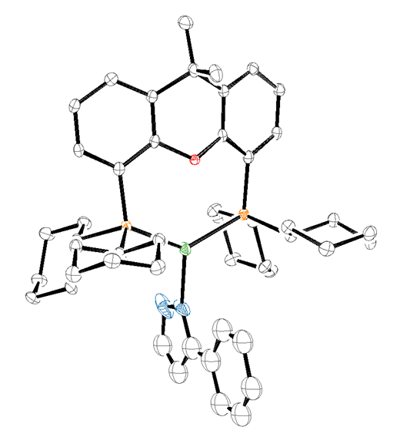
Figure S6. CyXant-Cu-N^{α} structure determined by X-ray diffraction
Experimental summary

A colorless crystal of approximate dimensions 0.206 x 0.094 x 0.075 mm was mounted in a cryoloop/on a glass fiber and transferred to a Bruker X8 Prospector diffractometer system. The APEX3 program package was used to determine the unit-cell parameters and for data collection (10 sec/frame scan time). The raw frame data was processed using SAINT and SADABS to yield the reflection data file. Subsequent calculations were carried out using the SHELXTL program package. The diffraction symmetry was mmm and the systematic absences were consistent with the orthorhombic space group Cmc2₁ that was later determined to be correct.

The structure was solved by direct methods and refined on F² by full-matrix least-squares techniques. The analytical scattering factors for neutral atoms were used throughout the analysis. Hydrogen atoms were located from a difference-Fourier map and refined (x,y,z and U_{iso}).

Least squares analysis yielded wR2 = 0.0999 and Goof = 1.027 for 238 variables refined against 4050 data (0.82 Å), R1 = 0.0397 for those 3906 data with I > 2.0σ(I). The absolute structure was assigned by refinement of the Flack parameter.⁸²

Definitions:

wR2 = [Σ[w(F_{o}²-F_{c}²)²] / Σ[w(F_{o}²)²] ]^{1/2}

R1 = Σ||F_{o}|-|F_{c}|| / Σ|F_{o}|

Goof = S = [Σ[w(F_{o}²-F_{c}²)²] / (n-p)]^{1/2} where n is the number of reflections and p is the total
number of parameters refined.

The thermal ellipsoid plot is shown at the 50% probability level.

Table S16. Crystal data and structure refinement.
Identification code CyXant-Cu-N^{α}
Empirical formula C48 H63 Cu N2 O P2
Formula weight 809.48
Temperature 100(2) K
Wavelength 1.54178 Å
Crystal system Orthorhombic
Space group Cmc2₁
Unit cell dimensions a = 14.3615(6) Å α = 90°.
b = 18.6461(9) Å β = 90°.
c = 15.8234(8) Å γ = 90°.
Volume 4237.3(3) Å3
Z 4
Density (calculated) 1.269 Mg/m3
Absorption coefficient 1.722 mm-1
F(000) 1728
Crystal color ?
Crystal size 0.206 x 0.094 x 0.075 mm3
Theta range for data collection 3.885 to 68.331°
Index ranges -17 <= h <= 17, -22 <= k <= 22, -19 <= l <= 19
Reflections collected 44717
Independent reflections 4050 [R(int) = 0.0812]
Completeness to theta = 67.679° 100.0 %
Absorption correction Semi-empirical from equivalents
Max. and min. transmission 0.7531 and 0.6791
Refinement method Full-matrix least-squares on F2
Data / restraints / parameters 4050 / 1 / 238
Goodness-of-fit on F2 1.027
Final R indices [I>2sigma(I) = 3906 data] R1 = 0.0397, wR2 = 0.0987
R indices (all data, ? Å) R1 = 0.0425, wR2 = 0.0999
Absolute structure parameter 0.000(8)
Extinction coefficient n/a
Largest diff. peak and hole 0.858 and -0.640 e.Å-3
Table S17. Atomic coordinates (x 104) and equivalent isotropic displacement parameters (Å2 x 103).
U(eq) is defined as one third of the trace of the orthogonalized Uij tensor.
________________________________________________________________________________
x y z U(eq)
________________________________________________________________________________
Cu(1) 5000 3121(1) 4824(1) 17(1)
P(1) 3579(1) 2762(1) 4403(1) 13(1)
O(1) 5000 1765(2) 3709(2) 12(1)
N(1) 5000 3918(4) 5662(5) 38(2)
C(11) 2606(3) 2076(2) 3054(2) 14(1)
C(13) 3298(3) 1194(2) 2133(2) 16(1)
C(12) 2533(3) 1603(2) 2378(2) 16(1)
C(28) 1986(3) 1112(2) 6128(3) 21(1)
C(19) 2842(3) 3538(2) 4110(2) 15(1)
C(20) 2606(3) 3992(2) 4893(3) 18(1)
C(15) 4182(3) 1721(2) 3243(2) 13(1)
C(21) 2033(3) 4652(2) 4632(2) 19(1)
C(10) 3436(3) 2148(2) 3506(3) 14(1)
C(29) 3016(3) 1252(2) 6278(3) 21(1)
C(22) 2557(3) 5107(2) 3983(3) 22(1)
C(30) 3468(3) 1602(2) 5505(3) 17(1)
C(27) 1484(3) 1809(2) 5897(3) 21(1)
C(26) 1918(3) 2151(2) 5122(3) 18(1)
C(17) 5000 132(3) 2945(4) 23(1)
N(2) 5000 4542(4) 5217(7) 59(2)
C(23) 2818(3) 4661(2) 3209(3) 23(1)
C(25) 2953(3) 2302(2) 5274(3) 16(1)
C(14) 4141(3) 1248(2) 2556(2) 14(1)
C(24) 3383(3) 3995(2) 3466(3) 19(1)
C(18) 5000 541(4) 1438(4) 27(1)
C(16) 5000 795(3) 2354(4) 18(1)
C(3) 5000 4029(8) 6511(8) 69(1)
C(9) 5000 2745(7) 6911(8) 69(1)
C(1) 5000 5073(8) 5793(7) 69(1)
C(4) 5000 3487(8) 7124(8) 69(1)
C(2) 5000 4805(7) 6585(8) 69(1)
C(8) 5000 2190(7) 7512(7) 69(1)
C(6) 5000 3058(7) 8567(8) 69(1)
C(7) 5000 2407(8) 8382(8) 69(1)
C(5) 5000 3642(7) 7999(7) 69(1)
________________________________________________________________________________
Table S18. Bond lengths [Å] and angles [°].
_____________________________________________________
Cu(1)-N(1) 1.992(6)
Cu(1)-P(1) 2.2484(10)
Cu(1)-P(1)#1 2.2484(10)
P(1)-C(10) 1.836(4)
P(1)-C(19) 1.851(4)
P(1)-C(25) 1.856(4)
O(1)-C(15)#1 1.389(4)
O(1)-C(15) 1.389(4)
N(1)-C(3) 1.358(13)
N(1)-N(2) 1.361(12)
C(11)-C(12) 1.389(6)
C(11)-C(10) 1.396(6)
C(11)-H(11) 0.9500
C(13)-C(14) 1.388(6)
C(13)-C(12) 1.394(6)
C(13)-H(13) 0.9500
C(12)-H(12) 0.9500
C(28)-C(29) 1.521(6)
C(28)-C(27) 1.531(6)
C(28)-H(28A) 0.9900
C(28)-H(28B) 0.9900
C(19)-C(24) 1.539(5)
C(19)-C(20) 1.539(5)
C(20)-C(21) 1.536(5)
C(20)-H(20A) 0.9900
C(20)-H(20B) 0.9900
C(15)-C(10) 1.399(6)
C(15)-C(14) 1.401(5)
C(21)-C(22) 1.532(6)
C(21)-H(21A) 0.9900
C(21)-H(21B) 0.9900
C(29)-C(30) 1.531(6)
C(29)-H(29A) 0.9900
C(29)-H(29B) 0.9900
C(22)-C(23) 1.527(6)
C(22)-H(22A) 0.9900
C(22)-H(22B) 0.9900
C(30)-C(25) 1.544(5)
C(30)-H(30A) 0.9900
C(30)-H(30B) 0.9900
C(27)-C(26) 1.517(6)
C(27)-H(27A) 0.9900
C(27)-H(27B) 0.9900
C(26)-C(25) 1.531(6)
C(26)-H(26A) 0.9900
C(26)-H(26B) 0.9900
C(17)-C(16) 1.550(8)
C(17)-H(17A) 0.9800
C(17)-H(17B) 0.9800
C(17)-H(17C) 0.9800
N(2)-C(1) 1.345(13)
C(23)-C(24) 1.539(6)
C(23)-H(23A) 0.9900
C(23)-H(23B) 0.9900
C(14)-C(16) 1.529(5)
C(24)-H(24A) 0.9900
C(24)-H(24B) 0.9900
C(18)-C(16) 1.525(9)
C(18)-H(18A) 0.9800
C(18)-H(18B) 0.9800
C(18)-H(18C) 0.9800
C(16)-C(14)#1 1.529(5)
C(3)-C(4) 1.402(19)
C(3)-C(2) 1.452(18)
C(9)-C(8) 1.405(18)
C(9)-C(4) 1.424(18)
C(9)-H(9) 0.9500
C(1)-C(2) 1.349(18)
C(1)-H(1) 0.9500
C(4)-C(5) 1.414(15)
C(2)-H(2) 0.9500
C(8)-C(7) 1.435(15)
C(8)-H(8) 0.9500
C(6)-C(7) 1.248(17)
C(6)-C(5) 1.413(18)
C(6)-H(6) 0.9500
C(7)-H(7) 0.9500
C(5)-H(5) 0.9500

N(1)-Cu(1)-P(1) 114.76(3)
N(1)-Cu(1)-P(1)#1 114.76(3)
P(1)-Cu(1)-P(1)#1 130.41(6)
C(10)-P(1)-C(19) 103.27(18)
C(10)-P(1)-C(25) 103.39(18)
C(19)-P(1)-C(25) 105.71(18)
C(10)-P(1)-Cu(1) 121.05(13)
C(19)-P(1)-Cu(1) 111.15(13)
C(25)-P(1)-Cu(1) 110.95(14)
C(15)#1-O(1)-C(15) 115.5(4)
C(3)-N(1)-N(2) 112.4(8)
C(3)-N(1)-Cu(1) 140.5(8)
N(2)-N(1)-Cu(1) 107.1(6)
C(12)-C(11)-C(10) 121.4(4)
C(12)-C(11)-H(11) 119.3
C(10)-C(11)-H(11) 119.3
C(14)-C(13)-C(12) 120.9(4)
C(14)-C(13)-H(13) 119.6
C(12)-C(13)-H(13) 119.6
C(11)-C(12)-C(13) 120.2(4)
C(11)-C(12)-H(12) 119.9
C(13)-C(12)-H(12) 119.9
C(29)-C(28)-C(27) 110.4(3)
C(29)-C(28)-H(28A) 109.6
C(27)-C(28)-H(28A) 109.6
C(29)-C(28)-H(28B) 109.6
C(27)-C(28)-H(28B) 109.6
H(28A)-C(28)-H(28B) 108.1
C(24)-C(19)-C(20) 109.9(3)
C(24)-C(19)-P(1) 108.1(3)
C(20)-C(19)-P(1) 110.8(3)
C(21)-C(20)-C(19) 110.0(3)
C(21)-C(20)-H(20A) 109.7
C(19)-C(20)-H(20A) 109.7
C(21)-C(20)-H(20B) 109.7
C(19)-C(20)-H(20B) 109.7
H(20A)-C(20)-H(20B) 108.2
O(1)-C(15)-C(10) 117.2(4)
O(1)-C(15)-C(14) 119.0(3)
C(10)-C(15)-C(14) 123.9(3)
C(22)-C(21)-C(20) 111.1(3)
C(22)-C(21)-H(21A) 109.4
C(20)-C(21)-H(21A) 109.4
C(22)-C(21)-H(21B) 109.4
C(20)-C(21)-H(21B) 109.4
H(21A)-C(21)-H(21B) 108.0
C(11)-C(10)-C(15) 116.5(4)
C(11)-C(10)-P(1) 123.5(3)
C(15)-C(10)-P(1) 120.0(3)
C(28)-C(29)-C(30) 111.2(4)
C(28)-C(29)-H(29A) 109.4
C(30)-C(29)-H(29A) 109.4
C(28)-C(29)-H(29B) 109.4
C(30)-C(29)-H(29B) 109.4
H(29A)-C(29)-H(29B) 108.0
C(23)-C(22)-C(21) 110.9(3)
C(23)-C(22)-H(22A) 109.5
C(21)-C(22)-H(22A) 109.5
C(23)-C(22)-H(22B) 109.5
C(21)-C(22)-H(22B) 109.5
H(22A)-C(22)-H(22B) 108.1
C(29)-C(30)-C(25) 110.2(3)
C(29)-C(30)-H(30A) 109.6
C(25)-C(30)-H(30A) 109.6
C(29)-C(30)-H(30B) 109.6
C(25)-C(30)-H(30B) 109.6
H(30A)-C(30)-H(30B) 108.1
C(26)-C(27)-C(28) 110.8(4)
C(26)-C(27)-H(27A) 109.5
C(28)-C(27)-H(27A) 109.5
C(26)-C(27)-H(27B) 109.5
C(28)-C(27)-H(27B) 109.5
H(27A)-C(27)-H(27B) 108.1
C(27)-C(26)-C(25) 110.4(3)
C(27)-C(26)-H(26A) 109.6
C(25)-C(26)-H(26A) 109.6
C(27)-C(26)-H(26B) 109.6
C(25)-C(26)-H(26B) 109.6
H(26A)-C(26)-H(26B) 108.1
C(16)-C(17)-H(17A) 109.5
C(16)-C(17)-H(17B) 109.5
H(17A)-C(17)-H(17B) 109.5
C(16)-C(17)-H(17C) 109.5
H(17A)-C(17)-H(17C) 109.5
H(17B)-C(17)-H(17C) 109.5
C(1)-N(2)-N(1) 106.2(10)
C(22)-C(23)-C(24) 110.9(3)
C(22)-C(23)-H(23A) 109.5
C(24)-C(23)-H(23A) 109.5
C(22)-C(23)-H(23B) 109.5
C(24)-C(23)-H(23B) 109.5
H(23A)-C(23)-H(23B) 108.0
C(26)-C(25)-C(30) 110.3(3)
C(26)-C(25)-P(1) 116.0(3)
C(30)-C(25)-P(1) 109.5(3)
C(13)-C(14)-C(15) 117.2(3)
C(13)-C(14)-C(16) 124.2(4)
C(15)-C(14)-C(16) 118.5(4)
C(19)-C(24)-C(23) 110.8(3)
C(19)-C(24)-H(24A) 109.5
C(23)-C(24)-H(24A) 109.5
C(19)-C(24)-H(24B) 109.5
C(23)-C(24)-H(24B) 109.5
H(24A)-C(24)-H(24B) 108.1
C(16)-C(18)-H(18A) 109.5
C(16)-C(18)-H(18B) 109.5
H(18A)-C(18)-H(18B) 109.5
C(16)-C(18)-H(18C) 109.5
H(18A)-C(18)-H(18C) 109.5
H(18B)-C(18)-H(18C) 109.5
C(18)-C(16)-C(14)#1 111.8(3)
C(18)-C(16)-C(14) 111.8(3)
C(14)#1-C(16)-C(14) 107.5(5)
C(18)-C(16)-C(17) 109.0(5)
C(14)#1-C(16)-C(17) 108.3(3)
C(14)-C(16)-C(17) 108.3(3)
N(1)-C(3)-C(4) 125.1(11)
N(1)-C(3)-C(2) 103.4(12)
C(4)-C(3)-C(2) 131.5(11)
C(8)-C(9)-C(4) 123.7(11)
C(8)-C(9)-H(9) 118.2
C(4)-C(9)-H(9) 118.2
N(2)-C(1)-C(2) 110.9(13)
N(2)-C(1)-H(1) 124.5
C(2)-C(1)-H(1) 124.5
C(3)-C(4)-C(5) 122.0(13)
C(3)-C(4)-C(9) 122.4(11)
C(5)-C(4)-C(9) 115.6(13)
C(1)-C(2)-C(3) 107.1(11)
C(1)-C(2)-H(2) 126.5
C(3)-C(2)-H(2) 126.5
C(9)-C(8)-C(7) 116.2(12)
C(9)-C(8)-H(8) 121.9
C(7)-C(8)-H(8) 121.9
C(7)-C(6)-C(5) 126.9(13)
C(7)-C(6)-H(6) 116.5
C(5)-C(6)-H(6) 116.5
C(6)-C(7)-C(8) 120.0(14)
C(6)-C(7)-H(7) 120.0
C(8)-C(7)-H(7) 120.0
C(6)-C(5)-C(4) 117.7(12)
C(6)-C(5)-H(5) 121.2
C(4)-C(5)-H(5) 121.2
_____________________________________________________________
Symmetry transformations used to generate equivalent atoms:
#1 -x+1,y,z
Table S19. Anisotropic displacement parameters (Å2 x 103).
The anisotropic displacement factor exponent takes the form: -2π2[ h2 a*2U11 + ... + 2 h k a* b* U12 ]
______________________________________________________________________________
U11 U22 U33 U23 U13 U12
______________________________________________________________________________
Cu(1) 12(1) 16(1) 23(1) -3(1) 0 0
P(1) 10(1) 13(1) 15(1) 0(1) 1(1) 1(1)
O(1) 9(2) 16(2) 12(2) -3(1) 0 0
N(1) 18(3) 35(4) 60(4) -31(3) 0 0
C(11) 10(2) 16(2) 17(2) 4(2) 1(2) 1(2)
C(13) 16(2) 17(2) 15(2) 2(2) 1(2) -3(2)
C(12) 13(2) 20(2) 15(2) 3(2) -2(2) -1(2)
C(28) 25(2) 20(2) 18(2) 3(2) 4(2) -3(2)
C(19) 16(2) 12(2) 17(2) -1(2) 1(2) 4(2)
C(20) 17(2) 19(2) 17(2) 2(2) 4(2) 5(2)
C(15) 9(2) 15(2) 15(2) 4(2) -1(2) -2(2)
C(21) 23(2) 16(2) 19(2) -2(2) 4(2) 5(2)
C(10) 13(2) 15(2) 14(2) 4(2) 1(2) -1(2)
C(29) 26(2) 19(2) 18(2) 4(2) -2(2) 1(2)
C(22) 32(2) 16(2) 19(2) 2(2) 1(2) 6(2)
C(30) 17(2) 17(2) 17(2) 2(2) -1(2) 2(2)
C(27) 18(2) 23(2) 23(2) 2(2) 5(2) -5(2)
C(26) 14(2) 20(2) 20(2) 2(2) 1(2) 0(2)
C(17) 16(3) 16(3) 38(4) -1(3) 0 0
N(2) 20(3) 37(4) 119(7) -37(4) 0 0
C(23) 32(2) 20(2) 18(2) 2(2) 2(2) 6(2)
C(25) 15(2) 15(2) 16(2) 1(2) 1(2) 2(2)
C(14) 12(2) 14(2) 14(2) 2(1) 0(2) -1(2)
C(24) 22(2) 19(2) 16(2) 3(2) 3(2) 5(2)
C(18) 18(3) 30(3) 32(4) -13(3) 0 0
C(16) 10(3) 21(3) 25(3) -3(2) 0 0
C(3) 18(1) 116(3) 74(2) -35(2) 0 0
C(9) 18(1) 116(3) 74(2) -35(2) 0 0
C(1) 18(1) 116(3) 74(2) -35(2) 0 0
C(4) 18(1) 116(3) 74(2) -35(2) 0 0
C(2) 18(1) 116(3) 74(2) -35(2) 0 0
C(8) 18(1) 116(3) 74(2) -35(2) 0 0
C(6) 18(1) 116(3) 74(2) -35(2) 0 0
C(7) 18(1) 116(3) 74(2) -35(2) 0 0
C(5) 18(1) 116(3) 74(2) -35(2) 0 0
______________________________________________________________________________
Table S20. Hydrogen coordinates (x 104) and isotropic displacement parameters (Å2 x 103).
________________________________________________________________________________
x y z U(eq)
________________________________________________________________________________

H(11) 2081 2355 3212 17
H(13) 3242 873 1669 19
H(12) 1960 1559 2083 19
H(28A) 1704 905 6644 25
H(28B) 1911 760 5663 25
H(20A) 2246 3700 5301 21
H(20B) 3188 4149 5173 21
H(21A) 1432 4493 4388 23
H(21B) 1896 4946 5138 23
H(29A) 3335 793 6403 25
H(29B) 3090 1570 6774 25
H(22A) 2162 5516 3806 27
H(22B) 3129 5304 4244 27
H(30A) 3447 1267 5020 21
H(30B) 4130 1710 5629 21
H(27A) 819 1707 5786 26
H(27B) 1520 2147 6379 26
H(26A) 1592 2605 4990 22
H(26B) 1848 1825 4631 22
H(17A) 4463 -172 2813 35
H(17B) 4961 292 3535 35
H(17C) 5576 -141 2862 35
H(23A) 3189 4958 2814 28
H(23B) 2244 4509 2912 28
H(24A) 3520 3703 2958 23
H(24B) 3983 4147 3716 23
H(18A) 4514 178 1361 40
H(18B) 5608 333 1301 40
H(18C) 4878 949 1064 40
H(9) 5000 2618 6329 83
H(1) 5000 5570 5660 83
H(2) 5000 5073 7095 83
H(8) 5000 1699 7351 83
H(6) 5000 3172 9152 83
H(7) 5000 2056 8816 83
H(5) 5000 4123 8197 83
________________________________________________________________________________
Table S21. Torsion angles [°].
________________________________________________________________
C(10)-C(11)-C(12)-C(13) -0.6(6)
C(14)-C(13)-C(12)-C(11) 0.1(6)
C(10)-P(1)-C(19)-C(24) -78.7(3)
C(25)-P(1)-C(19)-C(24) 173.1(3)
Cu(1)-P(1)-C(19)-C(24) 52.6(3)
C(10)-P(1)-C(19)-C(20) 160.9(3)
C(25)-P(1)-C(19)-C(20) 52.7(3)
Cu(1)-P(1)-C(19)-C(20) -67.8(3)
C(24)-C(19)-C(20)-C(21) 58.1(4)
P(1)-C(19)-C(20)-C(21) 177.4(3)
C(15)#1-O(1)-C(15)-C(10) -143.2(3)
C(15)#1-O(1)-C(15)-C(14) 38.0(6)
C(19)-C(20)-C(21)-C(22) -57.8(4)
C(12)-C(11)-C(10)-C(15) -0.2(6)
C(12)-C(11)-C(10)-P(1) 180.0(3)
O(1)-C(15)-C(10)-C(11) -177.3(3)
C(14)-C(15)-C(10)-C(11) 1.4(6)
O(1)-C(15)-C(10)-P(1) 2.5(5)
C(14)-C(15)-C(10)-P(1) -178.7(3)
C(19)-P(1)-C(10)-C(11) -34.7(4)
C(25)-P(1)-C(10)-C(11) 75.3(4)
Cu(1)-P(1)-C(10)-C(11) -159.8(3)
C(19)-P(1)-C(10)-C(15) 145.4(3)
C(25)-P(1)-C(10)-C(15) -104.6(3)
Cu(1)-P(1)-C(10)-C(15) 20.3(4)
C(27)-C(28)-C(29)-C(30) -56.8(5)
C(20)-C(21)-C(22)-C(23) 56.6(5)
C(28)-C(29)-C(30)-C(25) 56.5(5)
C(29)-C(28)-C(27)-C(26) 57.6(5)
C(28)-C(27)-C(26)-C(25) -58.2(5)
C(3)-N(1)-N(2)-C(1) 0.000(3)
Cu(1)-N(1)-N(2)-C(1) 180.000(3)
C(21)-C(22)-C(23)-C(24) -55.6(5)
C(27)-C(26)-C(25)-C(30) 57.6(4)
C(27)-C(26)-C(25)-P(1) -177.1(3)
C(29)-C(30)-C(25)-C(26) -56.6(4)
C(29)-C(30)-C(25)-P(1) 174.6(3)
C(10)-P(1)-C(25)-C(26) -59.3(3)
C(19)-P(1)-C(25)-C(26) 48.9(3)
Cu(1)-P(1)-C(25)-C(26) 169.5(3)
C(10)-P(1)-C(25)-C(30) 66.4(3)
C(19)-P(1)-C(25)-C(30) 174.6(3)
Cu(1)-P(1)-C(25)-C(30) -64.8(3)
C(12)-C(13)-C(14)-C(15) 1.0(6)
C(12)-C(13)-C(14)-C(16) 177.1(4)
O(1)-C(15)-C(14)-C(13) 176.9(3)
C(10)-C(15)-C(14)-C(13) -1.8(6)
O(1)-C(15)-C(14)-C(16) 0.6(6)
C(10)-C(15)-C(14)-C(16) -178.1(4)
C(20)-C(19)-C(24)-C(23) -57.8(4)
P(1)-C(19)-C(24)-C(23) -178.7(3)
C(22)-C(23)-C(24)-C(19) 56.6(5)
C(13)-C(14)-C(16)-C(18) 26.1(6)
C(15)-C(14)-C(16)-C(18) -157.9(4)
C(13)-C(14)-C(16)-C(14)#1 149.0(3)
C(15)-C(14)-C(16)-C(14)#1 -34.9(6)
C(13)-C(14)-C(16)-C(17) -94.1(5)
C(15)-C(14)-C(16)-C(17) 81.9(5)
N(2)-N(1)-C(3)-C(4) 180.000(3)
Cu(1)-N(1)-C(3)-C(4) 0.000(6)
N(2)-N(1)-C(3)-C(2) 0.000(3)
Cu(1)-N(1)-C(3)-C(2) 180.000(4)
N(1)-N(2)-C(1)-C(2) 0.000(5)
N(1)-C(3)-C(4)-C(5) 180.000(4)
C(2)-C(3)-C(4)-C(5) 0.000(6)
N(1)-C(3)-C(4)-C(9) 0.000(6)
C(2)-C(3)-C(4)-C(9) 180.000(4)
C(8)-C(9)-C(4)-C(3) 180.000(4)
C(8)-C(9)-C(4)-C(5) 0.000(5)
N(2)-C(1)-C(2)-C(3) 0.000(4)
N(1)-C(3)-C(2)-C(1) 0.000(4)
C(4)-C(3)-C(2)-C(1) 180.000(4)
C(4)-C(9)-C(8)-C(7) 0.000(4)
C(5)-C(6)-C(7)-C(8) 0.000(6)
C(9)-C(8)-C(7)-C(6) 0.000(6)
C(7)-C(6)-C(5)-C(4) 0.000(6)
C(3)-C(4)-C(5)-C(6) 180.000(4)
C(9)-C(4)-C(5)-C(6) 0.000(5)
________________________________________________________________
Symmetry transformations used to generate equivalent atoms:
#1 -x+1,y,z

Table S22. Hydrogen bonds [Å and °].
____________________________________________________________________________
D-H...A d(D-H) d(H...A) d(D...A) <(DHA)
____________________________________________________________________________

General Procedure to Prepare Aryne Precursors
The synthesis of trifluoromethanesulfonate (Kobayashi precursors) were performed using standard literature-reported procedures.⁸³

The synthesis of triaryoxonium ions (Smith precursors) were performed using standard literature-reported procedures.³⁵

NMR Spectra
1,5-Diphenyl-1H-pyrazole (3a)
5-Methyl-1-phenyl-1H-pyrazole (3b)
5-Cyclopropyl-1-phenyl-1H-pyrazole (3c)
5-Isopropyl-1-phenyl-1H-pyrazole (3d)
5-(Tert-butyl)-1-phenyl-1H-pyrazole (3e)
5-Bromo-1-phenyl-1H-pyrazole (3f)
5-Iodo-1-phenyl-1H-pyrazole (3g)
1-Phenyl-5-(o-tolyl)-1H-pyrazole (3h)
5-(2-Fluorophenyl)-1-phenyl-1H-pyrazole (3i)

5-(2-Bromophenyl)-1-phenyl-1H-pyrazole (3j)
5-(2-Methoxyphenyl)-1-phenyl-1H-pyrazole (3k)
1-Phenyl-5-(p-tolyl)-1H-pyrazole (3l)
5-(4-Chlorophenyl)-1-phenyl-1H-pyrazole (3m)
5-(4-Fluorophenyl)-1-phenyl-1H-pyrazole (3n)

5-(3-Methoxyphenyl)-1-phenyl-1H-pyrazole (3o)
5-(4-Methoxyphenyl)-1-phenyl-1H-pyrazole (3p)
5-(Furan-2-yl)-1-phenyl-1H-pyrazole (3q)
4-(1-Phenyl-1H-pyrazol-5-yl)pyridine (3r)
3-Methyl-1,5-diphenyl-1H-pyrazole (3s)
5-(Tert-butyl)-3-methyl-1-phenyl-1H-pyrazole (3t)
5-(Tert-butyl)-3-iodo-1-phenyl-1H-pyrazole (3u)
1,5-Diphenyl-1H-pyrazol-3-amine (3v)
3-Cyclopropyl-1-phenyl-5-(trifluoromethyl)-1H-pyrazole (3w)
Methyl 5-ethyl-1-phenyl-1H-pyrazole-3-carboxylate (3x)

Methyl 4-bromo-1-phenyl-1H-pyrazole-3-carboxylate (3y)

Ethyl 5-cyclopropyl-1-phenyl-1H-pyrazole-4-carboxylate (3z)
1-Phenyl-1H-indazole (3aa)
1,5-Diphenyl-1H-1,2,4-triazole (3ab)
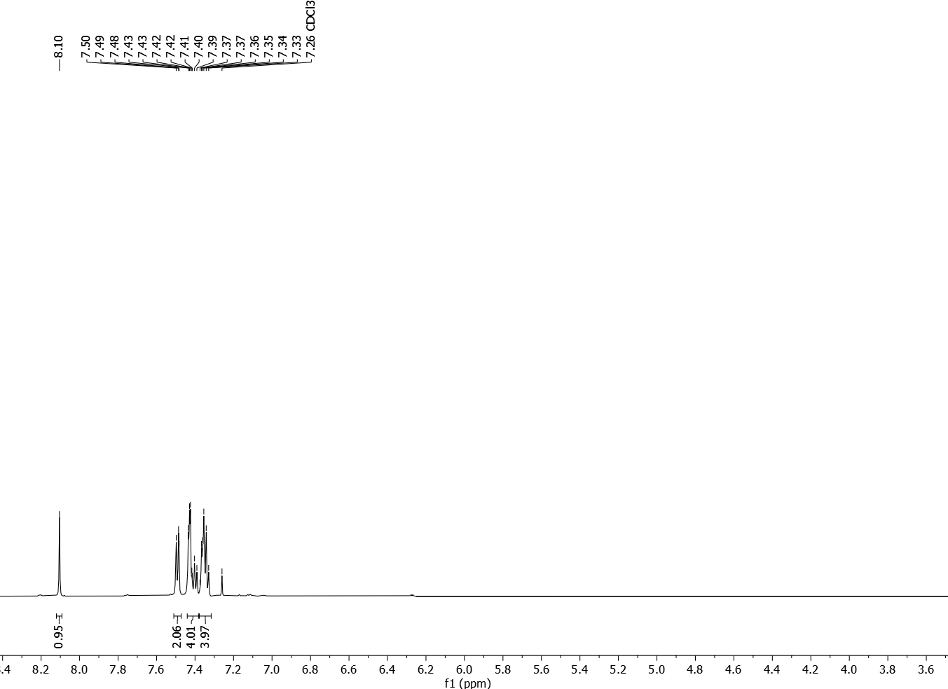
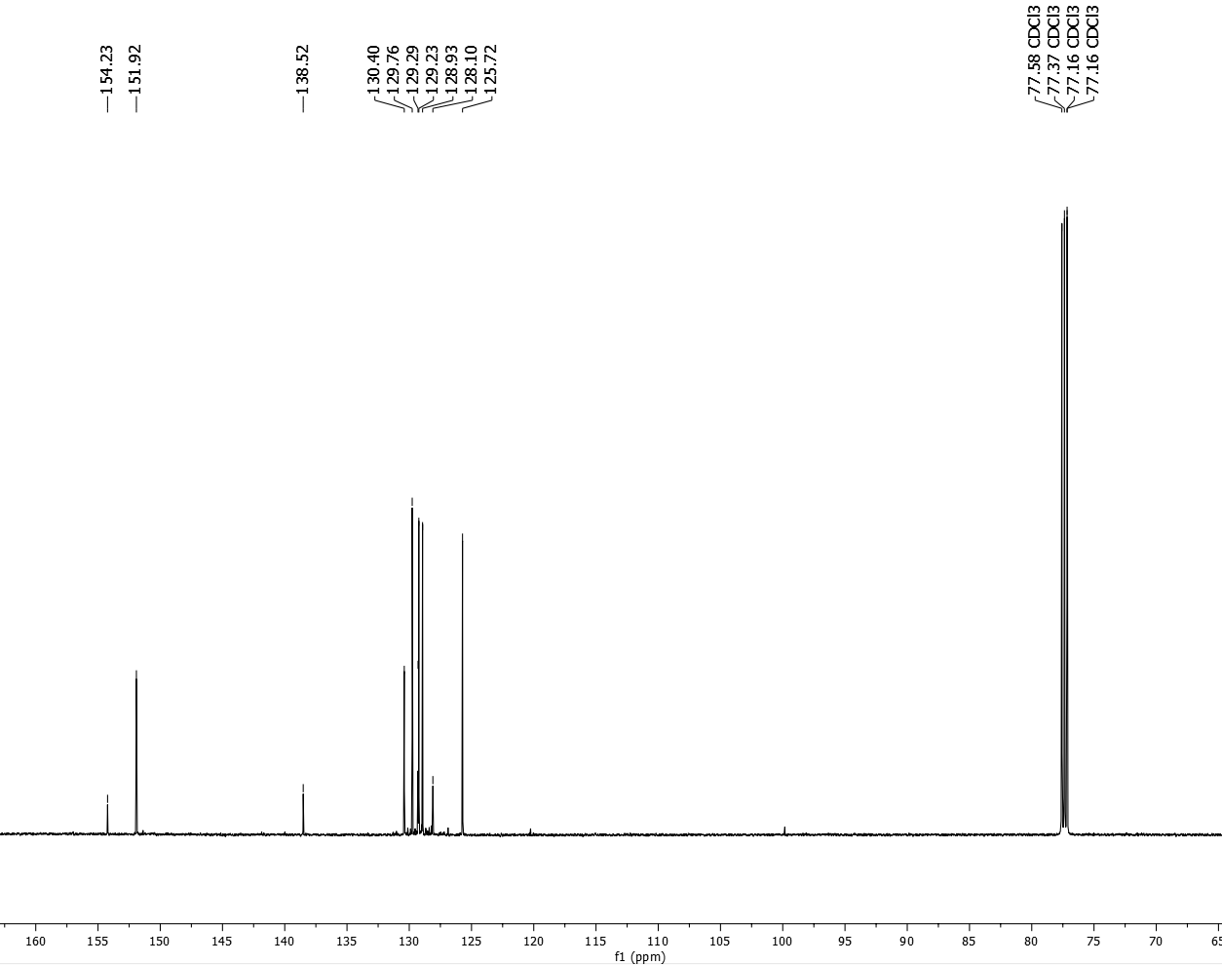
4-Bromo-2-phenyl-2H-1,2,3-triazole (3ac)
1,3-Diphenyl-1H-pyrazole (4a)
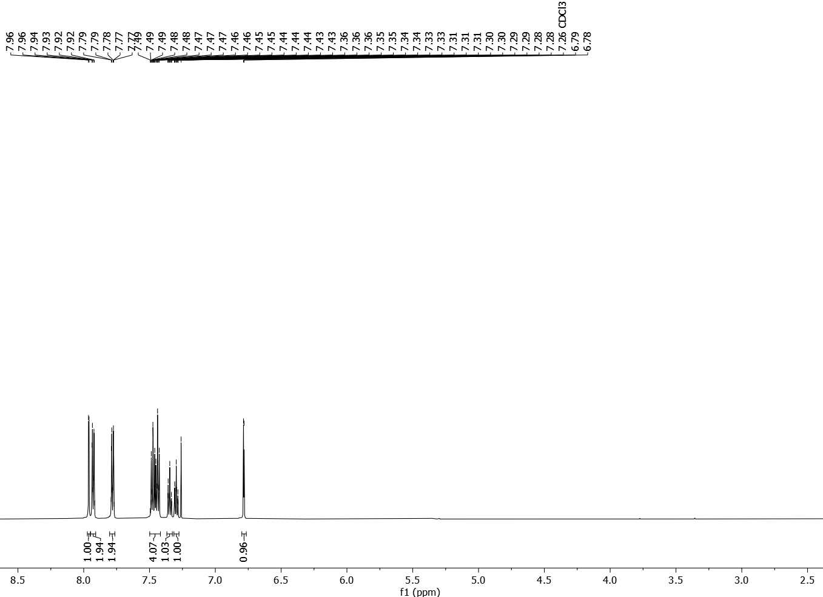
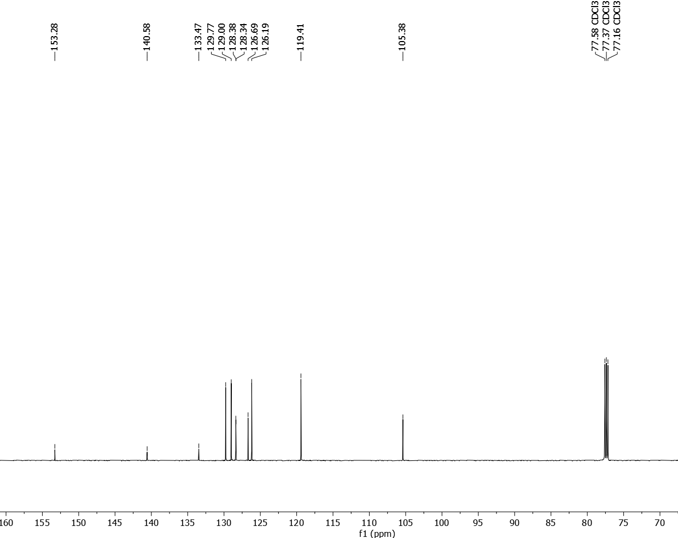
3-Methyl-1-phenyl-1H-pyrazole (4b)

3-Cyclopropyl-1-phenyl-1H-pyrazole (4c)
3-Isopropyl-1-phenyl-1H-pyrazole (4d)
3-(Tert-butyl)-1-phenyl-1H-pyrazole (4e)
1-Phenyl-3-(o-tolyl)-1H-pyrazole (4f)
3-(2-Fluorophenyl)-1-phenyl-1H-pyrazole (4g)

3-(2-Bromophenyl)-1-phenyl-1H-pyrazole (4h)
3-(2-Methoxyphenyl)-1-phenyl-1H-pyrazole (4i)
1-Phenyl-3-(p-tolyl)-1H-pyrazole (4j)
3-(4-Chlorophenyl)-1-phenyl-1H-pyrazole (4k)
3-(4-Fluorophenyl)-1-phenyl-1H-pyrazole (4l)

3-(4-Methoxyphenyl)-1-phenyl-1H-pyrazole (4m)

3-(3-Methoxyphenyl)-1-phenyl-1H-pyrazole (4n)

3-(Furan-2-yl)-1-phenyl-1H-pyrazole (4o)
5-Methyl-1,3-diphenyl-1H-pyrazole (4p)
3-(Tert-butyl)-5-methyl-1-phenyl-1H-pyrazole (4q)
1,3-Diphenyl-1H-pyrazol-5-amine (4r)
Ethyl 3-cyclopropyl-1-phenyl-1H-pyrazole-4-carboxylate (4s)
1-Phenyl-1H-indazole (4t)

1-(3,4-Dimethylphenyl)-5-phenyl-1H-pyrazole (5a)
1-(3,4-Dimethoxyphenyl)-5-phenyl-1H-pyrazole (5b)
1-(Naphthalen-2-yl)-5-phenyl-1H-pyrazole (5c)
5-Phenyl-1-(m-tolyl)-1H-pyrazole (5f)
5-Phenyl-1-(2-(trimethylsilyl)phenyl)-1H-pyrazole (5g)

1-([1,1'-Biphenyl]-2-yl)-5-phenyl-1H-pyrazole (5h)

5h
NOE (600 MHz, CD₃CN)

1-(Naphthalen-1-yl)-5-phenyl-1H-pyrazole (5j’)

3-Cyano-N-(5-phenyl-1H-pyrazol-3-yl)benzamide (6)
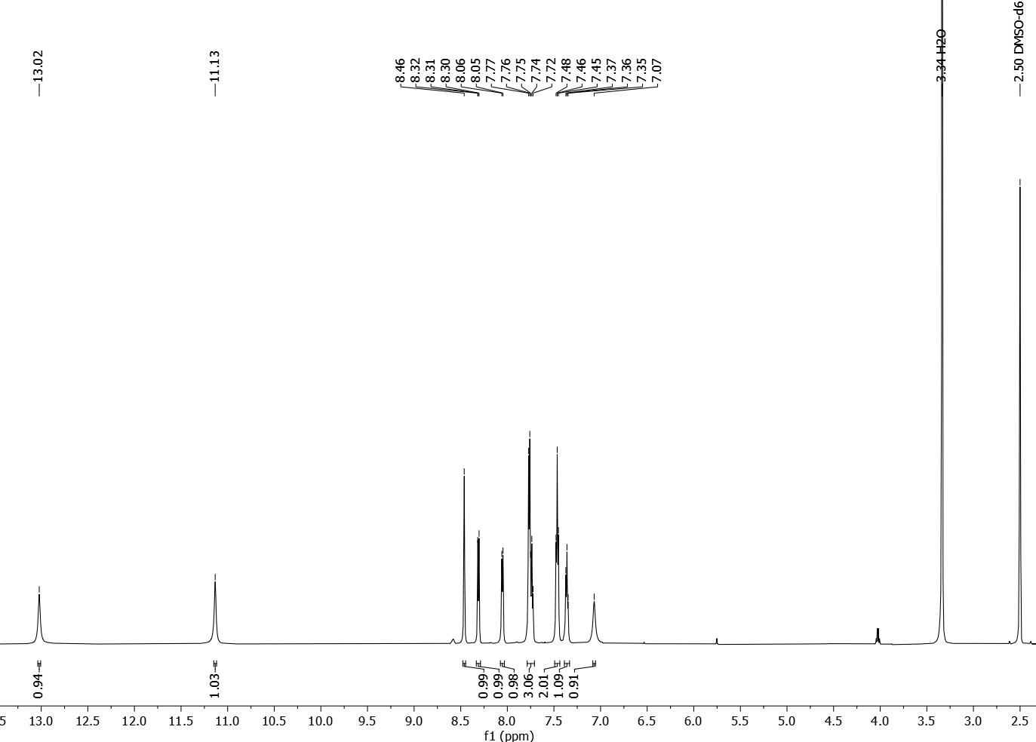
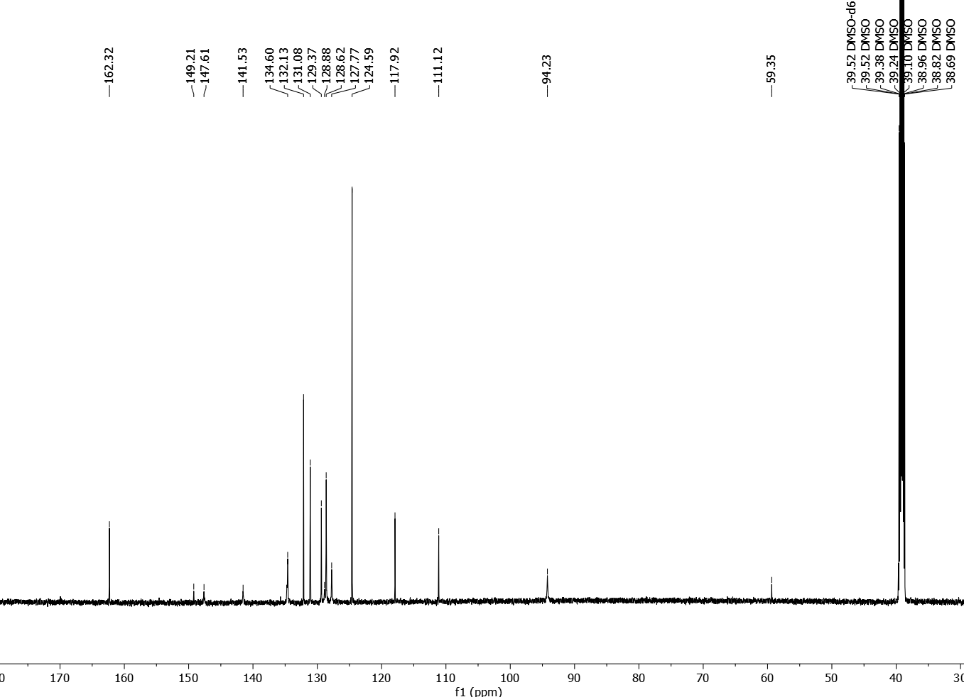
3-Cyano-N-(1,3-diphenyl-1H-pyrazol-5-yl)benzamide (7, CDPPB)
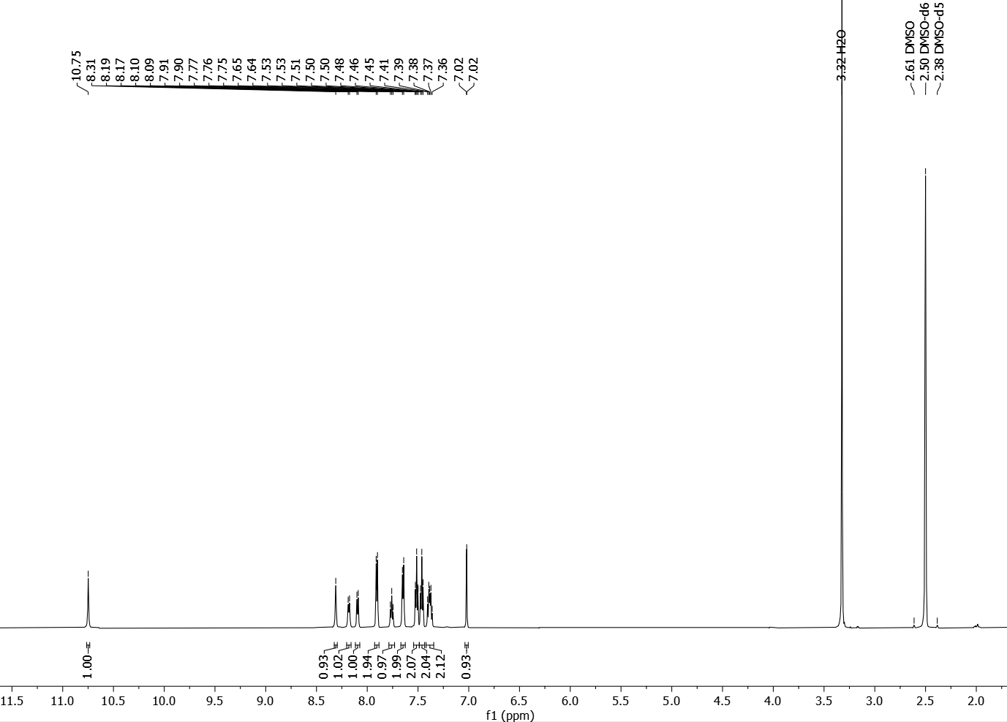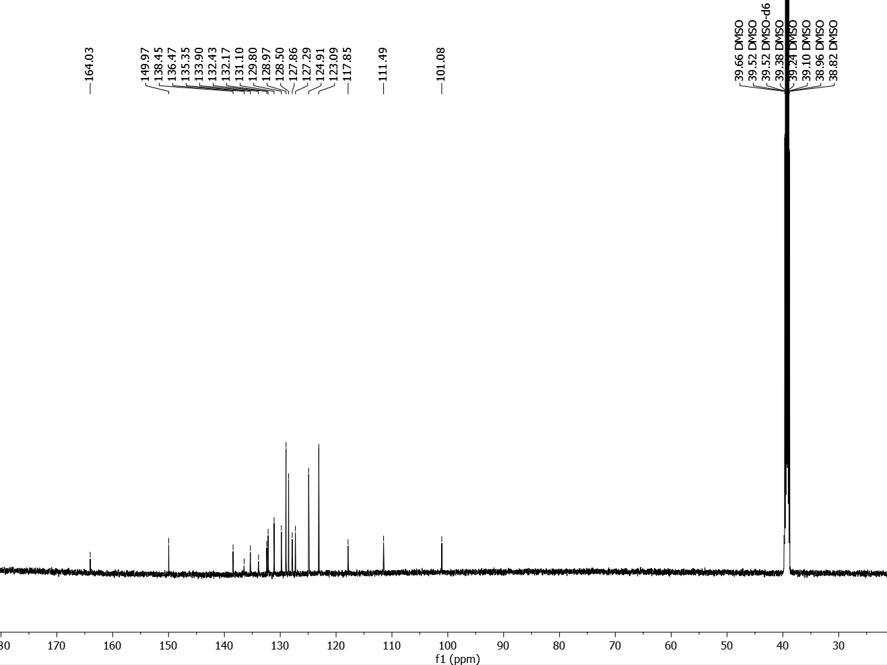
3-Cyano-N-(1,5-diphenyl-1H-pyrazol-3-yl)benzamide (8, CDPPB-N-Isomer)
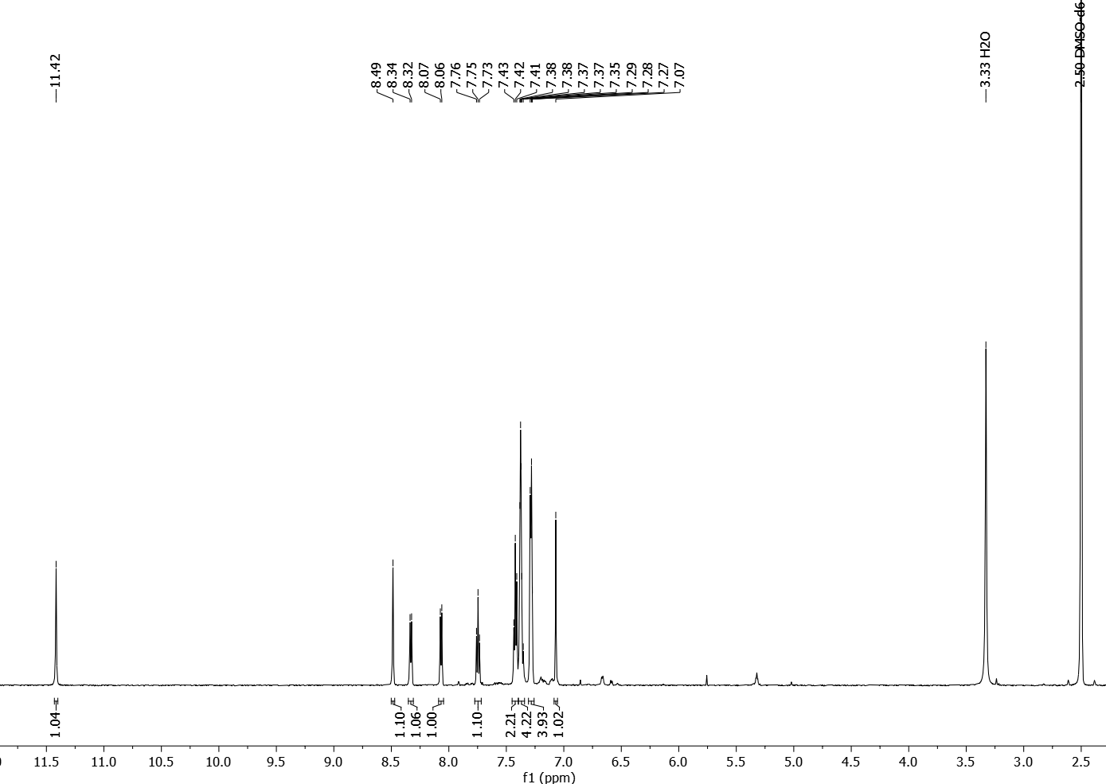
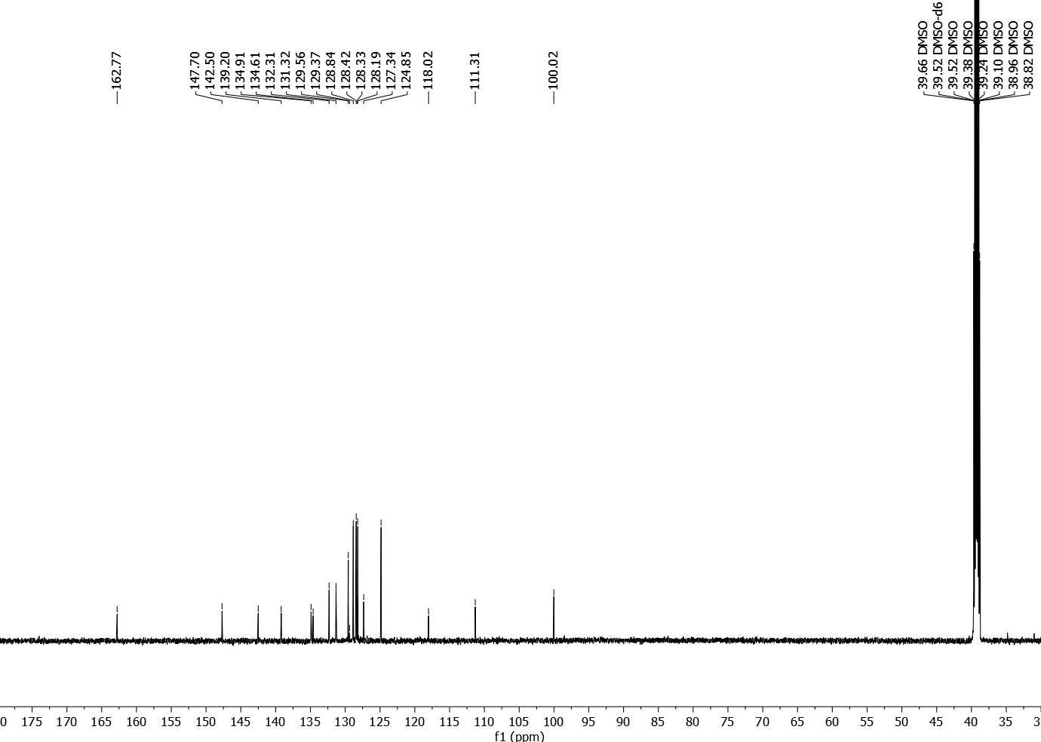
CyXant-Cu-N^{α}
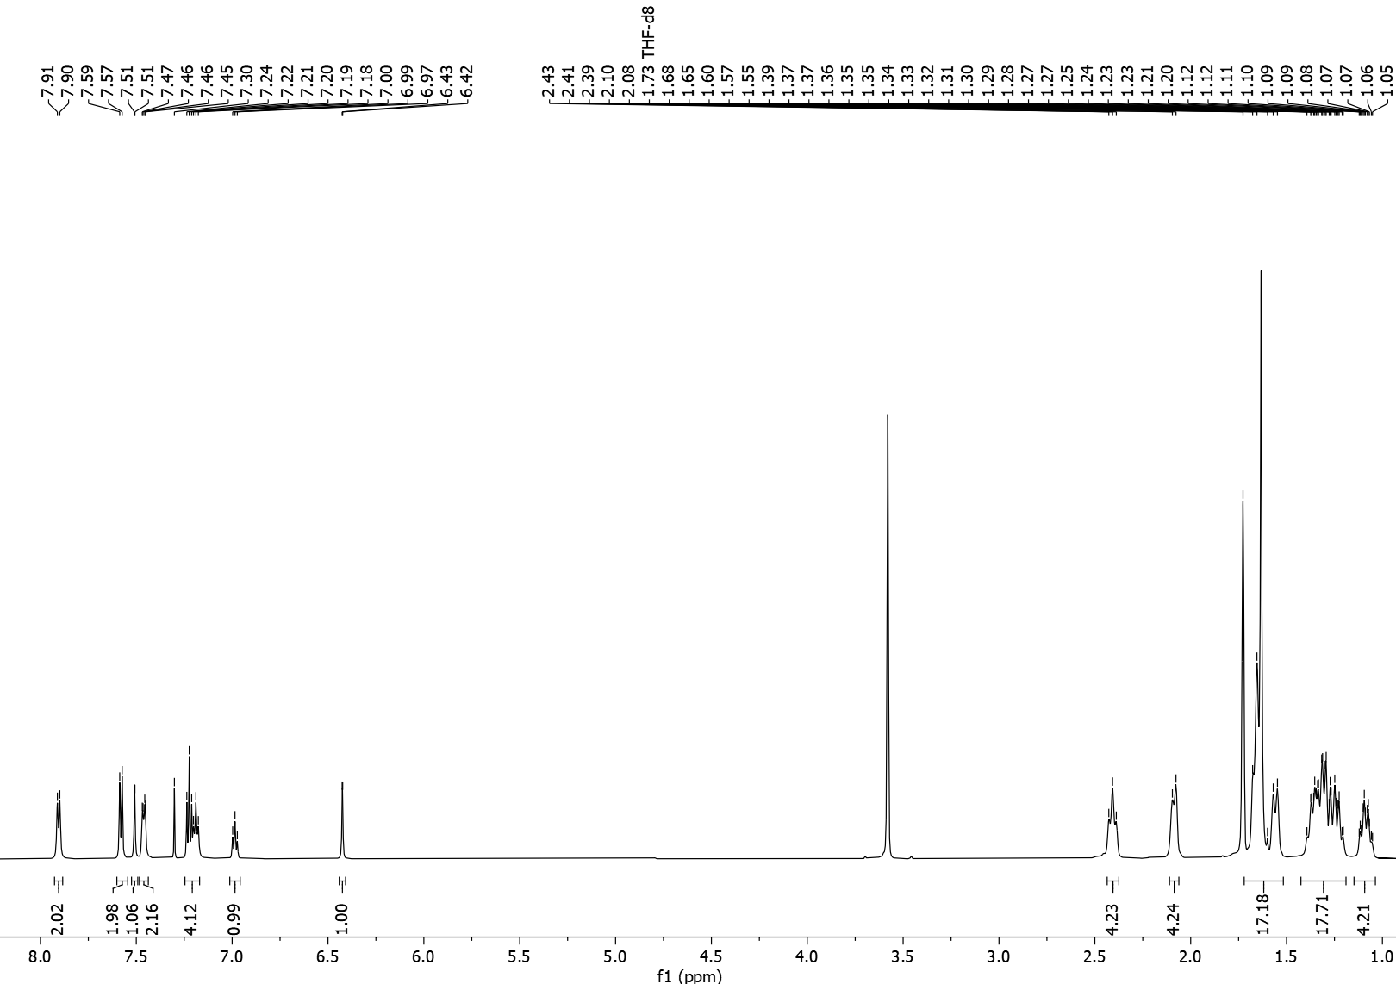
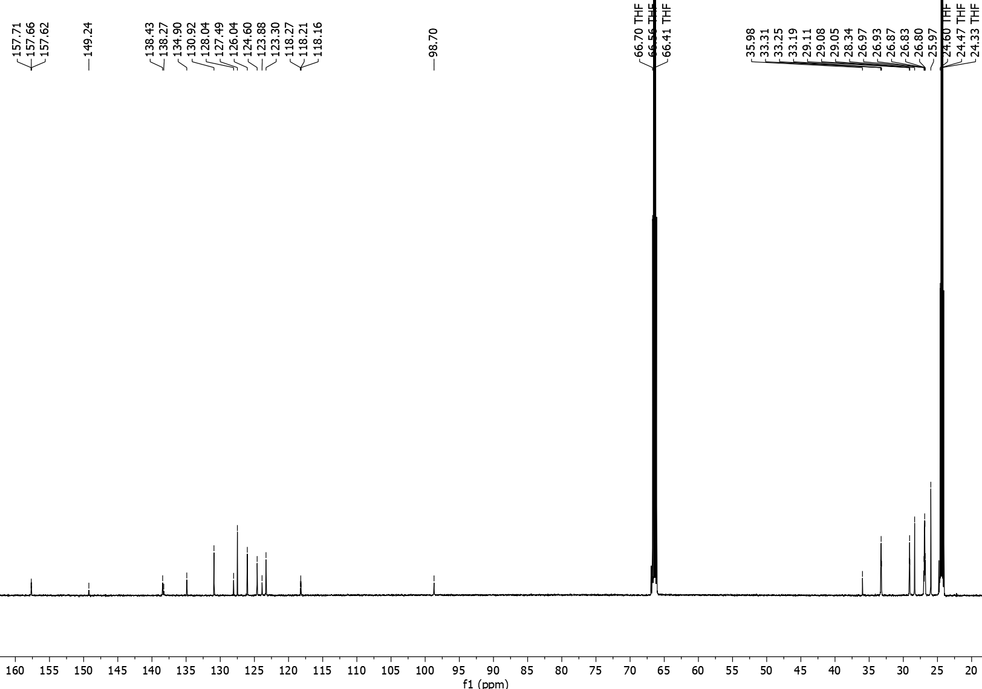
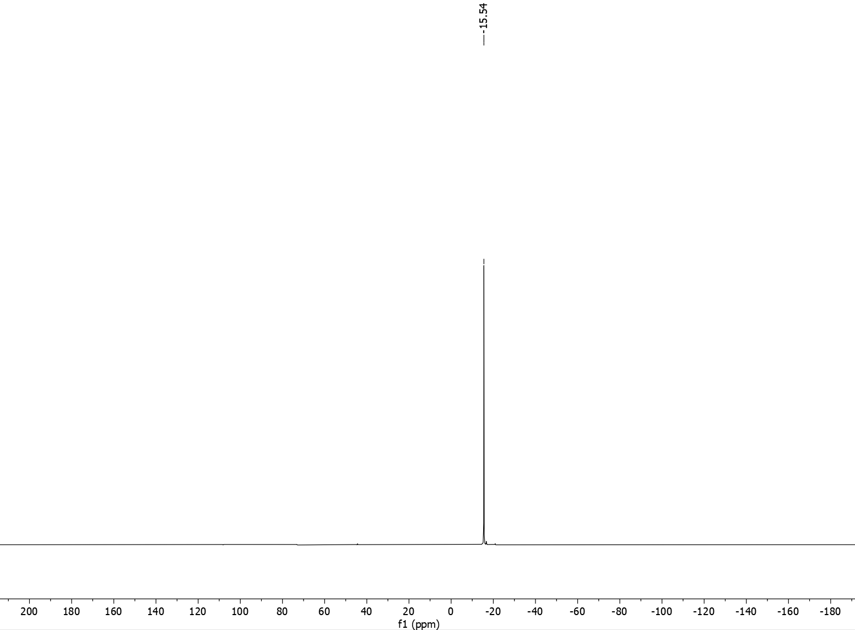

References and Notes
1. Wenk, H. H., Winkler, M. & Sander, W. One Century of Aryne Chemistry. Angew. Chem. Int. Ed. 42, 502–528 (2003).
2. Tadross, P. M. & Stoltz, B. M. A Comprehensive History of Arynes in Natural Product Total Synthesis. Chem. Rev. 112, 3550–3577 (2012).
3. Marshall, C. M., Federice, J. G., Bell, C. N., Cox, P. B. & Njardarson, J. T. An Update on the Nitrogen Heterocycle Compositions and Properties of U.S. FDA-Approved Pharmaceuticals (2013–2023). J. Med. Chem. acs.jmedchem.4c01122 (2024) doi:10.1021/acs.jmedchem.4c01122.
4. Blakemore, D. C. et al. Organic synthesis provides opportunities to transform drug discovery. Nat. Chem. 10, 383–394 (2018).
5. Campos, K. R. et al. The importance of synthetic chemistry in the pharmaceutical industry. Science 363, eaat0805 (2019).
6. Hartwig, J. F. Catalyst-Controlled Site-Selective Bond Activation. Acc. Chem. Res. 50, 549–555 (2017).
7. Shugrue, C. R. & Miller, S. J. Applications of Nonenzymatic Catalysts to the Alteration of Natural Products. Chem. Rev. 117, 11894–11951 (2017).
8. Hoye, T. R., Baire, B., Niu, D., Willoughby, P. H. & Woods, B. P. The hexadehydro-Diels–Alder reaction. Nature 490, 208–212 (2012).
9. Niu, D., Willoughby, P. H., Woods, B. P., Baire, B. & Hoye, T. R. Alkane desaturation by concerted double hydrogen atom transfer to benzyne. Nature 501, 531–534 (2013).
10. Humke, J. N. et al. Nickel binding enables isolation and reactivity of previously inaccessible 7-aza-2,3-indolynes. Science 384, 408–414 (2024).
11. Ishihara, Y., Montero, A. & Baran, P. S. The Portable Chemist’s Consultant: A Survival Guide for Discovery, Process, and Radiolabeling. (Apple Publishing Group, La Jolla, California, 2013).
12. Cernak, T., Dykstra, K. D., Tyagarajan, S., Vachal, P. & Krska, S. W. The medicinal chemist’s toolbox for late stage functionalization of drug-like molecules. Chem. Soc. Rev. 45, 546–576 (2016).
13. Li, F., Nie, J., Sun, L., Zheng, Y. & Ma, J. Silver‐Mediated Cycloaddition of Alkynes with CF ₃ CHN ₂ : Highly Regioselective Synthesis of 3‐Trifluoromethylpyrazoles. Angew. Chem. Int. Ed. 52, 6255–6258 (2013).
14. Antilla, J. C., Baskin, J. M., Barder, T. E. & Buchwald, S. L. Copper−Diamine-Catalyzed N -Arylation of Pyrroles, Pyrazoles, Indazoles, Imidazoles, and Triazoles. J. Org. Chem. 69, 5578–5587 (2004).
15. Ruiz-Castillo, P. & Buchwald, S. L. Applications of Palladium-Catalyzed C–N Cross-Coupling Reactions. Chem. Rev. 116, 12564–12649 (2016).
16. West, M. J., Fyfe, J. W. B., Vantourout, J. C. & Watson, A. J. B. Mechanistic Development and Recent Applications of the Chan–Lam Amination. Chem. Rev. 119, 12491–12523 (2019).
17. Ghosh, I. et al. General cross-coupling reactions with adaptive dynamic homogeneous catalysis. Nature (2023) doi:10.1038/s41586-023-06087-4.
18. Wang, M. et al. Copper-Catalyzed Hydroamination: Enantioselective Addition of Pyrazoles to Cyclopropenes. J. Am. Chem. Soc. 145, 14573–14580 (2023).
19. Kim, K. & Lee, Y. Copper-Catalyzed Hydroamination of Oxa- and Azabenzonorbornadienes with Pyrazoles. J. Org. Chem. 87, 569–578 (2022).
20. Bullock, R. M. et al. Using nature’s blueprint to expand catalysis with Earth-abundant metals. Science 369, eabc3183 (2020).
21. Kainz, Q. M. et al. Asymmetric copper-catalyzed C-N cross-couplings induced by visible light. Science 351, 681–684 (2016).
22. Chai, Y., Shen, S., Weng, G. & Pan, Y. Gas-phase synthesis and reactivity of Cu⁺ –benzyne complexes. Chem Commun 50, 11668–11671 (2014).
23. Mizukoshi, Y., Mikami, K. & Uchiyama, M. Aryne Polymerization Enabling Straightforward Synthesis of Elusive Poly( ortho -arylene)s. J. Am. Chem. Soc. 137, 74–77 (2015).
24. Wiberg, K. B. The Concept of Strain in Organic Chemistry. Angew. Chem. Int. Ed. Engl. 25, 312–322 (1986).
25. Kelleghan, A. V., Bulger, A. S., Witkowski, D. C. & Garg, N. K. Strain-promoted reactions of 1,2,3-cyclohexatriene and its derivatives. Nature 618, 748–754 (2023).
26. Xu, D. et al. Magnesium-Catalyzed N2-Regioselective Alkylation of 3-Substituted Pyrazoles. Synlett 31, 595–599 (2020).
27. Chen, S.-J., Golden, D. L., Krska, S. W. & Stahl, S. S. Copper-Catalyzed Cross-Coupling of Benzylic C–H Bonds and Azoles with Controlled N -Site Selectivity. J. Am. Chem. Soc. 143, 14438–14444 (2021).
28. Desai, S. P., Yatzoglou, G., Turner, J. A. & Taylor, M. S. Boronic Acid-Catalyzed Regio- and Stereoselective N -Glycosylations of Purines and Other Azole Heterocycles: Access to Nucleoside Analogues. J. Am. Chem. Soc. 146, 4973–4984 (2024).
29. Dalton, D. M., Walroth, R. C., Rouget-Virbel, C., Mack, K. A. & Toste, F. D. Utopia Point Bayesian Optimization Finds Condition-Dependent Selectivity for N -Methyl Pyrazole Condensation. J. Am. Chem. Soc. 146, 15779–15786 (2024).
30. Shi, J., Li, L. & Li, Y. o -Silylaryl Triflates: A Journey of Kobayashi Aryne Precursors. Chem. Rev. 121, 3892–4044 (2021).
31. Mukherjee, A., Subramanyam, U., Puranik, V. G., Mohandas, T. P. & Sarkar, A. Pyrazole‐Tethered Heteroditopic Ligands and Their Transition Metal Complexes: Synthesis, Structure, and Reactivity. Eur. J. Inorg. Chem. 2005, 1254–1263 (2005).
32. Xu, Z.-L. et al. Cu(OAc)2·H2O-catalyzed N-arylation of nitrogen-containing heterocycles. Tetrahedron 67, 5282–5288 (2011).
33. Onodera, S., Kochi, T. & Kakiuchi, F. Synthesis of N -Arylpyrazoles by Palladium-Catalyzed Coupling of Aryl Triflates with Pyrazole Derivatives. J. Org. Chem. 84, 6508–6515 (2019).
34. Ueda, S., Su, M. & Buchwald, S. L. Highly N ² ‐Selective Palladium‐Catalyzed Arylation of 1,2,3‐Triazoles. Angew. Chem. Int. Ed. 50, 8944–8947 (2011).
35. Smith, O. et al. Harnessing triaryloxonium ions for aryne generation. Nat. Synth. (2023) doi:10.1038/s44160-023-00408-1.
36. Cheong, P. H.-Y. et al. Indolyne and Aryne Distortions and Nucleophilic Regioselectivites. J. Am. Chem. Soc. 132, 1267–1269 (2010).
37. Denman, B. N., Plasek, E. E. & Roberts, C. C. Ligand-Induced Regioselectivity in Metal-Catalyzed Aryne Reactions Using Borylaryl Triflates as Aryne Precursors. Organometallics 42, 859–864 (2023).
38. Lindsley, C. W. et al. Discovery of Positive Allosteric Modulators for the Metabotropic Glutamate Receptor Subtype 5 from a Series of N -(1,3-Diphenyl-1 H - pyrazol-5-yl)benzamides That Potentiate Receptor Function in Vivo. J. Med. Chem. 47, 5825–5828 (2004).
39. Watanabe, Y. et al. Copper(I)–Pyrazolate Complexes as Solid-State Phosphors: Deep-Blue Emission through a Remote Steric Effect. J. Am. Chem. Soc. 144, 10186–10192 (2022).
40. M06-2X/6-311+G(d,p) PCM(acetonitrile)//M06-2X/6-31G(d) level of theory was employed for the shown models, as implemented in Gaussian 16 (52–56). See SI for comparison of key transition states at various levels of theory.
41. Gianatassio, R. et al. Strain-release amination. Science 351, 241–246 (2016).
42. Wiesenfeldt, M. P. et al. General access to cubanes as benzene bioisosteres. Nature 618, 513–518 (2023).
43. Kleinmans, R. et al. Intermolecular [2π+2σ]-photocycloaddition enabled by triplet energy transfer. Nature 605, 477–482 (2022).
44. Tena Meza, A. et al. σ-Bond insertion reactions of two strained diradicaloids. Nature (2025) doi:10.1038/s41586-025-08745-1.
45. Hehre, W. J., Stewart, R. F. & Pople, J. A. Self-Consistent Molecular-Orbital Methods. I. Use of Gaussian Expansions of Slater-Type Atomic Orbitals. J. Chem. Phys. 51, 2657–2664 (1969).
46. Miertuš, S., Scrocco, E. & Tomasi, J. Electrostatic interaction of a solute with a continuum. A direct utilizaion of AB initio molecular potentials for the prevision of solvent effects. Chem. Phys. 55, 117–129 (1981).
47. Zhao, Y. & Truhlar, D. G. The M06 suite of density functionals for main group thermochemistry, thermochemical kinetics, noncovalent interactions, excited states, and transition elements: two new functionals and systematic testing of four M06-class functionals and 12 other functionals. Theor. Chem. Acc. 120, 215–241 (2008).
48. Tomasi, J., Mennucci, B. & Cammi, R. Quantum Mechanical Continuum Solvation Models. Chem. Rev. 105, 2999–3094 (2005).
49. Frisch, M. J.; Trucks, G. W.; Schlegel, H. B.; Scuseria, G. E.; Robb, M. A.; Cheeseman, J. R.; Scalmani, G.; Barone, V.; Petersson, G. A.; Nakatsuji, H.; Li, X.; Caricato, M.; Marenich, A. V.; Bloino, J.; Janesko, B. G.; Gomperts, R.; Mennucci, B.; Hratchian, H. P.; Ortiz, J. V.; Izmaylov, A. F.; Sonnenberg, J. L.; Williams; Ding, F.; Lipparini, F.; Egidi, F.; Goings, J.; Peng, B.; Petrone, A.; Henderson, T.; Ranasinghe, D.; Zakrzewski, V. G.; Gao, J.; Rega, N.; Zheng, G.; Liang, W.; Hada, M.; Ehara, M.; Toyota, K.; Fukuda, R.; Hasegawa, J.; Ishida, M.; Nakajima, T.; Honda, Y.; Kitao, O.; Nakai, H.; Vreven, T.; Throssell, K.; Montgomery, J. A., Jr.; Peralta, J. E.; Ogliaro, F.; Bearpark, M. J.; Heyd, J. J.; Brothers, E. N.; Kudin, K. N.; Staroverov, V. N.; Keith, T. A.; Kobayashi, R.; Normand, J.; Raghavachari, K.; Rendell, A. P.; Burant, J. C.; Iyengar, S. S.; Tomasi, J.; Cossi, M.; Millam, J. M.; Klene, M.; Adamo, C.; Cammi, R.; Ochterski, J. W.; Martin, R. L.; Morokuma, K.; Farkas, O.; Foresman, J. B.; Fox, D. J. Gaussian 16; Rev. C.01: Wallingford, CT, 2016.
50. Lu, T. & Chen, Q. Independent gradient model based on Hirshfeld partition: A new method for visual study of interactions in chemical systems. J. Comput. Chem. 43, 539–555 (2022).
51. Peruncheralathan, S., Khan, T. A., Ila, H. & Junjappa, H. Regioselective Synthesis of 1-Aryl-3,4-substituted/annulated-5-(methylthio)pyrazoles and 1-Aryl-3-(methylthio)-4,5-substituted/annulated Pyrazoles. J. Org. Chem. 70, 10030–10035 (2005).
52. G. Menozzi, L. Mosti, P. Schenone, Reaction of 2‐dimethylaminomethylene‐1,3‐diones with dinucleophiles. VI. Synthesis of ethyl or methyl 1,5‐disubstituted 1 H ‐pyrazole‐4‐carboxylates. Journal of Heterocyclic Chem 24, 1669–1675 (1987).
53. A. Boelke, T. J. Kuczmera, E. Lork, B. J. Nachtsheim, N‐Heterocyclic Iod(az)olium Salts – Potent Halogen‐Bond Donors in Organocatalysis. Chemistry A European J 27, 13128–13134 (2021).
54. S. Hernández, I. Moreno, R. SanMartin, G. Gómez, M. T. Herrero, E. Domínguez, Toward Safer Processes for C−C Biaryl Bond Construction: Catalytic Direct C−H Arylation and Tin-Free Radical Coupling in the Synthesis of Pyrazolophenanthridines. J. Org. Chem. 75, 434–441 (2010).
55. M. Rey, S. Beaumont, Molybdenum-Mediated One-Pot Synthesis of Pyrazoles from Isoxazoles. Synthesis 51, 3796–3804 (2019).
56. M. Kashiwa, Y. Kuwata, M. Sonoda, S. Tanimori, Oxone-mediated facile access to substituted pyrazoles. Tetrahedron 72, 304–311 (2016).
57. R. S. Foster, H. Jakobi, J. P. A. Harrity, A General and Regioselective Synthesis of 5-Trifluoromethyl-pyrazoles. Org. Lett. 14, 4858–4861 (2012).
58. G. Pai, A. P. Chattopadhyay, N-Arylation of nitrogen containing heterocycles with aryl halides using copper nanoparticle catalytic system. Tetrahedron Letters 57, 3140–3145 (2016).
59. N. Yang, G. Yuan, A Multicomponent Electrosynthesis of 1,5-Disubstituted and 1-Aryl 1,2,4-Triazoles. J. Org. Chem. 83, 11963–11969 (2018).
60. X. Tang, L. Huang, J. Yang, Y. Xu, W. Wu, H. Jiang, Practical synthesis of pyrazoles via a copper-catalyzed relay oxidation strategy. Chem. Commun. 50, 14793–14796 (2014).
61. G. Shan, P. Liu, Y. Rao, A New Synthesis of Pyrazoles through a Lewis Acid Catalyzed Union of 3-Ethoxycyclobutanones with Monosubstituted Hydrazines. Org. Lett. 13, 1746–1749 (2011).
62. F. Pünner, Y. Sohtome, M. Sodeoka, Solvent-dependent copper-catalyzed synthesis of pyrazoles under aerobic conditions. Chem. Commun. 52, 14093–14096 (2016).
63. V. V. Voronin, M. S. Ledovskaya, E. G. Gordeev, K. S. Rodygin, V. P. Ananikov, [3 + 2]-Cycloaddition of in Situ Generated Nitrile Imines and Acetylene for Assembling of 1,3-Disubstituted Pyrazoles with Quantitative Deuterium Labeling. J. Org. Chem. 83, 3819–3828 (2018).
64. G.-Q. Jin, W.-X. Gao, Y.-B. Zhou, M.-C. Liu, H.-Y. Wu, Efficient synthesis of 2-aryl-2 H -indazoles by base-catalyzed benzyl C–H deprotonation and cyclization. Chem. Commun. 56, 14617–14620 (2020).
65. A. C. Spivey, C. M. Diaper, H. Adams, A. J. Rudge, A New Germanium-Based Linker for Solid Phase Synthesis of Aromatics: Synthesis of a Pyrazole Library. J. Org. Chem. 65, 5253–5263 (2000).
66. Liu, J. et al. Copper-mediated tandem ring-opening/cyclization reactions of cyclopropanols with aryldiazonium salts: synthesis of N -arylpyrazoles. Chem. Commun. 56, 2202–2205 (2020).
67. C. Dunker, L. Imberg, A. I. Siutkina, C. Erbacher, C. G. Daniliuc, U. Karst, D. V. Kalinin, Pyrazole-Based Thrombin Inhibitors with a Serine-Trapping Mechanism of Action: Synthesis and Biological Activity. Pharmaceuticals 15, 1340 (2022).
68. S. Grimme. Supramolecular binding thermodynamics by dispersion-corrected density functional theory. Chem. Eur. J. 18, 9955-9964 (2012).
69. C. Y. Legault. CYLview, 1.0b; Université de Sherbrooke, 2009 (http://www.cylview.org).
70. T. Lu, F. Chen. Multiwfn: A multifunctional wavefunction analyzer. J. Comput. Chem. 33, 580-592 (2012).
71. W. Humphrey, A. Dalke, K. Schulten. "VMD - Visual Molecular Dynamics" J. Molec. Graphics, 14, 33-38 (1996).
72. E. F. Peterson, T. D. Goddard, C. C. Huang, E. C. Meng, G. S. Couch, T. I. Croll, J. H. Morris, T. E. Ferrin. “UCSF ChemieraX: Structure visualization for researchers, educators, and developers.” Protein Sci, 30, 70-82 (2021).
73. A. D. Becke. Density‐functional thermochemistry. III. The role of exact exchange. J. Chem. Phys. 98, 5648-5652 (1993).
74. S. Grimme, J. Antony, S. Ehrlich, H. A. Krieg. Consistent and accurate ab initio parametrization of density functional dispersion correction (DFT-D) for the 94 elements H-Pu. J. Chem. Phys. 132, 154104 (2010).
75. S. Grimme. Semiempirical GGA-type density functional constructed with a long-range dispersion correction. J. Comput. Chem. 27, 1787-1799 (2006).
76. A. Becke. Density-Functional Thermochemistry. V. Systematic Optimization of Exchange-Correlation Functionals. J. Chem. Phys. 107, 8554-8560 (1997).
77. J. D. Chai, M. Head-Gordon. Long-range corrected hybrid density functionals with damped atom-atom dispersion corrections. Phys. Chem. Chem. Phys. 10, 6615-6620 (2008).
78. F. Weigend, R. Ahlrichs. Balanced basis sets of split valence, triple zeta valence and quadruple zeta valence quality for H to Rn: Design and assessment of accuracy. Phys. Chem. Chem. Phys. 7, 3297-3305 (2005).
79. A. V. Marenich, C. J. Cramer, D. G. Truhlar. Universal solvation model based on solute electron density and on a continuum model of the solvent defined by the bulk dielectric constant and atomic surface tensions. J. Phys. Chem. B 113, 6378-6396 (2009).
80. A. J. Schaefer, V. M. Ingman, and S. E. Wheeler, "SEQCROW: A ChimeraX Bundle to Facilitate Quantum Chemical Applications to Complex Molecular Systems" J. Comp. Chem. 42, 1750 (2021).
81. V. M. Ingman, A. J. Schaefer, L. R. Andreola, and S. E. Wheeler, "QChASM: Quantum Chemistry Automation and Structure Manipulation" WIREs Comp. Mol. Sci. 11, e1510 (2021).
82. S. Parsons, H. D. Flack, T. Wagner, Use of intensity quotients and differences in absolute structure refinement. Acta Crystallogr B Struct Sci Cryst Eng Mater 69, 249–259 (2013).
84. B. Lakshmi, U. Wefelscheid, U. Kazmaier, Synthesis of Aryl Stannanes from Silyl Triflates via Aryne Intermediates. Synlett 2011, 345–348 (2011).

