Online Resource for:

Living Together but Apart: Spatial and trophic niche segregation of two termite species sharing the same nest.

Insectes Sociaux
Johanne Timmermans¹, Nicolas Fontaine¹, Gilles Lepoint² and Yves Roisin¹

¹Evolutionary Biology and Ecology, Université libre de Bruxelles, 50 avenue F.D. Roosevelt, 1050 Brussels, Belgium
²Laboratoire d'Ecologie trophique et isotopique, Université de Liège, 11 allée du Six Août, 4000 Liège, Belgium

Correspondence

Johanne Timmermans, Evolutionary Biology and Ecology (CP 160/12), Université Libre de Bruxelles, 50 avenue F.D. Roosevelt, 1050 Brussels, Belgium, email: johanne.timmermans@ulb.be

Figure S1. Location of the four studied sites in French Guiana where nests of C. cavifrons were collected. Map was designed with QGIS using Topomap as background (QGIS Development Team, 2023).

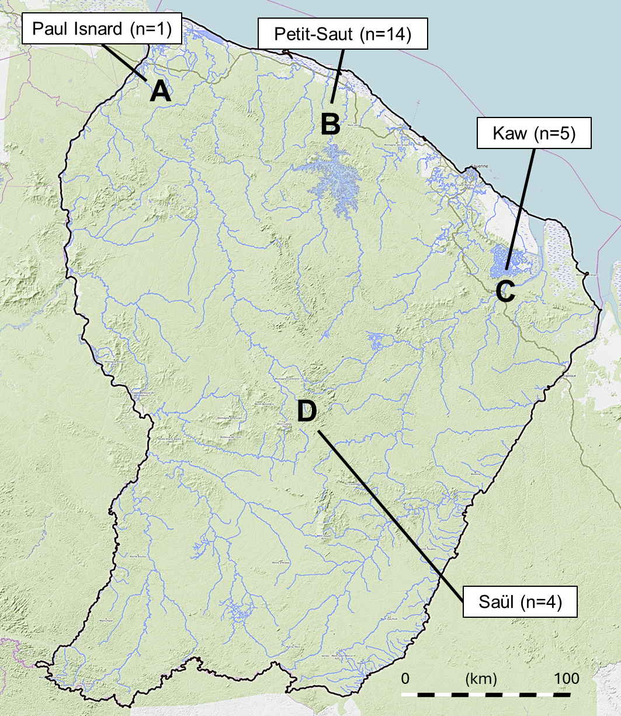

Figure S2. Example of one section of the nest (N4, 10-20 cm) for the analysis of the location of the inquiline galleries inside the host nest. a. differences between the C. cavifrons galleries and I. inquilinus galleries. b. division of the section in two equal surfaces for the center/periphery analysis and c. division of the section in two equal surfaces for the interior/exterior analysis. One point is noted for the center of each inquiline gallery.

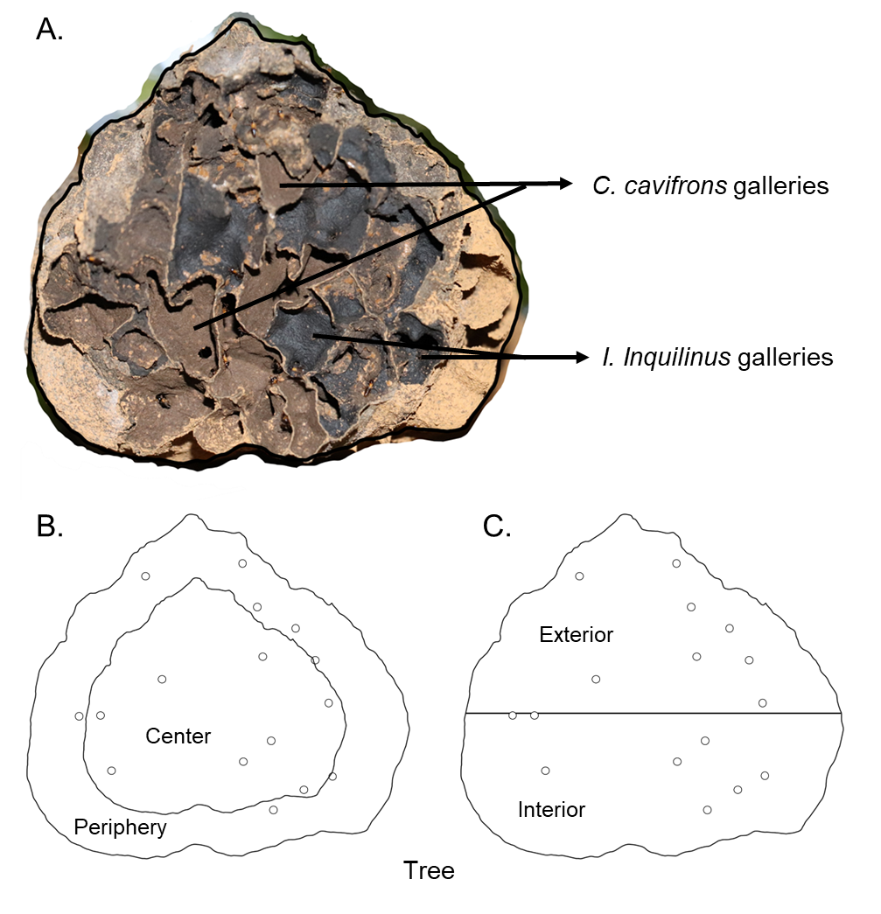
Figure S3. Graphs of carbon and azote isotopic composition for each colony, classified according to stage of host–inquiline association: A: nest inhabited by host only, B: nest inhabited by host and mature inquiline colony, C: nest inhabited by host and incipient inquiline colony and D: nest abandoned by host and inhabited by mature inquiline colony.
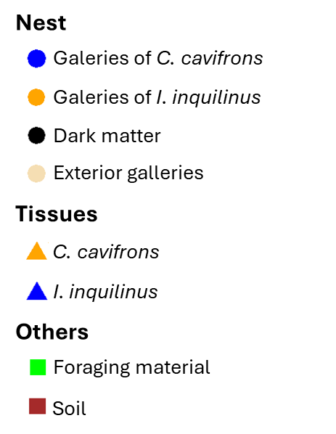
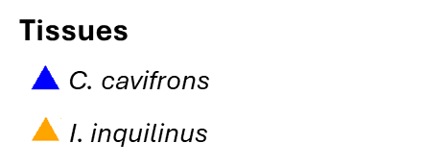

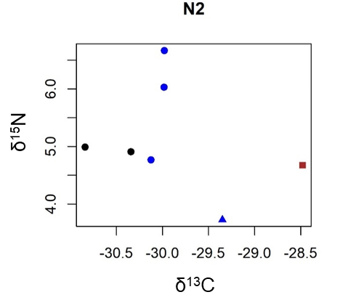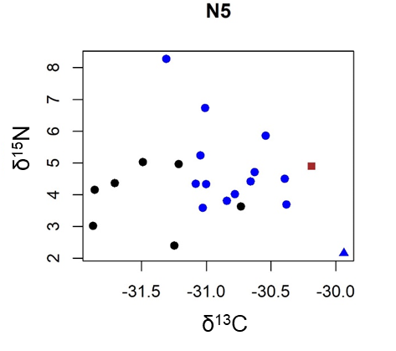
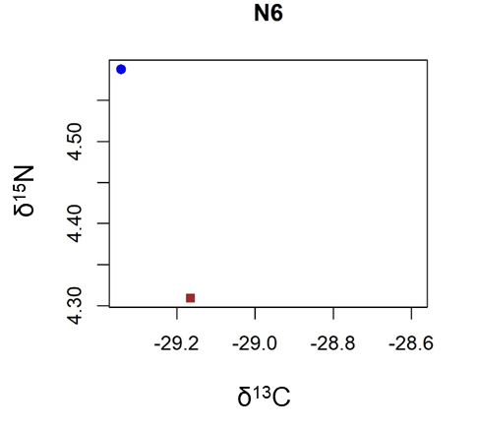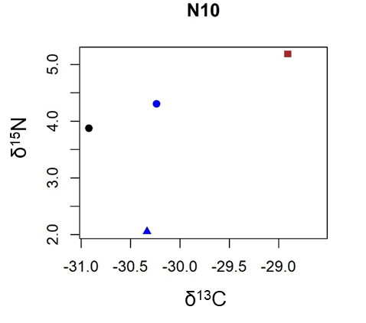

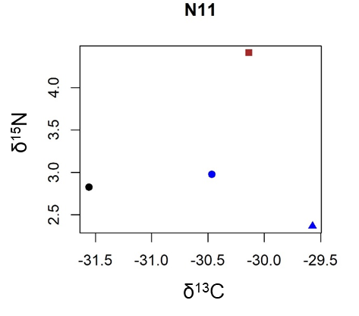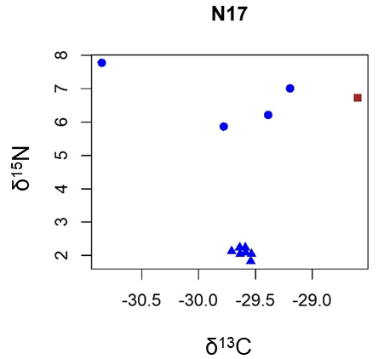
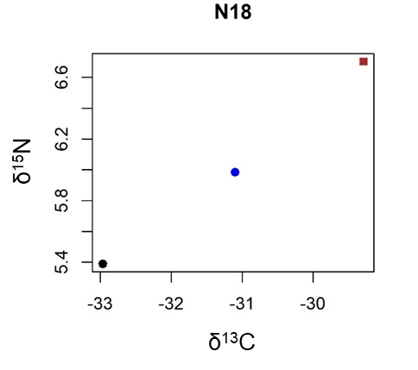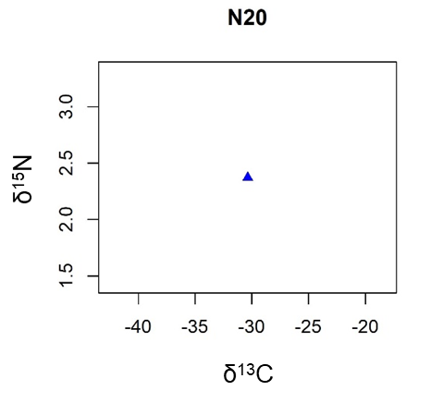
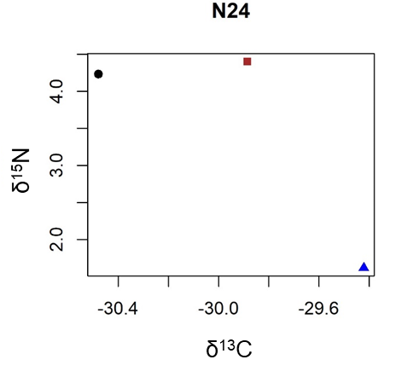

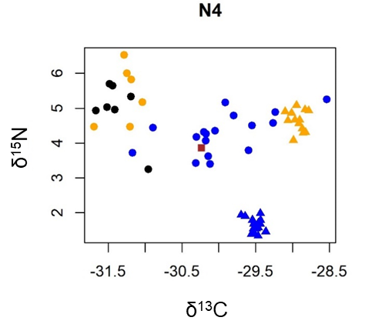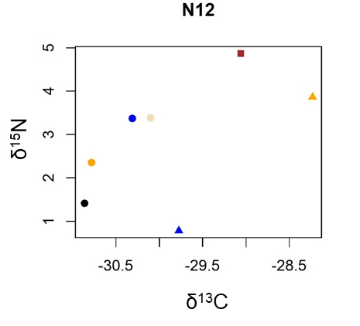
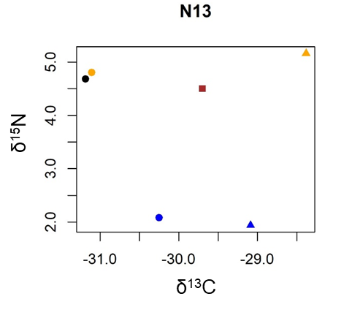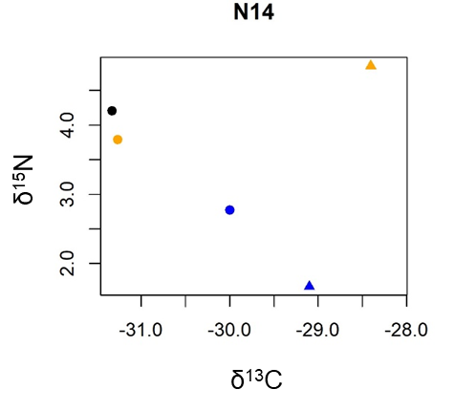
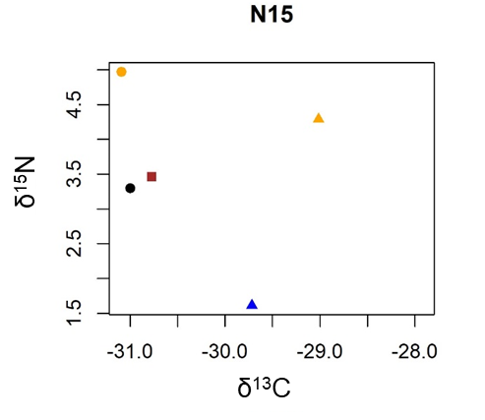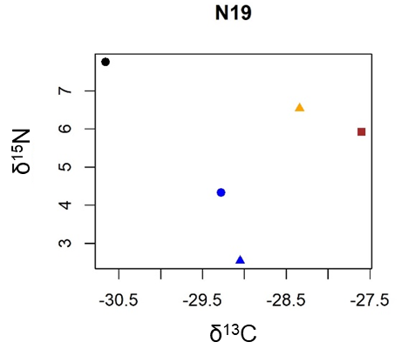
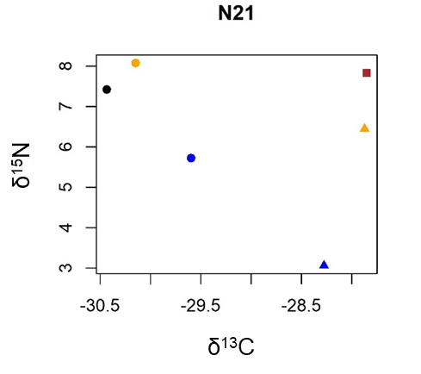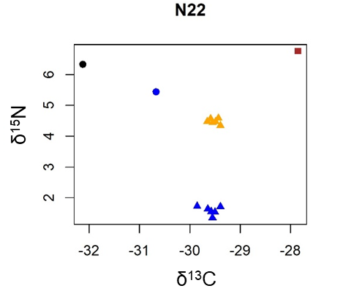

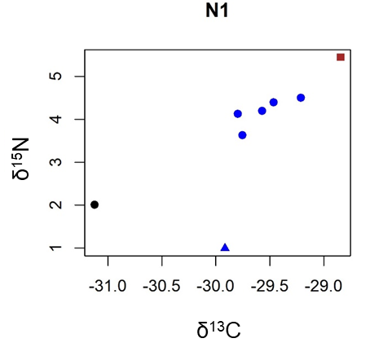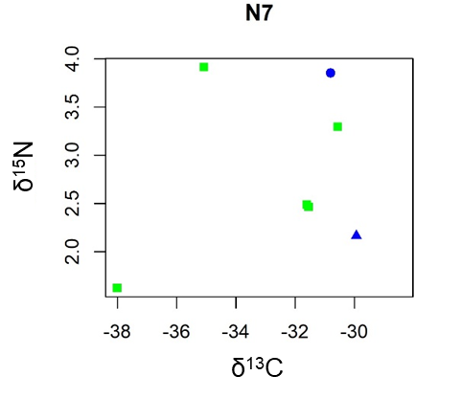
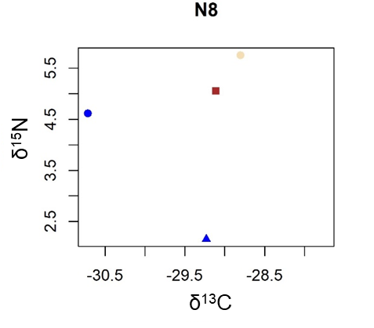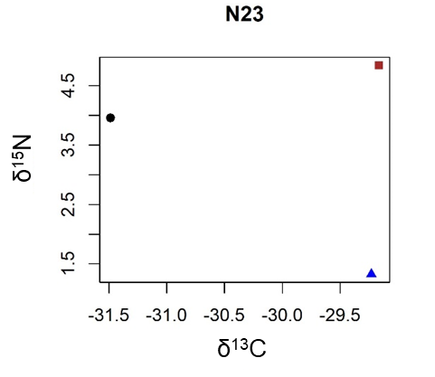

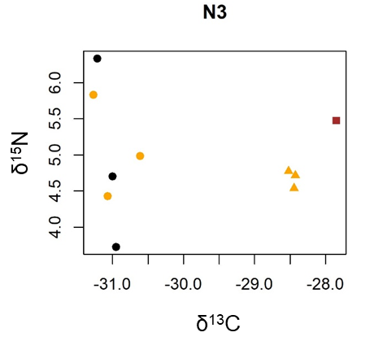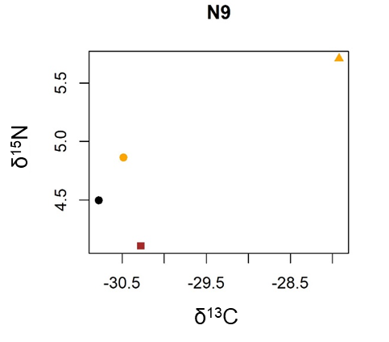
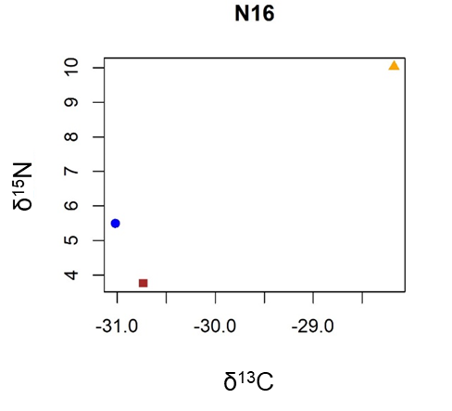

Figure S4. Biplot of the linear regression between each material for a. δ¹⁵N and b. δ¹³C. R² are indicated for each correlation and confidence intervals at 95% are obtained with a bootstrap method. Graphs were generated with Python 3.12.5.

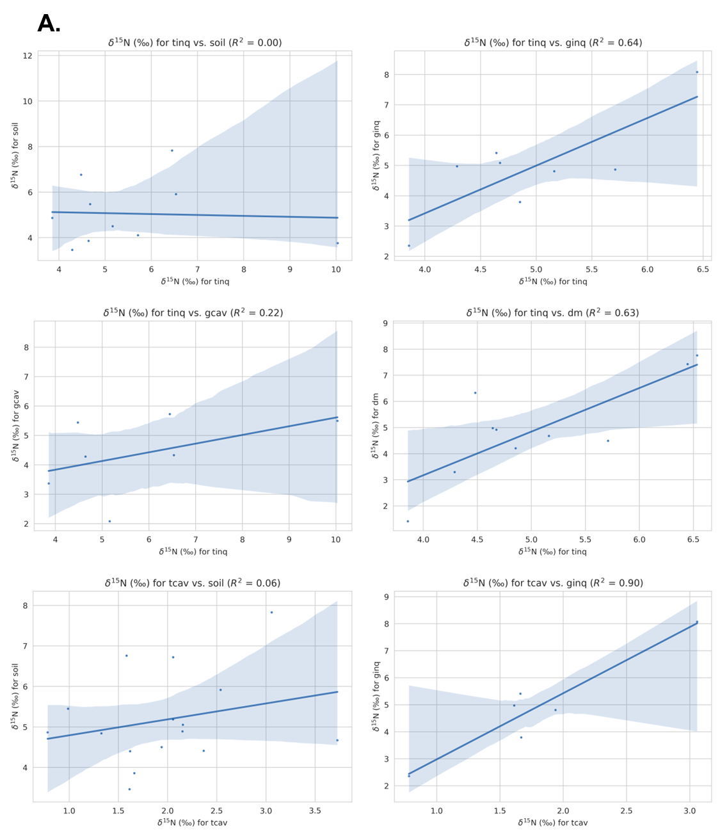

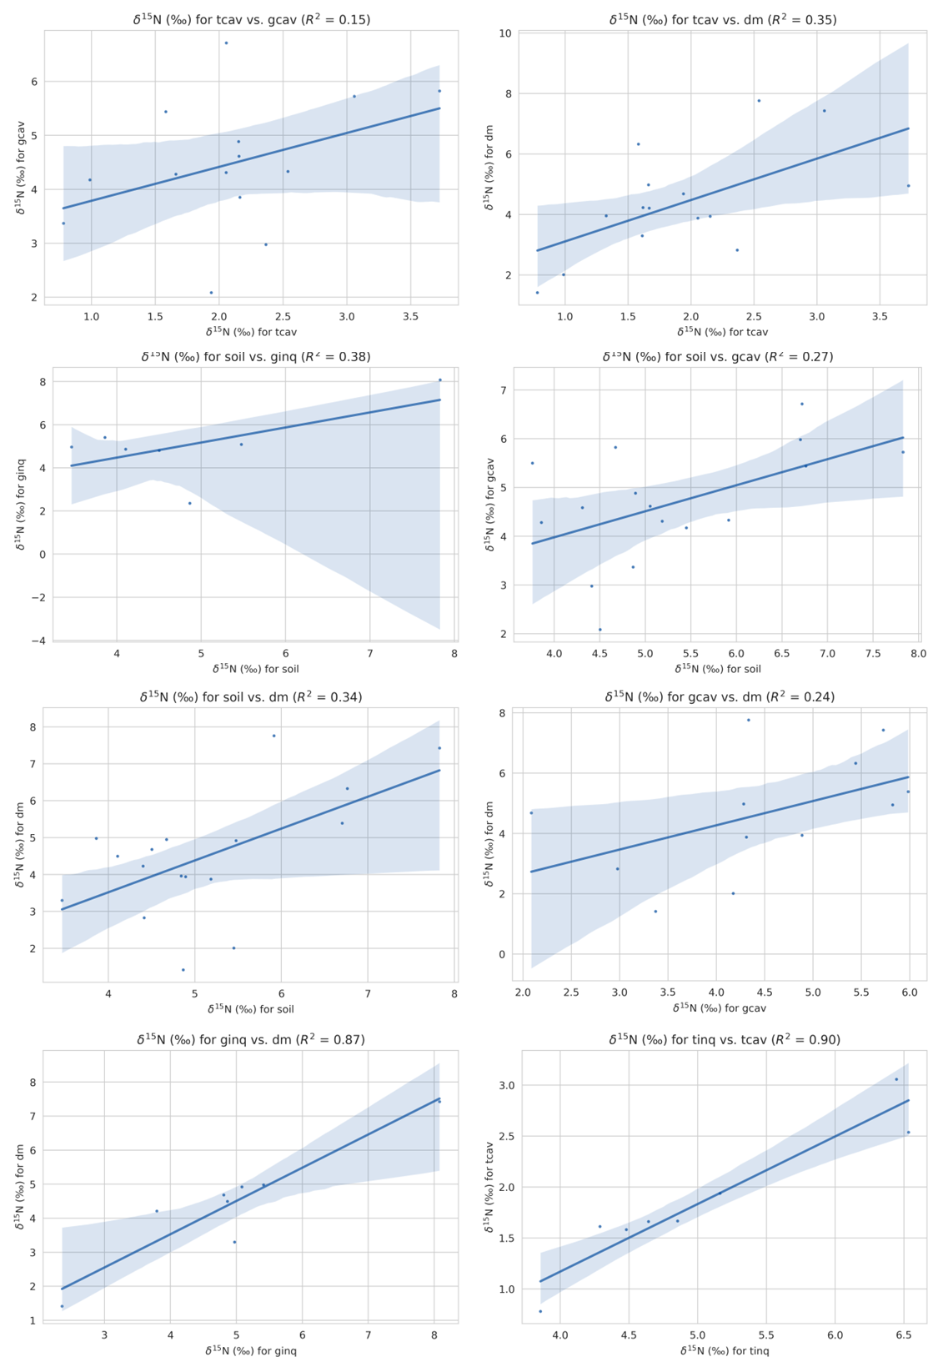
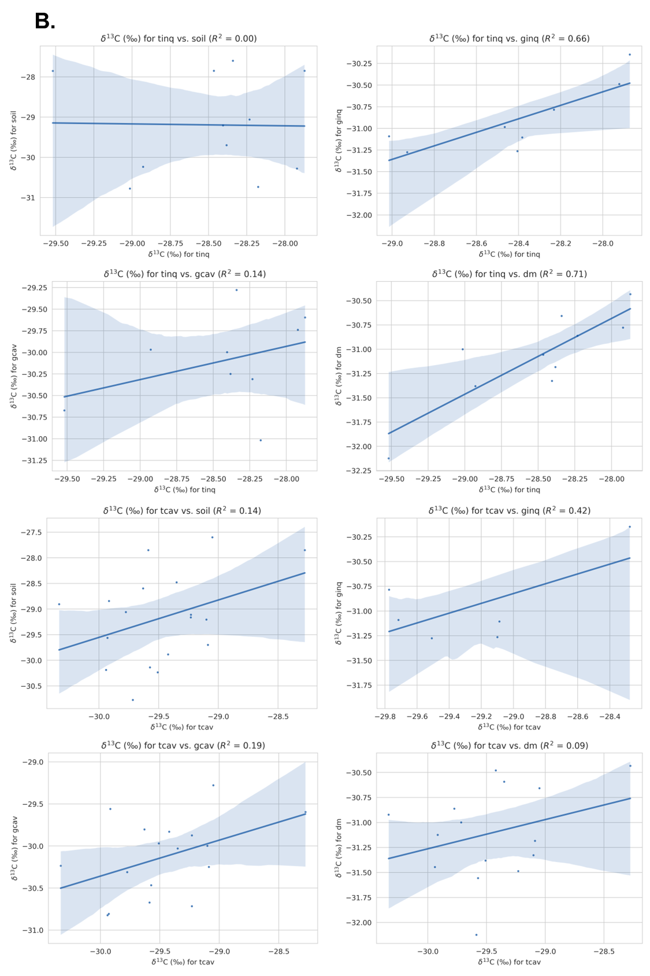
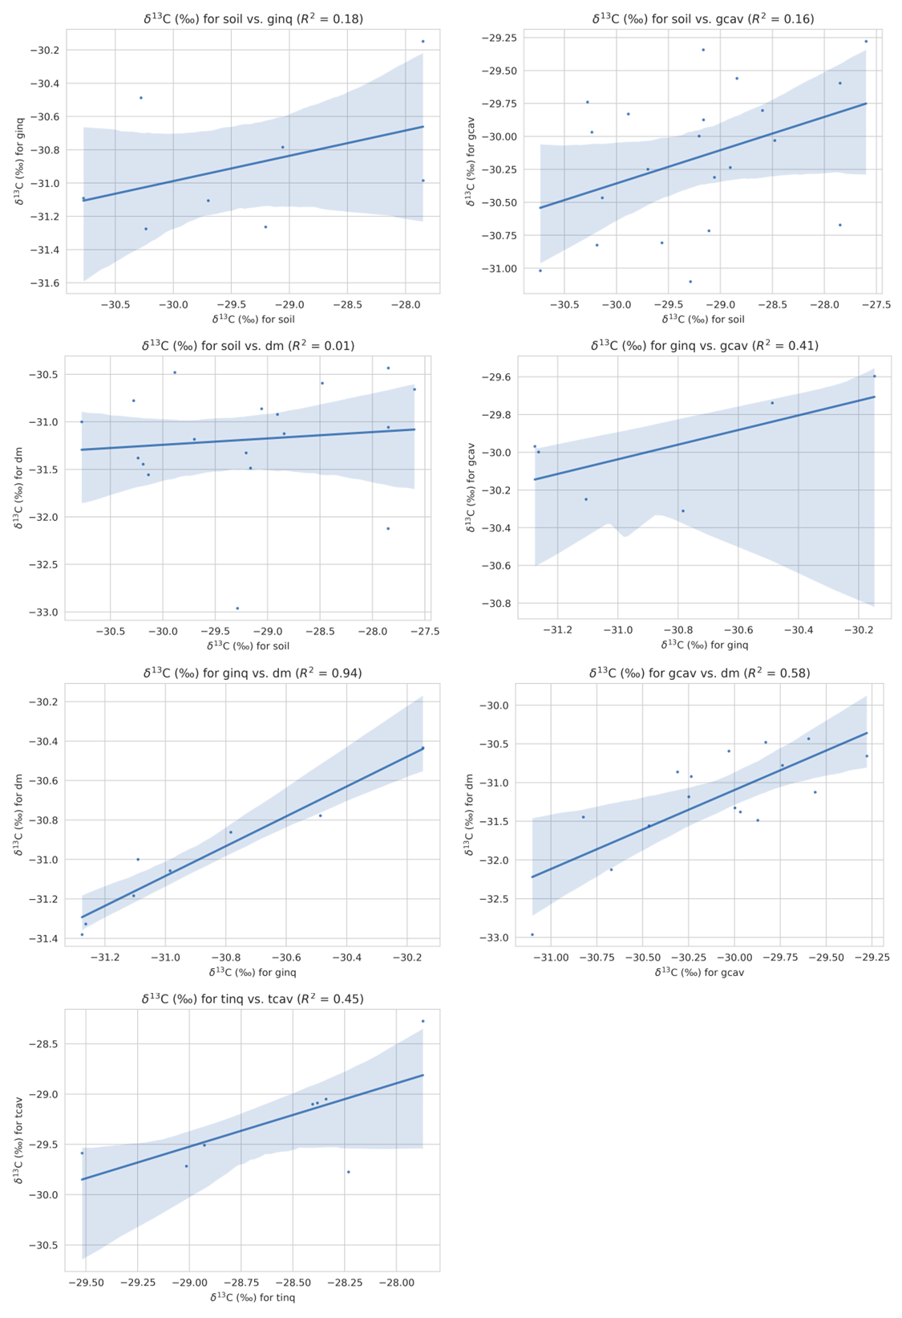
Figure S5. a. Percentage of the three different materials observed inside C. cavifrons nests at the different nest heights. The friability of each section is indicated with a count from 0 to 5, 5 being to most friable. b. Density graphs of neuters of C. cavifrons and I. inquilinus at different nest heights. The section where the queen or king was found is indicated in graphs. This study was done for the following nests: N1, N2, N3 and N5. In nest N3 (presence of inquiline and absence of the host), the establishment of a colony of ants prevented us from collecting more than the first three sections, making data unreliable.
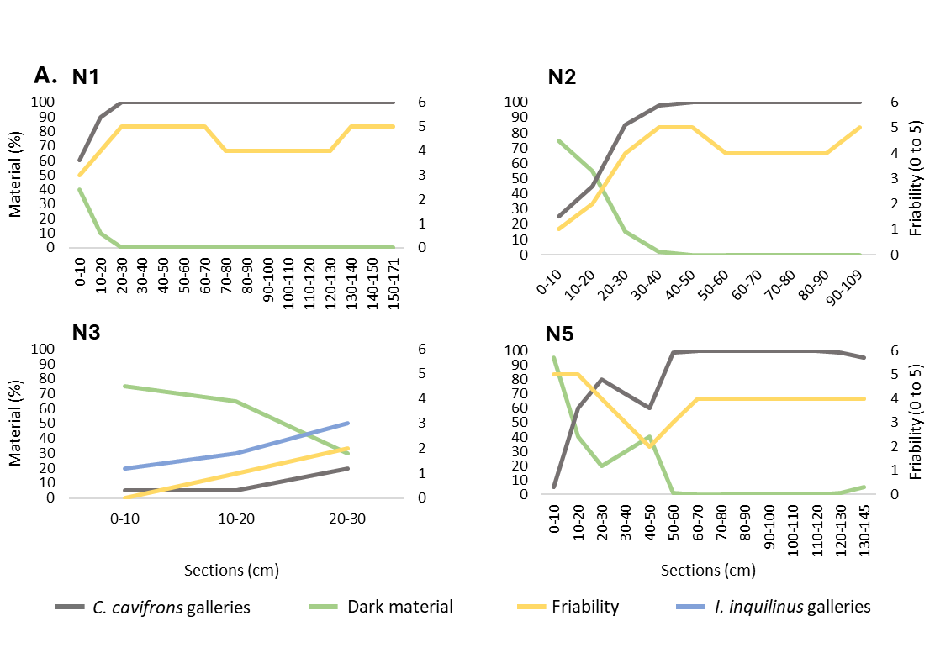
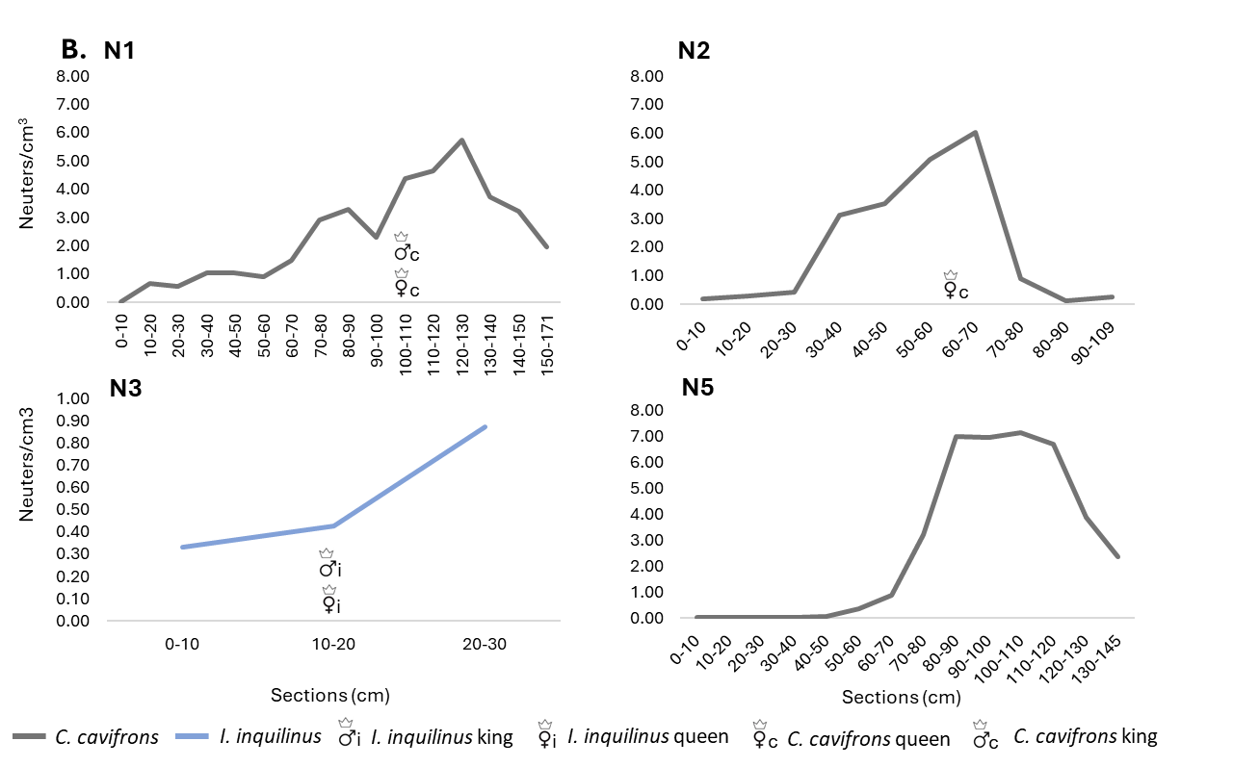
Figure S6. Number of individuals and corresponding density estimation of the different castes: neuters (workers and soldiers), reproductives (nymphs and alates if present), juveniles (larvae and eggs) and primary reproductives (queen and king) with the height inside the nest (N4). a. I. inquilinus b. C. cavifrons.

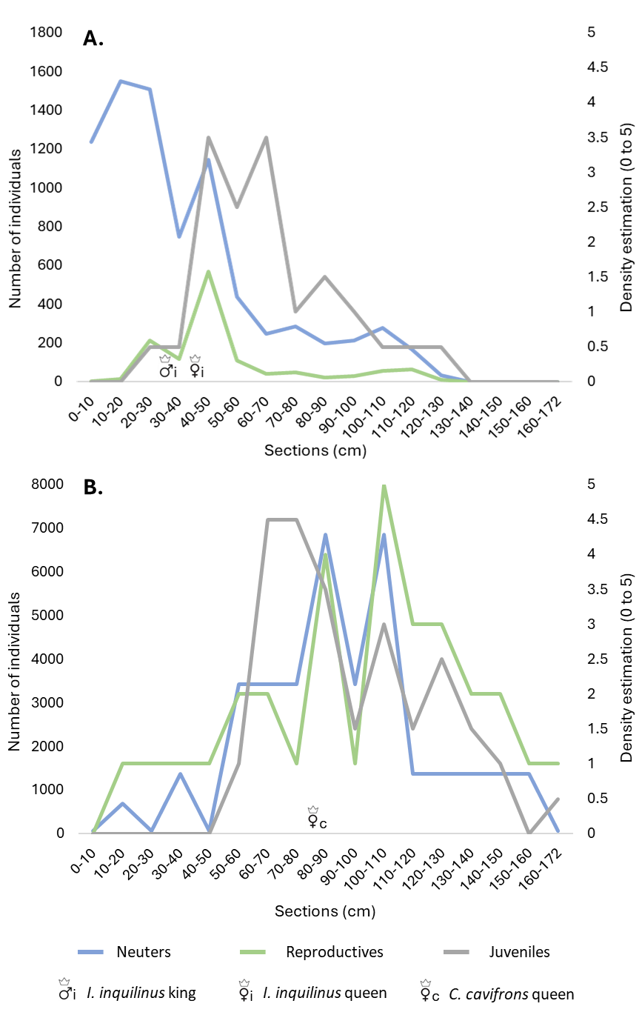
Figure S7. Analysis of carbon and nitrogen isotopic niches of C. cavifrons between A. the three different colony types; B. the three nest size intervals. C. Biplot of nest size and ground height. Plots are generated using R v4.3.1.

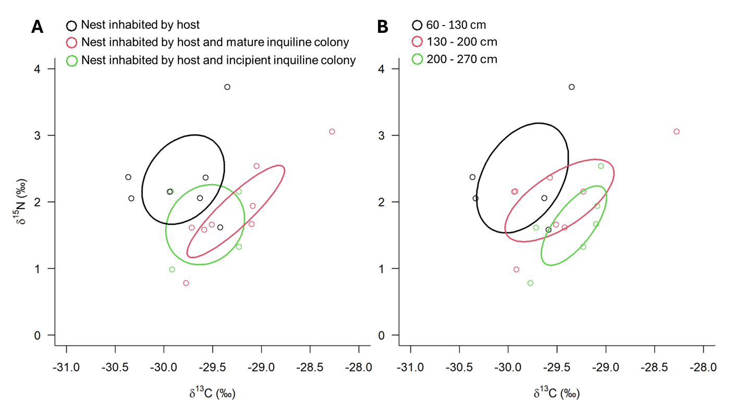
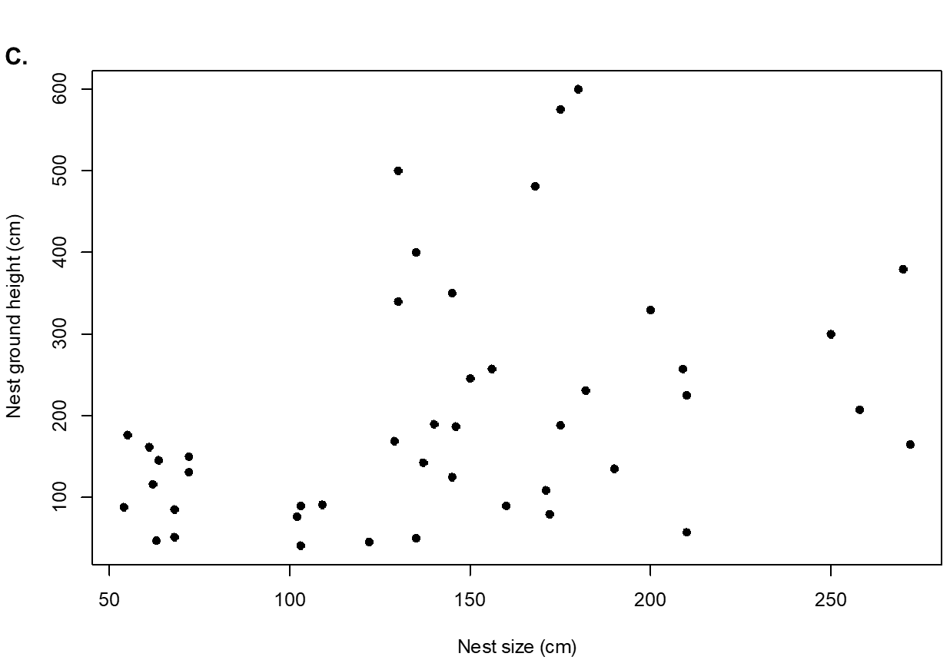
Table S1. Collection details of the sampled nests of C. cavifrons. Category A: nest inhabited by host (n=9), category B: nest inhabited by host and mature inquiline colony (n=8), category C: nest inhabited by host and incipient inquiline colony (n=4) and category D: nest abandoned by host and inhabited by mature inquiline colony (n=3). Nest: if “yes” it was used for the nest characterization analysis. Isotope: if “yes” it was used for the isotopic analysis. Site A: Paul-Isnard (n=1), Site B: Petit-Saut (n=14), Site C: Kaw (n=5) and Site D: Saül (n=4).
Colony  code | Category | Nest | Isotope | Length  (m) | Width  (cm) | Circumference  (cm) | Height from  ground (m) | Collection  date | Long | Lat | Altitude | Site
N1 | A | yes | yes | 1.71 | 20 | 33 | 1.09 | 10/2023 | -52.97994 | 5.08144 | 89 | B
N2 | A | yes | yes | 1.09 | 36 | 49 | 0.92 | 10/2023 | -53.05508 | 5.07028 | 29 | B
N3 | D | yes | yes | 1.35 | 22 | 43 | 0.51 | 10/2023 | -52.97295 | 5.07469 | 89 | B
N4 | B | yes | yes | 1.72 | 23 | 38 | 0.80 | 11/2023 | -52.33900 | 4.32948 | 70 | C
N5 | A | yes | yes | 1.45 | 23 | 44 | 1.25 | 11/2023 | -52.34130 | 4.31757 | 140 | C
N6 | A | no | yes | 0.64 | 13 | 23 | 1.46 | 19-08-21 | -52.97907 | 5.06789 | 80 | B
N7 | C | no | yes | 3.56 | 25 | 46 | 0 | 25-08-21 | -52.97912 | 5.07376 | 88 | B
N8 | C | no | yes | 1.68 | N/A | N/A | 4.81 | 20-08-21 | -52.97949 | 5.07391 | 88 | B
N9 | D | no | yes | 1.45 | N/A | N/A | 3.50 | 20-08-21 | -52.97949 | 5.07391 | 88 | B
N10 | A | no | yes | 0.63 | 21 | 32 | 0.48 | 18-08-21 | -52.97914 | 5.07426 | 91 | B
N11 | A | no | yes | 1.75 | 20 | 52 | 1.88 | 23-08-21 | -52.97855 | 5.07110 | 66 | B
N12 | B | no | yes | 2.10 | 19 | 43 | 2.26 | 24-08-21 | -52.97595 | 5.07509 | 77 | B
N13 | B | no | yes | 2.50 | 28 | 59 | 3.01 | 23-08-21 | -52.97975 | 5.07259 | 80 | B
N14 | B | no | yes | 2.09 | 24 | 56 | 2.58 | 22-08-21 | -52.97949 | 5.07243 | 78 | B
N15 | B | no | yes | 2.58 | N/A | N/A | 2.08 | 17-10-21 | -52.14411 | 4.19371 | 84 | C
N16 | D | no | yes | 0.27 | N/A | N/A | 1.17 | 28-10-21 | -53.95357 | 5.32715 | 43 | A
N17 | A | no | yes | 0.68 | 19 | 31 | 0.85 | 18-01-22 | -52.33418 | 4.30674 | 135 | C
N18 | A | no | yes | 1.22 | 11 | 26 | 0.46 | 21-01-22 | -52.34169 | 4.32452 | 71 | C
N19 | B | no | yes | 2.70 | N/A | N/A | 3.80 | 25-01-22 | -53.21261 | 3.61367 | 218 | D
N20 | A | no | yes | 0.61 | 21 | 46 | 1.62 | 25-01-22 | -53.21774 | 3.61225 | 240 | D
N21 | B | no | yes | 1.40 | 26 | 47 | 1.90 | 29-01-23 | -53.18039 | 3.61259 | 234 | D
N22 | B | no | yes | 1.29 | 36 | 41 | 1.70 | 31-01-23 | -53.21407 | 3.63942 | 329 | D
N23 | C | no | yes | 2.72 | 38 | 48 | 1.65 | 11-02-23 | -52.92586 | 5.15206 | 98 | B
N24 | A | no | yes | 1.60 | 18 | 60 | 0.90 | 12-02-23 | -52.92420 | 5.15208 | 84 | B

Table S2. Analysis of the location of inquiline galleries inside the nest N4, comparing the number of galleries found in the center versus the periphery and in the interior versus exterior part of the nest. The exact surface of each section part is also indicated.
 | Center |  | Periphery |  | Exterior |  | Interior
Section | Surface  (cm²) | Number of galleries | Surface  (cm²) | Number of galleries | Surface  (cm²) | Number of galleries | Surface  (cm²) | Number of galleries
0-10 | 22.15 | 14.5 | 22.36 | 19.5 | 20.94 | 18 | 23.30 | 16
10-20 | 44.29 | 8 | 49.88 | 8 | 46.68 | 8 | 46.95 | 8
20-30 | 36.88 | 14 | 39.62 | 13 | 39.38 | 14 | 36.55 | 13
30-40 | 41.44 | 7 | 44.01 | 2 | 41.62 | 8 | 43.17 | 1
40-50 | 52.96 | 10 | 57.14 | 14 | 52.40 | 5 | 56.79 | 19
50-60 | 68.59 | 6 | 79.22 | 2 | 73.50 | 8 | 70.60 | 0
60-70 | 60.05 | 2 | 62.09 | 5 | 56.48 | 4 | 64.77 | 3
70-80 | 69.58 | 3 | 73.03 | 2 | 67.70 | 3 | 73.82 | 2
80-90 | 79.94 | 4 | 111.40 | 9 | 90.05 | 5 | 94.14 | 8
90-100 | 64.60 | 2 | 89.36 | 2 | 79.90 | 3 | 72.85 | 1
100-110 | 69.62 | 4 | 90.76 | 9 | 73.39 | 6 | 85.76 | 7
110-120 | 66.90 | 2 | 80.40 | 1 | 70.26 | 0 | 75.78 | 3
120-130 | 43.42 | 0 | 66.27 | 3 | 53.55 | 2 | 52.39 | 1
Total | 720.41 | 76.5 | 865.54 | 89.5 | 765.84 | 84 | 796.88 | 82
Gallery/cm² |  | 0.106 |  | 0.103 |  | 0.110 |  | 0.103
Gallery (%) |  | 0.507 |  | 0.493 |  | 0.516 |  | 0.484

Table S3. Number of samples of each material for the isotopic analysis. Codes: tissues of C. cavifrons (tcav), tissues of I. inquilinus (tinq), galleries of C. cavifrons (gcav), exterior galleries (gext), galleries of I. inquilinus (ginq), dark material (dm), pellets (p), topsoil layer (soil), foraging material (fm).
Colony  code | tcav | tinq | gcav | gext | ginq | dm | p | soil | fm
N1 | 1 | 0 | 5 | 0 | 0 | 1 | 0 | 1 | 0
N2 | 1 | 0 | 3 | 0 | 0 | 2 | 0 | 1 | 0
N3 | 0 | 3 | 0 | 0 | 3 | 3 | 0 | 1 | 0
N4 | 17 | 13 | 17 | 0 | 6 | 7 | 0 | 1 | 0
N5 | 1 | 0 | 13 | 0 | 0 | 7 | 0 | 1 | 0
N6 | 0 | 0 | 1 | 0 | 0 | 0 | 1 | 1 | 0
N7 | 1 | 0 | 1 | 1 | 0 | 0 | 1 | 1 | 5
N8 | 1 | 0 | 1 | 1 | 0 | 0 | 2 | 1 | 0
N9 | 0 | 1 | 1 | 0 | 1 | 1 | 0 | 1 | 0
N10 | 1 | 0 | 1 | 0 | 0 | 1 | 1 | 1 | 0
N11 | 1 | 0 | 1 | 0 | 0 | 1 | 0 | 1 | 0
N12 | 1 | 1 | 1 | 1 | 1 | 1 | 0 | 1 | 0
N13 | 1 | 1 | 1 | 0 | 1 | 1 | 0 | 1 | 0
N14 | 1 | 1 | 1 | 1 | 1 | 1 | 1 | 1 | 0
N15 | 1 | 1 | 0 | 1 | 1 | 1 | 0 | 1 | 0
N16 | 0 | 1 | 1 | 0 | 0 | 0 | 0 | 1 | 0
N17 | 7 | 0 | 4 | 0 | 0 | 0 | 0 | 1 | 0
N18 | 0 | 0 | 1 | 0 | 0 | 1 | 0 | 1 | 0
N19 | 1 | 1 | 1 | 0 | 0 | 1 | 0 | 1 | 0
N20 | 1 | 0 | 0 | 0 | 0 | 0 | 0 | 0 | 0
N21 | 1 | 1 | 1 | 0 | 1 | 1 | 0 | 1 | 0
N22 | 6 | 6 | 1 | 0 | 0 | 1 | 0 | 1 | 0
N23 | 1 | 0 | 1 | 0 | 0 | 1 | 0 | 1 | 0
N24 | 1 | 0 | 1 | 0 | 0 | 1 | 0 | 1 | 0
Colony (n) | 19 | 11 | 21 | 5 | 8 | 18 | 5 | 23 | 1
Sample (n) | 46 | 30 | 58 | 5 | 15 | 33 | 6 | 23 | 5

Table S4. Metrics of δ¹⁵N, δ¹³C, N‰, C‰ and C/N calculated for each material types. Averages, standard deviations and confidence intervals at 95% were obtained using Excel. Codes: tissues of C. cavifrons (tcav), tissues of I. inquilinus (tinq), galleries of C. cavifrons (gcav), exterior galleries (gext), galleries of I. inquilinus (ginq), dark material (dm), pellets (p), topsoil layer (soil), foraging material (fm).
δ¹⁵N (‰) | Lower IC | Mean | Upper IC | SD | Sample (n) | Colony (n)
tcav | 1.6828 | 1.9901 | 2.2973 | 0.6833 | 46 | 19
tinq | 4.4980 | 5.5165 | 6.5351 | 1.7236 | 30 | 11
gcav | 4.0870 | 4.5728 | 5.0585 | 1.1357 | 54 | 18
gext | 3.0961 | 4.5676 | 6.0391 | 1.6788 | 2 | 2
ginq | 3.8058 | 4.9208 | 6.0358 | 1.6090 | 15 | 8
dm | 3.7313 | 4.4834 | 5.2356 | 1.6282 | 33 | 18
p | N/A | N/A | N/A | N/A | 0 | 0
soil | 4.6409 | 5.1035 | 5.5662 | 1.1321 | 21 | 21
fm | 1.9863 | 2.7553 | 3.5244 | 0.8774 | 5 | 1
δ¹³C (‰) | Lower IC | Mean | Upper IC | SD | Sample (n) | Colony (n)
tcav | -29.7481 | -29.5274 | -29.3066 | 0.4910 | 46 | 19
tinq | -28.7697 | -28.4779 | -28.1862 | 0.4937 | 30 | 11
gcav | -30.3945 | -30.1649 | -29.9352 | 0.5370 | 58 | 21
gext | -30.3060 | -29.3091 | -28.3123 | 1.1373 | 5 | 5
ginq | -31.1681 | -30.8923 | -30.6166 | 0.3979 | 15 | 8
dm | -31.4723 | -31.1871 | -30.9018 | 0.6175 | 33 | 18
p | -28.5961 | -28.3094 | -28.0228 | 0.3271 | 6 | 5
soil | -29.6159 | -29.2371 | -28.8583 | 0.9270 | 23 | 23
fm | -36.0834 | -33.3561 | -30.6288 | 3.1115 | 5 | 1
N (%) | Lower IC | Mean | Upper IC | SD | Sample (n) | Colony (n)
tcav | 12.8931 | 13.1435 | 13.3939 | 0.5569 | 46 | 19
tinq | 12.2089 | 12.8833 | 13.5578 | 1.1413 | 30 | 11
gcav | 0.2685 | 0.3441 | 0.4198 | 0.1769 | 58 | 21
gext | 0.1086 | 0.1853 | 0.2620 | 0.0875 | 5 | 5
ginq | 0.6066 | 0.8519 | 1.0971 | 0.3539 | 15 | 8
dm | 1.0547 | 1.2876 | 1.5206 | 0.5043 | 33 | 18
p | 0.0553 | 0.1000 | 0.1447 | 0.0510 | 6 | 5
soil | 0.3168 | 0.3930 | 0.4693 | 0.1865 | 23 | 23
fm | 1.4301 | 1.7780 | 2.1259 | 0.3969 | 5 | 1
C (%) | Lower IC | Mean | Upper IC | SD | Sample (n) | Colony (n)
tcav | 47.4943 | 48.5021 | 49.5100 | 2.2414 | 46 | 19
tinq | 46.4345 | 48.8015 | 51.1685 | 4.0053 | 30 | 11
gcav | 4.6194 | 6.1804 | 7.7415 | 3.6499 | 58 | 21
gext | 1.0143 | 2.8273 | 4.6403 | 2.0684 | 5 | 5
ginq | 12.1121 | 17.1144 | 22.1167 | 7.2188 | 15 | 8
dm | 23.0330 | 28.3295 | 33.6260 | 11.4650 | 33 | 18
p | 0.5603 | 1.3200 | 2.0797 | 0.8667 | 6 | 5
soil | 4.7597 | 6.3878 | 8.0159 | 3.9837 | 23 | 23
fm | 46.4456 | 49.6340 | 52.8224 | 3.6376 | 5 | 1
C/N | Lower IC | Mean | Upper IC | SD | Sample (n) | Colony (n)
tcav | 3.6488 | 3.6908 | 3.7328 | 0.0934 | 46 | 19
tinq | 3.7396 | 3.7918 | 3.8440 | 0.0883 | 30 | 11
gcav | 16.4967 | 17.5178 | 18.5390 | 2.3876 | 58 | 21
gext | 11.5486 | 14.2641 | 16.9797 | 3.0981 | 5 | 5
ginq | 19.0953 | 20.3079 | 21.5204 | 1.7498 | 15 | 8
dm | 20.9597 | 22.2003 | 23.4410 | 2.6856 | 33 | 18
p | 11.1290 | 12.8111 | 14.4933 | 1.9191 | 6 | 5
soil | 14.1711 | 15.6234 | 17.0758 | 3.5537 | 23 | 23
fm | 23.0035 | 29.0488 | 35.0940 | 6.8969 | 5 | 1
Table S5. p-value of the pairwise Wilcoxon tests realized with a Benjamini and Hochberg correction for multiple testing; performed on δ¹⁵N, δ¹³C, N‰, C‰ and C/N for each material type. Codes: tissues of C. cavifrons (tcav), tissues of I. inquilinus (tinq), galleries of C. cavifrons (gcav), exterior galleries (gext), galleries of I. inquilinus (ginq), dark material (dm), pellets (p), topsoil layer (soil), foraging material (fm).
δ¹⁵N (‰) | tcav | dm | fm | gcav | gext | ginq | tinq | p
dm | 0.00002 | N/A | N/A | N/A | N/A | N/A | N/A | N/A
fm | 0.12341 | 0.04697 | N/A | N/A | N/A | N/A | N/A | N/A
gcav | 0.00000 | 0.85470 | 0.01595 | N/A | N/A | N/A | N/A | N/A
gext | 0.05333 | 1.00000 | 0.35556 | 1.00000 | N/A | N/A | N/A | N/A
ginq | 0.00010 | 0.61772 | 0.07516 | 0.90765 | 1.00000 | N/A | N/A | N/A
tinq | 0.00000 | 0.31478 | 0.00366 | 0.36370 | 0.85470 | 0.90765 | N/A | N/A
p | N/A | N/A | N/A | N/A | N/A | N/A | N/A | N/A
soil | 0.00000 | 0.34760 | 0.00099 | 0.53069 | 0.85470 | 1.00000 | 0.90765 | N/A
δ¹³C (‰) | tcav | dm | fm | gcav | gext | ginq | tinq | p
dm | 0.00000 | N/A | N/A | N/A | N/A | N/A | N/A | N/A
fm | 0.00015 | 0.10233 | N/A | N/A | N/A | N/A | N/A | N/A
gcav | 0.00131 | 0.00002 | 0.00176 | N/A | N/A | N/A | N/A | N/A
gext | 0.56553 | 0.00214 | 0.02381 | 0.14514 | N/A | N/A | N/A | N/A
ginq | 0.00002 | 0.36910 | 0.06009 | 0.00321 | 0.01703 | N/A | N/A | N/A
tinq | 0.00011 | 0.00000 | 0.00104 | 0.00000 | 0.24880 | 0.00011 | N/A | N/A
p | 0.00085 | 0.00018 | 0.01299 | 0.00011 | 0.11823 | 0.00280 | 0.76389 | N/A
soil | 0.24880 | 0.00000 | 0.00023 | 0.00104 | 1.00000 | 0.00006 | 0.02413 | 0.03170
N (%) | tcav | dm | fm | gcav | gext | ginq | tinq | p
dm | 0.00000 | N/A | N/A | N/A | N/A | N/A | N/A | N/A
fm | 0.00014 | 0.07006 | N/A | N/A | N/A | N/A | N/A | N/A
gcav | 0.00000 | 0.00001 | 0.00161 | N/A | N/A | N/A | N/A | N/A
gext | 0.00014 | 0.00213 | 0.01020 | 0.07452 | N/A | N/A | N/A | N/A
ginq | 0.00001 | 0.05638 | 0.00430 | 0.00218 | 0.00430 | N/A | N/A | N/A
tinq | 0.96625 | 0.00004 | 0.00118 | 0.00002 | 0.00118 | 0.00010 | N/A | N/A
p | 0.00167 | 0.00171 | 0.01431 | 0.00430 | 0.09920 | 0.00568 | 0.00345 | N/A
soil | 0.00000 | 0.00001 | 0.00150 | 0.50955 | 0.01121 | 0.00345 | 0.00002 | 0.00164
C (%) | tcav | dm | fm | gcav | gext | ginq | tinq | p
dm | 0.00000 | N/A | N/A | N/A | N/A | N/A | N/A | N/A
fm | 0.24906 | 0.00050 | N/A | N/A | N/A | N/A | N/A | N/A
gcav | 0.00000 | 0.00000 | 0.00117 | N/A | N/A | N/A | N/A | N/A
gext | 0.00013 | 0.00014 | 0.00985 | 0.03128 | N/A | N/A | N/A | N/A
ginq | 0.00000 | 0.00683 | 0.00233 | 0.00083 | 0.00430 | N/A | N/A | N/A
tinq | 0.17228 | 0.00000 | 0.85055 | 0.00002 | 0.00082 | 0.00009 | N/A | N/A
p | 0.00013 | 0.00014 | 0.00985 | 0.00257 | 0.10714 | 0.00233 | 0.00082 | N/A
soil | 0.00000 | 0.00000 | 0.00007 | 0.95315 | 0.02278 | 0.00082 | 0.00000 | 0.00018
C/N | tcav | dm | fm | gcav | gext | ginq | tinq | p
dm | 0.00000 | N/A | N/A | N/A | N/A | N/A | N/A | N/A
fm | 0.00011 | 0.00359 | N/A | N/A | N/A | N/A | N/A | N/A
gcav | 0.00000 | 0.00001 | 0.00009 | N/A | N/A | N/A | N/A | N/A
gext | 0.00011 | 0.00082 | 0.01020 | 0.04604 | N/A | N/A | N/A | N/A
ginq | 0.00000 | 0.06738 | 0.00243 | 0.00471 | 0.01350 | N/A | N/A | N/A
tinq | 0.01487 | 0.00000 | 0.00082 | 0.00000 | 0.00082 | 0.00009 | N/A | N/A
p | 0.00011 | 0.00013 | 0.01020 | 0.00151 | 0.69048 | 0.00243 | 0.00082 | N/A
soil | 0.00000 | 0.00000 | 0.00007 | 0.03885 | 0.46018 | 0.00336 | 0.00000 | 0.07531

Table S6. Correlation between materials, nest size and height with R², associated p-value and sample size (n) for carbon and nitrogen isotope ratios. Codes: tissues of C. cavifrons (tcav), tissues of I. inquilinus (tinq), galleries of C. cavifrons (gcav), galleries of I. inquilinus (ginq), dark material (dm), topsoil layer (soil).
δ¹³C (‰)
Size |  |  |  |  | Height
Material | n | R² | P-value |  | Material | n | R² | P-value
dm | 18 | 0.011 | 0.679 |  | dm | 18 | 0.080 | 0.257
gcav | 21 | 0.002 | 0.834 |  | gcav | 21 | 0.038 | 0.398
ginq | 8 | 0.298 | 0.161 |  | ginq | 8 | 0.063 | 0.550
soil | 23 | 0.003 | 0.803 |  | soil | 23 | 0.001 | 0.880
tcav | 19 | 0.066 | 0.288 |  | tcav | 19 | 0.223 | 0.041
tinq | 11 | 0.018 | 0.697 |  | tinq | 11 | 0.114 | 0.310
δ¹⁵N (‰)
Size |  |  |  |  | Height
Material | n | R² | P-value |  | Material | n | R² | P-value
dm | 18 | 0.006 | 0.760 |  | dm | 18 | 0.035 | 0.455
gcav | 17 | 0.361 | 0.011 |  | gcav | 17 | 0.099 | 0.218
ginq | 8 | 0.203 | 0.262 |  | ginq | 8 | 0.054 | 0.581
soil | 21 | 0.021 | 0.534 |  | soil | 21 | 0.009 | 0.691
tcav | 19 | 0.070 | 0.274 |  | tcav | 19 | 8.13E-05 | 0.971
tinq | 11 | 0.352 | 0.054 |  | tinq | 11 | 0.000 | 0.952

Table S7. Correlation between materials and height inside the nest, and between materials for a same section by nests. The R², the associated adjusted p-value (Benjamini and Hochberg) and the sample size (n) for carbon and nitrogen isotope are annotated. Codes: tissues of C. cavifrons (tcav), tissues of I. inquilinus (tinq), galleries of C. cavifrons (gcav), exterior galleries (gext), galleries of I. inquilinus (ginq), dark material (dm), pellets (p), topsoil layer (soil), foraging material (fm).
Material vs. height inside the nest
δ¹³C (‰) |  |  |  |  |  | δ¹⁵N (‰)
Nest | Material | (n) | R² | P-value |  | Nest | Material | (n) | R² | P-value
N4 | dm | 7 | 0.07 | 0.7441 |  | N4 | dm | 7 | 0.48 | 0.2744
N4 | gcav | 17 | 0.48 | 0.0409 |  | N4 | gcav | 17 | 0.01 | 0.7459
N4 | tinq | 13 | 0.05 | 0.7272 |  | N4 | tinq | 13 | 0.54 | 0.0420
N4 | ginq | 6 | 0.31 | 0.4389 |  | N4 | ginq | 6 | 0.73 | 0.2065
N4 | tcav | 17 | 0.10 | 0.4260 |  | N4 | tcav | 17 | 0.20 | 0.2744
N5 | dm | 7 | 0.08 | 0.7441 |  | N5 | dm | 7 | 0.01 | 0.9106
N5 | gcav | 13 | 0.23 | 0.2824 |  | N5 | gcav | 13 | 0.02 | 0.7459
N17 | tcav | 7 | 0.35 | 0.4136 |  | N17 | tcav | 7 | 0.59 | 0.2140
N22 | tinq | 6 | 0.30 | 0.4389 |  | N22 | tinq | 6 | 0.00 | 0.9843
N22 | tcav | 6 | 0.05 | 0.7459 |  | N22 | tcav | 6 | 0.36 | 0.4260
Material vs. material for a same nest interval
δ¹³C (‰) |  |  |  |  |  | δ¹⁵N (‰)
Nest | Material | (n) | R² | P-value |  | Nest | Material | (n) | R² | P-value
N4 | gcav/dm | 7 | 0.21 | 0.7026 |  | N4 | gcav/dm | 7 | 0.10 | 0.7184
N4 | tinq/dm | 7 | 0.04 | 0.9130 |  | N4 | tinq/dm | 7 | 0.26 | 0.7026
N4 | tinq/gcav | 13 | 0.01 | 0.9278 |  | N4 | tinq/gcav | 13 | 0.06 | 0.7026
N4 | ginq/dm | 6 | 0.34 | 0.7026 |  | N4 | ginq/dm | 6 | 0.28 | 0.7026
N4 | ginq/gcav | 6 | 0.02 | 0.9278 |  | N4 | ginq/gcav | 6 | 0.16 | 0.7026
N4 | ginq/tinq | 6 | 5.24E-05 | 0.9891 |  | N4 | ginq/tinq | 6 | 0.19 | 0.7026
N4 | tcav/dm | 7 | 0.69 | 0.4904 |  | N4 | tcav/dm | 7 | 0.25 | 0.7026
N4 | tcav/gcav | 17 | 0.00 | 0.9891 |  | N4 | tcav/gcav | 17 | 0.02 | 0.8858
N4 | tcav/tinq | 13 | 0.07 | 0.7026 |  | N4 | tcav/tinq | 13 | 0.01 | 0.9278
N4 | tcav/ginq | 6 | 0.18 | 0.7026 |  | N4 | tcav/ginq | 6 | 0.39 | 0.7026
N5 | gcav/dm | 6 | 0.55 | 0.7026 |  | N5 | gcav/dm | 6 | 0.52 | 0.7026
N22 | tcav/tinq | 6 | 0.00 | 0.9891 |  | N22 | tcav/tinq | 6 | 0.16 | 0.7026

Table S8. Detail of all I. inquilinus galleries width, length, height and volume, as well as the density of individuals found inside (on a 0 to 5 scale) for the first three 10-cm sections of nest N3.
Section | Width  (mm) | Length  (mm) | Height  (mm) | Volume  (mm³) | Workers | Soldiers | Nymphs | Alates | Queen | King
0-10 | 3 | 6 | 2 | 36 | 0 | 0 | 0 | 0 | 0 | 0
0-10 | 11 | 12 | 8 | 1056 | 0 | 0 | 0 | 0 | 0 | 0
0-10 | 7 | 16 | 6 | 672 | 0 | 0 | 0 | 0 | 0 | 0
0-10 | 5 | 15 | 5 | 375 | 0 | 0 | 0 | 0 | 0 | 0
0-10 | 7 | 11 | 6 | 462 | 0 | 0 | 0 | 0 | 0 | 0
0-10 | N/A | N/A | N/A | N/A | 10 | 1 | 0 | 0 | 0 | 0
0-10 | 7 | 9 | 4 | 252 | 14 | 0 | 0 | 0 | 0 | 0
0-10 | 8 | 13 | 7 | 728 | 5 | 0 | 0 | 0 | 0 | 0
0-10 | 9 | 10 | 6 | 540 | 1 | 0 | 0 | 0 | 0 | 0
0-10 | 8 | 12 | 7 | 672 | 2 | 0 | 0 | 0 | 0 | 0
0-10 | 7 | 10 | 7 | 490 | 3 | 1 | 0 | 0 | 0 | 0
0-10 | 5 | 6 | 4 | 120 | 3 | 0 | 0 | 0 | 0 | 0
0-10 | 3 | 9 | 5 | 135 | 10 | 0 | 0 | 0 | 0 | 0
0-10 | 9 | 16 | 11 | 1584 | 30 | 2 | 0 | 0 | 0 | 0
0-10 | 5 | 6 | 5 | 150 | 8 | 0 | 0 | 0 | 0 | 0
0-10 | 5 | 5 | 3 | 75 | 10 | 0 | 0 | 0 | 0 | 0
10-20 | 5 | 6 | 4 | 120 | 4 | 0 | 0 | 0 | 0 | 0
10-20 | 3 | 11 | 3 | 99 | 7 | 0 | 0 | 0 | 0 | 0
10-20 | 9 | 12 | 6 | 648 | 1 | 0 | 0 | 0 | 0 | 0
10-20 | 10 | 11 | 8 | 880 | 12 | 0 | 0 | 0 | 0 | 0
10-20 | 12 | 14 | 10 | 1680 | 5 | 0 | 0 | 0 | 0 | 0
10-20 | 10 | 11 | 6 | 660 | 7 | 0 | 0 | 0 | 0 | 0
10-20 | 10 | 25 | 8 | 2000 | 5 | 0 | 0 | 0 | 0 | 0
10-20 | 7 | 9 | 9 | 567 | 13 | 0 | 0 | 0 | 0 | 0
10-20 | 7 | 9 | 5 | 315 | 13 | 0 | 0 | 0 | 0 | 0
10-20 | N/A | N/A | N/A | N/A | 10 | 1 | 0 | 0 | 0 | 0
10-20 | 13 | 17 | 14 | 3094 | 39 | 0 | 1 | 0 | 0 | 0
20-30 | 5 | 9 | 7 | 315 | 5 | 0 | 1 | 0 | 0 | 0
20-30 | 12 | 20 | 8 | 1920 | 4 | 0 | 2 | 0 | 0 | 0
20-30 | 11 | 20 | 12 | 2640 | 8 | 0 | 0 | 0 | 1 | 1
20-30 | 9 | 17 | 8 | 1224 | 15 | 0 | 0 | 1 | 0 | 0
Average
0-10 | 6.60 | 10.40 | 5.73 | 489.80 | 8.73 | 0.36 | 0.00 | 0.00 | 0.00 | 0.00
10-20 | 8.60 | 12.50 | 7.30 | 1006.30 | 10.55 | 0.09 | 0.09 | 0.00 | 0.00 | 0.00
20-30 | 9.25 | 16.50 | 8.75 | 1524.75 | 8.00 | 0.00 | 0.75 | 0.25 | 0.25 | 0.25
Total | 7.66 | 11.97 | 6.69 | 810.66 | 9.38 | 0.19 | 0.15 | 0.04 | 0.04 | 0.04

Table S9. Raw data of the vertical spatial segregation analysis between the host and the inquiline. A. Nests sections measurements and composition. The density of neuters per cm³ is also indicated based on the volume of the section. B. Density count for I. inquilinitermes and density estimation for C. cavifrons (0 to 5) for each caste. Note that for the neuters the estimation of the number individuals is based on the model of Vasconcellos et al. (2007).
A.
N1 | Nest |  |  |  |  |  |  | Density of  neuters/cm³
Height  (cm) | Volume  (cm³) | Length  (cm) | Width  (cm) | Friability  (0 to 5) | Dark  Material (%) | I. inquilinus  galleries (%) | C. cavifrons  galleries (%) | C. cavifrons
0-10 | 1323 | 13.6 | 7.0 | 3 | 40 | 0 | 60 | 0.03
10-20 | 605 | 14.0 | 7.0 | 4 | 10 | 0 | 90 | 0.68
20-30 | 735 | 16.0 | 8.0 | 5 | 0 | 0 | 100 | 0.56
30-40 | 778 | 15.5 | 7.0 | 5 | 0 | 0 | 100 | 1.06
40-50 | 794 | 14.5 | 6.8 | 5 | 0 | 0 | 100 | 1.03
50-60 | 451 | 14.0 | 4.7 | 5 | 0 | 0 | 100 | 0.91
60-70 | 556 | 16.5 | 5.5 | 5 | 0 | 0 | 100 | 1.48
70-80 | 708 | 16.5 | 5.5 | 4 | 0 | 0 | 100 | 2.90
80-90 | 628 | 16.5 | 5.5 | 4 | 0 | 0 | 100 | 3.27
90-100 | 897 | 17.5 | 7.0 | 4 | 0 | 0 | 100 | 2.29
100-110 | 942 | 19.0 | 5.5 | 4 | 0 | 0 | 100 | 4.36
110-120 | 882 | 19.0 | 6.0 | 4 | 0 | 0 | 100 | 4.66
120-130 | 717 | 15.0 | 4.5 | 4 | 0 | 0 | 100 | 5.73
130-140 | 549 | 15.0 | 3.5 | 5 | 0 | 0 | 100 | 3.74
140-150 | 255 | 12.5 | 3.0 | 5 | 0 | 0 | 100 | 3.22
150-171 | 211 | 10.0 | 2.0 | 5 | 0 | 0 | 100 | 1.95
Total | 11028 |  |  |  | 3.13 |  | 96.88 | 2.31
N2 | Nest |  |  |  |  |  |  | Density of  neuters/cm³
Height  (cm) | Volume  (cm³) | Length  (cm) | Width  (cm) | Friability  (0 to 5) | Dark  Material (%) | I. inquilinus  galleries (%) | C. cavifrons  galleries (%) | C. cavifrons
0-10 | 380 | 12.0 | 9.5 | 1 | 75 | 0 | 25 | 0.20
10-20 | 2630 | 31.0 | 8.0 | 2 | 55 | 0 | 45 | 0.29
20-30 | 3662 | 33.0 | 10.0 | 4 | 15 | 0 | 85 | 0.41
30-40 | 2408 | 34.0 | 10.0 | 5 | 2 | 0 | 98 | 3.12
40-50 | 2129 | 34.0 | 6.0 | 5 | 0 | 0 | 100 | 3.53
50-60 | 1481 | 32.0 | 7.0 | 4 | 0 | 0 | 100 | 5.07
60-70 | 1242 | 33.0 | 7.5 | 4 | 0 | 0 | 100 | 6.04
70-80 | 845 | 26.0 | 6.0 | 4 | 0 | 0 | 100 | 0.89
80-90 | 591 | 23.0 | 5.0 | 4 | 0 | 0 | 100 | 0.13
90-109 | 308 | 16.5 | 4.5 | 5 | 0 | 0 | 100 | 0.24
Total | 15676 |  |  |  | 14.70 |  | 85.30 | 2.12

N3 | Nest |  |  |  |  |  |  | Density of  neuters/cm³
Height  (cm) | Volume  (cm³) | Length  (cm) | Width  (cm) | Friability  (0 to 5) | Dark  Material (%) | I. inquilinus  galleries (%) | C. cavifrons  galleries (%) | I. inquilinus
0-10 | 563 | 13.0 | 6.0 | 0 | 75 | 20 | 5 | 0.33
10-20 | 1112 | 16.0 | 11.0 | 1 | 65 | 30 | 5 | 0.43
20-30 | 1305 | 14.0 | 19.0 | 2 | 30 | 50 | 20 | 0.87
30-40 | N/A | N/A | N/A | N/A | N/A | N/A | N/A | N/A
40-50 | N/A | N/A | N/A | N/A | N/A | N/A | N/A | N/A
50-60 | N/A | N/A | N/A | N/A | N/A | N/A | N/A | N/A
60-70 | N/A | N/A | N/A | N/A | N/A | N/A | N/A | N/A
70-80 | N/A | N/A | N/A | N/A | N/A | N/A | N/A | N/A
80-90 | N/A | N/A | N/A | N/A | N/A | N/A | N/A | N/A
90-100 | N/A | N/A | N/A | N/A | N/A | N/A | N/A | N/A
100-110 | N/A | N/A | N/A | N/A | N/A | N/A | N/A | N/A
110-120 | N/A | N/A | N/A | N/A | N/A | N/A | N/A | N/A
120-135 | N/A | N/A | N/A | N/A | N/A | N/A | N/A | N/A
Total | 2981 |  |  |  |  |  |  | 0.61
N4 | Nest |  |  |  |  |  |  | Density of  neuters/cm³
Height  (cm) | Volume  (cm³) | Length  (cm) | Width  (cm) | Friability (0 to 5) | Dark  Material (%) | I. inquilinus  galleries (%) | C. cavifrons  galleries (%) | C. cavifrons | I. inquilinus
0-10 | 445 | 8.0 | 10.0 | 1 | 5 | 85 | 10 | 0.15 | 2.78
10-20 | 942 | 12.0 | 8.0 | 3 | 15 | 70 | 15 | 0.73 | 1.65
20-30 | 765 | 12.5 | 8.5 | 0 | 20 | 72 | 8 | 0.09 | 1.97
30-40 | 855 | 14.0 | 9.0 | 3 | 10 | 60 | 30 | 1.60 | 0.87
40-50 | 1101 | 16.0 | 8.5 | 0 | 40 | 52 | 8 | 0.06 | 1.04
50-60 | 1478 | 16.5 | 9.0 | 4 | 10 | 30 | 60 | 2.32 | 0.30
60-70 | 1221 | 18.0 | 8.0 | 4 | 1 | 7 | 92 | 2.81 | 0.20
70-80 | 1426 | 18.0 | 7.0 | 4 | 1 | 9 | 90 | 2.40 | 0.20
80-90 | 1913 | 22.0 | 7.5 | 4 | 2 | 8 | 90 | 3.58 | 0.10
90-100 | 1540 | 20.0 | 6.0 | 4 | 0 | 5 | 95 | 2.23 | 0.14
100-110 | 1604 | 20.0 | 6.5 | 4 | 0 | 4 | 96 | 4.27 | 0.17
110-120 | 1473 | 21.0 | 6.0 | 4 | 0 | 7 | 93 | 0.93 | 0.11
120-130 | 1097 | 17.0 | 6.5 | 4 | 0 | 1 | 99 | 1.25 | 0.03
130-140 | 814 | 15.0 | 5.5 | 4 or 5 | 0 | 0 | 100 | 1.68 | 0.00
140-150 | 706 | 14.0 | 4.0 | 5 | 0 | 0 | 100 | 1.94 | 0.00
150-160 | 263 | 12.0 | 2.0 | 5 | 0 | 0 | 100 | 5.22 | 0.00
160-172 | 42 | 5.0 | 1.0 | 5 | 0 | 0 | 100 | 1.64 | 0.00
Total | 17684 |  |  |  | 6.12 | 24.12 | 69.76 | 2.07 | 0.46

N5 | Nest |  |  |  |  |  |  | Density of  neuters/cm³
Height  (cm) | Volume  (cm³) | Length  (cm) | Width  (cm) | Friability (0 to 5) | Dark  Material (%) | I. inquilinus  galleries (%) | C. cavifrons  galleries (%) | C. cavifrons
0-10 | 576 | 9.0 | 10.0 | 5 | 95 | 0 | 5 | 0.00
10-20 | 1407 | 15.5 | 9.0 | 5 | 40 | 0 | 60 | 0.00
20-30 | 2069 | 20.0 | 9.5 | 4 | 20 | 0 | 80 | 0.00
30-40 | 2102 | 21.0 | 9.0 | 3 | 30 | 0 | 70 | 0.00
40-50 | 2277 | 24.0 | 8.5 | 2 | 40 | 0 | 60 | 0.04
50-60 | 2514 | 24.5 | 7.5 | 3 | 1 | 0 | 99 | 0.34
60-70 | 1965 | 24.0 | 6.0 | 4 | 0 | 0 | 100 | 0.87
70-80 | 1323 | 21.0 | 8.0 | 4 | 0 | 0 | 100 | 3.22
80-90 | 1218 | 21.0 | 9.0 | 4 | 0 | 0 | 100 | 7.00
90-100 | 1225 | 21.0 | 6.5 | 4 | 0 | 0 | 100 | 6.96
100-110 | 1193 | 19.0 | 6.0 | 4 | 0 | 0 | 100 | 7.15
110-120 | 634 | 15.0 | 5.0 | 4 | 0 | 0 | 100 | 6.72
120-130 | 439 | 14.0 | 4.5 | 4 | 1 | 0 | 99 | 3.89
130-145 | 363 | 12.0 | 3.0 | 4 | 5 | 0 | 95 | 2.35
Total | 19305 |  |  |  | 16.57 |  | 83.43 | 2.04

B.
N1 | C. cavifrons  (density from 0 to 5)
Height  (cm) | Total | Neuters | Neuters  (estimation) | Nymphs | Alates | Larvae | Eggs | Queen | King
0-10 | 1 | 1 | 41 | 0 | 0 | 0 | 0 | 0 | 0
10-20 | 2 | 2 | 411 | n=2 | 0 | 1 | 0 | 0 | 0
20-30 | 2 | 2 | 411 | n=3 | 0 | 2 | 0 | 0 | 0
30-40 | 3 | 3 | 822 | 3 | 0 | 3 | 0 | 0 | 0
40-50 | 3 | 3 | 822 | 3 | 0 | 3 | 0 | 0 | 0
50-60 | 3 | 2 | 411 | 4 | 0 | 4 | 0 | 0 | 0
60-70 | 3 | 3 | 822 | n=3 | 0 | 3 | 1 | 0 | 0
70-80 | 4 | 4 | 2054 | 4 | 0 | 5 | 5 | 0 | 0
80-90 | 4 | 4 | 2054 | 3 | 0 | 4 | 4 | 0 | 0
90-100 | 4 | 4 | 2054 | 4 | 0 | 4 | 0 | 0 | 0
100-110 | 5 | 5 | 4108 | 3 | 0 | 3 | 0 | n=1 | n=1
110-120 | 5 | 5 | 4108 | 2 | 0 | 2 | 0 | 0 | 0
120-130 | 4 | 5 | 4108 | 1 | 0 | 1 | 1 | 0 | 0
130-140 | 4 | 4 | 2054 | 1 | 0 | 1 | 1 | 0 | 0
140-150 | 3 | 3 | 822 | 1 | 0 | 1 | 1 | 0 | 0
150-171 | 2 | 2 | 411 | 1 | 0 | 1 | 0 | 0 | 0
Total |  |  | 25508

N2 | C. cavifrons  (density from 0 to 5)
Height  (cm) | Total | Neuters | Neuters  (estimation) | Nymphs | Alates | Larvae | Eggs | Queen | King
0-10 | 1 | 1 | 75 | 0 | 0 | 0 | 0 | 0 | 0
10-20 | 1 | 2 | 751 | 1 | 0 | 1 | 0 | 0 | 0
20-30 | 3 | 3 | 1502 | 3 | 0 | 2 | 0 | 0 | 0
30-40 | 4 | 5 | 7508 | 4 | 0 | 3 | 0 | 0 | 0
40-50 | 4 | 5 | 7508 | 4 | 0 | 4 | 1 | 0 | 0
50-60 | 5 | 5 | 7508 | 3 | 0 | 0 | 0 | 0 | 0
60-70 | 5 | 5 | 7508 | 3 | 0 | 1 | 0 | n=1 | 0
70-80 | 3 | 2 | 751 | 2 | 0 | 0 | 0 | 0 | 0
80-90 | 2 | 1 | 75 | 1 | 0 | 0 | 0 | 0 | 0
90-109 | 1 | 1 | 75 | n=5 | 0 | 0 | 0 | 0 | 0
Total |  |  | 33259

N3 | I. inquilinitermes
Height  (cm) | Total | Workers | Soldiers | Neuters | Nymphs | Alates | Larvae | Eggs | Queen | King
0-10 | 188 | 184 | 4 | 188 | 0 | 0 | 0 | 0 | 0 | 0
10-20 | 486 | 470 | 6 | 476 | 8 | 0 | 0 | 0 | 1 | 1
20-30 | 1235 | 1136 | 5 | 1141 | 53 | 39 | 1 | 1 | 0 | 0
30-135 | N/A | N/A | N/A | N/A | N/A | N/A | N/A | N/A | N/A | N/A
Total | 1909 | 1790 | 15 | 1805 | 61 | 39 |  |  | 1 | 1

N4 | C. cavifrons  (density from 0 to 5)
Height  (cm) | Total | Neuters | Neuters  (estimation) | Nymphs | Alates | Larvae | Eggs | Queen | King
0-10 | 1 | 1 | 69 | 0 | 0 | 0 | 0 | 0 | 0
10-20 | 2 | 2 | 686 | n=1 | 0 | 0 | 0 | 0 | 0
20-30 | 1 | 1 | 69 | n=2 | 0 | 0 | 0 | 0 | 0
30-40 | 3 | 3 | 1371 | 1 | 0 | 0 | 0 | 0 | 0
40-50 | 1 | 1 | 69 | n=1 | 0 | 0 | 0 | 0 | 0
50-60 | 4 | 4 | 3428 | 2 | 0 | 2 | 0 | 0 | 0
60-70 | 4 | 4 | 3428 | 2 | 0 | 4 | 5 | 0 | 0
70-80 | 4 | 4 | 3428 | 1 | 0 | 4 | 5 | 0 | 0
80-90 | 5 | 5 | 6856 | 4 | 0 | 5 | 2 | 1 | 0
90-100 | 4 | 4 | 3428 | 1 | 0 | 3 | 0 | 0 | 0
100-110 | 5 | 5 | 6856 | 5 | 0 | 5 | 1 | 0 | 0
110-120 | 3 | 3 | 1371 | 3 | 0 | 2 | 1 | 0 | 0
120-130 | 3 | 3 | 1371 | 3 | 0 | 4 | 1 | 0 | 0
130-140 | 2 | 2 | 1371 | 2 | 0 | 2 | 1 | 0 | 0
140-150 | 2 | 2 | 1371 | 2 | 0 | 2 | 0 | 0 | 0
150-160 | 2 | 2 | 1371 | 1 | 0 | 0 | 0 | 0 | 0
160-172 | 1 | 1 | 69 | 1 | 0 | 1 | 0 | 0 | 0
Total |  |  | 36609

N4 | I. inquilinitermes
Height  (cm) | Total | Workers | Soldiers | Neuters | Nymphs | Alates | Larvae | Eggs | Queen | King
0-10 | 1241 | 1231 | 7 | 1238 | 3 | 0 | 0 | 0 | 0 | 0
10-20 | 1565 | 1535 | 15 | 1550 | 15 | 0 | 0 | 0 | 0 | 0
20-30 | 1718 | 1500 | 6 | 1506 | 149 | 63 | 1 | 0 | 0 | 0
30-40 | 867 | 736 | 11 | 747 | 67 | 52 | 1 | 0 | 0 | 1
40-50 | 1713 | 1114 | 31 | 1145 | 205 | 362 | 2 | 5 | 1 | 0
50-60 | 551 | 432 | 8 | 440 | 64 | 47 | 2 | 3 | 0 | 0
60-70 | 289 | 240 | 9 | 249 | 35 | 5 | 4 | 3 | 0 | 0
70-80 | 334 | 278 | 8 | 286 | 47 | 1 | 2 | 0 | 0 | 0
80-90 | 217 | 191 | 6 | 197 | 20 | 0 | 3 | 0 | 0 | 0
90-100 | 244 | 203 | 10 | 213 | 31 | 0 | 2 | 0 | 0 | 0
100-110 | 336 | 268 | 10 | 278 | 58 | 0 | 1 | 0 | 0 | 0
110-120 | 229 | 131 | 35 | 166 | 63 | 0 | 1 | 0 | 0 | 0
120-130 | 45 | 34 | 1 | 35 | 10 | 0 | 1 | 0 | 0 | 0
130-140 | 0 | 0 | 0 | 0 | 0 | 0 | 0 | 0 | 0 | 0
140-150 | 0 | 0 | 0 | 0 | 0 | 0 | 0 | 0 | 0 | 0
150-160 | 0 | 0 | 0 | 0 | 0 | 0 | 0 | 0 | 0 | 0
160-172 | 0 | 0 | 0 | 0 | 0 | 0 | 0 | 0 | 0 | 0
Total | 9349 | 7893 | 157 | 8050 | 767 | 530 |  |  | 1 | 1

N5 | Constrictotermes  (density from 0 to 5)
Height  (cm) | Total | Neuters | Neuters  (estimation) | Nymphs | Alates | Larvae | Eggs | Queen | King
0-10 | 0 | 0 | 0 | 0 | 0 | 0 | 0 | 0 | 0
10-20 | 0 | 0 | 0 | 0 | 0 | 0 | 0 | 0 | 0
20-30 | 0 | 0 | 0 | 0 | 0 | 0 | 0 | 0 | 0
30-40 | n=3 | n=3 | 3 | 0 | 0 | 0 | 0 | 0 | 0
40-50 | 1 | 1 | 85 | n=1 | 0 | 0 | 0 | 0 | 0
50-60 | 2 | 2 | 853 | 2 | 0 | 1 | 0 | 0 | 0
60-70 | 3 | 3 | 1705 | n=5 | 0 | 3 | 0 | 0 | 0
70-80 | 4 | 4 | 4264 | 1 | 0 | 3 | 0 | 0 | 0
80-90 | 5 | 5 | 8527 | 1 | 0 | 3 | 1 | 0 | 0
90-100 | 5 | 5 | 8527 | 1 | 0 | 4 | 2 | 0 | 0
100-110 | 5 | 5 | 8527 | 1 | 0 | 3 | 3 | 0 | 0
110-120 | 4 | 4 | 4264 | 1 | 0 | 1 | 1 | 0 | 0
120-130 | 3 | 3 | 1705 | 1 | 0 | 0 | 0 | 0 | 0
130-145 | 2 | 2 | 853 | n=2 | 0 | 0 | 0 | 0 | 0
Total |  |  | 39313

Table S10. Bayesian ellipse metrics of the isotopic niche for each material. Standard ellipse area (SEAc), overlap aera and overlap percentage between ellipse. Codes: tissues of C. cavifrons (tcav), tissues of I. inquilinus (tinq), galleries of C. cavifrons (gcav), galleries of I. inquilinus (ginq), dark material (dm), topsoil layer (soil).
A | B | SEAc (A) | SEAc (B) | Overlap  area | Overlap  (%)
tcav | tinq | 1.064 | 2.655 | 0 | 0
tcav | gcav | 1.064 | 2.290 | 1.4E-17 | 4.3E-16
tcav | ginq | 1.064 | 2.019 | 0 | 0
tcav | dm | 1.064 | 3.354 | 0 | 0
tcav | soil | 1.064 | 2.302 | 1.7E-18 | 5.2E-17
tinq | gcav | 2.655 | 2.290 | 0 | 0
tinq | ginq | 2.655 | 2.019 | 0 | 0
tinq | dm | 2.655 | 3.354 | 0 | 0
tinq | soil | 2.655 | 2.302 | 0.752 | 17.873
gcav | ginq | 2.290 | 2.019 | 0.380 | 9.669
gcav | dm | 2.290 | 3.354 | 0.339 | 6.381
gcav | soil | 2.290 | 2.302 | 0.522 | 12.826
ginq | dm | 2.019 | 3.354 | 1.527 | 39.723
ginq | soil | 2.019 | 2.302 | 0 | 0
dm | soil | 3.354 | 2.302 | 0 | 0

